**1. What is wrapper class in java and what is the use of wrapper class as data type?**

**Wrapper Class:** A Wrapper class is a class whose object wraps or contains a primitive data types. When we create an object to a wrapper class, it contains a field and in this field, we can store a primitive data types. In other words, we can wrap a primitive value into a wrapper class object.

We come across situations where we need to use objects instead of primitive data types. In order to achieve this, Java provides **wrapper classes**.

All the wrapper classes (Integer, Long, Byte, Double, Float, Short) are subclasses of the abstract class Number.

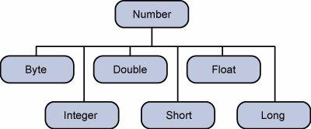

The object of the wrapper class contains or wraps its respective primitive data type. Converting primitive data types into object is called **boxing**, and this is taken care by the compiler. Therefore, while using a wrapper class you just need to pass the value of the primitive data type to the constructor of the Wrapper class.

And the Wrapper object will be converted back to a primitive data type, and this process is called unboxing. The **Number** class is part of the java.lang package.

**Primitive Data types and their Corresponding Wrapper class**

**[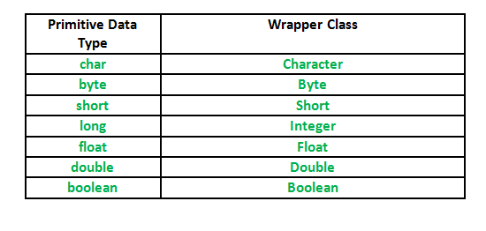](http://www.contribute.geeksforgeeks.org/wp-content/uploads/Wrapper-Class.png)**

**Auto boxing:** Automatic conversion of primitive types to the object of their corresponding wrapper classes is known as auto boxing. For example – conversion of int to Integer, long to Long, double to Double etc.

**Un boxing:** It is just the reverse process of auto boxing. Automatically converting an object of a wrapper class to its corresponding primitive type is known as un boxing. For example – conversion of Integer to int, Long to long, Double to double etc.

**Need of Wrapper Classes**

1. They convert primitive data types into objects. Objects are needed if we wish to modify the arguments passed into a method (because primitive types are passed by value).
2. The classes in java.util package handles only objects and hence wrapper classes help in this case also.
3. Data structures in the Collection framework, such as [ArrayList](http://www.geeksforgeeks.org/arraylist-in-java/) and [Vector](http://www.geeksforgeeks.org/vector-vs-arraylist-java/), store only objects (reference types) and not primitive types.
4. An object is needed to support synchronization in multithreading.

**2. What is Operator and why it is required in programming?**

**Operator:** Operator in java is a symbol that is used to perform operations. For example: +, -, *, / etc.

There are many types of operators in java which are given below:

* Unary Operator,
* Arithmetic Operator,
* shift Operator,
* Relational Operator,
* Bitwise Operator,
* Logical Operator,
* Ternary Operator and
* Assignment Operator.

**3. What is Conditional Constructs and why it is required in programming?**

Decision making structures have one or more conditions to be evaluated or tested by the program, along with a statement or statements that are to be executed if the condition is determined to be true, and optionally, other statements to be executed if the condition is determined to be false.

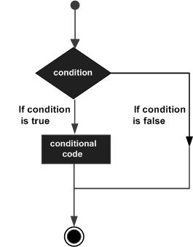

|  |  |
| --- | --- |
| **Sr.No.** | **Statement & Description** |
| 1 | [**if statement**](https://www.tutorialspoint.com/java/if_statement_in_java.htm)  An **if statement** consists of a boolean expression followed by one or more statements. |
| 2 | [**if...else statement**](https://www.tutorialspoint.com/java/if_else_statement_in_java.htm)  An **if statement** can be followed by an optional **else statement**, which executes when the Boolean expression is false. |
| 3 | [**nested if statement**](https://www.tutorialspoint.com/java/nested_if_statements_in_java.htm)  You can use one **if** or **else if** statement inside another **if** or **else if** statement(s). |
| 4 | [**switch statement**](https://www.tutorialspoint.com/java/switch_statement_in_java.htm)  A **switch** statement allows a variable to be tested for equality against a list of values. |

**4. What is difference between if-else and switch case?** The **If statement** is used to select among two alternatives. It uses a Boolean expression to decide which alternative should be executed. The **switch statement** is used to select among multiple alternatives. It uses an int expression to determine which alternative should be executed**.**

**IF Statement:** Checks the value of data is less than or greater than. (in ranges).

**Example:** Can tell whether an input age is more than 18 and less than 60.  
  
**SwitchCase**: Checks the value of data that is pre specified.   
**Example:** Can only generate output if the value matches. When the age is 18 or when the age is 60. No comparison of data based on greater than or smaller than. Compares data based on equality.

**5. What is looping constructs and why it is required in programming?**

It tests the condition before executing the **loop** body. Execute a sequence of statements multiple times and abbreviates the code that manages the **loop** variable.

Looping constructs in Java are:

* For statement
* For-each statement
* While statement
* Do while statement

1. **Difference between while, do while and for loop?**

**While Loop:** While loop checks for the condition first. so it may not even enter into the loop, if the condition is false.

**Do While Loop:** do while loop, execute the statements in the loop first before checks for the condition. At least one iteration takes places, even if the condition is false.

**For Loop:** for loop is similar to while loop except that

* + Initialization statement, usually the counter variable initialization.
  + A statement that will be executed after each and every iteration in the loop, usually counter variable increment or decrement.