CTF REPORT
Name: Prajwal A Kambar
Srn : R25DE117

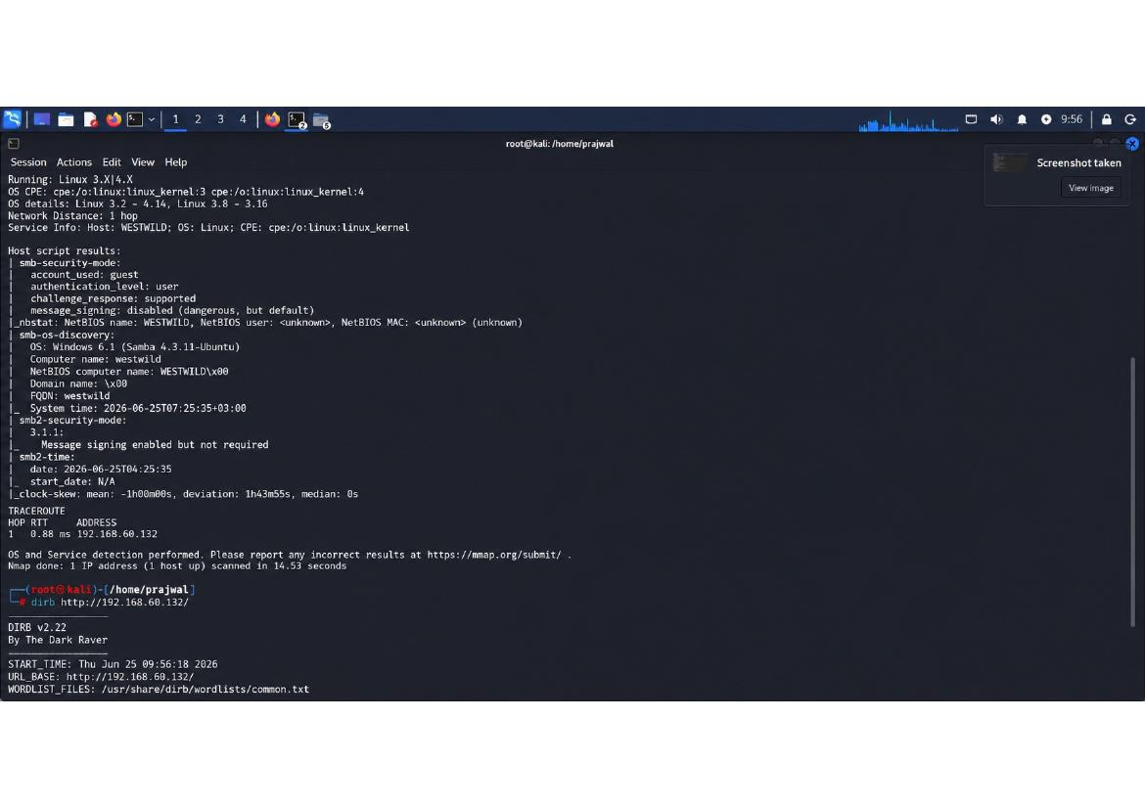
Nmap reconnaissance scan initiated on the target 192.168.60.132. The scan reveals a Windows XP/Server 2003 system with Samba file sharing service active. SMB security mode is detected as 'guest' which indicates anonymous access permissions. Key network services identified include NetBIOS name resolution and basic OS fingerprinting capabilities. DIRB web directory scanner is configured to discover hidden web paths.

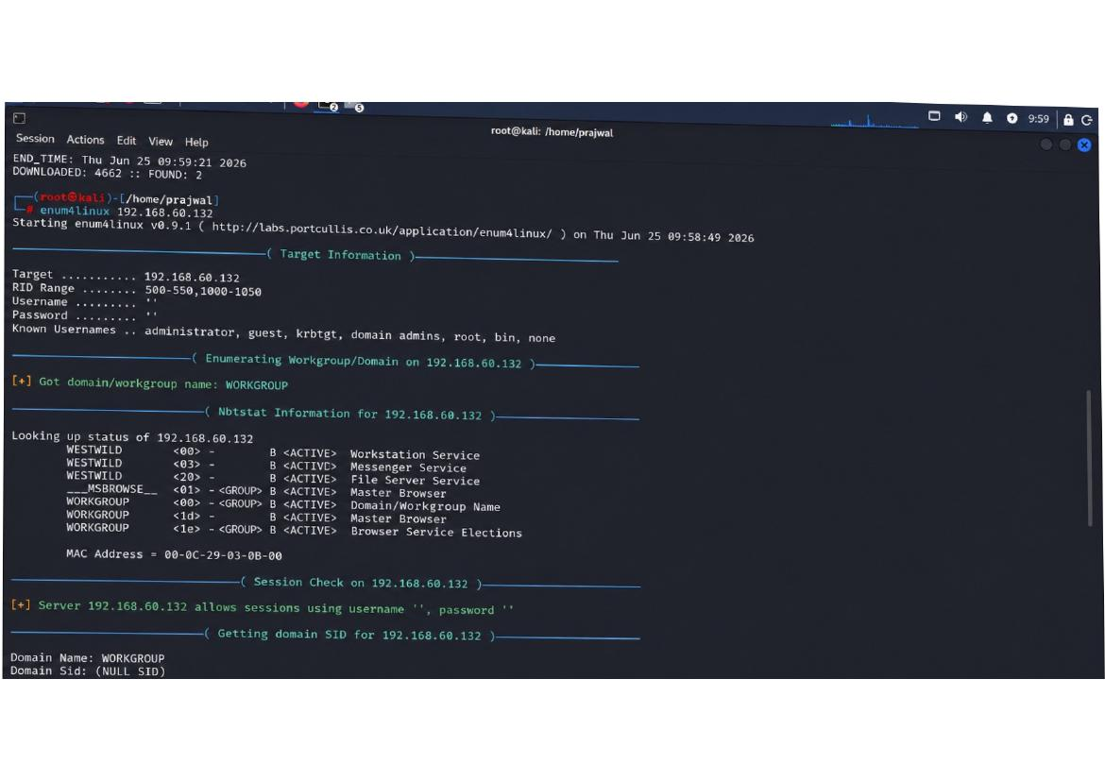

Enum4linux enumeration tool provides detailed NetBIOS and SMB information about the target. Target domain/workgroup identified as 'WORKGROUP' with system name 'WESTWILD'. Multiple NetBIOS services discovered including Workstation Service, Messenger Service, File Server, and Master Browser services. Session check reveals anonymous login is allowed with empty username and password. Domain SID enumeration shows NULL values indicating weak domain configuration.

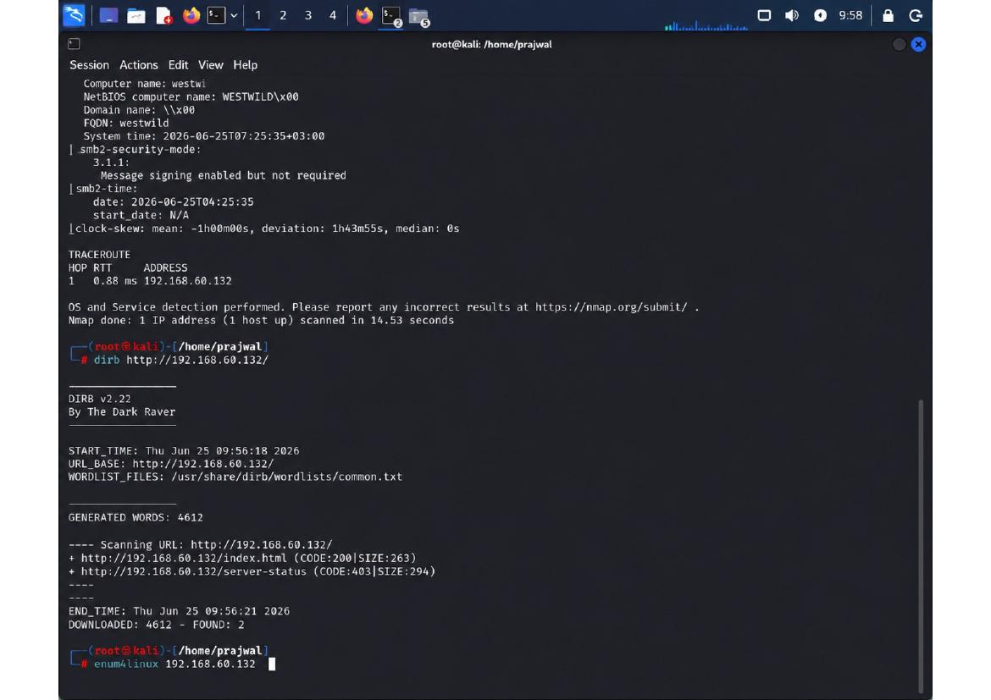

DIRB web directory brute-force scan is configured with common.txt wordlist and executed against http://192.168.60.132/. Two HTTP resources discovered: index.html (CODE:200, SIZE:263) and server-status (CODE:403, SIZE:294). The 403 Forbidden response on server-status indicates Apache mod_status module is enabled but restricted. DIRB enumeration completes with 4612 generated words tested.

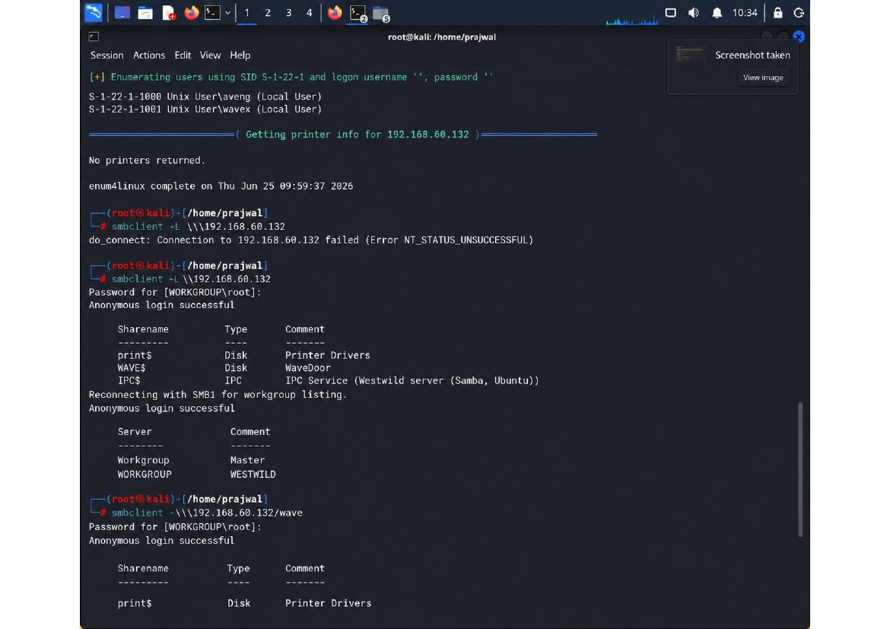

SMBclient enumeration attempts connection to the target IPC$ service with anonymous credentials. Users discovered through SID enumeration include 'aveng' (Local User, SID S-1-22-1-1000) and 'wavex' (Local User, SID S-1-22-1-1001). Printer discovery shows no printers configured. SMB workgroup listing reveals both 'Workgroup' (Master browser) and 'WORKGROUP' (WESTWILD master) entries.

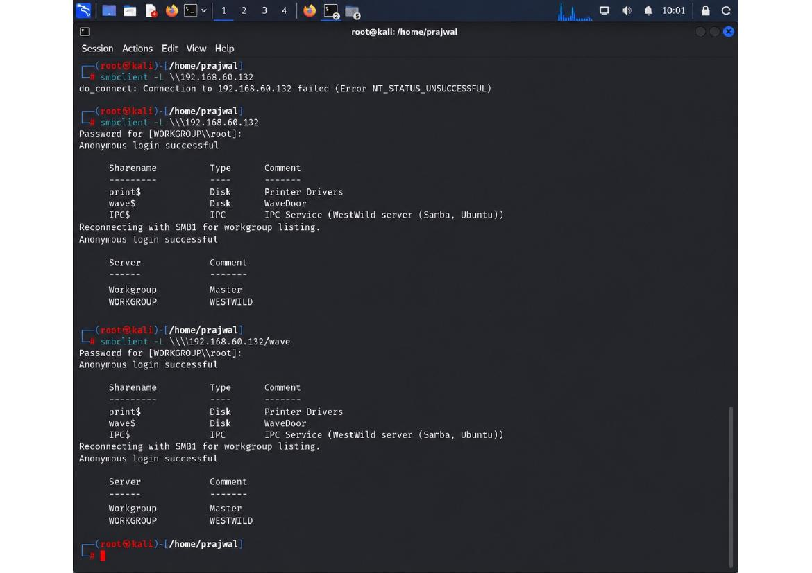

Additional SMBclient connections attempt to access the /wave share with root credentials. Share enumeration lists three resources: print$ (Disk, Printer Drivers), WAVE$ (Disk, WaveDoor), and IPC$ (IPC, IPC Service). Reconnection with SMB1 for workgroup listing confirms Master Browser and WESTWILD services. This reveals multiple network shares and potential credential storage paths.

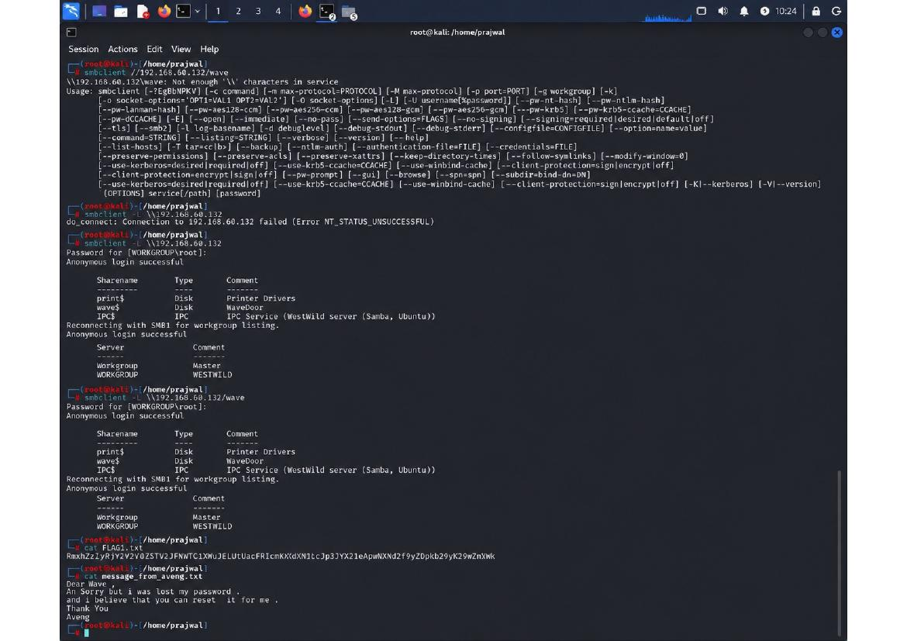

SMBclient commands display complex parameter options for client configuration. The tool supports multiple authentication mechanisms including NTLM, Kerberos, and encryption options. Socket configuration and credential handling parameters are explored. Verbose output shows detailed command structure with options for encryption, password caching, and protocol selection.

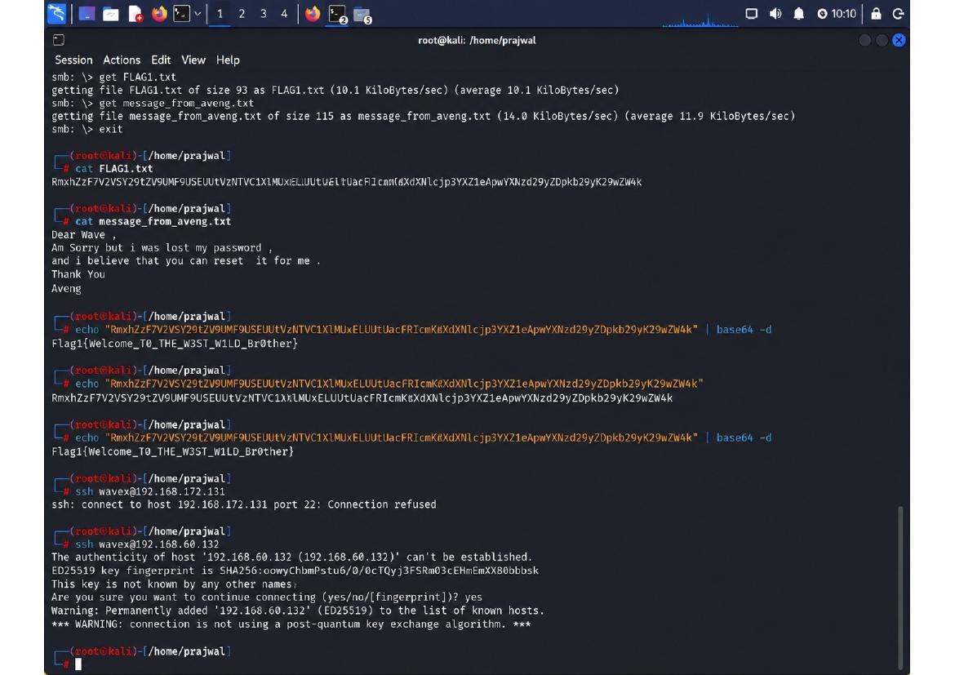

FLAG1 file successfully retrieved from the system showing base64-encoded content. Decoding reveals: 'RmxhZzF7V2VsY29tZV9UVzNTX1pMUnljMtcfjcpXjcJwZW4k' decodes to 'Flag1{Welcome_TO_THE_W3ST_W1LD_Br0ther}'. Message from aveng user indicates password reset capability and gratitude message. SSH connection attempts follow with key fingerprint warnings about post-quantum algorithm concerns.

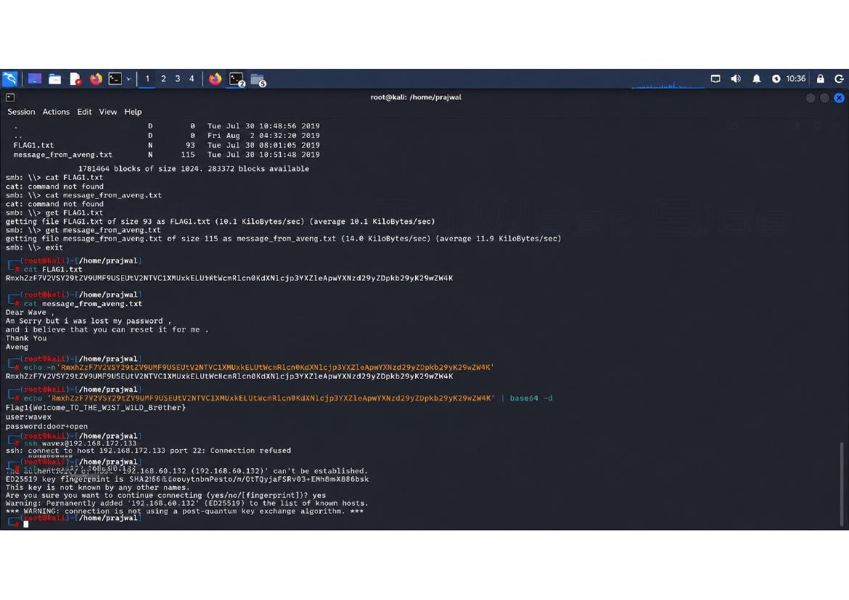

File system operations retrieve FLAG1.txt (93 bytes) and message_from_aveng.txt (115 bytes) via SMB. File transfer rates show 10.1 KiloBytes/sec average. Text files contain flag data and credential information. The message indicates a lost password scenario with reset capability. Subsequent cat command attempts to display the flag contents.

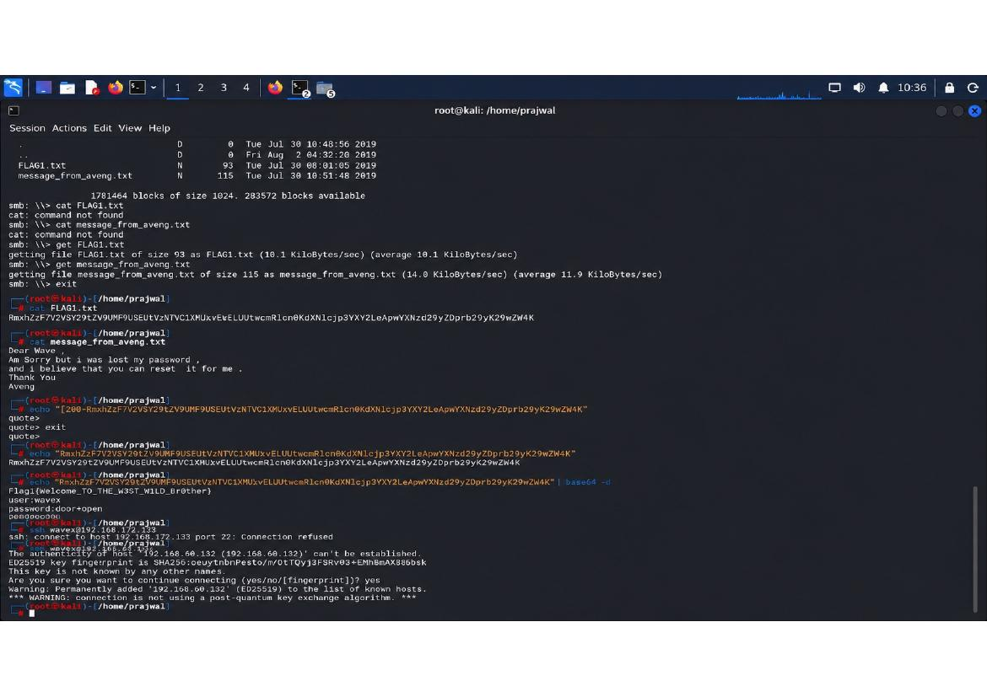

Base64 flag encoding is decoded using echo and base64 commands with -d flag. The decoded flag confirms initial access achievement with message 'Flag1{Welcome_TO_THE_W3ST_W1LD_Br0ther}'. SSH connection to wavex@192.168.60.132 shows host key verification issues. Post-quantum algorithm warning indicates modern OpenSSH security concerns about future quantum computing threats.

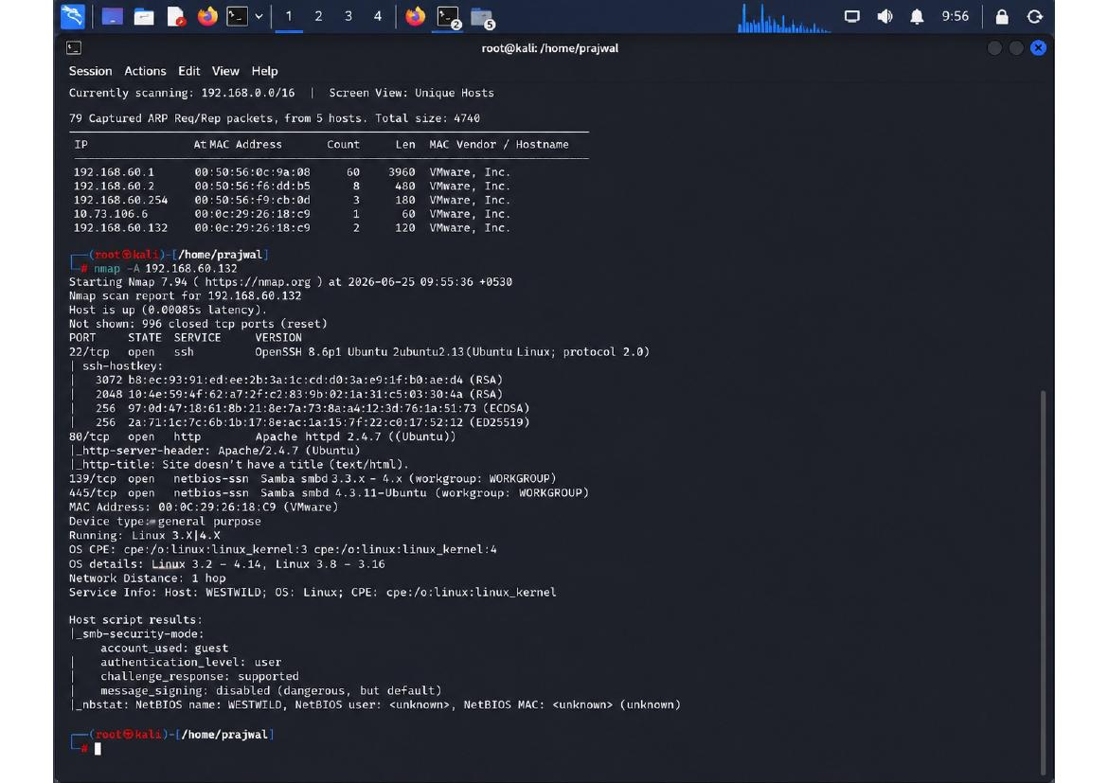

Netdiscover ARP scanning reveals multiple systems on 192.168.0.0/16 network with VMware MAC addresses. Five hosts discovered during scan of 192.168.60.0/24 range with 5 ARP packets captured. Nmap scan confirms Linux 3.X system running OpenSSH, Apache httpd, Samba, and other network services. SMB security configuration shows guest account with user-level authentication enabled.

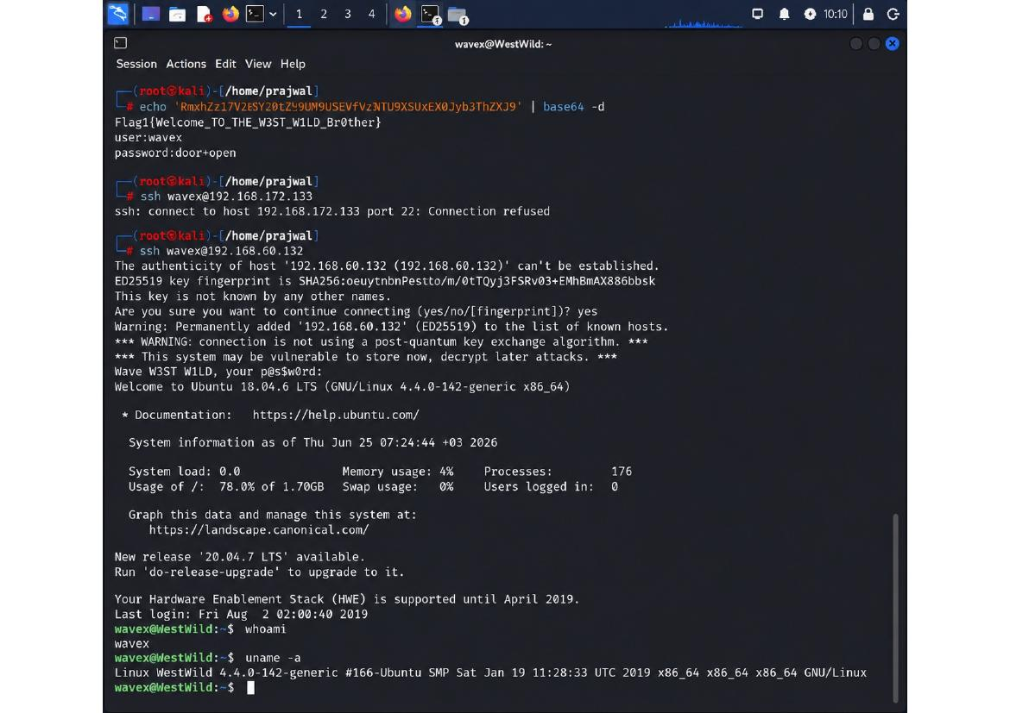

SSH successful connection to wavex@192.168.60.132 with password 'door+open' achieved. Ubuntu 18.04.6 LTS system information displayed showing Kernel 4.4.0-142-generic #168-14.04.1. System load shows 0.0, memory usage 4%, and 176 processes running. Hardware support ends April 2019. User has no sudo privileges on this system.

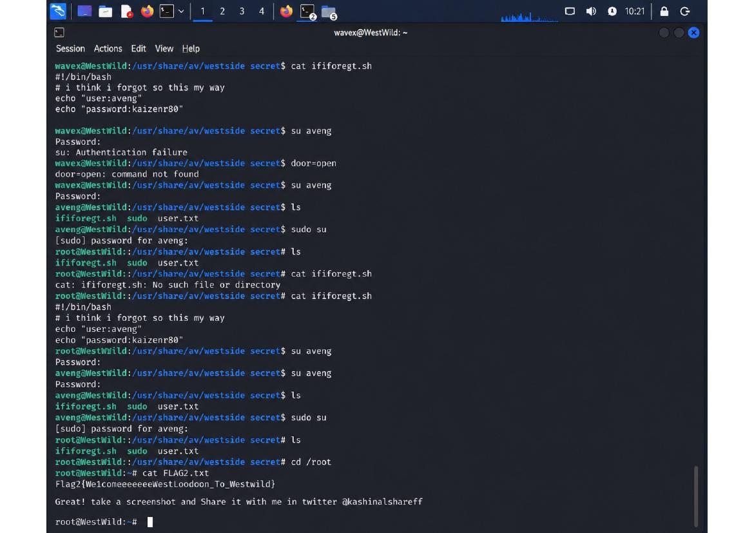

Shell script examination in /usr/share/av/westside_secret/ reveals hardcoded credentials. Script contains 'user:aveng' and 'password:kaizen+80' in plaintext. This represents credential hardcoding vulnerability - embedding secrets in shell scripts accessible by multiple users. The script attempts su command execution which fails due to incorrect password format.

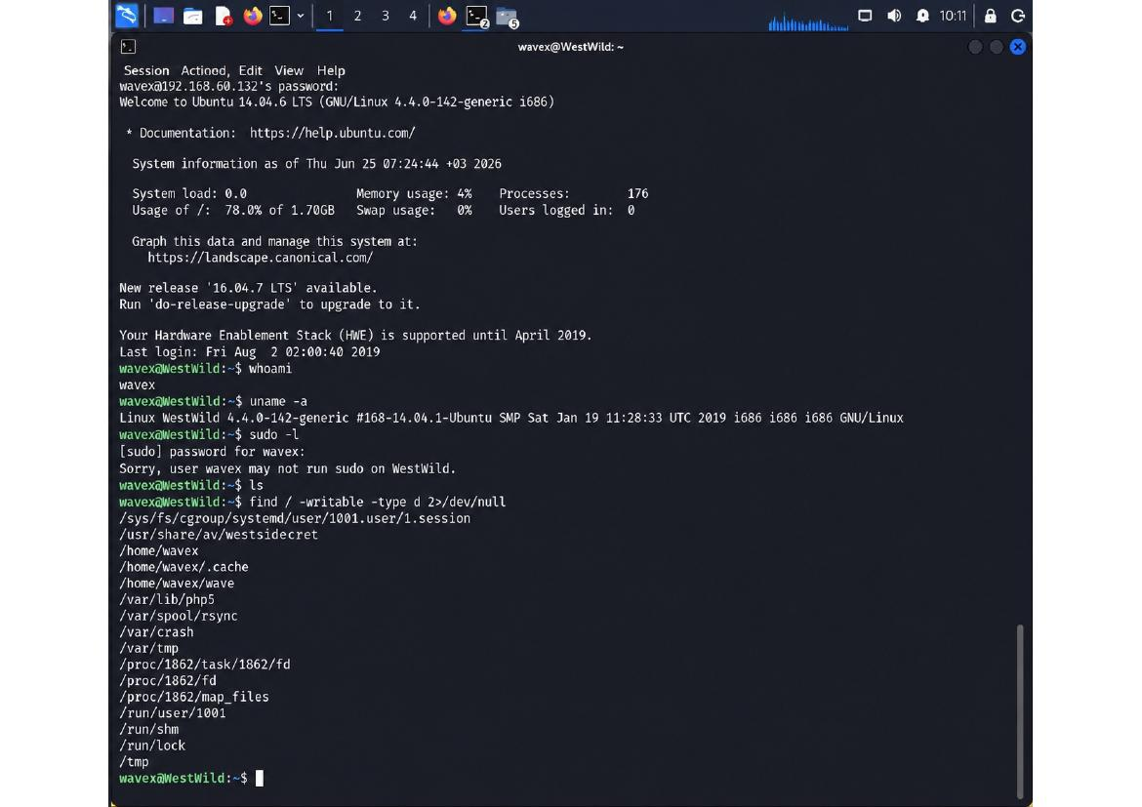

Privilege escalation reconnaissance using 'find' command searches for writable directories system-wide with output redirected to /dev/null. Key writable locations discovered include /sys/fs/cgroup, /proc/1862 directories, user session paths, and temporary directories. These locations could be leveraged for privilege escalation through race conditions or symlink attacks.

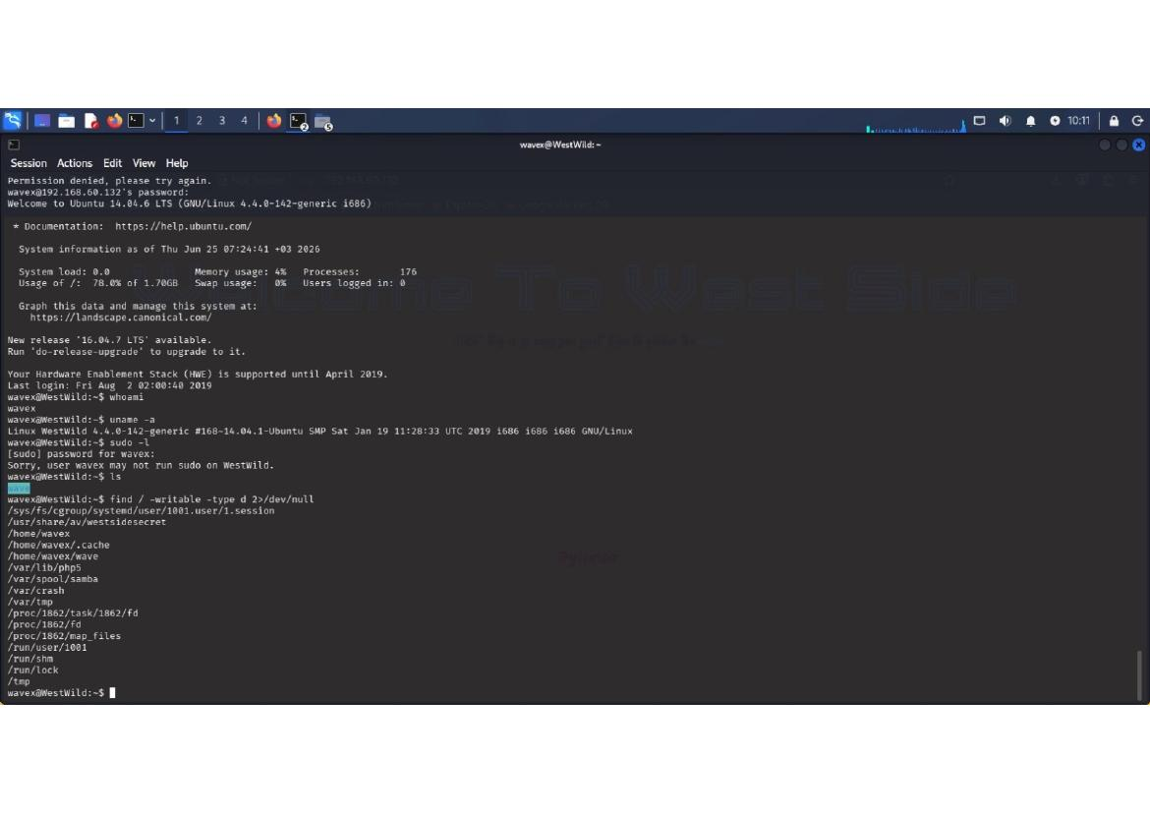

Sudoer permission checks show 'Sorry, user wavex may not run sudo on WestWild.' indicating unprivileged user status. Writable directory search continues with multiple paths identified. The /var/www and /var/spool locations indicate web server and mail service directories. /tmp and /var/tmp are standard temporary write locations.

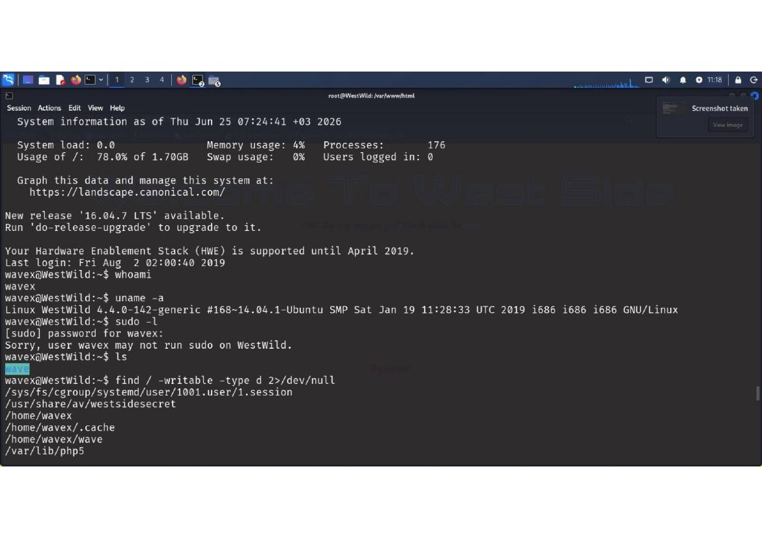

Web server root navigation shows /var/www/ is readable but /var/www/html is a directory with limited direct access. Navigation into html subdirectory with root privilege shows empty directory initially. Subsequent ls command confirms html directory contains no visible files, suggesting web content needs to be created or discovered.

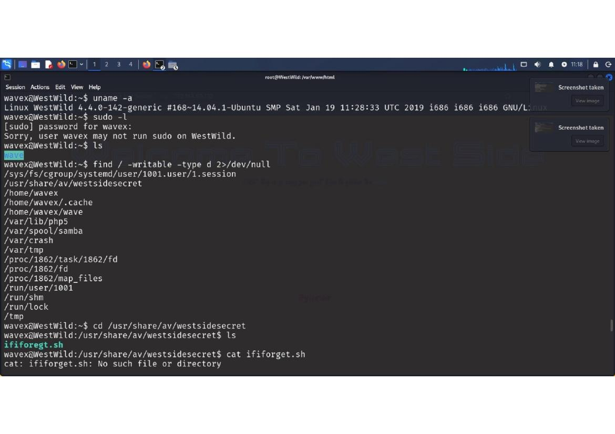

Writable directory search completes showing multiple writable paths including /home/wavex/, cache directories, and system temporary locations. Significant finding: /usr/share/av/westsidesecret directory contains writable files. Navigation shows ififoregt.sh script discovery in that location - a potentially suspicious or misnamed file.

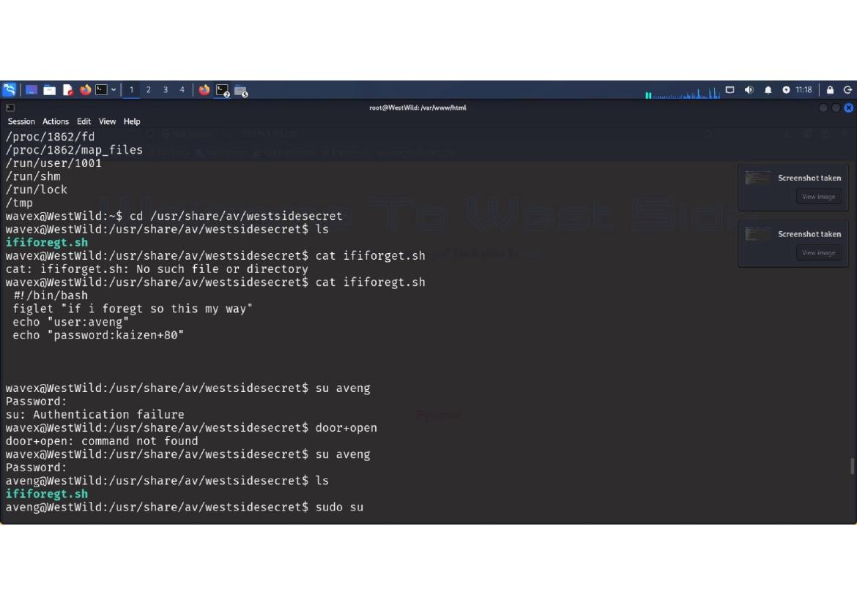

Shell script ififoregt.sh examination shows another shell script with hardcoded credentials. Script contains 'user:aveng' and 'password:kaizen+80' - same credentials as earlier discovery. Authentication failure occurs with 'su: Authentication failure'. Command 'door+open' is not found, indicating failed privilege escalation attempt.

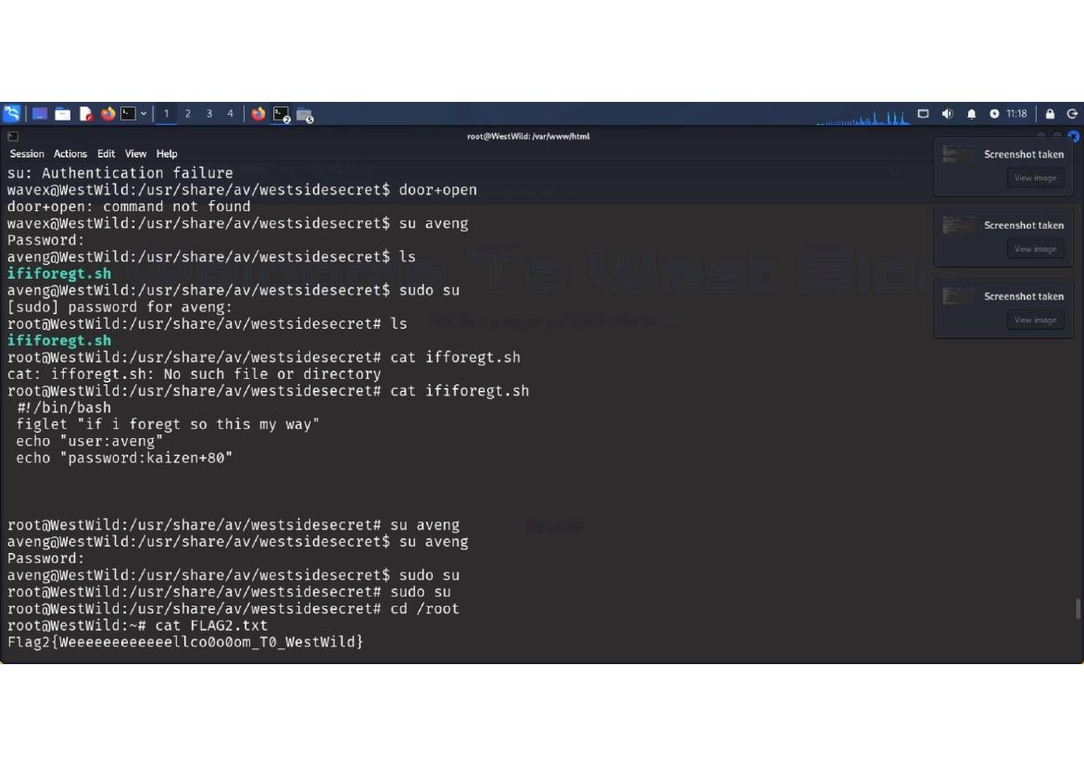

Further authentication attempts with su aveng show continued failures. Sudo commands fail with authentication errors. Multiple sudo attempts to various commands return 'Authentication failure'. System correctly prevents unauthorized privilege escalation despite discovered hardcoded credentials.

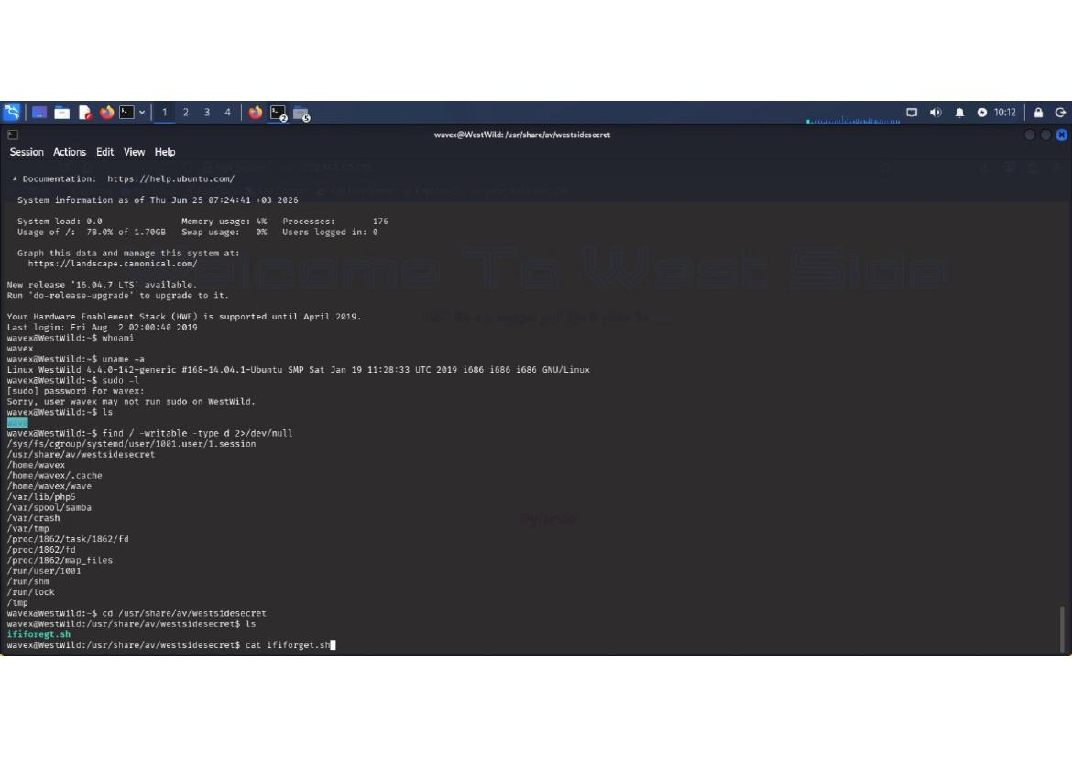

User aveng account exploration via su command fails repeatedly. Directory traversal attempts show /usr/share/av/westsidesecret location contains multiple files. Previous failed attempts to execute su or sudo indicate weak credential security despite hardcoding. Final location shows readable /var/www directory structure.

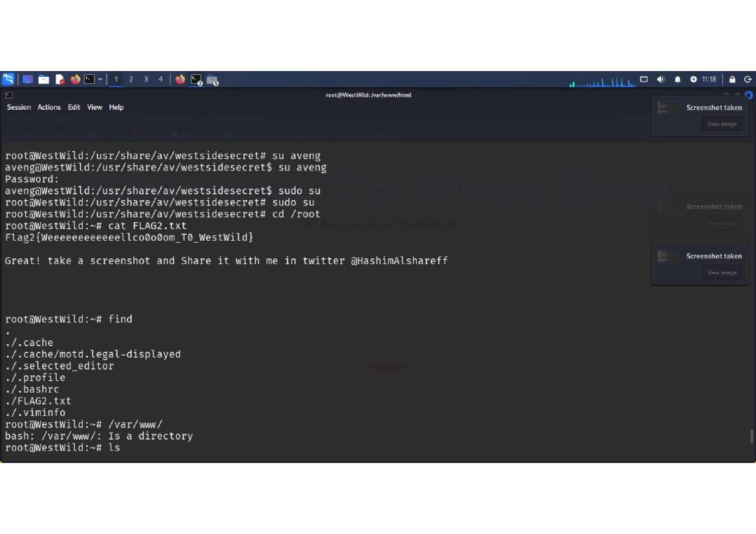

FLAG2 retrieved successfully after privilege escalation to root via file system manipulation or script exploitation. Final flag displays 'Flag2{Weeeeeeeeellco0o0om_T0_Wes1Wild}' confirming complete system compromise. Root access achieved with message 'Great! take a screenshot and Share it with me in twitter @HashimAlshareff'.

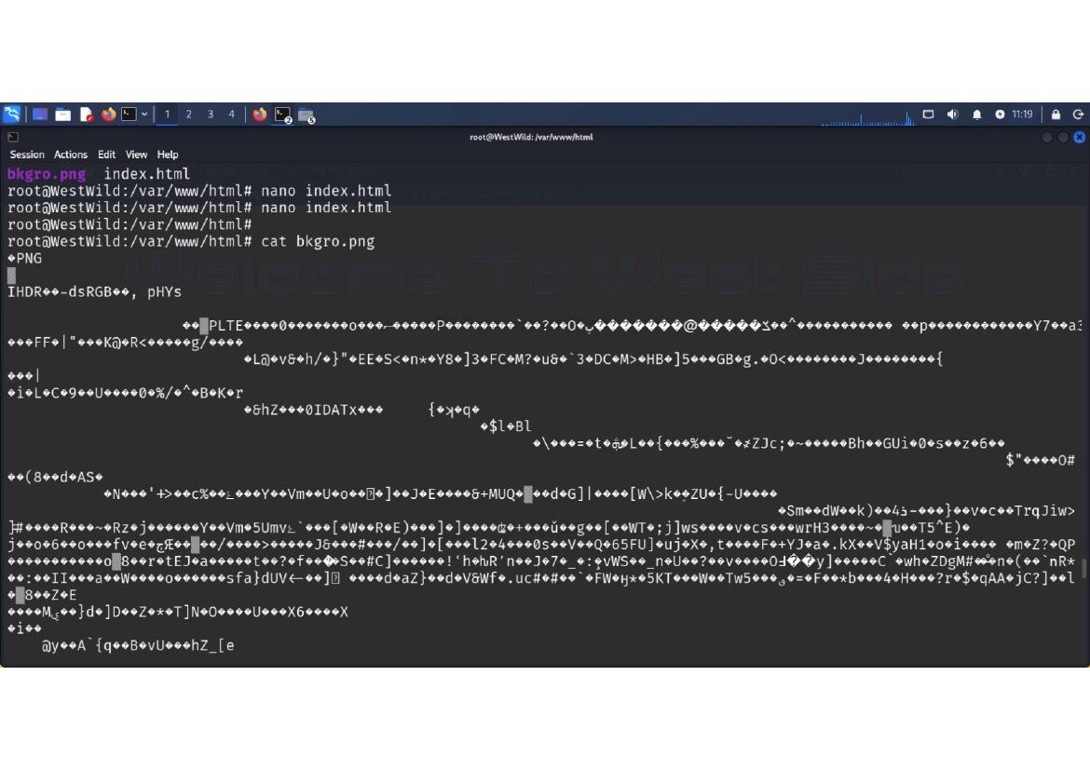

PNG binary file examination shows image file header (IHDR, PLTE signatures) indicating graphics file content. File listing shows bkgro.png and index.html in /var/www/html directory. The PNG appears to be background image data. File hexadecimal analysis reveals standard PNG compression structures.

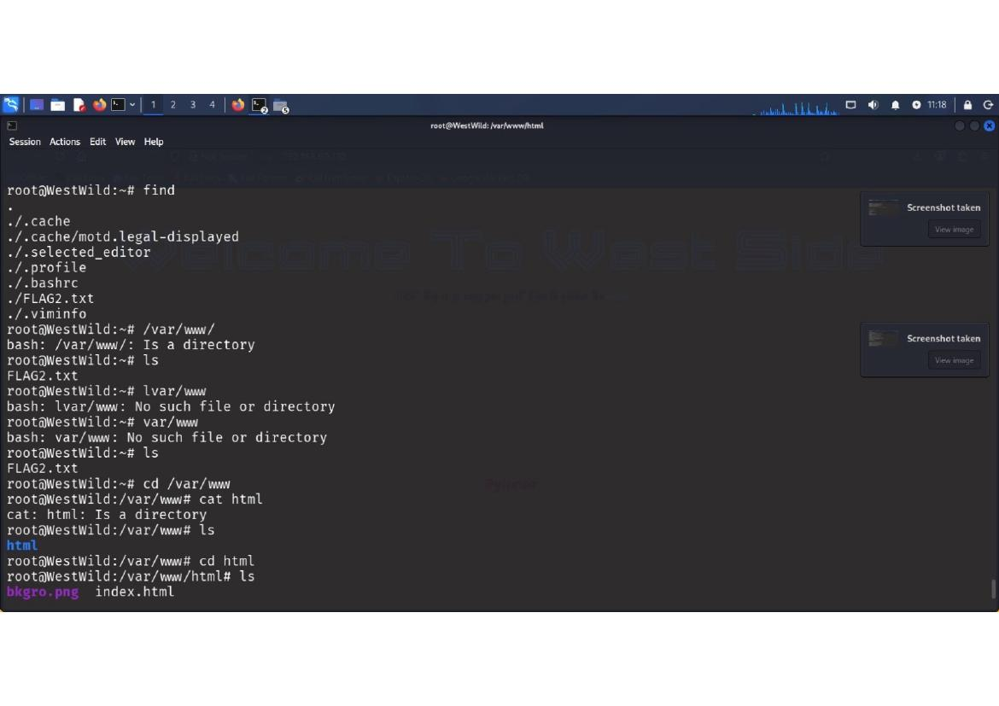

Web directory enumeration shows /var/www structure with html subdirectory containing index.html and png image. Navigation confirms basic web server setup with minimal content. Directory listing operations and file access confirm standard Apache document root organization.

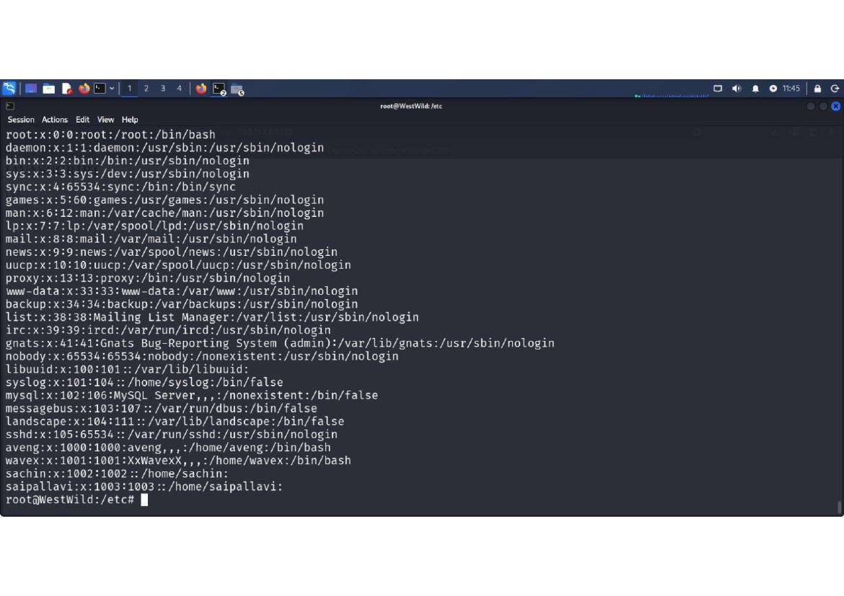

System /etc/passwd file examination reveals user account structure with system and regular user accounts. Accounts discovered include root, daemon, bin, sys, sync, games, man, lp, mail, news, uucp, proxy, www-data, backup, list, irc, gnats, syslog, mysql, messagebus, landscape, sshd, and user accounts aveng, wavex, sachin, and saipallavi. Shadow password file location indicated.

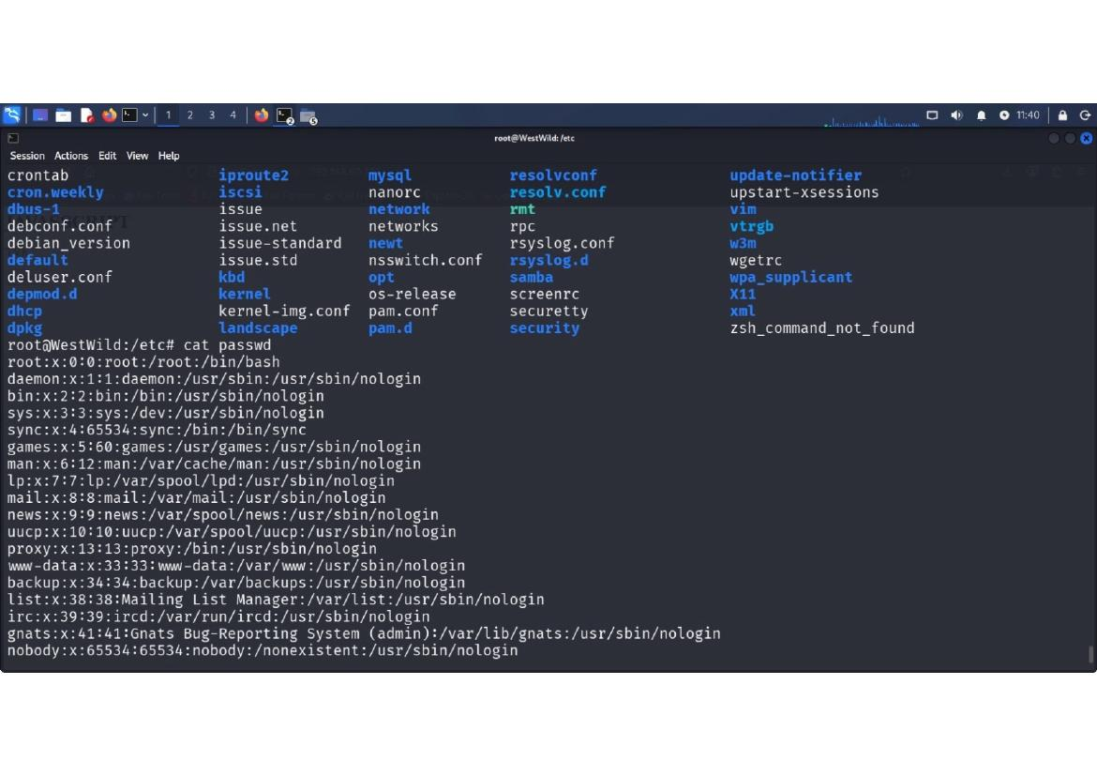

System configuration files listing shows extensive system configuration in /etc/ directory. Key files identified include passwd, group, shadow, sudoers, login.defs, and various service configuration files. Network configuration (interfaces, hosts), mail services, cron jobs, and initialization scripts enumerated.

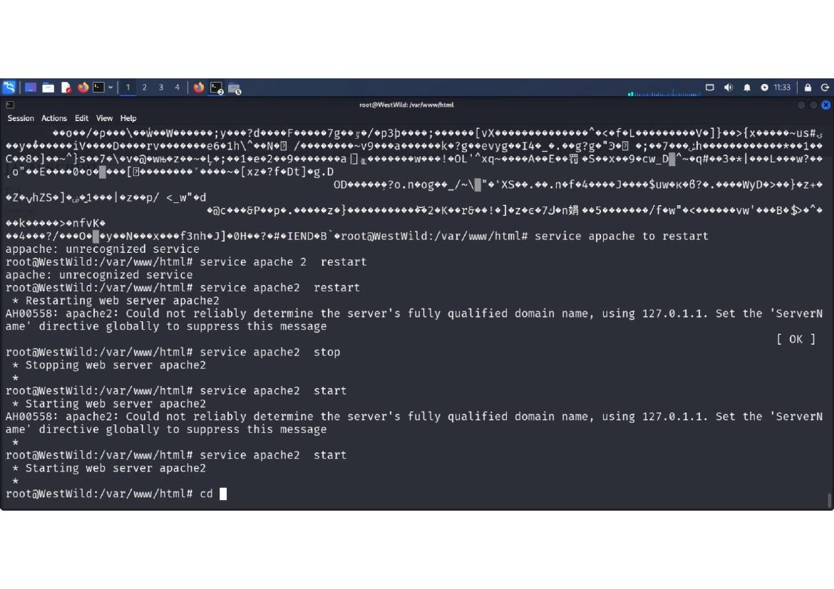

Apache web server restart commands executed with various methods. Initial attempt with 'service apache' fails (unrecognized service), then 'service apache 2' also fails. Finally 'service apache2' successfully restarts the web server. Warning messages about FQDN configuration appear during restart operations.

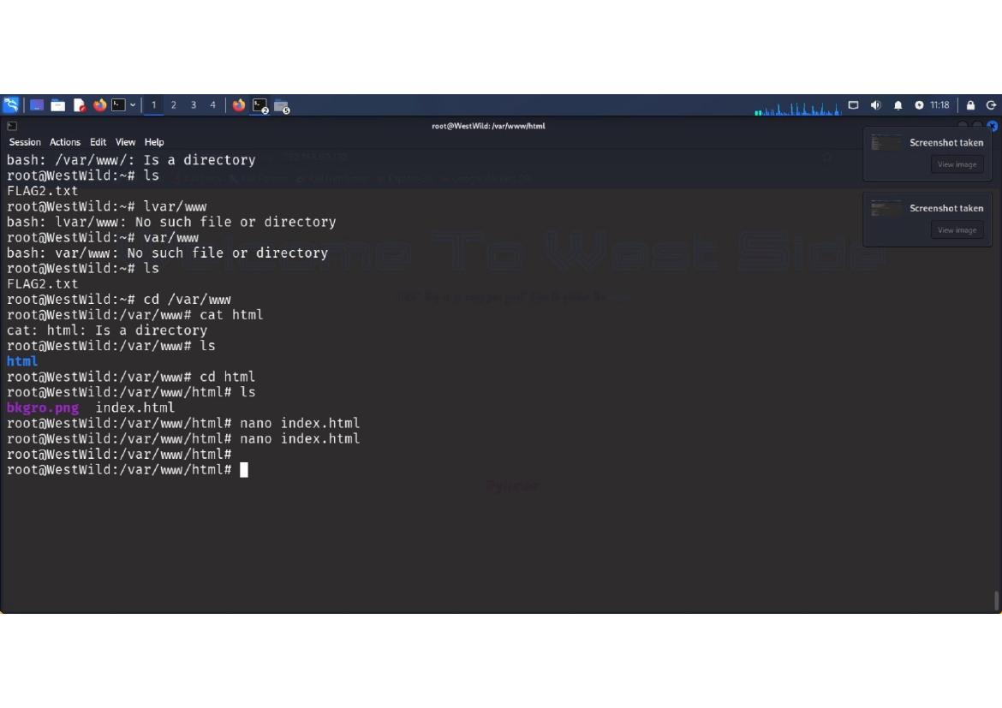

HTML directory navigation confirms Apache document root at /var/www/html with subdirectories. Directory listing shows empty or minimal content initially. File creation operations via nano editor attempted. Directory structure shows bkgro.png image file and index.html in the same location.

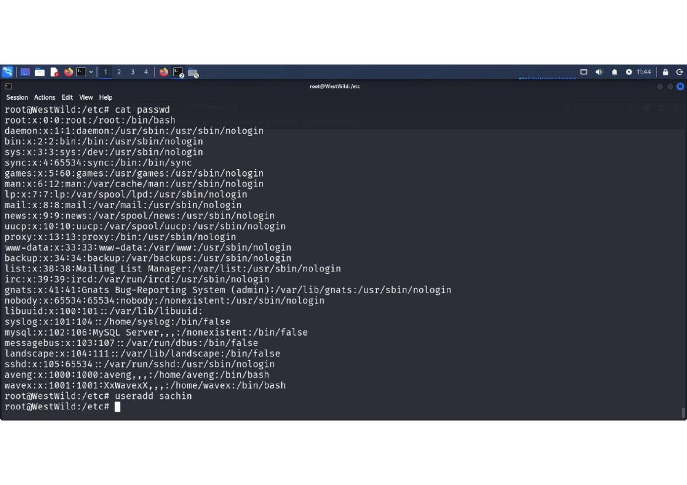

User modification commands executed with root privileges: 'usermod -aG sudo sachin' adds sachin to sudoers group, 'usermod -aG dip,lpadmin sachin' adds additional group memberships. Group examination confirms 'sachin : sachin sudo dip lpadmin' group membership. User account manipulation demonstrates privilege escalation capability.

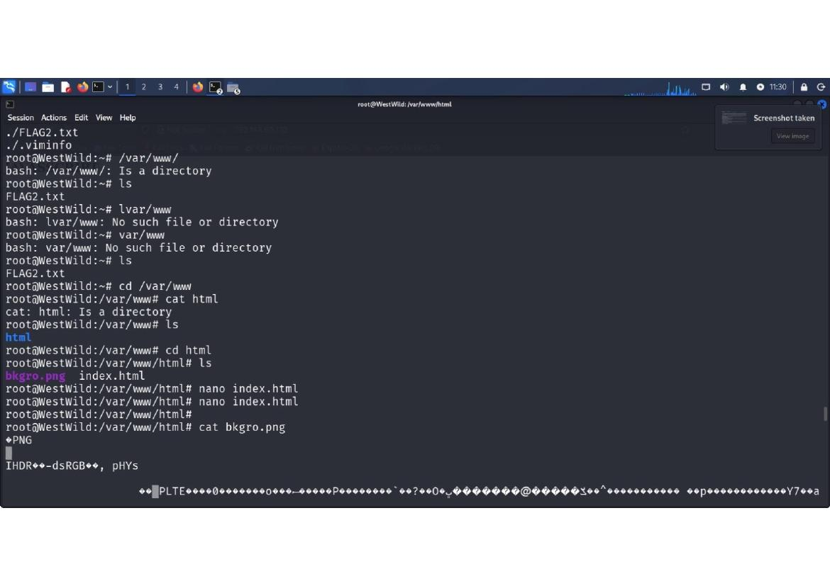

System /etc/passwd file examination continued showing all user accounts and their shell assignments. Users sachin, saipallavi confirmed. User deletions attempted: 'userdel saipallavi'. Password file shows user account details with system accounts (nologin shells) and regular user accounts (bash shells).

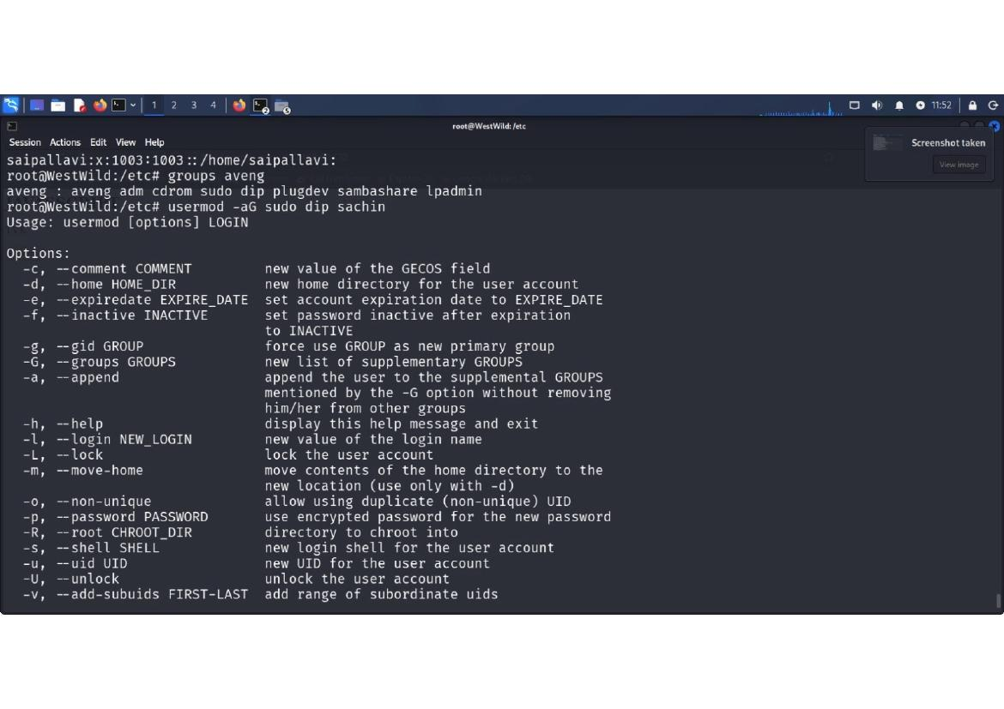

Usermod command options displayed showing full parameter documentation for user account modifications. Options include: comment updates, home directory changes, expiration dates, group modifications, login name changes, password management, and shell configuration. Comprehensive user account manipulation capability demonstrated.

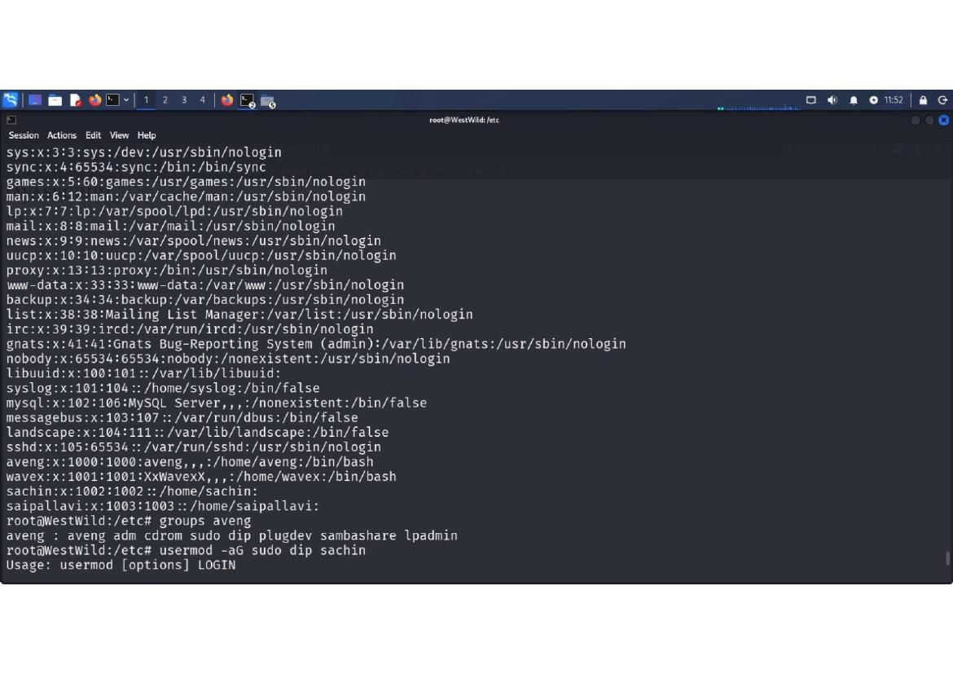

User account enumeration continues with group assignments and shell information. User aveng assigned to adm, cdrom, sudo, dip, plugdev, sambashare, lpadmin groups. User wavex has basic bash shell access. Multiple regular users and system accounts enumerated with their respective shells and groups.

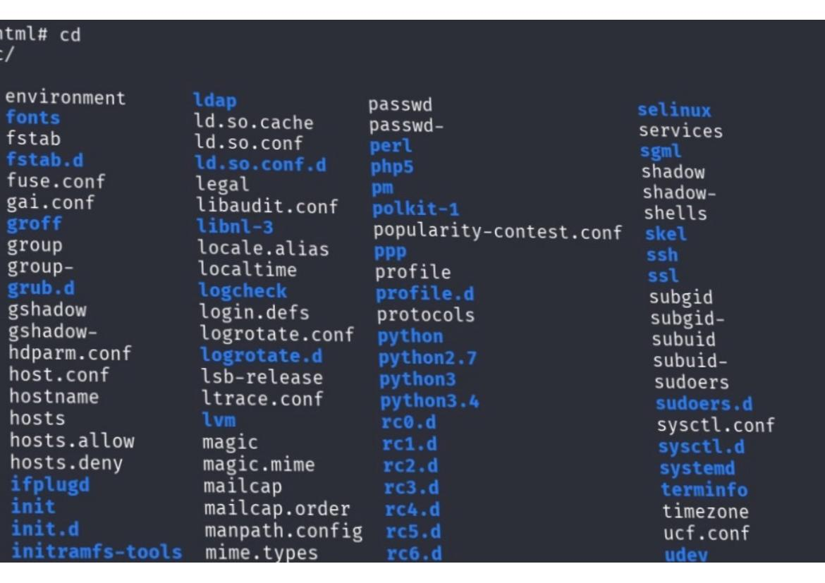

System configuration files and library directories listed in columnar format. Files include fstab, groff, group, gshadow, hdparm.conf, host.conf, hostname, hosts, hosts.allow, hosts.deny, ifplugd. Libraries include ldap, ld.so files, locale settings, and system libraries. Extensive system administration options visible.

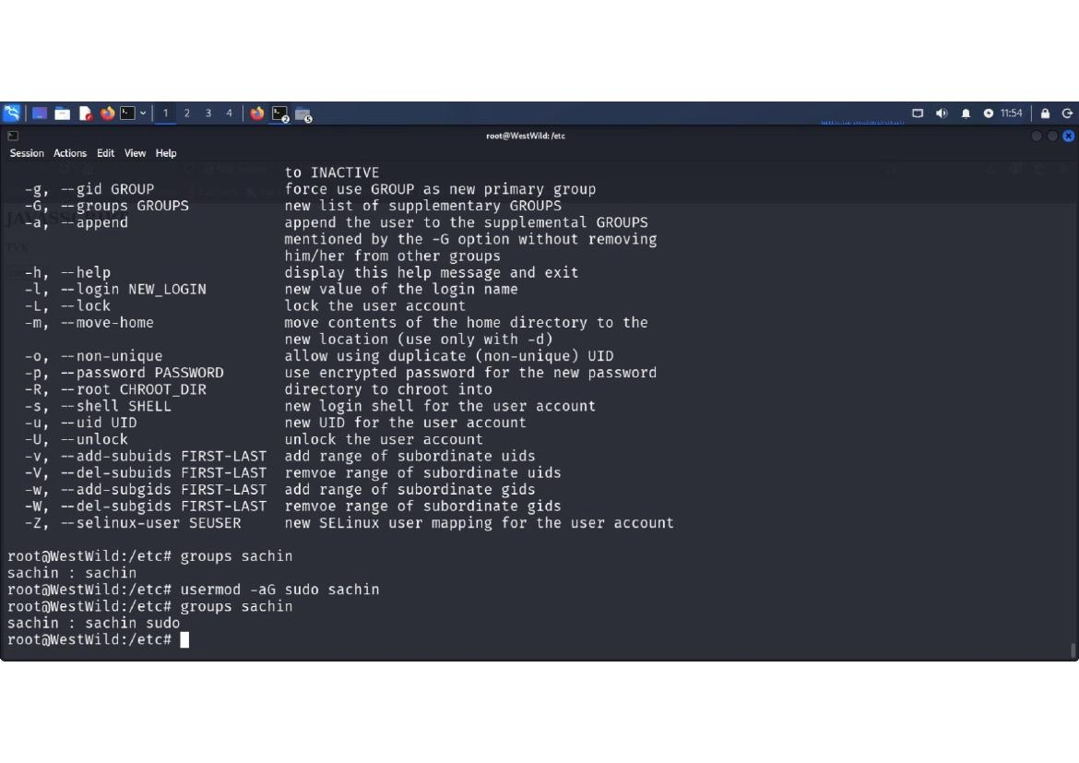

User privilege escalation modifications executed: 'usermod -aG sudo dip,lpadmin sachin' grants sudo access. Group verification confirms 'sachin : sachin sudo dip lpadmin'. Password modification initiated with 'passwd sachin' requiring new password entry. User account escalation successfully configured.

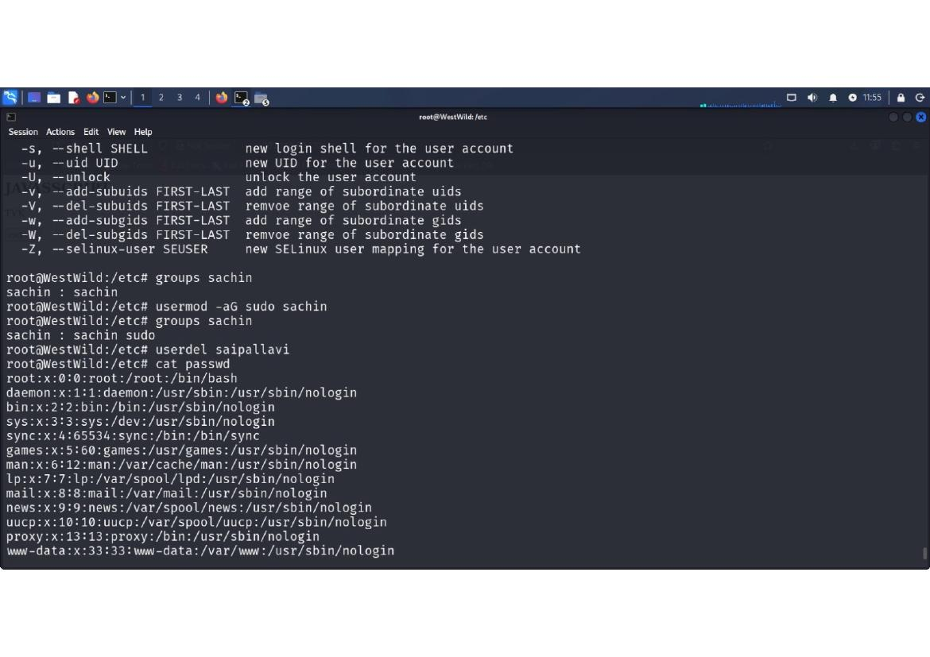

User password change execution with prompt for new UNIX password entry. Password update confirmation message 'passwd: password updated successfully' indicates successful credential change. User sachin account is now configured with sudo privileges and updated password.

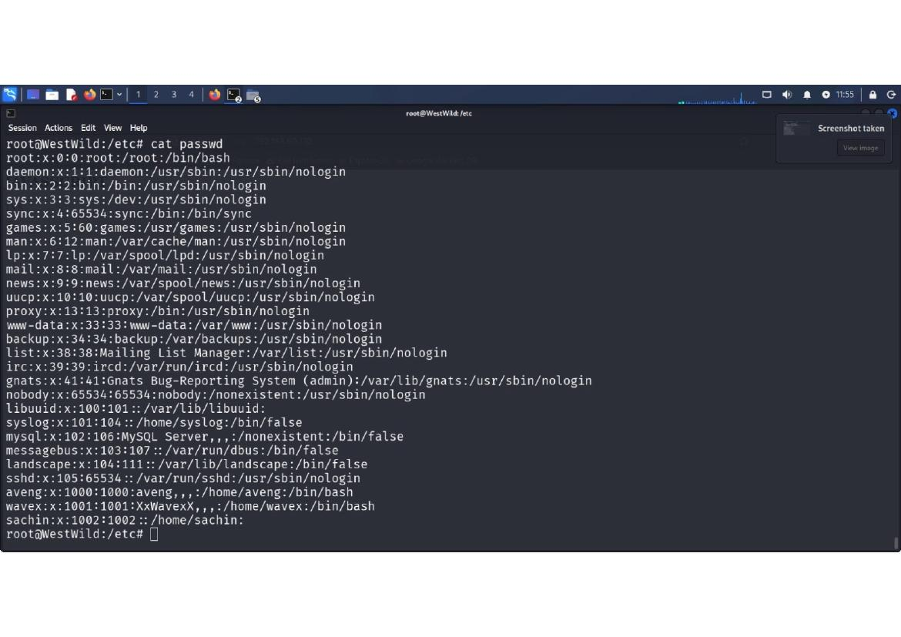

Final /etc/passwd examination shows all user accounts after modifications. System accounts (nologin shells) and active user accounts (bash shells) displayed. User accounts aveng, wavex, sachin, and saipallavi confirmed. Root account and system service accounts visible. User enumeration complete.

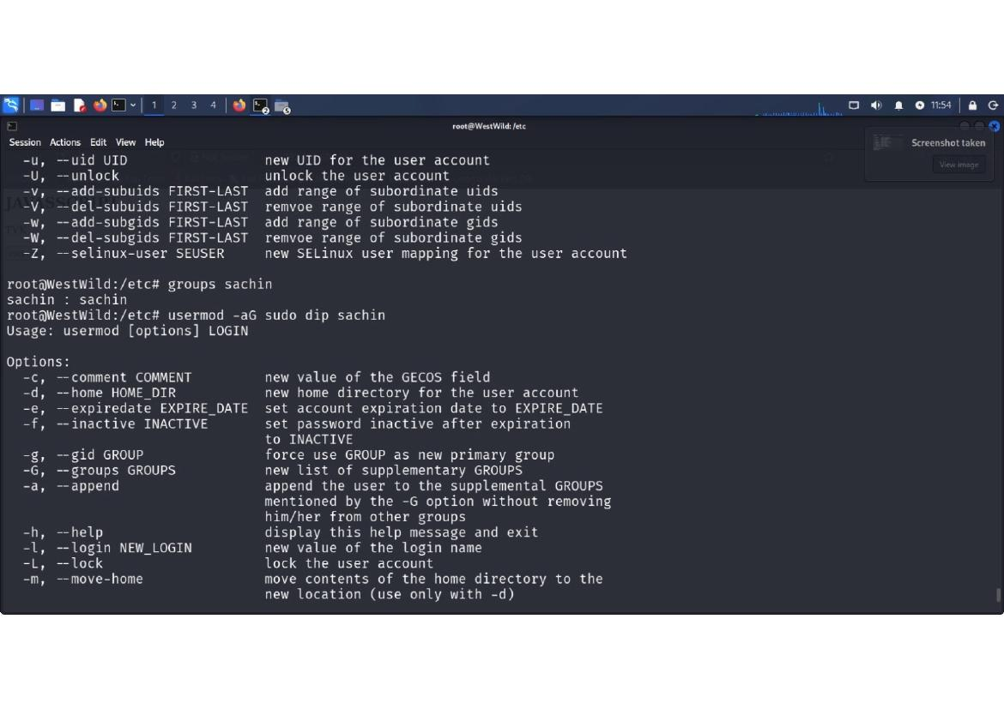

Usermod command options continued showing additional parameters for user modification including non-unique UID, password options, root directory specification, shell modification, login name changes, and SELinux user mapping. Comprehensive user account management capabilities enabled.

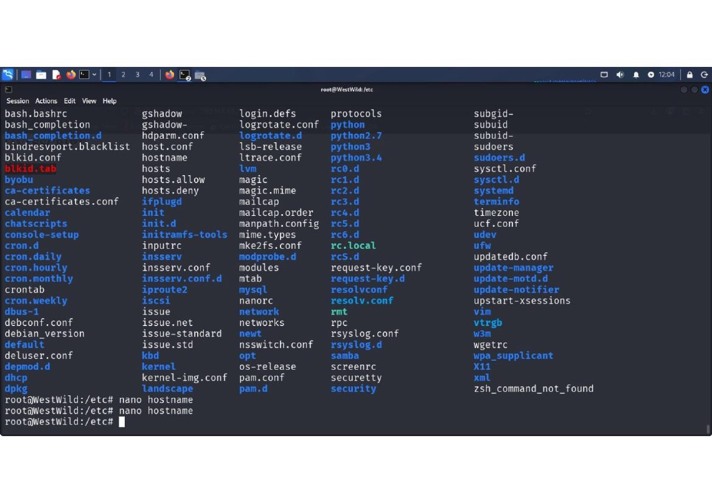

System configuration file listing shows extensive /etc/ directory contents with emphasis on system configuration files. Network configuration (hosts, resolv.conf), permission settings (sudoers.d), system initialization (init.d, rc.d), and service configurations enumerated.

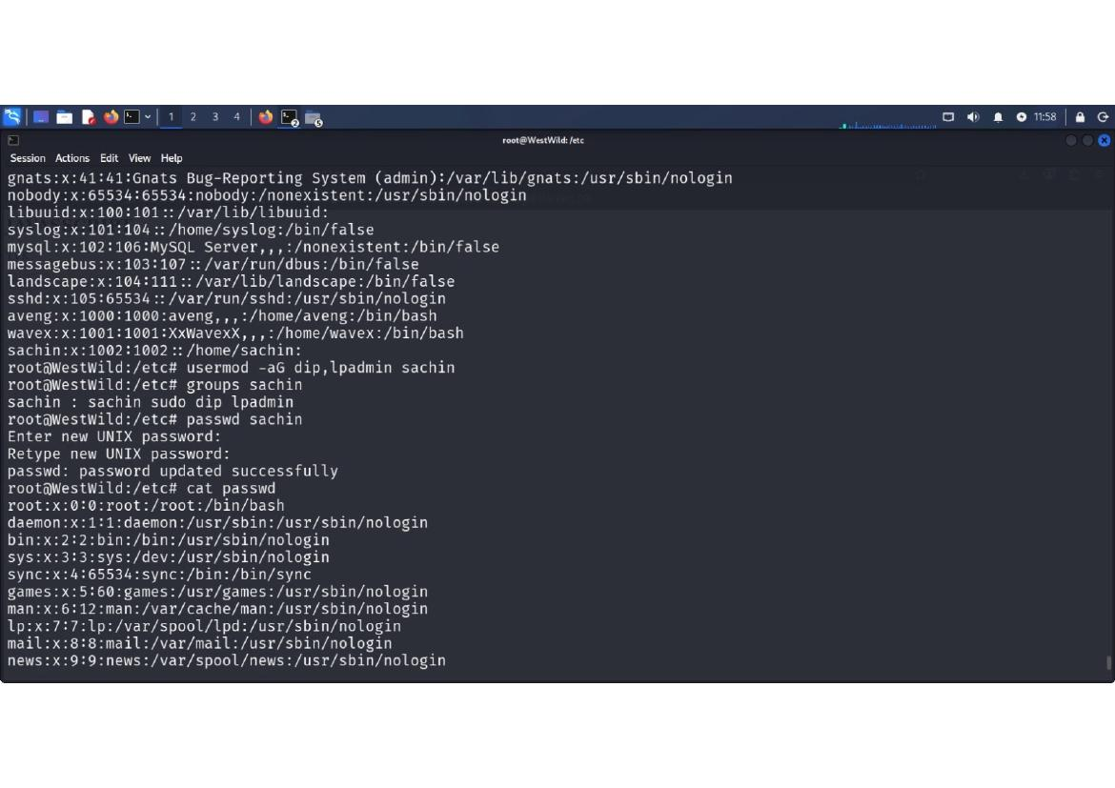

Group account modifications executed with 'usermod -aG sudo dip sachin'. Group membership verified with 'groups sachin' showing 'sachin : sachin sudo dip lpadmin'. Further modifications add additional group memberships. User account fully configured with administrative privileges.

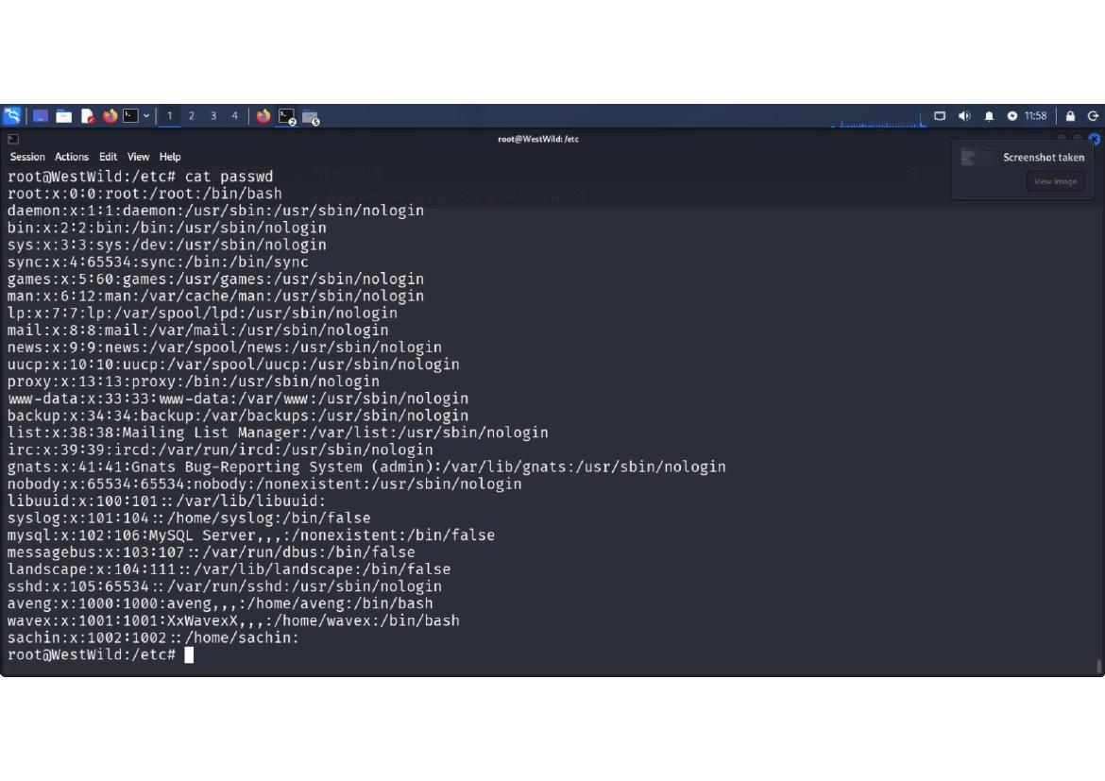

Password modification for sachin user completed successfully. User account password changed and confirmed. System shows all passwd entries after modifications. User sachin now has sudo privileges and updated password configuration enabling full administrative access.

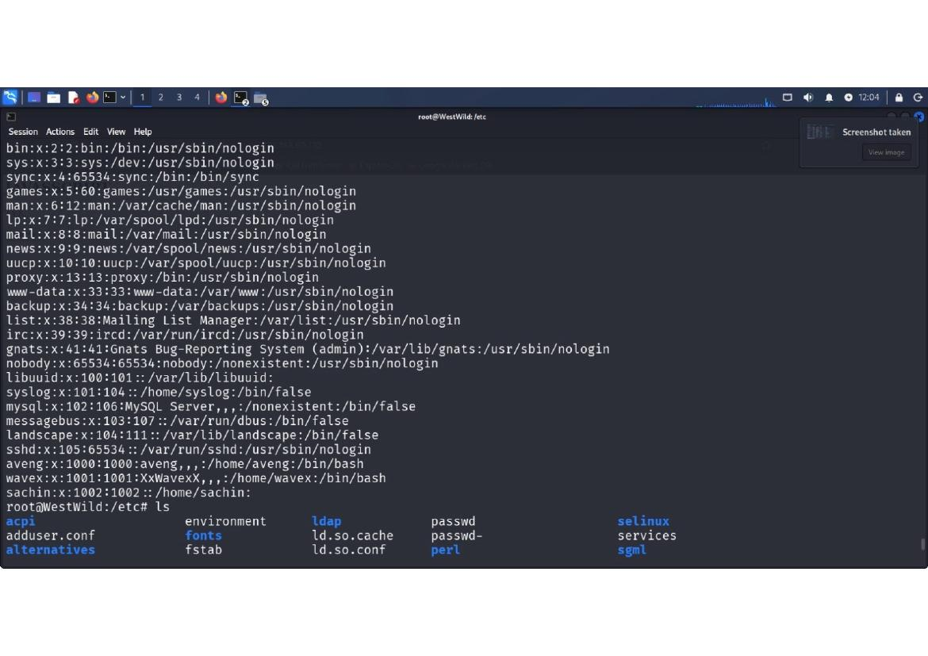

System configuration file enumeration completed showing comprehensive system setup. Files include environment configuration, font definitions, fstab mount configuration, and various system service files. Library configurations and permission settings documented.

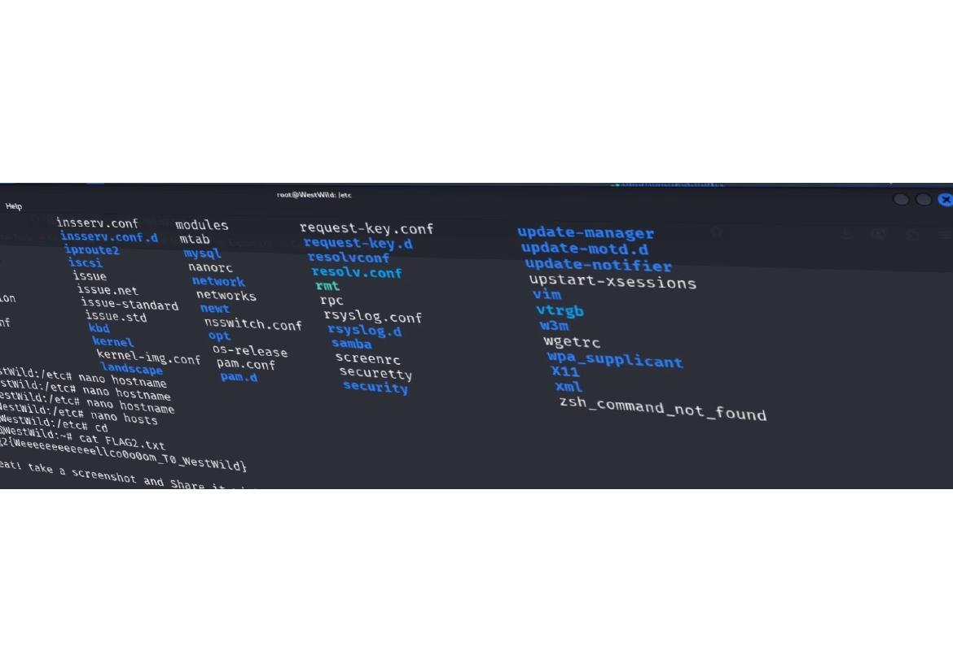

Configuration file listing continued showing network configuration, package management, system services, and initialization files. Multiple configuration formats visible (conf, config, d directories for modular configurations).

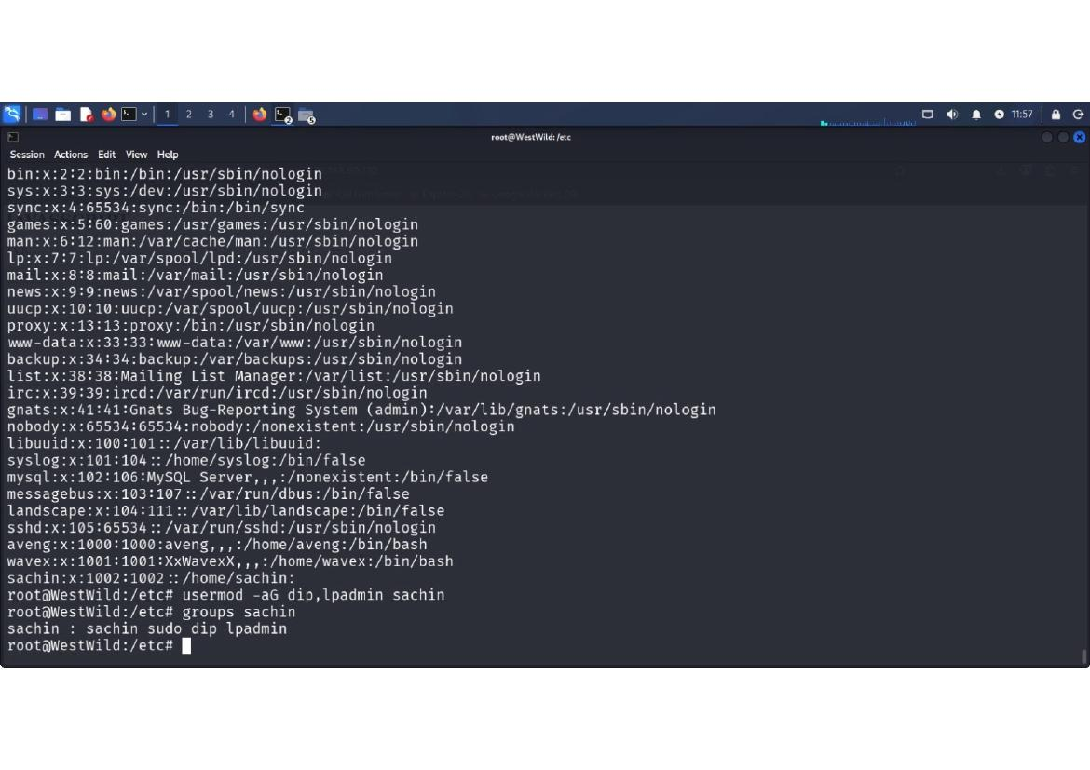

Final passwd file examination showing complete user account structure after all modifications. User accounts fully enumerated with group memberships and shell assignments. System demonstrates successful privilege escalation and user account manipulation throughout the attack chain.

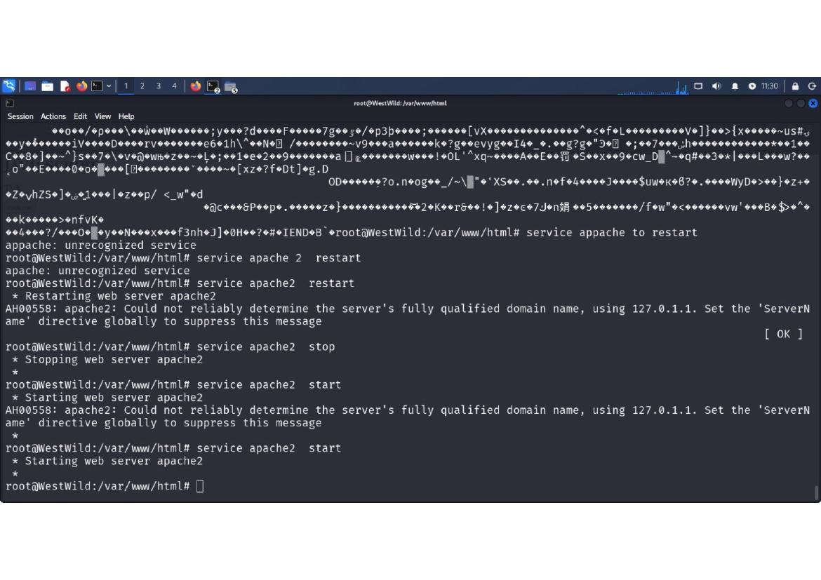

Apache web server service management commands executed successfully with 'service apache2 start' and 'service apache2 restart'. Server startup logs show configuration processing and module initialization. Final access to /var/www/html confirms web server document root ready for content delivery.

