**Pradaga HS Athletics Events Management System – Report**

Pradaga High School Athletic Events Management System is a system built to maintain the data of all sports/athletic events occurring at Pradaga High School along with information about event schedules, participants and sponsors.

The different roles in this system are:

1. Event Manager (anyone who creates an event or an authorized member of the Pradaga HS),
2. Participant (participating in an event),
3. Sponsors (sponsoring an event).

Brief Description:

* Anyone who navigates to the website URL can view all events.
* Existing users can login into the system and new users can register.
* Once logged in, users will be able to create an event, register to participate in an event and sponsor an event.
* Users will be assigned the event manager roles for events created by them and can modify/update or delete the event.
* A single user can be the event manager, participate and sponsor a event.

The URL of the Homepage is:

<https://pk549.rutgers-sci.domains/Final_DBMS_Project_Prajwal/Homepage.php>

Credentials for testing:

Username: [prajwalk.2010@gmail.com](mailto:prajwalk.2010@gmail.com)

Password: abcdef

The screenshots of the various navigation options are available below:

Homepage:

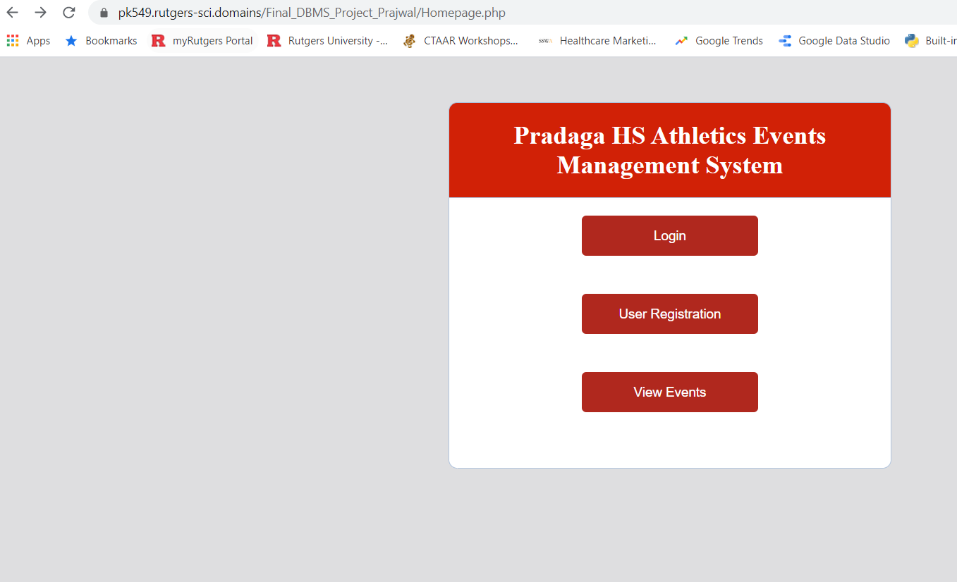

View all events:

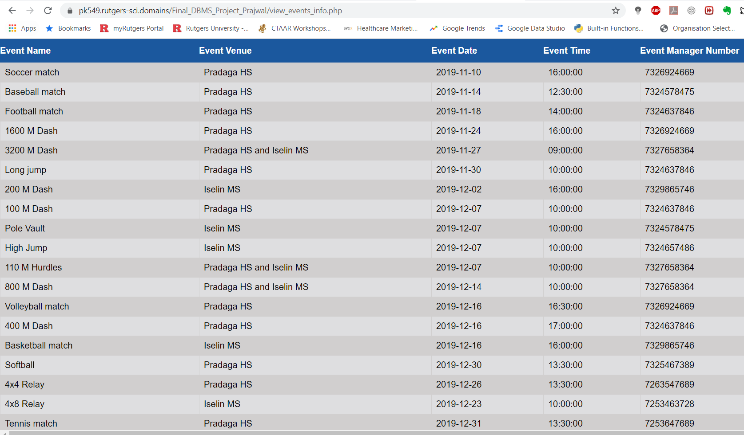

Login page:

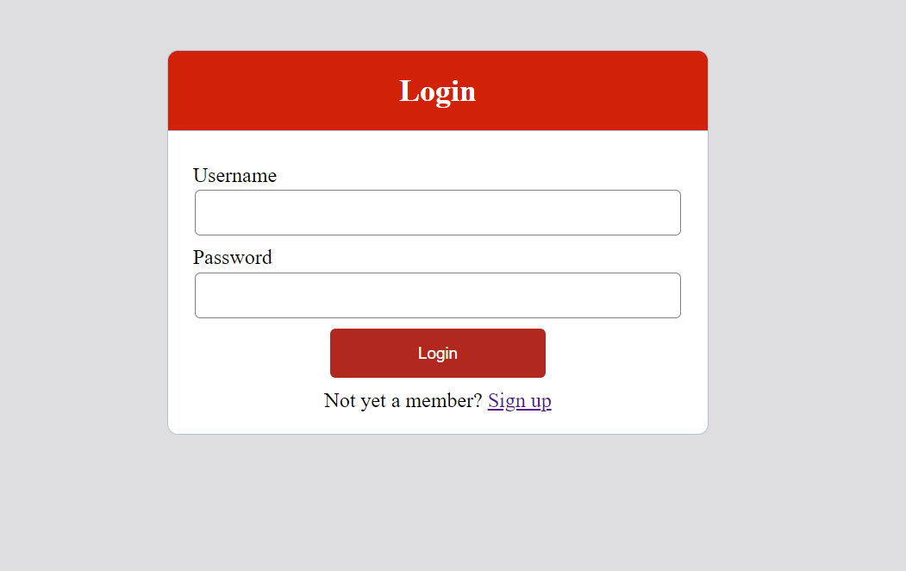

New user registration page:

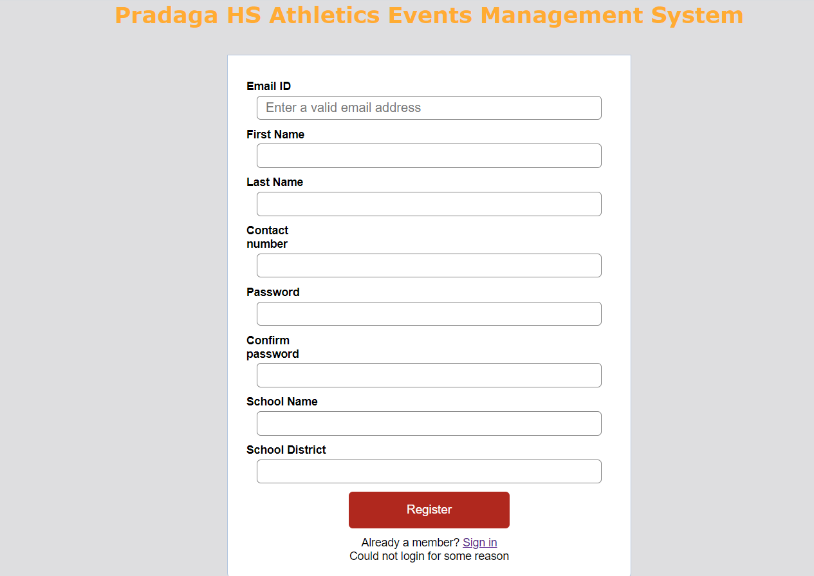

Logged in User screen:



Create an Event page:

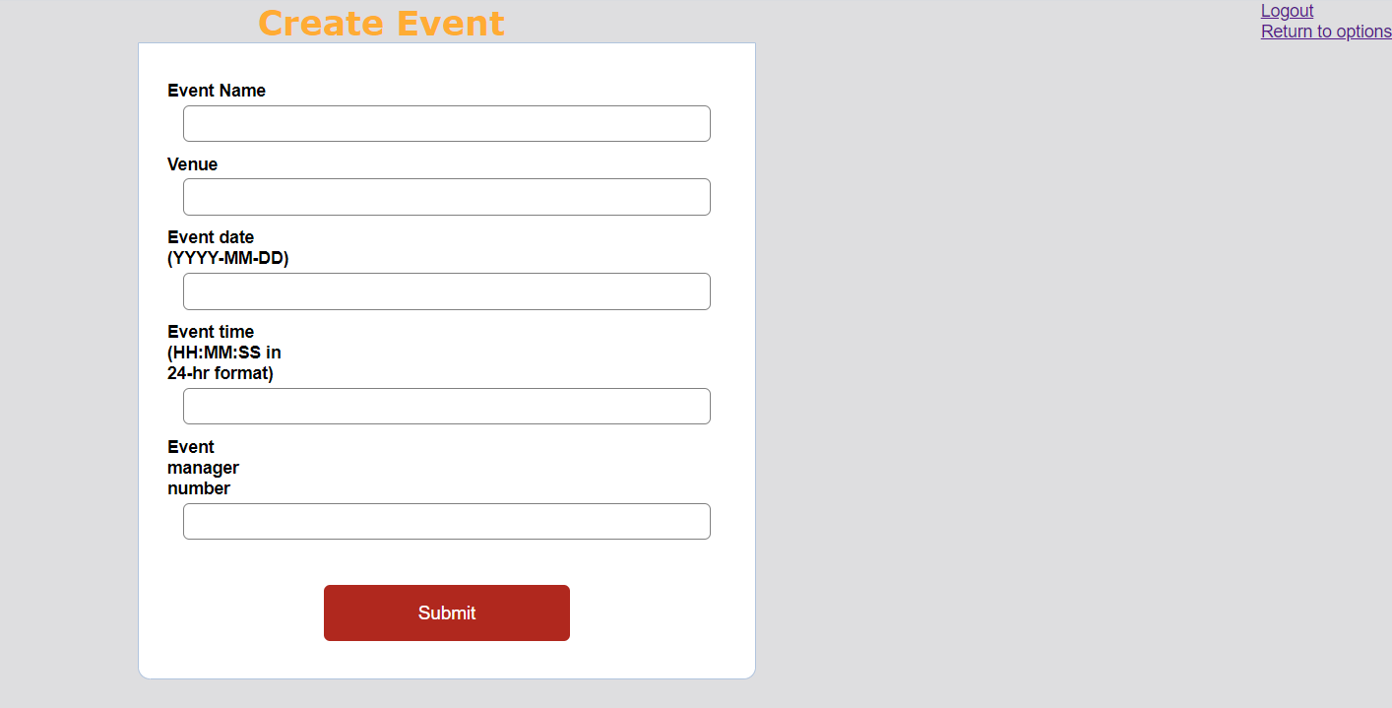

Event participant page:

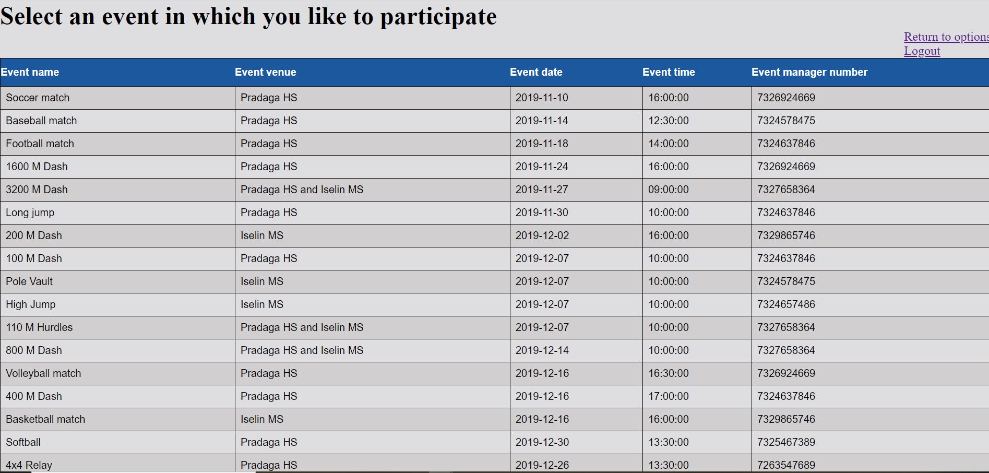

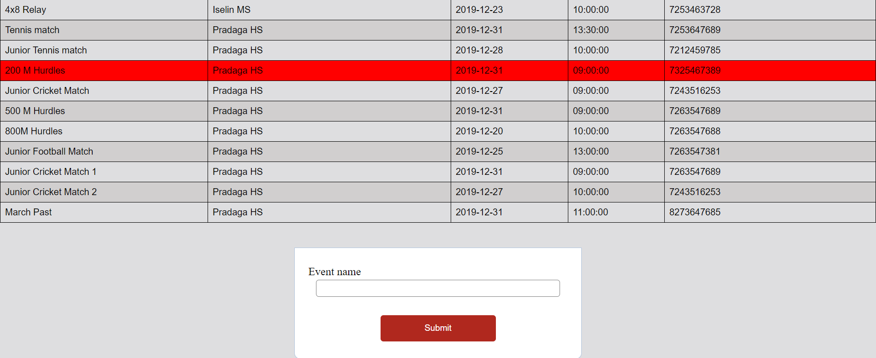

Event sponsor page:

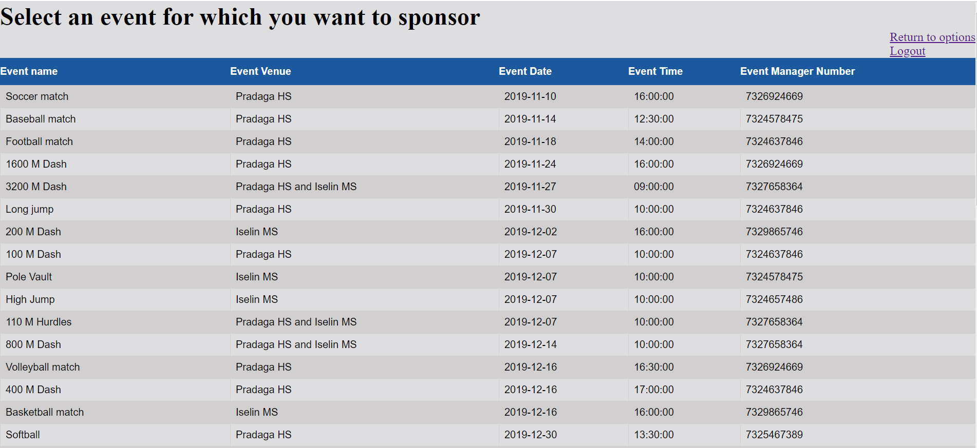

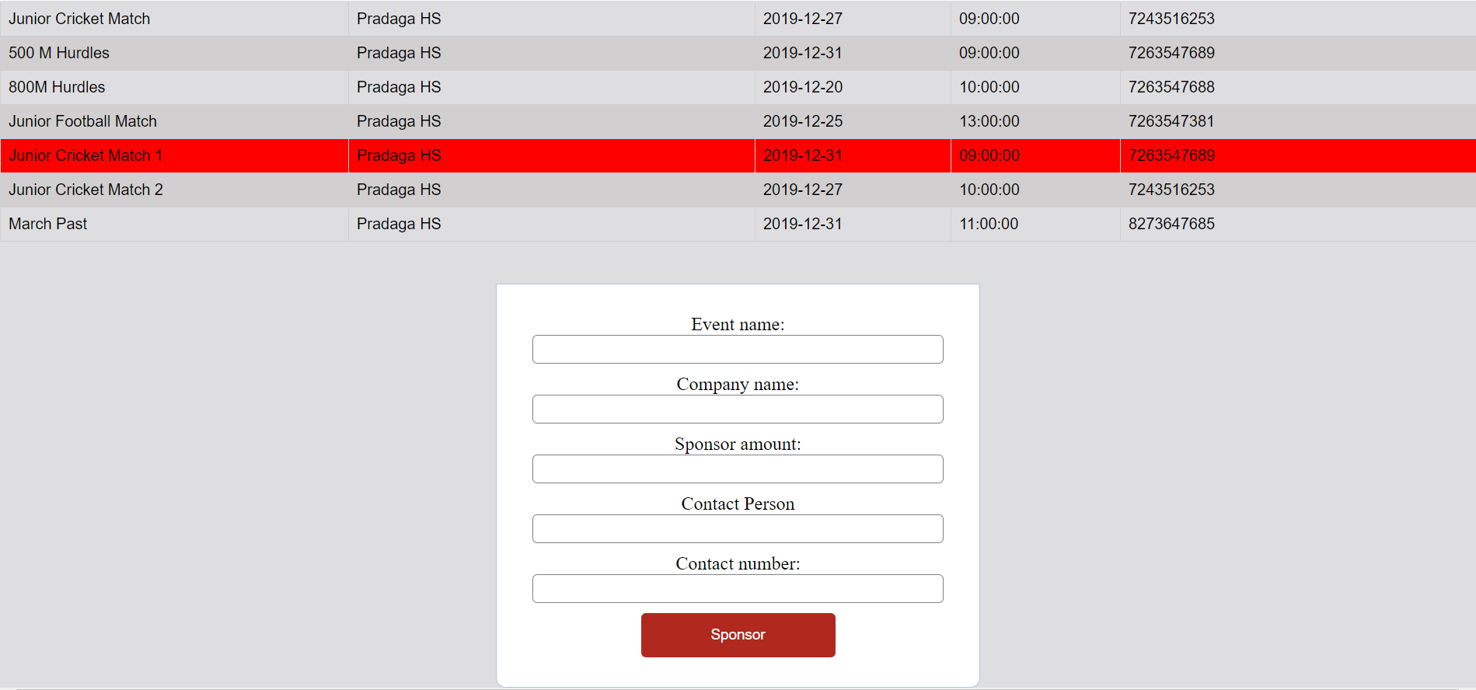

Viewing managing events with Update/Delete options:

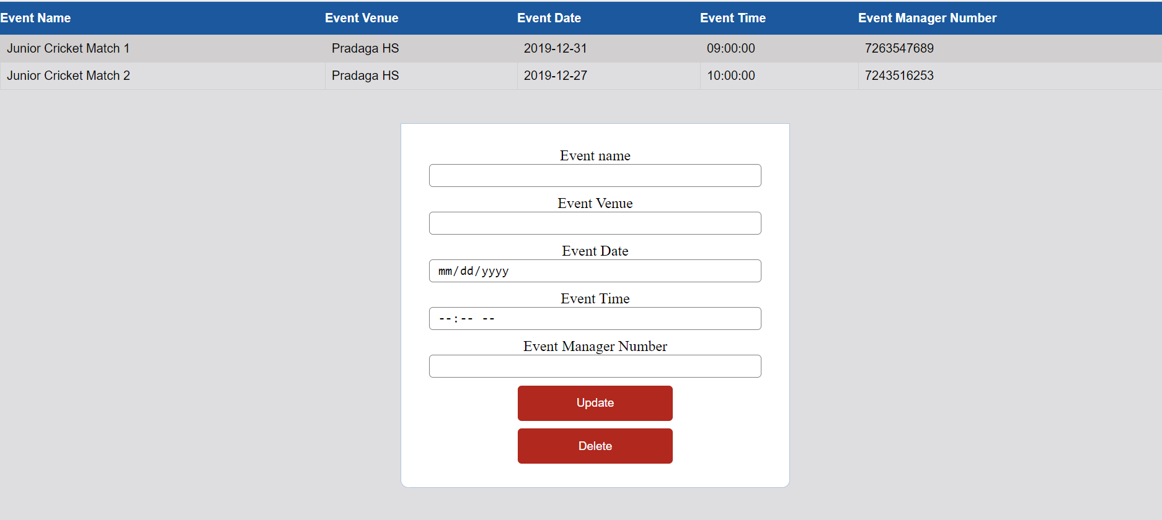

View Sponsoring events:

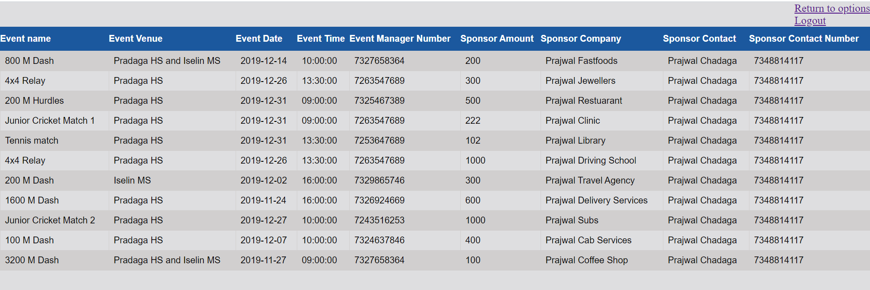

View participating events:

