MALNAD COLEGE OF ENGINEERING

Under the auspices of M.T.E.S
(An autonomous institution under Visvesvaraya Technological University, Belgaum) Hassan – 573201, Karnataka, India


Report on
Course Title: Full Stack Development
Project Title: “Cookbook Content”
Submitted by team number :14

Name | USN
Prashnat | 4MC23IS076
Jeevan M Y | 4MC24IS400
Prajwal H R | 4MC24IS408

Submitted to
Mr. Krishna Swaroop A (Assistant Professor Dept. of ISE)
Department of Information Science & Engineering Malnad College of Engineering
Hassan– 573202
2025-26
Date of Submission:

Index

Section/Contents Page Number
- Abstract 1
- Introduction 2
- Objectives 3-4
4, System Requirements 4-5
  - Software Requirements 4
  - Hardware Requirements 5
- System Design 5
- Database Design 6-7
  - ER Diagram 7
- Implementation 8-9
  - Models overview 8
  - URL routing overview 8
  - Important functionality 9
- Screenshots 10
- Testing 11-16
  - Form validation 11-13
  - CRUD operations 14-15
  - Error handling & resilience 16
- Results 17
- Conclusion 18
- Future Enhancements 18-19
- References 20

Abstract
The CookBook Content project is a full-stack web application developed using the Django framework, falling under the domain of web development, database-driven content management systems, and user-generated digital platforms. The project aims to address the growing need for centralized, organized, and easily accessible recipe management, as food enthusiasts often face challenges such as unstructured recipe storage, scattered digital notes, and limited options for collaborative sharing. Traditional methods—ranging from handwritten notes to screenshots and social media posts—are inefficient, prone to loss, and lack standardized formatting, making retrieval and sharing cumbersome.
To overcome these limitations, the CookBook platform provides a structured digital environment where users can discover, upload, curate, and share recipes within an interactive community ecosystem. The system integrates a secure authentication module, allowing users to create personalized accounts for managing their recipes. Core features include image-supported recipe uploads, categorized browsing, community recipe viewing, structured ingredient lists, detailed cooking steps, and visually rich recipe displays. The frontend, built with HTML, CSS, and JavaScript, ensures an intuitive user experience, while the Django backend manages data flow, authentication, form handling, and file storage. SQLite is used as the database to store recipe metadata, user information, and uploaded content efficiently.
The outcome of the project is a functional, scalable, and high-usability recipe-sharing platform that simplifies culinary content management and encourages community engagement. By digitalizing the process of recipe collection and organization, the CookBook system improves accessibility, reduces manual effort, enhances user interaction, and creates a unified platform that supports personal creativity and community learning. This project demonstrates the successful application of full-stack development principles to solve a relevant real-world problem in an efficient and user-centric manner.

Introduction
Cooking is an essential part of daily life, and with the increasing popularity of experimenting with new cuisines, people consciously try to document and preserve their recipes. However, most individuals still rely on unorganized and inconsistent storage methods such as handwritten notes, loose paper sheets, physical cookbooks, mobile screenshots, voice notes, and scattered messages in chat applications. Over time, these recipes become difficult to locate, retrieve, or update, causing frustration and inefficiency. The absence of a structured platform makes it challenging for users to maintain a personal recipe collection that is both reliable and easy to use.
At the same time, the rise of digital communication and social media has increased the desire to share recipes with friends, family, and the community. But existing sharing methods lack standardization—recipes shared through WhatsApp, Instagram posts, or YouTube videos often have incomplete steps, missing ingredient lists, or lack proper formatting. Many recipe-based platforms on the internet also restrict user personalization, limit content uploads, or follow premium subscription models, which discourage regular users. These limitations highlight the need for a free, structured, and user-friendly recipe management system.
The domain of web-based recipe management was chosen due to its growing relevance, ease of accessibility, and potential to positively impact a wide user community. A centralized online platform ensures that recipes remain permanently stored, easy to categorize, visually rich, and accessible anytime across devices. With the integration of images, step-by-step instructions, ingredient details, and personal notes, the user experience becomes more immersive and helpful.
The proposed CookBook Content Platform aims to address these exact challenges by providing a clean, modern, and digital solution. The system allows users to upload their own recipes, organize them under various categories, attach images for better clarity, and explore recipes contributed by the community. By incorporating secure user login, the platform protects personal content and ensures accountability. Additionally, the browsing and search features help users quickly find recipes based on categories, ingredients, or titles.
Overall, the CookBook system delivers a centralized, digital, and highly accessible solution that overcomes the shortcomings of traditional recipe management. It enhances the cooking experience, encourages community engagement, and supports seamless recipe sharing in a structured and visually appealing manner.

Objectives of the Project

The CookBook Content platform has been developed with the following key objectives, ensuring a comprehensive solution to the challenges faced in modern recipe management:
• To build an online platform for managing community and personal recipes
The primary objective is to design a centralized digital system where users can store their own recipes and access recipes shared by the community. This ensures that all culinary content is organized and accessible from a single platform.
• To simplify the process of uploading and browsing recipes
The project aims to make recipe contribution and exploration easy for all users. By providing intuitive upload forms, categorized browsing, and a user-friendly interface, the system minimizes complexity and enhances overall usability.
• To provide users with a structured and image-supported recipe database
Another major goal is to maintain consistency in how recipes are stored and displayed. The platform supports images, ingredient lists, step-by-step instructions, and tags, ensuring that each recipe entry is visually informative and well-organized.
• To digitize the manual process of recipe collection and sharing
Traditional recipe storage—such as notebooks, screenshots, or chat messages—is replaced with a systematic digital method. This objective aims to eliminate data loss, improve long-term accessibility, and modernize how users manage culinary information.
• To offer secure access with user authentication and personalized accounts
The system integrates Django’s authentication framework to ensure that only verified users can upload, modify, or manage their recipes. Personalized accounts allow users to maintain their own collections safely.
• To improve management efficiency and reduce redundancy in recipe storage
By centralizing content and standardizing recipe formats, the platform minimizes duplication and enhances efficiency. Users can easily search, categorize, and update their recipes without repetitive or unstructured entries.

• To encourage community engagement and knowledge sharing
An additional objective is to create a collaborative culinary environment where users can learn new dishes, explore diverse cuisines, and exchange cooking ideas within a digital community.
• To develop a scalable platform for future enhancements
The project also aims to create a foundation that can be extended with additional features—such as reviews, ratings, favorites, social sharing, and mobile app integration—in future phases.

System Requirements

Software Requirements
• Python 3.10+
Python serves as the core programming language for the project. Version 3.10 or above is required to ensure compatibility with the latest Django version, improved performance, and access to advanced language features such as enhanced type hints and structural pattern matching.
• Django 5.0+
Django is the primary web framework used to build the application. Version 5.0 or higher provides modern security features, improved asynchronous support, optimized ORM features, and compatibility with the project's architecture. Django handles authentication, URL routing, form processing, and database operations.
• IDE: VS Code / PyCharm
An Integrated Development Environment (IDE) such as VS Code or PyCharm is needed for writing and organizing project files. These IDEs offer syntax highlighting, debugging support, Git integration, virtual environment setup, and extensions for improved development workflow.
• Database: SQLite (default)
SQLite is used as the development database because it is lightweight, serverless, and easy to configure. It efficiently handles recipe storage, user accounts, and image metadata. The project can be easily scaled to use advanced databases like PostgreSQL or MySQL if required.
• Dependencies:
- pillow: Required for handling image uploads and processing recipe images.
- django-crispy-forms: Used for improving the UI and styling of forms such as login, signup, and recipe upload pages.
Additional optional dependencies may include django-staticfiles, bootstrap, or whitenoise for improved frontend design and deployment.

Hardware Requirements
• Minimum 4GB RAM
A minimum of 4GB RAM is required to smoothly run the Django development server, IDE, and other background processes. For advanced features or multitasking, higher RAM (8GB+) is recommended.
• Intel i3 or above processor
A basic multi-core processor such as Intel i3 ensures efficient execution of Python scripts, handling of backend processes, virtual environments, and database operations. Faster processors like Intel i5/i7 or AMD Ryzen enhance performance during development.
• 2GB free storage space
At least 2GB of disk space is required to store project files, virtual environment data, cached dependencies, database files, and image uploads. Additional storage may be needed as more recipes and images are added.
• System with stable internet connection (recommended)
While not mandatory, internet access is helpful for installing dependencies, accessing Django documentation, and downloading external libraries or UI assets.

6. System Design
6.1 Architecture Diagram
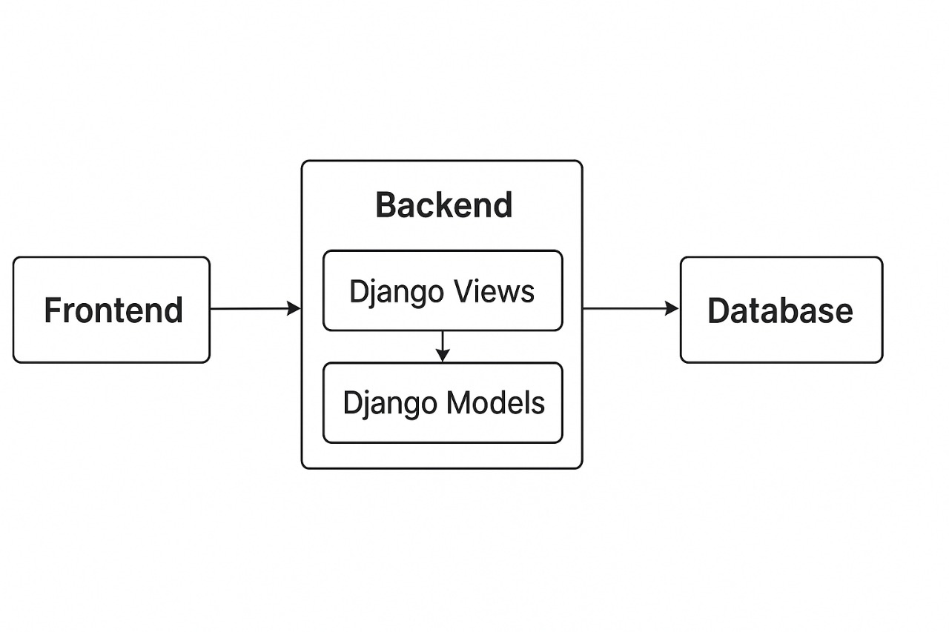

Explanation of Architecture
The CookBook Content platform is developed using a three-tier architecture, ensuring clear separation of responsibilities, modularity, and scalability. The architecture consists of the Frontend Layer, Backend Layer, and Database Layer. Each layer plays a crucial role in processing user interactions, managing data, and displaying the final output.

Database Design
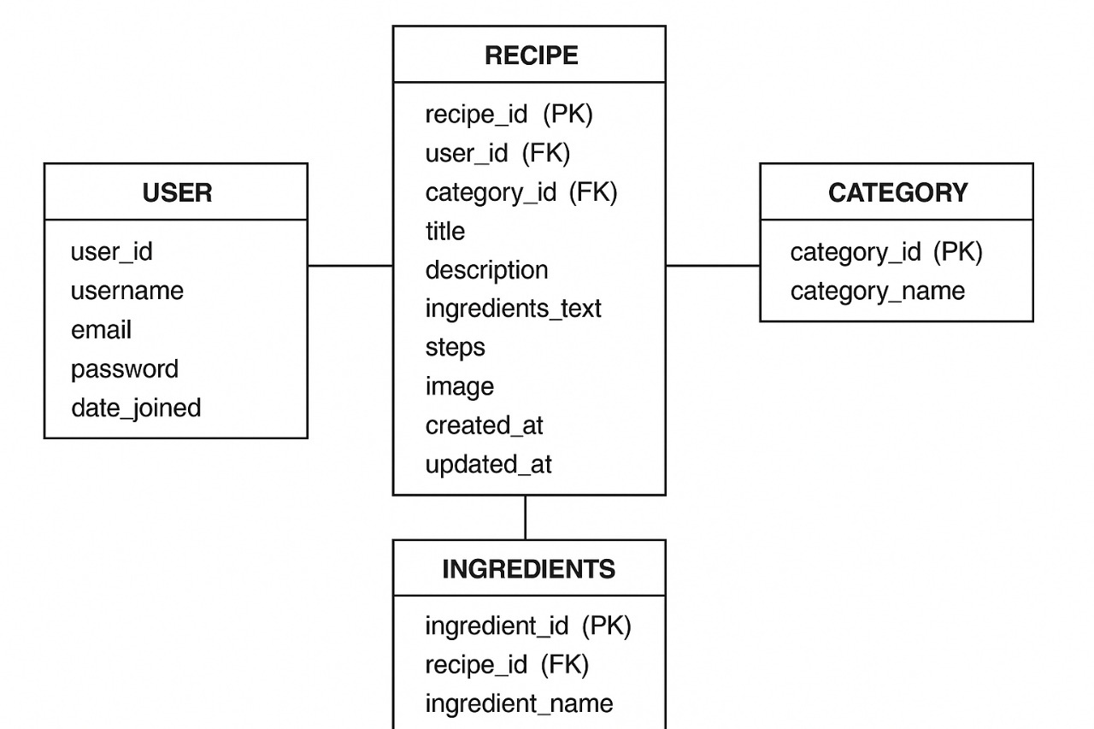The database design of the CookBook Content platform follows a relational model using SQLite. The core goal of the database is to store user accounts, recipes, images, ingredients, and category information in a structured, normalized, and efficient manner. Django ORM is used to manage these tables, ensuring seamless interaction between backend logic and database operations.
An Entity–Relationship (ER) Diagram typically includes the main entities such as User, Recipe, Ingredients, and Categories, along with their attributes and relationships.
Entities and Relationships
1. User Table
Stores authenticated user information.
Attributes:
- user_id (PK) – Unique identifier for each user
- username
- email
- password (hashed)
- date_joined
Role:
Each user can create multiple recipes (1-to-many relationship).
2. Recipe Table
Stores details of recipes posted by users.
Attributes:
- recipe_id (PK) – Unique identifier
- user_id (FK → User.user_id) – Identifies the recipe owner
- category_id (FK → Category.category_id)
- title
- description
- ingredients_text (optional if using free-text ingredients)
- steps
- image (file path)
- created_at
- updated_at
Role:
Each recipe belongs to one user and one category.
Each recipe can have multiple ingredients.
3. Ingredients Table
Stores detailed ingredient items for each recipe.
Attributes:
- ingredient_id (PK)
- recipe_id (FK → Recipe.recipe_id)
- ingredient_name
- quantity
Role:
A recipe can have many ingredients (one-to-many relationship).
4. Category Table
Stores classification of recipes.
Attributes:
- category_id (PK)
- category_name
Role:
A category can have many recipes (one-to-many).
Examples: Breakfast, Desserts, South Indian, Snacks, Drinks.
Relationships Overview
Relationship Type | Description
User — Recipe | One-to-Many (one user can upload multiple recipes)
Recipe — Ingredients | One-to-Many (each recipe consists of multiple ingredients)
Category — Recipe | One-to-Many (one category can contain many recipes)
Keys Used
- Primary Keys (PK):
Uniquely identify each record (e.g., user_id, recipe_id).
- Foreign Keys (FK):
Enforce relational mapping between tables
(e.g., recipe.user_id → user.user_id).
- Composite Keys (optional):
Can be used for associations, such as unique ingredient combinations.

ER Diagram Description
The ER diagram visually represents these entities and their relationships:
- The User entity links to Recipe with a one-to-many arrow.
- The Recipe entity connects to Ingredients with a one-to-many arrow.
- The Category entity links to Recipe with a one-to-many arrow.
This structure ensures efficient data retrieval, minimal redundancy, and strong data integrity.

Implementation
The CookBook Content platform is implemented using Django’s Model–View–Template (MVT) architecture, which separates data handling, application logic, and user interface presentation. This structure enhances maintainability, scalability, and clarity in code organization.
Model Layer (Data Structure Implementation)
The Models represent the core database structure, defining how recipe data, user information, and categories are stored. Key models include:
• User Model
Handles authentication and stores user profile information using Django’s built-in authentication system.
• Recipe Model
Stores recipe-specific details such as title, description, steps, images, timestamps, and foreign keys linking to the user and category.
• Ingredients Model
Maintains detailed ingredient lists for each recipe, supporting one-to-many relationships.
• Category Model
Organizes recipes under various categories for easier browsing and filtering.
Django ORM automatically converts these models into relational database tables within SQLite.

View Layer (Business Logic Implementation)
The Views process incoming user requests and control the application logic. Key views include:
- Login & Signup Views: Handle user authentication, validation, and session creation.
- Recipe Upload View: Processes form data, validates image uploads, and stores the recipe in the database.
- Recipe List & Detail Views: Fetch recipes and render them for browsing.
- Admin Management Views: Auto-generated by Django for managing recipes, users, and categories.
Each view interacts with the appropriate model, fetches or updates data, and prepares context data for templates.
URL Routing (Navigation Implementation)
Django’s urls.py maps each user action to the correct view function.
Examples include:
- /login/ → LoginView
- /signup/ → RegisterView
- /upload-recipe/ → RecipeUploadView
- /recipes/ → RecipeListView
- /recipe/<id>/ → RecipeDetailView
This ensures clean and readable URLs, improving user experience and SEO.
Template Layer (User Interface Implementation)
The Templates use HTML, CSS, and JavaScript along with Django Template Language (DTL) to create dynamic web pages.
Key templates include:
- login.html
- signup.html
- upload_recipe.html
- recipe_list.html
- recipe_detail.html
Templates use data passed from views to dynamically display recipes, images, and user information.
Major Functionalities Implemented
1. Secure Authentication System
- Login & logout
- Password hashing
- User sessions
- Permission-based access
2. Recipe Upload Module
- Form-based input
- Image upload via Django’s ImageField
- Validation of title, ingredients, and steps
3. Recipe Browsing & Discovery
- Recipe list view
- Category-based filtering
- Viewing detailed recipes with images
4. Admin Panel Management
Django’s built-in admin interface allows administrators to:
- Add/edit/delete recipes
- Manage users and categories
- Approve or monitor uploaded content
5. Database Interaction via Django ORM
- Automatic table creation
- CRUD operations
- Relationship handling (foreign keys, one-to-many structures)

Screenshots

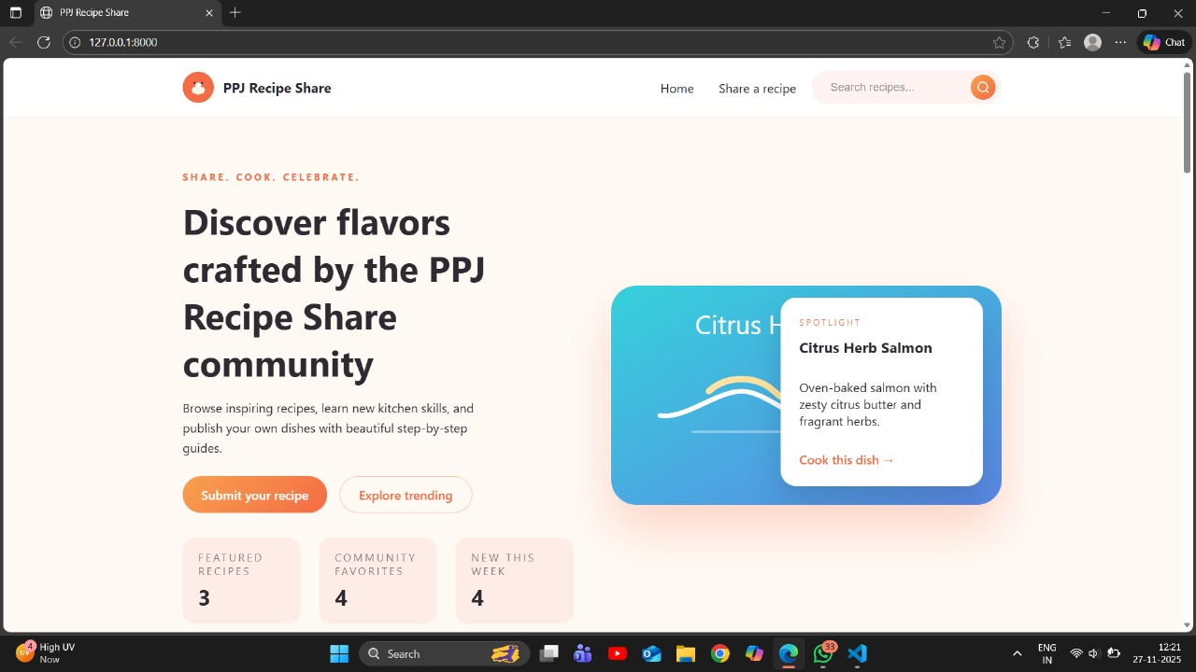

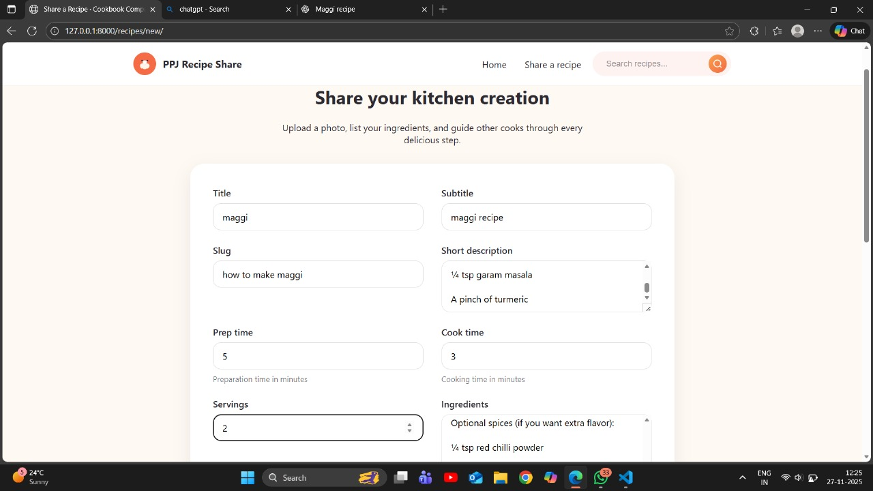

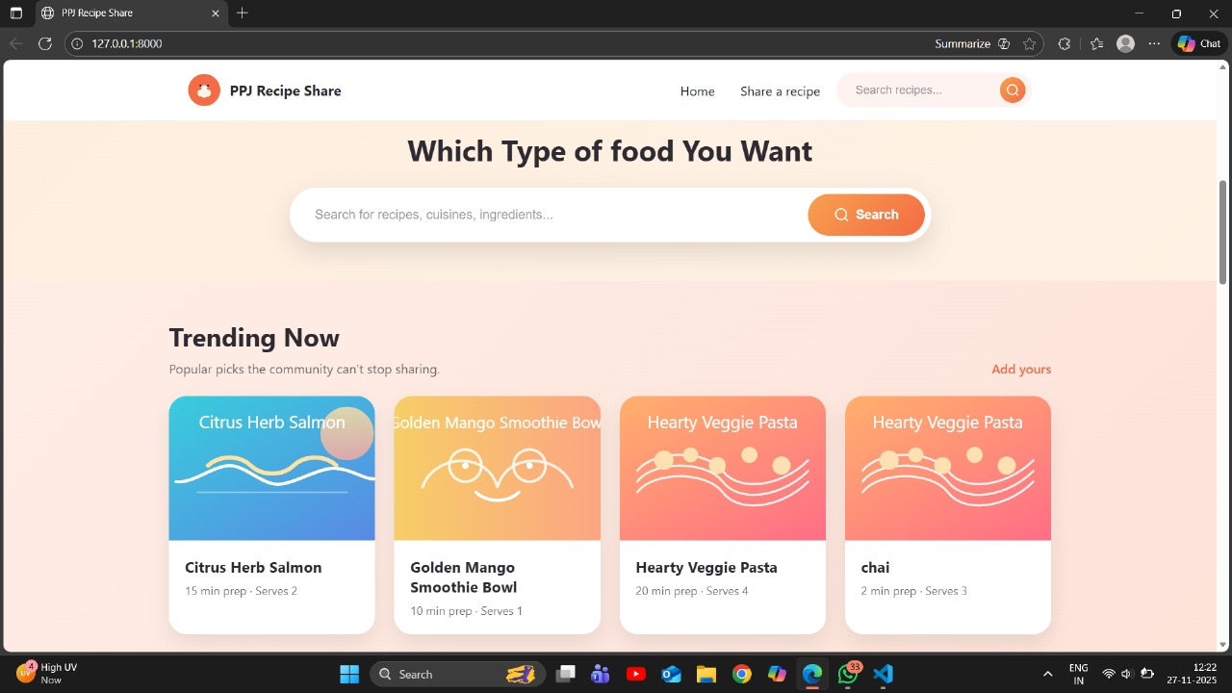

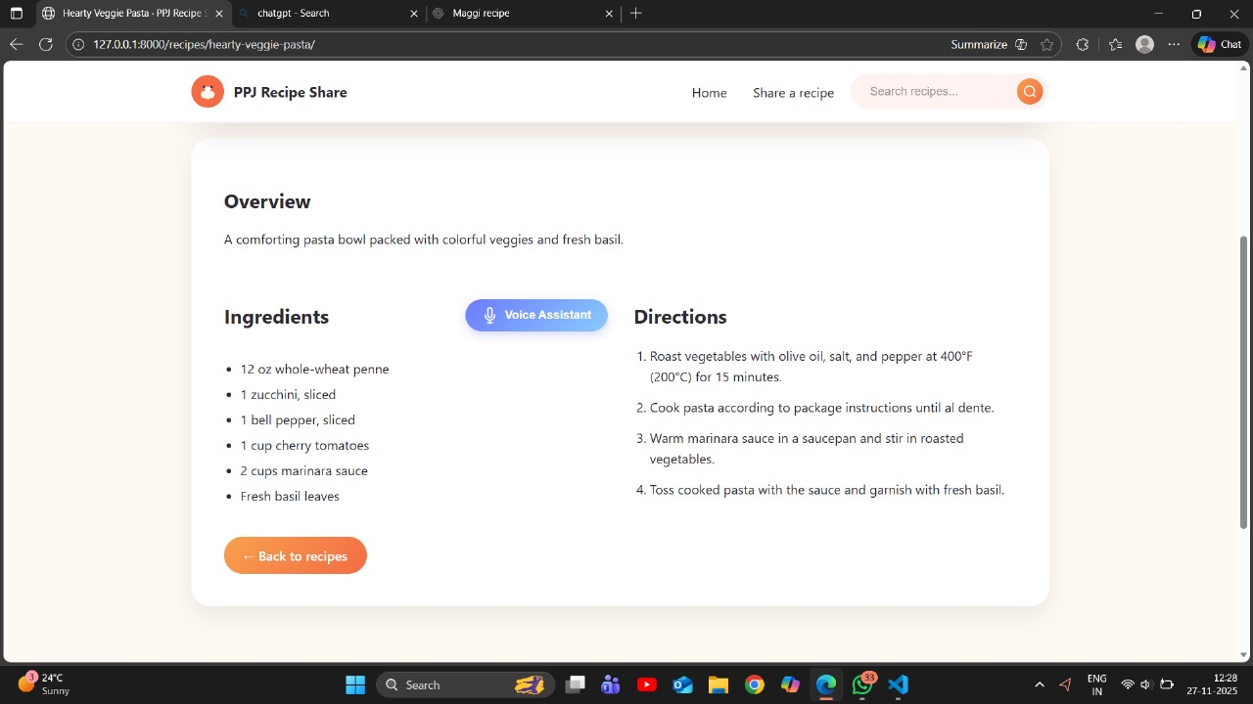

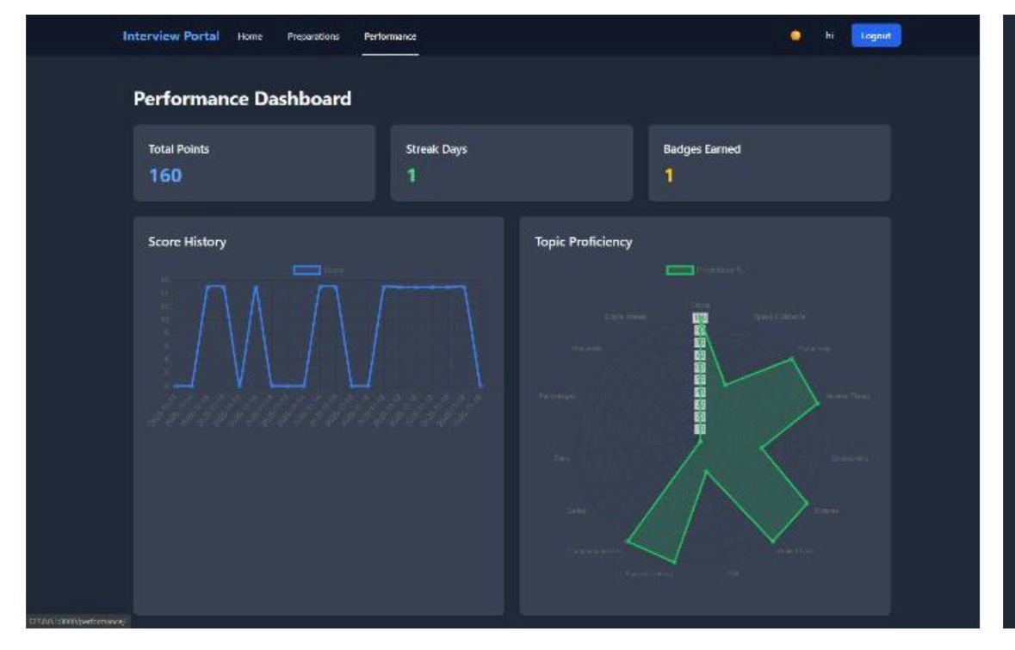

Testing
Testing is a crucial phase of the development process, ensuring that all features of the CookBook Content platform function correctly, efficiently, and securely. Various test cases were executed to validate inputs, verify user interactions, and ensure the overall stability of the system. The following categories describe the primary testing performed:
Form Validation Testing
Forms such as Login, Signup, and Recipe Upload were tested to verify that all required fields were properly validated.
Test checks included:
- Mandatory fields cannot be left blank
- Incorrect email formats are rejected
- Passwords must meet required criteria
- Recipe upload form must contain title, ingredients, and steps
- Invalid or missing data triggers error messages
This ensures accuracy and prevents invalid data from entering the system.
Login Authentication Testing
Login functionality was tested to ensure only registered users can access authenticated features.
Test cases involved:
- Valid username/password → Successful login
- Incorrect credentials → Login failure warning
- Attempting access to restricted pages without login → Redirects to login page
- Session creation and logout functionality
This confirms secure access control.
Recipe CRUD Operation Testing
The entire lifecycle of recipe management was tested through CRUD (Create, Read, Update, Delete) operations.
Tests performed:
- Create: New recipes added successfully
- Read: All uploaded recipes display correctly
- Update: Users can edit their own recipes
- Delete: Users can remove their recipes
- Admin panel can manage all recipes
This ensures smooth data handling and consistency.
Image Upload Handling
Testing was conducted to ensure correct handling of recipe images.
Checks included:
- Accepting only allowed image formats (e.g., JPG, PNG)
- Proper file upload and storage in media directory
- Displaying uploaded images in recipe views
- Rejecting overly large or unsupported images
This maintains visual clarity and prevents file-related errors.
Error Handling for Invalid Inputs
The system was tested for robustness against incorrect or malicious inputs.
Tested scenarios include:
- Submitting empty fields
- Uploading unsupported file types
- Entering excessively long text
- Database-level validation errors
- Unauthorized access attempts
Appropriate error messages and safe fallbacks were confirmed.
Additional Optional Tests (If Required for Report)
You may include these if your college expects more categories:
- Cross-browser testing (Chrome, Edge, Firefox)
- Responsiveness testing (mobile & desktop)
- Performance testing (page load speed)
- Database migration/testing using Django ORM
- Security testing (SQL injection prevention, CSRF protection)

Results
The CookBook Content platform successfully meets the objectives defined at the start of the project, providing a fully functional and user-friendly digital recipe management system. The implementation of Django’s MVT architecture ensures a smooth flow of data between the backend, database, and user interface, resulting in efficient system performance.
The platform allows users to securely register and log in, ensuring that personal recipe collections remain protected. The recipe upload feature, complete with image support, enables contributors to create visually rich and detailed recipe entries. Users can browse recipes submitted by the community, access structured ingredient lists, view step-by-step preparation methods, and explore categories with ease.
Furthermore, the project effectively addresses the common challenges associated with traditional recipe management—such as scattered data, difficulty retrieving stored recipes, lack of standard formatting, and limited sharing options. By centralizing all recipe-related data in a single digital platform, the system significantly enhances accessibility and organization.
Overall, the developed application demonstrates strong functionality in terms of:
- Secure authentication
- Recipe creation and management
- Image handling and storage
- Efficient database operations
- Simple and intuitive user experience

Conclusion
The CookBook Content platform successfully achieves its goal of providing a structured, efficient, and user-friendly digital solution for managing both personal and community recipes. By integrating Django’s powerful backend framework with a clean and intuitive frontend interface, the system offers a seamless experience for users who wish to upload, organize, and explore a wide variety of culinary content.
Through the digitization of traditional recipe management methods, the platform eliminates common issues such as scattered notes, missing information, and difficulty in retrieving or sharing recipes. Users benefit from secure authentication, organized storage, image-supported recipe entries, and easy browsing features, making the platform suitable for everyday home cooks as well as culinary enthusiasts.
The project demonstrates the successful application of full-stack web development principles, including relational database design, dynamic content rendering, and secure user management. Overall, the CookBook Content system enhances accessibility, promotes community engagement, and provides a scalable foundation for future feature expansion. It stands as a practical and effective solution for modernizing recipe management in the digital era.

Future Enhancements
Although the CookBook Content platform currently provides essential features for recipe management and community interaction, there is significant potential to extend its functionality and user engagement. The following enhancements can be incorporated in future versions of the project:
• Add Recipe Reviews and Ratings
Implementing a review and rating system would allow users to provide feedback on recipes, helping others identify popular or highly recommended dishes. This feature would enhance community involvement and improve the overall usefulness of the platform.

• Introduce Advanced Search Filters
Future updates could include filters such as cuisine type, cooking time, difficulty level, dietary preferences (vegan, gluten-free), or popularity. This would allow users to quickly discover relevant recipes based on their specific needs.

• Add Bookmarking/Favorites System
A bookmarking system would let users save their favorite recipes for quick access later. This feature improves usability and encourages repeated platform usage by maintaining a personalized experience.

• Develop a Mobile App Version
Creating a mobile application for Android and iOS would greatly enhance accessibility. A mobile version would allow users to browse and upload recipes on the go, providing a more convenient and portable experience.

• Enable Social Media Recipe Sharing
Integrating social media sharing options (WhatsApp, Instagram, Facebook) would allow users to instantly share their recipes with friends and followers. This would increase platform visibility and encourage community growth.

• Implement Recommendation System (Optional Enhancement)
Using user behavior and preferences, the platform could suggest relevant recipes through AI-based recommendations, improving personalization.

References
- Django Documentation
Django Software Foundation. Official Django Documentation.
Available at: https://docs.djangoproject.com
Python Official Documentation
Python Software Foundation. Python Language Reference.
Available at: https://docs.python.org
- HTML/CSS/JavaScript Standard References
Mozilla Developer Network (MDN). Web Technologies Documentation.
Available at: https://developer.mozilla.org
- SQLite Documentation
SQLite Consortium. SQLite Database Engine Documentation.
Available at: https://www.sqlite.org/docs.html
- Bootstrap (Optional if used)
Bootstrap Team. Bootstrap Framework Guide.
Available at: https://getbootstrap.com
- Stack Overflow (for debugging and implementation support)
Various Contributors. Programming Q&A Discussions.
Available at: https://stackoverflow.com
- W3Schools Web Development Tutorials
W3Schools. HTML, CSS, JavaScript Tutorials.
Available at: https://www.w3schools.com

