A

Project Report

On

**Project Management System**

Submitted to

**SHIVAJI UNIVERSITY, KOLHAPUR**

For the partial fulfillment of the requirement for the award

**BACHELOR OF COMPUTER APPLICATIONS**

**(SEM –IV)**

By

**Prajwal Prakash Kulkarni**

**Atharv Arun Kulkarni**

Under the guidance of

**Dr. A. A. Sattikar**

Through

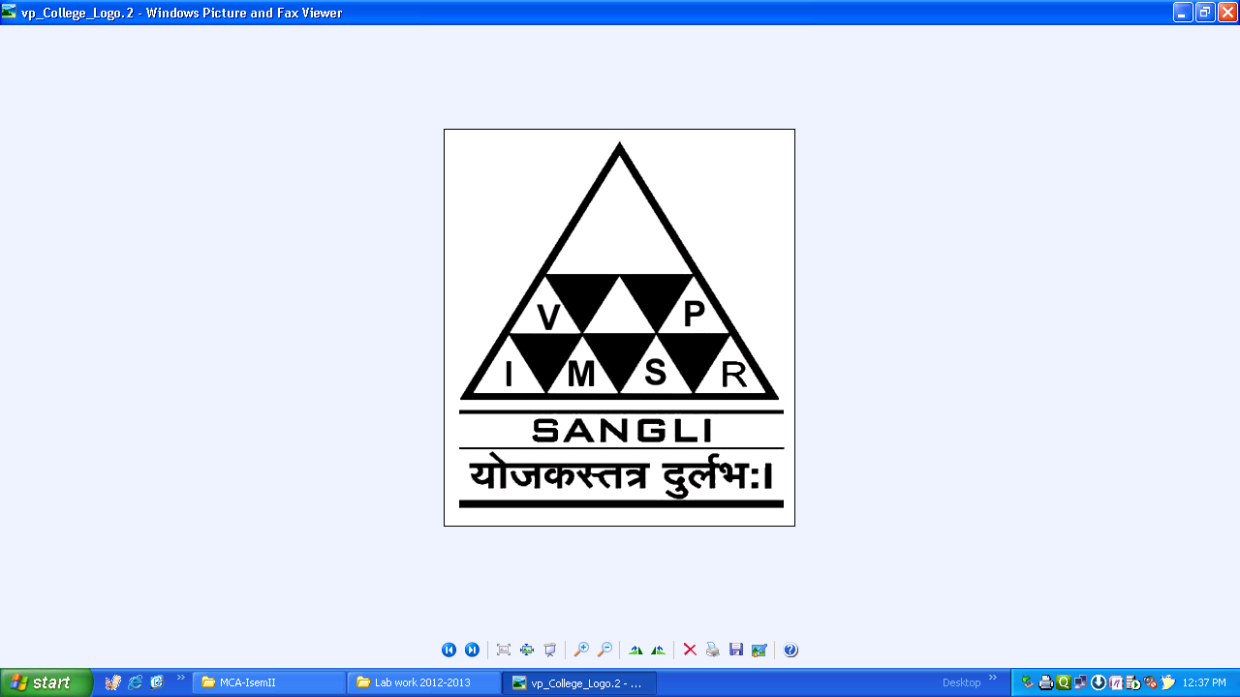

The Principal

**V. P. INSTITUTE OF MANAGEMENT STUDIES AND RESEARCH, SANGLI**

2022-23

**V. P. Institute of Management Studies & Research, Sangli - 416 414**

Certificate

**Department of Computer Applications**

This is to certify that, the project report entitled **Project Management System** is the record of project work carried out in this college by **Atharv Arun Kulkarni, Prajwal Prakash Kulkarni** in partial fulfillment of the award of Bachelor of Computer Applications (Sem-IV) as laid down by SHIVAJI UNIVERSITY, KOLHAPUR.

This project presents their/his/her sincere work carried out under my guidance in the year 2022-23.

Date:

Place:

Dr.A.A.Sattikar Dr. Ms. V. S. Jadhav

**Guide**  **H.O.D.**

Examiner: 1) 2)

**DECLARATION**

To,

The Registrar,

Shivaji University, Kolhapur

Sir,

We undersigned **Atharv Arun Kulkarni** hereby declare that the project report entitled **Project Management System** submitted by us under the guidance of **Dr.A.A.Sattikar,** is my/our original work.

We have not reproduced any information from any report submitted to Shivaji University, Kolhapur this year or any of the previous years.

We understand that any such copying is liable to punish in a way that University Authorities deem fit.

Place:

Date:

**Atharv Arun Kulkarni**

**Prajwal Prakash Kulkarni**

**Acknowledgement**

I am grateful to the honorable principal Dr.R.A.Shinde, and senior professor Dr.M.Ali sir for providing all necessary facilities to carry out the project work and whose encouraging part has been a perpetual source of inspiration.

It is my foremost duty to express my deep senesce of gratitude and respecttof the Dr.A.A.Sattikar for helping his uplifting tendency and for inspiring us for taking up this project work completely successfully.

Last but not least I am thankful to all my parents and all who helped me directly or indirectly throughout this project work.

Place :   
Date :

Atharv Arun Kulkarni   
 Prajwal Prakash Kulkarni

**INDEX**

|  |  |  |
| --- | --- | --- |
| **Sr. No.** | **Contents** | **Page No.** |
| **1** | **Introduction to Project**  1.1] Introduction  1.2] Existing System |  |
| **2** | **Proposed System**  2.1] Objectives  2.2] Requirement Engineering  • Requirement Gathering  • SRS  • System Analysis |  |
| **3** | **System Analysis**  3.1] System Diagram  • Site Map  • DFD |  |
| **4** | **System Design**  4.1] Database Design  4.2] Input Design  4.3] Output Design |  |
| **5** | **Implementation**  5.1] System Requirement   * Hardware * Software   5.2] Installation process  5.3] User Guidelines |  |
| **6** | **Reports** |  |
| **7** | **Conclusion and Suggestions**  7.1] Conclusion  7.2] Limitations  7.3] Suggestions |  |
| **8** | **References:-**   * Books / Journals:- * Periodicals and Newspapers / Web * Questioner/Schedule(if used) * Source code(Include Main Logic source code) |  |

**Introduction**

A system is a group of essential parts of subsystems, that can affect the behavior and properties of the whole system and none of which has an independent effect on it.

We have developed a Project Management System to solve the problem of software companies that are facing now like not working in proper coordination.

If any software company uses the Project Management System to manage their project and project-related tasks then we ensure that the developed product is better than the previous one and coordination between the requirement gathers, developers, and testers becomes good and they work more efficiently and in a more productive manner.

In Project Management System we help software company to manage their project and generate reports related to that project. In Project Management System the task allocated is arranged in a proper manner. To use Project Management System, you do not require a lot of technical knowledge. Anyone literally a new developer/fresher who has just started his / her journey can also use this software.

**Existing System**

To manage the project-related task now the company is using various options like some offline software / online software like Google Keep, Google Task, and Microsoft Planner which are not too much effective this software pay user/company, and the different offers offered by them are not worth it. Some other uses pen and paper to manage the task but it becoming difficult to maintain track of all record.

Dealing with problems -

To deal with problems that arose in the system the user took the help of paper and pen. The testing team tells the problem to the developer team and they solve that problem one by one.

Dealing with keeping the records of the project -

The user maintains the Excel sheet to store the information of projects done by them. User store name of the project, description of the project, and date when the project started in the excel sheet.

Generating reports -

As said before, the user is using pen and paper to manage the task. With pen and paper, they are unable to generate reports. And suppose they are using Google Keep, Google Tasks, and Microsoft Planner this software does not provide any option to generate the report.

**Objectives**

**Visualize your work with Project Management System:**

1. To give you an excellent overview of your current work situation.

2. Visualizing work in a team environment simplifies communication and leads to improved productivity.

**Stop starting - Start finishing:**

1. Limit your work in progress and get more done. Get a better flow of your work by focusing on completing tasks instead of starting new tasks.

2. Delivering value more often will lead to reduced risk for your project and put less stress on your team. Your customers will be happier. You will be happier.

**Collaborate in real-time – anywhere:**

1. Any changes you make to your project management system are instantly available to all members of the team.

2. Away from your desktop? Stay up-to-date with our mobile web app. Always know what your team is working on at any moment, anywhere.

**Analytics and Reporting:**

1. You can easily analyze how much the project is completed

2. Track performance using your developer, tester, and requirement gathers by how many tasks they add on the board

3. You can also see the completion of a project in progress which help you to better visualize

**Requirement Engineering**

Requirements engineering (RE) refers to the process of defining, documenting, and maintaining requirements in the engineering design process. Requirement engineering provides the appropriate mechanism to understand what the customer desires, analyze the need, and assessing feasibility, negotiate a reasonable solution, specify solution clearly, validating the specifications and managing the requirements as they are transformed into a working system. Thus, requirement engineering is the disciplined application of proven principles, methods, tools, and notation to describe a proposed system's intended behavior and its associated constraints. Requirement Engineering include Feasibility Study.

Feasibility Study:

The objective behind the feasibility study is to create the reasons for developing the software that is acceptable to users, flexible to change and conformable to established standards. The Project Management System if flexible we can change this according to the requirement of the user.

Economic Feasibility - Economic feasibility decides whether the necessary software can generate financial profits for an organization. The Project Management System is open source and free of cost.

Technical Feasibility - Technical feasibility evaluates the current technologies, which are needed to accomplish customer requirements within the time and budget. We used technology like PHP for server-side scripting, JAVASCRIPT for client-side scripting and HTML, CSS.

**Requirement Gathering**

For gathering the requirement of the user/company we used the Primary data collection method. Primary data collection is the process of gathering data directly from a first-hand source. In other words, it is data that is collected by the organization that expects to use it. Methods include surveys, interviews, observation, and focus groups. For example, The World Bank tracked the impact of COVID-19 in Afghanistan through 14,000 phone surveys. The data collected through these surveys is primary data.

Stakeholders –

The stakeholder means a person with interest or concern in the outcome of a project who is affected by the system. For example- end-user, direct user, indirect user, senior manager, etc. By collecting requirements from these stakeholders, understanding system requirements can be very easy. When we are dealing with Stakeholders, we used the FORM to collect data.

Interviewing –

Interviewing is an important and very effective method of requirement gathering. Different questions are being asked about the system and its uses to stakeholders a by team of requirement engineering so that identification of requirements can be done using these answers. While developing Project Management System we interviewed the senior managers many times to collect accurate information as well as requirements from them.

**SRS**

The introduction of the Software Requirements Specification (SRS) provides an overview of the entire SRS with purpose, scope, definitions, acronyms, abbreviations, references, and an overview of the SRS. The aim of this document is to gather and analyze and give an in-depth insight into the complete Project Management System by defining the problem statement in detail. Nevertheless, it also concentrates on the capabilities required by users and their needs while defining high-level product features. The detailed requirements of the Project Management System are provided in this document.

Functional Role 1 – System’s Pages

Home - which denotes the dashboard of the project

Project- which displays the information about the project related to that user

Report- which gives some report related to the project selected and added by that user

Help- which gives the answer to frequently asked questions.

Functional Role 2 – Dealing with Unregistered Users

When an unregistered user tries to access the system's main pages, the system restricts the user from accessing the system's main pages and redirects the page to the signup page. Once a user is done with signing up then the system allows the user to access the system’s main pages and then from the signup page, the system redirects to the home page. Then the user can access any page as mentioned in the system's page function.

Functional role 3 – Dealing with Registered Users When a registered user tries to access the system’s main pages, we restrict users from accessing the system's main pages and redirect the page to the login page. Once a user is

done with login then the system allows the user to access the system’s main pages and then from the signup page, we redirect to the homepage of the system. Then the user can access any page as mentioned in the system's page function.

Functional role 4 – Features of the system

Functional role 4.1 – Display username on the right side of the welcome

The system displays the name of the user on the right of the welcome to welcome the user. The first system identifies which user is logged in now and then fetches the username from the database and

displays it.

Functional role 4.2 – Providing a logout button

Once you login then the system shows the log-out button on the top right side of the page to exit the system.

Functional role 4.3 – Functional role of the home page

As mentioned above functional role 1 home page displays the problem related to selected projects which are added by the user.

Functional role 4.3.1 – How to add a new problem

Suppose a new problem is raised in the project and you want to add that problem to the dashboard then simply click on the plus button which is on the right side of the do-it section. Then the modal will open, and you must enter your problem and click on the save button. Once the problem is saved you will get an alert and the problem added by the user is visible in the do-it section.

Functional role 4.3.2 – How to move the problem

To move content from one section to another section then drag that problem and drop it to another section. Now if you reload the page that content will be there in a new section.

Functional role 4.3.4 - What that count indicates?

The count indicates how many problems are present in that section. It helps to better understand the user. With this feature, the user does not need to make a count of problems related to a particular section and in the project.

Functional role 4.3.4 - How to see the dashboard of another project?

We have provided an input box that provides you with details that indicate the project name added by the user. Now from that list select the project name and click on the search button. Now you can see the dashboard of that project.

Functional role 4.4 – Functional role of the project page

As mentioned above functional role 1 project page denotes which displays the information about the project related and added by the user.

Functional role 4.4.1 - How to add another project?

If a user wants to add a new project, then click on the plus button on the top right side of the page to add the new project to the system.

Functional role 4.4.2 - How to see information on a particular project?

If a user wants to see the information about a particular project, then click on the I button which aligns in the same table row. After clicking on the I button, the user can see detailed information about that project.

Functional role 4.5 – Functional role of the report page

As mentioned above functional role 1 report page gives some reports related to the project selected and added by that user. These reports are system generated and 99% accurate. By generating reports from this page, the user can plan his strategy to complete the project as early as possible by solving all errors that occurred in the project.

Functional role 4.5.1 - How to generate reports?

For generating reports users must click on the project name button. Then the user will see the reports which are generated by the system.

Functional role 4.5.2 - What that half or full-filled bar says?

The half or full-filled bar indicates how much project is completed which is selected by that user. By seeing that bar user can easily understand how much work is pending about that project.

Functional role 4.5.3 - What does that number mean which are appearing after Do it, In progress, Verify, and Done? The number is indicating how much content is present for that section about that project and user.

Functional role 4.6 – Functional role of the help page

As mentioned above functional role 1 help page gives the answer to frequently asked questions.

Functional role 4.6.1 - How to see the answer to the question?

If the user wants to see the answer to a particular section, then click on the drop-down button that aligns in the same row.

Functional role 4.6.2 - How to ask a new question?

If you have some new questions which do not appear in the question section then click on the plus button on the top right side of the page to ask the new questions about the system.

Non-Functional Requirement

Non-Functional Role 1 – Interface

Usability The interface should be simple and yet can easily be navigated even by inexperienced users.

Non-Functional Role 2 – Performance

The system shall require no more than 20 seconds to retrieve and respond to a client's request. However, in case of operations that may take longer than the specified period, users shall be notified in advance accordingly.

Non-Functional role 3 – Security

The system must ensure that only authorized people can view or update records strictly based on functional requirements.

**Site Map**

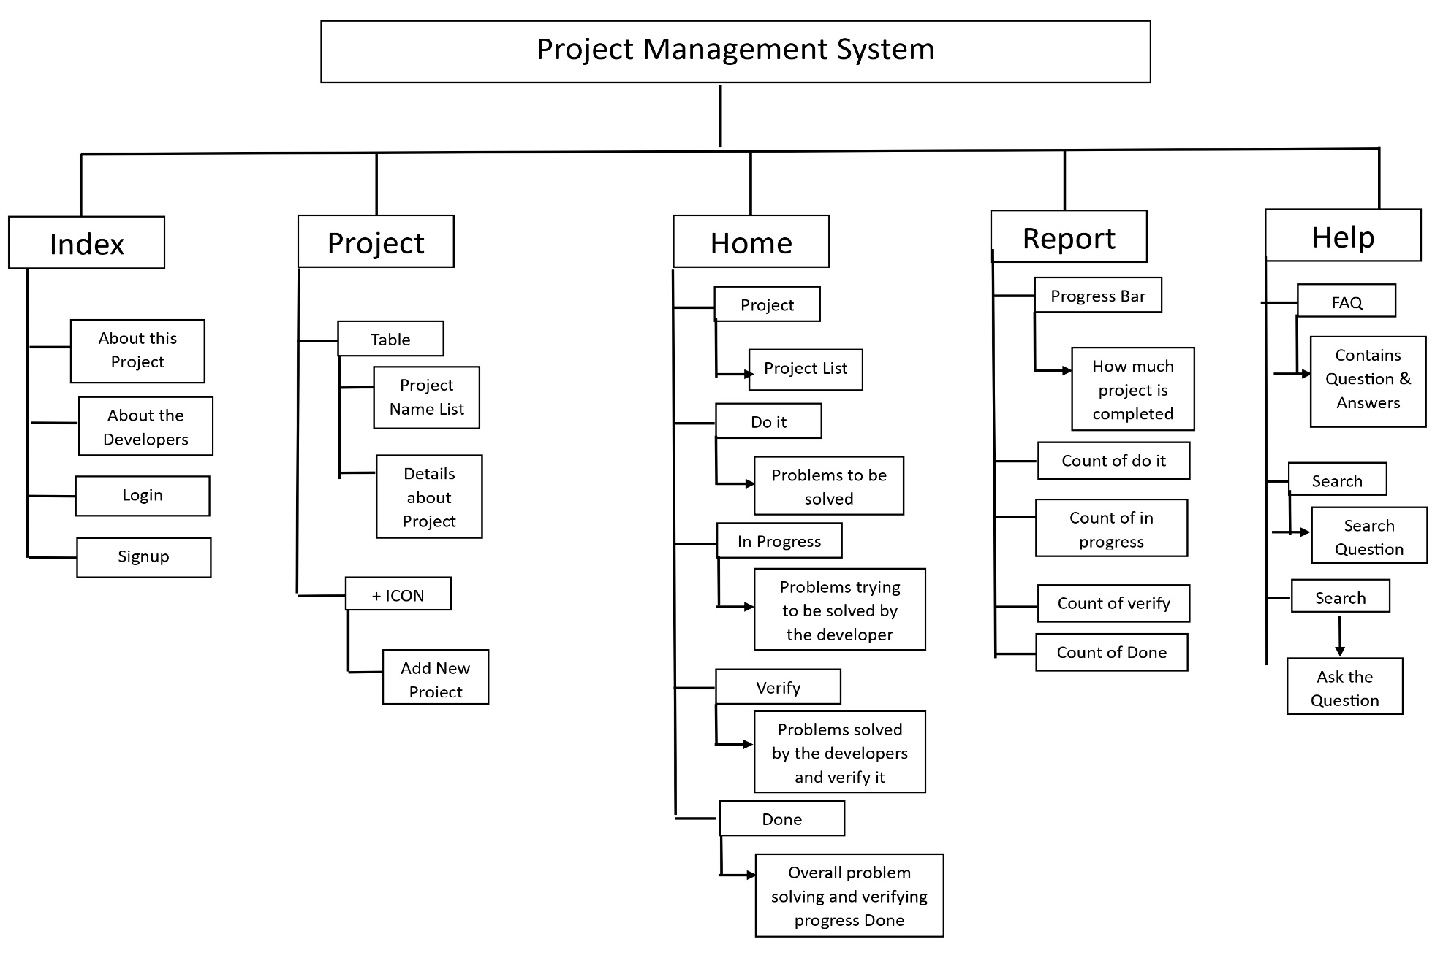

**DFD**

**Login Process DFD:**

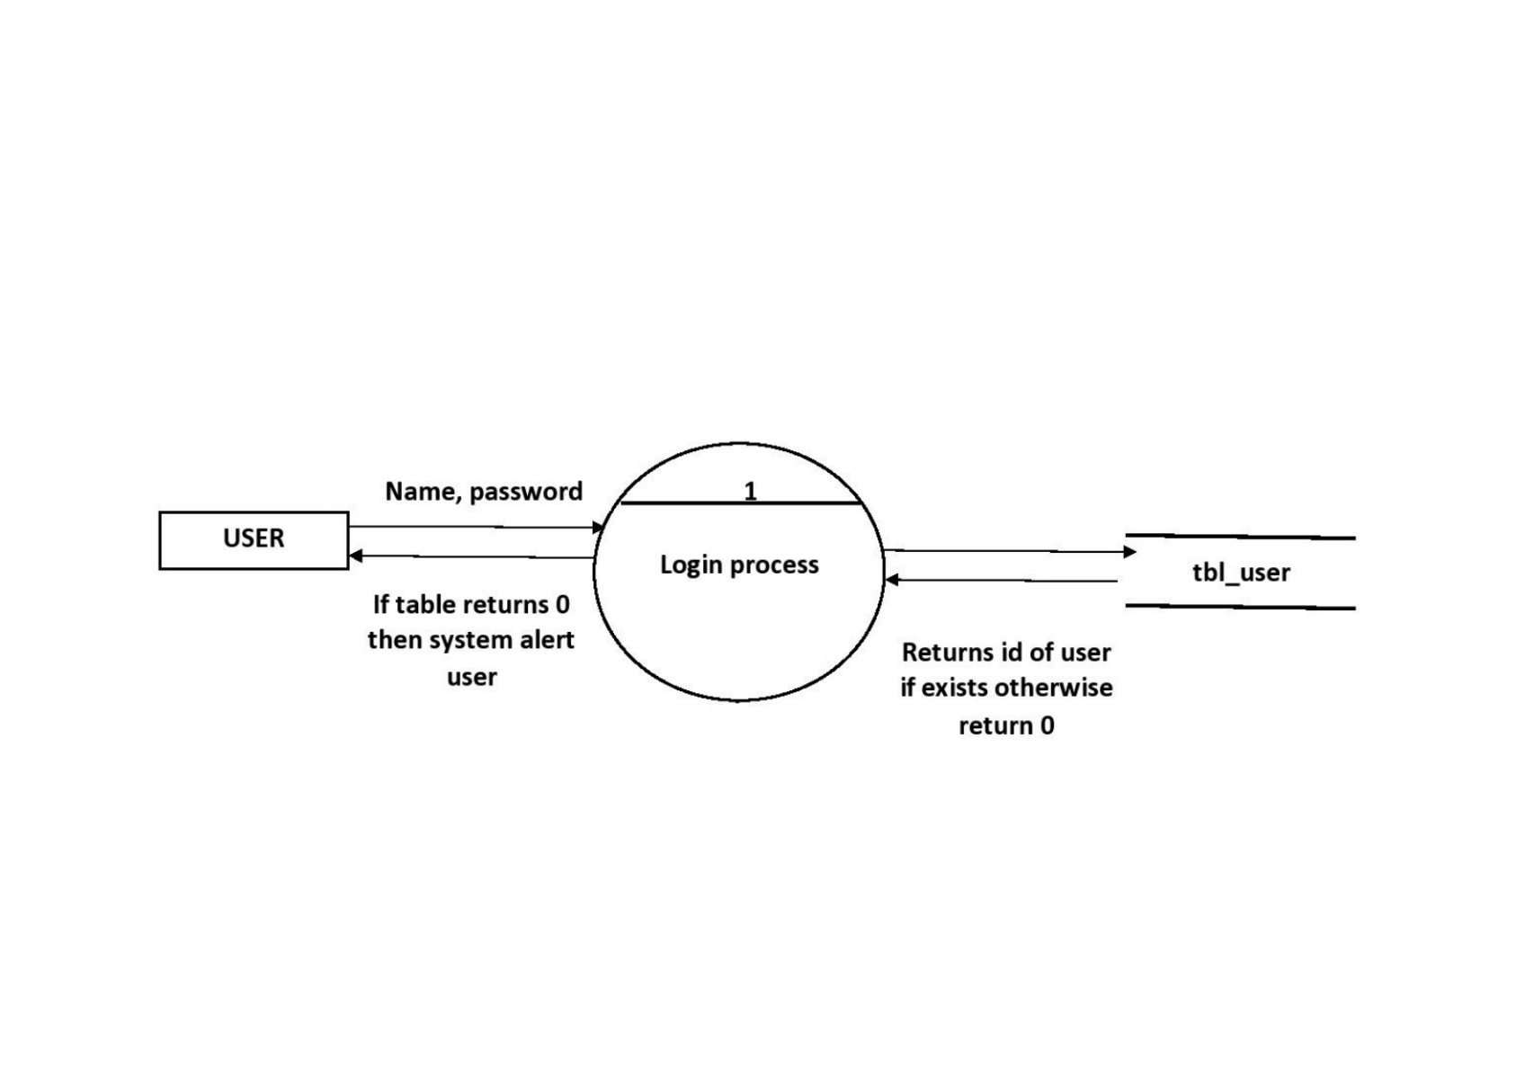

**Report Process DFD:**

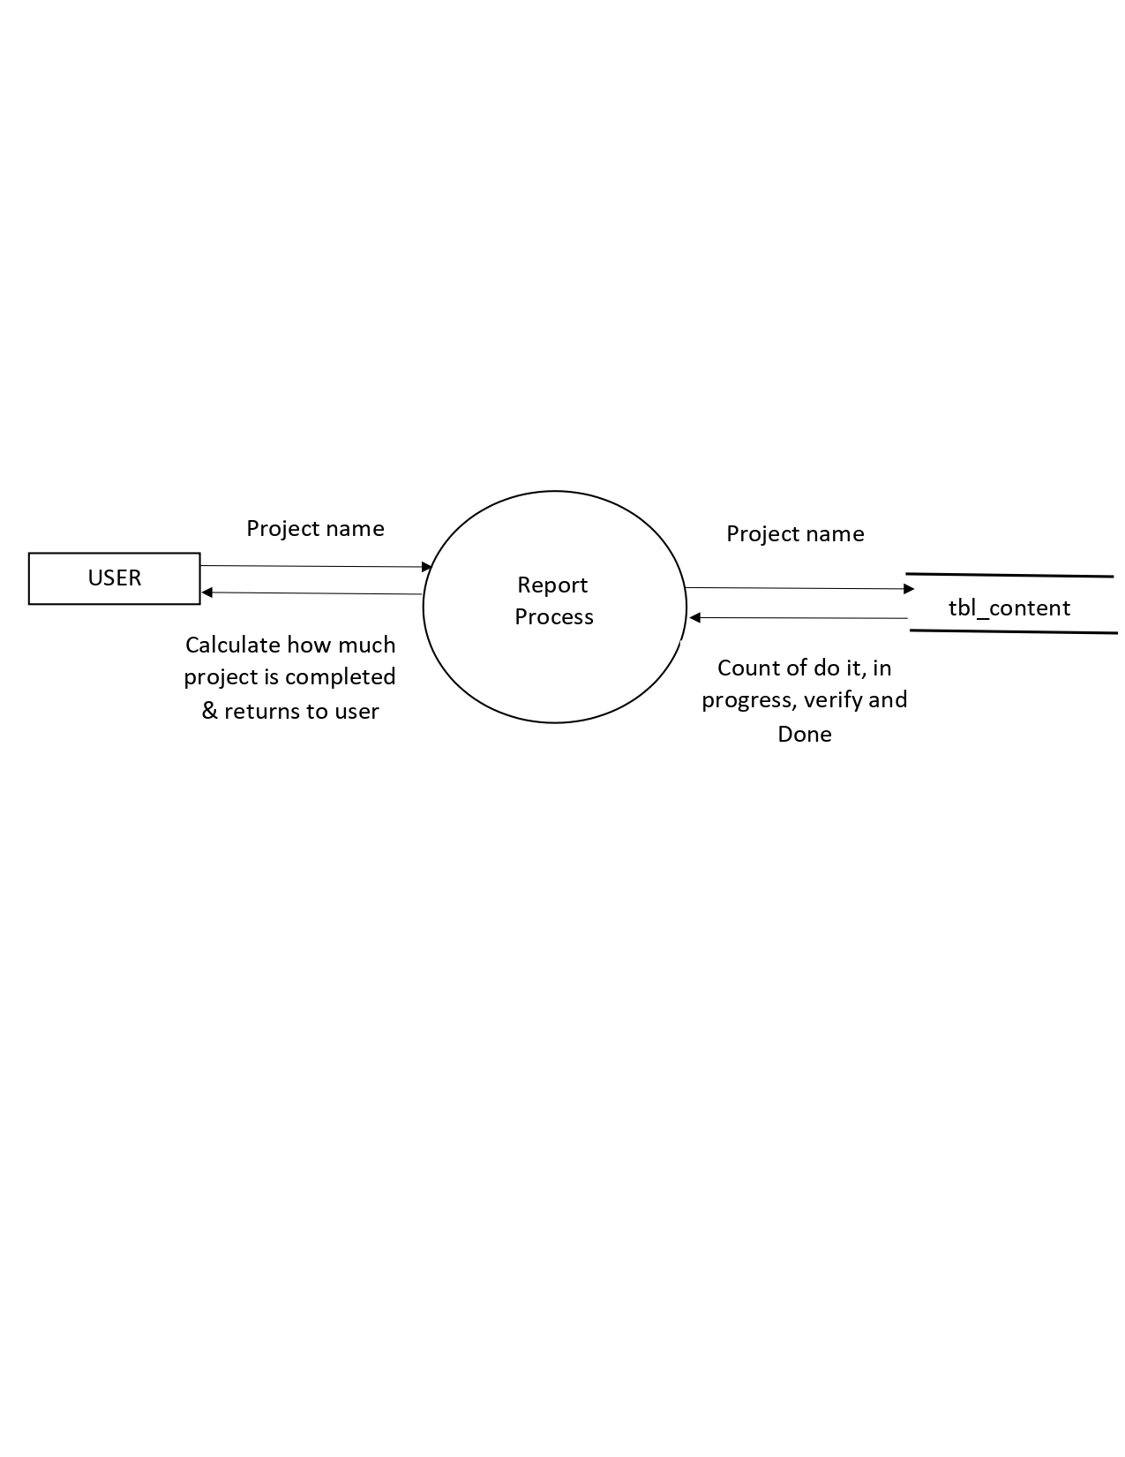

**Home Process DFD:**

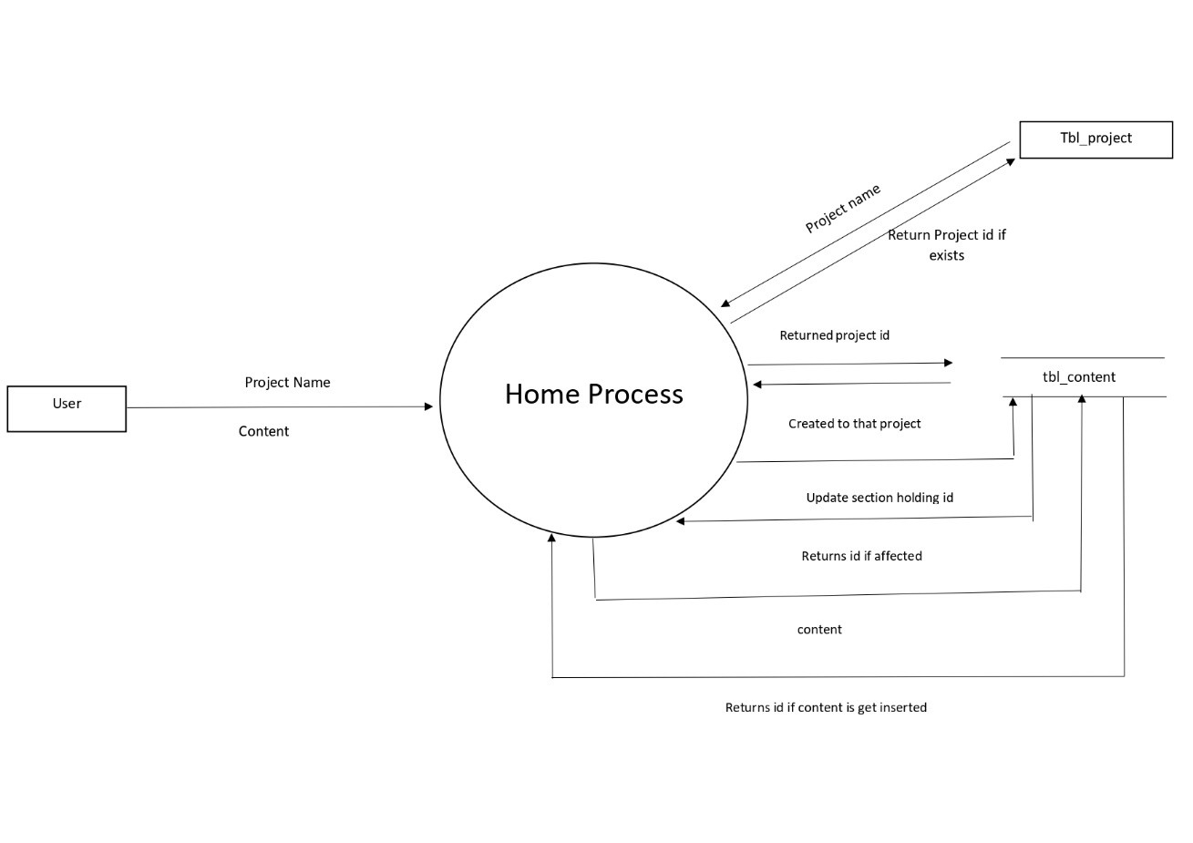

**Project Process DFD:**

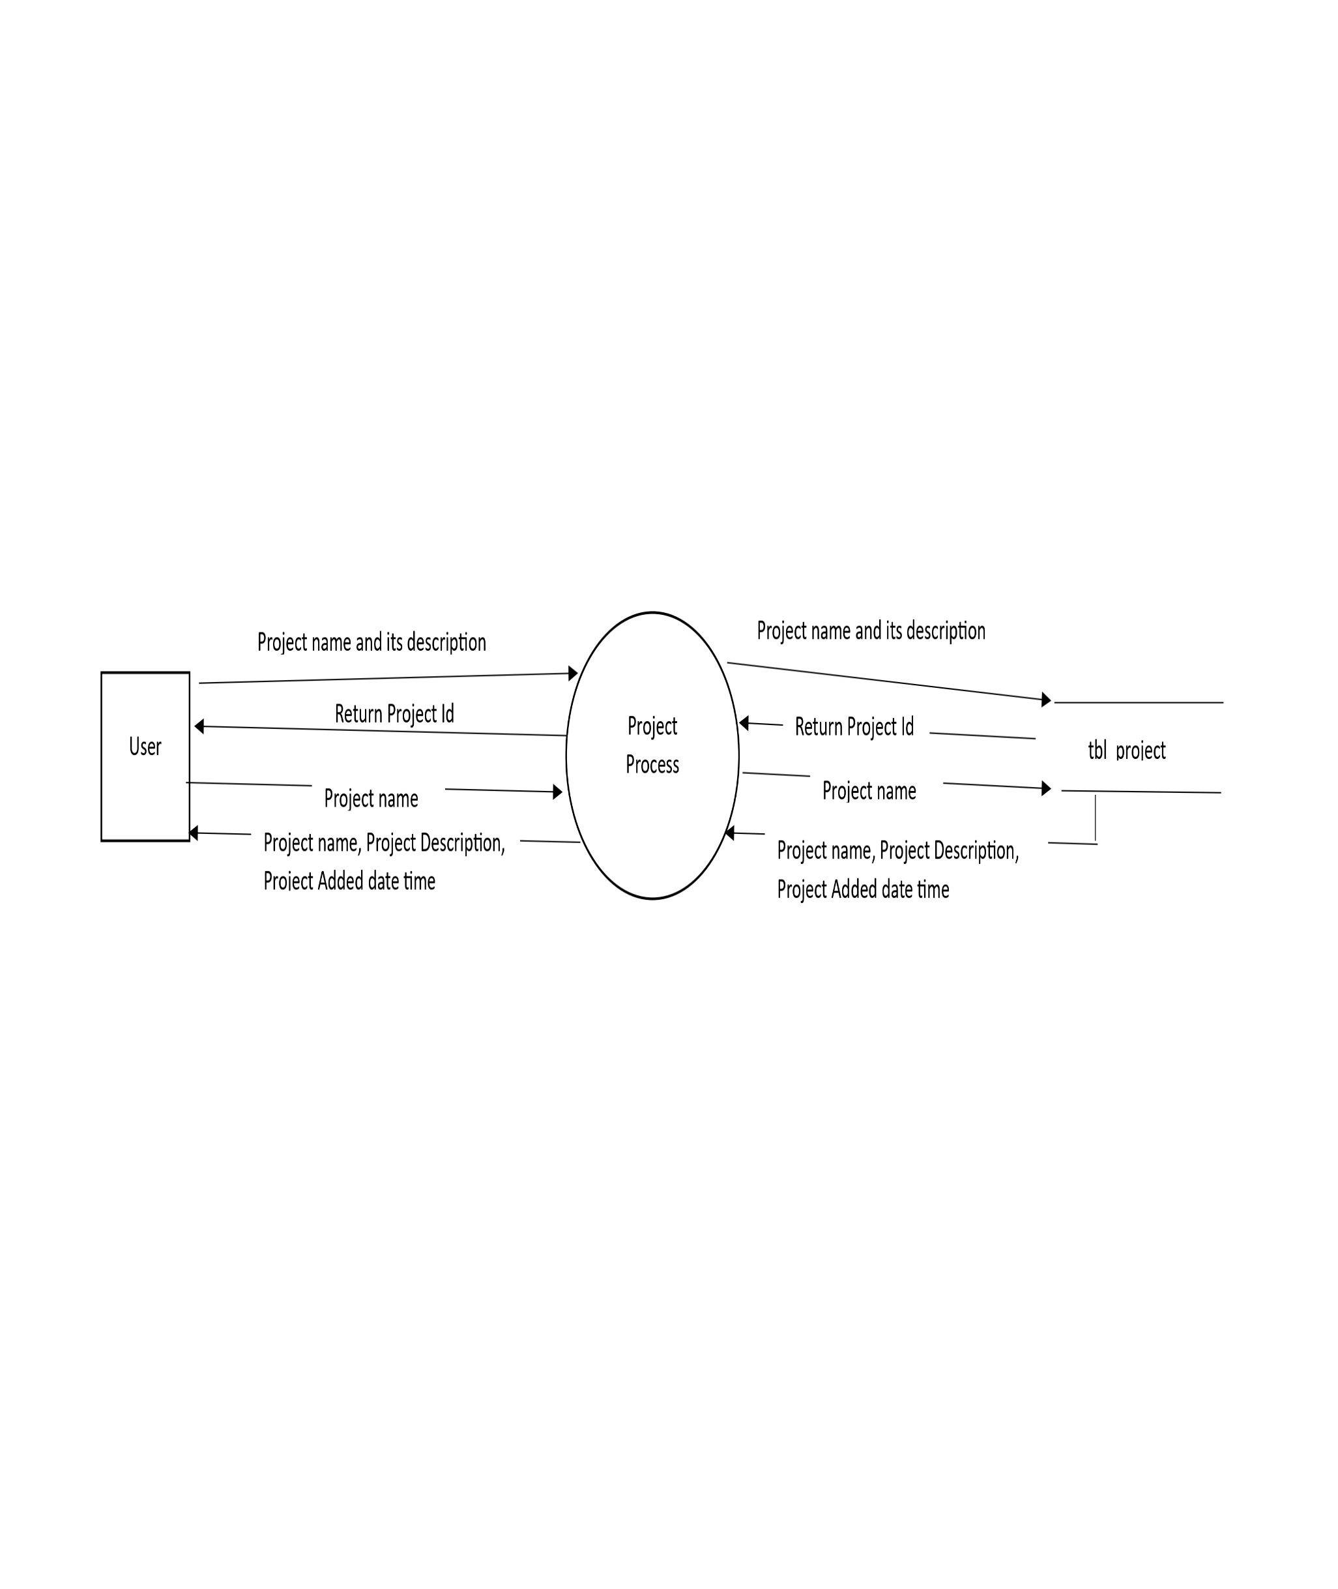

**System Design**

**Database Design:**

Table 1: tbl_user

About tbl_user:

The system will use this table to store the username and password added by the user at the time of signup. After storing the system will use this data at the time of login to identify which user is trying to log in. If the user’s record is present in this table and the user has entered the correct username and password then the system will redirect the user to the home page otherwise the system will alert the user.

The table structure of tbl_user:



Table tbl_user columns and its use:



Table 2 : tbl_project

About tbl_project:

In this table, the system is storing the project name, its description, when the project is added, and the user id to identify which user is added.

The table structure of tbl_project:



Table tbl_project columns and its use:



Table 3 : tbl_content

About tbl_content:

In this table, the system will store problems added by the user for that project. This problem fetches the system when the user clicks on the search button which is present on the homepage of the system. After fetching the content of that project related to a user system will append the content in the respective section (do it, in progress, verify and done). The system will fetch data from column content. Suppose after fetching contents the user moves the problem/content from one section to another section the system will update only the section_holding_ids column. For example, if a user moves content from the Do It section to In Progress section the system will update the section_holding_ids from 1 to 2. 1 for the do it section, 2 for in progress section, 3 for Verify section, and 4 for the done section.

The table structure of tbl_content:



Table tbl_cotent columns and its use:



Table 4 : tbl_count

About tbl_count:

In this table, the system is storing the count of do it, in progress, verify, do for that project. Which is useful while generating a report. This table's new row for the project gets inserted when the user adds a new project. After inserting a row, we will update the count of do it, in progress, verify, and do relate to that project added by the user. The table gets updated when users add new content to the dashboard then the count of doing it increases by 1 when one piece of content is added. And, users move content from one section to another section then the count of sections from where content is moved is subtracted by 1 and the count of sections where that content is moved is added by 1.

The table structure of tbl_count:



Table tbl_count columns and its use:



Table 5 : tbl_faq

About tbl_faq:

In this table, the system stores the questions asked by users and their answers given by the admin. The system will fetch this data when the user lands on the help page and display only questions. When the user clicks on the drop button then the system will display the answer to that question.

The table structure of tbl_faq:



Table tbl_faq columns and their use:



**Input Output Design**

**Login Page:**

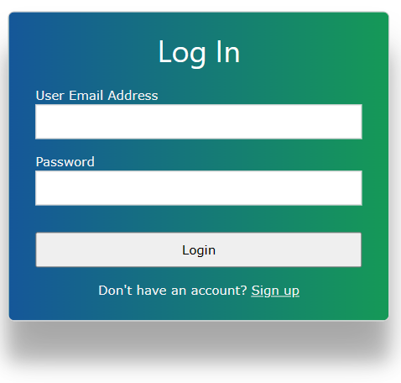

**Sign up page:**

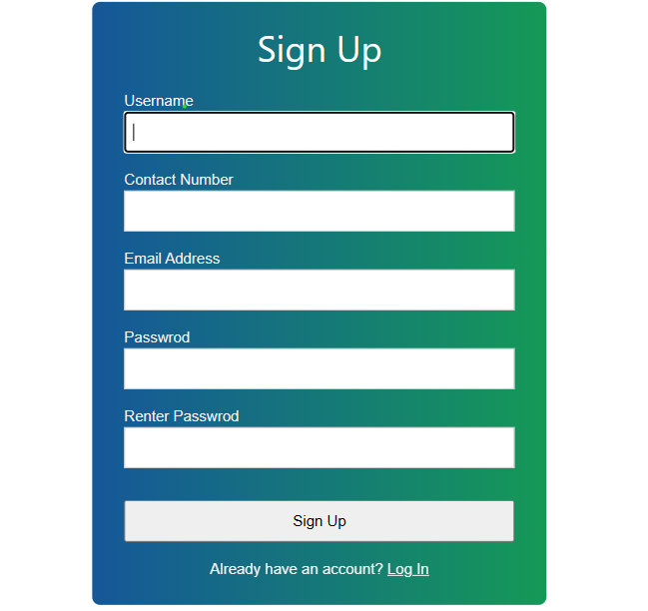

**Home page:**

To add content on the home page first click on the plus button which is present in the do it section. After clicking on the plus button, you can see the following modal open and you have to enter your content in the text area. Once you are done creating content you can click on the save button.

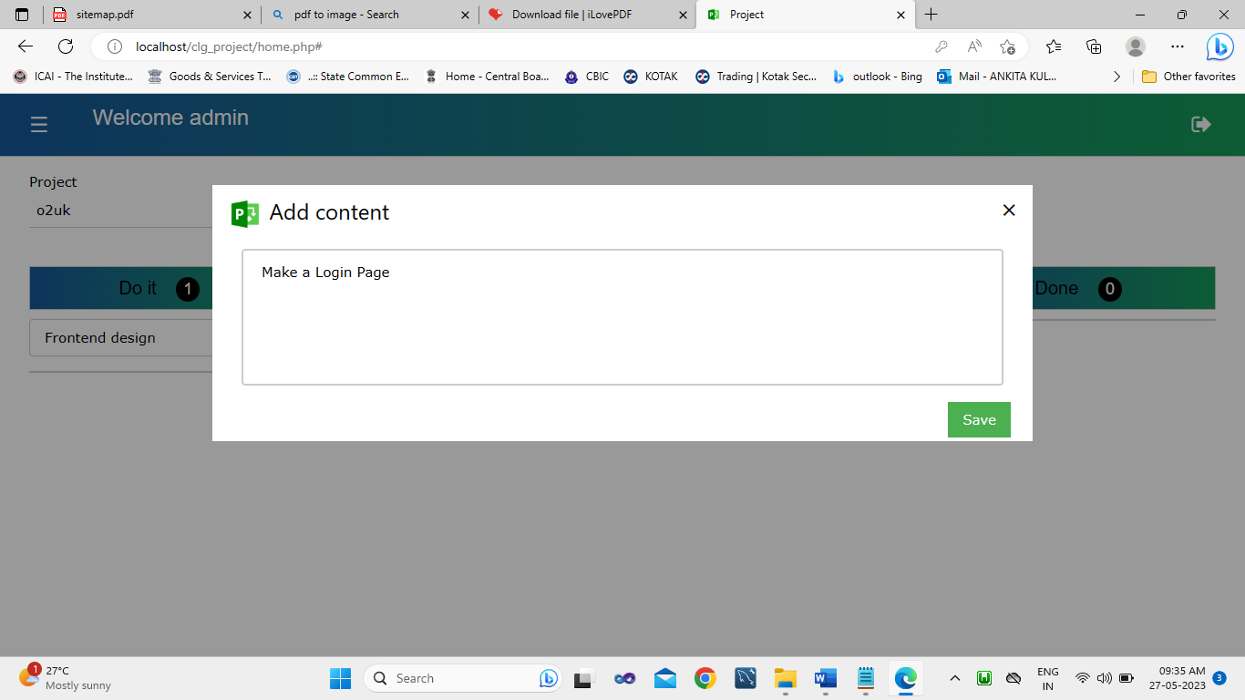

After clicking on the save button you can see the following alert which shows information about whether content is added or not.

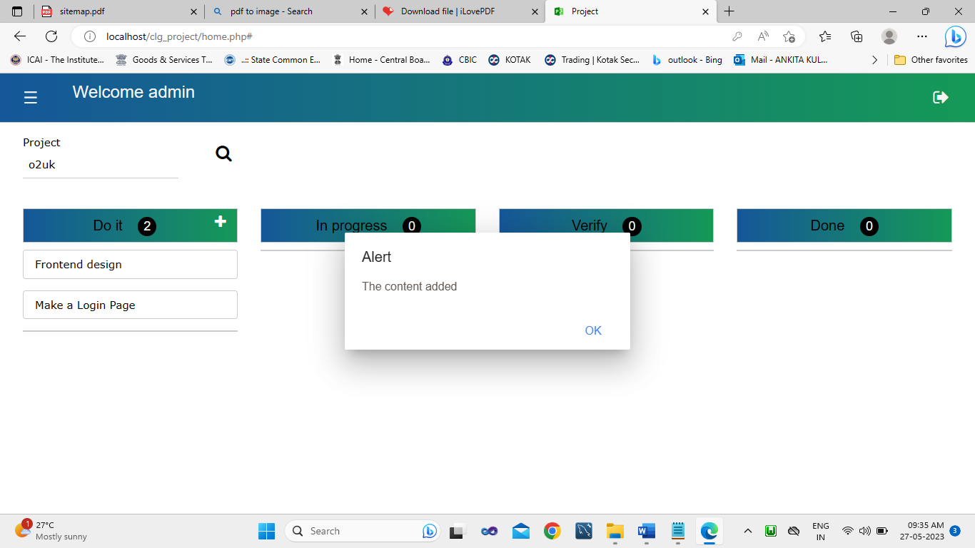

Once you click on ok of the above alert box then you can see that your content is added in the do it section.

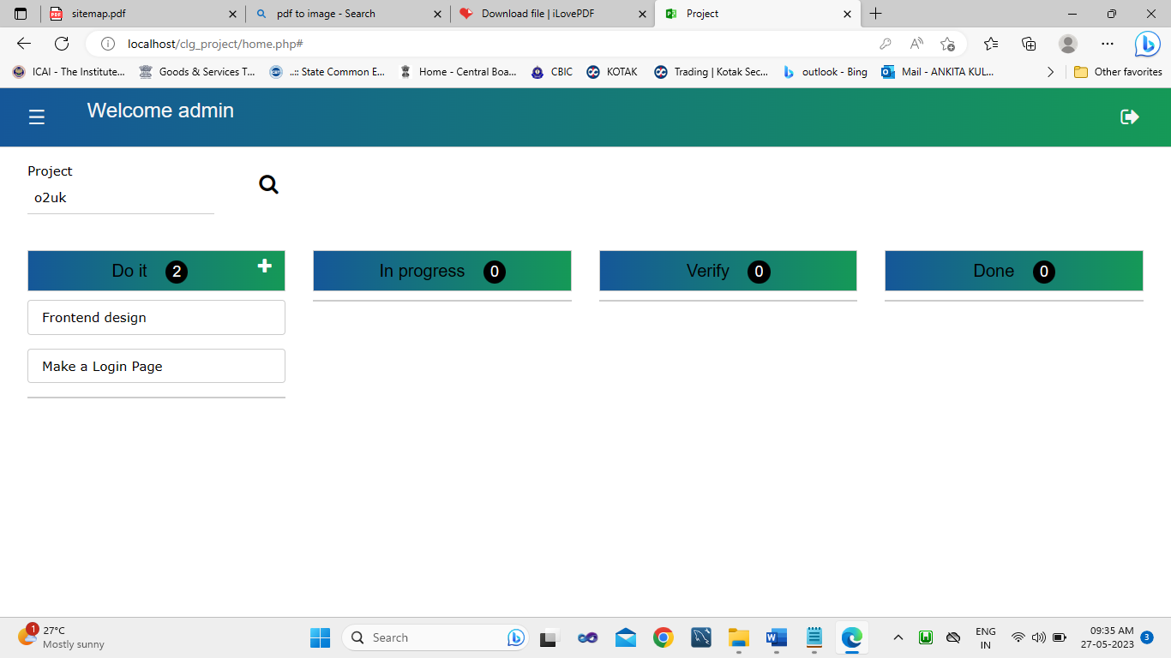

To move content from one section to another section you have to just drag that content and drop in which ever section you want.

**Project Page:**

To add new project you have click on plus button displayed on the top right side. Once you click on that plus button you can following modal and enter your project name and project description in that modal and click on save button.

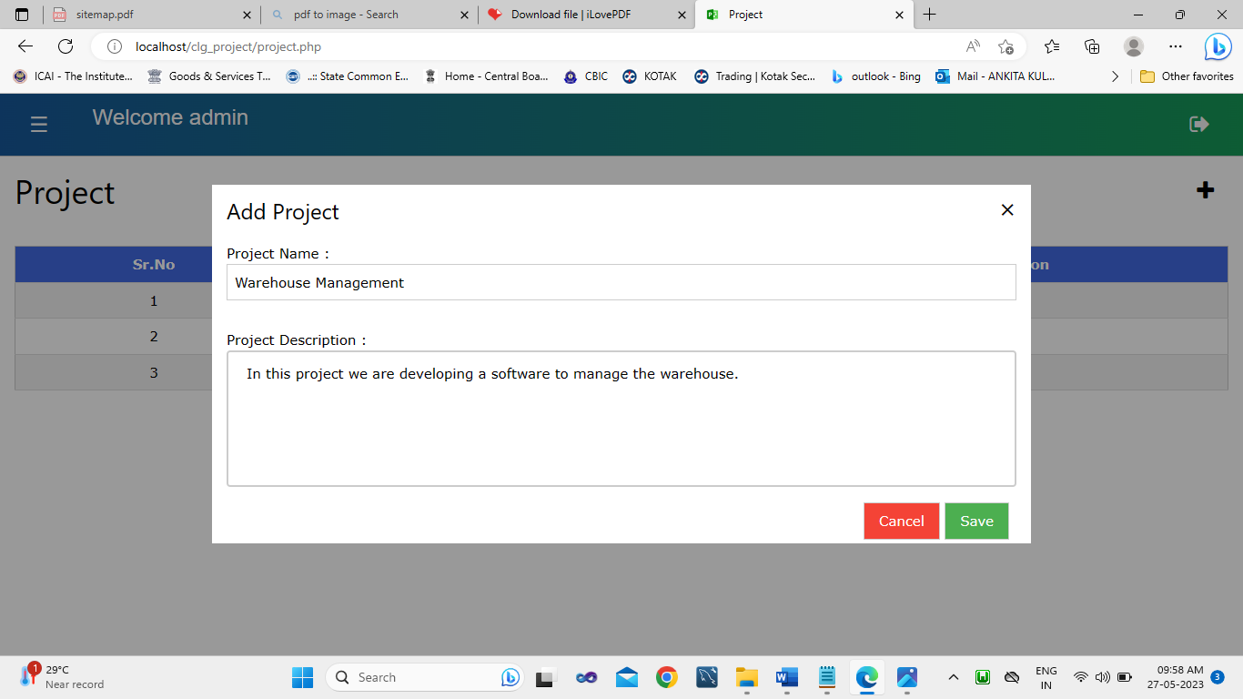

After clicking on the save button you can see the following alert which shows information about whether project is added or not.

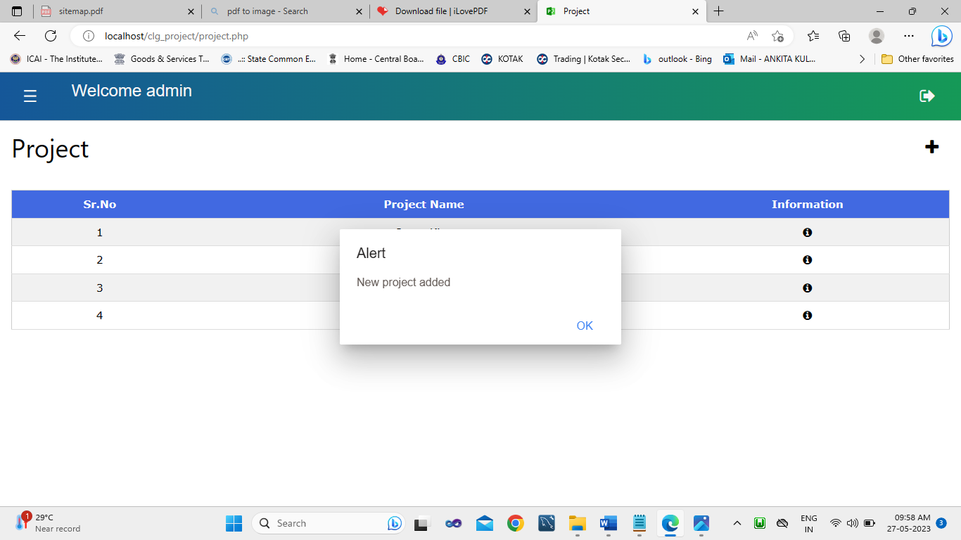

Once you click on the ok of the above alert box then you can see that your project is added.

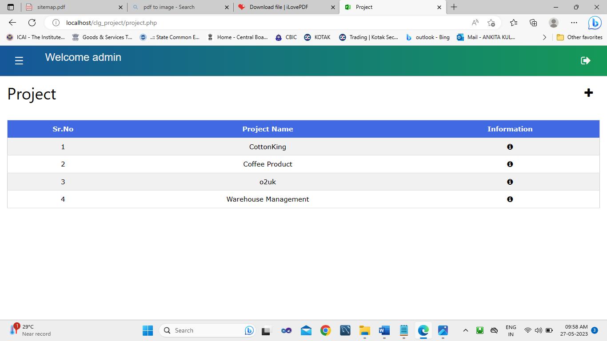

To see the details of project, click on information button which is displayed under information column. Once you click on that button the modal opens and you can see details of project like name of the project, when project is added (date and time) and description of the project.

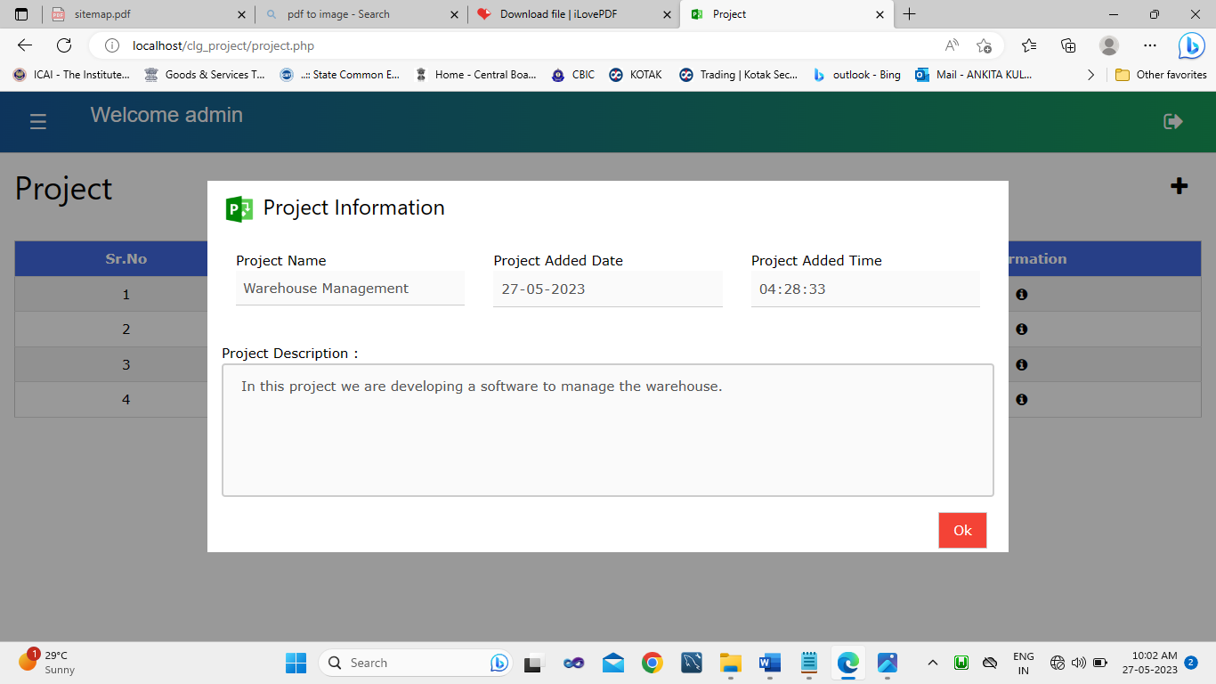

**Report Page:**

To generate the report of the project you must click on the name of project. Once you click on project name then you can see clearly in the following image system will display how much your project is completed and which section contain how much content.

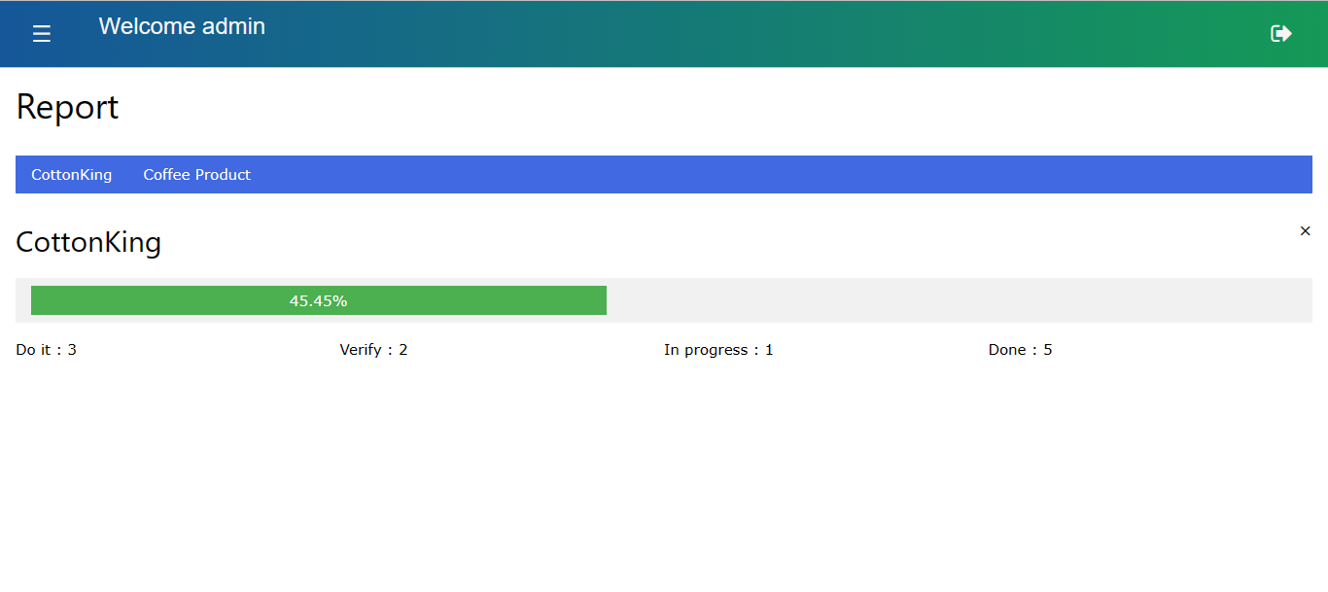

**FAQ Page:**

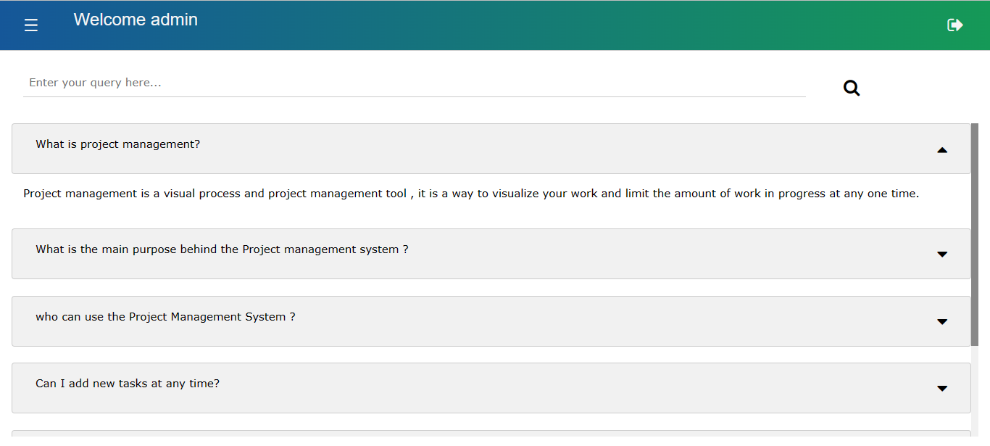

**System Requirement**

**Hardware**

We are proposing a web (browser-based) application for escalated requirements. It is not only made for desktop and laptop users but also for mobile users where anyone can use this software in a smooth way with no feature compromise. It is not only made for desktop and laptop users but also for users where anyone can use this software flexibly. No such hardware requirement is needed to run this project because it is a web application but you must need at least 512MB or 1 GB ram.

**Software**

As I mentioned before it is a web application. So, you can use this application on any operating system no such software requirement is needed for it. But you need at least a web browser. Web browsers like Google Chrome, Microsoft Edge, Internet Explorer, and Firefox.

**Installation process**

No installation process is needed for the use of this software. If you don’t have a web browser installed on your computer/laptop then you have to install that only.

**User Guidelines**

You don’t require any technical knowledge to use Project Management System. For using Project Management System you just have to follow the following guidelines:

1. to add new content you must click on plus button given in the do-it section.

2. To move content from one section to another section you just must drag and drop that content.

3. To add a new project you have to go to the project page and click on the plus button and fill in the required details and click on save. After saving you can see that your project is added to the list.

4. To generate the report of the project you must go to the report page and click on the name of the project and you can see the name of the project and how much it is completed (calculation in the percentage). You can also able to see which section contains how much content.

**Reports**

By using a project management system, you can generate a report. You can also easily get the status of the project by clicking on the project name.

For generating the report in the project management system you have to go to the report page where you can see the following UI:



Where you can see the blue horizontal bar, Project names are displayed. These are are all projects created by you / the user. You just click on it to generate the report.

You can see how much project is completed is displayed in the progress bar. By using the result, you can easily decide how much attention is required to complete this project.

Below that progress bar 4 sections are mentioned which help you to get an exact number of content present in that project.

For generating the report of another project, you just have to click on another project name and you will see the report of that project.

**Conclusion**

Project Management System is problem-solving software in the eyes of the software development organization. We have achieved the decided objectives to give a complete solution to the user.

The first objective we decided to achieve is to visualize your work, to give you an excellent overview of the current work situation of the project and provide an environment that leads to improved productivity.

By using the project management system, we also get better workflow and delivering value more often will lead to reduced risk for the project.

We can easily analyze how much the project is completed. We can also track the performance of the developer, tester, and requirement gathers.

**Limitations**

Home Page:

1. Users cannot add content in In-progress, verify, or done sections like the do-it section.

2. User cannot comment on content that encourages them to communicate properly

Project Page:

1. User cannot remove or delete projects from the list

2. Role-wise rights are not present anyone who has the username and password he/she can access the dashboard and other content

Report Page:

1. When content is not added to the project then it will display NaN in the progress bar

2. The user cannot see what content is present in which section

FAQ Page:

1. User cannot add/ask new questions

User cannot access this software when he/she is offline or does not have an active internet connection.

**Suggestions**

By providing the plus button in every section system can overcome its first limitation that is the user cannot add content in In-progress, verify, or do-it sections like the do-it section. This is based on the requirement of the user but we suggest the plus button is only available in the do-it section so everyone follows the flow of work.

By providing the comment option for the content present in the project it provides a better option to encourage communication between different teams.

By providing role-wise rights in the system we can improve the rights of the user and provide some unique features for higher authority. It includes features like generating a report based on the individual employee, skills, performance, etc.

By providing the option to users that will empower them to ask questions that have never been asked before by anyone else.

**Source code**

**Signup.php:**

<!DOCTYPE html>

<html lang="en">

<head>

<meta charset="UTF-8">

<meta http-equiv="X-UA-Compatible" content="IE=edge">

<meta name="viewport" content="width=device-width, initial-scale=1.0">

<title>Sign Up</title>

<?php

include 'login_signup_header.php';

?>

<style>

#box_of_signup

{

font-family:Arial;

background: -webkit-linear-gradient(to right, #155799, #159957);

background: linear-gradient(to right, #155799, #159957);

color:whitesmoke;

}

</style>

</head>

<body>

<p></p>

<div class="w3-third w3-display-middle w3-padding w3-round-large" id="box_of_signup">

<div class="w3-container">

<h1 class="w3-center w3-xxlarge w3-text-white">Sign Up</h1>

<div class="w3-section w3-bar">

<div class="w3-bar-item group">

<label class="">Username</label>

<input class="w3-input w3-border w3-margin-bottom" maxlength="25" type="text" id="user_name" onchange="validate_username()" autofocus required>

<b>

<p id="username_msg" class="w3-text-red" style="display:none;"></p>

</b>

</div>

<div class="w3-bar-item group">

<label class="">Contact Number</label>

<input class="w3-input w3-border w3-margin-bottom" maxlength="10" type="text" id="user_contact_no" onchange="validate_contactno()" required>

<b>

<p id="contact_no_msg" class="w3-text-red" style="display:none;"></p>

</b>

</div>

<div class="w3-bar-item group">

<label class="">Email Address</label>

<input class="w3-input w3-border w3-margin-bottom" type="text" id="user_email_add" maxlength="30" onchange="validate_emailadd()" required>

<b>

<p id="email_msg" class="w3-text-red" style="display:none;"></p>

</b>

</div>

<div class="w3-bar-item group">

<label class="">Passwrod</label>

<input class="w3-input w3-border w3-margin-bottom" maxlength="8" type="password" id="user_password" onchange="validate_password()" required>

<b>

<p id="password_msg" class="w3-text-red" style="display:none;"></p>

</b>

</div>

<div class="w3-bar-item group">

<label class="">Renter Passwrod</label>

<input class="w3-input w3-border w3-margin-bottom" maxlength="8" type="password" id="user_rentered_password" required>

<b>

<p id="rentered_password_msg" class="w3-text-red" style="display:none;"></p>

</b>

</div>

<div class="w3-bar-item group">

<b>

<p id="problem_msg" class="w3-text-red" style="display:none;"></p>

</b>

</div>

<div class="w3-bar-item group">

<button class="w3-col l12 m12 s12 w3-button w3-padding w3-section w3-right w3-text-black" type="button" onclick="signup()">Sign Up</button>

</div>

<div class="w3-bar-item group">

<div class="w3-center">

<div class="text-center">Already have an account? <a href="login.php">Log In</a></div>

</div>

</div>

</div>

</div>

</div>

</body>

</html>

**Dal_login_signup.php:**

if (isset($_POST['sign_up'])) {

$user_name = $_POST['user_name'];

$user_contact_no = $_POST['user_contact_no'];

$user_email_add = $_POST['user_email_add'];

$user_password = $_POST['user_password'];

$signup = "INSERT INTO `tbl_user` (`user_name`, `user_contact_no`, `user_email_add`, `user_password`, `user_signup_date`) VALUES ('$user_name', '$user_contact_no', '$user_email_add', '$user_password', CURRENT_TIMESTAMP)";

if (mysqli_query($con, $signup)) {

$last_id = mysqli_insert_id($con);

$_SESSION['user_id'] = $last_id;

$_SESSION['user_name'] = $user_name;

echo "1";

} else {

echo "0";

}

mysqli_close($con);

exit();

}

**Project.php:**

<!DOCTYPE html>

<html lang="en">

<head>

<meta charset="UTF-8">

<meta http-equiv="X-UA-Compatible" content="IE=edge">

<meta name="viewport" content="width=device-width, initial-scale=1.0">

<?php

include 'header.php';

?>

<script src="jquery/project.js"></script>

<style>

#tr_color{

background-color:#4169E1

}

</style>

</head>

<body onload="get_project()">

<?php

include 'dal/dal_db.php';

include 'menu.php';

?>

<div class="w3-container ">

<h1>Project <a onclick="document.getElementById('modal_of_add_project').style.display='block'" class="w3-right w3-xlarge w3-button w3-hover-text-red" title="Add"><i class="fa fa-plus" aria-hidden="true"></i></a> </h1>

</div>

<div id="modal_to_display_info_about_project" class="w3-modal">

<div class="w3-modal-content">

<header class="w3-container">

<h3 class="w3-padding-left"><img src="img/microsoft-project-480.png" alt="Project Management System Icon" class="w3-image" height="2vh" width="40vw"> Project Information</h3>

</header>

<div class="w3-bar">

<div class="w3-padding w3-row">

<div class="w3-bar-item w3-col l4 m4 s12 w3-padding group">

<label>Project Name</label>

<input id="modal_project_name" class="w3-input" type="text" disabled>

</div>

<div class="w3-bar-item w3-col l4 m4 s12 w3-padding group">

<label>Project Added Date</label>

<input id="modal_project_date" class="w3-input" type="date" disabled>

</div>

<div class="w3-bar-item w3-col l4 m4 s12 w3-padding group">

<label>Project Added Time</label>

<input id="modal_project_time" class="w3-input" type="time" disabled>

</div>

</div>

</div>

<div class="w3-margin-top w3-padding w3-contanier">

<div class="w3-contanier"><label>Project Description : </label><textarea id="modal_project_description" style="overflow-y:auto;" disabled></textarea></div>

</div>

<footer class="w3-container">

<div class="w3-right w3-padding-small">

<button class="w3-button w3-red w3-border" onclick="document.getElementById('modal_to_display_info_about_project').style.display='none';document.getElementById('project_name').value = '';document.getElementById('project_description').value = ''">Ok</button>

</div>

</footer>

</div>

</div>

<div class="w3-margin-top w3-padding" style="height:30rem;overflow-y: auto;">

<table class="w3-table-all w3-padding-small" id="tbl_id">

<tr id="tr_color">

<th class="w3-center w3-text-white">Sr.No</th>

<th class="w3-center w3-hide w3-text-white">Project Id</th>

<th class="w3-center w3-text-white">Project Name</th>

<th class="w3-center w3-hide w3-text-white">Project Description</th>

<th class="w3-center w3-hide w3-text-white">Project Added Date</th>

<th class="w3-center w3-text-white">Information</th>

</tr>

</table>

</div>

</body>

</html>

**Dal_project.php**

<?php

include 'dal_db.php';

session_start();

if (isset($_POST['add_project_to_table'])) {

$projectname = $_POST['project_name'];

$user_id = $_SESSION['user_id'];

$projectdescription = $_POST['project_description'];

mysqli_query($con, "@out_parameter=0");

mysqli_query($con, "CALL project_management_system_sp1($user_id,'','$projectname','$projectdescription',0,0,0,CURRENT_TIMESTAMP,3,@out_parameter)");

$rs2 = mysqli_query($con, "SELECT @out_parameter as out_parameter ");

$row = mysqli_fetch_assoc($rs2);

$date = date('Y-m-d H:i:s');

if($row['out_parameter'] > 0)

{

echo "added#".$row['out_parameter']." " . $date;

}

else

{

echo "not_added#0";

}

mysqli_close($con);

exit();

}

if (isset($_POST['get_project'])) {

$total = "";

$userid = $_SESSION['user_id'];

$get_project_list = "SELECT project_id,project_name,project_description,project_added_date FROM tbl_project WHERE user_id = $userid";

$result = mysqli_query($con, $get_project_list);

if (isset($result)) {

while ($row = mysqli_fetch_array($result)) {

$total = $total . $row['project_id'] . "#" . $row['project_name'] . "#" . $row['project_description'] . "#" . $row['project_added_date'] . "*";

}

}

echo $total;

mysqli_close($con);

exit();

}

Thank You!!...