Table of Contents
Chapter 1: Introduction 2
1.1 Introduction 2
1.2 Existing system and need for system 2
1.3 Limitation of existing system 3
Chapter 2: Proposed system 4
2.1 Problem statements 4
2.2 Product overview 4
2.3 Assumptions and dependencies 5
2.4 Objective of proposed system 6
2.5 Functional requirement 7
2.6 Non functional requirement 8
2.7 Users summary 10
2.8 Scope of system 10
2.9 Module specification 10
2.10 Operating environment 11
Chapter 3: Requirement determination and analysis 13
3.1 Requirement Gathering 13
3.2 Requirement Analysis 13
Chapter 4: System analysis and design 14
4.1 Use case diagram 14
4.2 Sequence diagram 15
4.3 Activity diagram 16
4.4 ERD 17
4.5 Class diagram 18
4.6 Object diagram 19
4.7 Sitemap 19
Chapter 5: User manual 20
5.1 User manual 20
Chapter 6: Drawbacks and limitations 21
6.1 Technical Limitations 21
6.2 Functional Limitations 21
6.3 User-Centric Limitations 21
6.4 Security Limitations 22
6.5 Maintenance and Upgrades 22
Chapter 7: Proposed enhancement 23
Chapter 8: Conclusion 25
Chapter 9: Bibliography 26
Chapter 10: Annexure 27
10.1 UI screens 27
10.2 Program code 31

Chapter 1: Introduction

1.1 Introduction
​
The BlogSphere covers all the essential functionalities of a modern blogging platform. This project aims to provide a complete user experience for both content creators and readers. On this platform users can create, share, read, listen and interact with blog content. Allow users to discover, read, and interact with blogs via comments, likes, and shares. Personalized blog recommendations based on user preferences and reading history. This platform also help an individuals who want to publish articles and reach an audience, individuals who want to explore and read or listen blogs across various topics.

BlogSphere proposes an advanced, user-centric blogging platform with enhanced functionalities, such as:

- User-Friendly Interface: A modern, responsive UI that allows users to easily create, read, and engage with content.
- Blog Listening: A text-to-speech feature enabling users to listen to blogs on the go.
- Personalized Recommendations: Blogs suggested based on a user's reading history, preferences, and engagement with other blogs.
- Notifications: Users will receive real-time notifications on likes, comments, and new content from followed blogs.
- Engagement Features: Options to like, comment, and follow bloggers, enhancing social interactions on the platform.
- Data-Driven Insights: By analyzing user activity, the system will provide users with tailored blog recommendations and encourage engagement.

1.2 Existing system and need for system

There are many existing system which are currently in trending such as Blogs from google, Medium, WordPress, Tumblr, ghost, postach, etc. BlogSphere draws inspiration from these well-established blogging platforms. From above mentioned system Medium and Blogger are most widely used blogging platform across a word.

- Medium: A clean, user-friendly interface for both creators and readers. Medium offers features like blog recommendations, story highlights, and user engagement with applause (likes) and comments.
- Blogger: A simple, easy-to-use platform by Google that allows users to create blogs with minimal technical knowledge. Blogger offers basic customization and integration with Google services.
- WordPress: A powerful content management system that offers extensive customization, plugins, and themes for users. It has a broad user base, ranging from casual bloggers to professional content creators

These systems serve as benchmarks, but BlogSphere aims to address the gaps by offering a personalized recommendation engine and blog listening feature, which are either limited or absent in existing systems.

1.3 Limitation of existing system

Lack of good user-interface

- The existing systems often have outdated or poorly designed interfaces, which can make navigation cumbersome for users.
- The lack of visual appeal and responsiveness can deter users from spending more time on the platform.
- Features like seamless navigation, clear layouts, and interactive design elements are often missing, leading to a less engaging experience.
- This limitation makes it challenging for users to quickly access the information they need or perform desired actions efficiently.

Very simple text editor
- Most existing systems provide only basic text editing functionality, such as adding plain text without advanced formatting options.
- Features like bold, italics, underline, bullet points, or integration of images, videos, and links are absent or poorly implemented.
- The inability to preview content or add rich formatting makes the content creation process less creative and more restrictive.
- This limitation is especially problematic for users who want to create blogs or articles that are visually appealing and professional-looking.

Not having personalized recommendation
- The current systems lack the ability to analyze user preferences, browsing patterns, or interests to provide tailored content suggestions.
- Without a personalized recommendation engine, users may struggle to find content that aligns with their interests, leading to lower engagement.
- This limitation often results in users seeing irrelevant or repetitive content, which can lead to frustration and decreased retention.
- Personalization has become a standard in modern systems, and its absence puts the platform at a disadvantage compared to competitors.

Chapter 2: Proposed system

2.1 Problem statements

Unappealing and Inefficient User Interface
- Existing platforms lack a modern and intuitive design, making navigation and content consumption challenging for users.
- The absence of a responsive and interactive interface results in lower user engagement and satisfaction.
Limited Content Creation Capabilities

- The basic text editor provided in current systems restricts users from creating rich and visually appealing content.
- Features like advanced formatting options, multimedia integration, and live previews are missing, limiting creativity.

Lack of Personalization
- Users are not provided with personalized content recommendations based on their preferences or behavior.
- This results in irrelevant or repetitive content suggestions, reducing user retention and engagement.

Low Content Discoverability

- Users face challenges in discovering trending or relevant content due to poor organization and lack of intelligent sorting mechanisms.

Poor User Engagement Metrics

- Existing platforms fail to track and display meaningful engagement metrics like likes, claps, or comments effectively.
- Users and authors cannot easily monitor the performance of their content or identify trends.

2.2 Product overview

The proposed system is a modern blogging platform designed to overcome the limitations of existing solutions by offering an enhanced user experience, rich content creation tools, and intelligent personalization. The platform addresses user needs and improves engagement by introducing the following key features:

Enhanced User Interface

- A visually appealing, intuitive, and responsive design ensures seamless navigation and a better user experience across devices.
- Interactive elements, such as category filters, content previews, and notifications, improve usability.

Advanced Content Editor

- A feature-rich text editor allows users to create and format content effortlessly.
- Options for embedding images, videos, and hyperlinks enable users to produce engaging multimedia content.

Personalized Recommendations

- Powered by machine learning algorithms, the platform delivers content suggestions tailored to each user’s interests and browsing behavior.
- Categories like "Trending," "For You," and "Following" enhance content discoverability.

User Engagement Tools

- Features like claps, comments, and shares allow users to interact with content and authors.
- Analytics for authors, such as engagement trends and performance metrics, provide actionable insights.

2.3 Assumptions and dependencies

Assumptions

User Access and Devices
- Users will primarily access the platform through modern web browsers on desktops, laptops, or mobile devices.
- Users will have stable internet connections for a seamless experience.

Usage Expectations
- Users are familiar with basic blogging platforms and social media interaction models (e.g., clapping, commenting).
- Authors and readers will actively engage with the platform's features, such as personalized recommendations and content creation.

Data Availability
- The platform will have sufficient user-generated content for personalized recommendations and trend analysis.
- Users will provide accurate data during registration to facilitate better personalization.

System Resources
- The hosting environment will provide adequate computational resources (CPU, memory, and storage) to handle real-time recommendations and analytics.

Dependencies

Third-Party Services and APIs
- Integration with third-party services such as cloud storage, email notification systems, or analytics tools.
- Reliance on external libraries or frameworks for implementing features like machine learning recommendations or advanced text editing.

Database Management
- The performance and scalability of the database will be critical to handle user data, blog content, and interaction records.

Machine Learning Models
- The accuracy of personalized recommendations depends on the availability of high-quality training data and properly tuned algorithms.
- Periodic retraining of models will require adequate computational resources.

Security Measures
- Dependence on secure authentication mechanisms (e.g., JWT) and encryption standards to protect user data and privacy.

External Dependencies
- Compatibility with web standards and dependencies on frameworks like React, FastAPI, or other chosen technologies for frontend and backend.
- Dependency on hosting providers to ensure uptime, reliability, and scalability.
User Feedback and Interaction
- Continuous improvement of features depends on timely user feedback and engagement metrics.

Team and Timeline
- Assumes the availability of a dedicated development team with expertise in the required technologies.
- The project timeline is dependent on smooth communication and task delegation among team members.

2.4 Objective of proposed system

The objective of the proposed system is to create an intuitive and feature-rich blogging platform that addresses the limitations of the existing system and enhances user engagement through advanced functionality. The system aims to:

Improve User Interface (UI):
- Provide a modern, responsive, and visually appealing interface for users across all devices.
- Implement an interactive and user-friendly dashboard for blog management and content discovery.

Advanced Text Editor:
- Offer a powerful text editor with rich formatting options, allowing users to create professional-quality blog posts with ease.
- Enable features such as adding images, videos, and other multimedia to enhance blog content.

Personalized Recommendations:
- Leverage machine learning algorithms to provide tailored blog recommendations based on user preferences and interaction history.
- Present trending and relevant content to keep users engaged.

Enhanced Engagement Features:
- Implement features such as clapping, commenting, and sharing to promote interaction between authors and readers.
- Provide real-time notifications for user activities, such as blog comments, follows, and likes.

Comprehensive Analytics:
- Equip users with detailed insights into blog performance, including views, claps, comments, and trends over time.

Scalability and Security:
- Ensure the platform can handle increasing user activity and data volume while maintaining high performance and security standards.

Seamless User Experience:
- Integrate functionalities like "Read Later" lists, trending topics, and personalized dashboards for a holistic user experience.

2.5 Functional requirement

The functional requirements of the proposed system define the specific actions and tasks the system should perform to meet its objectives. These requirements ensure that the system is designed and implemented to deliver the intended features effectively.

User Management
- Users can sign up and log in to the platform securely.
- Users can update their profile details, including bio, profile picture, and contact information.
- Admins can manage user accounts (create, update, deactivate, or delete users).

Blog Management
- Users can create, edit, and delete blogs using an advanced text editor with multimedia support.
- Users can assign tags to blogs for better categorization and discoverability.
- Blogs are displayed with details such as title, subtitle, content, author, date, and tags.

Blog Discovery and Recommendations
- Users can search blogs using keywords, tags, or author names.
- The platform provides personalized blog recommendations based on user activity, preferences, and history.
- Trending blogs are highlighted for users based on overall engagement.

Interaction Features
- Users can clap for blogs to show appreciation, and the total clap count is displayed on each blog.
- Users can comment on blogs, and the author is notified of new comments.
- Users can share blogs via social media or email.
- Users can add blogs to a "Read Later" list for future reference.

Analytics and Insights
- Users can view blog performance metrics, including views, claps, and comments over time.
- Admins can generate and view reports on user activity, blog engagement, and system usage.

Notifications
- Real-time notifications are sent for activities such as new comments, followers, or trending blogs.
- Summary notifications for activities like daily claps or comments are provided.

Security and Authentication
- Users must authenticate using secure credentials (e.g., password or Oauth).
- Token-based authentication ensures secure communication between the client and server.
- Sensitive user data is encrypted and stored securely.

Admin Features
- Admins can manage blogs, users, and tags in the system.
- Admins can monitor system performance and usage statistics.
- Admins can moderate and remove inappropriate content.
Scalability and Performance
- The system can handle a growing number of users, blogs, and interactions without performance degradation.
- Efficient database queries ensure fast response times for user actions and analytics.
Multi-platform Support
- The platform is accessible across multiple devices, including desktops, tablets, and mobile phones.

2.6 Non functional requirement

Non-functional requirements define the operational qualities and constraints of the system, ensuring it performs efficiently, securely, and reliably while meeting user expectations.

Performance Requirements
- The system should respond to user actions (e.g., loading a blog, posting a comment) within 2 seconds under normal load conditions.
- The platform should support at least 10,000 concurrent users without performance degradation.

Scalability
- The system should be scalable to accommodate an increasing number of users, blogs, and interactions as the platform grows.
- The architecture should support horizontal scaling to handle peak loads effectively.

Security
- User data, including passwords, must be stored securely using encryption techniques.
- The system must implement role-based access control to prevent unauthorized actions.
- All communications between client and server must use HTTPS for secure data transmission.

Usability
- The platform should have a clean, intuitive user interface that is easy to navigate for users of all skill levels.
- Error messages and help documentation should be clear and user-friendly.

Availability
- The system should maintain 99.9% uptime, with minimal disruptions due to maintenance or technical issues.
- Critical features like blog reading and writing should remain accessible even during system updates.

Maintainability
- The codebase should follow standard coding practices and be well-documented for ease of maintenance and updates.
- The system architecture should allow easy integration of new features and modules.

Portability
- The platform should work seamlessly across all major browsers (e.g., Chrome, Firefox, Safari, Edge).
- The system must be compatible with desktop and mobile devices, providing a responsive design.

Reliability
- The platform must handle unexpected user actions gracefully without crashing.
- Backup mechanisms should ensure data integrity in case of a system failure.

Accessibility
- The platform should be accessible to users with disabilities, complying with WCAG 2.1 standards.
- Features like keyboard navigation, screen reader support, and text scaling should be available.

Auditability
- The system should log user actions and system events for debugging and security audits.
- Admins should have access to activity logs for monitoring purposes.

Data Retention and Backup
- The platform should retain user data and activity logs for a defined period based on privacy policies.
- Regular backups should be performed to prevent data loss in case of hardware or software failures.

2.7 Users summary

This section provides an overview of the different types of users interacting with the system, their roles, and their responsibilities.

End Users (Blog Readers and Writers)
Description: General users who create, read, and engage with blogs on the platform.
Responsibilities:
- Create an account and log in to access personalized features.
- Write, edit, and publish blogs.
- Read blogs from other users.
- Interact with blogs by clapping, commenting, and saving them to read later.
- Follow other users to receive updates on their posts.

Admin Users
Description: Administrators responsible for managing the platform and ensuring smooth operations.
Responsibilities:
- Monitor platform usage and generate system reports.
- Manage user accounts, including handling complaints or removing inactive users.
- Review and address inappropriate or flagged content.
- Add or update platform-wide notifications and announcements.

2.8 Scope of system

The scope of BlogSphere covers all the essential functionalities of a modern blogging platform. This project aims to provide a complete user experience for both content creators and readers. On this platform users can create, share, read, listen and interact with blog content. Allow users to discover, read, and interact with blogs via comments, likes, and shares. Personalized blog recommendations based on user preferences and reading history. Users can register, log in, and manage their profiles. Users can write, format, and publish blogs with rich text editors, including media support. This platform also help an individuals who want to publish articles and reach an audience, individuals who want to explore and read or listen blogs across various topics.

2.9 Module specification

- User Authentication Module: This module securely manages user sign-ups, logins, and sessions, utilizing techniques like password hashing and token-based authentication to ensure user data protection and privacy.

- Blog Management Module: This module allows users to create, edit, and publish blog posts, as well as manage categories and tags, ensuring a streamlined workflow for content creation.

- Content Interaction Module: Designed to enhance user engagement, this module enables users to comment, like, and share content, fostering community interaction and real-time feedback on blog posts.
- Notification Module: This module sends timely alerts to users about new content, interactions (like comments or likes), and other relevant updates, helping to keep users engaged and informed.

- Recommendation Module: Utilizing algorithms to analyze user behavior and preferences, this module suggests personalized content to users, enhancing their experience and encouraging exploration of related topics.

- Text-to-speech: This feature converts written content into spoken words, making it accessible for users who prefer auditory consumption and broadening the audience reach of the content.

- Search and Discovery Module: This module facilitates efficient content searching through advanced filtering and sorting options, helping users easily find relevant articles or topics based on keywords or categories.

- Analytics and Insights Module: This module gathers and analyzes data on user interactions, content performance, and engagement metrics, providing valuable insights that can inform content strategy and improve user experience.

2.10 Operating environment

The operating environment outlines the hardware, software, and network infrastructure required to support the development, deployment, and usage of the proposed system.

Hardware Requirements

Server-Side:
Processor: Multi-core processor (e.g., Intel Xeon or equivalent)
Memory: Minimum 16 GB RAM (scalable based on concurrent user load)
Storage: Minimum 500 GB SSD for faster read/write operations
Network: High-speed internet connection with a minimum bandwidth of 100 Mbps

Client-Side (User Devices):
Desktop or Laptop: 2 GHz dual-core processor, 4 GB RAM, and 500 MB free disk space
Mobile: Smartphones with at least 2 GB RAM and Android/iOS support

Software Requirements

Server-Side:
Operating System: Linux (Ubuntu, CentOS, or equivalent) or Windows Server
Web Server: Nginx or Apache for handling HTTP requests
Database: PostgreSQL or MySQL for data storage
Backend Framework: FastAPI (Python-based) for REST API development
Additional Tools: Redis (for caching and queue management), Docker (for containerization)

Client-Side:
Web Browser: Chrome, Firefox, Safari, or Edge (latest versions)
Frontend: React-based UI, compatible with HTML5, CSS3, and JavaScript

Network Requirements
Reliable internet connectivity for users accessing the platform
Cloud hosting environment (e.g., AWS, Azure, or Google Cloud) for deployment, ensuring
scalability and high availability

Development Environment
IDEs: Visual Studio Code, PyCharm, or WebStorm for development
Version Control: Git (GitHub or GitLab for repository management)
Testing Tools: Postman for API testing, Selenium for UI testing
Dependency Management: Pip for Python packages, npm for JavaScript libraries

Deployment Environment
Production: Cloud-based platform (e.g., AWS EC2 or Heroku) with load balancers to manage traffic
Staging: Dedicated server for pre-deployment testing
Monitoring: Tools like Prometheus and Grafana for performance monitoring

User Environment
End users can access the platform via:
Web browsers on desktops, laptops, or mobile devices
Mobile-responsive UI for seamless user experience across all device types

Chapter 3: Requirement determination and analysis

This chapter outlines the process of gathering, analyzing, and documenting the requirements for the proposed system. It ensures that the system meets the needs of its users and stakeholders while adhering to technical and operational constraints.

3.1 Requirement Gathering
The requirements were gathered through the following methods:
Stakeholder Interviews: Conducted interviews with potential users to understand their needs and pain points.
Questionnaires and Surveys: Distributed surveys to collect feedback on the limitations of existing blogging platforms.
Observation: Observed user interaction with similar systems to identify areas for improvement.
Research and Analysis: Studied existing systems and analyzed their drawbacks to determine potential enhancements.

3.2 Requirement Analysis
Analyzing the gathered data helped in identifying:
User Needs:
An intuitive and responsive user interface for seamless navigation.
A feature-rich text editor for creating and formatting blogs effectively.
Personalized recommendations based on user preferences and history.

System Features:
Secure user authentication and authorization.
Robust storage and retrieval mechanisms for blogs.
Notification system for updates and interactions.

Chapter 4: System analysis and design

4.1 Use case diagram
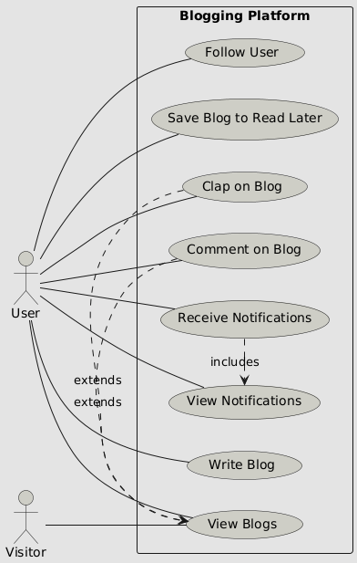

4.2 Sequence diagram
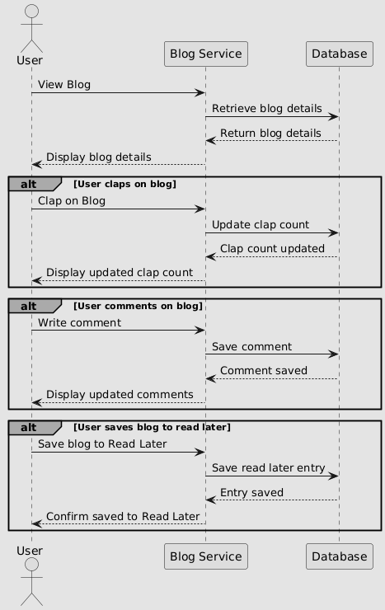

4.3 Activity diagram
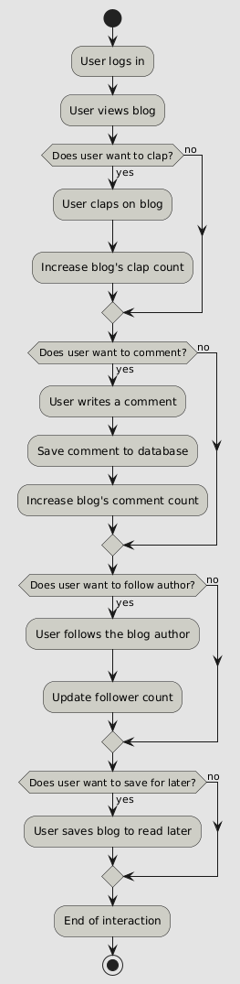

4.4 ERD
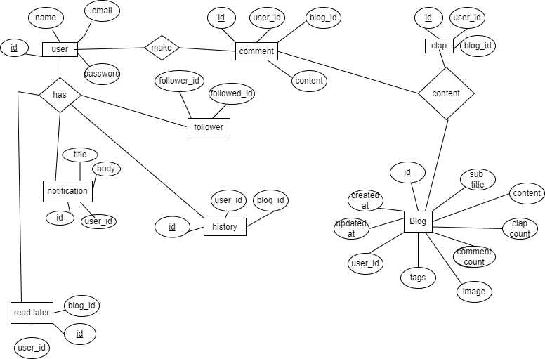

4.5 Class diagram

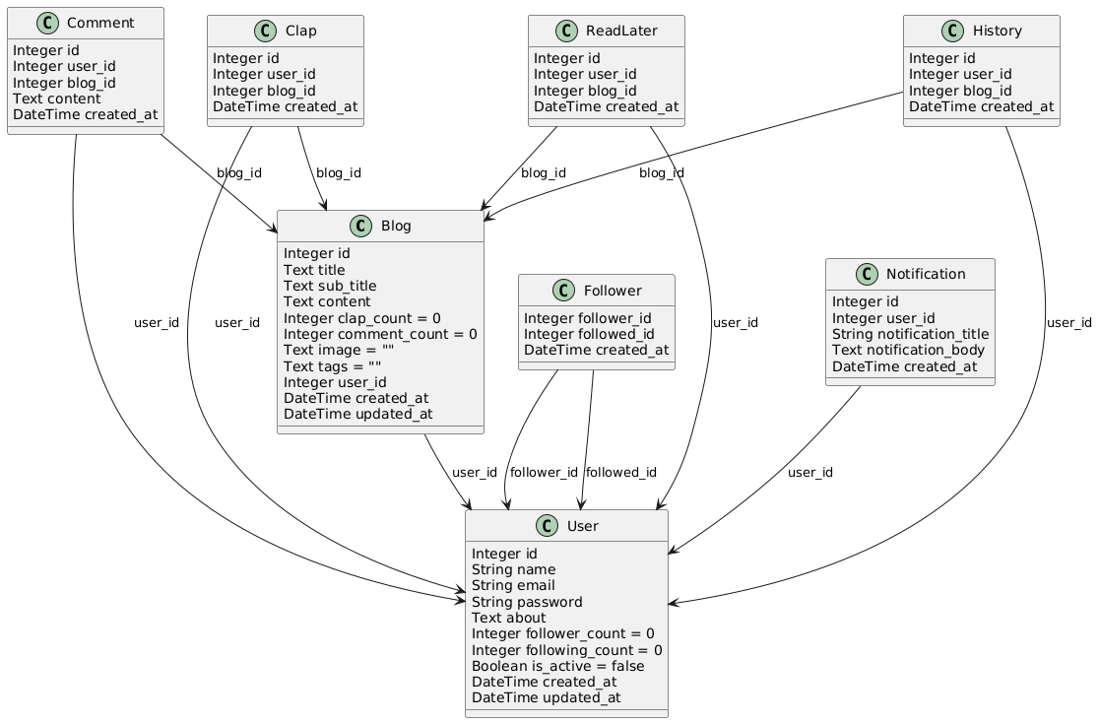

4.6 Object diagram
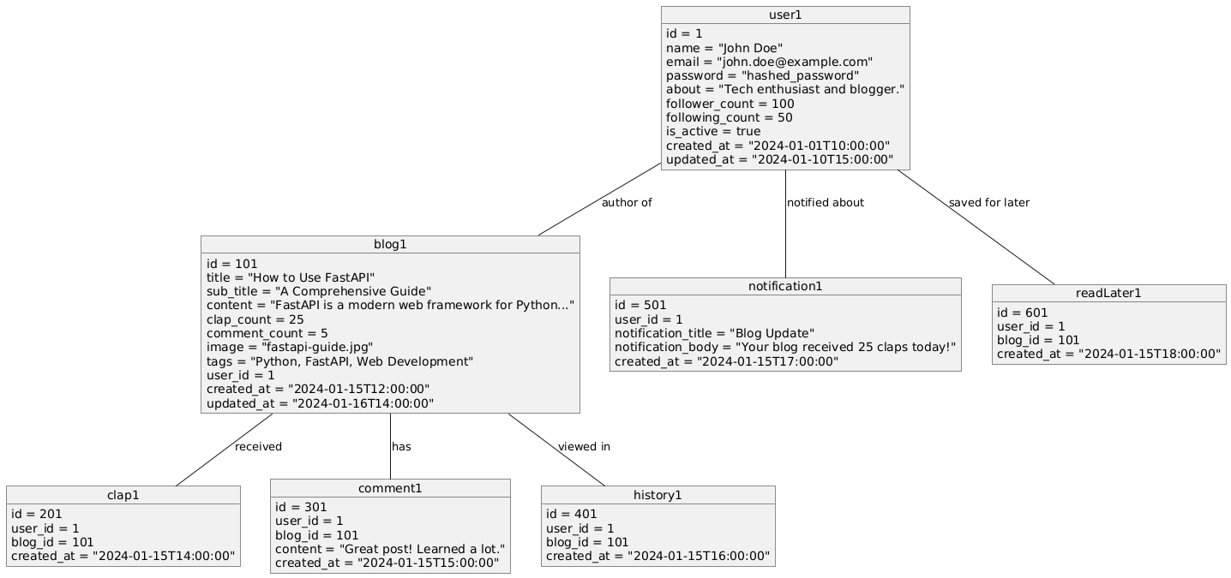

4.7 Sitemap
- Home
  - Foryou
  - Following
  - Trending
  - Readlater

- Write
- Notification
- Profile
- Reports
  - User report
  - Blog report
  - Clap and Comment report
- Push notification

Chapter 5: User manual

5.1 User manual
The user manual provides detailed instructions for end users, administrators, and other stakeholders to interact effectively with the system. It ensures that users can navigate the platform's features seamlessly.
End User Guide
Creating an Account
Visit the platform's home page and click on the Sign-Up button.
Fill in the required details, including name, email, and password.
Verify the account via the confirmation email sent to your registered email address.

Logging In
Enter your registered email and password on the Login page.
Click Login to access your personalized dashboard.

Writing and Publishing Blogs
Navigate to the Write section.
Enter the title, subtitle, content, and tags for the blog.
Optionally, upload an image to enhance the blog’s appeal.
Click Publish to make your blog live.

Interacting with Blogs
Read blogs under categories such as Trending, For You, or Following.
Click the Clap button to appreciate a blog.
Leave a comment using the Comment section.
Save a blog to the Read Later tab for future reading.

Managing Your Profile
Go to the Profile page to edit details such as name, email, and bio.
View your published blogs and follower/following count here.

Receiving Notifications
Check the Notifications tab to stay updated on claps, comments, and other interactions with your blogs.

Admin User Guide
Managing Users
Access the Admin Dashboard.
View, activate, or deactivate user accounts as necessary.

Generating Reports
Navigate to the Reports section to generate and download data on user engagement, blogs, and platform usage.

Chapter 6: Drawbacks and limitations

Despite the numerous benefits and features of the proposed system, there are some drawbacks and limitations that must be acknowledged. These limitations can serve as a guide for future improvements and enhancements.

6.1 Technical Limitations
Scalability Constraints:
- While the system can handle a moderate number of users, a sudden spike in user traffic might require significant infrastructure scaling.

Real-Time Processing Challenges:
- Notifications and recommendations may not always update in real time during peak loads due to server limitations.

Cross-Platform Optimization:
- Ensuring compatibility across all browsers and mobile devices may result in some inconsistencies in the user interface.

6.2 Functional Limitations

Simplistic Editor Features:
- The text editor lacks advanced formatting tools like Markdown support, collaboration features, or real-time grammar checks.

Limited Personalization:
- Recommendations rely on basic algorithms and may not fully adapt to complex user behaviors or preferences.

Dependency on Stable Internet:
The platform's functionality depends on a stable internet connection, which might restrict users in areas with poor connectivity.

6.3 User-Centric Limitations

Steep Learning Curve for Non-Tech Users:
- New users unfamiliar with digital blogging platforms might take time to adapt to the system.

No Offline Mode:
- Users cannot draft or access blogs offline, which limits usability for those without continuous internet access.

Lack of Advanced Analytics for Users:
- Users may not have access to detailed insights about their blogs' performance beyond basic metrics like claps and views.

6.4 Security Limitations

Data Breach Risks:
- Although basic security measures are in place, advanced cyberattacks could still pose a threat to sensitive user information.

Authentication Flaws:
- Current token-based authentication might need more robust mechanisms to prevent unauthorized access or session hijacking.

6.5 Maintenance and Upgrades

Cost of Maintenance:
- Regular server upgrades and dependency management can increase operational costs over time.

Dependency on Third-Party Tools:
The system relies on third-party tools (e.g., Redis, FastAPI, and React), which might face versioning issues or deprecation.

Chapter 7: Proposed enhancement

To overcome the limitations and drawbacks identified in the previous chapter, the following enhancements are proposed for future iterations of the system. These improvements aim to increase functionality, user satisfaction, and system performance while maintaining scalability and reliability.

Enhanced User Experience
Advanced Text Editor:
Integrate features such as Markdown support, real-time collaboration, grammar and spelling suggestions, and an autosave option.

Responsive and Interactive UI:
Enhance the user interface with modern design principles to ensure a seamless experience across devices, including desktop, tablet, and mobile platforms.

Offline Mode:
Implement offline capabilities, allowing users to draft, edit, and view blogs without an active internet connection.

Improved Personalization
AI-Powered Recommendations:
Upgrade the recommendation engine to utilize advanced machine learning algorithms, including natural language processing and deep learning, for highly personalized blog suggestions.

Behavioral Insights:
Analyze detailed user behaviors such as time spent on blogs, scroll depth, and interaction history to refine content recommendations.

Scalability and Performance
Cloud-Based Architecture:
Transition to a cloud-based infrastructure for auto-scaling to handle traffic surges effectively.

Optimized Real-Time Notifications:
Improve notification delivery with real-time updates using WebSockets or server-sent events (SSE).

Enhanced Caching Mechanisms:
Leverage advanced caching strategies with tools like Redis to optimize load times and reduce server strain.

Advanced Analytics for Users
Detailed Blog Metrics:
Provide authors with comprehensive insights into blog performance, such as audience demographics, peak reading times, and traffic sources.

Engagement Trends:
Include visual dashboards to display engagement trends over time (views, claps, and comments).
Robust Security Enhancements
Multi-Factor Authentication (MFA):
Introduce MFA to ensure secure user logins.

Data Encryption:
Encrypt sensitive user data both in transit and at rest to prevent unauthorized access.

Proactive Threat Detection:
Implement intrusion detection systems to identify and respond to potential security breaches in real time.

Accessibility Improvements
WCAG Compliance:
Ensure the platform adheres to Web Content Accessibility Guidelines (WCAG) for users with disabilities, such as screen reader support and keyboard navigation.

Multi-Language Support:
Add localization features to make the platform accessible to a global audience.

Developer-Focused Enhancements
API Expansion:
Develop additional APIs to allow integration with third-party tools and platforms.

Modular Codebase:
Refactor the codebase for easier maintenance and addition of new features.

Automated Testing:
Implement automated testing frameworks to ensure code quality and reduce the likelihood of bugs during deployment.

Chapter 8: Conclusion

The development and implementation of the proposed system have addressed key challenges in the blogging domain, such as providing a better user interface, enhanced personalization, and improved functionality. By combining modern technologies with thoughtful design principles, the system has successfully created a platform that meets user needs for seamless blog creation, interaction, and engagement.

Achievements

User-Focused Features:
The platform offers an intuitive interface, a robust text editor, personalized recommendations, and engaging tools like notifications and metrics dashboards.

Scalability and Reliability:
The architecture supports a growing user base with cloud-enabled scalability and high performance.

Secure and Accessible:
Advanced security measures and adherence to accessibility standards ensure inclusivity and user data protection.

Impact

Enhanced Blogging Experience:
Writers can easily create, publish, and track their blogs, while readers enjoy curated content tailored to their interests.

Community Growth:
The platform fosters interaction and engagement, encouraging a vibrant community of writers and readers.

Chapter 9: Bibliography

- Books
  - Sommerville, Ian. Software Engineering (10th Edition). Pearson Education, 2015.
  - Pressman, Roger S. Software Engineering: A Practitioner's Approach (8th Edition). McGraw Hill Education, 2014.

- Research Papers
  - Smith, John, and Brown, Emily. "User Interface Design for Blogging Platforms: A Comparative Study." Journal of Web Development Research, 2020.
  - Chen, Wei, et al. "Personalized Recommendation Systems Using Machine Learning." IEEE Transactions on Knowledge and Data Engineering, 2021.

- Websites
  - W3Schools. "HTML, CSS, and JavaScript Tutorials." Available at: https://www.w3schools.com
  - FastAPI Documentation. Available at: https://fastapi.tiangolo.com
  - React Official Documentation. Available at: https://reactjs.org

- Tools and Technologies
  - MySQL Database. Available at: https://www.mysql.com
  - Python Programming Language. Available at: https://www.python.org
  - Visual Studio Code IDE. Available at: https://code.visualstudio.com

- Additional Resources
  - GeeksforGeeks. "Understanding Blogging Platforms and Features." Available at: https://www.geeksforgeeks.org
  - Medium Engineering Blog. "How Personalized Recommendations Drive Engagement." Available at: https://medium.com

Chapter 10: Annexure

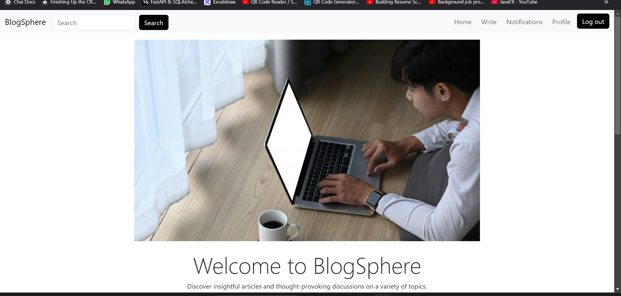
10.1 UI screens

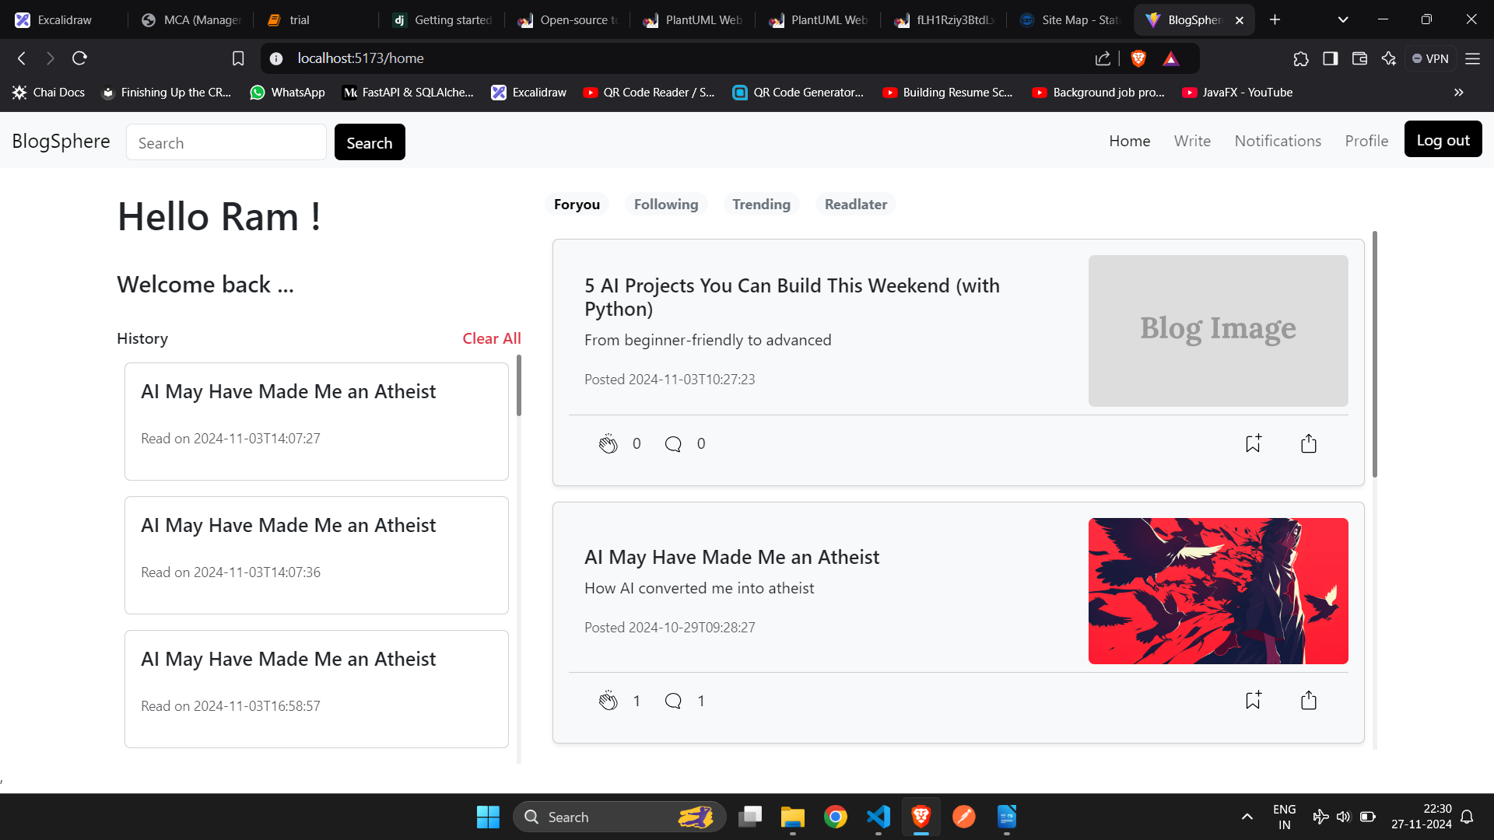

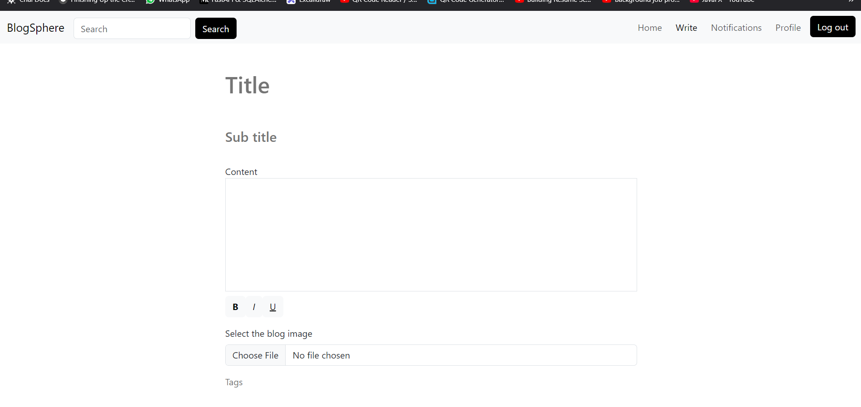
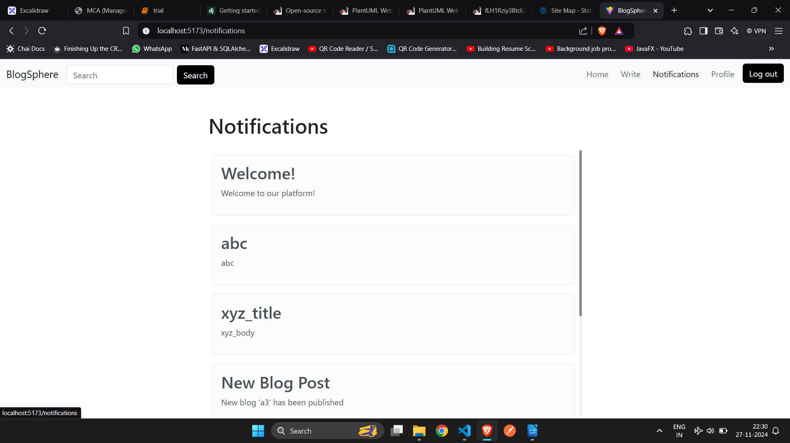

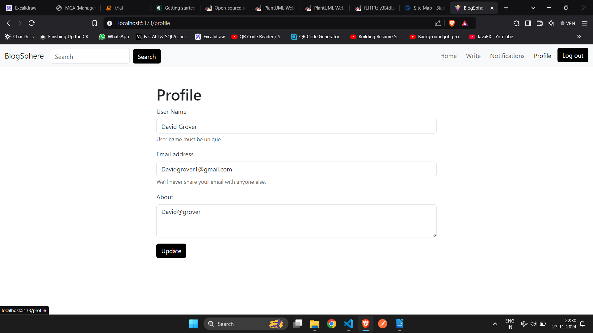

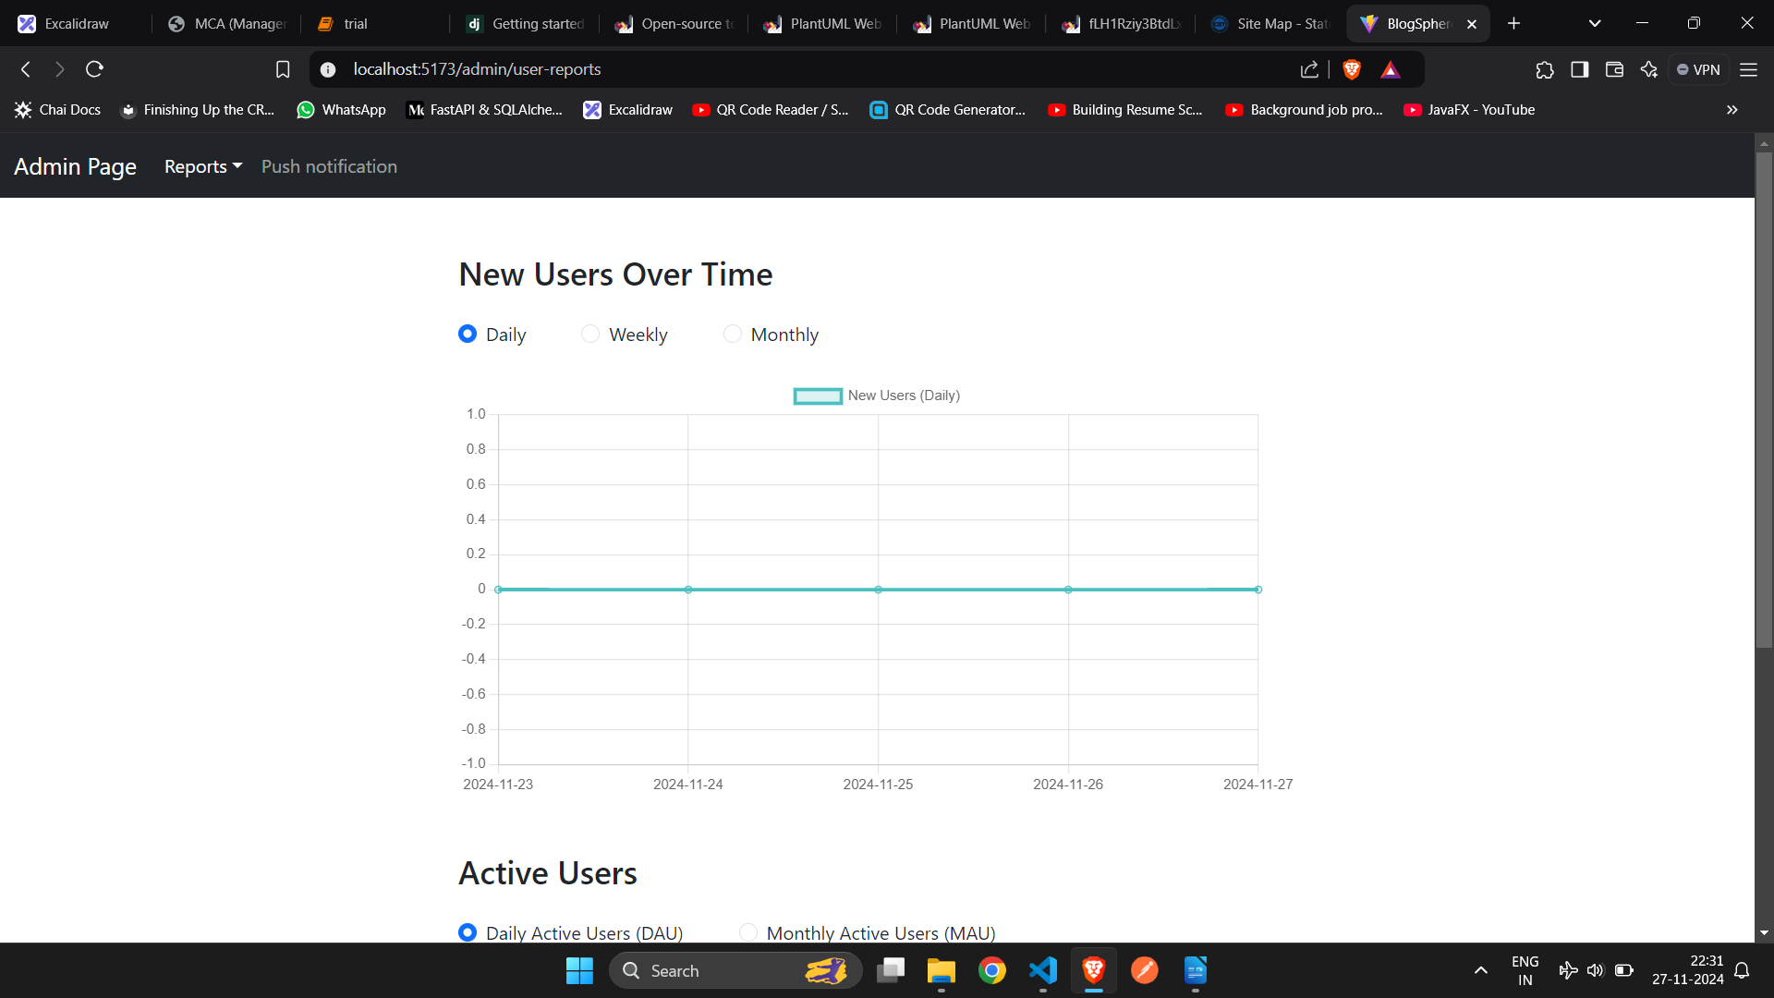

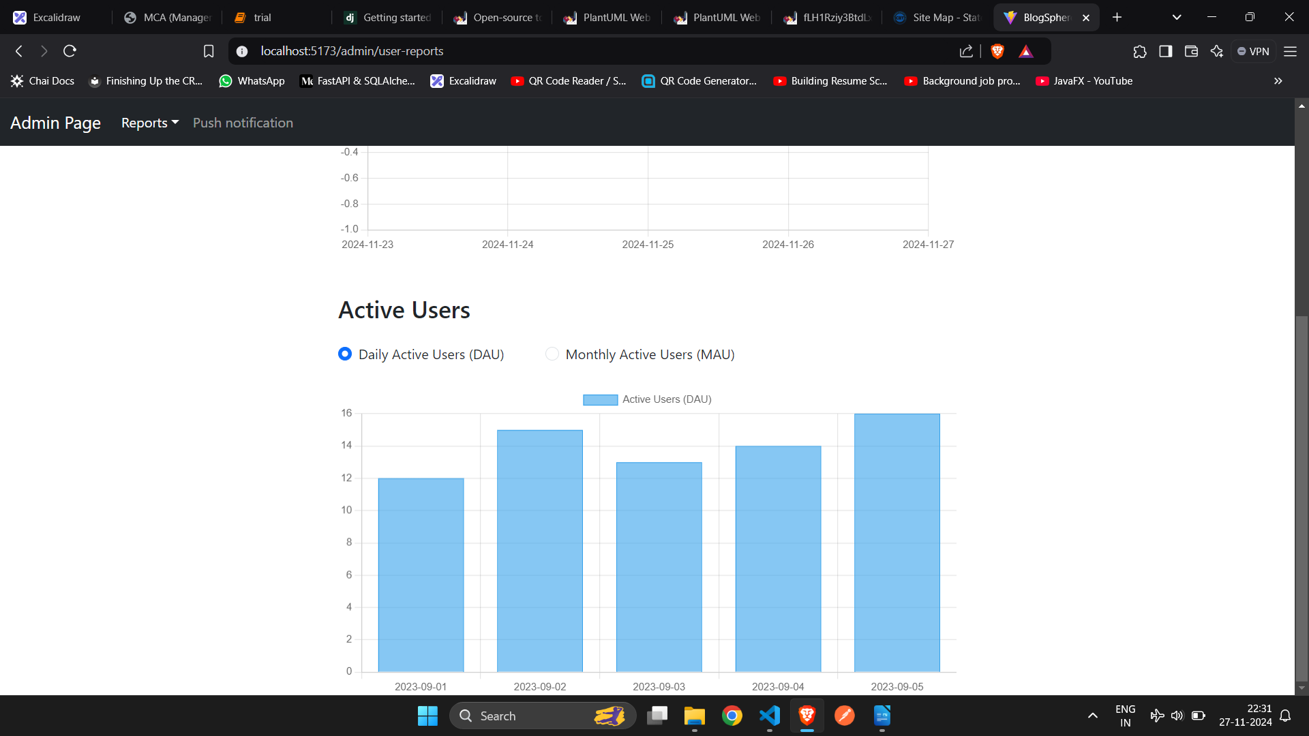

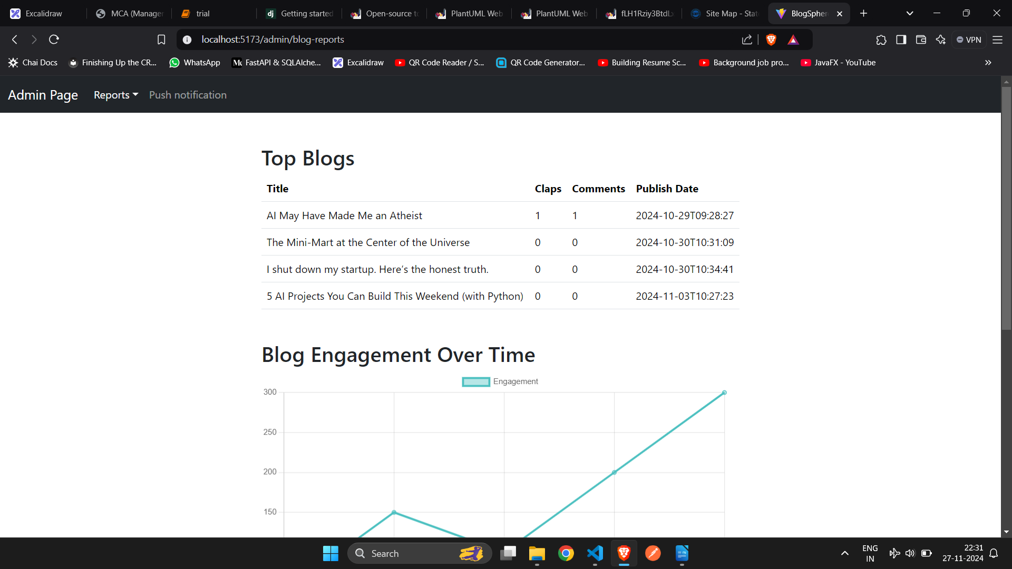

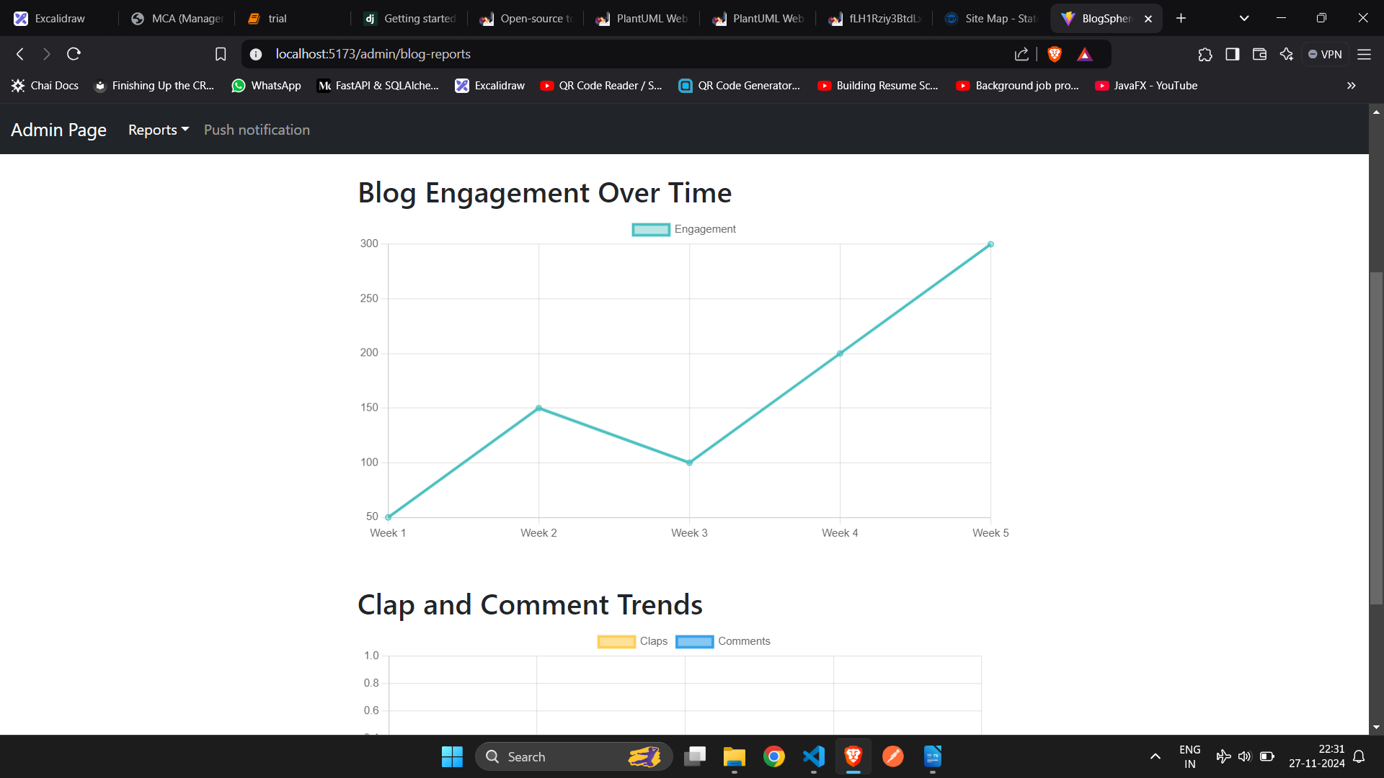

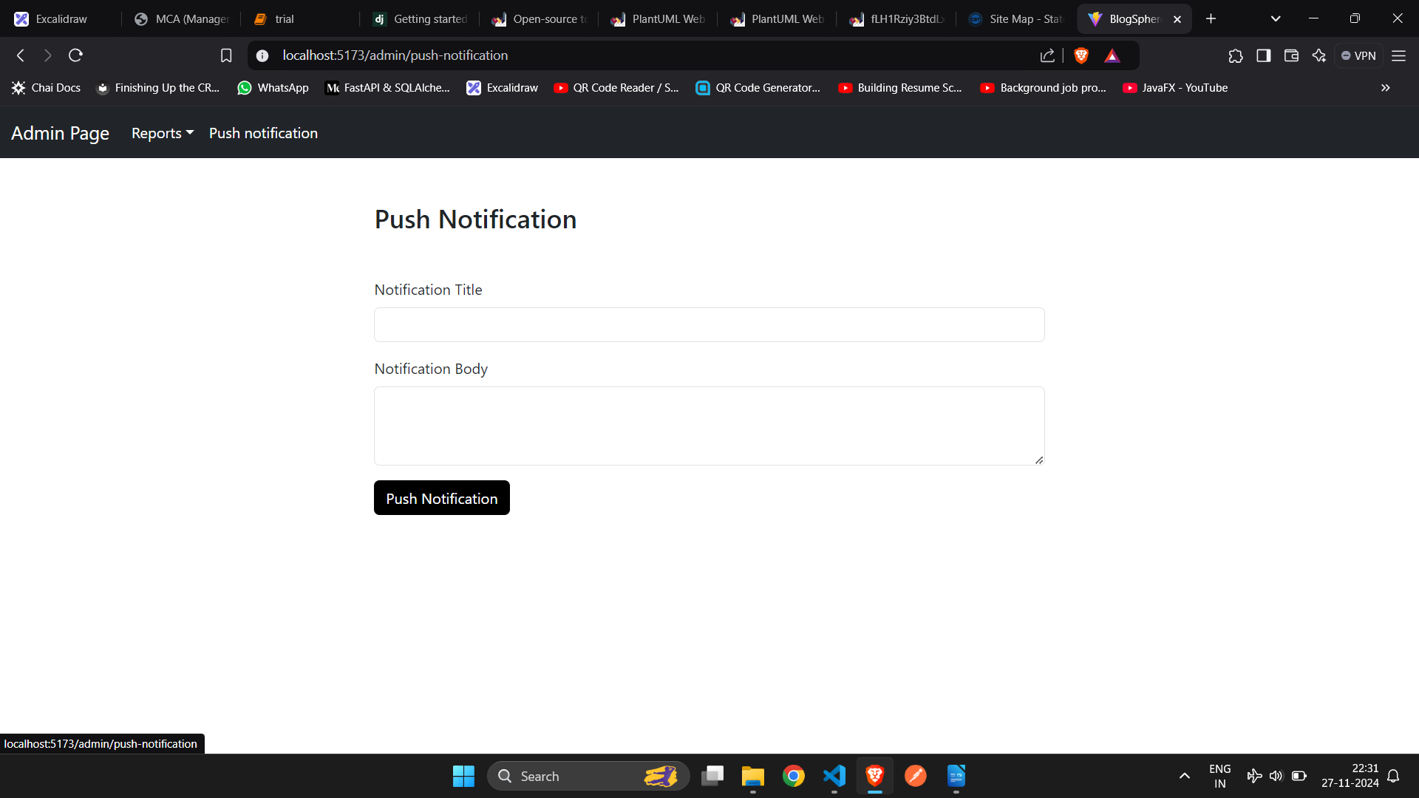

10.2 Program code

from ..schemas import clap as schemas
from ..models import clap as models
from ..models import blog
from sqlalchemy.orm import Session
from ..utilities.token import get_current_user
from sqlalchemy import and_

def create_clap(db: Session, clap: schemas.ClapCreate, token: str):
decoded_token = get_current_user(token)
exisiting_clap = (
db.query(models.Clap)
.filter(
and_(
models.Clap.blog_id == clap.blog_id,
models.Clap.user_id == decoded_token["id"],
)
)
.first()
)

if exisiting_clap:
return exisiting_clap

db_clap = models.Clap(
user_id=decoded_token["id"],
blog_id=clap.blog_id,
)

db_blog = db.query(blog.Blog).filter(blog.Blog.id == clap.blog_id).first()

if db_blog:
db_blog.clap_count += 1
db.add(db_clap)
db.commit()
db.refresh(db_clap)
db.refresh(db_blog)

return db_clap

def remove_clap(db: Session, clap_id: int):
db_clap = db.query(models.Clap).filter(models.Clap.id == clap_id).first()

if db_clap is None:
return None

db_blog = db.query(blog.Blog).filter(blog.Blog.id == db_clap.blog_id).first()

if db_blog:
db_blog.clap_count -= 1
db.add(db_blog)

db.delete(db_clap)
db.commit()
return {"msg": "Clap deleted successfully"}

