**SYSTEM SURVEILLANCE USING KEYLOGGER**

**A PROJECT REPORT**

***Submittedby***

# NAME OF THE CANDIDATE

PRAJWAL S BABANGOL

# BACHELOR OF ENGINEERING

COMPUTER SCIENCE(IOT AND CYBER SECURITY INCLUDING BLOCKCHAIN TECHNOLOGY)

ABSTRACT

In many companies now-a-days data security and data recovery is the most important factor. So there are many cases where data recovery is required. For these kinds of problems keylogger is one of the best solutions which is often referred to as keylogging or keyboard capturing.

Keyboard capturing is the action of recording the keys stroke on a keyboard, typically covertly, so that the person using the keyboard is unaware that their actions are being monitored. Using keylogger application users can retrieve data when working file is damaged due to several reasons like loss of power etc.

This is a surveillance application used to track the users which logs keystrokes; uses log files to retrieve information. Using this application we can recall forgotten email or URL. In this keylogger project, whenever the user types something through the keyboard, the keystrokes are captured and mailed to the mail id of admin without the knowledge of the user within the time set.

**OBJECTIVE:**

The purpose of this application is to keep tracks on every key that is typed through the keyboard and send it to the admin through the mail server in the time set or given. It provides confidentiality as well as data recovery to all the IT infrastructures in need.

**HARDWARE REQUIREMENTS:**

**Operating system** : Windows and Linux specified

**RAM** : 512MB (minimum requirement)

**Hard Disk** : 1GB working space (minimum requirement)

**SOFTWARE REQUIREMENTS:**

**Languages**  : Python

**Tools**  : PyCharm, Python 3.8.0

**Technology**  : Advanced programming using Python

**TABLE OF CONTENTS**

1.0. Introduction .............................................................................................................. 1

1.1. Purpose ................................................................................................................. 1

1. 2.Scope of Developing the project ............................................................................. 2
2. 0.Problem Identification ............................................................................................... 3
   1. Project Function.......................................................................................................3
   2. Operating Environment............................................................................................3
   3. Features................................................................................................................ 4
3. 0.Code Implementation and testing .............................................................................. 5
4. 0.Output ..................................................................................................................... 11

5.0. Conclusion and Future Work …………………………………………………….....14

6.0. Bibliography…………………………………………………………………………14

7.0 External References……………………………………………………………….….14

**1. Introduction**

In many IT infrastructure organizations now-a-days, data security and data recovery are the most important factors which is basically deployed in Computer Forensics. Computer forensics consists of the art of examining digital media to preserve, recover and analyze the data in an effective manner. There are many cases where data recovery is required essentially. So by using keylogger application users can retrieve data in the time of disaster and damaging of working file due to loss of power etc. Keyloggers are specially effective in monitoring ongoing crimes. This is a surveillance application used to track the users which log keystrokes, uses log files to retrieve information, capture a record of all typed keys. The collected information is saved on the system as a hidden file or emailed to the Admin or the forensic analyst.

**1.1. Purpose**

The main objective of this document is to illustrate the requirements of the project Keylogger. Nowa-days IT business infrastructures are mostly in need of the cyber security factor that is Computer Forensics. Keyloggers can effectively assist a computer forensics analyst in the examination of digital media.

Keystroke loggers are available in software and hardware form, and are used to capture and compile a record of all typed keys. The information gathered from a keystroke logger can be saved on the system as a hidden file, or emailed to the forensic analyst or the Administrator. Generic keystroke loggers typically record the keystrokes associated with the keyboard typing. Advanced keystroke loggers have many additional features. Our project keylogger has the following features;

* + - Monitors Keystrokes
    - Sends mail to the Admin’s mail Id
    - Logs keystrokes including special keys

Keyloggers have the advantage of collecting information before it is encrypted; thus making a forensic analyst’s job easier. Most keyloggers show no signs of any intrusion within the system allowing for them to gain typed information without anyone having knowledge of its actions except the user who use it. Keyloggers incorporate a wide array of cyber security issues and provide a practical approach to understand topics such as attacker goals, varieties of malware and their implementation, the role of malware in infecting and how stealth is archived in an infected system.

* + - **Programming Environment:**

* + 1. Python 3.8.0
    2. PyCharm

• **Program Files Used:**

* + 1. Keylogger.py
    2. Execute_keylogger.py

• **Document Conventions**

* + - Entire document should be justified.
    - Convention for Main title
      * Font face: Times New Roman
      * Font style: Bold
      * Font Size: 14

➢ Convention for Sub title

* + - * Font face: Times New Roman
      * Font style: Bold
      * Font Size: 12

➢ Convention for body

* + - * Font face: Times New Roman
      * Font Size: 12

**1.2. Scope of Developing the Project**

Keylogger is basically using keystroke logs to monitor the system and send the details to the admin through the mail server.Keyloggerss provide the best solutions in case of such cases like; IT organizations can indicate their concerns by going after the culprit whose performance is deteriorating that of the whole organization, parents can maintain a check on their children’s activities, a particular person’s activities can be monitored, storing passwords of various social media profiles. Above all, keylogger is one of the best implementation of fundamentals of ethical hacking. By using this some measures could be done accordingly that would save personal data from being in the hands of total strangers.

### Fig 1.2 Increased use of keylogger

**2. Problem Identification**

Hackers and other third parties are always looking for the vulnerabilities present inside the system. To gain knowledge about what they require from the organizations, they either gain access to the confidential data stored in the system and either cause harm to the integrity of data or may cause data loss. Another problem is that cyber crimes are increasing day by day. If we will have the chat logs or keystroke logs of victim’s laptop then we can easily analyze the entire planning of the victim which will provide the best solution to eradicate or solve the problem.

**2.1.Project Function:**

Authorized use of a keylogger is use of such software with the knowledge and consent of the PC Owner or security administrator. As a rule, authorized monitoring software products require physical access to computer and administrative privilege for configuration and installation that excludes (or at least minimizes) risks of unauthorized use of programs. As per the rule, such software products have ability to obtain and configure a “packed” installation executable file that is delivered to the user’s computer with the help of various ethical and authorized schemes. During installation it doesn’t display any messages or create any windows on the screen.

1. **2.Operating Environment:**

The product will be operating in windows, Linux environment. The hardware configuration include Hard Disk: 40 GB, Monitor: 15” Color monitor, Keyboard: 122 keys. The basic input devices required are keyboard, mouse and output devices are monitor, mobile devices etc.

**2.3. Features:**

Features of designed keylogger that are implemented and are going to be implemented in thisproject;

* + - Keystroke Recording
    - Remote Monitoring
    - Web History logging
    - Screenshot History
    - Invisible mode & password protection
    - Application monitoring and file tracking
    - Email reports

* + - **Modules used:**
  1. **Smtplib:**The module included in python defines an SMTP client session object that can be used to send mail to any internet machine with an SMTP listener daemon.
  2. **Threading:**It is one of the modules provided with python includes a simple-to-implement locking mechanism that allows you to synchronize threads.
  3. **Pynput:**This library allows the users to control and monitor input devices. e.g.; pynput.mouse, pynput.keyboard.

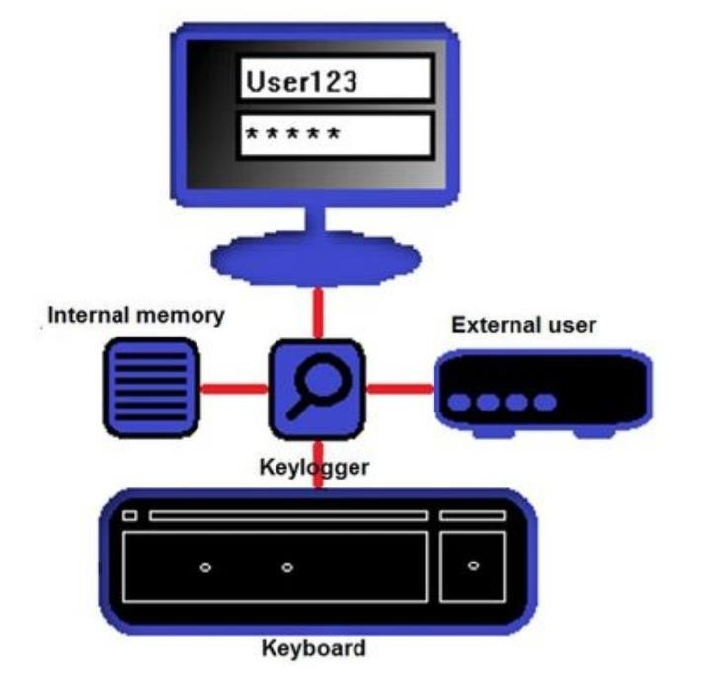

1. **Code Implementation AND Testing:**

### Fig 3.1

### 

### Fig 3.2

### 

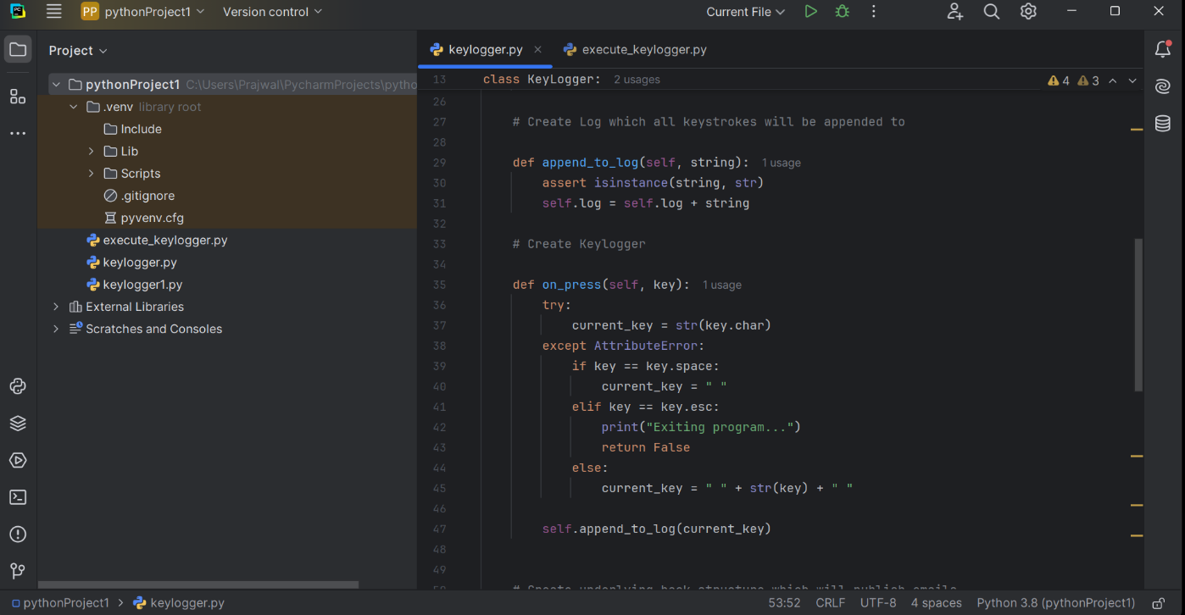

### Fig 3.3

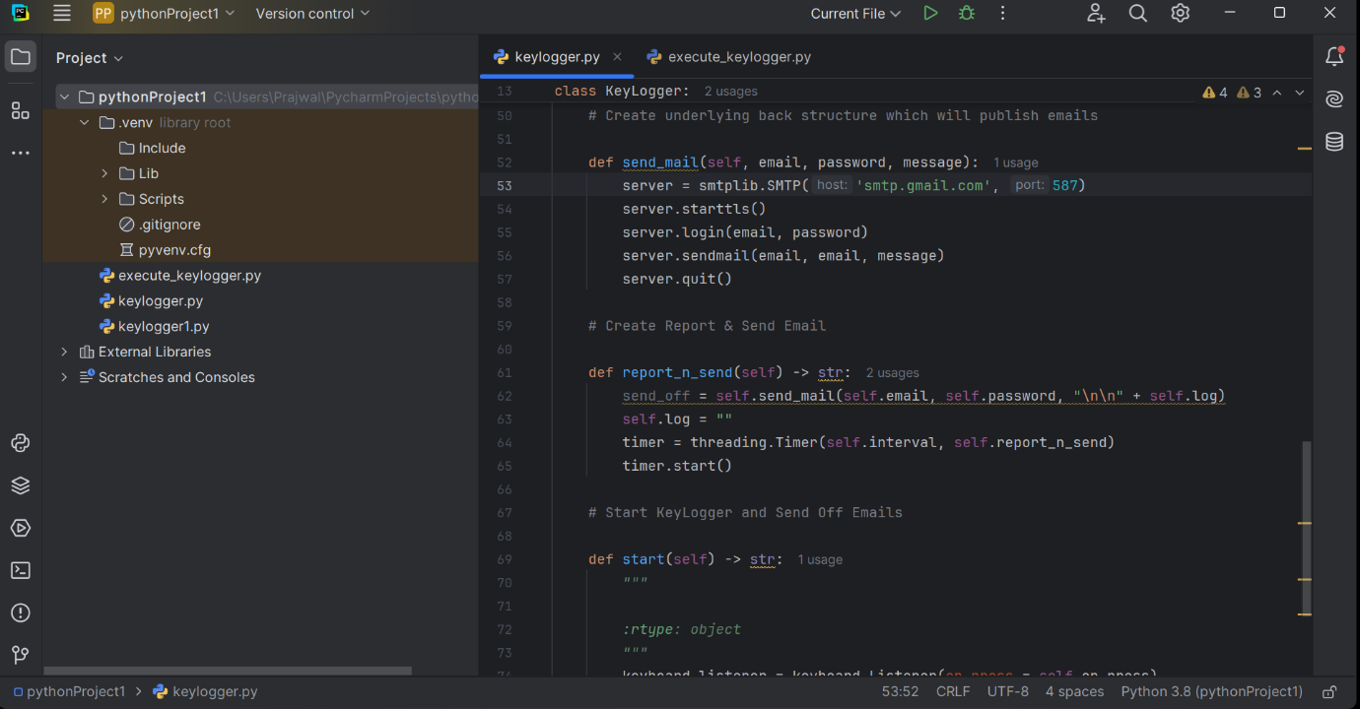

### Fig 3.4

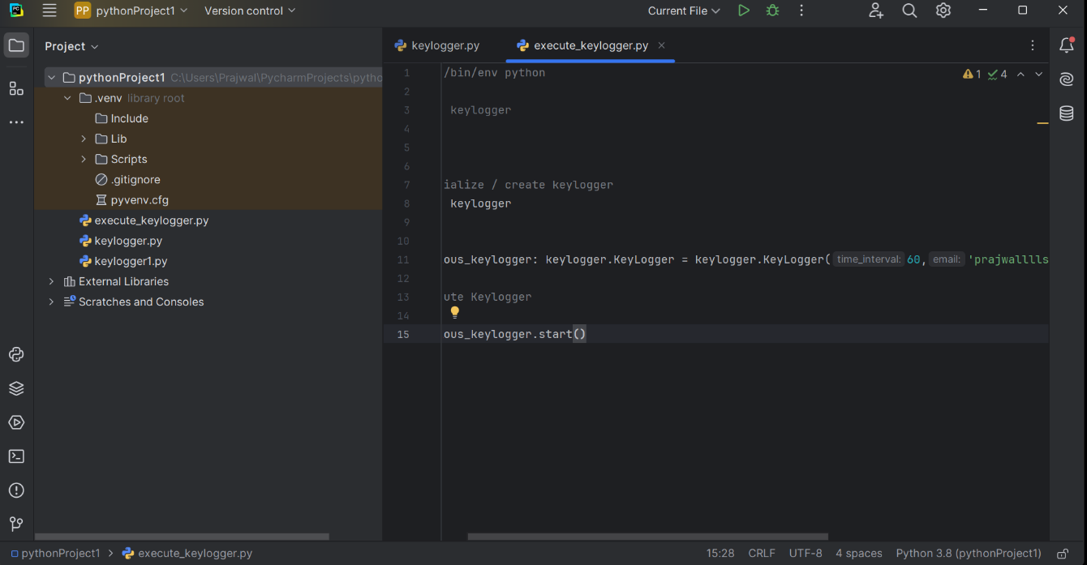

### Fig 3.5

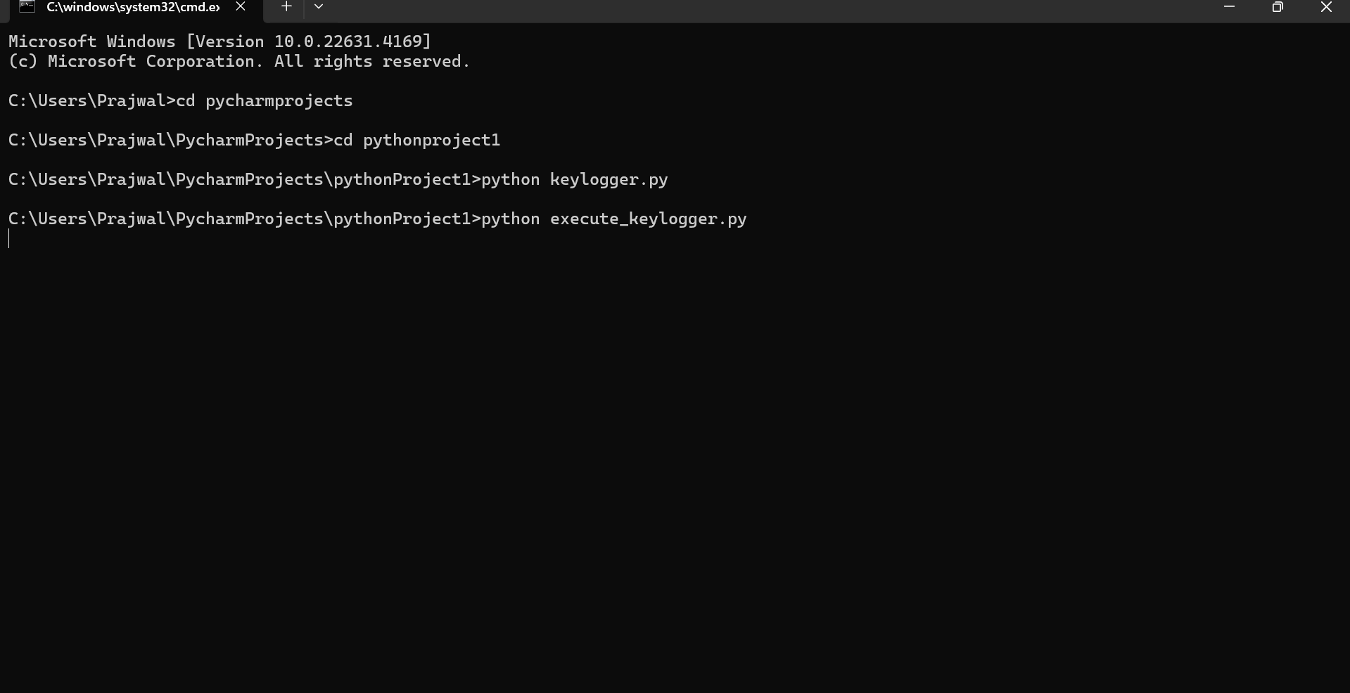

Fig 3.6



1. **OUTPUT:**

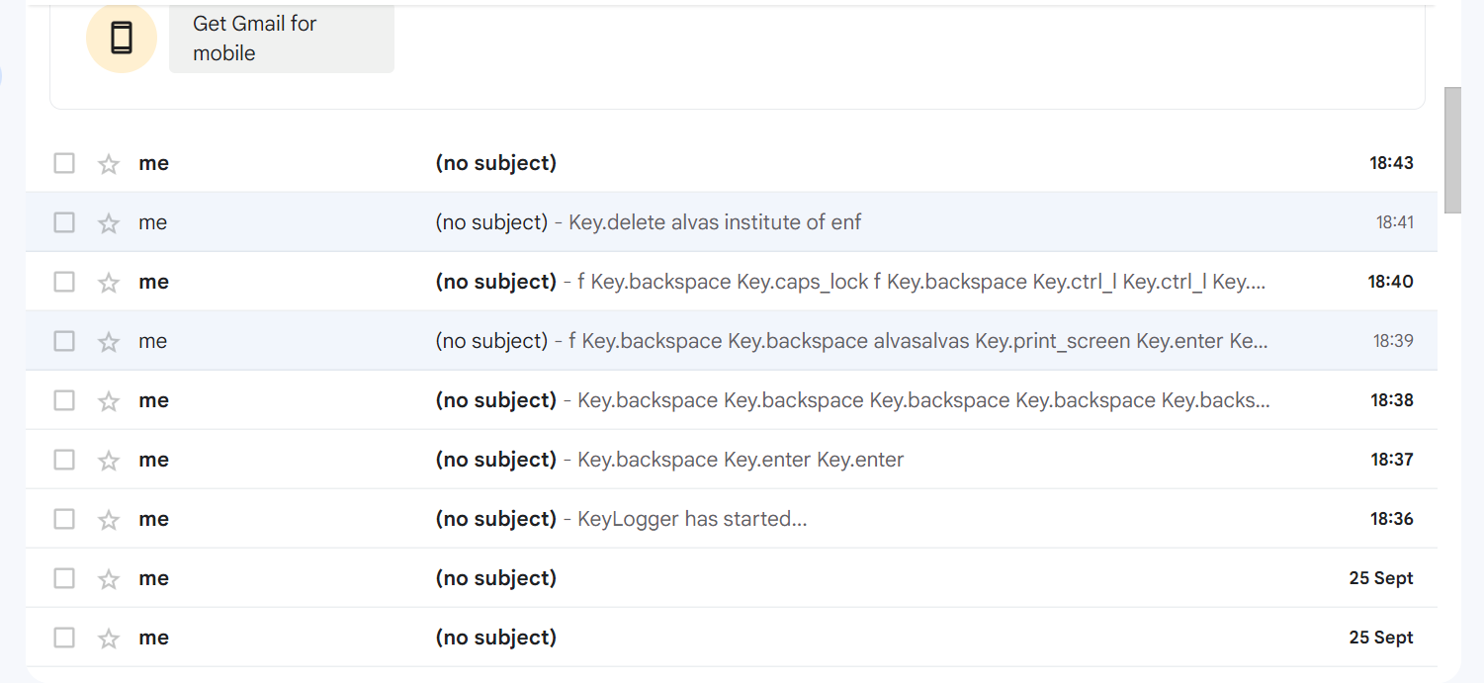

1. **Conclusion and Future Work:**

A Keylogger is a form of software which is used to track or log the all the keys that a user strikes on their keyboard, usually in secret so that the user of the system doesn’t know that their actions are being monitored. It is otherwise known as keyboard capturer. These are perfectly legal and useful. They can be installed by employers to oversee the use of their computers, meaning that the employees have to complete their tasks instead of procrastinating on social media. Some of the possible amendments and improvements in this project are;

* + Adding screenshots of pages visited
  + Recording of system screen
  + Full remote cloud monitoring
  + Screenshot of immediately changed pages
  + Secure web account for data storing
  + Password Protection
  + Parental Control

1. **Bibliography:**

For the all the knowledge and experience that we gained while doing this project, we Sukanya Mohanty, Chinmayeemoti Sahoo and Sahil Ali Khan would like to thank my project guide Mr. Bharat Kumar Padhifor his support and help during the semester period .

At last but not the least I would like to give my gratitude to my mentor and my lecturer for their support during internship and my friends for their help and moral support.