Given Challenge:
Tech challenge SDET
Instructions :
• Use Python and a test framework (e.g., Robot Framework, pytest, unittest).
• Test the public API: https://jsonplaceholder.typicode.com/posts
• Validate important parts of API.
• Add one negative test.
• Structure your test suite for maintainability.
• Include a README with setup instructions.
Basic Requirements :
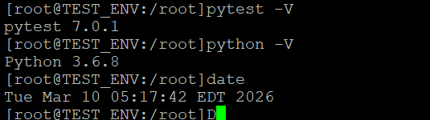
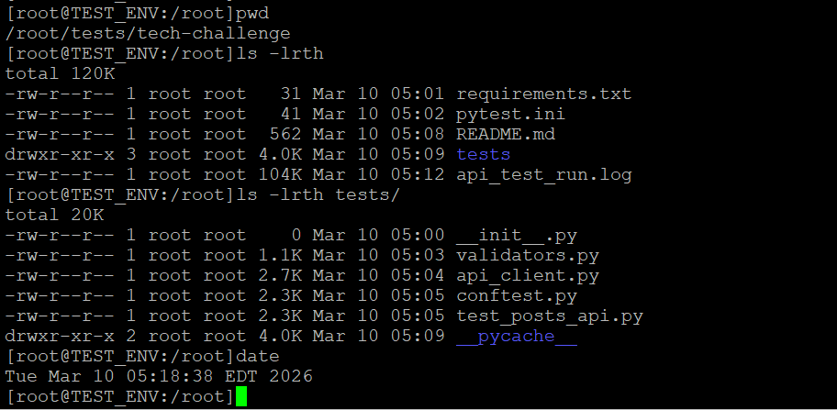
[root@TEST_ENV:/root]pytest -vv -s
==================================================================== test session starts ====================================================================
platform linux -- Python 3.6.8, pytest-7.0.1, pluggy-1.0.0 -- /usr/bin/python3
cachedir: .pytest_cache
rootdir: /root/tests/tech-challenge, configfile: pytest.ini, testpaths: tests
collected 8 items

tests/test_posts_api.py::test_get_posts_returns_200_and_json 2026-03-10 05:12:56 | INFO | ==========================================================================================
2026-03-10 05:12:56 | INFO | TEST RUN START (UTC): 2026-03-10 09:12:56Z
2026-03-10 05:12:56 | INFO | Working dir: /root/tests/tech-challenge
2026-03-10 05:12:56 | INFO | Log file : /root/tests/tech-challenge/api_test_run.log
2026-03-10 05:12:56 | INFO | ==========================================================================================
2026-03-10 05:12:56 | INFO | --- TEST START: test_get_posts_returns_200_and_json ---
2026-03-10 05:12:56 | INFO | REQUEST | GET https://jsonplaceholder.typicode.com/posts | params=None
2026-03-10 05:12:56 | INFO | RESPONSE | status=200 | latency_ms=36.47 | content-type=application/json; charset=utf-8
2026-03-10 05:12:56 | INFO | BODY (json) PREVIEW | total_items=100 | showing_first=3
2026-03-10 05:12:56 | INFO | BODY (json) PREVIEW:
[
{
"userId": 1,
"id": 1,
"title": "sunt aut facere repellat provident occaecati excepturi optio reprehenderit",
"body": "quia et suscipit\nsuscipit recusandae consequuntur expedita et cum\nreprehenderit molestiae ut ut quas totam\nnostrum rerum est autem sunt rem eveniet architecto"
},
{
"userId": 1,
"id": 2,
"title": "qui est esse",
"body": "est rerum tempore vitae\nsequi sint nihil reprehenderit dolor beatae ea dolores neque\nfugiat blanditiis voluptate porro vel nihil molestiae ut reiciendis\nqui aperiam non debitis possimus qui neque nisi nulla"
},
{
"userId": 1,
"id": 3,
"title": "ea molestias quasi exercitationem repellat qui ipsa sit aut",
"body": "et iusto sed quo iure\nvoluptatem occaecati omnis eligendi aut ad\nvoluptatem doloribus vel accusantium quis pariatur\nmolestiae porro eius odio et labore et velit aut"
}
]
PASSED2026-03-10 05:12:56 | INFO | --- TEST END : test_get_posts_returns_200_and_json ---

tests/test_posts_api.py::test_get_posts_returns_list_and_has_data 2026-03-10 05:12:56 | INFO | --- TEST START: test_get_posts_returns_list_and_has_data ---
2026-03-10 05:12:56 | INFO | REQUEST | GET https://jsonplaceholder.typicode.com/posts | params=None
2026-03-10 05:12:56 | INFO | RESPONSE | status=200 | latency_ms=9.75 | content-type=application/json; charset=utf-8
2026-03-10 05:12:56 | INFO | BODY (json) PREVIEW | total_items=100 | showing_first=3
2026-03-10 05:12:56 | INFO | BODY (json) PREVIEW:
[
{
"userId": 1,
"id": 1,
"title": "sunt aut facere repellat provident occaecati excepturi optio reprehenderit",
"body": "quia et suscipit\nsuscipit recusandae consequuntur expedita et cum\nreprehenderit molestiae ut ut quas totam\nnostrum rerum est autem sunt rem eveniet architecto"
},
{
"userId": 1,
"id": 2,
"title": "qui est esse",
"body": "est rerum tempore vitae\nsequi sint nihil reprehenderit dolor beatae ea dolores neque\nfugiat blanditiis voluptate porro vel nihil molestiae ut reiciendis\nqui aperiam non debitis possimus qui neque nisi nulla"
},
{
"userId": 1,
"id": 3,
"title": "ea molestias quasi exercitationem repellat qui ipsa sit aut",
"body": "et iusto sed quo iure\nvoluptatem occaecati omnis eligendi aut ad\nvoluptatem doloribus vel accusantium quis pariatur\nmolestiae porro eius odio et labore et velit aut"
}
]
PASSED2026-03-10 05:12:56 | INFO | --- TEST END : test_get_posts_returns_list_and_has_data ---

tests/test_posts_api.py::test_posts_schema_and_types_for_sample 2026-03-10 05:12:56 | INFO | --- TEST START: test_posts_schema_and_types_for_sample ---
2026-03-10 05:12:56 | INFO | REQUEST | GET https://jsonplaceholder.typicode.com/posts | params=None
2026-03-10 05:12:56 | INFO | RESPONSE | status=200 | latency_ms=8.49 | content-type=application/json; charset=utf-8
2026-03-10 05:12:56 | INFO | BODY (json) PREVIEW | total_items=100 | showing_first=3
2026-03-10 05:12:56 | INFO | BODY (json) PREVIEW:
[
{
"userId": 1,
"id": 1,
"title": "sunt aut facere repellat provident occaecati excepturi optio reprehenderit",
"body": "quia et suscipit\nsuscipit recusandae consequuntur expedita et cum\nreprehenderit molestiae ut ut quas totam\nnostrum rerum est autem sunt rem eveniet architecto"
},
{
"userId": 1,
"id": 2,
"title": "qui est esse",
"body": "est rerum tempore vitae\nsequi sint nihil reprehenderit dolor beatae ea dolores neque\nfugiat blanditiis voluptate porro vel nihil molestiae ut reiciendis\nqui aperiam non debitis possimus qui neque nisi nulla"
},
{
"userId": 1,
"id": 3,
"title": "ea molestias quasi exercitationem repellat qui ipsa sit aut",
"body": "et iusto sed quo iure\nvoluptatem occaecati omnis eligendi aut ad\nvoluptatem doloribus vel accusantium quis pariatur\nmolestiae porro eius odio et labore et velit aut"
}
]
PASSED2026-03-10 05:12:56 | INFO | --- TEST END : test_posts_schema_and_types_for_sample ---

tests/test_posts_api.py::test_get_post_by_id_returns_correct_post[1] 2026-03-10 05:12:56 | INFO | --- TEST START: test_get_post_by_id_returns_correct_post[1] ---
2026-03-10 05:12:56 | INFO | REQUEST | GET https://jsonplaceholder.typicode.com/posts/1 | params=None
2026-03-10 05:12:56 | INFO | RESPONSE | status=200 | latency_ms=10.00 | content-type=application/json; charset=utf-8
2026-03-10 05:12:56 | INFO | BODY (json) OBJECT:
{
"userId": 1,
"id": 1,
"title": "sunt aut facere repellat provident occaecati excepturi optio reprehenderit",
"body": "quia et suscipit\nsuscipit recusandae consequuntur expedita et cum\nreprehenderit molestiae ut ut quas totam\nnostrum rerum est autem sunt rem eveniet architecto"
}
PASSED2026-03-10 05:12:56 | INFO | --- TEST END : test_get_post_by_id_returns_correct_post[1] ---

tests/test_posts_api.py::test_get_post_by_id_returns_correct_post[2] 2026-03-10 05:12:56 | INFO | --- TEST START: test_get_post_by_id_returns_correct_post[2] ---
2026-03-10 05:12:56 | INFO | REQUEST | GET https://jsonplaceholder.typicode.com/posts/2 | params=None
2026-03-10 05:12:56 | INFO | RESPONSE | status=200 | latency_ms=10.82 | content-type=application/json; charset=utf-8
2026-03-10 05:12:56 | INFO | BODY (json) OBJECT:
{
"userId": 1,
"id": 2,
"title": "qui est esse",
"body": "est rerum tempore vitae\nsequi sint nihil reprehenderit dolor beatae ea dolores neque\nfugiat blanditiis voluptate porro vel nihil molestiae ut reiciendis\nqui aperiam non debitis possimus qui neque nisi nulla"
}
PASSED2026-03-10 05:12:56 | INFO | --- TEST END : test_get_post_by_id_returns_correct_post[2] ---

tests/test_posts_api.py::test_get_post_by_id_returns_correct_post[3] 2026-03-10 05:12:56 | INFO | --- TEST START: test_get_post_by_id_returns_correct_post[3] ---
2026-03-10 05:12:56 | INFO | REQUEST | GET https://jsonplaceholder.typicode.com/posts/3 | params=None
2026-03-10 05:12:56 | INFO | RESPONSE | status=200 | latency_ms=9.28 | content-type=application/json; charset=utf-8
2026-03-10 05:12:56 | INFO | BODY (json) OBJECT:
{
"userId": 1,
"id": 3,
"title": "ea molestias quasi exercitationem repellat qui ipsa sit aut",
"body": "et iusto sed quo iure\nvoluptatem occaecati omnis eligendi aut ad\nvoluptatem doloribus vel accusantium quis pariatur\nmolestiae porro eius odio et labore et velit aut"
}
PASSED2026-03-10 05:12:56 | INFO | --- TEST END : test_get_post_by_id_returns_correct_post[3] ---

tests/test_posts_api.py::test_filter_posts_by_userId 2026-03-10 05:12:56 | INFO | --- TEST START: test_filter_posts_by_userId ---
2026-03-10 05:12:56 | INFO | REQUEST | GET https://jsonplaceholder.typicode.com/posts | params={'userId': 1}
2026-03-10 05:12:56 | INFO | RESPONSE | status=200 | latency_ms=10.02 | content-type=application/json; charset=utf-8
2026-03-10 05:12:56 | INFO | BODY (json) PREVIEW | total_items=10 | showing_first=3
2026-03-10 05:12:56 | INFO | BODY (json) PREVIEW:
[
{
"userId": 1,
"id": 1,
"title": "sunt aut facere repellat provident occaecati excepturi optio reprehenderit",
"body": "quia et suscipit\nsuscipit recusandae consequuntur expedita et cum\nreprehenderit molestiae ut ut quas totam\nnostrum rerum est autem sunt rem eveniet architecto"
},
{
"userId": 1,
"id": 2,
"title": "qui est esse",
"body": "est rerum tempore vitae\nsequi sint nihil reprehenderit dolor beatae ea dolores neque\nfugiat blanditiis voluptate porro vel nihil molestiae ut reiciendis\nqui aperiam non debitis possimus qui neque nisi nulla"
},
{
"userId": 1,
"id": 3,
"title": "ea molestias quasi exercitationem repellat qui ipsa sit aut",
"body": "et iusto sed quo iure\nvoluptatem occaecati omnis eligendi aut ad\nvoluptatem doloribus vel accusantium quis pariatur\nmolestiae porro eius odio et labore et velit aut"
}
]
PASSED2026-03-10 05:12:56 | INFO | --- TEST END : test_filter_posts_by_userId ---

tests/test_posts_api.py::test_get_nonexistent_post_returns_404 2026-03-10 05:12:56 | INFO | --- TEST START: test_get_nonexistent_post_returns_404 ---
2026-03-10 05:12:56 | INFO | REQUEST | GET https://jsonplaceholder.typicode.com/posts/999999 | params=None
2026-03-10 05:12:56 | INFO | RESPONSE | status=404 | latency_ms=12.13 | content-type=application/json; charset=utf-8
2026-03-10 05:12:56 | INFO | BODY (json) OBJECT:
{}
PASSED2026-03-10 05:12:56 | INFO | --- TEST END : test_get_nonexistent_post_returns_404 ---

===================================================================== 8 passed in 0.13s =====================================================================
[root@TEST_ENV:/root]date
Tue Mar 10 05:14:40 EDT 2026
[root@TEST_ENV:/root]

