So in this is a subcarrier assembly module which has the input as the output of the qpsk module it converts this qpsk input into the format given below
1. Module Goal (Black Box View)
Your module takes 6 parallel data slots (which are the actual QAM symbols) and arranges them into the full 16-slot parallel vector required by the IFFT core, inserting fixed values where necessary.
2. Inputs and Outputs (The Wires)
Type | Signal Name | Quantity | Width (Total Bits) | Purpose
Input | DATA_IN_R[5:0] | 6 Vectors | 16 bits each | Real (I) component of the 6 data symbols.
Input | DATA_IN_I[5:0] | 6 Vectors | 16 bits each | Imaginary (Q) component of the 6 data symbols.
Output | SC_OUT_R[15:0] | 16 Vectors | 16 bits each | Real (I) component of the final 16-point vector.
Output | SC_OUT_I[15:0] | 16 Vectors | 16 bits each | Imaginary (Q) component of the final 16-point vector.
3. The Assignment Map (The Core Logic) You must use a combinational block (like an assign statement or an always_comb block) to directly wire each output vector (SC_OUT_R[k], SC_OUT_I[k]) to one of three sources:
- A Data Input (e.g., DATA_IN_R[0])
- The Pilot Value (A fixed, high-amplitude number)
- The Zero Value (A fixed zero)
Use the following fixed binary values for the 16-bit Q5.10 format:
Value Name | Decimal Value | 16-bit Binary (Real/Imaginary)
Pilot Amplitude | $+3.0$ | 0000110000000000
Zero (Guard/DC) | $0.0$ | 0000000000000000

Assignment List (16 Parallel Wires)
Output Index k | Real Component (SC_OUT_R[k]) | Imaginary Component (SC_OUT_I[k])
0 | Zero | Zero
1 | DATA_IN_R[0] | DATA_IN_I[0]
2 | DATA_IN_R[1] | DATA_IN_I[1]
3 | DATA_IN_R[2] | DATA_IN_I[2]
4 | Pilot Amplitude | Zero
5 | Zero | Zero
6 | Zero | Zero
7 | Zero | Zero
8 | Zero | Zero
9 | Zero | Zero
10 | Zero | Zero
11 | Zero | Zero
12 | Pilot Amplitude | Zero
13 | DATA_IN_R[3] | DATA_IN_I[3]
14 | DATA_IN_R[4] | DATA_IN_I[4]
15 | DATA_IN_R[5] | DATA_IN_I[5]

Code (sam.v)
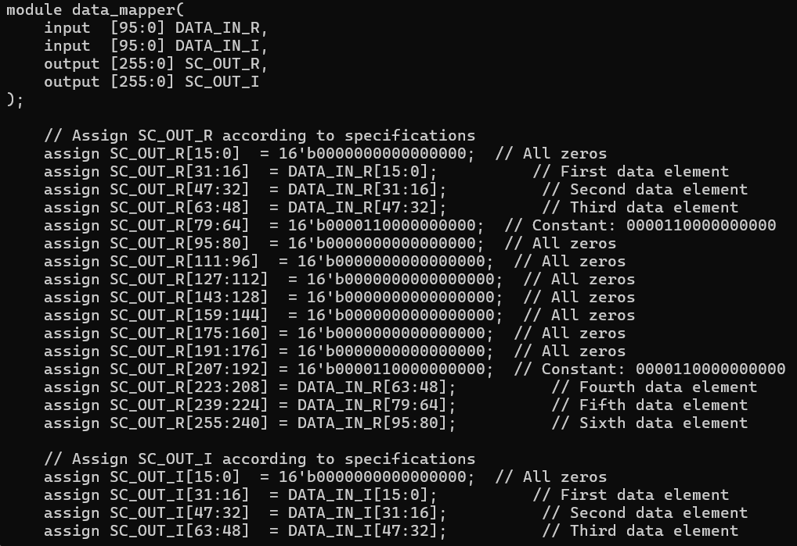
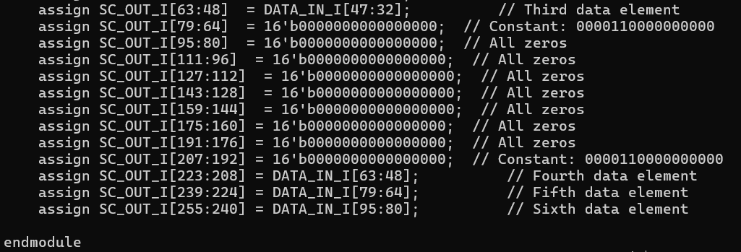
Test Bench (tb_sam.v)
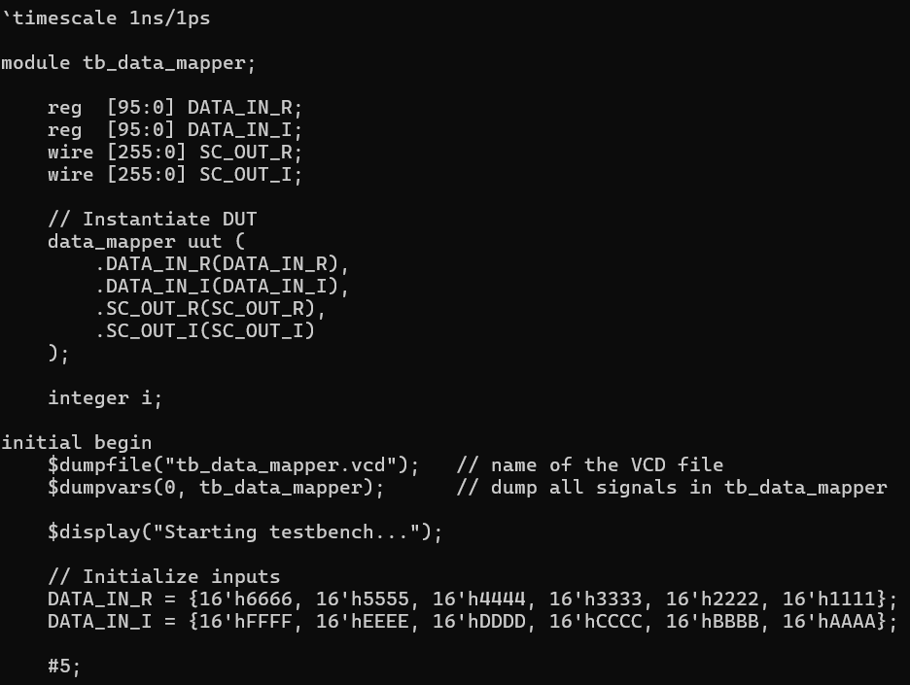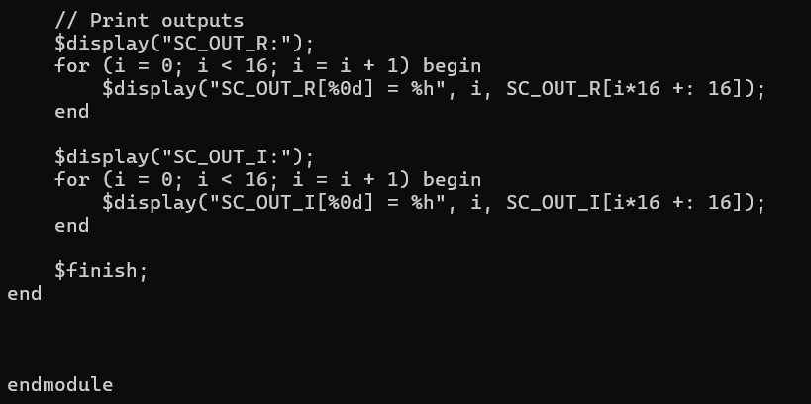

Simulation
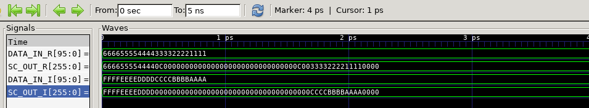
This is the Hexadecimal form of the input output
In the simulation it can be clearly seen in the case of SC_OUT_R has the first 12 bits(here by bits I mean position) of DATA_IN_R[0], DATA_IN_R[1], DATA_IN_R[2] respectively which satisfies our condition
The next 4 bits represent 3 in q5.10 format ie 0000110000000000 -> 0C00(in Hexadeximal)
The next 28 bits with 0
The next 4 bits are again the representation of 3 in hexadecimal q5.10 format
The last 12 bits with DATA_IN_R[3], DATA_IN_R[4], DATA_IN_R[5]

The results of DATA_IN_I and SC_OUT_I are also same, here the difference between I and R is we are nowhere using 3 in q5.10 format instead these positions are filled with 0’s

