**NITTE MEENAKSHI INSTITUTE OF TECHNOLOGY**

(AN AUTONOMOUS INSTITUTION)

(AFFILIATED TO VISVESVARAYA TECHNOLOGICAL UNIVERSITY, BELGAUM, APPROVED BY AICTE & GOVT.OF KARNATAKA)

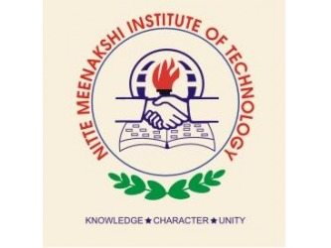

MINIPROJECT REPORT

ON

**CASE STUDY IMPLEMENTAION**

**(Data Mining and Data Warehousing)**

*Submitted by:*

**PRAJWAL R.****1NT15CS417**

*Under the guidance of*

**Mrs Chaithra H V**

(Assistant Professor)

Department of Computer Science and Engineering

Nitte Meenakshi Institute of Technology,

Yelahanka, Bangalore– 560064