**ABSTRACT**

smart glasses are wearable smart glasses that add information alongside to what user sees. Alternatively, smart glasses are sometimes defined as wearable computer glasses that are able to change their optical properties at runtime. Smart sunglasses which are programmed to change tint by electronic means these are an Example of the latter type of smart glasses. Superimposing information onto a field of view is achieved through an optical head-mounted display (OHMD) or embedded wireless glasses with transparent heads-up display (HUD) or augmented reality (AR) overlay. These systems have the capability to reflect projected digital images as well as allow the user to see through it or see better with it. While early models can perform basic tasks, such as serving as a front end display for a remote system, as in the case of smart glasses utilizing cellular technology or Wi-Fi, modern smart glasses are effectively wearable computers which can run self-contained mobile apps.

some are hands free and can communicate with the Internet via natural language voice commands, while others use touch buttons. Like other computers, smart glasses may collect information from internal or external sensors. It may control or retrieve data from other instruments or computers. It may support wireless technologies like Bluetooth, Wi-Fi, and GPS. A small number of models run a mobile operating system and function as portable media players to send audio and video files to the user via a Bluetooth or Wi-Fi headset. Some smart glasses models also feature full lifelogging and activity tracker capability. Smart glasses devices may also have features found on a smartphone Key Words: Wearable smart glass, Arduino based notification glass, Arduino based Bluetooth smart glass, Smart spectacles, Smart spectacles using Arduino.

**INTRODUCTION**

As technology is growing rapidly and integrating itself to all aspects of people’s life, designers and developers tried to provide a more pleasant experience of technology to people. One of the technology trends which aim to make life easier is wearable computing. Wearable’s aim to assist people to be in control of their life by augmenting the real life with extra information constantly and ubiquitously. One of the growing trends of wearable computing is Head Mounted Displays (HMD), as the head is a great gateway to receive audio, visual and hectic information. Also due to the Google Glass project, wearable’s in form of glasses gained much more attention during last year’s. Google Glass is as futuristic a gadget we’ve seen in recent times. A useful technique for all kinds of people including handicapped/disabled.

Inspired by Google glasses, I made a wearable prototype that can function quite similar to Google Glass. In this project, we will make a wearable extension that can work like Google glasses, and it will be used to send notifications of calls and messages received on mobile phones, and also show time and date, all in front of wearer’s eye.

Google Glasses are available in market at price of $1000-$1500. Here we will make this project under, Rs.1000 or $15.

Smart- Glasses are the wearable computing device used as an extension, which can be attached to the spectacles or sunglasses of the wearer, and can be paired with Smart Phones, via Bluetooth. This extension, contains an Arduino Micro-controller having ATmega328p microprocessor, which is programmed to connect with Smart-Phones through a Smart-phone application. A Bluetooth module, named HC-05 is interfaced with ATmega328p, which is used to connect with smart-phones. A battery / Re-chargeable battery of 5V is used as power supply for Smart-Glass. An SSD1306, 0.96” OLED display is interfaced with ATmega328p, which is used to display the data received from Smart-phones. Smart-Phone application is used to transmit data of the phone, i.e; Date, Time, Notifications of Phone call and Text messages.

The following are the main steps that are implemented during the whole process:

* Notifications Received.
* Encoding.
* Transmitting and Receiving.
* Decode and Process.
* Execution

The basic principle of this project is to create a working prototype and that too within a very less cost.

**PROBLEM STATEMENT:**

* It is inspired by Google glasses , It is a wearable that can work like Google glasses and it is used to send notifications of call and messages received on mobile phones , all in front of wearer’s eye.
* It is a useful technique for all kinds of people who are disabled and handicapped.
* The biggest advantage of smart learning system is, you are blessed with plethora of resources of knowledge free of cost. All you need is right guidance and understanding for which teachers are trained and are always available to help kids in the best possible manner.

**PROPOSED METHODOLOGY:**

The smart glass module works on the principle of reflection and focusing of light. The information displayed on the OLED screen will be shown on the antireflecting glass by reflecting it with the help of mirror and then it is focused on the screen with the help of a focal lens. The module is powered by 280 mA

Lithium Polymer battery which can be charged with the help of USB charger circuit and the power to the Arduino Nano is controlled with the help of a switch. The Bluetooth HC-05 module is controlled by Arduino Nano for displaying the received output on the OLED display. The Arduino pro Nano acts as CPU in this module it is interfaced with the Bluetooth module, OLED display.

The smart glass module works on the principle of reflection and focusing of light. The information displayed on the OLED screen will be shown on the anti-reflecting glass by reflecting it with the help of mirror and then it is focused on the screen with the help focused lens the module is powered by 280 mA Lithium Polymer battery with can be charged with the help of USB charger circuit and the power to the Arduino nano with the help of controlled switch .The Bluetooth HC-05 module is controlled by Arduino nano for displaying the received output on the OLED display . The Arduino nano acts as a CPU in the module it is interfaced with the Bluetooth module.

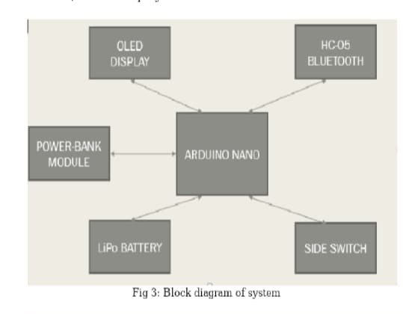

**BLOCK DIAGRAM OF SYSTEM**

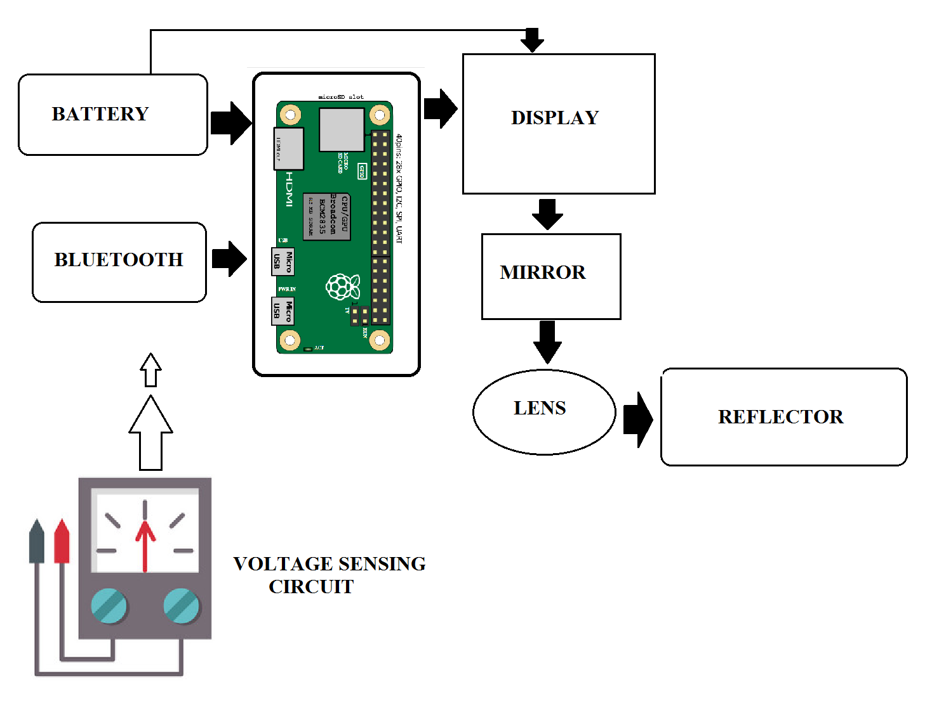

Fig: Block diagram of Smart glasses using Arduino

An Arduino Micro-controller having ATmega328p microprocessor, which is programmed to connect with Smart-Phones through a Smart-phone application. A Bluetooth module, named HC-05 is interfaced with ATmega328p, which is used to connect with smart-phones. A battery / Re-chargeable battery of 5V is used as power supply for Smart-Glass. An SSD1306, 0.96” OLED display is interfaced with ATmega328p, which is used to display the data received from

Smart-phones. Smart-Phone application is used to transmit data of the phone, i.e. Date, Time, Notifications of Phone call and Text messages.

The following are the main steps that are implemented during the whole process:

1. Notifications Received

2. Encoding.

3. Transmitting and Receiving.

4. Decode and Process.

5.Execution

**CIRCUIT CONNECTIONS**

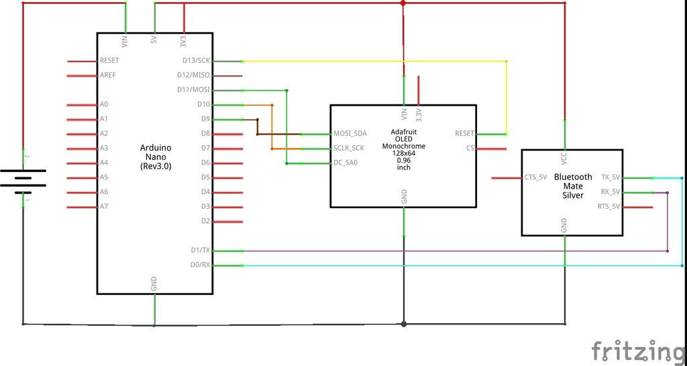

Fig: Circuit Connections

The above circuit will interact with the application through the Bluetooth module in the following manner

1. It will receive the notifications on the smart phone

2. This notification will be encoded via the mobile

application to be sent via the Bluetooth client

3. The encoded signal data will be received by the`

Bluetooth module HC05 and passes onto the ArduinoNano for decoding and forwading.

**RESULT**

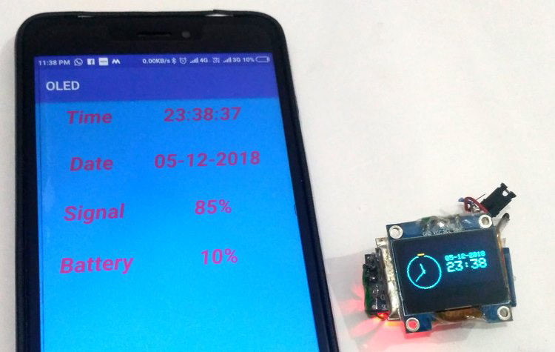

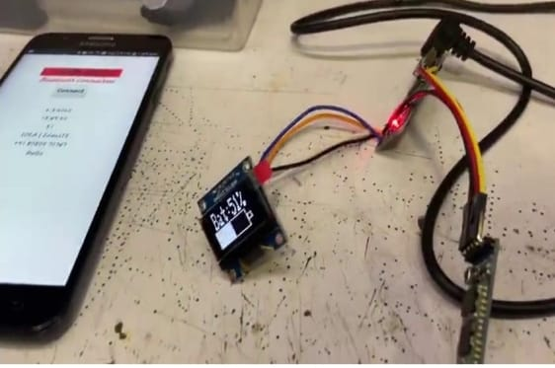

Fig: Display On Phone

**ADVANTAGES**:

* Easy to wear and use.
* Acts as a hands-free computer, so we won’t need to break your country law while driving.
* Can text trend and see the map while we are on our way.
* A new trend for fashion lovers together being an innovative technology.
* Usefull technology for disabled/handicapped people.
* Wearable headgear that allows some uses hands-free.
* λ User can receive information and notifications from Internet and social media without having to check a Phone or other mobile device.
* λ This is a neat feature that may come in handy when You travel abroad.

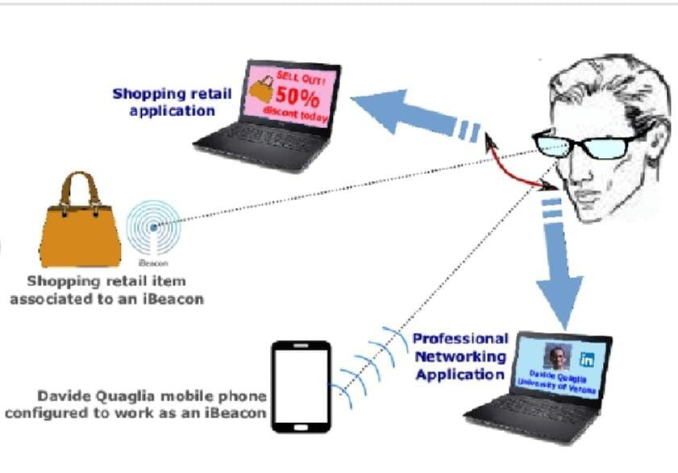

Fig: Description of Smart Glass

**APPLICATIONS**:

* Smart glasses are used in a variety of ways, including application development.
* Ex include information visualization, image data analysis, data processing, navigation, information transmission and sharing, and risk detection warning.
* In addition, smart glasses are used in a variety of ways, including application development. Examples include information visualization, image data analysis, data processing, navigation, information transmission and sharing, and risk detection and warning.

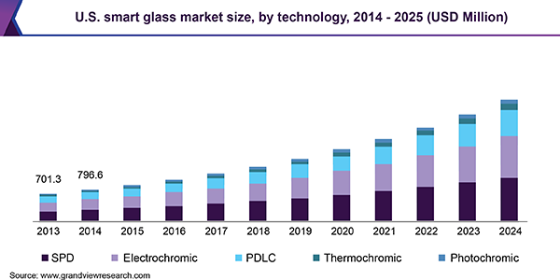

Fig: Bar Graph

**CONCLUSION**

* The system provides satisfactory results the system provides basic notifications to the display unit such as SMS, time, date and information about the sim card the phone is using in a continuous loop.
* This system is placed in a 3d case which fits with any spectacles and can be used as a portable device. After which one is able to observe the date, time, cellular operator, the text message.
* Google Glass is as futuristic a gadget we’ve seen in recent times. It’s limited in scope right now. The future, Google believes, is bright and the device itself is “incredibly compelling”.
* Google is trying their hardest to push the Project Glass through the FCC this year. Reports show that Google is trying to get the approval by the FCC this year but there are already several hundred glasses made for testing internally.
* Future scope of Google Glasses Google glasses are basically wearable computers that use the evolving familiar technologies that brings the sophistication and ease of communication and information access even for the physically challenged class of people those literally could not use general way of palmtops and mobile.

**OUTPUT DESIGN**:

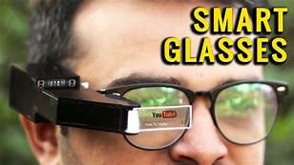

THANK YOU