Testing question | Yes/No | Notes / Evidence
Does the prototype open or start correctly? | Yes | 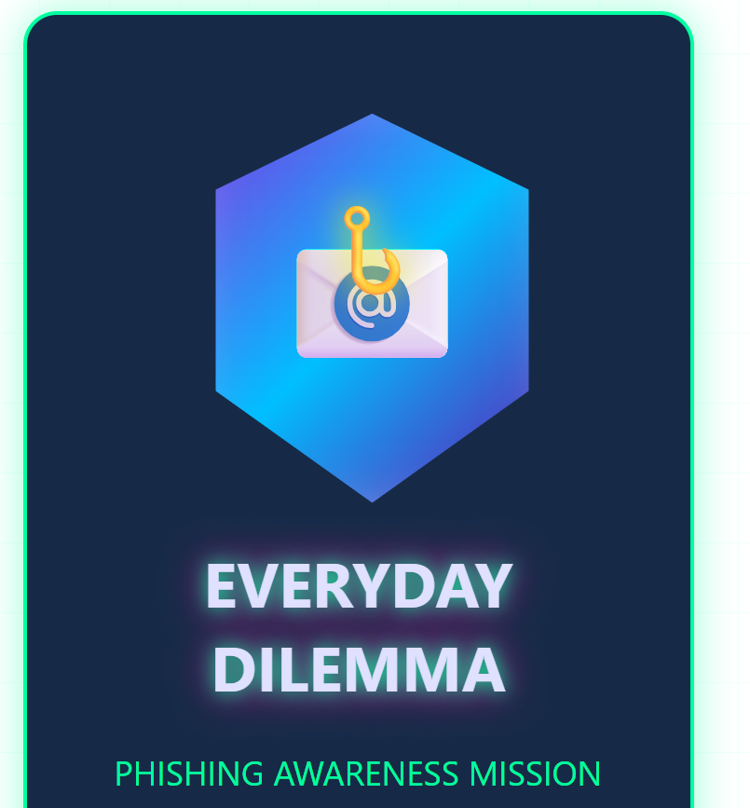
Is the welcome/title screen clear? | Yes | 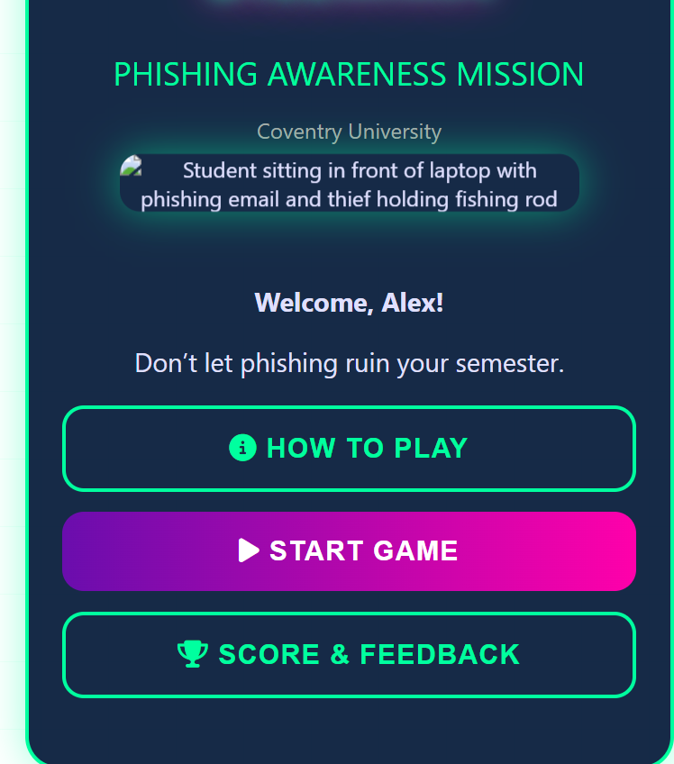
Are the instructions easy to understand? | Yes | 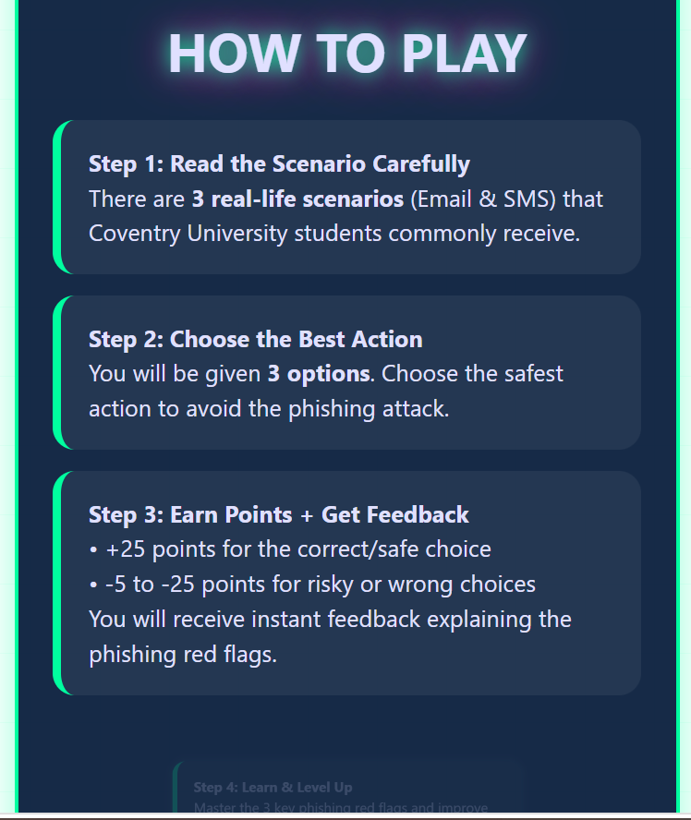
Is the first cyber-safety challenge visible? | No | In progress
Are the answer choices clear? | No | In progress
Does the correct answer show correct feedback? | No | In progress
Does the wrong answer show helpful feedback? | No | In progress
Does the feedback explain the cyber-safety lesson? | No | In progress
Is there a reward, score, star or success message? | No | In progress
Is the design suitable for the target audience? | Yes | Yes, the design is suitable for target audience as students love learning to be quick. So the design is perfect for rapid efficient learning.
What needs to be improved next? | Yes
Testing outcome: What worked well?
Today the welcome page and title is clear and when clicking in how to play icon its shows game instruction clearly_____________________________________________________________________________________
_____________________________________________________________________________________
_____________________________________________________________________________________
Testing outcome: What did not work or needs improvement?
Everything work properly bit the amination picture shows some error that need to improve in next week_____________________________________________________________________________________
_____________________________________________________________________________________
_____________________________________________________________________________________
Improvements for Prototype Version 2
For version just need to work in animated picture error correction._____________________________________________________________________________________
_____________________________________________________________________________________
_____________________________________________________________________________________

