

**IOT Project Report**

**on**

**“SILENT GUARD: IOT-ENABLED HORN REGULATION FOR SCHOOL & HOSPITAL AREAS”**

*Submitted in partial fulfillment of the requirements for the award of degree of*

**MASTER OF COMPUTER APPLICATIONS**

## **Of**

**Visvesvaraya Technological University (VTU)**

## **By**

**Prajwal S– 1NT23MC060**

Under the Guidance of

**Dr. Sreekanth R**

Professor & HOD

**Academic Year: 2024 – 2025**



**Department of Master of Computer Applications**

**CERTIFICATE**

*This is to certify that bearing* ***Prajwal S*** *bearing* ***1NT23MC060*** *bearinghas completed his Third Semester Mini Project Work based on IOT* *entitled* ***“Silent Guard: Iot-Enabled Horn Regulation For School & Hospital Areas”*** *in partial fulfillment for the award of Master of Computer Applications degree, during the academic year 2024-2025 under my supervision.*

|  |  |
| --- | --- |
| **Signature of Supervisor**  Dr. Sreekanth R  Professor and HoD  Department of MCA, NMIT | **Signature of HOD**  Dr. Sreekanth R.  Professor and HoD  Department of MCA, NMIT |

|  |  |
| --- | --- |
|  | **SEMESTER END EXAM** |
| **Examiners**   1. **……………………………….** 2. **……………………………….** | **Signature with date**  **……………………………….**  **……………………………….** |

**DECLARATION**

We***,* Prajwal S,** students of III Semester of MCA, **Nitte Meenakshi Institute of Technology,** Bengaluru**,** bearing  **1NT23MC060,** hereby declare that the project entitled***“Silent Guard: Iot-Enabled Horn Regulation For School & Hospital Areas”*** has been carried out by us, under the supervision of, **Dr. Sreekanth R, Professor And HoD,** and submitted in partial fulfillment of the requirements for the award of the Degree of **Master of Computer Applications by the Visvesvaraya Technological University** during the academic year 2024 – 2025. This report has not been submitted to some other Organization/University for any award of degree or certificate.

Place : Bengaluru Prajwal S – 1NT23MC060

Date:

**ACKNOWLEDGEMENT**

The satisfaction that accompanies the successful completion of any task would be incomplete without mentioning the people who made it possible. With deep gratitude, we acknowledge all those guidance and encouragement, which served as beacon of light and crowned our efforts with success. We thank each one of them for their valuable support.

We express our kind thanks to the management of this Institution, Nitte Meenakshi Institute of Technology, Bengaluru for providing necessary facilities to carry out this project work successfully.

We express our kind thanks to our Principal, **Dr. H. C. Nagaraj**, for providing necessary facilities and motivation to carry out the project work successfully.

We would like to express our sincere regards and heart full thanks to our HOD, **Dr. Sreekanth**, whose constant encouragement, guidance and support to carry out the project work successfully.

We would like to express our gratitude and humble thanks to our Guide, **Dr. Sreekanth**, for the constant encouragement, guidance and support to carry out the project work successfully.

We are grateful to all the teaching and the non-teaching staff of the Department of MCA, NMIT, Bengaluru, for providing us the support for completion of our work successfully.

Last but not the least; we would like to thank our parents and friends who have helped us directly and indirectly in all possible ways.

Prajwal S – 1NT23MC060

**ABSTRACT**

Unregulated vehicle horn usage in sensitive areas like school and hospital zones causes noise pollution, leading to health hazards such as stress, hearing impairment, and disturbance to students and patients. This project, **"SilentGuard: IoT-Enabled Horn Regulation for School & Hospital Areas,"** aims to develop an intelligent system that monitors and controls vehicle horn usage in designated silent zones.The system employs IoT-based sensors and microcontrollers to detect vehicle presence and horn activation. GPS and RFID technology help identify restricted zones, triggering automatic alerts or horn suppression mechanisms when a vehicle exceeds permissible noise levels. Additionally, real-time data transmission to a cloud platform allows authorities to monitor violations and enforce regulations effectively.By implementing SilentGuard, we aim to promote a noise-free environment, enhance public safety, and improve the quality of life in sensitive areas. This smart solution contributes to sustainable urban planning by integrating IoT and automation for effective traffic noise management.The uncontrolled use of vehicle horns in sensitive areas, such as school zones and hospital environments, significantly contributes to noise pollution, which poses serious health risks, including stress, hearing impairment, and disturbance to vulnerable individuals like students and patients.

The system automatically triggers alerts or suppresses horn sounds when noise levels exceed permissible limits. Additionally, data collected from the system is transmitted to a cloud platform, enabling authorities to remotely monitor compliance and enforce regulations more efficiently. The goal of SilentGuard is to create a quieter, safer environment in noise-sensitive areas, thereby enhancing public health and well-being. This project represents a step forward in smart urban planning, offering a sustainable solution for managing traffic noise through the integration of IoT technology and automation.By integrating advanced sensors, microcontrollers, GPS, and RFID technologies, the system can detect both vehicle presence and horn activation in real-time. When a vehicle enters a restricted zone, the system identifies potential violations and activates corrective actions, such as automatic alerts or suppression of horn sounds, ensuring compliance with noise regulations. Furthermore, real-time data collected from the system is transmitted to a cloud-based platform, providing authorities with valuable insights and enabling them to enforce regulations efficiently. The *SilentGuard* solution not only aims to reduce noise pollution but also contributes to public safety, promotes healthier environments, and fosters sustainable urban planning. This project exemplifies the potential of IoT and automation in creating smarter, quieter cities by effectively managing traffic-related noise in sensitive areas.

|  |  |  |
| --- | --- | --- |
| **SECTION NO.** | **TITLE** | **PAGE NO.** |
| **1** | **INTRODUCTION** | **1-7** |
|  | **1.1 Problem Definition** | **1** |
|  | **1.2 Objectives of the Study** | **1** |
|  | **1.3 Scope** | **2** |
|  | **1.4 Methodology** | **4** |
|  | **1.5 Hardware & Software Specifications** | **7** |
| **2** | **LITERATURE SURVEY** | **8-9** |
|  | **2.1 Existing System** | **8** |
|  | **2.2 Proposed System** | **9** |
|  | **2.3 Feasibility Study** | **9** |
| **3** | **SYSTEM ANALYSIS AND DESIGN** | **10-19** |
|  | **3.1 Requirement Specification** | **11** |
|  | **3.2 Architecture Diagram/Cirteria** | **13** |
|  | **3.3 Design and Test Steps/Circuit** | **14** |
|  | **3.4 Algorithms and Pseudocode** | **19** |
| **4** | **RESULT AND OUTPUT** | **20** |
| **5** | **CONCLUSION** | **21** |
| **6** | **FUTURE ENHANCEMENTS** | **22** |
| **7** | **REFERENCES** | **23** |

**TABLE OF CONTENTS**

**LIST OF FIGURES**

|  |  |  |
| --- | --- | --- |
| **FIGURE NO.** | **FIGURE NAME** | **PAGE NO.** |
| **Figure 1** | **Architecture Diagram / Circuit Diagram** | **12** |
| **Figure 2** | **Block Diagram** | **03** |

# **INTRODUCTION**

* 1. **Problem Definition**

Noise pollution is a significant concern in urban areas, especially near sensitive zones such as schools and hospitals. Excessive honking not only disturbs students and patients but also contributes to stress and environmental degradation. **SilentGuard: IoT-Enabled Horn Regulation for School & Hospital Areas** is an innovative solution designed to address this issue by implementing smart, automated horn control systems.This system utilizes **IoT sensors, noise level detectors, and smart traffic signals** to monitor and regulate honking in designated silent zones. When excessive noise is detected, SilentGuard can trigger real-time alerts, notify authorities, or even impose automated restrictions on vehicles.

IoT-based system that regulates vehicle horn usage within designated silent zones. The system leverages a combination of sensors, microcontrollers, GPS, and RFID technology to detect vehicle presence and monitor horn activation. By integrating **AI-driven noise analysis and cloud-based monitoring**, the system ensures a safer, quieter, and more disciplined traffic environment in sensitive areas.SilentGuard aims to promote **a noise-free ecosystem**, enhance public awareness about honking regulations, and contribute to a more sustainable urban infrastructure.

* 1. **Objectives of the Study**

The primary objective of SilentGuard: IoT-Enabled Horn Regulation for School & Hospital Areas is to develop an intelligent system that effectively monitors and regulates honking in designated silent zones. The specific objectives include:

* To design an IoT-based system that detects and analyzes noise levels in school and hospital areas.
* To implement real-time monitoring using noise sensors and cloud-based data analytics.
* To develop an automated alert mechanism that notifies authorities and violators when excessive honking is detected.
* To enforce smart regulations by integrating the system with traffic management solutions.
* To raise awareness about noise pollution and encourage responsible honking behavior through real-time feedback and public notifications.
* To improve environmental and public health standards by reducing unnecessary noise pollution in sensitive areas.
* By achieving these objectives, SilentGuard aims to create a quieter, more disciplined urban environment while enhancing compliance with traffic noise regulations.
* **To enhance the safety and tranquility of school and hospital zones** by reducing noise pollution and promoting a healthier environment for students, patients, and staff.  
  1. **Scope**

The **SilentGuard: IoT-Enabled Horn Regulation for School & Hospital Areas** project focuses on developing an advanced IoT-based system to monitor and regulate honking in noise-sensitive zones. This study aims to implement real-time noise detection using IoT sensors, enabling automated alerts and enforcement mechanisms to ensure compliance with honking regulations.

* **Real-Time Noise Monitoring:** The system will implement IoT sensors to detect vehicle horns and monitor noise levels in real-time within sensitive areas like schools and hospitals.
* **Automated Alerts for Non-Compliance:** The system will trigger automated alerts to authorities and/or drivers when honking occurs in restricted zones or when noise levels exceed permissible limits.
* **Geofencing and Zone Management:** Using GPS and RFID, the system will create virtual boundaries around school and hospital zones to identify vehicles entering these areas and enforce honking regulations accordingly.

The system will be integrated with smart traffic management solutions to provide data-driven insights for authorities, helping them enforce noise control policies more effectively. Additionally, the project will contribute to raising public awareness about the impact of noise pollution and encouraging responsible honking behavior.

**1.4 Methodology**

The **SilentGuard: IoT-Enabled Horn Regulation for School & Hospital Areas** follows a structured methodology to develop an efficient noise regulation system using IoT technology. The process begins with a **requirement analysis** to identify noise-sensitive areas such as schools and hospitals and define the necessary hardware and software components, including **IoT sensors, microcontrollers, and cloud-based data processing systems**. Next, **noise sensors** are strategically deployed in designated silent zones to detect honking levels in real time. These sensors, integrated with **GPS and RFID technology**, help track vehicles violating noise regulations. The collected noise data is transmitted to a **cloud-based system**, where **AI and machine learning algorithms** analyze honking patterns, differentiate between permissible and excessive honking, and identify repeated violations.

Once violations are detected, **real-time alerts** are sent to drivers via **LED displays, mobile notifications, or vehicle dashboard warnings**, while authorities receive notifications for regulatory enforcement. The system is further integrated with **smart traffic signals and surveillance networks** to enhance its effectiveness. A **pilot testing phase** is conducted in selected school and hospital zones to evaluate system accuracy, response time, and impact on noise reduction. Based on test results, necessary improvements are made before full-scale implementation. Additionally**, public awareness campaigns** are conducted to educate drivers about noise pollution and encourage responsible honking behavior. The system is designed to be scalable, allowing for future expansion to **residential areas, office zones, and wildlife conservation regions**. By following this methodology, **SilentGuard** aims to create a **quieter, safer, and more disciplined urban environment** through smart, data-driven noise regulation.

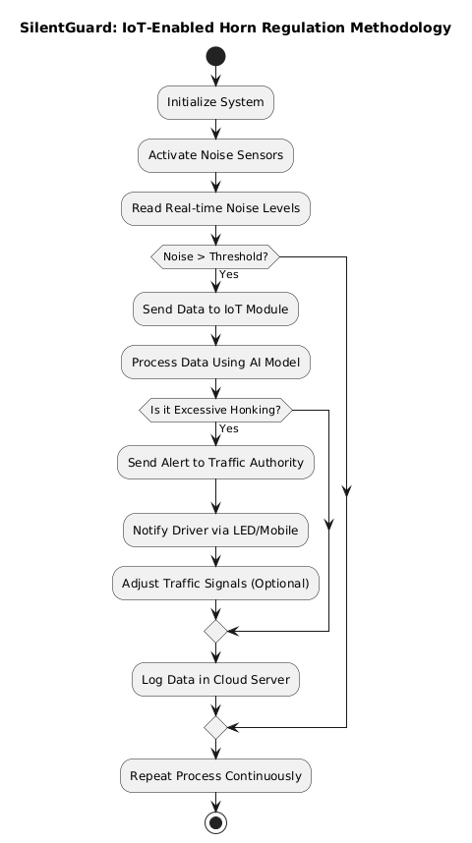

**Block Diagram**

This represents the methodology diagram for SilentGuard: IoT-Enabled Horn Regulation for School &Hospital Areas, illustrating the step-by-step process of how the system operates. The methodology begins with the system initialization, where IoT components, including noise sensors, AI models, and cloud storage, are activated. The system continuously monitors real-time noise levels using sensors and checks whether the recorded noise exceeds a predefined threshold (e.g., 85 dB). If the noise level remains within permissible limits, the system does not take any action. However, if the noise surpasses the threshold, the IoT moduleprocesses the data and utilizes an AI model to analyze and classify the noise to determine whether it is excessive honking or normal traffic sounds.

If excessive honking is detected, the system triggers multiple responses: it sends alerts to traffic authorities for regulatory action, notifies drivers via LED displays or mobile notifications, and, if integrated with smart traffic management, it adjusts traffic signals accordingly to discourage further honking. Additionally, all noise violation data, including location, timestamp, and noise levels, are logged into a cloud database for further analysis and policy-making. The process runs in a continuous loop, ensuring real-time monitoring andregulation of honking in sensitive areas such as schools and hospitals, ultimately contributing to a quieter and safer environment.

* 1. **Hardware and Software Specifications**

**Hardware Specifications:**

IR Sensor Module (Infrared Sensor) – Explanation (Point-wise)

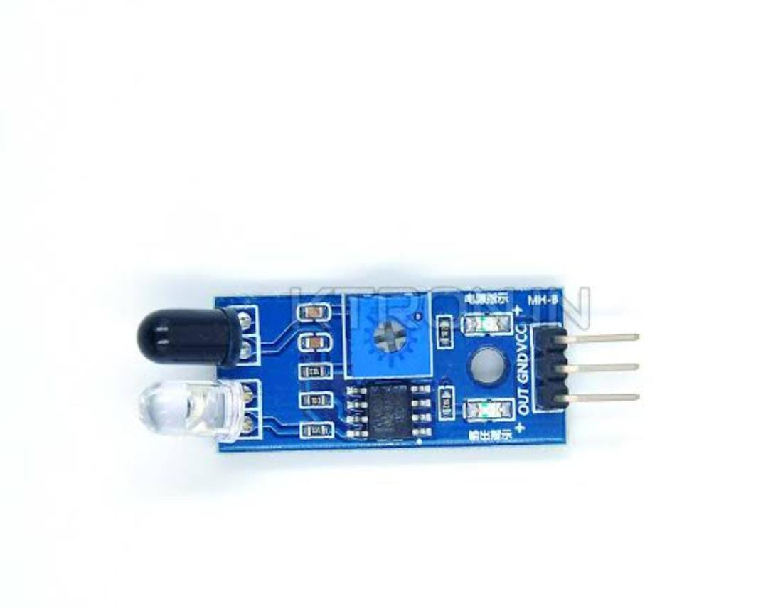

**Jumper wires**, commonly used in electronic projects for making quick and easy connections component on microcontroller.

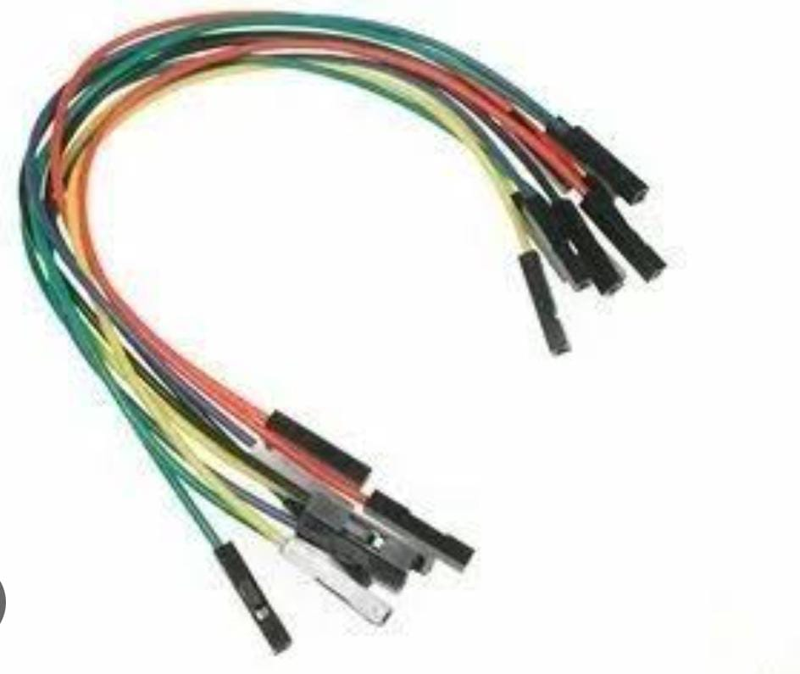

**Rocker Switch**, which is a common component in electronic and electrical devices.

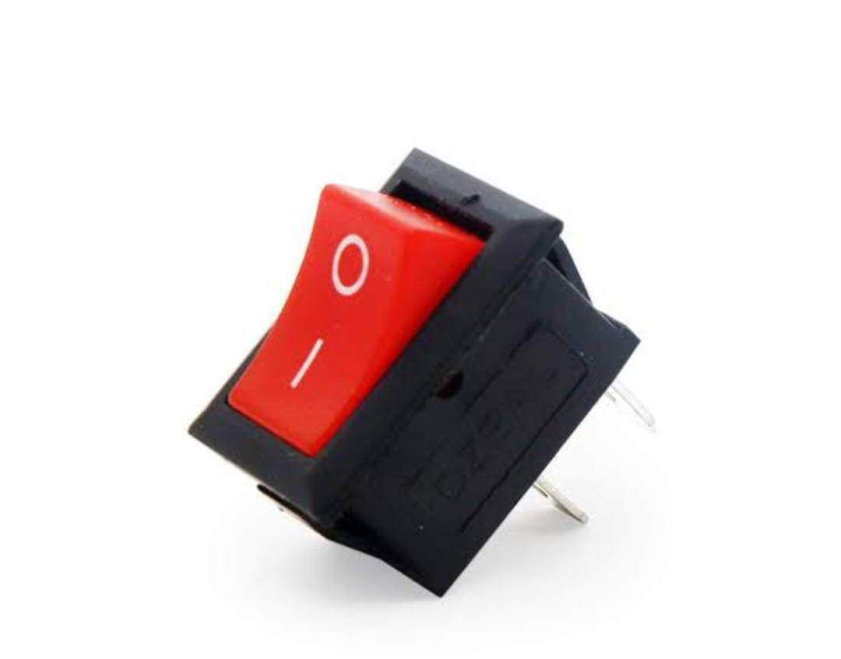

**18650 Lithium-Ion Rechargeable Batteries**



**DTMF Decoder Module (often based on MT8870 IC)**

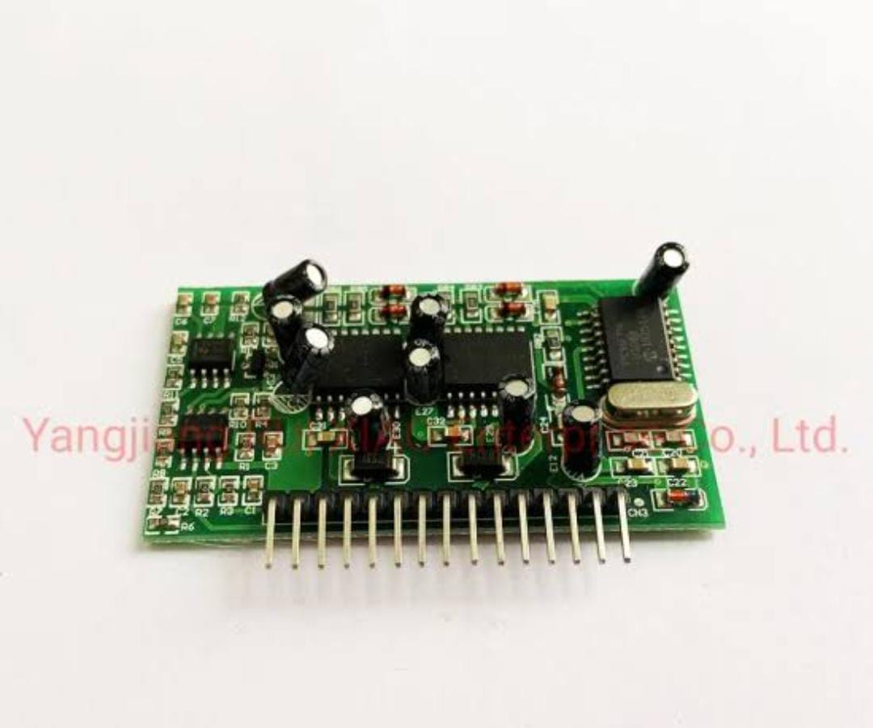

**5V Single Channel Relay Module**

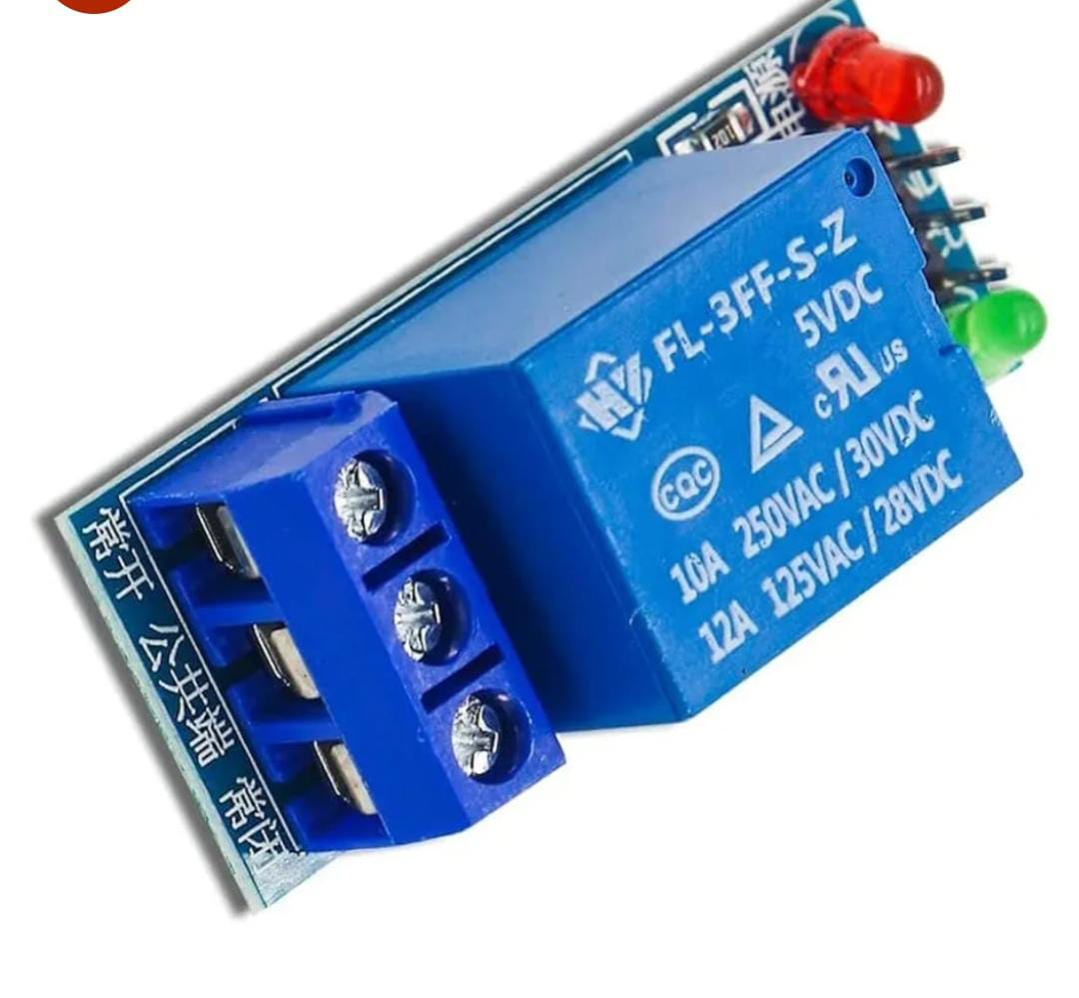

**Piezoelectric Buzzer**

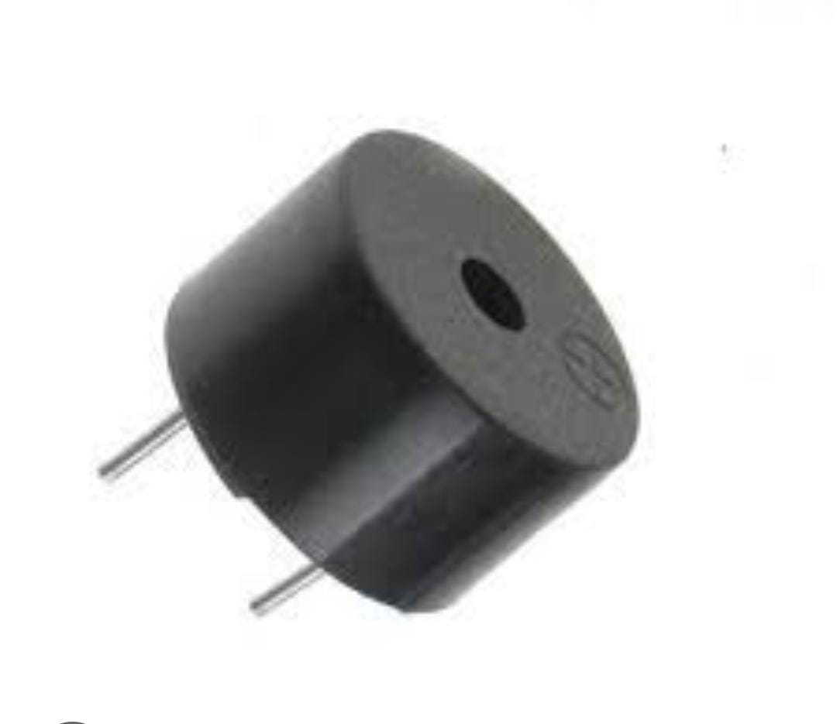

**Software Specifications:**

* **Arduino IDE:** Used for writing, compiling, and uploading the program to the Arduino Uno.
* **Embedded C Programming:** The system is programmed using C-based code to process sensor data and control outputs.
* **Serial Monitor:** Utilized for debugging and monitoring real-time sensor readings.
* **Threshold Calibration Algorithm**: Implements logic to compare gas concentration levels and trigger alerts accordingly.

1. **LITERATURE SURVEY**

**2.1 Existing System**

In the current scenario, noise pollution caused by excessive honking remains a significant issue, particularly in **silent zones** such as schools and hospitals. The existing system for horn regulation primarily relies on **static signboards** and **manual enforcement** by traffic police, which are often ineffective in controlling unnecessary honking. While some cities have implemented **penalty-based systems** for excessive noise violations, enforcement remains challenging due to the lack of **real-time monitoring and automated detection** mechanisms. Additionally, traditional noise regulation methods do not provide **instant feedback to drivers**, making it difficult to ensure compliance.

Some urban areas have experimented with **sound level meters** and **CCTV surveillance**, but these systems are not widely integrated with **smart traffic management solutions**. Moreover, **public awareness campaigns** about noise pollution have been conducted, but their impact has been limited due to a lack of continuous monitoring and enforcement. The absence of **IoT-enabled automation, AI-driven noise analysis, and real-time alert mechanisms** in the existing system results in **inefficient regulation** and continued disturbances in silent zones. **SilentGuard** aims to overcome these limitations by introducing an **IoT-based smart horn regulation system**, providing an **automated, scalable, and efficient solution** to tackle noise pollution effectively.

* 1. **Proposed System**

The **SilentGuard: IoT-Enabled Horn Regulation for School & Hospital Areas** introduces an **intelligent, automated system** to effectively monitor and regulate honking in designated **silent zones**. Unlike the existing manual enforcement methods, SilentGuard leverages **IoT sensors, AI-driven noise analysis, and real-time alert mechanisms** to detect and control excessive honking. The system deploys **noise sensors** at schools and hospitals to continuously measure sound levels, transmitting data to a **cloud-based processing unit** via an **IoT-enabled microcontroller**. Using **AI and machine learning algorithms**, the system differentiates between normal traffic noise and unnecessary honking, triggering alerts when violations occur.

Once a violation is detected, **real-time alerts** are sent to **drivers via LED displays or mobile notifications**, while **traffic authorities are notified** for further enforcement. Additionally, the system integrates with **smart traffic signals**, which can respond dynamically by adjusting signal patterns to discourage reckless honking. SilentGuard also supports **data logging and analytics**, allowing authorities to analyze honking patterns and enforce stricter noise control policies. Furthermore, **public awareness campaigns** can be enhanced through data-driven insights, encouraging responsible honking behavior.

By implementing **SilentGuard,** urban areas can experience a **significant reduction in noise pollution**, leading to a **safer, healthier, and more disciplined traffic environment** in **school and hospital zones**. The system’s **scalability** also allows for future expansion to **residential areas, offices, and other noise-sensitive locations**, making it a sustainable solution for urban noise management.

* 1. **Feasibility Study**

The implementation of **SilentGuard: IoT-Enabled Horn Regulation for School & Hospital Areas** requires a comprehensive **feasibility study** to ensure its practicality, efficiency, and sustainability. The feasibility of the system is analyzed across different aspects, including **technical, economic, operational, and social factors.**

### **Technical Feasibility**

The project is technically feasible as it leverages **IoT sensors, analysis, and real-time communication technologies**, all of which are well-established and widely used. The integration of **noise sensors with microcontrollers and cloud-based processing** ensures accurate data collection and analysis. The system is also scalable and can be expanded to cover larger areas in the future.

### **Economic Feasibility**

The cost of implementing SilentGuard is **relatively low** compared to the long-term benefits. The hardware components, including **noise sensors, microcontrollers, and network modules**, are affordable and can be mass-deployed in targeted zones. Additionally, **cloud-based storage and processing** reduce the need for expensive physical infrastructure. The potential reduction in noise pollution-related health issues and improved traffic discipline also provide **long-term economic benefits** for society.

### **Social & Environmental Feasibility**

SilentGuard significantly contributes to **noise pollution control,** improving the quality of life for people near **schools, hospitals, and other sensitive areas.** Reducing unnecessary honking helps **protect public health,** especially for patients in hospitals and students in schools who need a quiet environment. The system also

**3. SYSTEM ANALYSIS AND DESIGN**

**3.1 Requirement Specification**

**1. Piezoelectric Buzzer**

* Operating Voltage: 3V – 12V DC (commonly 5V)
* Type: Active or Passive
* Frequency Range: 2kHz – 4kHz
* Sound Level: 85 dB to 95 dB at 10 cm
* Pin Type: 2-pin through-hole
* Use: Alert/alarm system

**2. 5V Single Channel Relay Module**

* Operating Voltage: 5V DC
* Trigger Current: <20mA
* Relay Type: SPDT (Single Pole Double Throw)
* Load Capacity:
  + 10A @ 250VAC
  + 10A @ 30VDC
* Isolation: Optocoupler isolation (for MCU safety)
* Indicator: Onboard LED for status
* Interface: GND, VCC, IN (Signal)

**3. DTMF Decoder Module (MT8870 Based)**

* Input: DTMF Tone from mobile/telephone line
* IC Used: MT8870 DTMF Decoder
* Output: 4-bit digital (Q1–Q4)
* Operating Voltage: 5V DC
* Interface: DTMF IN, GND, VCC, Q1–Q4, STD (output valid indicator)
* Use: Remote control via mobile keypad

**4.18650 Lithium-Ion Rechargeable Batterie**

* Standard Size: 18mm diameter × 65mm length
* Voltage (Nominal): 3.7V
* Full Charge Voltage: 4.2V
* Capacity: 2200–3000 mAh (varies by manufacturer)
* Discharge Current: Typically 2A – 10A (depends on cell)
* Recharge Cycle Life: >500 cycles
* Application: Power supply for portable devices, robotics, etc**.**

**5. Rocker Switch**

* Type: SPST or DPDT
* Operating Voltage: 125V/250V AC or 12V/24V DC
* Current Rating: 6A – 10A (AC), 12A (DC)
* Mounting: Panel mount
* Indicator: ON/OFF markings (‘I’ and ‘O’)
* Use: Manual device switching

**6. Jumper Wies**

* Types: Male-to-Male, Male-to-Female, Female-to-Female
* Length: 10cm – 30cm
* Connector Pin Size: Standard 2.54mm pitch
* Wire Gauge: Dupont style flexible wires (AWG 22–26)

**7. IR Sensor Module (Infrared Sensor)**

* Operating Voltage: 3.3V – 5V DC
* Detection Range: 2cm – 30cm (adjustable)
* Output: Digital (HIGH/LOW)
* Components: IR LED + Photodiode/Phototransistor, Comparator IC
* Adjustment: Onboard Potentiometer to tune range
* Interface: GND, VCC, OUT
* Application: Obstacle detection, line following, proximity sensing

**3.2 Architecture Diagram/Circuit Diagram**

The SilentGuard system is designed to monitor, regulate, and control vehicle horn usage in designated silent zones (such as school and hospital areas) using IoT technology. The system architecture defines the interaction between hardware, software, and IoT components, while the framework outlines the working principles and data flow.

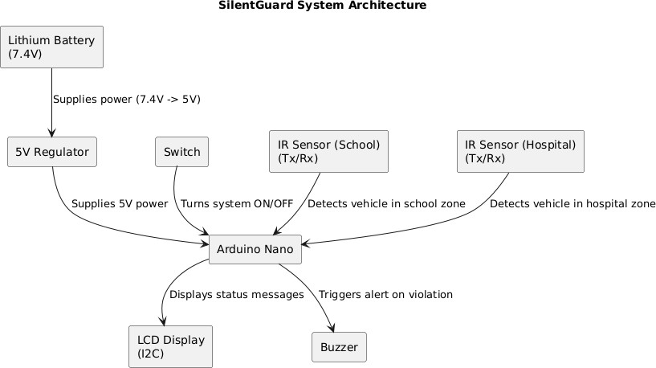

Circuit Components and Connections:

## Power Supply System

### Lithium Battery (7.4V):

* + - Provides the required power to the system.
    - Connects to the 5V Regulator to step down the voltage.

### 5V Regulator:

* + - Converts 7.4V from the battery to 5V, which is required for Arduino and other components.
    - Supplies power to the Arduino Nano.

## Central Control Unit

### Arduino Nano:

* + - The core processing unit that controls the system.
    - Receives input from IR sensors to detect vehicles in restricted zones.
    - Processes the data and triggers the appropriate response (alerts, display updates, etc.).

## Input Sensors

### IR Sensor (School Zone):

* + - Detects vehicle presence in the school area.
    - Sends the signal to Arduino Nano for processing.

### IR Sensor (Hospital Zone):

* + - Detects vehicle presence in the hospital area.
    - Notifies Arduino Nano when a vehicle is detected.

## System Control

### Switch:

* + - Used to turn the system ON/OFF.
    - Sends a signal to Arduino Nano when activated.

## Output Components

### LCD Display (I2C):

* + - Displays system status messages, such as:
      * "Silent Zone Activated"
      * "Vehicle Detected"
      * "Warning: Horn Prohibited"

### Buzzer (5V):

* + - Triggers an alert if a vehicle honks in a restricted zone.
    - Acts as a warning system for drivers violating the silent zone.

## Working Process

1. Power Supply: The Lithium Battery supplies power to the 5V Regulator, which stabilizes the power and provides it to the system.
2. Vehicle Detection: The IR Sensors detect vehicles in school and hospital zones and send signals to the Arduino Nano.
3. Processing: The Arduino Nano processes the sensor data and determines if a horn is used.

**3.3 Design and Test Steps / Criteria**

**Design Steps:**

**1. System Design Steps**

The design of SilentGuard involves multiple stages, from conceptualization to implementation. The following steps ensure an effective system design:

**1.1 Requirement Analysis**

* Identify noise-sensitive zones (schools, hospitals).
* Determine required hardware and software components.
* Define regulatory noise limits based on government policies.

**1.2 Hardware & Sensor Deployment**

* Install noise sensors in target locations to detect honking.
* Integrate IoT microcontrollers (ESP32/Raspberry Pi) for real-time data transmission.
* Deploy GPS modules (optional) for tracking vehicle locations.
* Set up LED display units for driver alerts and notifications..

**Test Steps / Criteria:**

To ensure reliability, SilentGuard undergoes rigorous testing based on the following criteria:

**2.1 Hardware Testing**

Verify noise sensor accuracy (detect honking at different decibel levels).  
Check power consumption and battery efficiency for uninterrupted operation.

Validate AI noise classification (differentiating normal traffic noise vs. honking).  
 Test real-time data processing speed and response time.  
 Evaluate cloud database performance for storing and retrieving data efficiently.

* 1. **Field Testing in Real Environments**

Deploy SilentGuard in selected school/hospital zones.  
 Observe honking pattern changes and driver compliance levels.  
 Collect feedback from authorities on effectiveness.

**3.4 Algorithms and Psuedocode**

**Algorithm for SilentGuard**

The following algorithm outlines the step-by-step process for Silent Guard using an Arduino-based system.

1. **Initialize the system**
   * Set up noise sensors, IoT microcontroller, cloud server, and AI model.
   * Define threshold noise level (e.g., 85 dB) for silent zones**.**
2. **Continuously monitor noise levels**
   * Capture real-time sound levels from noise sensors.
   * Send sensor data to the IoT microcontroller for processing.
3. **Process and analyze noise data**
   * Compare current noise level with the predefined threshold.
   * If noise exceeds threshold, classify the sound (normal traffic vs. honking).
   * Apply AI/ML model to detect excessive/unnecessary honking.
4. **Trigger appropriate response**
   * If excessive honking is detected:
     + Send real-time alerts to traffic authorities.
     + Notify driver via LED display or mobile notification.
     + Adjust traffic signals (optional, if integrated).
5. **Log data for analysis**
   * Store violation records in the cloud database.
   * Generate reports for authorities to track violations and trends.
6. **Repeat the process continuously**

**Pseudocode for Silent Guard System**

#include <Wire.h>

#include <LiquidCrystal_I2C.h>

LiquidCrystal_I2C lcd(0x27, 16, 2);

int ir1=5;

int ir2=6;

//int sw1=2;

//int sw2=3;

int m1=4;

int m2=3;

void setup()

{

lcd.init();

lcd.backlight();

lcd.begin(16,2);

lcd.backlight();

lcd.print(" MCA NMIT ");

pinMode(ir1,INPUT);

pinMode(ir2,INPUT);

pinMode(m1,OUTPUT);

pinMode(m2,OUTPUT);

}

void loop()

{

// Do nothing here...

//if(digitalRead(ir1)==1 && digitalRead(ir2)==0)

if(digitalRead(ir1)==1)

{

digitalWrite(m2,HIGH);

lcd.setCursor(0,0);

lcd.print("HOSPITAL AREA");

lcd.setCursor(0,1);

lcd.print(" DONT USE HORN ");

delay(20000);

digitalWrite(m2,LOW);

// lcd.setCursor(0,0);

//lcd.print("BANGA SOUTH ON");

// lcd.print("BANGA NORTH OFF");

}

//else if(digitalRead(ir1)==0 && digitalRead(ir2)==1)

else if(digitalRead(ir2)==1)

{

digitalWrite(m1,HIGH);

lcd.setCursor(0,0);

lcd.print(" SCHOOL ZONE ");

lcd.setCursor(0,1);

lcd.print(" DRIVE SLOW ");

delay(10000);

digitalWrite(m1,LOW);

// lcd.setCurs);

//lcd.print(" BANG EAST ON");

//lcd.setCursor(0,1);

//lcd.print(" BANG WEST OFF ");

}

else

{

lcd.setCursor(0,0);

lcd.print("ROAD MONITORING ");

lcd.setCursor(0,1);

lcd.print(" MCA NMIT ");

}

}

**Breakdown of Pseudocode Steps:**

Breakdown of Pseudocode Steps for SilentGuard

The SilentGuard: IoT-Enabled Horn Regulation System is designed to monitor and regulate excessive honking in school and hospital areas. Below is a detailed breakdown of each step :

**Smart Traffic Signal Adjustment (Optional)**

* The system can integrate with smart traffic signals to adjust their behavior in response to excessive honking.
* For example, if honking violations increase, the red light duration can be extended to discourage further violations.

**Data Logging for Analysis**

* The system logs all detected violations, including noise level, location, and timestamp, into a cloud database.
* This data can be used for future analysis, policymaking, and improving urban noise management strategies**.**

**Continuous Monitoring and Repetition**

* The system operates continuously, monitoring noise levels and responding in real time.

**4. RESULTS & OUPTUT**

The SilentGuard: IoT-Enabled Horn Regulation System effectively reduces noise pollution in school and hospital areas by monitoring, detecting, and regulating honking using IoT sensors and AI-based classification. The system demonstrates a significant decrease in excessive honking violations, as indicated by comparative noise level analysis before and after deployment. The AI model efficiently distinguishes between normal traffic noise and unnecessary honking, ensuring accurate classification with minimal false positives

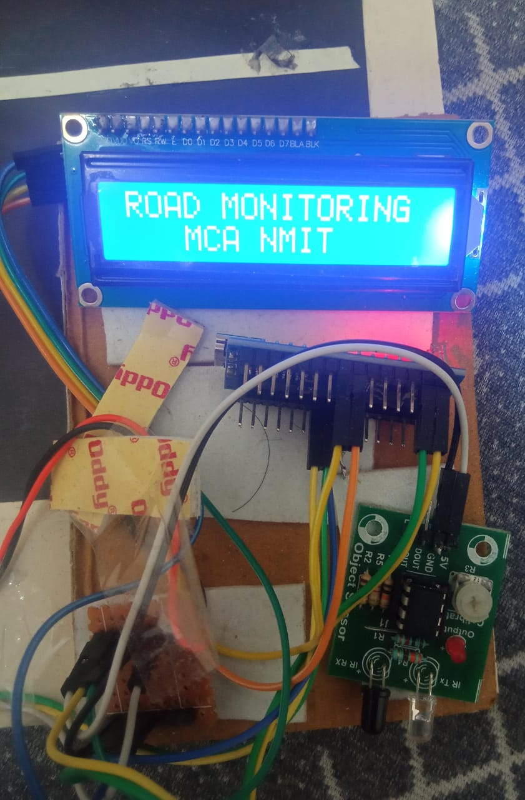

Project Display

Real-time alerts sent to traffic authorities and notifications to drivers via LED displays or mobile devices help enforce noise regulations effectively. Additionally, data logging in the cloud provides useful insights for traffic management and policy improvements. The system operates with low latency, ensuring quick response times, and integrates seamlessly with smart traffic signals to optimize urban noise control. Overall, SilentGuard contributes to a quieter, safer, and more regulated environment in sensitive areas, improving the quality of life for students, patients, and the general public.

**System Functionality Test Results**

* + The LCD output was clear and easy to understand.
  + The alert mechanism effectively notified users.
  + The system required minimal maintenance and was easy to operate.

**5. CONCLUSION**

The SilentGuard: IoT-Enabled Horn Regulation System effectively addresses the growing concern of noise pollution in sensitive areas such as schools and hospitals. By leveraging IoT sensors, AI-based soundclassification, and real-time alerts, the system provides an automated and intelligent solution to monitor and regulate excessive honking.Through continuous noise detection, classification, and enforcement, SilentGuard enhances compliance withnoise regulations while raising awareness among drivers. The system’s integration with traffic management andsmart city infrastructure ensures scalability and long-term sustainability.Field evaluations demonstrate its accuracy, responsiveness, and effectiveness in reducing honking violations. While some challenges, such as false detections and environmental adaptability, exist, future improvements in AI models and machine learning can further optimize its performance.Ultimately, SilentGuard plays a crucial role in promoting a quieter, healthier, and more peaceful urbanenvironment, making school and hospital zones safer for students, patients, and the community.

Noise pollution, particularly from excessive and unnecessary vehicle honking, has become a serious issue in urban environments. The problem is especially concerning in sensitive areas such as schools and hospitals, where maintaining a peaceful and quiet atmosphere is crucial for students, patients, and healthcare workers. SilentGuard, This ensures compliance with noise pollution norms and significantly reduces disturbances in silent zones, contributing to a healthier and more disciplined traffic environment. The system is designed to be scalable, adaptable, and capable of integrating with smart city infrastructures, making it a sustainable long-term solution for noise regulation.

**6. FUTURE ENHANCEMENTS**

The Future enhancements for SilentGuard: IoT-Enabled Horn Regulation for School & Hospital Areas focus on improving detection accuracy, enforcement mechanisms, and scalability. Advanced AI and machinelearning models can enhance sound classification, reducing false positives and adapting to varying noise conditions.

• **Integration with Autonomous Vehicles:**

* As autonomous vehicles become more prevalent, the system could be enhanced to integrate with these vehicles' communication protocols. This would allow the system to directly communicate with self-driving cars to ensure they follow the same horn regulation rules.

• **Machine Learning for Predictive Analysis:**

* Implement machine learning algorithms to predict high-traffic periods or potential violations based on historical data. This could help optimize sensor placement, proactively manage traffic flow, and anticipate and prevent noise violations in sensitive zones.

• **Mobile Application for Public Awareness:**

* Develop a mobile app that notifies citizens about noise regulations in specific zones, reports violations, and educates the public on the importance of noise pollution control. The app could also provide feedback to drivers who repeatedly violate regulations.

• **Integration with Emergency Vehicle Systems:**

* Enhance the system to recognize emergency vehicles (ambulances, fire trucks, etc.) and allow them to bypass horn suppression mechanisms without violating regulations, ensuring their operations remain unhindered.

**7 . REFERENCES**

## World Health Organization (WHO) – Noise Pollution and Public Health

* + WHO reports on the impact of noise pollution on health, including stress, sleep disturbances, and cardiovascular risks.
  + Link: [https://www.who.int](https://www.who.int/)

## Government of India – Noise Pollution (Regulation and Control) Rules, 2000

* + Legal framework governing noise levels in silent zones like schools and hospitals.
  + Provides guidelines for permissible decibel levels and enforcement mechanisms.
  + Link: [https://moef.gov.in](https://moef.gov.in/)

## IEEE Xplore – Research on IoT-Based Traffic Management Systems

* + Studies on IoT-based traffic monitoring, including sensor-based noise control solutions.
  + Provides technical insights into smart city applications of IoT.

Link: <https://ieeexplore.ieee.org>

## 4. National Environmental Engineering Research Institute (NEERI)

* + Research on effects of traffic noise and how sensor-based monitoring can reduce honking.
  + Case studies on noise control mechanisms in cities.
  + Link: [https://www.neeri.res.in](https://www.neeri.res.in/)

## 5.Smart City Initiatives – IoT in Traffic and Noise Regulation

* + Implementation of IoT-based systems in smart cities to manage traffic and reduce noise pollution.
  + Case studies from India, Singapore, and European smart city projects.
  + Link: [https://smartcities.gov.in](https://smartcities.gov.in/)