Sorting: Bubble Sort & Insertion Sort

Date of Submission:20 January 2020

To:

Rajani Ma’am

DOCSE

By:

Achyut Thapa

Aadarsha Thapa

Prajwol Manandhar

Type:Mini-Project.

Description

Sorting refers to arranging the given set of data in an order. It arranges all the input data in ascending or descending order. There are multiple types/ways of sorting. Here, we are going to talk about bubble sort and insertion sort. If input data is in ascending order but the sorting to be done is in descending order it will be the worst case.

Bubble sort is a simple sorting algorithm that swaps the adjacent elements is they are in the wrong order. It is one of the many types of sorting and easy to understand. The worst case scenario of bubble sort occurs when there is a need to swap every time it checks.

Insertion sort is another simple sorting algorithm that builds the final sorted array/list one at a time. It is more efficient than the bubble sort and is easy to understand.

The following table shows the complexities of bubble sort and insertion sort:

|  |  |  |
| --- | --- | --- |
|  | For Bubble sort | For Insertion sort |
| Best case complexity | O(*n*) comparisons, O(*1*) swaps | O(*n*) comparisons, O(*1*) swaps | |
| Worst case complexity | О(*n*2) comparisons and swaps | О(*n*2) comparisons and swaps | |
| Average case complexity | О(*n*2) comparisons and swaps | О(*n*2) comparisons and swaps | |
| Worst case space comp. | O(*1*) auxiliary | О(*n*) total, O(*1*) auxiliary | |

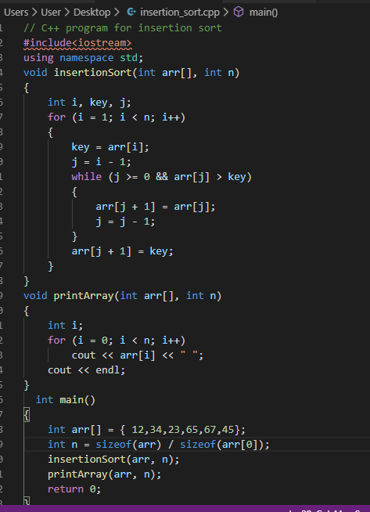The algorithms of the sorts are given below: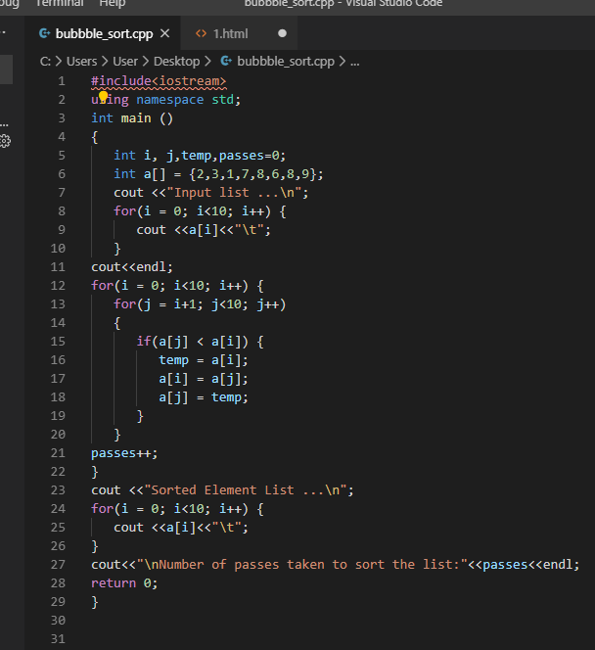

Conclusion

bubble sorting and insertion sorting are only two of the many types of sorting. Bubble sorting is the simplest of the sorting types which is done by simply swapping the adjacent elements if they are in wrong order. Insertion sort is another simple sorting algorithm that builds the final sorted array/list one at a time. The worst case scenario of the two sorting algorithms are given in the graphs. The worst case occurs when the time taken to sort in longest. The time taken to sort is longest when the arrangement is the exact opposite of how it is to be sorted. For eg: If the input is in ascending order but it is to be sorted in descending order, the worst case occurs. The time complexity of the worst case for both of the sorting algorithms is O(n^2).