NPM
It is the package manager that comes with Node.js and is used to install, manage, and share JavaScript/Node.js packages (libraries).
Instead of writing everything ourselves, we can install packages made by other developers.

NODEMON
We are repeatedly stopping and restarting the Node.js server every time we make a change. To avoid doing this manually, we can use nodemon, which automatically restarts the server whenever it detects changes in the project files.
Here, -g means we are installing nodemon globally, so it is available system-wide and can be used in other projects as well, rather than being installed only inside the current project.
Example 1:-
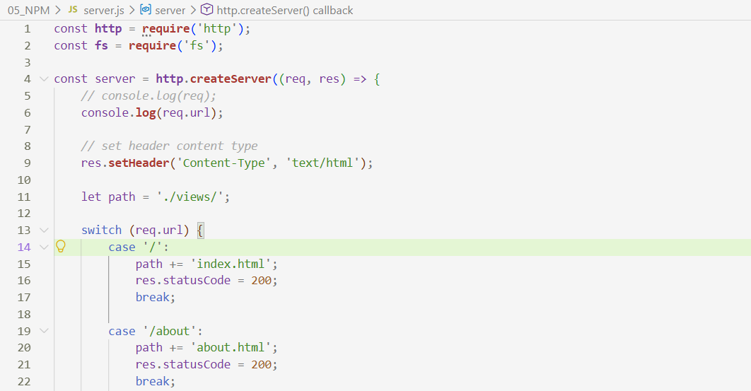
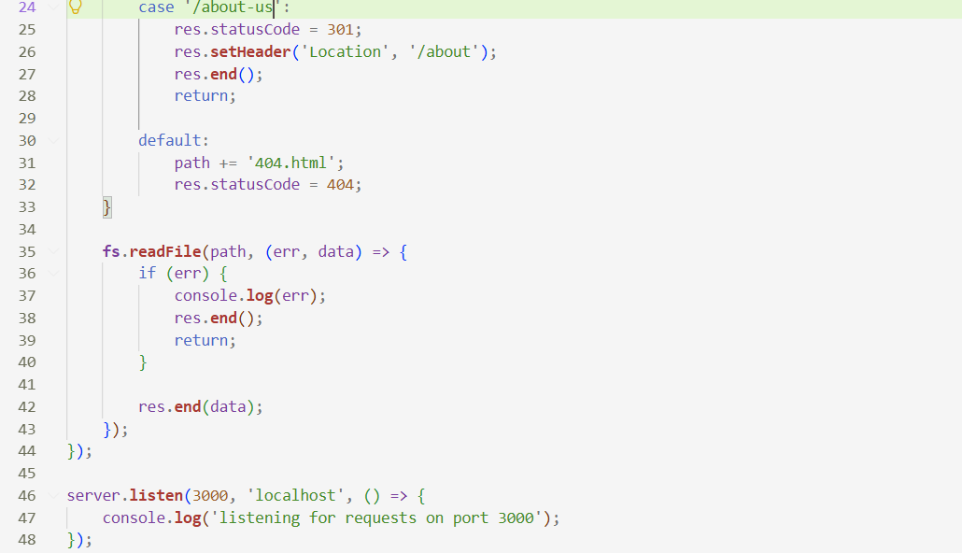
Here, we changed the route from /about-us to /about-bruh without manually stopping and restarting server.js. Since nodemon was running the server, it detected the change in the server code and automatically restarted the application. Basically, whenever we make a change to the server code, nodemon detects it and restarts the Node.js server automatically. This makes development much easier and saves us from repeatedly stopping and restarting the server manually.
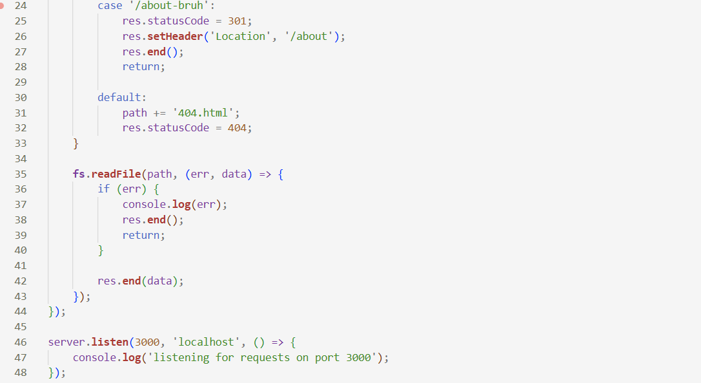
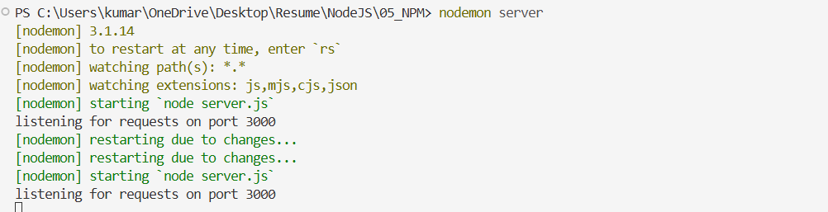

We should create a package.json file when our project uses third-party packages because it makes the project easier to recreate and manage. If we don’t provide specific values during npm init, npm fills in default values where possible, which we can change later as needed.
The package.json file contains information about the project, including the dependencies that the project needs to run. These dependencies are the packages installed locally for the project.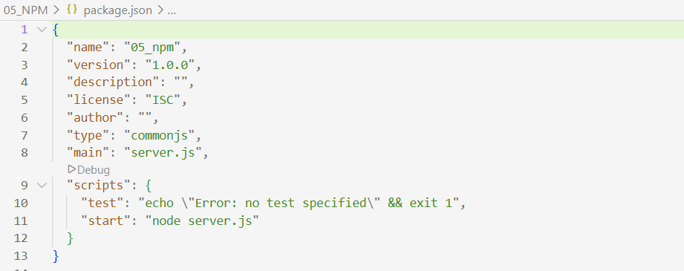
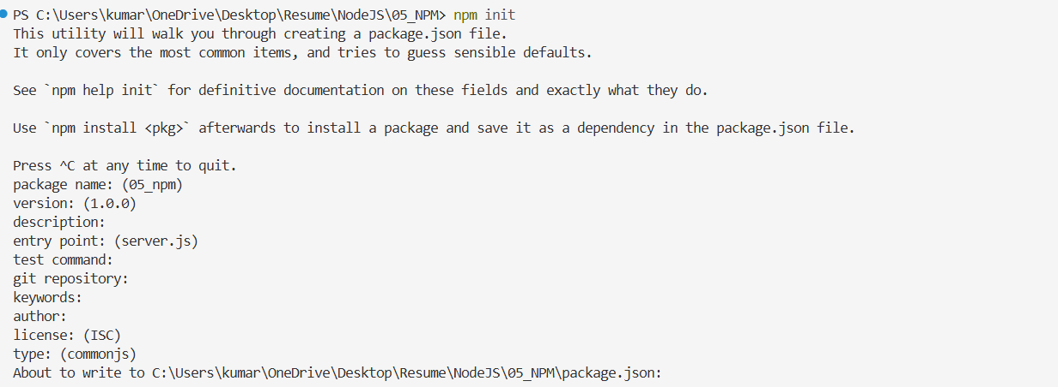
The reason nodemon does not appear in package.json is that we installed it globally. A globally installed package is available from any project on the computer, but it is not recorded as a dependency in the project's package.json.
If we want nodemon to appear in package.json, we can install it locally as a development dependency: npm install --save-dev nodemon
This adds nodemon under the devDependencies section of package.json.
LODASH
Lodash is a JavaScript utility library that provides many useful functions for working with arrays, objects, strings, and other data. Its functions are commonly accessed using the _ prefix, for example, _.chunk() or _.uniq().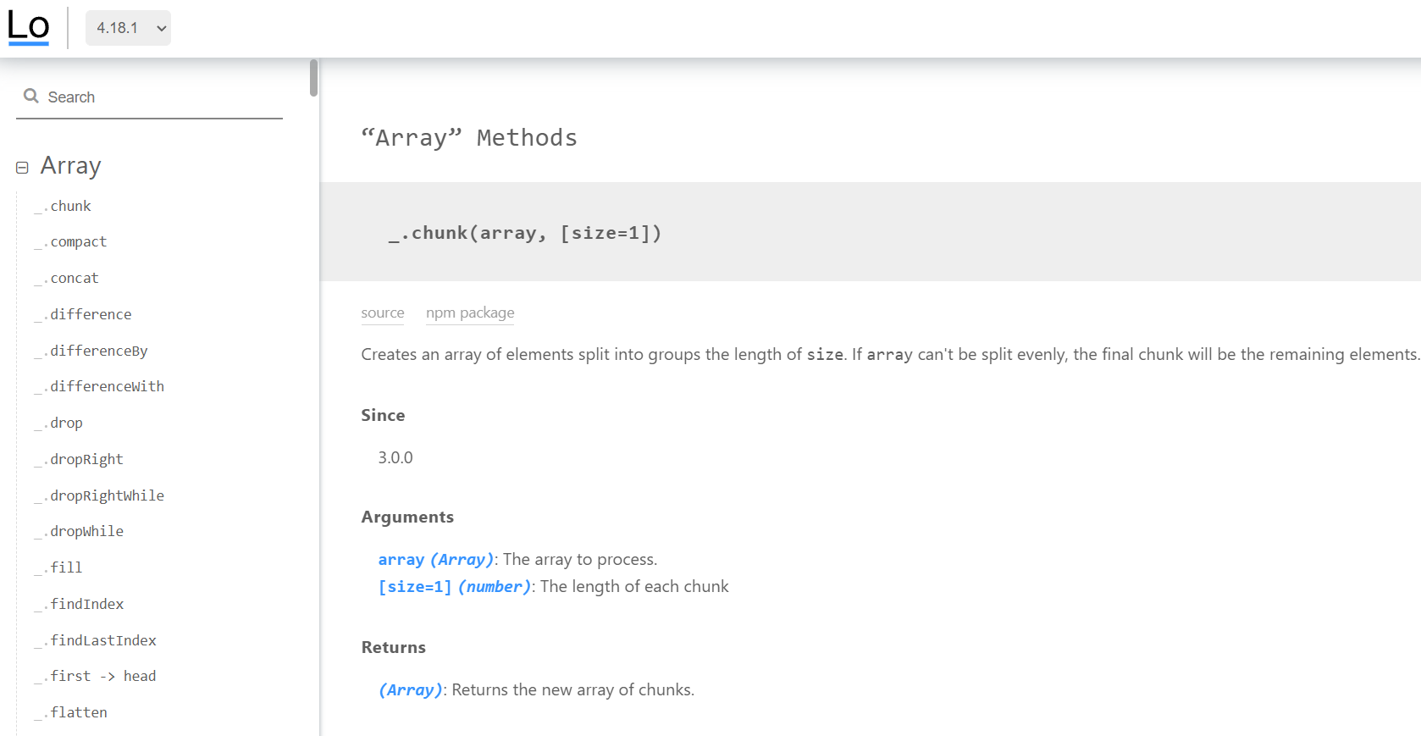
Installation :- Previously, we could use npm install --save lodash to install Lodash and save it in package.json. However, in modern npm versions, --save is the default behavior, so we can simply use: npm install lodash
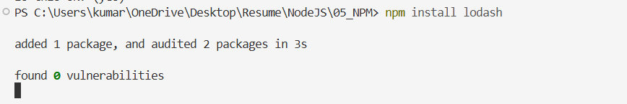
It will automatically add lodash to the dependencies section of package.json.

We can now see lodash inside package.json under the dependencies section. This means Lodash is installed as a local dependency of our project and is recorded in package.json.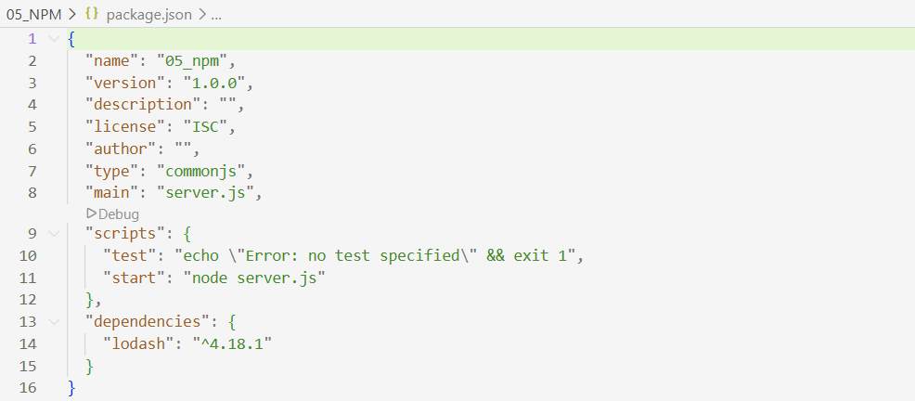
When we install a local dependency in a project, npm automatically creates a node_modules folder containing the installed package and its dependencies. If we delete the node_modules folder, the locally installed packages are removed from the project. However, they can be restored by running: npm install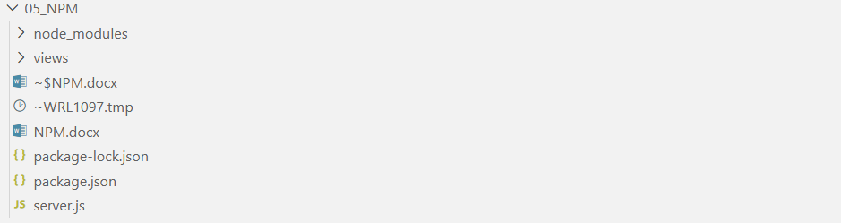
npm reads package.json (and the lockfile, if present) and reinstalls the required dependencies.
Example 3:- It is a convention to use _ as the variable name for Lodash, but we can use any valid variable name. The _.once() method ensures that a function runs only once. Even if greet() is called twice, it will execute only once during that server run, before the server is restarted or the module is reloaded.
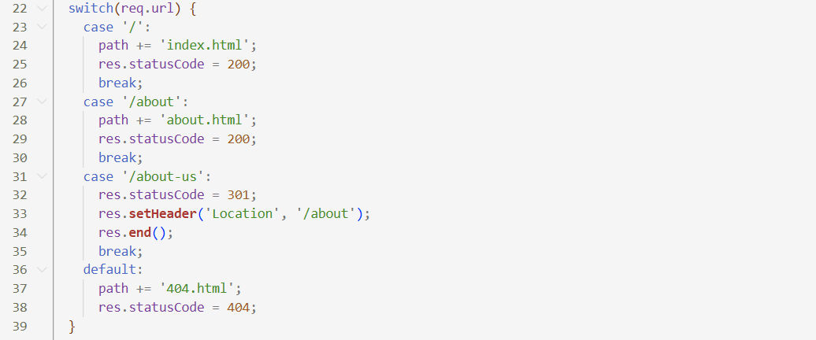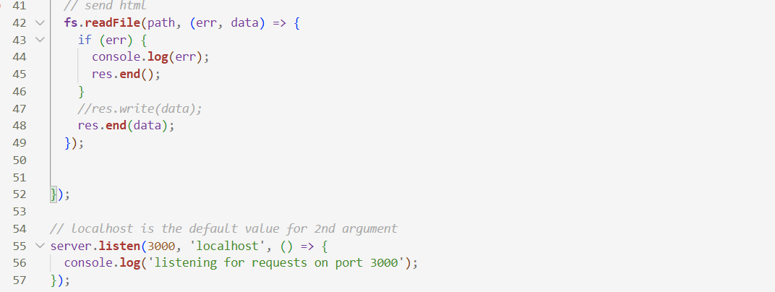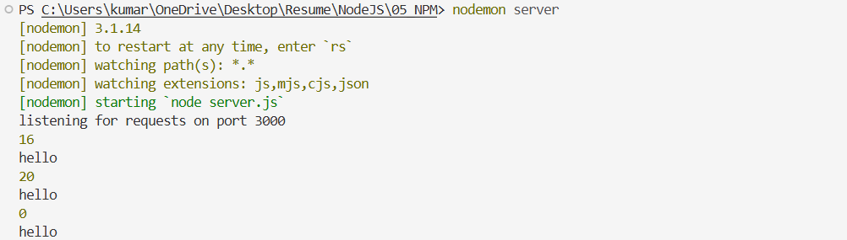

If we are sending our project to someone else, we generally do not send the node_modules folder because it can be very large and contains all the installed packages and their dependencies. Instead, we send the project code along with package.json (and usually package-lock.json).
Since the project depends on the packages listed in package.json, the recipient can simply run: npm install
npm will read the dependency information from package.json and install all the required packages into a new node_modules folder.

