Case Study - I
MACSE640



Under the kind guidance of
Dr. LOKESH KUMAR R

School of Computer Science and Engineering
Vellore Institute of Technology, Vellore August 2025

Name- Prajyot Kumar
Roll Number - 25MCS0055
Date – 09-04-2026
Virtual Laboratory Session Management

Project Overview
The Virtual Laboratory Session Management System is a full-stack web application designed to manage and validate virtual lab session records. The system enables users to create, search, and update session records using a combination of Session ID and Student ID as unique identifiers.
The primary objective of the system is to enforce controlled data updates based on session status, ensuring that only sessions in a scheduled state can be modified. This reflects real-world constraints where completed or cancelled sessions are locked from further changes.
The application follows a client-server architecture:
- The frontend provides an interactive user interface for managing sessions.
- The backend exposes RESTful APIs for handling business logic and validation.
- MongoDB is used as the database to store session records in a flexible document format.
Key Features:
- Creation of session records with validation
- Search functionality using Session ID and Student ID
- Controlled update mechanism with status-based restrictions
- Real-time feedback for success and failure cases
- Persistent storage using MongoDB
Business Rule:
Updates to fields such as Lab Module and Experiment Slot are permitted only when the session status is "scheduled". Any attempt to update records with status "completed" or "cancelled" is rejected by the system.
System Architecture (Simple Version)
The system follows a basic 3-layer architecture consisting of the frontend, backend, and database.
Frontend
The frontend is built using HTML, CSS, and JavaScript.
It provides a user interface to:
- Create session records
- Search for sessions
- Update session details
The frontend sends requests to the backend using HTTP (Fetch API).
Backend
The backend is developed using Node.js and Express.js.
It handles:
- API requests
- Validation of input data
- Business rules (update restrictions)
APIs used:
- POST /api/sessions → Create session
- GET /api/sessions/:sessionId/:studentId → Search session
- PUT /api/sessions/:sessionId/:studentId → Update session
Database
The database used is MongoDB.
- Stores session records
- Uses a collection called sessions
- Each record contains session details like ID, student ID, module, slot, and status
Code:-
Session.js
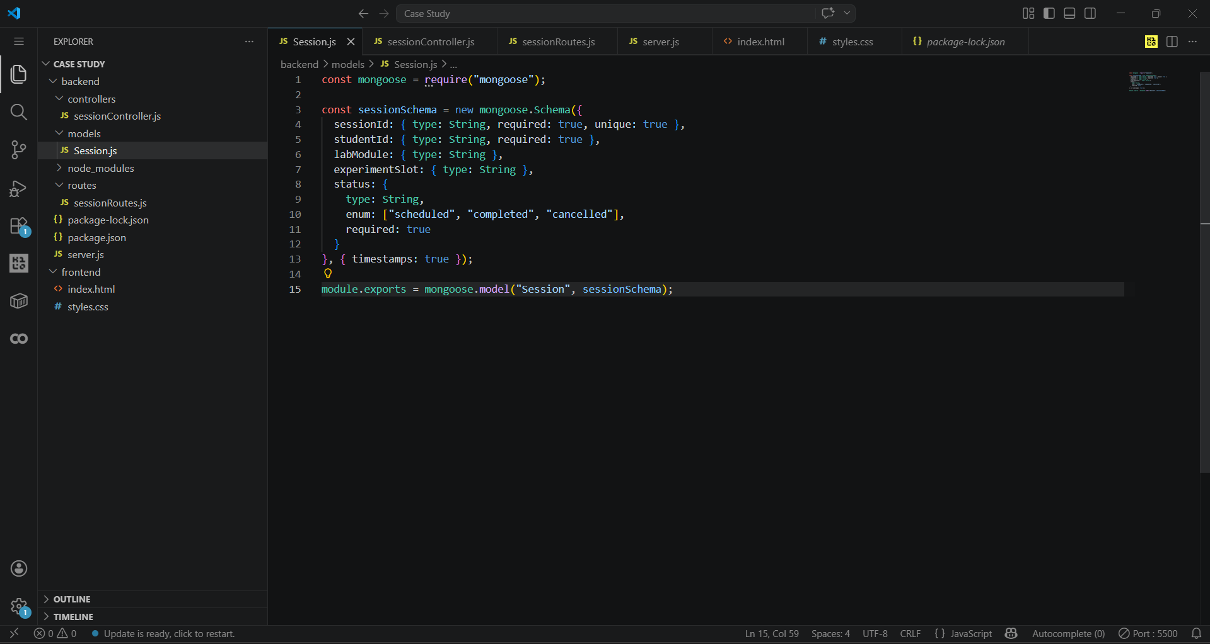

SessionController.js
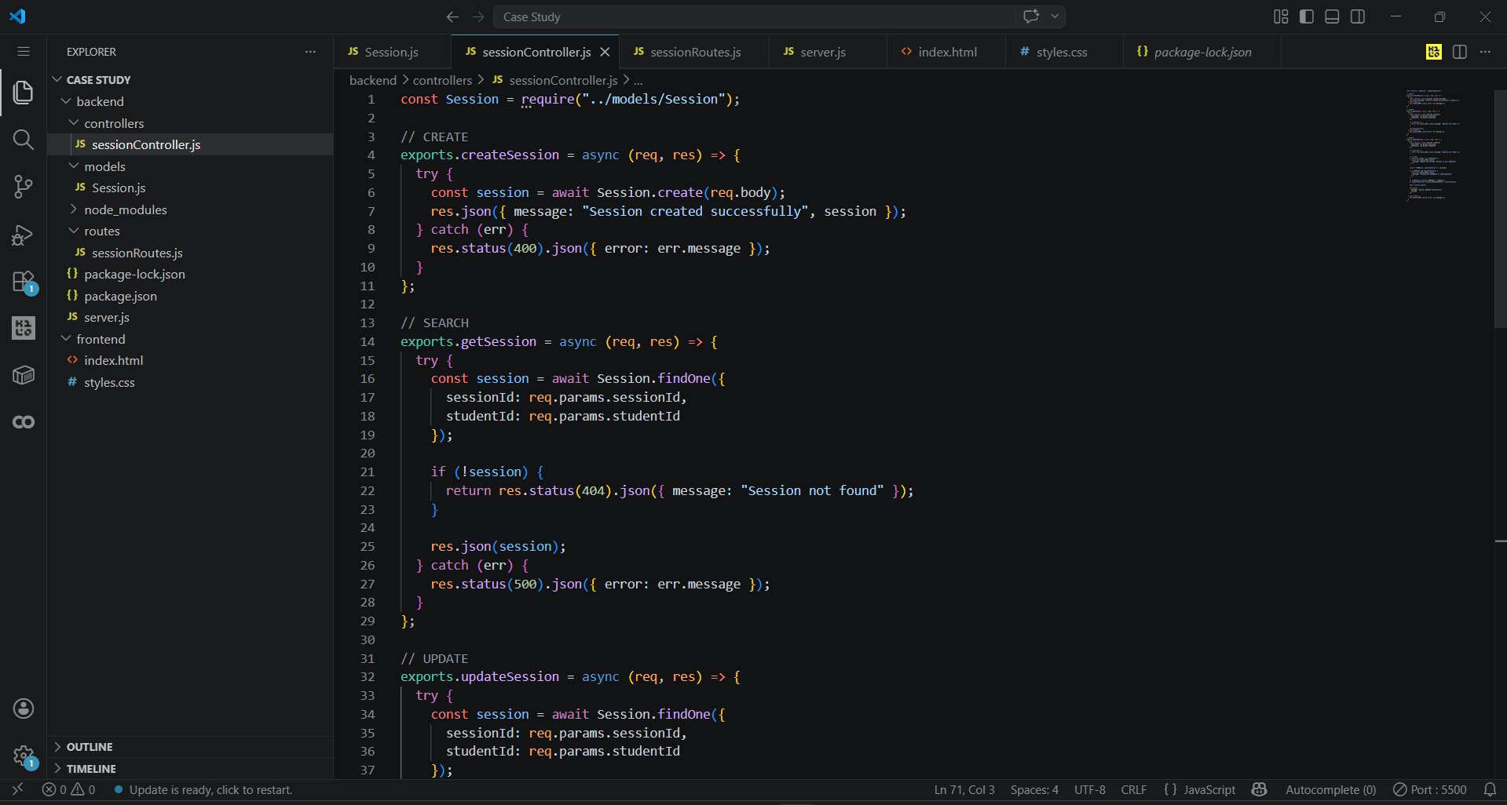

SessionRoutes.js
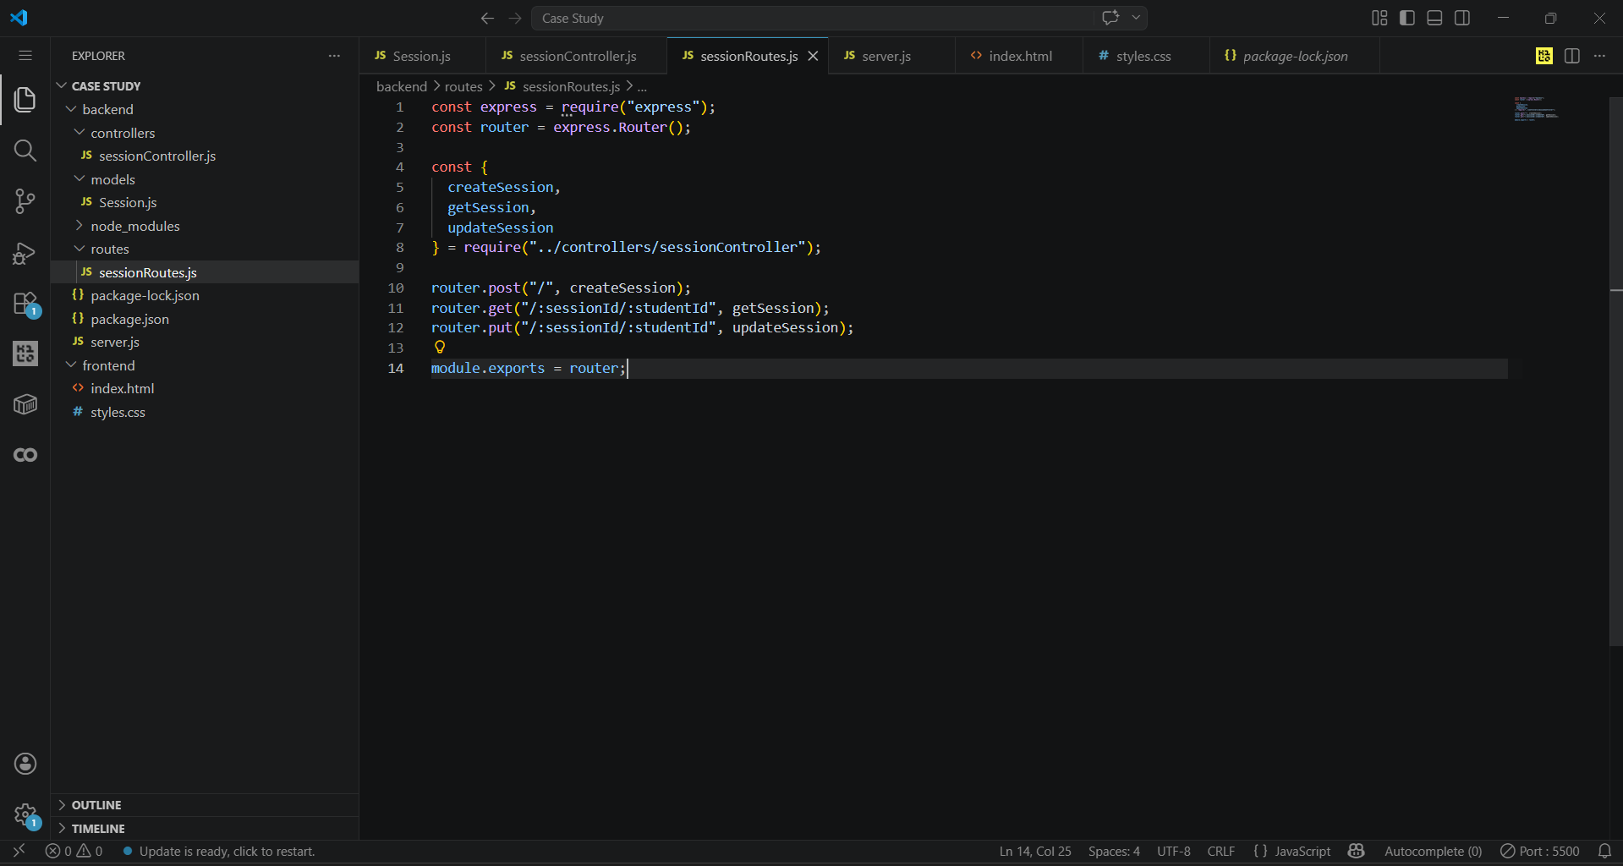

Server.js
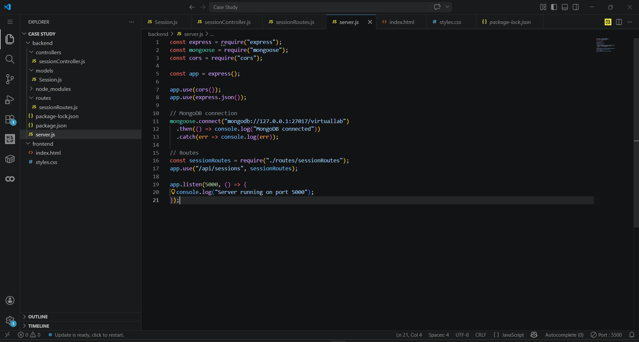

Index.html
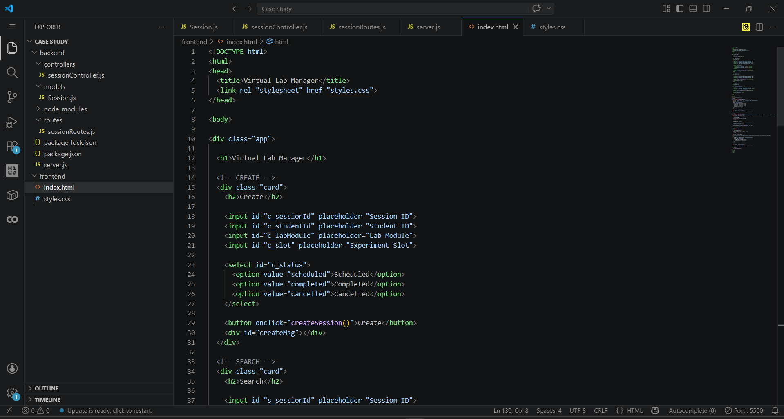

Style.css
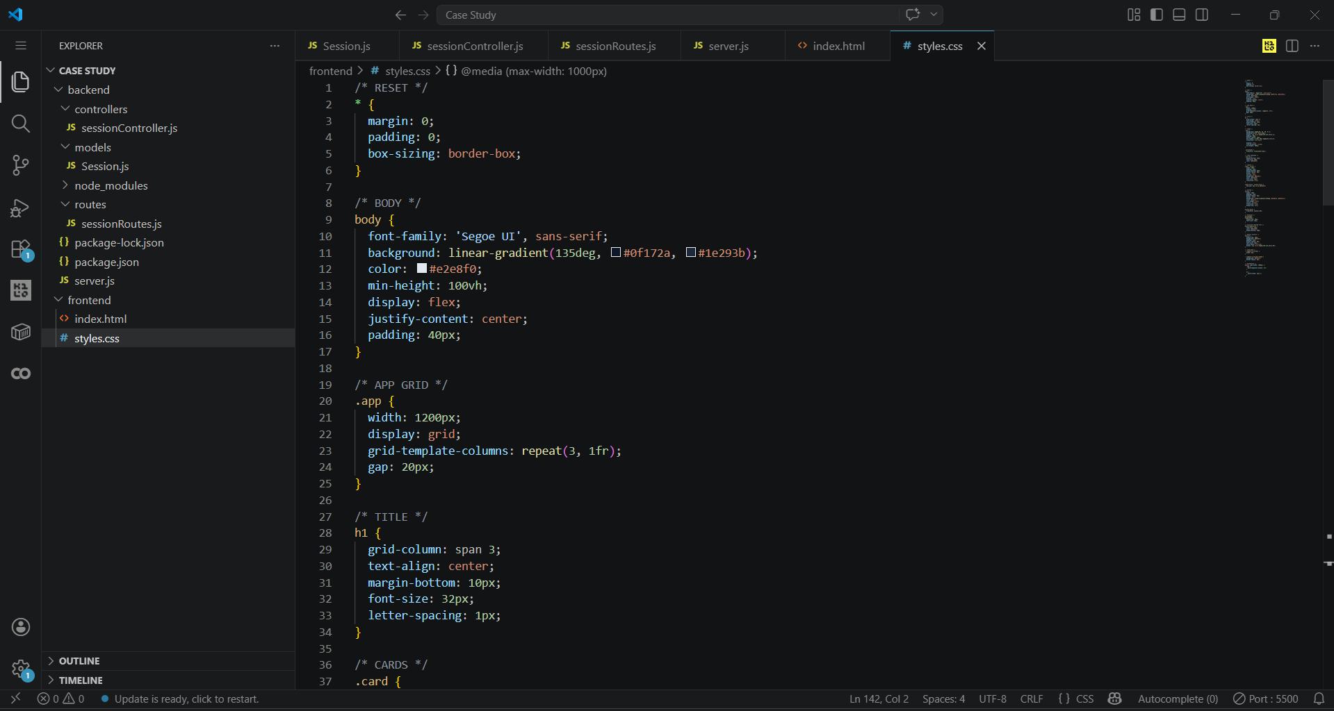

Output:-
This is the Front end section of the Project. We have 3 sections. One is to create and second to Search nased on SessionID and SudentID and last is update section where we Update our data which we gave when we created it.
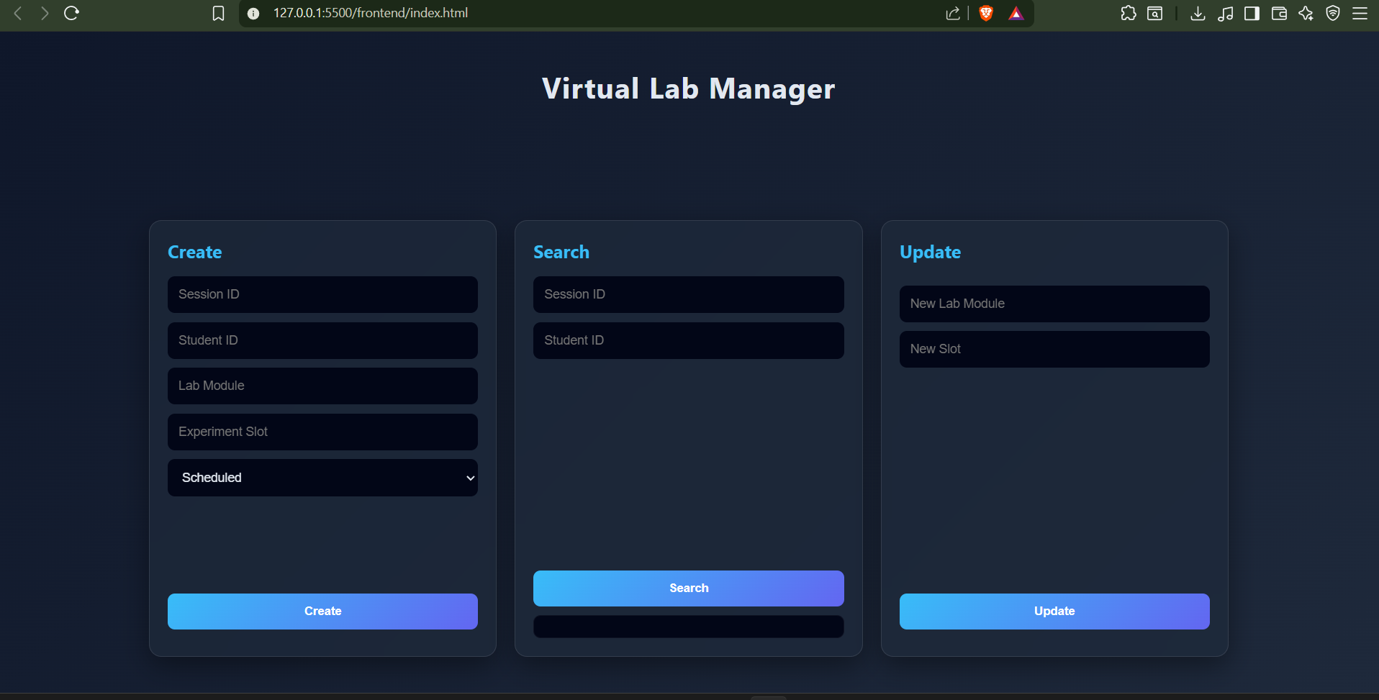

We simply gave it different values and create a new Session.
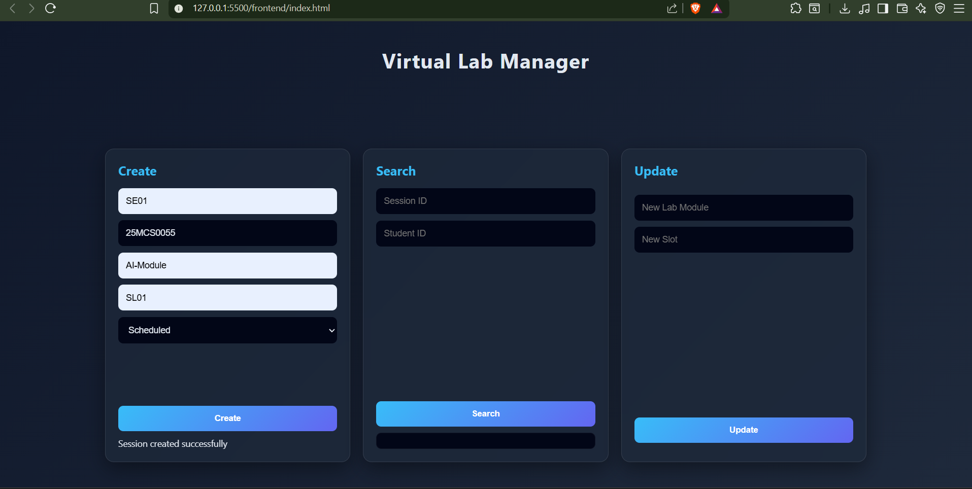
The change is similarly reflected in the MongoDB Compass with the exact we gave.
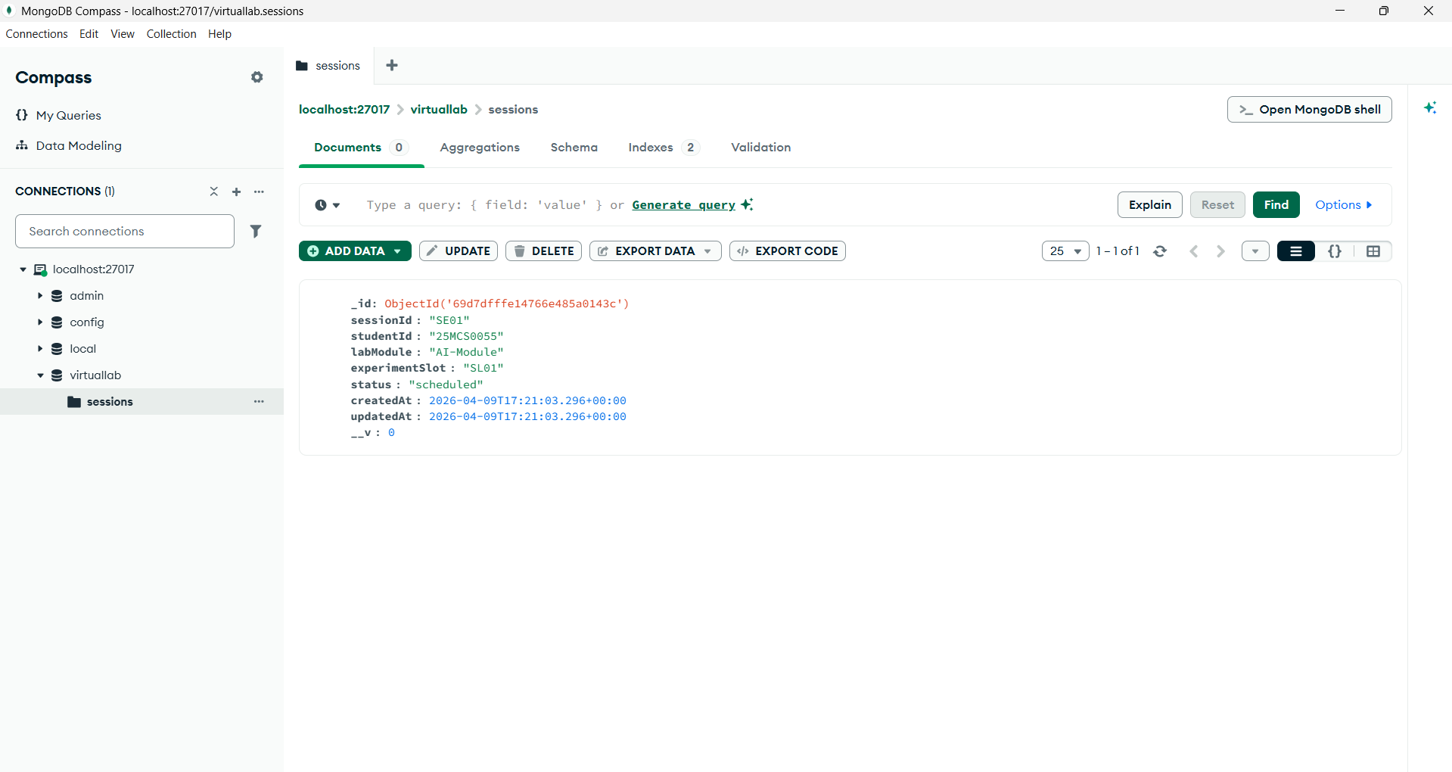

We can even add multiple people sessions here as we can see.
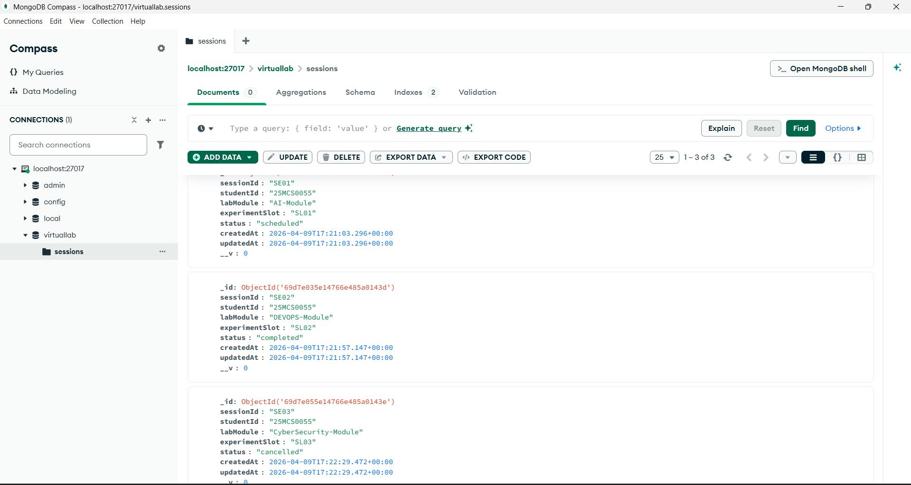

We search for the SE01 sessionID that we created before and we update the Lab manual value along with slot time.
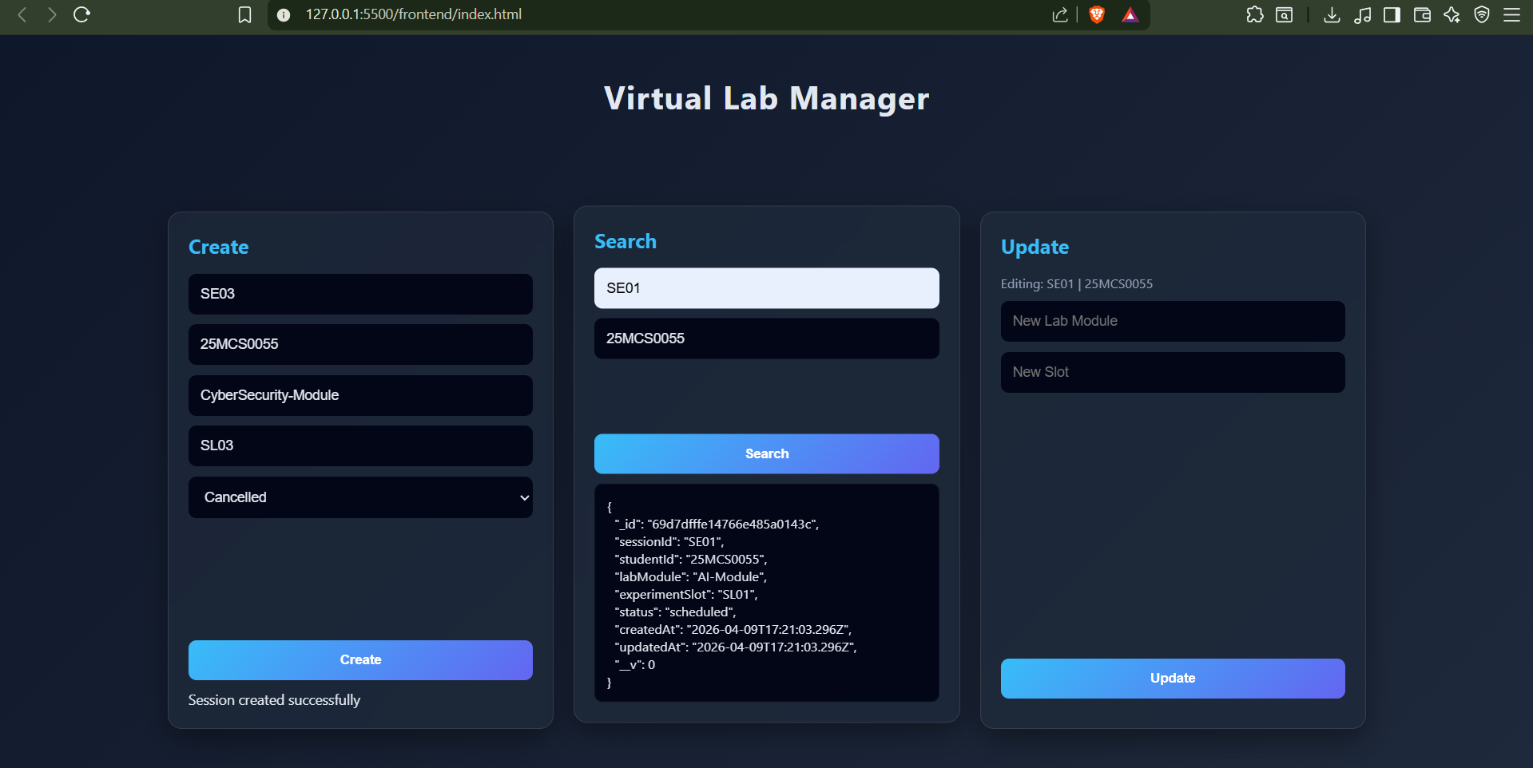
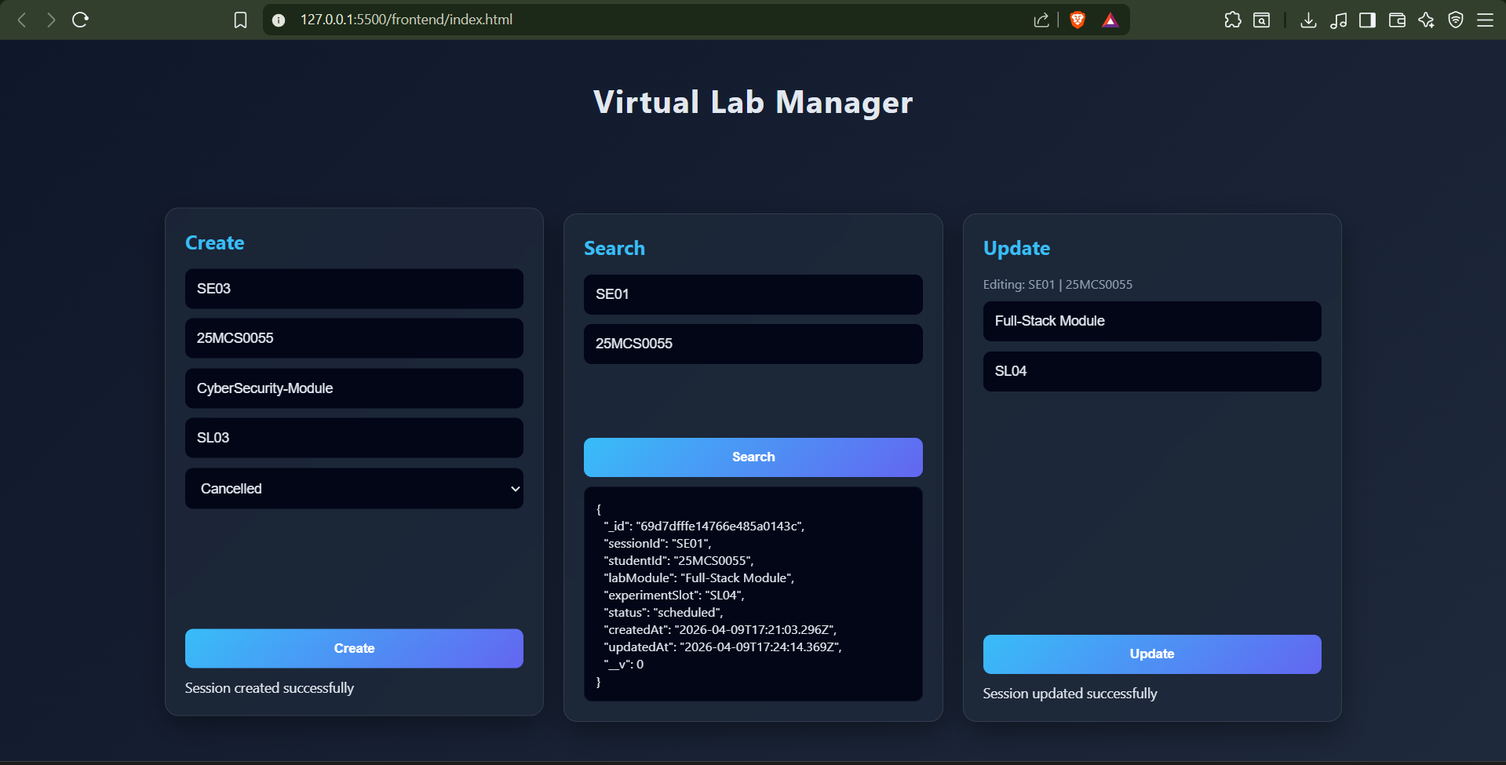

As we can the changes are being reflected in the compass.
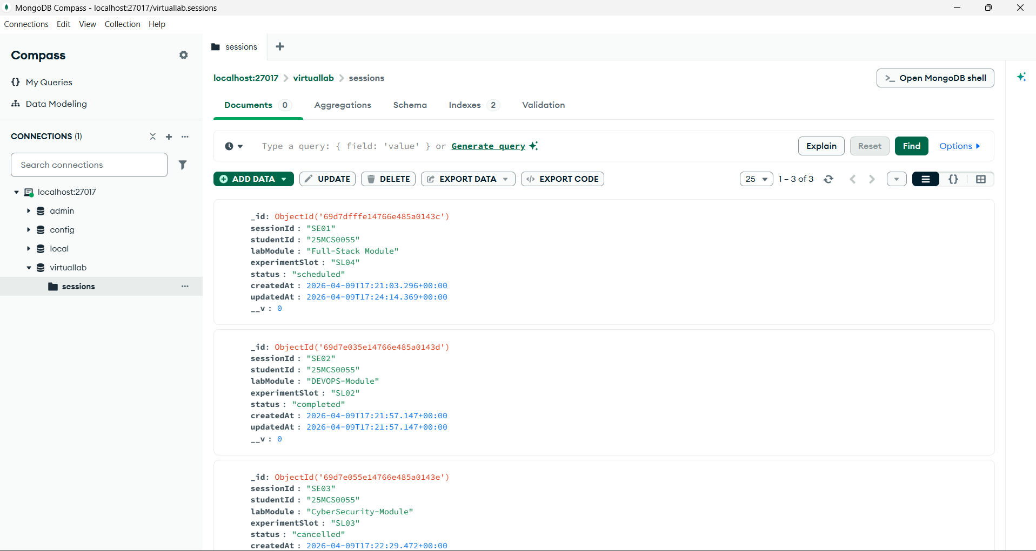

Here we checked with a wrong Session ID and it automatically gave us “ Session not found “.
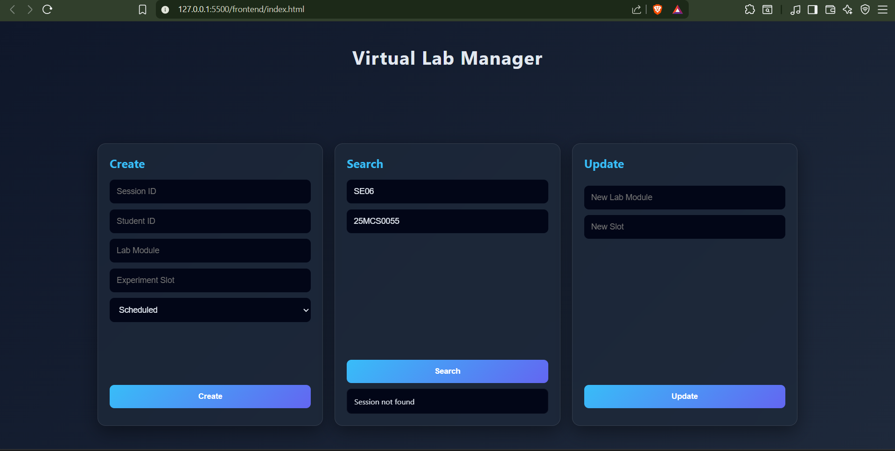

We checked another case here where we try to update a session which has a status of complete. Our code denies it since it only allows updation on those who has status as scheduled.
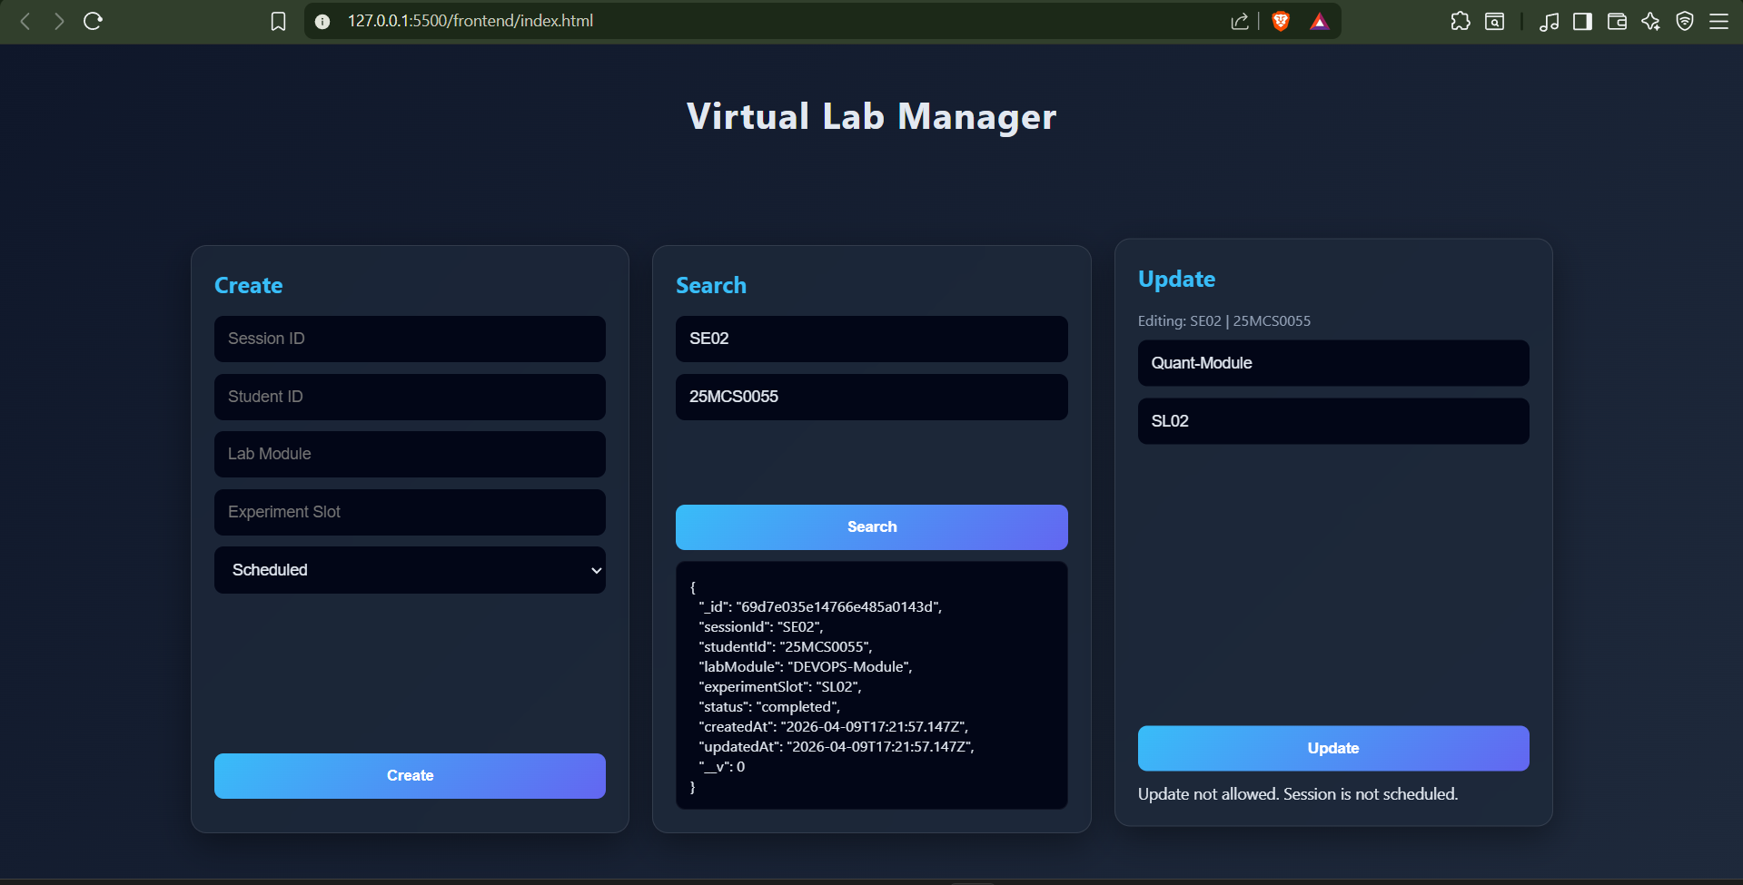

Also as we can see, our MongoDB is connected.
