SOFTWARE REQUIREMENTS SPECIFICATION
IEEE 29148 — Inspired Structure
Resilient Self-Healing Cache Engine
for Spring Boot
A reusable, provider-agnostic Spring Boot Starter delivering resilient,
observable caching with automated recovery and intelligent cache management.

Field | Value
Document Version | 1.0 (Frozen Architecture)
Document Type | Software Requirements Specification (SRS) + High-Level Design (HLD) + Low-Level Design (LLD)
Project Type | Reusable Spring Boot Starter (Middleware / Library)
Standard Followed | IEEE 29148:2018 (Systems and software engineering — Life cycle processes — Requirements engineering), adapted
Prepared For | Engineering, QA, DevOps and Architecture stakeholders
Status | Frozen — Baseline for Implementation

Document Control

Revision History
Version | Description | Author | Status
0.1 | Initial vision, problem statement and scope draft | Project Team | Superseded
0.5 | IEEE-inspired SRS, HLD and initial LLD package/interface design | Project Team | Superseded
0.8 | LLD expansion: core classes, providers, recovery, persistence, REST API, exceptions, events, UML | Project Team | Superseded
1.0 | Architecture freeze; consolidated into a single research-paper-style specification with full UML diagram set | Project Team | Current — Frozen

Distribution List
- Software Architects — full document
- Backend Engineers — Sections 3, 6, 7, 8, 10, 11
- QA Engineers — Sections 4, 5, 11
- DevOps Engineers — Sections 3.8, 6.2, 12, 13

Table of Contents

1. Introduction

1.1 Purpose
This document is the Software Requirements Specification (SRS) for the Resilient Self-Healing Cache Engine, a reusable Spring Boot Starter that abstracts cache provider implementations while adding production-inspired capabilities such as health monitoring, automated recovery, cache warm-up, adaptive TTL management, cache stampede protection, observability, and provider abstraction.
Beyond a conventional SRS, this document also consolidates the High-Level Design (HLD) and Low-Level Design (LLD) produced during the design phase, together with the full set of UML diagrams (class, sequence, ER, deployment) that will drive implementation. It is written to be read like a technical specification / research paper: it not only states what the system must do, but explains why each architectural and technological decision was made, what alternatives were considered, and what has been deliberately excluded from scope.
The SRS serves as the single source of truth for architecture, implementation, testing and future enhancement of the engine. Every class, endpoint and database table referenced in later chapters traces back to a functional or non-functional requirement defined here.

1.2 Document Conventions
- Requirement identifiers follow the pattern FR-n (Functional Requirement) and are referenced consistently throughout Sections 4, 6, 7 and 11 so that design elements can be traced back to the requirement that motivated them.
- Code identifiers (class names, package names, configuration keys) are set in monospace font.
- Priority levels are High / Medium / Low, reflecting criticality to the v1.0 frozen scope, not necessarily implementation difficulty.
- UML diagrams use a consistent colour key: blue = orchestration/core classes, yellow = ports/interfaces, red = adapters/infrastructure-facing classes, green = data/return flow, purple = asynchronous/event-driven flow.

1.3 Intended Audience
Audience | Relevant Sections
Software Architects | 1, 2, 3, 7, 9
Backend Engineers | 4, 6, 7, 8, 10
QA Engineers | 4, 5, 11, Appendix C
DevOps Engineers | 3.8, 6.2, 12, 13
Project Stakeholders / Reviewers | 1, 2, 14, 15

1.4 Project Scope
The system provides: provider-independent caching, first-class Redis and Caffeine support in a two-level (L1/L2) architecture, automated recovery, health monitoring, cache warm-up, adaptive TTL, cache stampede protection, cache analytics (hot-key detection, usage trends), an operational admin dashboard, Prometheus/Grafana metrics integration, and Spring Boot auto-configuration.
The system does not replace Redis or Spring Cache. Instead, it extends Spring Boot with an additional resilience and operational layer sitting between application code and the underlying cache providers. A complete breakdown of included vs. explicitly excluded capabilities, with rationale, is given in Section 2.8.

1.5 Definitions, Acronyms, and Abbreviations
Term | Meaning
Cache Provider | The underlying technology used to store cached data (Redis, Caffeine).
Cache Adapter | A concrete implementation that communicates with a specific cache provider (RedisAdapter, CaffeineAdapter).
Cache Port | An interface exposed by the core engine that adapters implement (Dependency Inversion).
L1 Cache | The first-level, in-process cache (Caffeine) — extremely low latency, node-local.
L2 Cache | The second-level, distributed cache (Redis) — shared across all application instances.
Recovery | Automatic restoration of cache provider functionality after a failure is detected.
Warm-up | Preloading frequently accessed ("hot") entries into cache after a restart or recovery.
Hot Key | A cache entry that is requested with disproportionately high frequency.
Cache Stampede | A condition where many concurrent requests attempt to rebuild the same expired/missing cache entry simultaneously, overloading the backing data source.
TTL | Time To Live — the duration a cache entry remains valid before expiry.
Hexagonal Architecture | An architectural style (Ports & Adapters) that isolates core business logic from external technology concerns.
Cache-Aside | A caching pattern where the application code is responsible for loading data into the cache on a miss.
Adaptive TTL | A strategy where TTL values are dynamically tuned based on observed access patterns rather than fixed at configuration time.
DTO | Data Transfer Object — a plain object used to move data across the API boundary, decoupled from JPA entities.

1.6 References
- IEEE Std 29148-2018 — Systems and software engineering — Life cycle processes — Requirements engineering.
- Spring Framework and Spring Boot reference documentation (spring.io).
- Caffeine caching library documentation — Window TinyLFU eviction policy.
- Redis documentation — data structures, TTL semantics, Lettuce client.
- Resilience4j documentation — retry, circuit breaker and bulkhead modules.
- Micrometer / Prometheus / Grafana documentation — metrics instrumentation and visualisation.

2. Overall Description

2.1 Product Perspective
The engine is not a standalone application; it is a library that sits between a Spring Boot host application and one or more cache providers, additionally reporting into a metadata database and a metrics/visualisation stack. Figure 1 shows this in context.
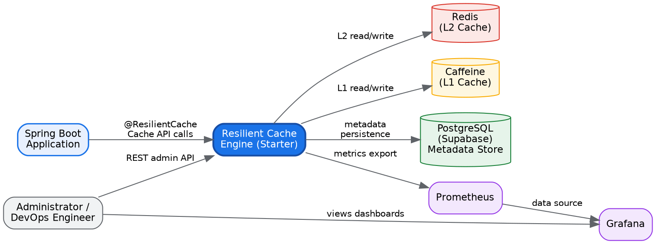
Figure 1. System context — the engine as middleware between a Spring Boot application, its cache providers, its metadata store, and the monitoring stack.

2.2 Problem Statement
Redis by itself is fast, but production systems that depend on a single external cache provider routinely encounter three classes of problems that are application-level, not infrastructure-level, and therefore cannot be solved by Redis configuration alone:
Cold-cache cascades: a Redis restart empties the cache; every subsequent request floods the origin database until the cache is repopulated naturally, which can itself overload the database.
Transient network failures: a brief Redis timeout surfaces as application errors instead of being retried or absorbed.
Cache stampedes: when a popular key expires, thousands of concurrent requests can each attempt to rebuild it from the origin simultaneously, multiplying database load by the number of concurrent callers.
The Resilient Self-Healing Cache Engine exists specifically to solve these three application-level problems through automated recovery, warm-up, and stampede protection, layered transparently on top of standard Redis/Caffeine usage.

2.3 Product Functions (Summary)
- Provider-independent, annotation-driven and programmatic caching (FR-1, FR-2, FR-3).
- Two-level (L1 Caffeine + L2 Redis) cache-aside strategy (FR-4).
- Continuous health monitoring with automated recovery and post-recovery warm-up (FR-5, FR-6, FR-7).
- Adaptive TTL and hot-key analytics (FR-8, FR-9).
- Cache stampede protection for concurrent rebuild storms (FR-10).
- Metrics, audit-event logging and an administrative dashboard (FR-11, FR-12, FR-14).
- Configuration-driven provider selection with startup-time validation (FR-13).

2.4 User Classes and Characteristics
User Class | Characteristics
Spring Boot Developers (Primary) | Integrate the starter into their services; expected to have working knowledge of Spring Boot, basic Redis concepts, and REST APIs. They interact mainly with `@ResilientCache` and the programmatic `CacheEngine` API.
Backend Engineers (Secondary) | Extend the engine itself — implement new adapters, add pipeline stages, or tune recovery/warm-up logic. Require familiarity with Hexagonal Architecture and the package structure in Section 7.1.
DevOps Engineers (Secondary) | Own the Docker Compose deployment, Prometheus/Grafana configuration, and production configuration of `application.yml`.
Software Architects (Secondary) | Review and evolve the architectural decisions in Sections 3 and 7 as the engine's adoption grows (e.g. adding new providers).
QA Engineers (Secondary) | Design and execute the test strategy in Section 11, including Testcontainers-based integration tests against real Redis/PostgreSQL.

2.5 Operating Environment
Category | Detail
Backend Runtime | Java 21, Spring Boot 3.x
Database | PostgreSQL (hosted on Supabase)
Cache Providers | Redis (L2), Caffeine (L1)
Monitoring | Prometheus (metrics store), Grafana (visualisation)
Deployment | Docker & Docker Compose (single-region, single Docker network)

2.6 Design and Implementation Constraints
- Must be implemented in Java 21 targeting Spring Boot 3.x — the engine cannot assume a different JVM baseline than its adopters.
- Must be built as a Maven multi-module project (`resilient-cache-starter` + `resilient-cache-demo`) matching conventional Spring Boot starter structure.
- Must use Docker Compose (not Kubernetes) for the reference deployment (Section 2.8).
- The Core module must have zero compile-time dependency on Redis- or Caffeine-specific classes (Hexagonal boundary, enforced by package visibility rules in Section 10).
- Persistent storage is for engine metadata only — the engine must never store or process the host application's business data.

2.7 Assumptions and Dependencies
- Redis is externally managed and reachable over the network; the engine does not provision or manage Redis Cluster/Sentinel topology itself.
- Developers integrating the starter already understand basic Spring Boot dependency injection and configuration conventions.
- Docker is installed for local development and evaluation of the reference stack.
- Network connectivity between the application container and Redis/PostgreSQL/Prometheus containers is available and unrestricted within the Docker Compose network.

2.8 Scope: Included vs. Explicitly Excluded

2.8.1 Included in v1.0
- Spring Boot Starter, Hexagonal Architecture, Redis Adapter, Caffeine Adapter, Provider Abstraction
- Cache-Aside Strategy, Automated Recovery, Cache Warm-up
- Health Monitoring, Adaptive TTL, Hot Key Detection, Cache Stampede Protection
- Metrics Collection, Admin Dashboard, Prometheus, Grafana
- Supabase (PostgreSQL) metadata storage, Docker Compose, Swagger/OpenAPI documentation

2.8.2 Explicitly Excluded from v1.0 — and Why
Scope discipline is treated as a first-class engineering decision on this project. Every excluded item below was considered and consciously deferred, with the reasoning recorded so the decision can be revisited deliberately rather than by scope creep.
Excluded Item | Rationale
Kubernetes manifests / Helm charts | Out of scope for a library-level project; Docker Compose is sufficient to demonstrate and evaluate the engine locally. Revisit once the engine is adopted by a service that already runs on Kubernetes.
API Gateway | The engine is a library embedded inside a Spring Boot application, not a network-facing service that requires its own gateway/ingress layer.
Kafka / RabbitMQ | Recovery and metrics events are internal, in-process concerns handled by Spring's `ApplicationEventPublisher`. Introducing a message broker would add an external dependency and operational burden disproportionate to the problem being solved.
Authentication Server (OAuth2/SSO) | Securing the admin REST API/dashboard is the responsibility of the host application; the engine does not prescribe an identity provider. v1.0 assumes the host application places the admin endpoints behind its own security configuration.
Service Discovery (Eureka/Consul) | The engine has no independently deployable service instances to register — it lives inside the consuming application's process.
Config Server (Spring Cloud Config) | Configuration is supplied via standard `application.yml`/environment variables, consistent with how other Spring Boot starters are configured.
Distributed Transactions / Saga | The engine does not participate in multi-service transactions; cache operations are inherently best-effort and idempotent by design.
CQRS / Event Sourcing | These are data-modelling patterns for application domains, not appropriate for a caching middleware whose own persisted data is simple metadata.
Custom Redis Cluster implementation | Redis Cluster/Sentinel topology, if used, is managed by the infrastructure team operating Redis; the engine talks to whatever single logical endpoint it is configured with via Lettuce.
Custom Retry Framework | Resilience4j already provides a mature, well-tested retry/backoff implementation — reinventing it would add risk without benefit.
Custom Circuit Breaker | Same rationale as above — Resilience4j's circuit breaker is reused rather than rebuilt.
Custom Rate Limiter | Rate limiting the origin service is outside the engine's responsibility; stampede protection (Section 7.3) already prevents the specific problem of concurrent rebuild storms.
Hazelcast / Ehcache / Memcached adapters | Deferred to Future Enhancements (Section 15) — the Provider Port is designed so these can be added without touching the Core.
Multi-region cache synchronisation | Out of scope for v1.0, which targets a single-region deployment; listed as a Future Enhancement.

3. System Architecture (High-Level Design)
Unlike Section 2, which describes what the system should do, this section explains how the system is organised: its architectural style, layers, modules, and the technology choices behind each layer, together with the reasoning behind each decision.

3.1 Architectural Style: Hexagonal Architecture (Ports & Adapters)
The architecture is frozen as Hexagonal Architecture. This decision follows directly from the core requirement of provider independence: the engine must support Redis and Caffeine today, and Hazelcast/Ehcache/Memcached in the future, without the Core ever knowing which concrete technology it is talking to.
Why Hexagonal, specifically: The Core depends only on interfaces (“ports”) such as CachePort, RecoveryPort, and MonitoringPort. External systems implement those interfaces as “adapters” (RedisAdapter, CaffeineAdapter). This gives high testability (ports can be mocked in unit tests), loose coupling, easy extensibility (a new provider is a new adapter, not a Core change), and strict SOLID compliance — specifically the Dependency Inversion Principle.
Alternative considered: A simpler layered architecture (Controller → Service → Repository) was considered, but it does not structurally prevent provider-specific code from leaking into the Core over time; Hexagonal Architecture makes that leak a compile-time impossibility rather than a code-review discipline.

3.2 Layered Architecture
The system is organised into seven layers, each with a single, non-overlapping responsibility. The Controller layer (belonging to the host application) never talks directly to Redis — every call is forced through the Core and its Ports.
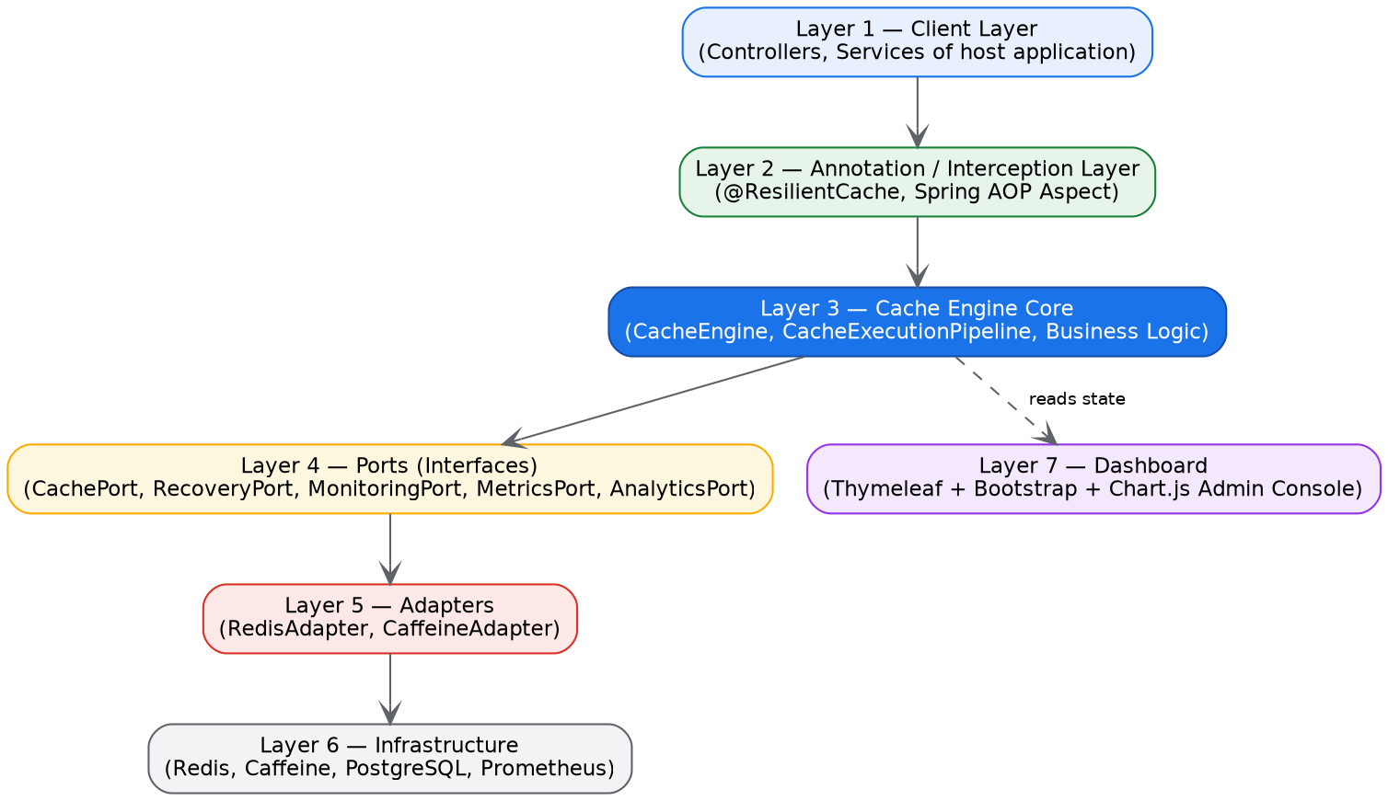
Figure 2. Seven-layer architecture, from the host application's Client Layer down to Infrastructure, with the Dashboard layer reading state from the Core.
Layer | Responsibility | Representative Classes
1. Client | REST/service calls made by the host application | ProductController, ProductService (host app)
2. Annotation / Interception | Reads @ResilientCache, generates cache key, resolves TTL, invokes engine | CacheAspect (Spring AOP)
3. Cache Engine Core | All business logic: workflow, recovery coordination, TTL decisions, stampede protection, hot-key analysis | CacheEngine, CacheExecutionPipeline
4. Ports | Interfaces only — no implementation | CachePort, RecoveryPort, MonitoringPort, MetricsPort, AnalyticsPort
5. Adapters | Implement the ports for a specific provider | RedisAdapter, CaffeineAdapter
6. Infrastructure | External technologies | Redis, Caffeine, PostgreSQL, Prometheus
7. Dashboard | Admin interface reading engine state | DashboardController + Thymeleaf views

3.3 Hexagonal View: Ports and Adapters
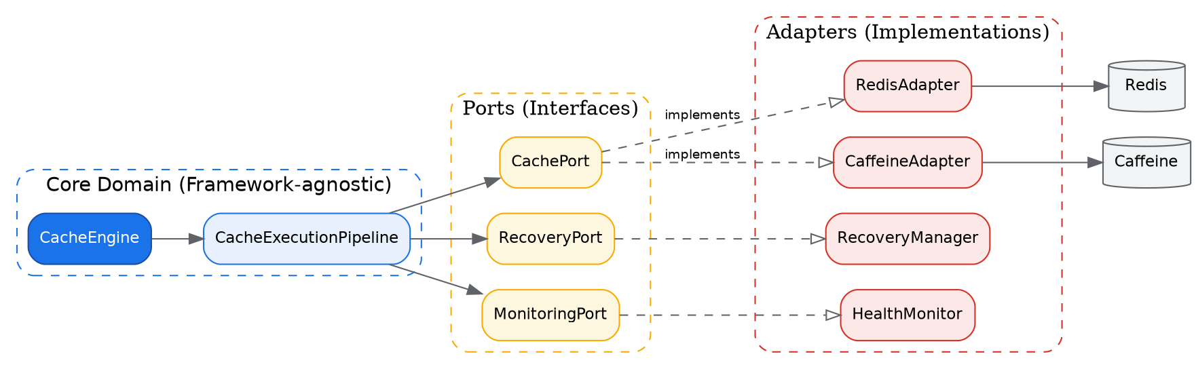
Figure 3. Ports & Adapters view: the framework-agnostic Core depends only on Port interfaces; concrete Adapters implement those Ports and talk to real infrastructure.

3.4 Major Modules
The system is divided into twelve independently testable modules, each answering exactly one question about where a given concern lives (e.g. “Where is recovery logic?” → the Recovery Module).
# | Module | Responsibilities
1 | Starter Module | Auto-configuration, Spring Bean registration, `application.yml` property binding via `@ConfigurationProperties`.
2 | Annotation Module | Defines `@ResilientCache` and reads/parses SpEL cache-key expressions.
3 | Cache Core | Coordinates every cache operation (read/write/update/delete) through the execution pipeline.
4 | Provider Module | Concrete Redis and Caffeine implementations of `CachePort`.
5 | Recovery Module | Detects provider failures, retries with backoff, and triggers warm-up on restoration.
6 | Health Module | Periodically pings providers, measures latency, and publishes health status.
7 | Metrics Module | Collects hit/miss counters, latency histograms, and recovery counts via Micrometer.
8 | Analytics Module | Detects hot keys, analyses TTL efficiency, and tracks usage trends.
9 | Persistence Module | Stores recovery history, health history, statistics, and configuration snapshots in PostgreSQL.
10 | Dashboard Module | Thymeleaf + Bootstrap + Chart.js administrative console.
11 | API Module | REST controllers exposed for administrators and demonstration purposes.
12 | Demo Application | A reference Spring Boot application (`resilient-cache-demo`) that exercises the starter end-to-end.

3.5 Module Communication Flow
A single incoming request flows strictly downward through the layers; the Controller never talks to Redis directly, and each intermediate class has exactly one collaborator it delegates to next.
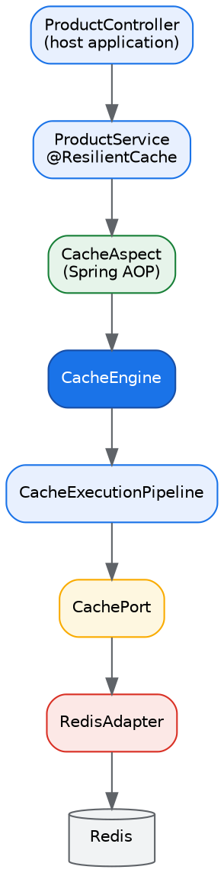
Figure 4. Module communication flow for a single cached request, from the host application's controller down to Redis.

3.6 Multi-Level Cache Architecture (L1 + L2)
Rather than choosing either Redis or Caffeine, the frozen v1.0 architecture uses both together, in a classic two-tier caching topology. This was the single highest-value architectural refinement identified during design: it turns the engine from a “provider switcher” into a genuine multi-level caching system, giving a clear architectural story for why both providers are supported simultaneously rather than as mutually exclusive options.
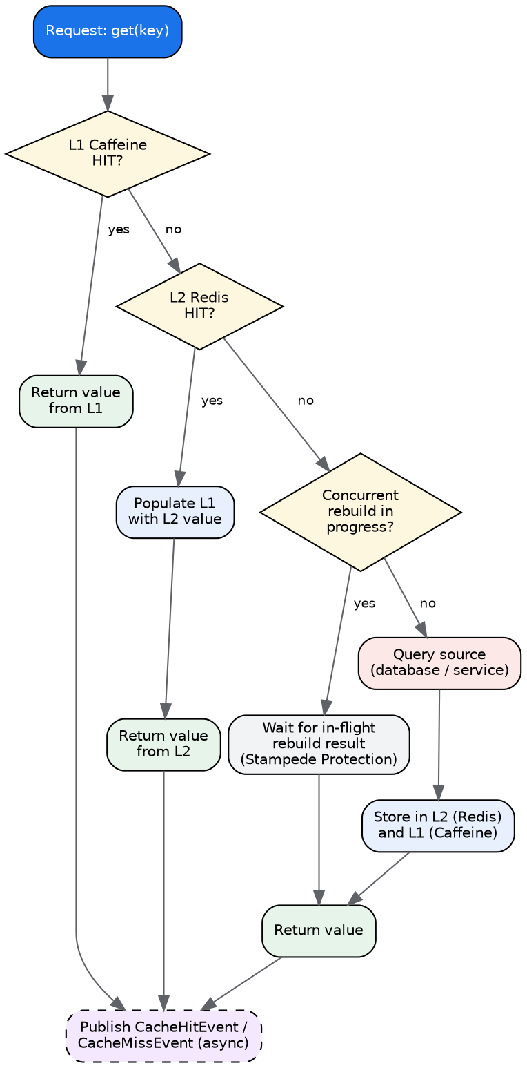
Figure 5. Multi-level cache-aside flow: L1 (Caffeine) is checked first, then L2 (Redis); a miss on both triggers stampede-protected origin load and population of both levels.
Why this matters: L1 (Caffeine) absorbs the vast majority of read traffic at sub-millisecond, node-local latency. L2 (Redis) provides a shared, distributed fallback so that a cache miss on one application instance can still be served from another instance's warm L2 entry, rather than always falling through to the origin database.

3.7 Synchronous vs. Asynchronous Design Decisions
One of the most consequential design decisions in the project is which operations must complete before a response is returned to the caller (synchronous) and which can continue in the background without the caller waiting (asynchronous). The rule applied throughout is simple: if the operation affects the correctness of the value the caller receives, it is synchronous; if it is purely for observability, analytics or audit, it is asynchronous.
Operation | Sync / Async | Reasoning
Cache lookup (L1/L2 read) | Synchronous | The caller is waiting for the data; it cannot receive a response before the cache is checked.
Cache write (store computed value) | Synchronous | If the write is deferred, the very next request could still miss the cache unnecessarily.
Metrics recording (hit/miss counters) | Asynchronous | The caller does not care whether metrics have been persisted; this is purely for administrators.
Health monitoring (periodic ping) | Asynchronous (scheduled) | Requests must not wait on a background health check; it runs on its own schedule.
Warm-up after recovery | Asynchronous | Users should keep using the application while thousands of keys are preloaded in the background.
Recovery event logging | Asynchronous | Persisting an audit row to PostgreSQL must never add latency to the request path.
Hot-key statistics update | Asynchronous | Per-request counter increments are deferred/batched so they never sit on the critical path.
The consequence of getting this wrong is significant: if every one of the above (metrics, event logging, hot-key tracking) were synchronous, and each added even 20–100 ms, every single cached request would be penalised by that combined latency — effectively negating the benefit of caching in the first place. Keeping the response path to lookup → (optional load) → store → return, and pushing everything else onto Spring's `@Async`-backed event listeners, is what allows the engine to add resilience and observability without adding response latency.

3.8 Deployment Architecture
The reference deployment brings up the full stack — application, Redis, PostgreSQL, Prometheus and Grafana — as a single Docker Compose network, satisfying the project's reusability and “evaluate in minutes” goals.
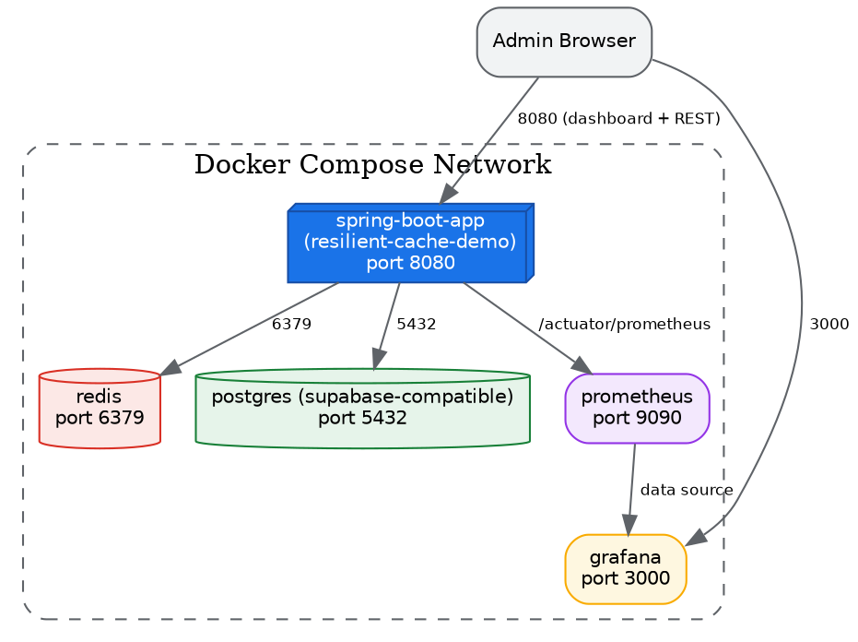
Figure 6. Deployment view: a single Docker Compose network hosting the Spring Boot application alongside Redis, PostgreSQL, Prometheus and Grafana.

3.9 Technology Stack and Justification
Every technology choice below was made deliberately, with at least one alternative considered and rejected for a stated reason, in the same way a technical design review would document them.
Layer | Technology | Why Chosen | Alternative(s) Considered
Language | Java 21 | LTS release with virtual threads, pattern matching and record types that simplify DTOs and reduce boilerplate in a library meant to be embedded in other teams' codebases. | Kotlin was considered but rejected — the target audience (enterprise Spring Boot teams) overwhelmingly standardises on Java, and a Java API is easier to consume from both Java and Kotlin consumers.
Framework | Spring Boot 3.x | Native auto-configuration and starter mechanism is exactly the extension point this project builds on top of; Spring's AOP support underpins the `@ResilientCache` annotation. | A framework-agnostic pure-Java library was considered but would have forced every adopting team to hand-wire configuration, defeating the 'plug-and-play' goal.
Build Tool | Maven (multi-module) | Multi-module layout cleanly separates `resilient-cache-starter` (the shippable artifact) from `resilient-cache-demo` (the reference consumer), matching how real Spring Boot starters (e.g. spring-boot-starter-data-redis) are structured. | Gradle offers faster incremental builds but Maven's BOM/dependency-management conventions are more familiar to enterprise Spring teams evaluating a new starter.
Architecture | Hexagonal (Ports & Adapters) | The core requirement is provider independence — the business logic must never know whether it is talking to Redis, Caffeine, or a future Hazelcast/Ehcache adapter. Hexagonal architecture enforces this through the Dependency Inversion Principle. | A simpler layered architecture was considered but does not cleanly prevent the core from acquiring provider-specific dependencies over time.
Distributed Cache (L2) | Redis | Industry-standard, sub-millisecond distributed cache with native TTL, pub/sub (used for cross-instance invalidation) and a mature Java client ecosystem. | Memcached is faster for pure key-value but lacks TTL granularity, pub/sub and persistence options used by the recovery/warm-up features.
In-Process Cache (L1) | Caffeine | The highest-throughput, lowest-latency Java caching library available, with window-TinyLFU eviction that outperforms Guava Cache and simple LRU maps under real-world access patterns. | Guava Cache was considered but Caffeine supersedes it in both throughput and eviction-hit-ratio benchmarks.
Redis Client | Lettuce | Spring Boot's default reactive, thread-safe Redis client; a single connection can be shared across threads, reducing connection-pool overhead versus Jedis. | Jedis was considered — simpler API, but not thread-safe by default and requires explicit pooling, adding complexity we don't need.
Database | PostgreSQL (hosted on Supabase) | Only engine metadata (recovery events, health history, statistics, hot keys) is persisted — a relational store with strong consistency and mature JPA tooling is sufficient and keeps the data model simple to query for the dashboard. | A document store (MongoDB) was considered given the metadata is fairly flat/event-shaped, but the team's familiarity with SQL and the benefit of relational integrity (foreign keys from events to providers) favoured PostgreSQL.
ORM | Spring Data JPA + Hibernate | Standard, well-understood persistence layer for Spring Boot; repository interfaces eliminate boilerplate CRUD code for the eight metadata entities. | Plain JDBC / jOOQ would give more query control but at a productivity cost not justified for simple metadata CRUD.
Fault Tolerance | Resilience4j | Lightweight, purely functional retry/circuit-breaker library with first-class Spring Boot integration used to implement the Recovery Manager's backoff/retry policy. | Netflix Hystrix was considered but is in maintenance mode / deprecated by its maintainers in favour of Resilience4j.
Monitoring | Spring Boot Actuator + Micrometer | Actuator exposes health/info endpoints out of the box; Micrometer is the vendor-neutral metrics facade that Prometheus scraping depends on. | Writing a custom metrics registry was rejected — Micrometer already integrates directly with the chosen visualisation stack.
Metrics Storage | Prometheus | Pull-based, time-series metrics store that is the de-facto standard for Spring Boot Actuator/Micrometer integration and pairs natively with Grafana. | InfluxDB was considered but Prometheus has a lower operational footprint for a project of this scope and is Micrometer's most natively supported backend.
Dashboard Visualisation | Grafana | Rich, ready-made panel types for time-series metrics with a Prometheus data source configured in minutes via Docker Compose. | A fully custom charting solution was rejected as unnecessary engineering effort duplicating Grafana's capabilities.
Admin Console | Thymeleaf + Bootstrap + Chart.js | Server-side rendering keeps the admin console dependency-light and avoids requiring consumers to run a separate SPA build pipeline just to view cache diagnostics. | A React/Vue SPA was considered but adds a second build toolchain to a library project whose primary deliverable is a JAR, not a web app.
API Documentation | springdoc-openapi (Swagger UI) | Auto-generates an interactive OpenAPI 3 specification directly from controller annotations, keeping documentation in sync with the code. | Hand-maintained Markdown API docs were rejected due to drift risk.
Testing | JUnit 5, Mockito, Testcontainers | Testcontainers spins up real Redis and PostgreSQL containers for integration tests, giving high confidence that adapters behave correctly against real infrastructure rather than mocks alone. | In-memory fakes (e.g. embedded Redis) were considered but Testcontainers gives closer parity with production behaviour.
Containerisation | Docker & Docker Compose | A single `docker compose up` must bring up the full stack (app, Redis, Postgres, Prometheus, Grafana) for local evaluation and CI, matching the project's reusability goal. | Kubernetes manifests were explicitly excluded from v1.0 scope (see Section 2.8) to avoid operational complexity not needed for a library-level project.

3.10 High-Level Architectural Principles Enforced
- Hexagonal Architecture (Ports & Adapters)
- SOLID principles, especially Dependency Inversion and Single Responsibility
- DRY (Don't Repeat Yourself) and KISS (Keep It Simple)
- Separation of Concerns across all twelve modules
- Interface-driven design — the Core depends on abstractions, never concretions

3.11 HLD Completion Criteria
The HLD is considered complete — and was frozen — once the following were all true: module boundaries were defined; interfaces between modules were identified; external systems were mapped; responsibilities were assigned per module; the technology stack was finalised; and the architecture diagrams in this section were reviewed and agreed upon.

4. Functional Requirements
Each functional requirement below is stated with its inputs, processing logic, outputs and a concrete, testable acceptance criterion, so that Section 11 (Testing Strategy) and Section 7 (LLD) can trace directly back to it.

FR-1 — Provider Abstraction [Priority: High]
The engine shall support multiple cache providers (Redis, Caffeine) through a single common interface (`CachePort`), so that the calling application code never depends on a specific provider.
Inputs: Provider selection from `application.yml` (`resilient-cache.provider=redis|caffeine|multi-level`).
Processing: `ProviderResolver` reads configuration at startup and instantiates the corresponding `CachePort` bean (Factory pattern).
Outputs: A fully configured `CachePort` implementation registered in the Spring context.
Acceptance Criteria: Switching the `provider` property and restarting the application changes the active adapter with zero code changes in the consuming service.

FR-2 — Annotation-Based Caching [Priority: High]
Developers shall be able to cache method results declaratively using the `@ResilientCache` annotation, in the style of Spring's native `@Cacheable`.
Inputs: Annotated method, SpEL key expression, optional TTL override.
Processing: `CacheAspect` (Spring AOP `@Around` advice) intercepts the call, generates a key via `CacheKeyGenerator`, and delegates to `CacheEngine.get()`.
Outputs: Cached or freshly computed method return value.
Acceptance Criteria: Annotating a service method with `@ResilientCache(key = "#id")` transparently caches its result without any explicit cache API calls in the method body.

FR-3 — Programmatic Cache API [Priority: High]
Developers shall be able to interact with the cache imperatively via an injectable `CacheEngine` bean for cases where annotations are insufficient (e.g. conditional caching).
Inputs: Cache key, value, optional TTL.
Processing: Direct calls to `cacheEngine.get()/put()/evict()/clear()`.
Outputs: Cache read/write result.
Acceptance Criteria: A service can autowire `CacheEngine` and call `get(key)`/`put(key, value)` directly.

FR-4 — Cache-Aside Strategy [Priority: High]
The engine shall implement the Cache-Aside pattern: on a miss, the engine loads from the origin (invoking the annotated method / supplied loader), stores the result, then returns it.
Inputs: Cache miss event, loader function (the annotated method itself).
Processing: `CacheExecutionPipeline` orchestrates lookup → miss handling → load → store → return.
Outputs: Freshly loaded and cached value.
Acceptance Criteria: On a cold cache, exactly one call reaches the origin per key and the result is available in cache for subsequent calls.

FR-5 — Health Monitoring [Priority: High]
The engine shall periodically monitor cache provider availability and latency.
Inputs: Configurable ping interval (default 5s).
Processing: `HealthScheduler` invokes `MonitoringPort.healthCheck()` on a fixed schedule and publishes `HealthStatusChangedEvent` on transitions.
Outputs: Current provider health status exposed via `GET /api/cache/health` and the dashboard.
Acceptance Criteria: A simulated Redis outage is reflected as `DOWN` status within one health-check interval.

FR-6 — Automated Recovery [Priority: High]
The engine shall detect provider failures and attempt recovery automatically without manual intervention.
Inputs: `ProviderFailureEvent` raised by the Health Module.
Processing: `RecoveryManager` retries the connection using a Resilience4j-backed exponential backoff policy, publishing `RecoveryStartedEvent`/`RecoveryCompletedEvent`.
Outputs: Restored provider connectivity and a persisted `RecoveryEventEntity` audit record.
Acceptance Criteria: After a simulated Redis restart, the engine reconnects and resumes normal operation without an application restart.

FR-7 — Cache Warm-up [Priority: High]
Immediately after a successful recovery, the engine shall preload previously identified hot keys to avoid a thundering-herd of cold-cache misses.
Inputs: Top-N hot keys from `HotKeyEntity` history.
Processing: `WarmupService` loads persisted hot keys and republishes them into the recovered provider.
Outputs: Pre-populated cache and a `WarmupJobEntity` record of keys loaded / duration.
Acceptance Criteria: After recovery, hit ratio for previously hot keys returns to baseline within the configured warm-up window rather than starting from zero.

FR-8 — Adaptive TTL [Priority: Medium]
The engine shall support configurable TTL strategies, including a fixed TTL and (from analytics) a suggested adaptive TTL based on observed access frequency.
Inputs: Static TTL configuration, or hot-key access frequency from the Analytics Module.
Processing: `TTLManager` computes the effective TTL per key/cache-name at write time.
Outputs: Effective TTL applied to the `put()` call.
Acceptance Criteria: Keys flagged as hot by the Analytics Module receive a longer TTL than the configured default.

FR-9 — Hot Key Detection [Priority: Medium]
The engine shall identify cache entries accessed with disproportionately high frequency.
Inputs: Per-request access counters.
Processing: `AnalyticsListener` increments an access counter per key (in-memory, periodically flushed to `HotKeyEntity`) and ranks keys by access count.
Outputs: Ranked hot-key list surfaced via `GET /api/analytics/hotkeys`.
Acceptance Criteria: The top-N most requested keys in a load test appear correctly ranked in the hot-key report.

FR-10 — Cache Stampede Protection [Priority: High]
The engine shall prevent multiple concurrent requests for the same missing/expired key from independently rebuilding it against the origin.
Inputs: Concurrent `get()` calls for the same key during a miss.
Processing: `StampedeProtectionManager` grants exactly one in-flight rebuild per key (via a `ConcurrentHashMap<String, CompletableFuture<Object>>` guard) and lets other callers await the in-flight result.
Outputs: A single origin call regardless of concurrent caller count.
Acceptance Criteria: Under a load test of 500 concurrent requests for one cold key, the origin (database) receives exactly one query.

FR-11 — Metrics Collection [Priority: High]
The engine shall expose operational metrics: hits, misses, latency, evictions, and recovery counts.
Inputs: Cache operation outcomes (hit/miss/evict/error).
Processing: `MetricsCollector` records counters/timers via Micrometer's `MeterRegistry`, exported at `/actuator/prometheus`.
Outputs: Prometheus-scrapeable metrics and Grafana dashboards.
Acceptance Criteria: `curl /actuator/prometheus` returns `cache_hits_total`, `cache_misses_total`, and `cache_latency_seconds` series.

FR-12 — Administrative Dashboard [Priority: Medium]
The system shall provide a Thymeleaf-based administrative dashboard summarising cache health, statistics, recovery history and hot keys.
Inputs: Aggregated data from Metrics, Persistence and Analytics modules.
Processing: `DashboardController` renders server-side Thymeleaf templates populated with data from the corresponding services.
Outputs: Rendered HTML dashboard pages.
Acceptance Criteria: Navigating to `/dashboard` shows current hit ratio, provider status, and recent recovery events without needing Grafana.

FR-13 — Provider Configuration [Priority: High]
The engine shall allow provider selection and tuning entirely through `application.yml` configuration, with startup-time validation.
Inputs: `resilient-cache.*` configuration properties.
Processing: `CacheProperties` (a `@ConfigurationProperties` bean) is validated by `InvalidCacheConfigurationException`-throwing checks during auto-configuration.
Outputs: A validated, ready-to-use engine configuration, or a fast, descriptive startup failure.
Acceptance Criteria: Supplying an unsupported `provider` value fails application startup with a clear error message rather than an obscure `NullPointerException` at runtime.

FR-14 — Event Logging & Audit [Priority: High]
Recovery and significant cache events shall be persisted for later analysis, independent of the metrics/Prometheus time-series.
Inputs: Domain events published by the Core (`RecoveryStartedEvent`, `CacheEvictedEvent`, etc.).
Processing: `PersistenceListener` asynchronously writes corresponding entity rows via the Persistence Module's services.
Outputs: Queryable event history via `GET /api/recovery/history` and `GET /api/cache/events`.
Acceptance Criteria: Every recovery attempt during a test run has a corresponding `RecoveryEventEntity` row with correct start/end times and status.

5. Non-Functional Requirements
Non-functional requirements are grouped by ISO/IEC 25010-style quality characteristics. Where a concrete target is not yet benchmarked, this is stated explicitly rather than inventing a number, consistent with the project's engineering discipline of not overstating certainty.

Performance
- Cache lookup (L1 Caffeine) shall complete in under 1 ms on average.
- Cache lookup (L2 Redis) shall complete in under 10 ms on average, excluding network latency to a remote Redis instance.
- The engine shall add no more than ~0.5 ms of orchestration overhead on top of the raw provider call (pipeline dispatch cost).
- Recovery detection shall begin within one health-check interval (default 5 seconds) of a failure occurring.

Reliability
- The engine shall recover automatically from a transient provider outage without requiring an application restart.
- A provider failure shall degrade gracefully (e.g. fall back to L1-only operation, or bypass cache and go direct to origin) rather than causing request failures, wherever feasible.
- Recovery and health-check logic shall be fault-isolated: a bug in the Recovery Module must not be able to crash the request-serving path.

Scalability
- The engine's core logic shall remain stateless so that it scales horizontally with the number of application instances.
- The architecture shall support adding new cache providers (Hazelcast, Ehcache) by implementing `CachePort` alone, with zero changes to `CacheEngine`.

Maintainability
- The codebase shall follow SOLID principles and Hexagonal Architecture boundaries strictly (see Section 7).
- Each package shall have a single, clearly named responsibility (see package structure, Section 7.1).
- Public APIs shall carry JavaDoc; internal implementation classes shall be package-private wherever possible (Section 10).

Security
- Administrative REST endpoints and the dashboard shall be designed to sit behind the host application's own security configuration (Spring Security), since the engine does not ship its own authentication server (see Section 2.8, Excluded Items).
- All configuration inputs (provider name, TTL values, thresholds) shall be validated at startup; invalid configuration shall fail fast with a descriptive `InvalidCacheConfigurationException`.
- Secrets (Redis password, database credentials) shall never be committed to source control and shall be supplied via environment variables or a secrets manager external to this project's scope.

Observability
- All cache operations shall be observable via Micrometer/Prometheus metrics and human-readable structured logs (Section 10.8).
- Health, recovery and warm-up events shall be visible in both the Grafana dashboards and the built-in Thymeleaf admin console.

Portability
- The engine shall run on any Spring Boot 3.x application on Java 21 without modification to the host application beyond adding the starter dependency and `@EnableResilientCache`.
- The reference deployment shall be fully reproducible via `docker compose up` on any machine with Docker installed.

Usability
- Integrating the starter into a new Spring Boot project shall require no more than a Maven dependency, one enabling annotation, and a small `application.yml` block.
- Error messages surfaced by configuration validation shall clearly state which property is invalid and why.

5.9 Constraints Recap
- Java 21, Spring Boot 3.x, Maven, Docker Compose, PostgreSQL, Redis, Caffeine — see Section 2.6 for full design/implementation constraints.

6. External Interface Requirements

6.1 REST API Specification
The REST API is for administrators and demonstration purposes — it is not the primary way host applications use the engine (that is FR-2/FR-3, the annotation and programmatic APIs). Every response follows a consistent success/failure envelope, detailed in Section 7.11.

GET /api/cache/stats
Aggregated hit/miss/eviction statistics per cache name.
{
"success": true,
"data": {
"cacheName": "productCache",
"hits": 18452,
"misses": 623,
"evictions": 41,
"hitRatio": 0.9673,
"averageLatencyMs": 2.1
}
}

GET /api/cache/providers
Lists configured providers and their current status.
{
"success": true,
"data": [
{ "providerName": "redis", "status": "UP", "latencyMs": 3.2 },
{ "providerName": "caffeine", "status": "UP", "latencyMs": 0.1 }
]
}

GET /api/cache/health
Current health-check result for all providers.
{ "success": true, "data": { "redis": "UP", "caffeine": "UP" } }

POST /api/cache/warmup
Manually triggers a warm-up cycle (also triggered automatically after recovery).
{ "success": true, "message": "Warm-up started", "data": {} }

POST /api/cache/rebuild
Forces a rebuild of a specific key from the origin, bypassing the current cached value.
{ "success": true, "message": "Key rebuilt", "data": { "key": "product:10" } }

POST /api/cache/clear
Clears an entire named cache (administrative operation).
{ "success": true, "message": "Cache cleared", "data": { "cacheName": "productCache" } }

GET /api/cache/hotkeys
Returns the ranked list of hot keys detected by the Analytics Module.
{
"success": true,
"data": [
{ "cacheKey": "product:10", "accessCount": 15234 },
{ "cacheKey": "product:22", "accessCount": 9876 }
]
}

GET /api/cache/events
Recent cache domain events (hit/miss/evict/store) for audit purposes.
{ "success": true, "data": [ { "eventType": "CACHE_MISS", "cacheKey": "product:5", "timestamp": "2026-07-11T09:00:00Z" } ] }

GET /api/config
Returns the current effective engine configuration.
{ "success": true, "data": { "provider": "multi-level", "defaultTtlSeconds": 1800 } }

PUT /api/config
Updates a subset of runtime-reloadable configuration values.
{ "success": true, "message": "Configuration updated", "data": {} }

GET /api/analytics/hotkeys
Detailed hot-key analytics (duplicated view tailored for the Analytics dashboard page).
{ "success": true, "data": [ { "cacheKey": "product:10", "accessCount": 15234, "lastAccessed": "2026-07-11T08:59:12Z" } ] }

GET /api/analytics/usage
Usage trend data (requests per interval) for dashboard charting.
{ "success": true, "data": { "intervalMinutes": 5, "series": [120, 134, 98, 210] } }

GET /api/analytics/ttl
TTL efficiency report — which TTLs are too short (causing avoidable misses) or too long (stale risk).
{ "success": true, "data": [ { "cacheName": "productCache", "suggestedTtlSeconds": 2400 } ] }

GET /api/recovery/history
Paginated recovery attempt history from `RecoveryEventEntity`.
{ "success": true, "data": [ { "provider": "redis", "status": "SUCCESS", "retryCount": 2, "durationMs": 4200 } ] }

GET /api/recovery/status
Whether a recovery is currently in progress.
{ "success": true, "data": { "recoveryInProgress": false } }

6.2 Configuration Interface
All engine behaviour is configured through standard Spring Boot `application.yml`, consistent with how other Spring Boot starters are configured (FR-13). A representative configuration block:
resilient-cache:
enabled: true
provider: multi-level # redis | caffeine | multi-level
default-ttl: 30m
stampede-protection: true
redis:
host: localhost
port: 6379
timeout: 2s
caffeine:
maximum-size: 10000
expire-after-write: 15m
recovery:
retry-max-attempts: 5
retry-backoff: 2s
monitoring:
health-check-interval: 5s
warmup:
enabled: true
top-n-keys: 200
dashboard:
enabled: true
path: /dashboard

6.3 Dashboard (Admin Console) Interface
Rendered server-side with Thymeleaf, Bootstrap and Chart.js. Pages and the data each surfaces:
Page | Displays
Dashboard (home) | Cache hit ratio, miss ratio, current provider status, active recovery indicator, total requests
Providers | Per-provider health (Redis / Caffeine), latency, connection status
Recovery | Recovery history, current recovery status, retry count, duration
Metrics | Charts for hits, misses, latency and evictions (Chart.js, backed by Micrometer data)
Analytics | Hot keys, TTL suggestions, usage trends
Settings | Current engine configuration (read-only view of Section 6.2's properties)

6.4 Hardware / Software Interfaces
- Redis: TCP connection via the Lettuce client, default port 6379.
- PostgreSQL (Supabase): JDBC connection via Spring Data JPA, default port 5432.
- Prometheus: HTTP scrape of `/actuator/prometheus` on the application's management port.
- Grafana: HTTP data-source connection to Prometheus; dashboard JSON provisioned via Docker Compose volume.

7. Low-Level Design (LLD)
This section descends from architecture into concrete class-level design: package layout, interface (port) contracts, core orchestration classes, provider adapters, and the supporting recovery, monitoring, metrics, analytics and persistence modules. The LLD was produced in the following order, and the engine will be implemented in this same order (Section 12 — Coding Order) so that no class is written before its dependencies are designed.
- Phase 1 — Package Design
- Phase 2 — Interface (Port) Design
- Phase 3 — Core Classes
- Phase 4 — Provider (Adapter) Classes
- Phase 5 — Recovery Classes
- Phase 6 — Monitoring Classes
- Phase 7 — Metrics & Analytics Classes
- Phase 8 — Persistence Classes
- Phase 9 — Dashboard Classes
- Phase 10 — DTOs and REST API Layer
- Phase 11 — Exception Hierarchy
- Phase 12 — Internal Event System
- Phase 13 — UML Diagrams (consolidated in Section 9)

7.1 Phase 1 — Package Design
Every package answers exactly one question about where a concern lives. Nothing is mixed: Redis-specific code lives only in `provider.redis`, recovery logic lives only in `recovery`, and so on.
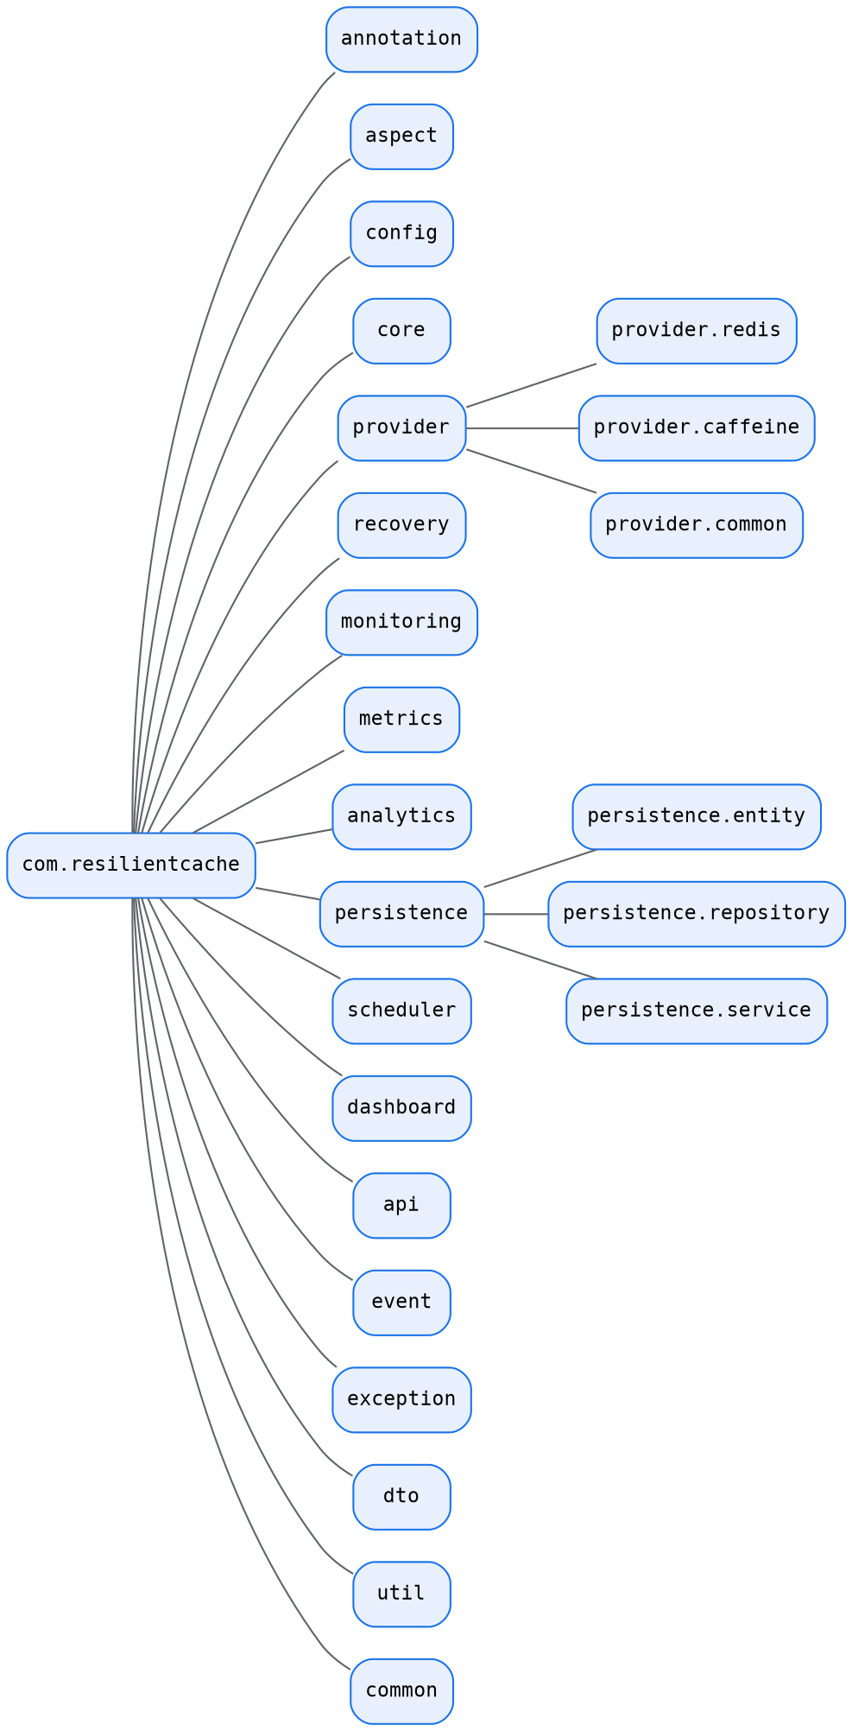
Figure 7. Package structure under com.resilientcache — each package maps to exactly one business capability.
Module dependency direction is strictly one-way: Controller → Aspect → Core → Port → Provider → Redis/Caffeine. The Controller never talks to Redis directly, and packages further down the chain have no knowledge of packages above them (the Core does not import anything from `api` or `dashboard`).

7.2 Phase 2 — Interface (Port) Design
This is where Hexagonal Architecture is expressed in code. Five ports form the entire contract surface between the Core and the outside world.
Port | Purpose | Implemented By | Design Pattern / SOLID
CachePort ⭐⭐⭐⭐⭐ | Represents any cache provider: get, put, delete, exists, clear, health check. The single most important interface — everything depends on it, and it depends on nothing. | RedisAdapter, CaffeineAdapter (future: HazelcastAdapter, EhcacheAdapter) | Adapter pattern; Dependency Inversion; Open/Closed
RecoveryPort | Start recovery, stop recovery, recover a specific provider. | RecoveryManager | Strategy pattern
MonitoringPort | Health check, latency measurement, status reporting. | HealthMonitor | Observer-adjacent; Strategy pattern
MetricsPort | Increment hit, increment miss, record latency, publish metrics. | MetricsCollector | Facade over Micrometer
AnalyticsPort | Detect hot keys, analyse TTL efficiency, usage trends. | AnalyticsEngine | Strategy pattern

7.3 Phase 3 — Core Classes
The Core is the brain of the system — it coordinates the entire cache workflow and never talks directly to Redis or Caffeine. Figure 7 shows the relationships between the principal Core classes and the Port/Adapter boundary.
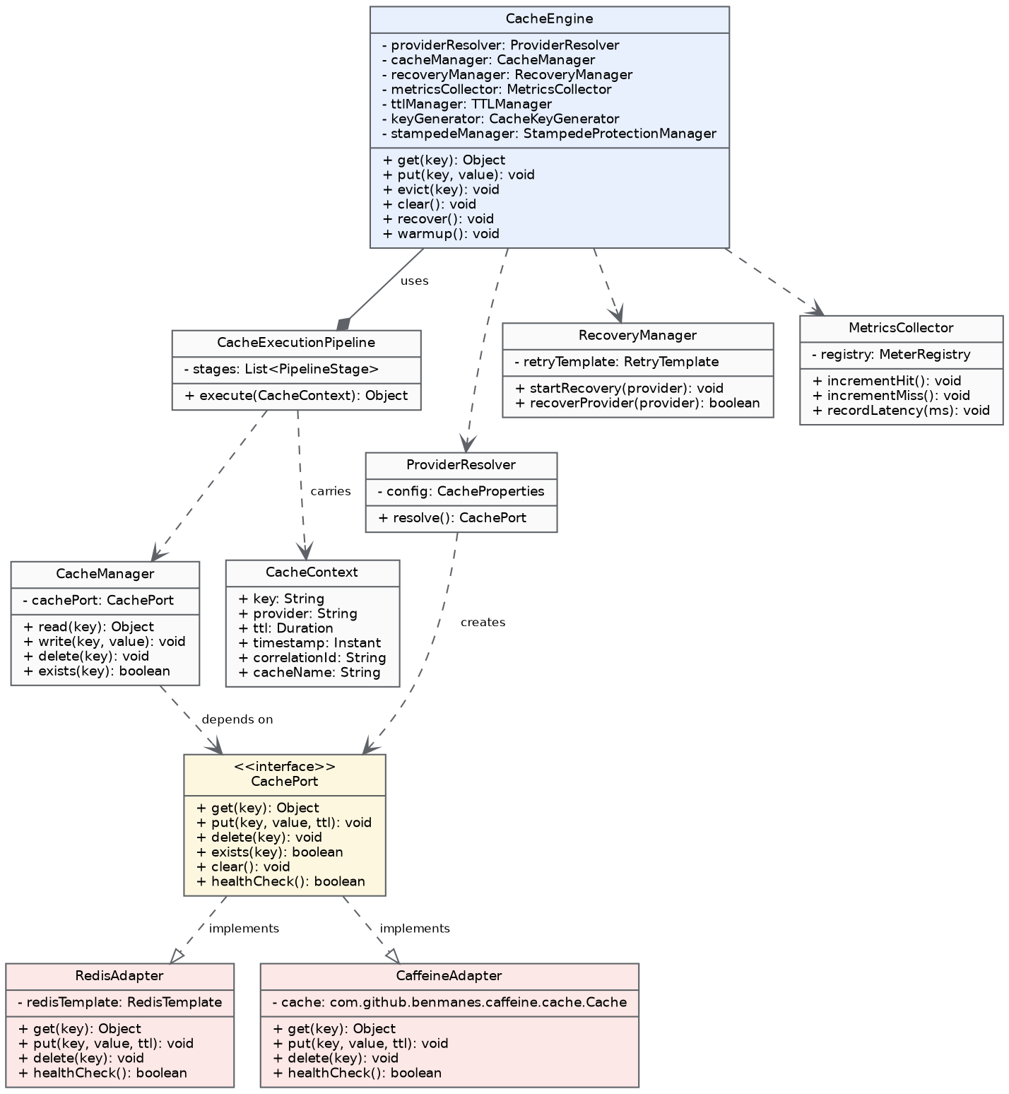
Figure 8. Core class diagram: CacheEngine orchestrates via CacheExecutionPipeline and delegates to CacheManager, which depends only on the CachePort interface implemented by RedisAdapter and CaffeineAdapter.

CacheEngine ⭐⭐⭐⭐⭐
Responsibility: Coordinates the entire cache workflow end-to-end; the single entry point every request passes through.
Depends on: ProviderResolver, CacheManager, RecoveryManager, MetricsCollector, TTLManager, CacheKeyGenerator, StampedeProtectionManager, ApplicationEventPublisher.
Key methods: get(key), put(key, value), evict(key), clear(), recover(), warmup().
Pattern: Facade / Orchestrator. SOLID: Single Responsibility, Dependency Inversion. Deliberately kept synchronous — the engine itself must never introduce non-deterministic latency into the request path.

CacheExecutionPipeline
A key architectural refinement made during design: rather than CacheEngine performing every step itself (which risked it becoming a large “god class”), CacheEngine delegates the actual request handling to an explicit pipeline of discrete stages — key generation, provider resolution, cache lookup, miss handling, result storage, and metrics/event emission.
Why this is better: CacheEngine becomes a thin coordinator instead of a monolith; the request flow becomes explicit and independently testable stage-by-stage; new stages (e.g. request validation, distributed tracing) can be added later without rewriting the engine; and it follows the Single Responsibility Principle far more closely than a single large method would.

CacheManager
Responsibility: Only performs cache operations (read, write, delete, exists) — explicitly not responsible for recovery, metrics, or health.
Depends on: CachePort. Pattern: Strategy.

ProviderResolver
Responsibility: Chooses which CachePort implementation is active (Redis, Caffeine, or both in multi-level mode) based on configuration.
Depends on: CacheProperties (configuration). Pattern: Factory.

CacheKeyGenerator
Responsibility: Deterministically generates a cache key (e.g. product:10) from a SpEL expression and method arguments. No dependencies. Pattern: Utility.

TTLManager
Responsibility: Calculates the effective TTL for a given put() call — either the configured static default, or (future-ready) an adaptive value informed by the Analytics Module.
Depends on: Configuration, Analytics (optional).

CacheContext
Responsibility: Carries everything needed for one cache request — key, provider, TTL, timestamp, correlation ID, cache name — as a single object rather than passing many parameters between pipeline stages. Pattern: Context Object.

StampedeProtectionManager ⭐⭐⭐⭐⭐
Responsibility: Ensures that if 500 concurrent callers request the same missing key, only one rebuilds it from the origin; the other 499 await that single in-flight result.
Pattern: Coordinator, backed by a ConcurrentHashMap<String, CompletableFuture<Object>> keyed by cache key. Deliberately synchronous from each caller's point of view (they must wait for the value), even though internally only one caller performs the actual origin call.

7.4 Phase 4 — Provider (Adapter) Layer
This layer is the concrete implementation half of Hexagonal Architecture. The Core never talks directly to Redis or Caffeine — every call passes through CachePort.
Class | Responsibilities | Explicitly NOT Responsible For
RedisAdapter | Redis get/put/delete operations via Lettuce; value serialization; TTL application at the Redis level; connection health check. | Metrics, recovery orchestration, analytics — these are separate modules, not adapter concerns.
CaffeineAdapter | In-process get/put/delete via the Caffeine cache instance; bounded size + window-TinyLFU eviction configuration; local health reporting (always UP unless the JVM itself is unhealthy). | Same as above — no metrics/recovery/analytics logic inside the adapter.
Each adapter knows only its own provider. This means adding HazelcastAdapter or EhcacheAdapter in a future release (Section 15) is purely additive — no existing class needs to change, satisfying the Open/Closed Principle.

7.5 Phase 5 — Recovery Module
RecoveryManager implements RecoveryPort. On receiving a ProviderFailureEvent from the Health Module, it uses a Resilience4j-backed retry policy with exponential backoff to attempt reconnection, publishing RecoveryStartedEvent and RecoveryCompletedEvent (or a RecoveryFailedException after exhausting the retry budget) along the way. On success, it triggers WarmupService (Section 7.6/FR-7) to preload previously hot keys before declaring recovery complete.

7.6 Phase 6 — Monitoring Module
HealthScheduler runs on a fixed interval (default 5 seconds, Section 6.2) and calls MonitoringPort.healthCheck() on each configured provider, measuring latency and publishing HealthStatusChangedEvent whenever a provider transitions between UP, DEGRADED and DOWN. This scheduled task is asynchronous by design (Section 3.7) — no request-serving thread ever waits on it.

7.7 Phase 7 — Metrics and Analytics Modules
MetricsCollector: Implements MetricsPort using Micrometer's MeterRegistry — incrementHit(), incrementMiss(), recordLatency(ms) — exported automatically at /actuator/prometheus.
AnalyticsEngine: Implements AnalyticsPort — maintains per-key access counters, ranks keys to identify hot keys (FR-9), and computes TTL efficiency suggestions (feeding FR-8's Adaptive TTL).

7.8 Phase 8 — Persistence Layer
Persistent storage is used only for engine metadata — never for the host application's business data. Full entity schemas are given in Section 8 (Data Design); at the class level, every entity has a corresponding Spring Data JPA repository and a thin service wrapping it so that business logic never lives directly in a repository.
Repository | Wraps Entity | Service
CacheProviderRepository | CacheProviderEntity | N/A (read mostly via ProviderResolver/HealthMonitor)
RecoveryRepository | RecoveryEventEntity | RecoveryHistoryService
HealthHistoryRepository | HealthHistoryEntity | HealthHistoryService
StatisticsRepository | CacheStatisticsEntity | StatisticsService
CacheEventRepository | CacheEventEntity | N/A (write-through from PersistenceListener)
HotKeyRepository | HotKeyEntity | HotKeyService
WarmupRepository | WarmupJobEntity | WarmupHistoryService
ConfigurationRepository | ConfigurationEntity | ConfigurationService

7.9 Phase 9 — Dashboard Classes
DashboardController, MetricsController, RecoveryController and ConfigurationController render the Thymeleaf pages described in Section 6.3, pulling their data from the service layer above rather than querying repositories directly (keeping the Dashboard layer thin, consistent with Section 3.2's layering rules).

7.10 Phase 10 — DTOs and REST API Contract
No JPA entity is ever returned directly from a controller. The flow is strictly Entity → Service → Mapper → DTO → Controller. Representative DTOs: RecoveryResponse, HealthResponse, StatisticsResponse, ProviderResponse, HotKeyResponse, ConfigurationResponse, WarmupResponse.
Every REST response (Section 6.1) follows one of these two envelope shapes:
Success:
{
"success": true,
"message": "Recovery completed",
"data": { }
}
Failure:
{
"success": false,
"message": "Redis unavailable",
"errorCode": "CACHE_102"
}

7.11 Phase 11 — Exception Hierarchy
Rather than throwing generic RuntimeExceptions, every failure mode in the engine is represented by a specific, named exception with an associated error code, carrying a message, root cause and timestamp for API responses.
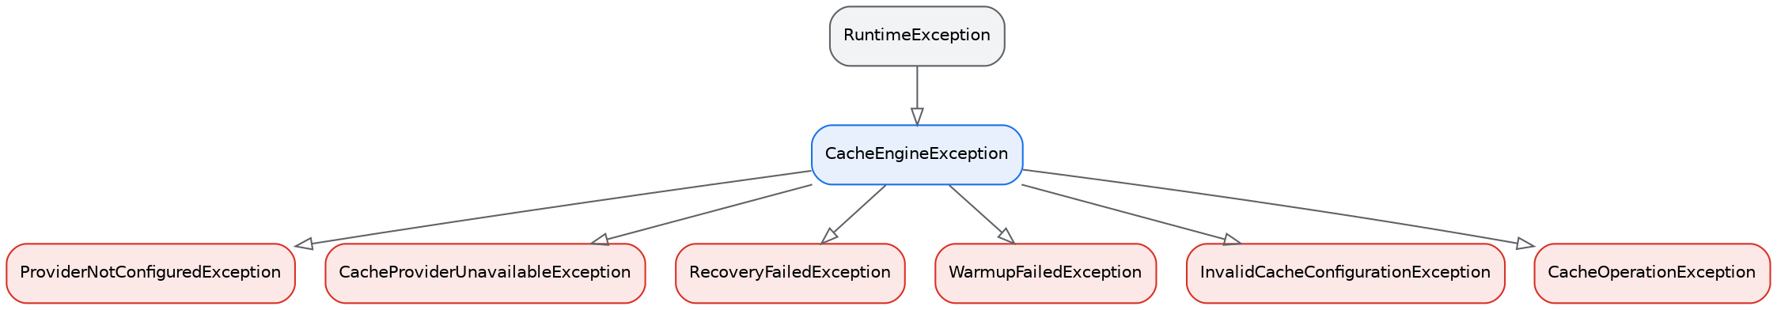
Figure 9. Exception hierarchy: every engine-specific exception extends the abstract CacheEngineException, itself a RuntimeException.
Exception | Error Code | HTTP Status | Thrown When
CacheEngineException | N/A (abstract base) | 500 | Base type for every exception raised by the engine; never thrown directly.
ProviderNotConfiguredException | CACHE_101 | 500 | Thrown when `application.yml` references a provider with no matching bean (misconfiguration caught at startup).
CacheProviderUnavailableException | CACHE_102 | 503 | Thrown when a provider call fails and no fallback (L1 or graceful degradation) is available.
RecoveryFailedException | CACHE_103 | 500 | Thrown when the Recovery Manager exhausts its retry budget without restoring connectivity.
WarmupFailedException | CACHE_104 | 500 | Thrown when the Warm-up Service cannot complete preloading (e.g. persistence read failure).
InvalidCacheConfigurationException | CACHE_105 | 400 | Thrown during startup validation when a configuration property is missing, malformed, or out of range.
CacheOperationException | CACHE_106 | 500 | Generic wrapper for unexpected low-level provider errors (serialization failures, connection resets).

7.12 Phase 12 — Internal Event System
Modules are kept decoupled using Spring's ApplicationEventPublisher: the Core publishes domain events, and interested listeners react independently, without the Core knowing who (if anyone) is listening. This is what allows Section 3.7's asynchronous operations (metrics, persistence, analytics, dashboard refresh) to be added or removed without ever touching CacheEngine.
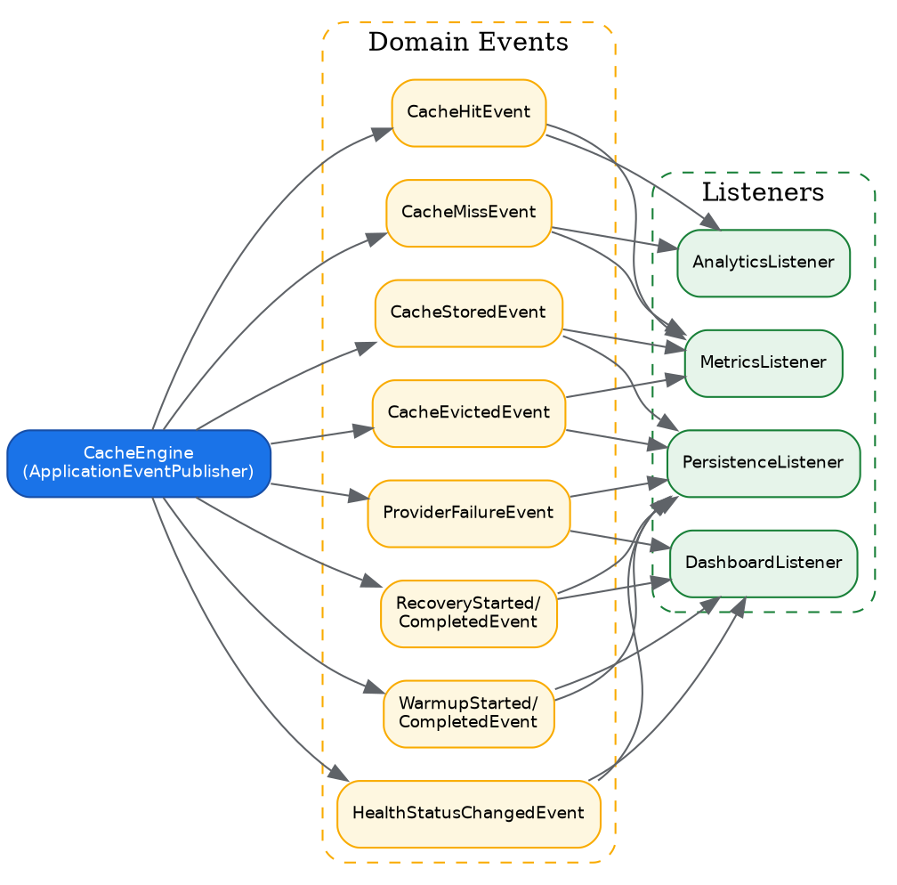
Figure 10. Internal event system: CacheEngine publishes ten domain events; four independent listeners subscribe to the subset relevant to their concern.

7.13 Design Rules Enforced Across the LLD
- Controllers never return entities — see the DTO rule in Section 7.10.
- Repositories only perform database access; no business logic (findByProvider(), save(), delete() — nothing more).
- Business logic belongs only in services; controllers stay thin (Controller → Service → Repository).
- Aspects only read annotations, generate cache metadata, and delegate to CacheEngine — no business logic inside AOP advice.
- CacheEngine coordinates and delegates; it must never contain Redis-specific code.
- Each adapter knows only its own provider (Section 7.4) — not metrics, not recovery, not analytics.
- Modules publish events; they never call listeners directly (Section 7.12).
- Every scheduled task must log, handle exceptions, and never block indefinitely.

8. Data Design
Persistent storage exists solely to support the engine's own operational concerns — recovery audit trails, health history, statistics, hot-key tracking, warm-up history and configuration snapshots. It never stores or transforms the host application's business data (e.g. Product, Order, User records belong entirely to the host application's own database).

8.1 Entity-Relationship Diagram
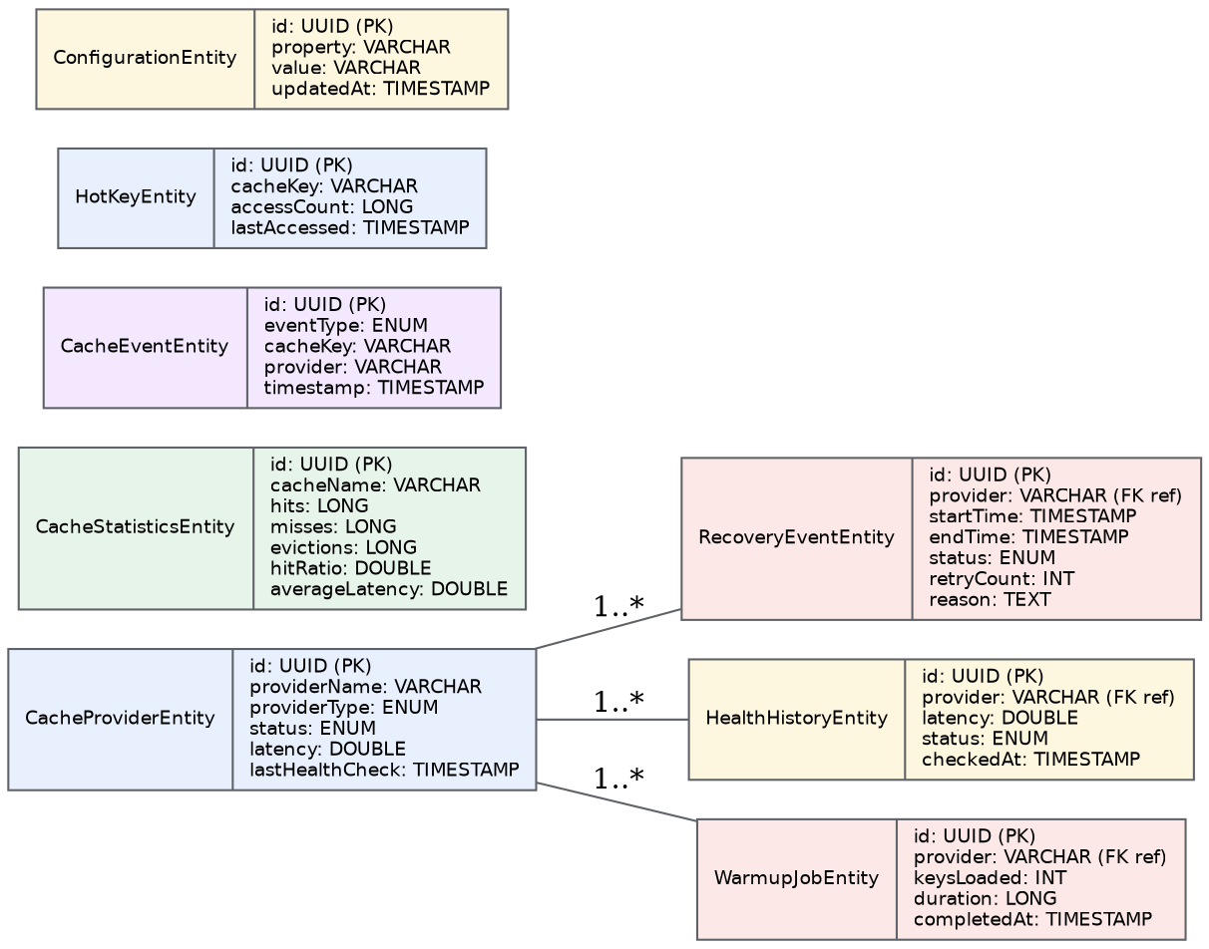
Figure 11. Entity-relationship diagram for the engine's metadata store. All events, health checks and warm-up jobs reference the provider they relate to.

8.2 Entity Schemas

CacheProviderEntity
Snapshot of each configured provider's identity and last known health.
Column | Type | Notes
id | UUID | Primary key
providerName | VARCHAR | e.g. "redis", "caffeine"
providerType | ENUM | REDIS | CAFFEINE | HAZELCAST (future)
status | ENUM | UP | DOWN | DEGRADED
latency | DOUBLE | Last measured round-trip latency (ms)
lastHealthCheck | TIMESTAMP | When status was last verified

RecoveryEventEntity
One row per recovery attempt, forming the audit trail behind FR-14.
Column | Type | Notes
id | UUID | Primary key
provider | VARCHAR | Provider that failed / recovered
startTime | TIMESTAMP | Recovery attempt start
endTime | TIMESTAMP | Recovery attempt end
status | ENUM | IN_PROGRESS | SUCCESS | FAILED
retryCount | INT | Number of retry attempts made
reason | TEXT | Failure reason / stack summary

HealthHistoryEntity
Time-series of individual health checks, feeding the dashboard's uptime chart.
Column | Type | Notes
id | UUID | Primary key
provider | VARCHAR | Provider checked
latency | DOUBLE | Measured latency (ms)
status | ENUM | UP | DOWN | DEGRADED
checkedAt | TIMESTAMP | Check timestamp

CacheStatisticsEntity
Periodically flushed aggregate counters, complementing the live Prometheus metrics with a persisted history.
Column | Type | Notes
id | UUID | Primary key
cacheName | VARCHAR | Logical cache name
hits | LONG | Cumulative hit count
misses | LONG | Cumulative miss count
evictions | LONG | Cumulative eviction count
hitRatio | DOUBLE | hits / (hits+misses)
averageLatency | DOUBLE | Rolling average latency (ms)

CacheEventEntity
Individual domain events (miss, recovery started, warm-up completed, etc.) for the audit/events API.
Column | Type | Notes
id | UUID | Primary key
eventType | ENUM | CACHE_MISS | RECOVERY_STARTED | ...
cacheKey | VARCHAR | Related key, if applicable
provider | VARCHAR | Related provider, if applicable
timestamp | TIMESTAMP | Event time

HotKeyEntity
Frequently accessed keys tracked over time, feeding both Adaptive TTL (FR-8) and Warm-up (FR-7).
Column | Type | Notes
id | UUID | Primary key
cacheKey | VARCHAR | The hot key
accessCount | LONG | Access counter
lastAccessed | TIMESTAMP | Most recent access

WarmupJobEntity
History of warm-up executions, used to verify FR-7's acceptance criteria over time.
Column | Type | Notes
id | UUID | Primary key
provider | VARCHAR | Provider warmed up
keysLoaded | INT | Number of keys preloaded
duration | LONG | Duration in milliseconds
completedAt | TIMESTAMP | Completion time

ConfigurationEntity
Snapshot of runtime configuration changes made via `PUT /api/config`, for auditability.
Column | Type | Notes
id | UUID | Primary key
property | VARCHAR | Configuration key changed
value | VARCHAR | New value
updatedAt | TIMESTAMP | When it was changed

8.3 Data Retention and Boundary
- All eight tables above are the complete database schema for v1.0 — no additional business tables are introduced by the engine.
- HealthHistoryEntity and CacheEventEntity are expected to be the highest-volume tables; a retention/rollup policy (e.g. archiving records older than 30 days) is recommended as an operational task but is not itself part of the v1.0 functional scope.
- All timestamps are stored in UTC to avoid ambiguity when the dashboard aggregates data across time zones.

9. UML Diagram Set (Consolidated Index)
The diagrams below are presented in full within the sections indicated; this index exists so that reviewers using this document as a research-paper-style reference can locate every diagram without re-reading the whole specification.
Figure | Diagram | Type | Location
1 | System Context Diagram | Context / Component | Section 2.1
2 | Seven-Layer Architecture | Layered Architecture | Section 3.2
3 | Hexagonal Ports & Adapters View | Component | Section 3.3
4 | Multi-Level (L1+L2) Cache Flow | Control Flow / Activity | Section 3.6
5 | Package Structure | Package Diagram | Section 7.1
6 | Module Communication Flow | Sequence-style Flow | Section 3.5
7 | Core Class Diagram | UML Class Diagram | Section 7.3
8 | Exception Hierarchy | UML Class Diagram (inheritance) | Section 7.11
9 | Sequence — Cache Hit | UML Sequence Diagram | Section 9.1
10 | Sequence — Cache Miss | UML Sequence Diagram | Section 9.2
11 | Sequence — Stampede Protection | UML Sequence Diagram | Section 9.3
12 | Sequence — Automated Recovery | UML Sequence Diagram | Section 9.4
13 | Entity-Relationship Diagram | ER Diagram | Section 8.1
14 | Deployment Diagram | Deployment | Section 3.8
15 | Internal Event System | Component / Event Flow | Section 7.12

9.1 Sequence Diagram — Cache Hit
The best case: a request served entirely from the in-process L1 (Caffeine) cache. Note that metrics recording is off the critical path (asynchronous), consistent with Section 3.7.
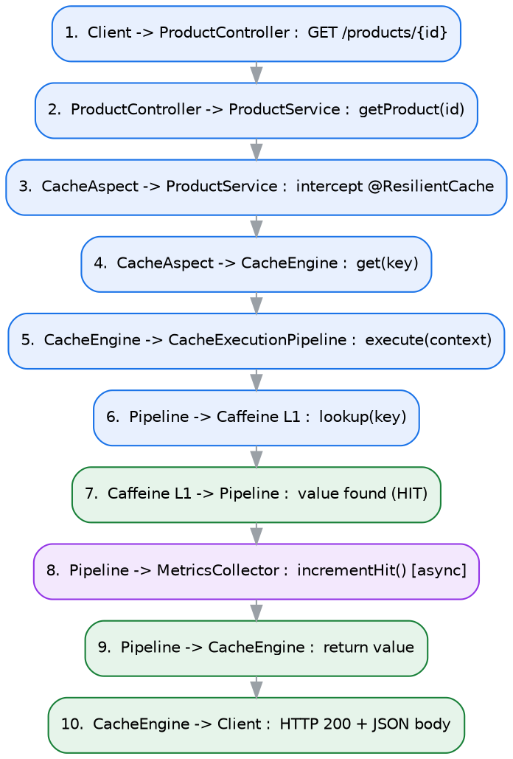
Figure 12. Sequence diagram for a Caffeine (L1) cache hit — the fastest possible path through the engine.

9.2 Sequence Diagram — Cache Miss (Full Cache-Aside Flow)
Both L1 and L2 miss, so the pipeline acquires a stampede-protection lock, loads from the origin database, populates both cache levels, and returns — with event publication kept asynchronous.
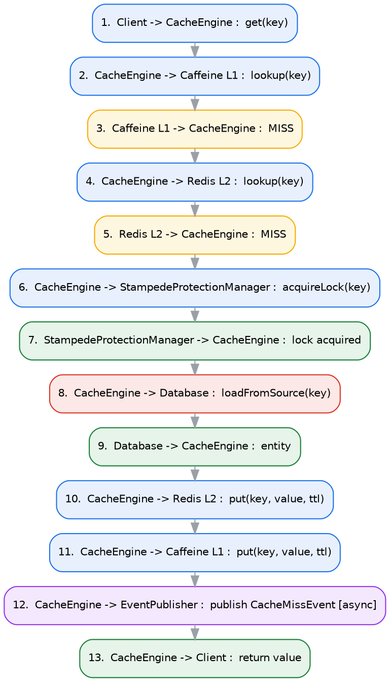
Figure 13. Sequence diagram for a full cache-aside miss: L1 miss → L2 miss → stampede lock → database load → populate both levels → return.

9.3 Sequence Diagram — Cache Stampede Protection
Illustrates FR-10 directly: when five concurrent requests miss the same key, only the first acquires the rebuild lock and hits the database; the remaining four are resolved from that single in-flight result once it completes.
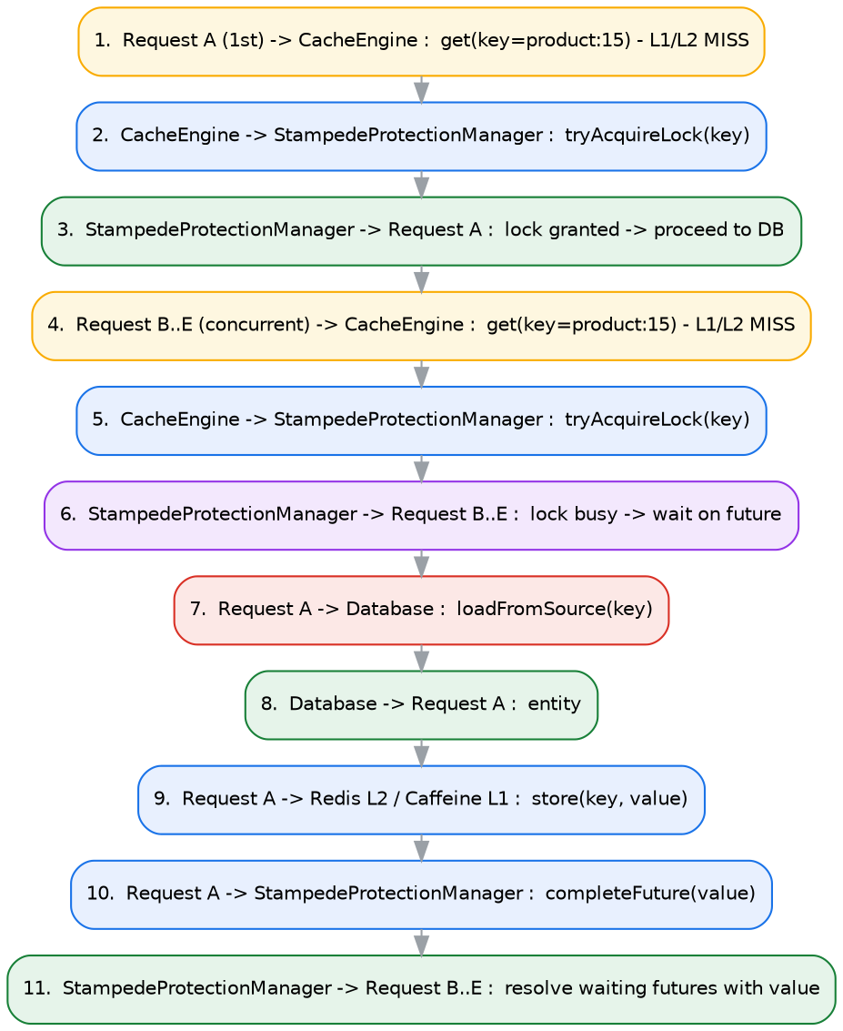
Figure 14. Sequence diagram showing stampede protection: only one of five concurrent requests for the same missing key reaches the database.

9.4 Sequence Diagram — Automated Recovery and Warm-up
Illustrates FR-5, FR-6 and FR-7 together: a failed health check triggers recovery, which on success triggers warm-up, with an audit record persisted asynchronously at the end.
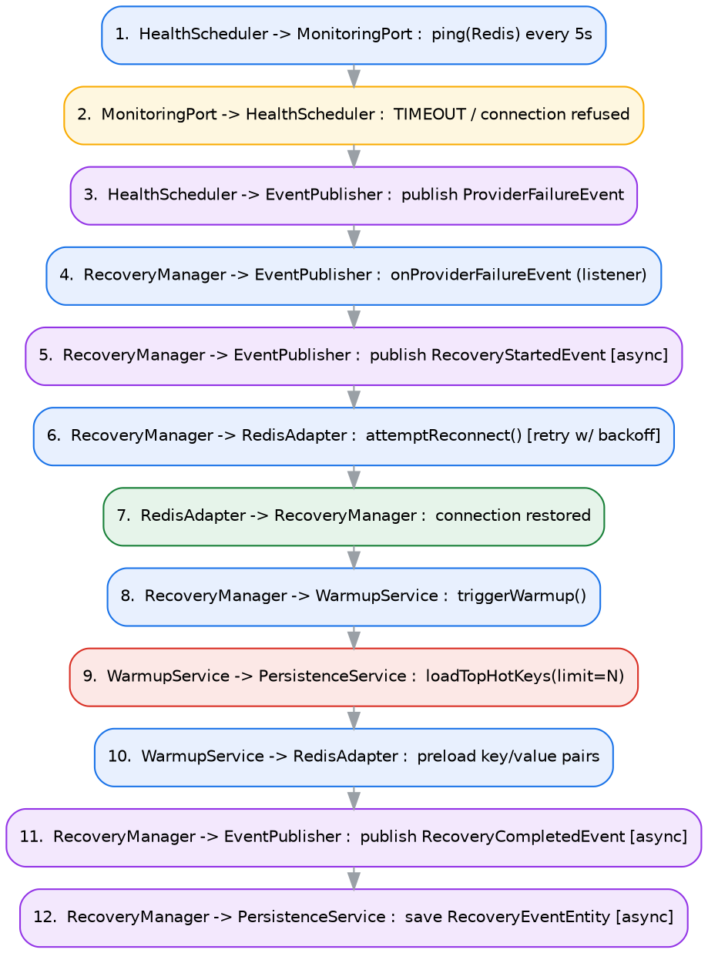
Figure 15. Sequence diagram for automated recovery: health-check failure → recovery attempt with backoff → reconnection → warm-up → audit persistence.

10. Coding Standards and Conventions
These conventions were frozen alongside the architecture so that code review focuses on logic, not style debates.

10.1 General Principles
- Favour composition over inheritance except in the exception hierarchy (Section 7.11), which is inheritance by design.
- No class exceeds a single, clearly statable responsibility (enforced informally via the Code Review Checklist, Section 10.6).

10.2 Naming Conventions
Element | Convention | Example
Package | lower.case, singular nouns | com.resilientcache.recovery
Class | UpperCamelCase, noun phrase | RecoveryManager
Interface | UpperCamelCase, often ending in Port | CachePort
Method | lowerCamelCase, verb phrase | recoverProvider()
Variable | lowerCamelCase, descriptive | retryCount
Constant | UPPER_SNAKE_CASE | DEFAULT_TTL_SECONDS

10.3 Package Visibility
Not everything is public. The public API surface is deliberately small — annotations, the CacheEngine facade, configuration properties, and DTOs. Internal implementation classes (pipeline stages, adapters' internals) are kept package-private wherever Java's module boundaries allow, which is itself part of demonstrating good framework design to consumers of the starter.

10.4 Logging Standard
Logs are deliberately human-readable, not JSON, in v1.0. JSON logs are primarily valuable when integrating with centralized log aggregation (ELK, Splunk), which is outside this project's scope (Section 2.8); human-readable logs are easier to read during local development and easier to explain when walking through the system's behaviour.
[INFO ] Cache HIT | Provider=Redis | Key=product:101 | Latency=3ms
[INFO ] Cache MISS | Provider=Redis | Key=product:105
[INFO ] Loading from Database | Key=product:105
[INFO ] Stored in Redis | TTL=30m
[WARN ] Redis Health Check Failed | Retry=1
[INFO ] Recovery Started
[INFO ] Recovery Completed | Duration=4.2s
[INFO ] Warm-up Started
[INFO ] Warm-up Completed | Loaded=150 Keys

10.5 JavaDoc Rules
Public APIs carry JavaDoc; private helper methods generally do not, unless the logic is non-obvious.
/**
* Retrieves a value from the configured cache provider.
*
* @param key unique cache key
* @return cached value if present
*/

10.6 Code Review Checklist
- Does it follow SOLID?
- Is the class focused on one responsibility?
- Are dependencies injected rather than constructed internally?
- Are logs meaningful and at the correct level?
- Are exceptions handled using the hierarchy in Section 7.11, not generic catches?
- Are unit/integration tests included per Section 11?
- Is the code readable without needing this document open?

10.7 Definition of Done
- Code compiles.
- Unit tests pass.
- Logging added per Section 10.4.
- Exceptions handled per Section 7.11.
- JavaDoc written for public APIs.
- Architecture boundaries respected (Section 3, Section 7.13).
- No TODOs left in the merged code.
- Feature verified manually against its acceptance criteria (Section 4).

11. Testing Strategy
Testing responsibility is assigned by architectural layer, so that every layer identified in Section 3.2 has a corresponding, appropriate test type.
Test Level | Scope | Tooling
Unit tests | Every service and Core class in isolation (mocked Ports) | JUnit 5, Mockito
Integration tests | Every provider adapter against a real Redis / PostgreSQL instance | Testcontainers
API tests | Every REST endpoint (Section 6.1) | MockMvc
End-to-end tests | Major workflows: cache-aside miss → hit, recovery → warm-up, stampede protection under load | Spring Boot Test + Testcontainers, where applicable
Testcontainers is specifically chosen (Section 3.9) so integration tests exercise real Redis and PostgreSQL behaviour — including real TTL expiry and real connection-failure semantics — rather than relying solely on mocks, which is critical for correctly validating FR-6 (Automated Recovery) and FR-10 (Stampede Protection).

12. Git Workflow and Branching Strategy

12.1 Commit Standard
Conventional Commits are used throughout:
feat: implement cache engine
feat: add redis adapter
fix: resolve recovery retry bug
refactor: simplify provider resolver
docs: update architecture
test: add cache manager tests

12.2 Branch Strategy
- main — always releasable
- develop — integration branch
- feature/cache-core, feature/redis, feature/caffeine, feature/recovery, feature/monitoring, feature/dashboard — one branch per milestone/feature (Section 14)
- release/v1.0 — release stabilisation branch

13. Risks and Mitigations
Risk | Severity | Mitigation
Redis provider downtime | High | Automated Recovery (FR-6) with retry/backoff via Resilience4j; multi-level cache allows continued L1-only service.
Configuration errors | Medium | Startup-time validation throwing `InvalidCacheConfigurationException` with a descriptive message (FR-13).
Cache inconsistency (stale data) | Medium | Cache-Aside strategy with bounded TTLs; explicit `evict()`/`clear()` APIs for manual invalidation.
Network latency to Redis | Medium | L1 (Caffeine) absorbs the majority of read traffic; L2 latency is monitored and surfaced via metrics.
Excessive memory usage (Caffeine) | Medium | Caffeine is configured with a bounded maximum size and window-TinyLFU eviction, not unbounded growth.
Improper TTL configuration by adopting teams | Low | Sensible defaults ship out of the box; Adaptive TTL (FR-8) suggests corrections via the Analytics Module.
Cache stampede on a hot key's expiry | High | Stampede Protection (FR-10) guarantees a single in-flight rebuild per key.
Metrics/monitoring pipeline failure | Low | Designed to degrade gracefully — a Prometheus scrape failure must not affect the request-serving path (fault isolation, NFR-Reliability).
All mitigation strategies above map directly onto functional requirements already specified in Section 4 — risk mitigation was designed in from the start rather than bolted on afterward.

14. Implementation Roadmap
The project is built in the exact order below; milestones are not reordered mid-project to avoid the scope-creep and half-finished-module risk that ad hoc development introduces.
Milestone | Focus | Key Tasks | Deliverable
M1 | Foundation | Multi-module Maven project, auto-configuration, `@ResilientCache` + AOP aspect, basic `CacheEngine`/`CacheManager`, Caffeine integration. | Demo app caching with Caffeine.
M2 | Multi-Level Caching | `CachePort`, `RedisAdapter`, `CaffeineAdapter`, `ProviderResolver`, L1→L2 flow, key generation, TTL support. | Working multi-level cache (Caffeine + Redis).
M3 | Resilience | Health monitoring, Recovery Manager, retry coordination, warm-up, Spring event publishing. | Automatic recovery from a simulated Redis failure.
M4 | Observability | Micrometer metrics, Prometheus export, Analytics Module, hot-key detection. | Engine exposes scrapeable operational metrics.
M5 | Persistence | Supabase/PostgreSQL integration, JPA entities, history and statistics storage. | Recovery history and analytics persist across restarts.
M6 | Dashboard | Thymeleaf + Bootstrap + Chart.js admin pages, engine controls. | Full monitoring dashboard.
M7 | Production Readiness | Docker Compose stack, Swagger/OpenAPI, Testcontainers integration tests, unit tests, documentation. | Production-quality, containerised, tested project.

15. Future Enhancements (Out of v1.0 Scope)
These are deliberately deferred rather than rejected — the Port-based architecture in Section 7.2 is specifically designed so each of these can be added without modifying the Core.
- HazelcastAdapter, EhcacheAdapter, MemcachedAdapter — new CachePort implementations only.
- Kubernetes deployment manifests / Helm chart, once an adopting team requires it (Section 2.8).
- Multi-level cache synchronisation and distributed cache coordination across regions.
- OpenTelemetry integration for distributed tracing alongside the existing Micrometer/Prometheus metrics.
- Multi-region support.

16. Glossary
Term | Meaning
Cache Provider | The underlying technology used to store cached data (Redis, Caffeine).
Cache Adapter | A concrete implementation that communicates with a specific cache provider (RedisAdapter, CaffeineAdapter).
Cache Port | An interface exposed by the core engine that adapters implement (Dependency Inversion).
L1 Cache | The first-level, in-process cache (Caffeine) — extremely low latency, node-local.
L2 Cache | The second-level, distributed cache (Redis) — shared across all application instances.
Recovery | Automatic restoration of cache provider functionality after a failure is detected.
Warm-up | Preloading frequently accessed ("hot") entries into cache after a restart or recovery.
Hot Key | A cache entry that is requested with disproportionately high frequency.
Cache Stampede | A condition where many concurrent requests attempt to rebuild the same expired/missing cache entry simultaneously, overloading the backing data source.
TTL | Time To Live — the duration a cache entry remains valid before expiry.
Hexagonal Architecture | An architectural style (Ports & Adapters) that isolates core business logic from external technology concerns.
Cache-Aside | A caching pattern where the application code is responsible for loading data into the cache on a miss.
Adaptive TTL | A strategy where TTL values are dynamically tuned based on observed access patterns rather than fixed at configuration time.
DTO | Data Transfer Object — a plain object used to move data across the API boundary, decoupled from JPA entities.

Appendix A — Full REST API Quick Reference
Method | Path | Purpose
GET | /api/cache/stats | Aggregated hit/miss/eviction statistics per cache name.
GET | /api/cache/providers | Lists configured providers and their current status.
GET | /api/cache/health | Current health-check result for all providers.
POST | /api/cache/warmup | Manually triggers a warm-up cycle (also triggered automatically after recovery).
POST | /api/cache/rebuild | Forces a rebuild of a specific key from the origin, bypassing the current cached value.
POST | /api/cache/clear | Clears an entire named cache (administrative operation).
GET | /api/cache/hotkeys | Returns the ranked list of hot keys detected by the Analytics Module.
GET | /api/cache/events | Recent cache domain events (hit/miss/evict/store) for audit purposes.
GET | /api/config | Returns the current effective engine configuration.
PUT | /api/config | Updates a subset of runtime-reloadable configuration values.
GET | /api/analytics/hotkeys | Detailed hot-key analytics (duplicated view tailored for the Analytics dashboard page).
GET | /api/analytics/usage | Usage trend data (requests per interval) for dashboard charting.
GET | /api/analytics/ttl | TTL efficiency report — which TTLs are too short (causing avoidable misses) or too long (stale risk).
GET | /api/recovery/history | Paginated recovery attempt history from `RecoveryEventEntity`.
GET | /api/recovery/status | Whether a recovery is currently in progress.

Appendix B — Exception-to-HTTP-Status Quick Reference
Exception | Error Code | HTTP Status
CacheEngineException | N/A (abstract base) | 500
ProviderNotConfiguredException | CACHE_101 | 500
CacheProviderUnavailableException | CACHE_102 | 503
RecoveryFailedException | CACHE_103 | 500
WarmupFailedException | CACHE_104 | 500
InvalidCacheConfigurationException | CACHE_105 | 400
CacheOperationException | CACHE_106 | 500

Appendix C — Definition of Done Checklist
- Code compiles cleanly with no warnings suppressed without justification.
- Unit tests pass and cover the class's public behaviour.
- Integration test added if the class touches Redis, PostgreSQL, or another external system.
- Logging added at appropriate levels per Section 10.4.
- Exceptions thrown using the hierarchy in Section 7.11, never a bare RuntimeException.
- JavaDoc present on all public methods/classes.
- No TODOs left in the merged code.
- Feature manually verified against the acceptance criteria stated in Section 4.

Appendix D — Document Approval
Role | Name | Signature | Date
Software Architect
Engineering Lead
QA Lead

