CSA1023 – SOFTWARE ENGINEERING

Question 5

Q. Use the following requirements for a Library Management System:

• Add a feature to search books by title and author.

• Implement an online book reservation system.

• Generate monthly reports on borrowed books for administrators.

• Enable email notifications for overdue books.

• Add support for QR code scanning for borrowing and returning books.

• Create a user-friendly dashboard for librarians.

• Allow users to review and rate books.

• Integrate a chatbot for user assistance.

• Develop a mobile app version of the system.

• Provide multi-language support. Categorize each requirement using MOSCOW Method (Must-Have, Should-Have, Could-Have, or Won’t-Have) based on the following criteria:

• Impact on the users and stakeholders.

• Feasibility considering time, budget, and resource constraints. Finally Submit the completed Google Sheet or Excel file with all requirements categorized and justified.

A.• **Open Google Sheets or Excel**.

• **Create a table** with these columns:

* Feature
* MoSCoW Category
* Justification

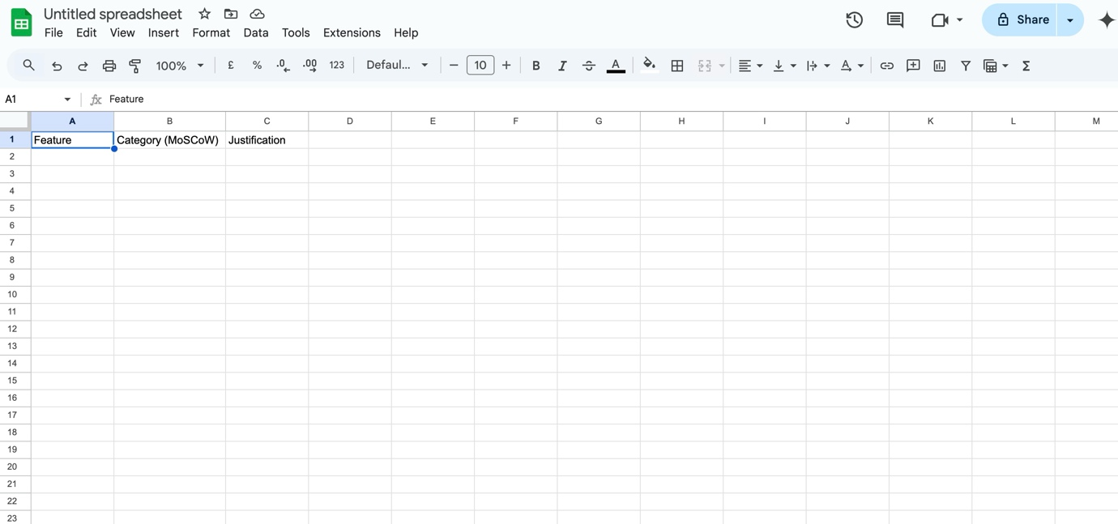

• **Enter the data** as per the above table.

• **Format the table** (Bold headers, highlight categories for clarity)

