CSA1023-SOFTWARE ENGINEERING

Question-7

7. You are designing a Task Management System for a small team. The system should include the following features: 1.User Login and Role Assignment 2.Task Creation and Assignment 3.Task Prioritization and Deadlines 4.Progress Tracking and Reporting Prioritize these requirements using the MoSCoW and Kano models in Jira.

To properly prioritize these requirements in **Jira**, we need to apply:

**MoSCoW Model** (Must-have, Should-have, Could-have, Won’t-have)

**MoSCoW Prioritization for Task Management System:**

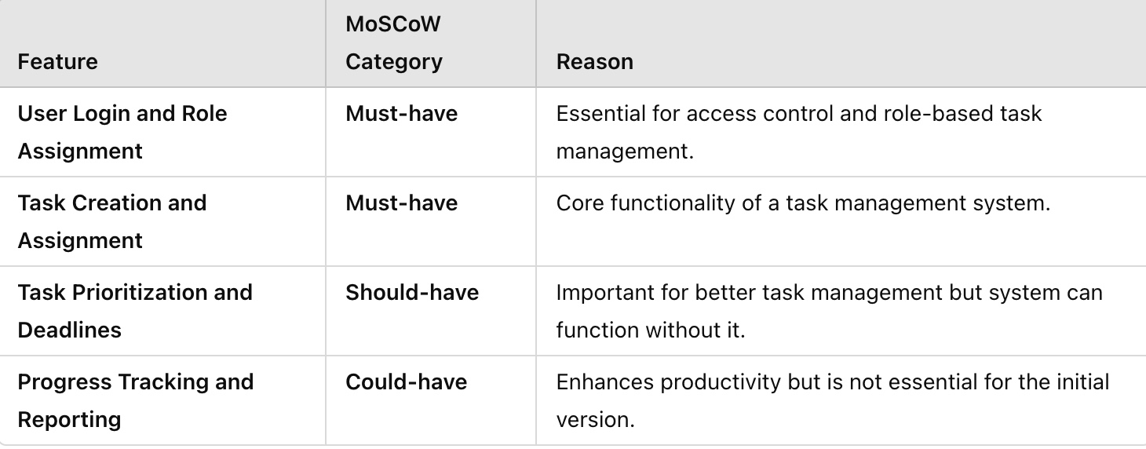

✅ **Jira Implementation:**

* **Must-have**: Create as **"High Priority"** Epics.
* **Should-have**: Create as **"Medium Priority"** Stories.
* **Could-have**: Create as **"Low Priority"** Stories for later sprint.

Step 1). Create issues in backlogs :-

• Navigate to **Backlog**.

• Click **Create Issue** and enter each feature as a User Story:

* **User Login and Role Assignment**
* **Task Creation and Assignment**
* **Task Prioritization and Deadlines**
* **Progress Tracking and Reporting**

• Assign an **Issue Type** (Story).

• Click **Create** for each item.

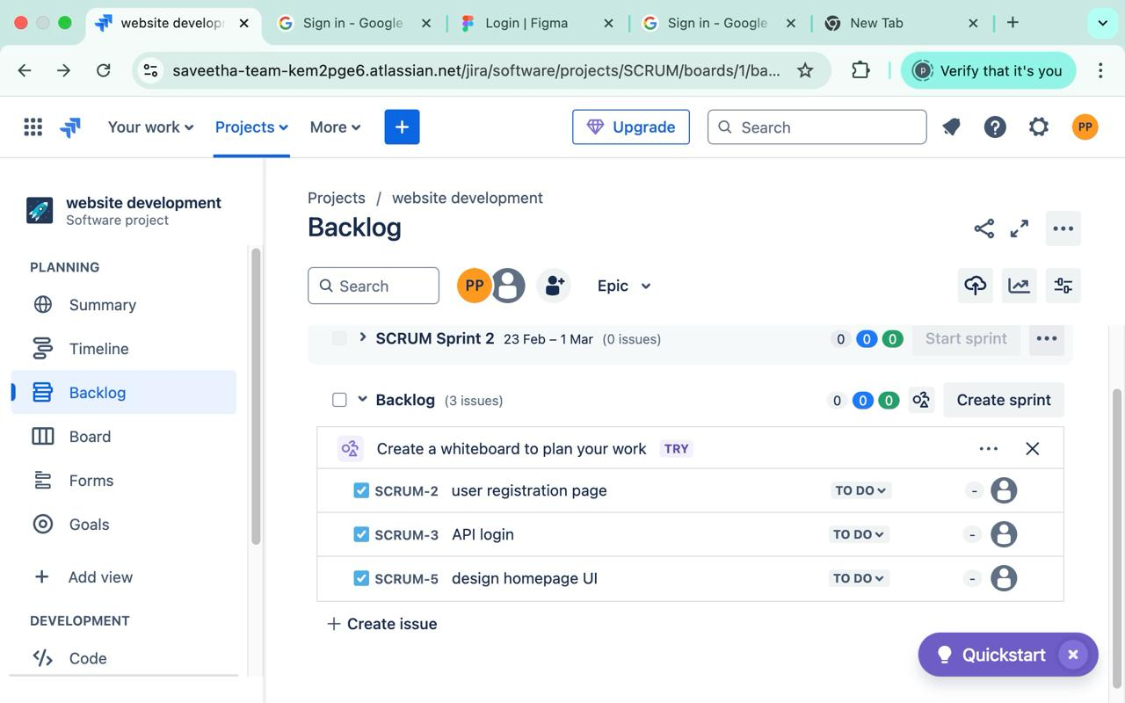

Step 2). Create sprint :-

* Click **Create Sprint** in the **Backlog**.
* Move **Must-Have and Basic Need** features into Sprint 1.
* Start the Sprint and assign tasks to team members.

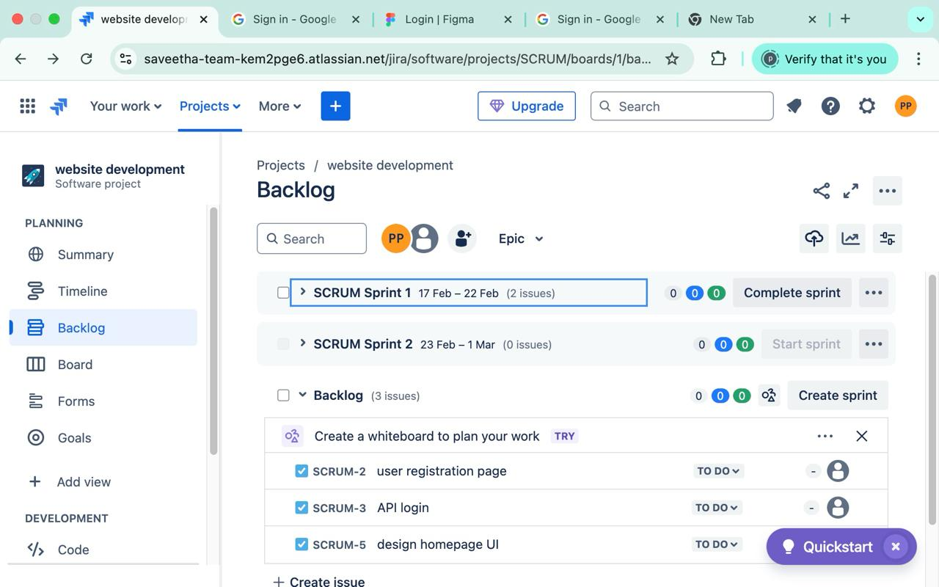

Step 3). Start sprint :-

* Click **Active Sprint** to view the Sprint Board.
* Move tasks across **To Do → In Progress → Done**.
* Generate Jira Reports:
  + **Burndown Chart** to track task completion.
  + **Sprint Report** to analyse completed vs. pending tasks.

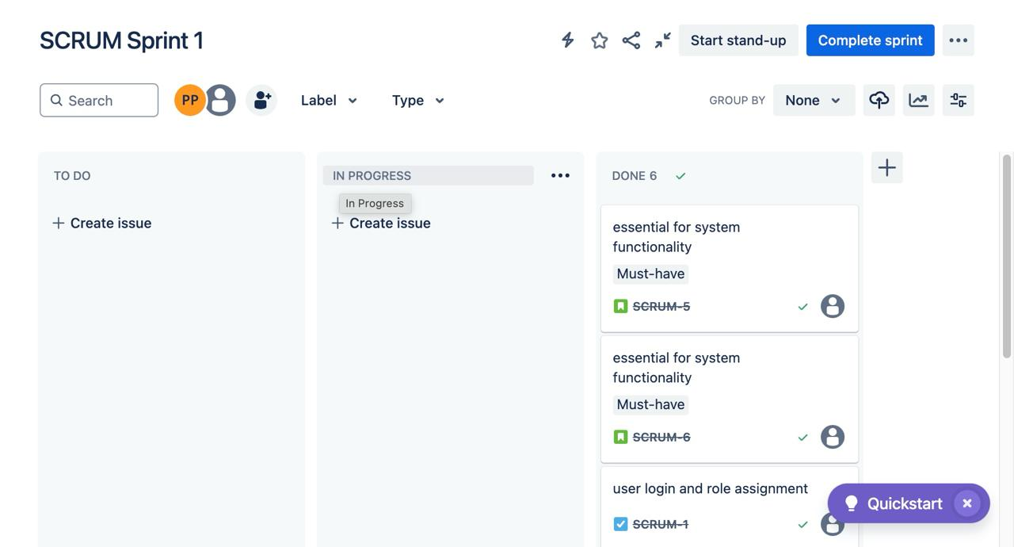

Step 4) Capture **Jira Reports** after sprint completion.

