Dear Students,

Please find the Questions for CLA-1

1. a) Explain the purpose of text formatting tags.

b) Write a html program to get the following output using various text formatting tags.

Article Title (Bold) This is an HTML tutorial where we cover **bold text** and **strong emphasis**. Use *italicized text* or *emphasized text* to highlight ideas. This is an underlined word in HTML. Old price: $100, New price: $80. H₂O represents water, and x² + y² = r² is a circle equation. Here is a sample code: print("Hello, World!"

2.a) Create an HTML page that displays an image using the <img> tag. Ensure that:

* The image is responsive and scales according to different screen sizes.
* If the image is not available, an alternate text is displayed.
* When a user hovers over the image, a tooltip appears.

**Hint:** Use attributes like src, alt, title, and CSS properties like max-width and height.

**b) Audio Tag (<audio>) - Custom Audio Player**

**Question:**  
Embed an audio file in an HTML page using the <audio> tag.

* The audio file should play automatically when the page loads (without sound).
* Provide controls for play, pause, and volume.
* Add a fallback message for browsers that do not support the <audio> tag.

**Hint:** Use attributes like autoplay, muted, controls, and preload.

**c) Question:**  
Create a webpage that embeds a video using the <video> tag and:

* Supports multiple formats (MP4, WebM, Ogg) to ensure browser compatibility.
* Includes controls for play, pause, and fullscreen.
* Displays a custom thumbnail before playing.
* Shows an error message if the video format is not supported.

**Hint:** Use <source> tags inside <video>, and attributes like poster, controls, and fallback text.

3) Compare the three types of CSS (inline, internal, external). Analyze their advantages and disadvantages in different scenarios using suitable example for each.

4) Analyze the role of CSS selectors like Class and ID selectors in targeting elements for styling. Give examples to demonstrate Class and ID selectors.

5) Explain the importance of responsive web design. How do CSS features like media queries contribute to creating adaptable layouts?

6) Discuss the importance of box model properties such as margin, border, padding, and width in layout design.

7) Use appropriate html list tags to display the following output.

8) Create an **HTML webpage** to demonstrate the usage of the target attribute in hyperlinks. Your page should include:

1. A **text link** that opens "<https://www.example.com>" in the **same tab** (_self).
2. A **text link** that opens "<https://www.google.com>" in a **new tab** (_blank).
3. A **text link** that opens "<https://www.wikipedia.org>" in a **new window** (_blank).
4. A **text link** that loads "<https://www.youtube.com>" inside an **iframe** on the same page (use a named target).

9) Design the table using HTML as shown below:

* 1. Design the table using HTML as shown belowA table with numbers and numbers

     Description automatically generated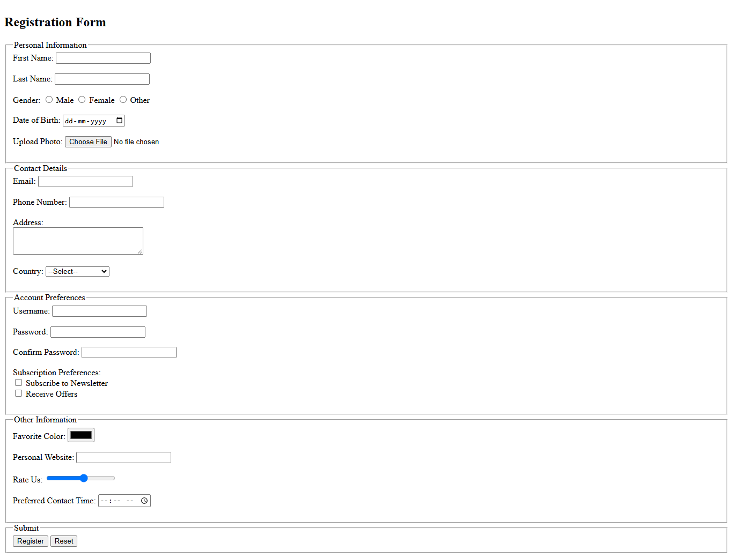11. Design the HTML form as shown below:

12).Design the HTML table

13). Design the form as shown below:

14) Differentiate <iframe>, <form> ,<link> and <a> tags in HTML 5 with examples.

15) Demonstrate on CSS link properties, background properties and animation properties with examples.