**CAMERA CONTROLLER PRO**

**version 1.2.6**

Introduction

This camera controller makes the process of developing 3D actions simpler. Controller has all necessary settings for its adaptation for concrete games. It supports third person view.

There are 4 logical parts of the camera controller editor: «Position», «Control», «Limits» and «Overlay». All of them are described in the points 1-4. Player controller is represented in the point 5.

To see camera in action following steps should be made after uploading package:

1. open the demo scene that is inside the root folder;
2. start the game mode and use these keys by default: «W», «A», «S», «D», «Space» or custom keys to control the player;
3. to change camera distance, you should use scrolling and to change height and rotation any useful key can be used by drag and drop but «Mouse 1» (right mouse button) is used by default;
4. to see and check all controller settings in the inspector during game mode do not select «Maximize On Play».

1. Position

Position settings consist of target and camera position.

First and only necessary thing for start using controller is to choose the target object (player) in inspector manually otherwise it will be made by script automatically with selecting game object with tag «Player». Also, you can set up the position offset (x, y, z) – point of target object which will be followed by camera automatically.

Camera position is described by 3 different parameters (0, 1, ..., 100):

* distance – distance from camera to player;
* height – vertical rotation angle;
* rotation – horizontal rotation angle (-∞; +∞).

These parameters can be changed manually by toolbars in editor and during game mode by keys of keyboard or mouse/touchpad.

Panel of main settings is shown at figure 1.

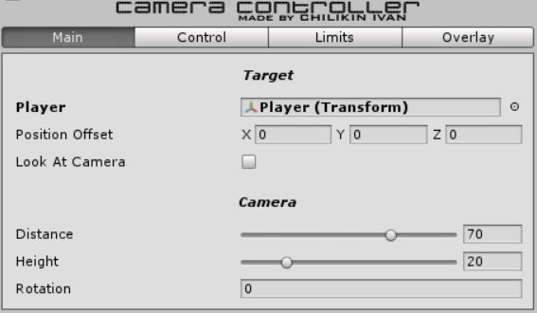

Figure 1 – Position settings

2. Control

Control settings consist of 3 parts: distancing, rotation and lifting.

Each action has following settings:

* speed: 0 (lock) – 100;
* smoothness – smoothness of controlling (0, 1, ..., 100).

Distance is changed by scrolling, rotation and height (lifting) are changed by pressing concrete key that can be chosen.

Also, there is a possibility of simultaneous (!) rotating, lifting and zooming.

Panel of control settings is shown at figure 2.

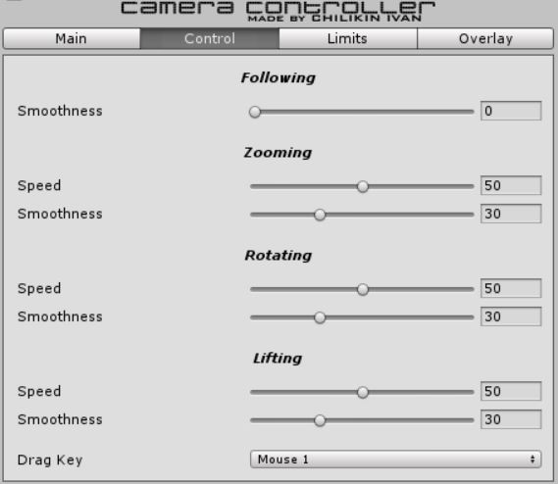

Figure 2 – Camera control settings

3. Limits

2 aspects of camera position such as distance and height have their own limits that can be edited by changing these parameters (1, 2, ..., 10):

* minimum (distance);
* maximum (distance);
* minimum (height);
* maximum (height).

Panel of camera position limits settings is shown at figure 3.

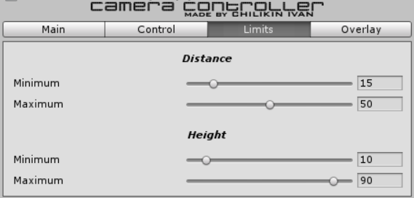

Figure 3 – Camera position limits settings

4. Overlay

Environment objects that overlay player (camera target) can disappear and appear smoothly by camera controller. Speed of such actions can be edited by changing following parameters (0,1, ..., 100):

* disappearance speed;
* appearance speed.

Panel of screen border control settings is shown at figure 4.

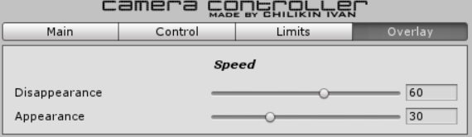

Figure 4 – Environment overlay settings

5. Player

There is a simple player controller to demonstrate functions of camera controller. Player movement speed and height of his jump can be changed by slidebars. All control keys have default values, but they can be changed by custom ones.

Panel of player controller settings is shown at figure 5.

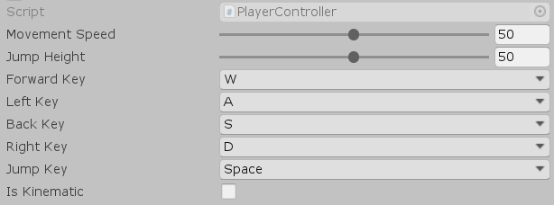

Figure 5 – Player controller settings

Conclusion

Controller will be improving in following aspects:

* usability;
* functionality;
* presentability.

Thanks for downloading my package!

I hope you will enjoy using it!

All the best,

Chilikin Ivan (CIV)