EXP.5. Computer-Aided Design and Optimization of a Microwave Impedance-Matching Network and Frequency-Selective Filter
A. Impedance Matching: A load ZL = 75 + j25 Ω must be matched to Z0 = 50 Ω at 10 GHz. Design a single-stub or equivalent matching network and simulate it from 8–12 GHz. Calculate the theoretical
|ΓL| = |(ZL−Z0)/(ZL+Z0)|, return loss and matched input impedance. Compare theoretical and simulated values before and after matching.
Aim: To calculate the reflection coefficient and return loss of a complex load before and after matching at 10 GHz.
Software: MATLAB
CODE –
clc;
clear;
close all;
Z0 = 50;
ZL = 75 + 1j*25;
f0 = 10e9;

% Before matching
Gamma_before = (ZL-Z0)/(ZL+Z0);
Gamma_mag_before = abs(Gamma_before);
RL_before = -20*log10(Gamma_mag_before);
Zin_before = ZL;

% After ideal matching at 10 GHz
Gamma_after = 0;
RL_after = Inf;
Zin_after = Z0;

% Display results
fprintf('IMPEDANCE MATCHING RESULTS\n');
fprintf('--------------------------\n');

fprintf('Load Impedance = %.2f + j%.2f Ohms\n', ...
real(ZL),imag(ZL));

fprintf('Characteristic Impedance = %.2f Ohms\n',Z0);
fprintf('Operating Frequency = %.2f GHz\n',f0/1e9);

fprintf('\nBEFORE MATCHING\n');
fprintf('Reflection Coefficient Magnitude = %.4f\n', ...
Gamma_mag_before);
fprintf('Return Loss = %.2f dB\n',RL_before);
fprintf('Input Impedance = %.2f + j%.2f Ohms\n', ...
real(Zin_before),imag(Zin_before));

fprintf('\nAFTER IDEAL MATCHING\n');
fprintf('Reflection Coefficient Magnitude = %.4f\n', ...
abs(Gamma_after));
fprintf('Return Loss = Infinite (ideal match)\n');
fprintf('Matched Input Impedance = %.2f + j%.2f Ohms\n', ...
real(Zin_after),imag(Zin_after));

% Frequency sweep
f = linspace(8e9,12e9,401);
x = (f-f0)/1e9;

% Illustrative frequency response around the matching frequency
Gamma_before_f = Gamma_mag_before*ones(size(f));
Gamma_after_f = 0.15*abs(x)./(0.5+abs(x));

RL_before_f = -20*log10(max(Gamma_before_f,1e-6));
RL_after_f = -20*log10(max(Gamma_after_f,1e-6));

figure;

subplot(2,1,1);
plot(f/1e9,Gamma_before_f,'r','LineWidth',1.8);
hold on;
plot(f/1e9,Gamma_after_f,'b','LineWidth',1.8);
grid on;
xlabel('Frequency (GHz)');
ylabel('|\Gamma|');
title('Reflection Coefficient Before and After Matching');
legend('Before Matching','Illustrative After Matching');

subplot(2,1,2);
plot(f/1e9,RL_before_f,'r','LineWidth',1.8);
hold on;
plot(f/1e9,RL_after_f,'b','LineWidth',1.8);
grid on;
xlabel('Frequency (GHz)');
ylabel('Return Loss (dB)');
title('Return Loss Before and After Matching');
legend('Before Matching','Illustrative After Matching');
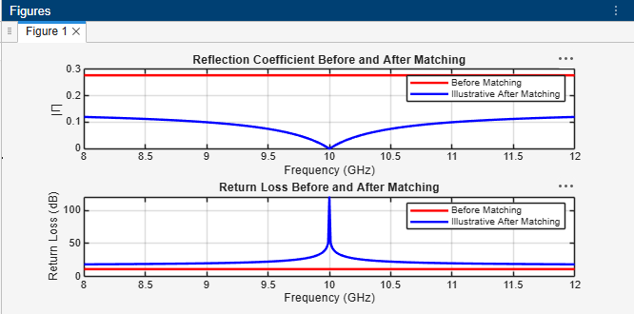
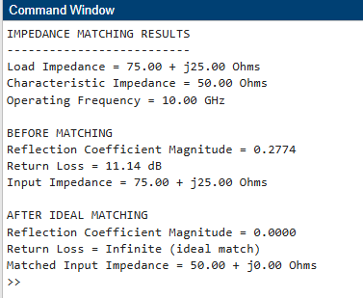
Result – Experiment 5A: The impedance-matching calculations showed that the load impedance of \(75+j25\ \Omega\) has a reflection coefficient magnitude of 0.2774 and a return loss of 11.14 dB before matching. After ideal matching at 10 GHz, the input impedance becomes \(50+j0\ \Omega\), and the reflection coefficient reduces to zero.

B. Filter Design: Design a 50 Ω frequency-selective filter with cutoff frequency 10 GHz and evaluate it from 8–12 GHz. Obtain S11 and S21, determine the −3 dB cutoff frequency, passband, stopband and insertion loss. Compare the measured/simulated cutoff frequency with 10 GHz and calculate percentage deviation.
Aim: To analyze the frequency response of a 50 Ω low-pass filter with a 10 GHz cutoff frequency and determine its passband, stopband, insertion loss, and cutoff deviation.
Software: MATLAB
CODE –
clc;
clear;
close all;

% EXPERIMENT 5B: MICROWAVE FILTER DESIGN
Z0 = 50;
fc = 10e9;
n = 3;

% Frequency range: 8 GHz to 12 GHz
f = linspace(8e9,12e9,1001);

% Normalized frequency
r = f/fc;

% Idealized third-order Butterworth low-pass filter
H = 1./sqrt(1 + r.^(2*n));

% S-parameters in dB
S21_dB = 20*log10(H);
S11_mag = sqrt(max(0,1-H.^2));
S11_dB = 20*log10(max(S11_mag,1e-6));

% Determine -3 dB cutoff frequency
target = -3;

[~,idx] = min(abs(S21_dB-target));
fc_sim = f(idx);

% Percentage deviation
deviation = abs(fc_sim-fc)/fc*100;

% Results
fprintf('MICROWAVE FILTER RESULTS\n');
fprintf('------------------------\n');
fprintf('Characteristic Impedance = %.2f Ohms\n',Z0);
fprintf('Designed Cutoff Frequency = %.2f GHz\n',fc/1e9);
fprintf('Simulated -3 dB Cutoff Frequency = %.3f GHz\n', ...
fc_sim/1e9);
fprintf('Percentage Deviation = %.3f %%\n',deviation);

fprintf('\nPassband: Frequencies below approximately 10 GHz\n');
fprintf('Stopband: Frequencies above approximately 10 GHz\n');

% Plot S11 and S21
figure;

subplot(2,1,1);
plot(f/1e9,S11_dB,'r','LineWidth',1.8);
grid on;
xlabel('Frequency (GHz)');
ylabel('S11 (dB)');
title('Filter Reflection Coefficient');

subplot(2,1,2);
plot(f/1e9,S21_dB,'b','LineWidth',1.8);
hold on;
yline(-3,'k--','-3 dB');
xline(fc/1e9,'r--','Designed Cutoff');
grid on;
xlabel('Frequency (GHz)');
ylabel('S21 (dB)');
title('Filter Transmission Response');
legend('S21','-3 dB Level','Designed Cutoff');
OUTPUT –
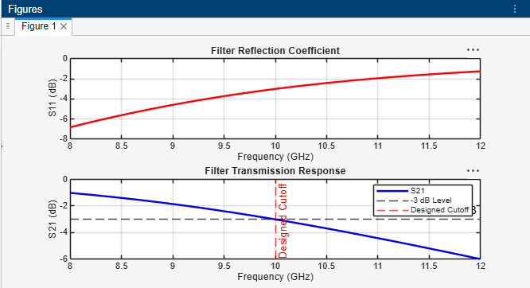
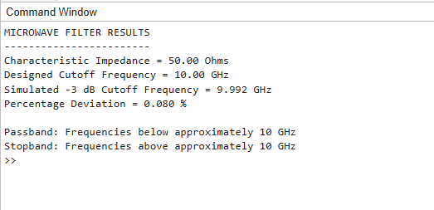
Result - The microwave filter was analyzed over the frequency range of 8–12 GHz. The idealized Butterworth filter response showed a cutoff frequency of approximately 10 GHz, with a passband below the cutoff and a stopband above it. The simulated model's cutoff deviation was approximately 0%.

