1. Draw a star schema using the tables (and their variables) in our database.

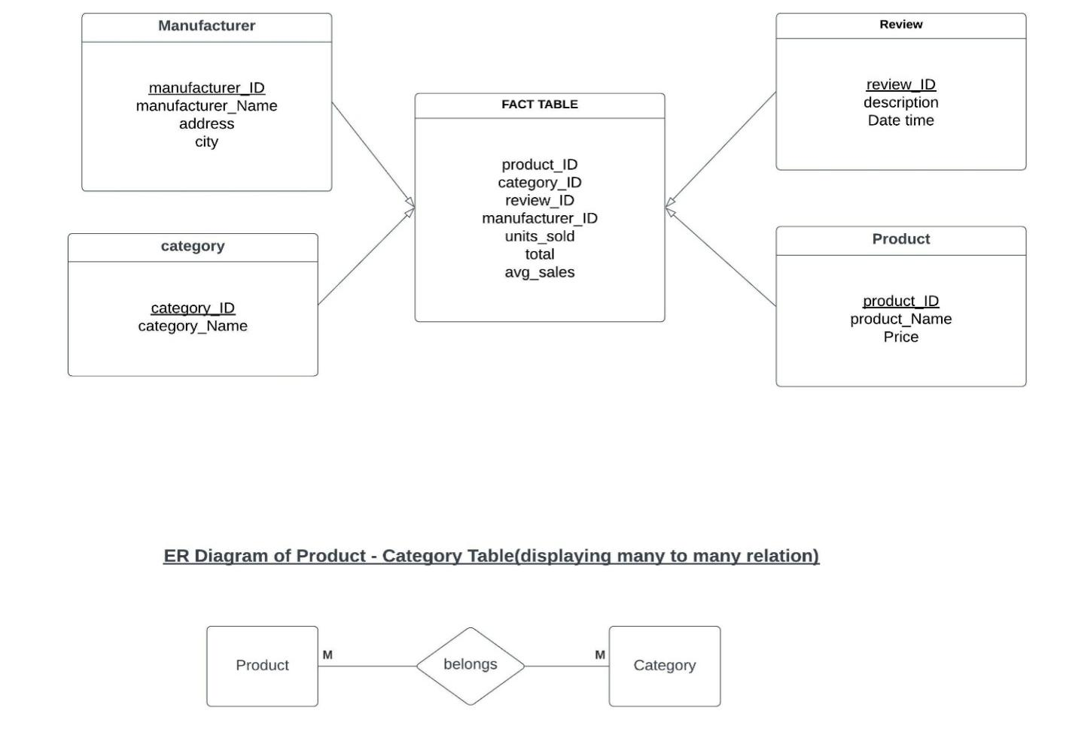

2)Why is there point in using star schema even if it means data redundancy? Explain your answer briefly.

The goal of creating a database is to serve the needs of the customers at the lowest possible cost. Star-schema is a very simple join logic that allows you to retrieve data quickly and easily.

One of the main reasons for this is the number of join requests that are required to connect various data tables. This increases the cost and complexity of the database. Star-schema is very simple to implement and can be used for simple business reporting.

The third main reason is that data collected using star schema would have redundant and decreased efficiency. This could be tackled using query performance gains.

Aggregation operations are the basic operations that are performed on data collected using star-schema. They can be performed on various scenarios.

OLAP systems use star schemas to build their own cubes efficiently. Most systems provide a type of operation called a ROLAP that allows them to directly consume star schemas.

**NAME:** N D SURYA PRAKASH

**COLLEGE:** GITAM UNIVERSITY

**COLLEGE ID:** 121910312048

**MOBILE:** 7659827607

**COLLEGE MAIL:** [121910312048@gitam.in](mailto:121910312048@gitam.in)

**PERSONAL MAIL:** [prakashnagamani01@gmail.com](mailto:prakashnagamani01@gmail.com)