**Accuracy score:** 91%

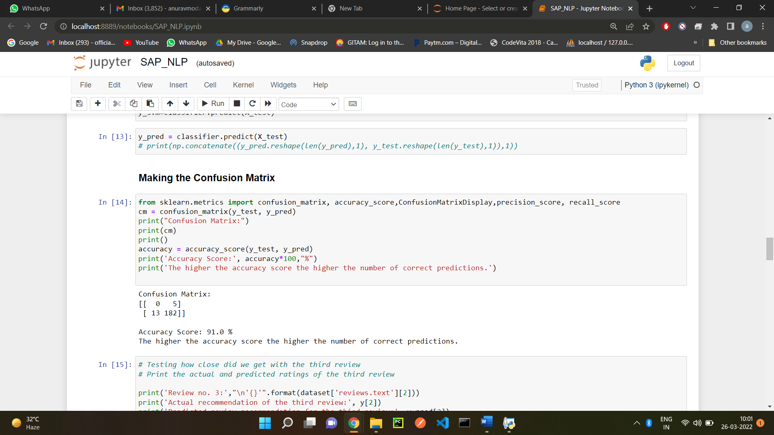

**Precision score:** 97.3%

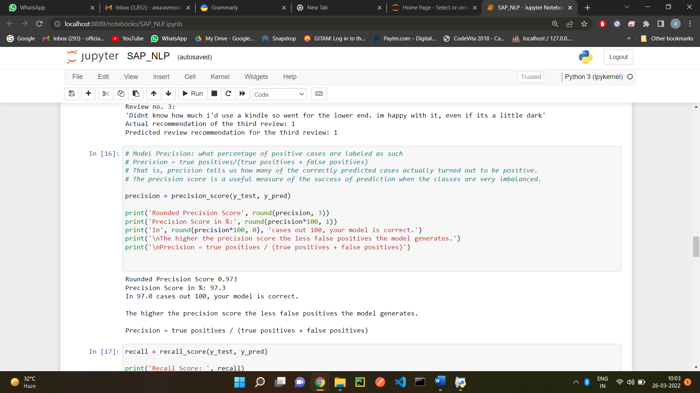

**Recall score:** 93.3%

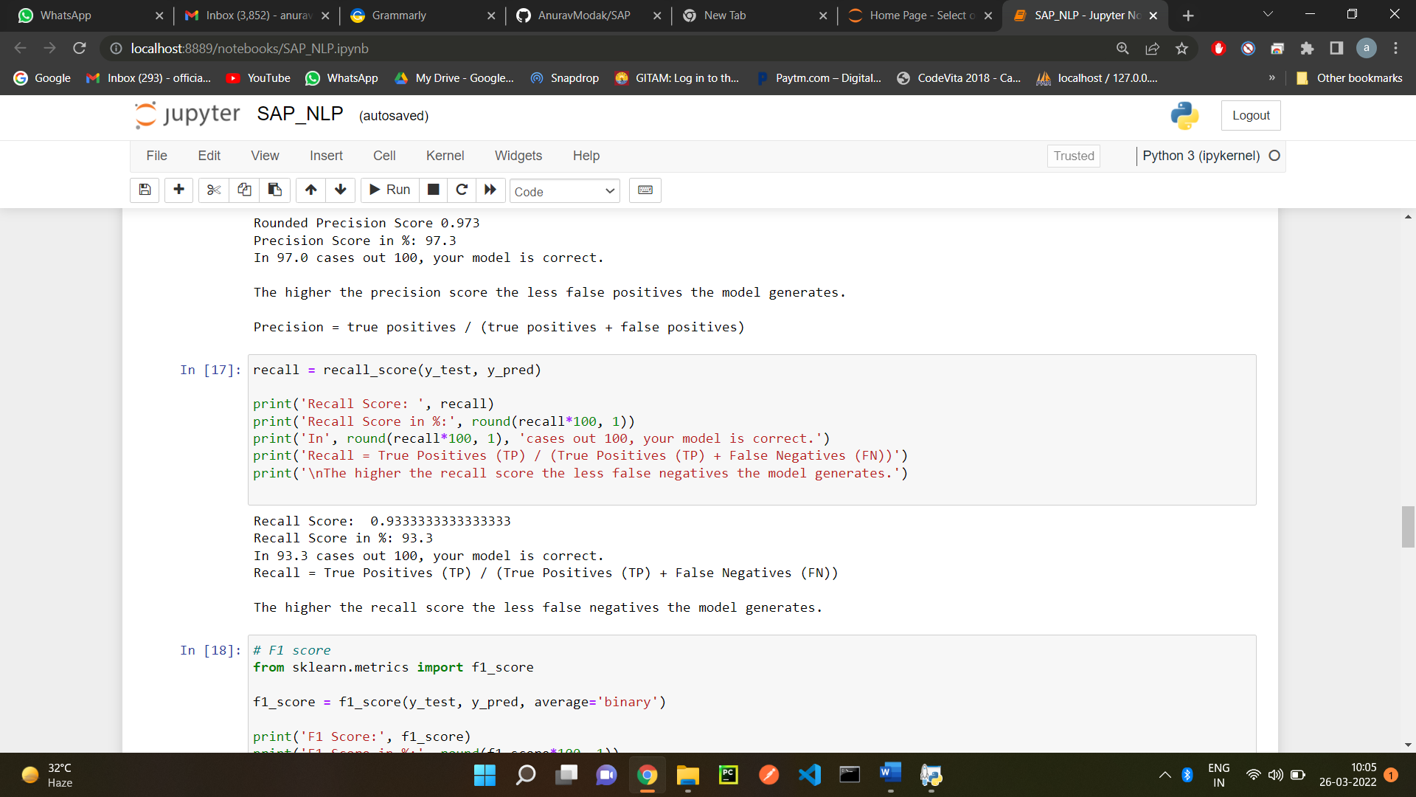

**F1 score:** 95.3%

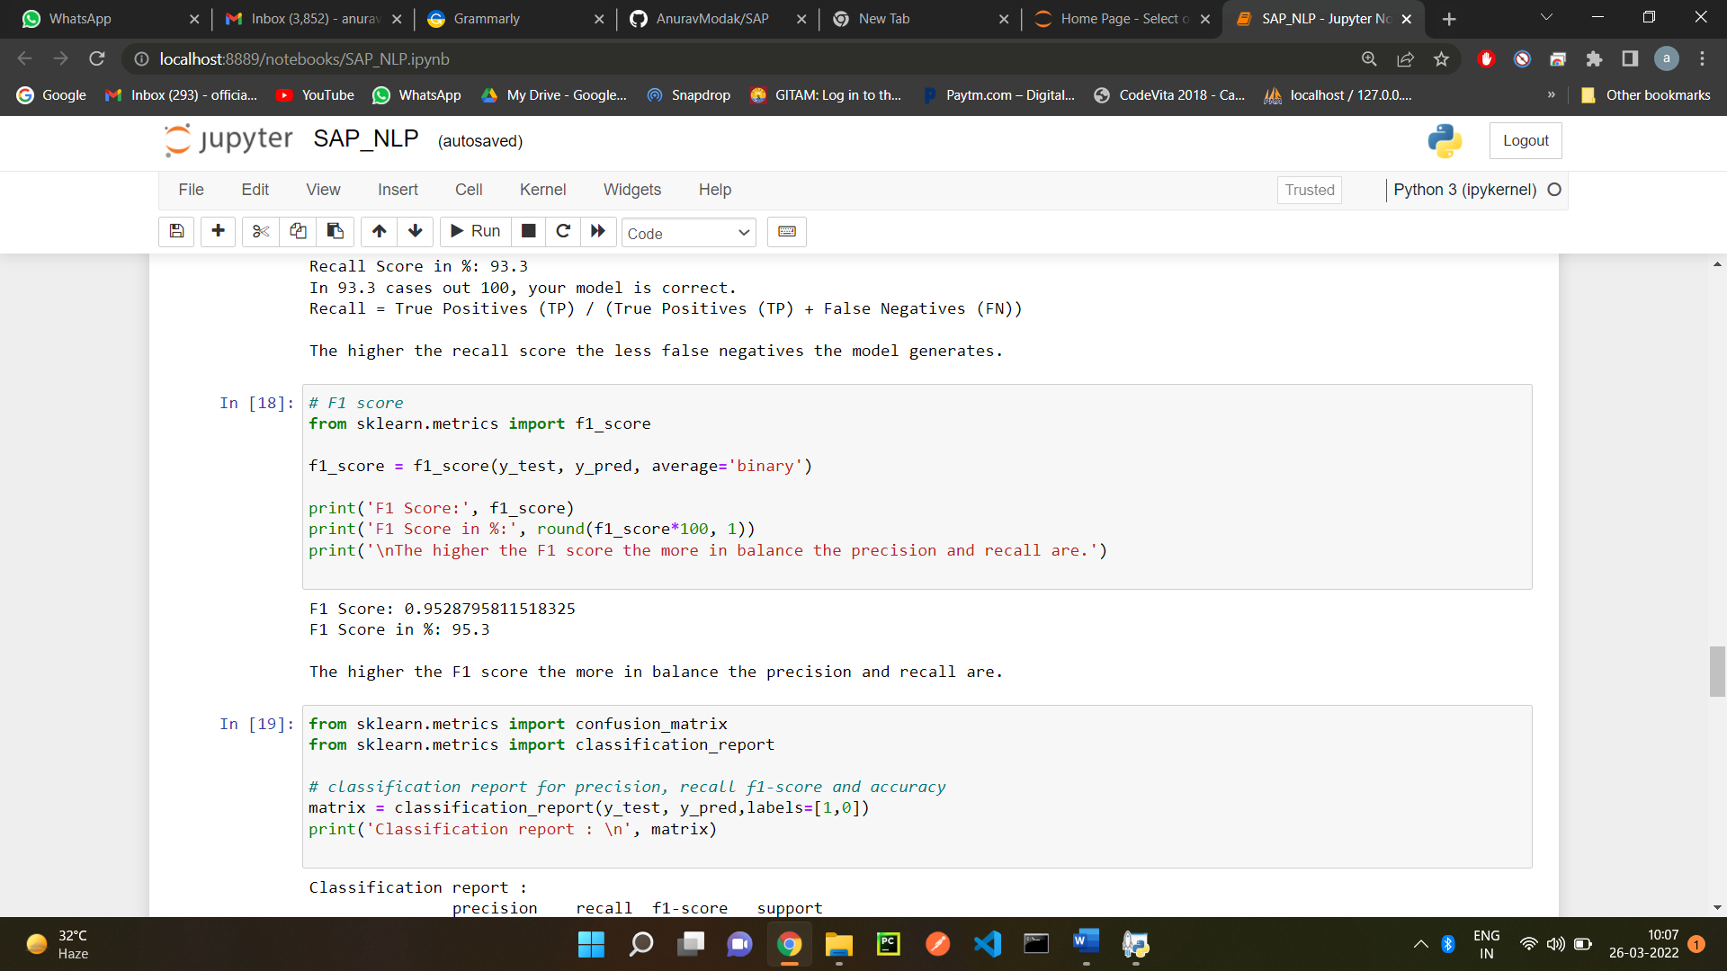

**Confusion Matrix:**

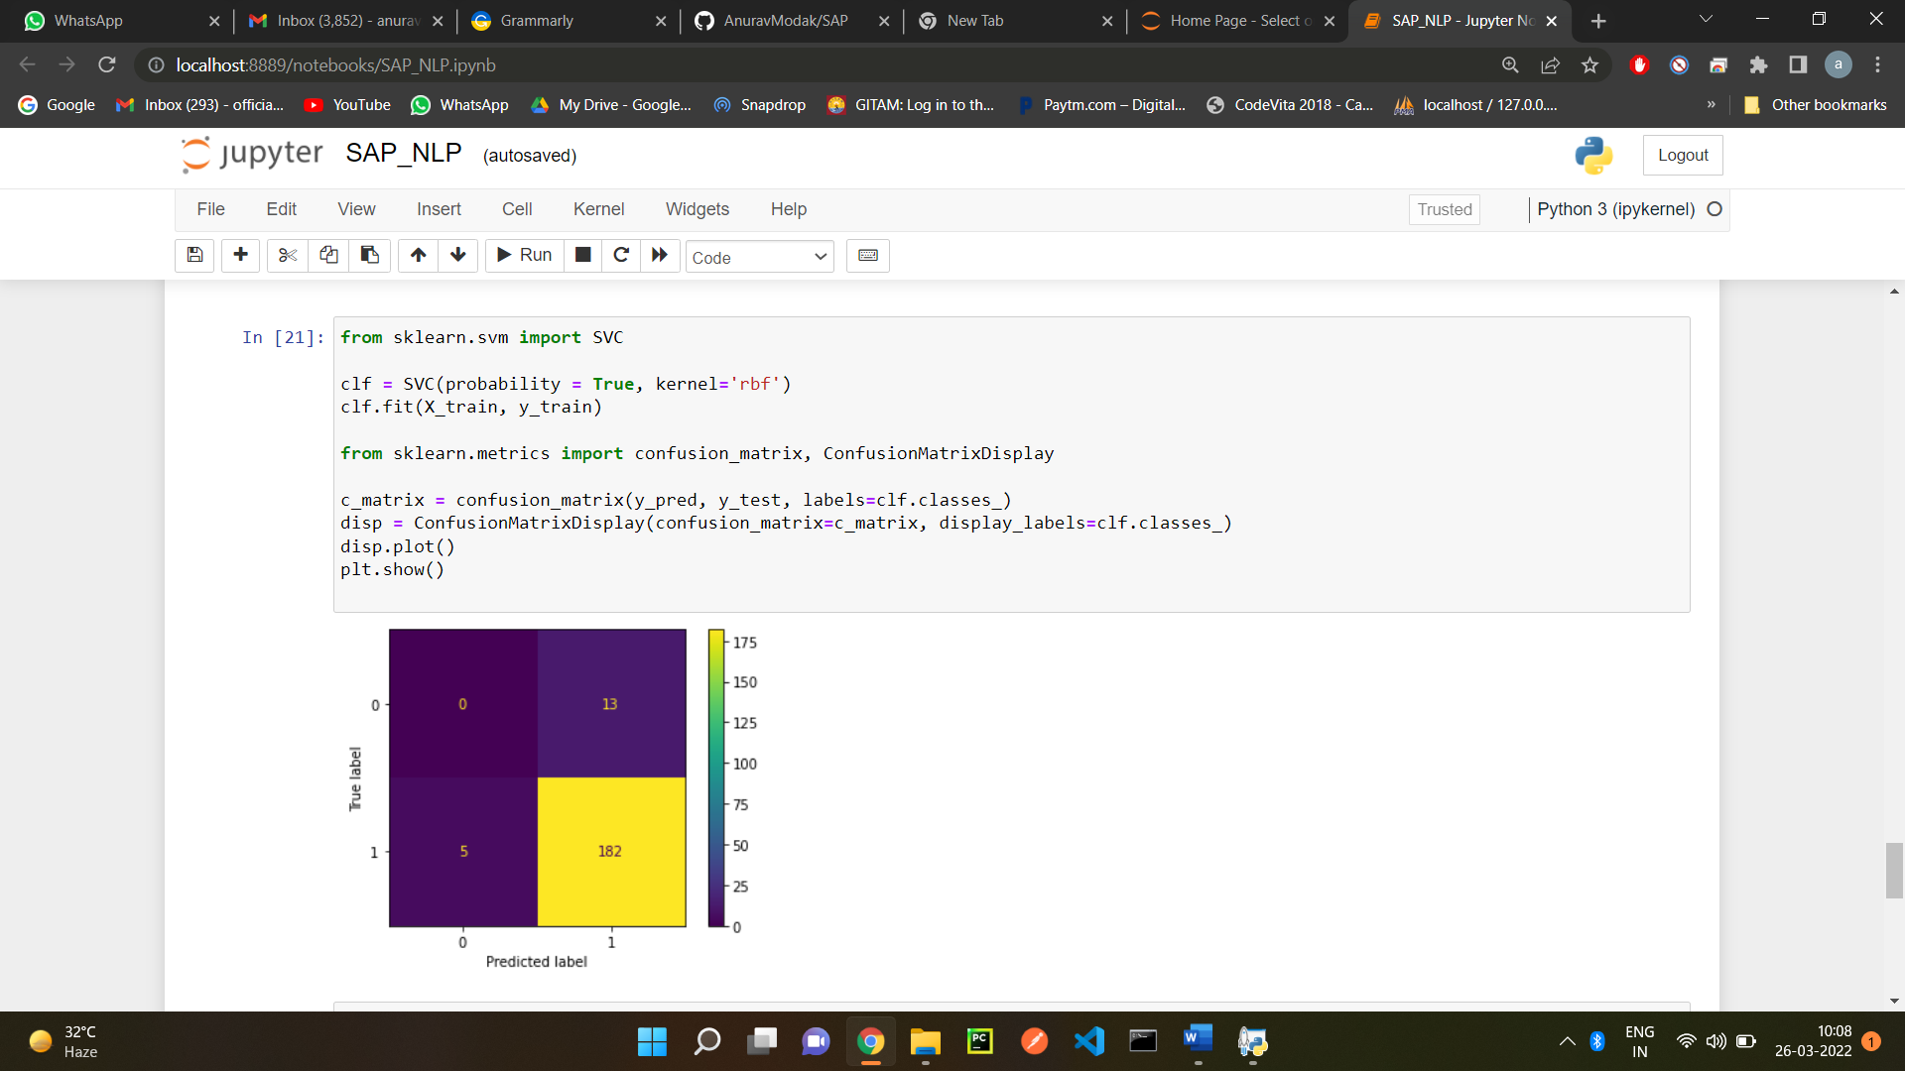

Explain your selection (i.e., comparison to other alternatives)

Here I will be using F1 score as both the Precision score and Recall score is quite high, so seek a balance between both of them we may use F1 score. Also, if we go by the definition of the F-score, also called the F1-score, is a measure of a model’s accuracy on a dataset. It is used to evaluate binary classification systems, which [classify](https://deepai.org/machine-learning-glossary-and-terms/classifier) examples into ‘positive’ or ‘negative’, that is in our case we have product “recommended” or “not recommended”.

**NAME:** N D SURYA PRAKASH

**COLLEGE:** GITAM UNIVERSITY

**COLLEGE ID:** 121910312048

**MOBILE:** 7659827607

**COLLEGE MAIL:** [121910312048@gitam.in](mailto:121910312048@gitam.in)

**PERSONAL MAIL:** [prakashnagamani01@gmail.com](mailto:prakashnagamani01@gmail.com)