Leetcode Two Pointer Theory: [Two_Pointers](https://leetcode.com/explore/featured/card/leetcodes-interview-crash-course-data-structures-and-algorithms/703/arraystrings/4501/) - ( i and j, or left and right)

1. It is mostly used to solve array & string-based problems

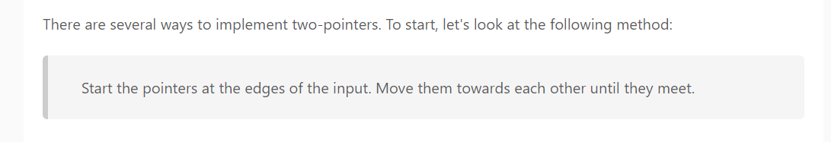

Instructions:

Converting this idea into instructions:

1. Start one pointer at the first index 0 and the other pointer at the last index input.length - 1.
2. Use a while loop until the pointers are equal to each other.
3. At each iteration of the loop, move the pointers towards each other. This means either increment the pointer that started at the first index, decrement the pointer that started at the last index, or both. Deciding which pointers to move will depend on the problem we are trying to solve.

Here's some pseudocode illustrating the concept:

function fn(arr):

left = 0

right = arr.length - 1

while left < right:

Do some logic here depending on the problem

Do some more logic here to decide on one of the following:

1. left++

2. right--

3. Both left++ and right--

