DNSENUM TOOL – COMPREHENSIVE TECHNICAL DOCUMENTATION
A DNS Enumeration Tool for Ethical Hacking & Penetration Testing
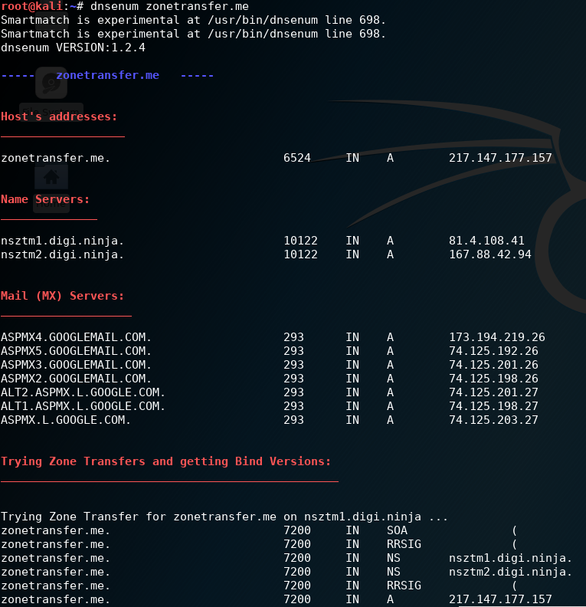
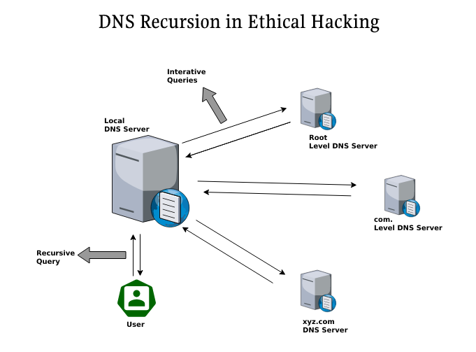
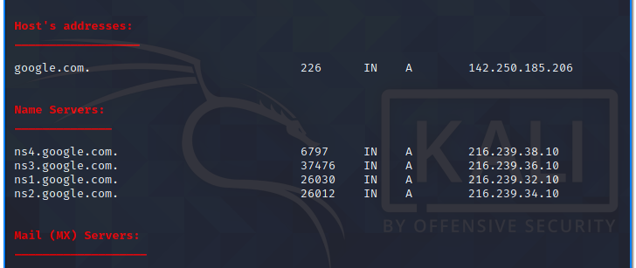
4

ABSTRACT
In modern cyber security assessments, reconnaissance plays a critical role in determining the overall success of a penetration testing engagement. Among reconnaissance techniques, Domain Name System (DNS) enumeration is one of the most effective methods for uncovering hidden infrastructure details of an organization. This document presents a comprehensive technical study of DNSENUM, a widely used DNS enumeration tool. The report explains the theoretical background, internal working mechanism, command usage, practical case study, advantages, limitations, and security implications of DNSENUM. The objective of this document is to demonstrate how DNSENUM assists ethical hackers in expanding the attack surface while also highlighting defensive considerations for organizations.

1. INTRODUCTION
The Domain Name System (DNS) is often described as the “phonebook of the internet.” It translates human-readable domain names into IP addresses that computers can understand. Due to its fundamental role in networking, DNS becomes an unavoidable component in any digital infrastructure. However, improper DNS configuration can unintentionally expose sensitive information about an organization’s internal structure.
DNS enumeration is the systematic process of extracting DNS-related information such as subdomains, mail servers, name servers, and associated IP addresses. Attackers frequently use this information to identify entry points into a target network. Ethical hackers and penetration testers replicate this behavior to assess the security posture of an organization.
DNSENUM is a specialized tool designed to automate DNS enumeration tasks efficiently. This document explores DNSENUM in depth, focusing on both theoretical and practical aspects.

2. OBJECTIVE OF THE STUDY
The primary objectives of this documentation are:
- To understand the importance of DNS enumeration in cyber security
- To analyze how DNSENUM works internally
- To study the commands and features offered by DNSENUM
- To demonstrate real-world usage through a practical case study
- To evaluate strengths, limitations, and security risks
- To provide exam-ready and submission-ready material

3. BACKGROUND: DNS ENUMERATION IN CYBER SECURITY
DNS enumeration is classified under the Information Gathering (Reconnaissance) phase of penetration testing. Unlike exploitation, reconnaissance focuses on collecting publicly accessible information without directly attacking systems.
DNS data can reveal:
- Hidden subdomains (development, testing, admin portals)
- Email infrastructure used by the organization
- Naming conventions that indicate internal roles
- Legacy or forgotten systems still accessible online
Since DNS data is often publicly queryable, attackers can gather this information without triggering intrusion detection systems. DNSENUM automates this process and presents the findings in a structured manner.

4. OVERVIEW OF DNSENUM TOOL
DNSENUM is an open-source DNS enumeration tool written in Perl and commonly available in Kali Linux. It combines multiple DNS reconnaissance techniques into a single execution flow. Instead of running several tools independently, DNSENUM integrates them into one unified workflow.
DNSENUM is not an exploitation tool. Its sole purpose is information disclosure through DNS analysis. However, the intelligence it provides can be critical for subsequent attack phases.

5. ARCHITECTURE AND WORKING MECHANISM
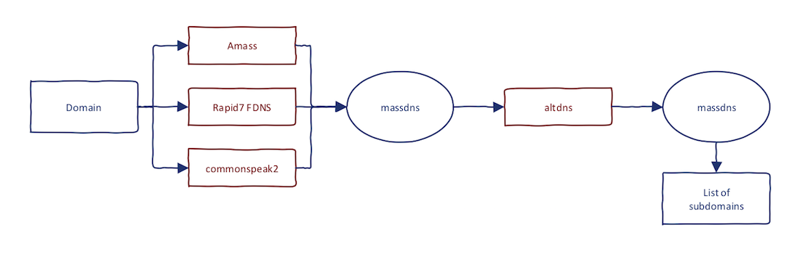

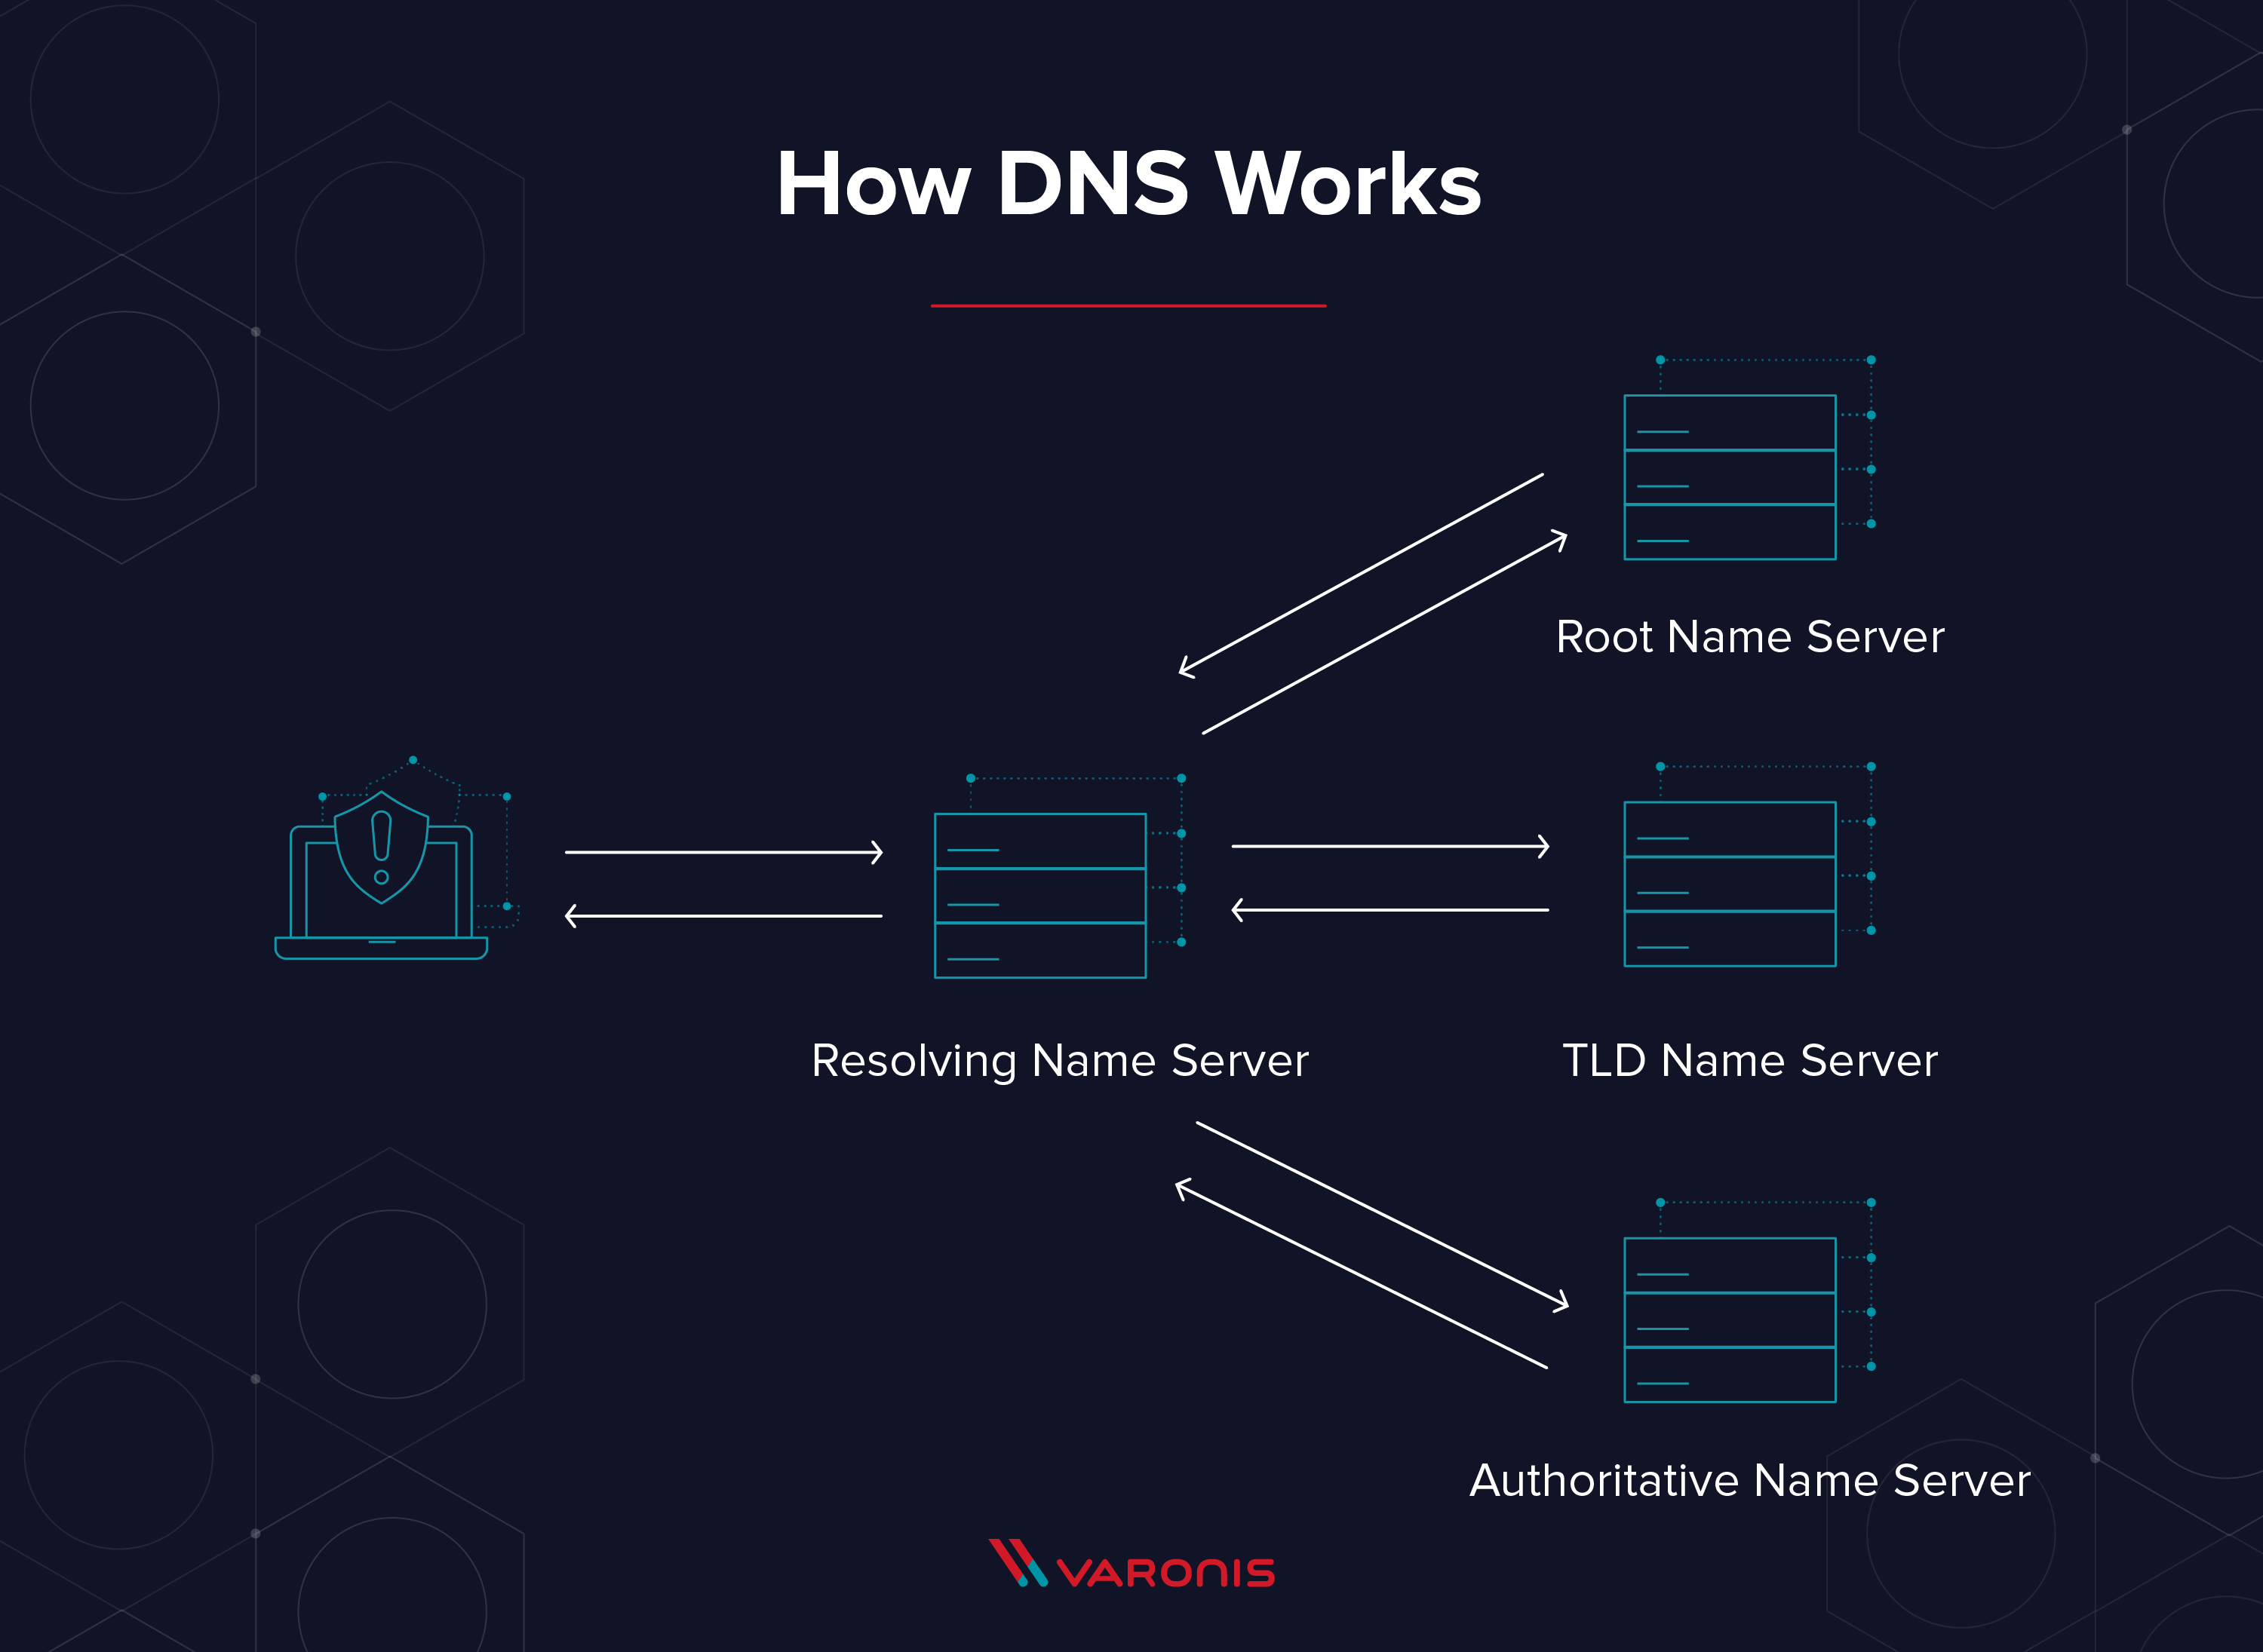
DNSENUM follows a multi-stage working mechanism:
- DNS Record Collection
The tool queries standard DNS records such as A, AAAA, NS, MX, TXT, and SOA records.
- Name Server Identification
DNSENUM identifies authoritative name servers responsible for the domain.
- Zone Transfer Testing
The tool attempts DNS zone transfers to check for misconfigurations.
- Subdomain Brute Forcing
Using wordlists, DNSENUM brute-forces potential subdomains.
- Reverse DNS Lookups
IP ranges are mapped back to domain names.
- Result Correlation
All gathered data is correlated and displayed in a readable format.
This layered approach ensures maximum coverage of DNS information.

6. INSTALLATION AND ENVIRONMENT
DNSENUM is pre-installed in Kali Linux. The tool requires Perl and DNS resolution libraries.
To verify installation:
dnsenum --help
DNSENUM is primarily executed in Linux-based penetration testing environments.

7. COMMAND USAGE AND ANALYSIS
7.1 Basic Enumeration
dnsenum example.com
This command performs standard DNS enumeration, including name servers, mail servers, and basic subdomain discovery.

7.2 Subdomain Brute Force Enumeration
dnsenum --enum example.com
This mode aggressively searches for hidden subdomains that may not be indexed by search engines.

7.3 Custom Wordlist Usage
dnsenum --enum -f wordlist.txt example.com
Used when testing organizations with predictable naming conventions.

7.4 Zone Transfer Testing
dnsenum --zonetransfer example.com
If successful, this reveals the entire DNS zone, representing a severe security misconfiguration.

7.5 Reverse DNS Enumeration
dnsenum --reverse 192.168.1.0/24
This command maps IP addresses back to domain names.

8. PRACTICAL CASE STUDY
Scenario
An ethical hacking assessment is conducted on a fictional organization, example-corp.com.
Execution
dnsenum example-corp.com
Observations
- dev.example-corp.com revealed a development server
- mail.example-corp.com exposed SMTP infrastructure
- vpn.example-corp.com indicated a remote access gateway
Impact Analysis
The discovered subdomains significantly expanded the attack surface and provided multiple vectors for further security testing.

9. ADVANTAGES OF DNSENUM
- Automates multiple DNS techniques
- Easy to use for beginners
- Suitable for academic and professional use
- Integrates well with other security tools

10. LIMITATIONS OF DNSENUM
- Slower than dedicated brute-force tools
- Dependent on wordlists for subdomain discovery
- Generates noise during aggressive scans
- Not ideal for very large enterprise environments

11. SECURITY AND DEFENSIVE CONSIDERATIONS
Organizations can protect against DNS enumeration by:
- Disabling DNS zone transfers
- Implementing split-horizon DNS
- Limiting public DNS records
- Monitoring DNS query behavior

12. LEGAL AND ETHICAL CONSIDERATIONS
DNSENUM must only be used on systems where explicit authorization has been granted. Unauthorized DNS enumeration can violate cyber laws and organizational policies.

13. CONCLUSION
DNSENUM is a powerful reconnaissance tool that highlights the importance of secure DNS configuration. While it does not exploit vulnerabilities directly, the intelligence gathered through DNSENUM can enable attackers to plan highly effective attacks. For ethical hackers, understanding DNSENUM is essential to mastering the reconnaissance phase of penetration testing.

14. REFERENCES
- DNS RFC Standards
- Kali Linux Documentation
- OWASP Information Gathering Guide

🔥 NEXT STEP (Highly Recommended)
I can now:
- Convert this into professional DOCX / PDF
- Add cover page, index, page numbers
- Add flowcharts & labeled diagrams
- Format it exactly like college project submission
- Add professor-friendly language & citations

