WHOIS, DIG & NSLOOKUP – COMPREHENSIVE TECHNICAL DOCUMENTATION
Core DNS & Network Intelligence Tools for Ethical Hacking & Penetration Testing
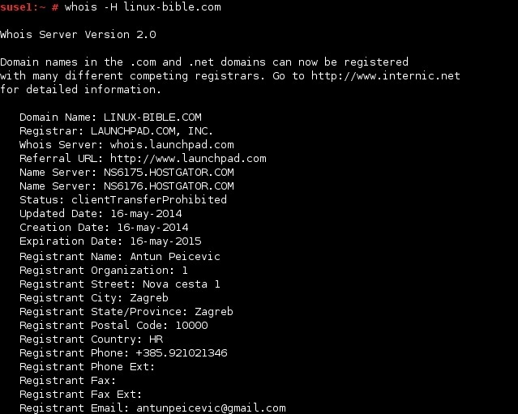
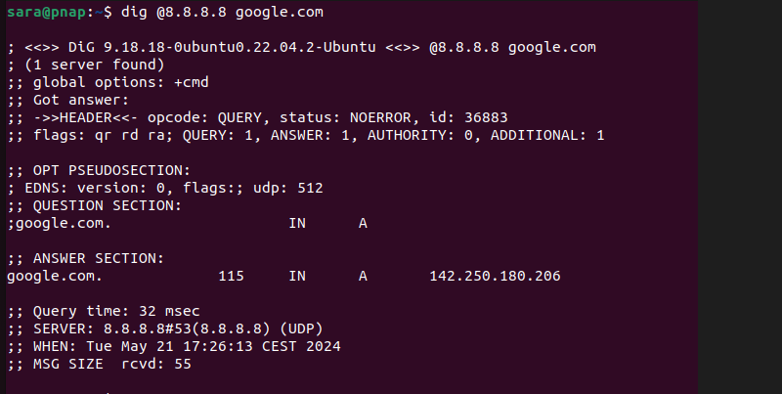
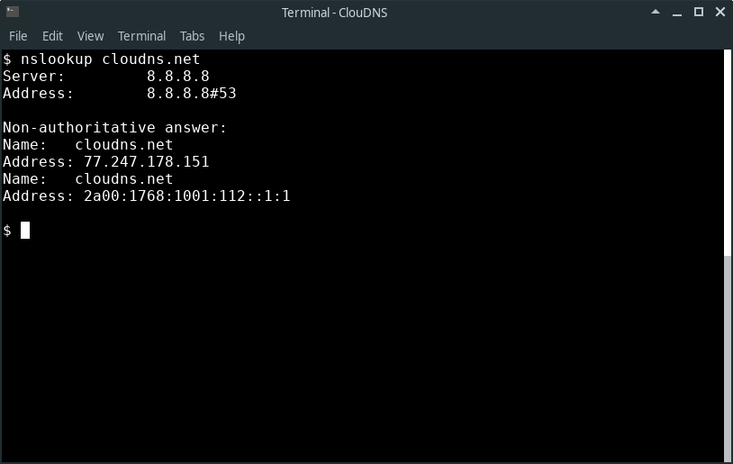

ABSTRACT
Domain and network-level intelligence gathering forms the foundation of reconnaissance in penetration testing. Before performing active scans or exploitation, ethical hackers rely on low-noise tools to understand domain ownership, DNS records, name servers, and IP mappings. This document presents a comprehensive technical study of three fundamental reconnaissance tools: WHOIS, DIG, and NSLOOKUP. These tools are widely used in cyber security for DNS analysis, infrastructure discovery, and verification of network configurations. The report explains theoretical concepts, working mechanisms, command usage, practical case studies, advantages, limitations, and defensive considerations. The objective is to provide a strong academic and practical understanding suitable for cybersecurity coursework and professional assessments.

PART A: WHOIS TOOL
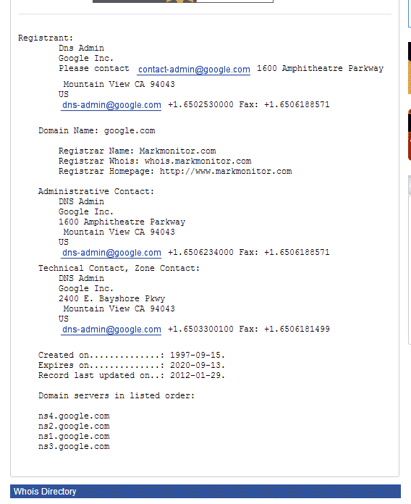
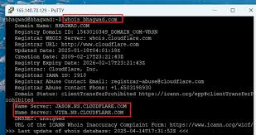

1. INTRODUCTION TO WHOIS
WHOIS is a query protocol used to retrieve registration and ownership information of internet resources such as domain names, IP address ranges, and autonomous systems. When a domain is registered, details about the owner, registrar, registration dates, and name servers are stored in WHOIS databases.
From a cyber security perspective, WHOIS provides organizational intelligence that helps attackers and defenders understand who owns an asset, how long it has existed, and where it is hosted.

2. OBJECTIVE OF USING WHOIS
The primary objectives of WHOIS in penetration testing are:
- To identify domain ownership details
- To determine registrar and hosting provider
- To discover name servers and IP ranges
- To understand organizational footprint
WHOIS is commonly used during passive reconnaissance.

3. WORKING MECHANISM OF WHOIS
WHOIS operates by querying distributed WHOIS servers maintained by domain registrars and Regional Internet Registries (RIRs). Based on the queried domain or IP address, the request is forwarded to the authoritative WHOIS server, which returns the stored registration information.
Because WHOIS queries are passive, they do not interact with the target infrastructure directly.

4. COMMAND USAGE AND ANALYSIS (WHOIS)
4.1 Domain WHOIS Lookup
whois example.com
Retrieves domain registration details such as registrar, creation date, and name servers.

4.2 IP Address WHOIS Lookup
whois 8.8.8.8
Returns IP ownership, ASN, and ISP information.

4.3 Organization WHOIS Search
whois "Example Corporation"
Used to identify domains registered under an organization.

5. PRACTICAL CASE STUDY (WHOIS)
Scenario
A penetration tester performs reconnaissance on example-corp.com.
Findings
- Registrar details reveal hosting provider
- Creation date indicates legacy infrastructure
- Name servers hint at third-party DNS services
Impact
This information assists in infrastructure mapping and social engineering preparation.

6. ADVANTAGES & LIMITATIONS (WHOIS)
Advantages
- Completely passive
- Provides ownership and infrastructure context
- Easy to use
Limitations
- Privacy protection may hide owner details
- Information may be outdated

PART B: DIG TOOL
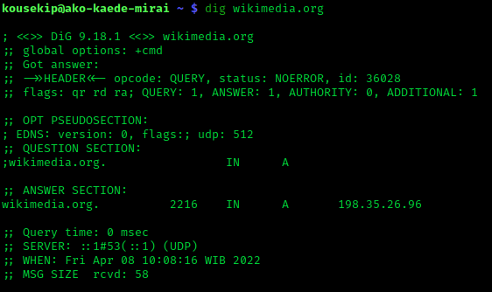
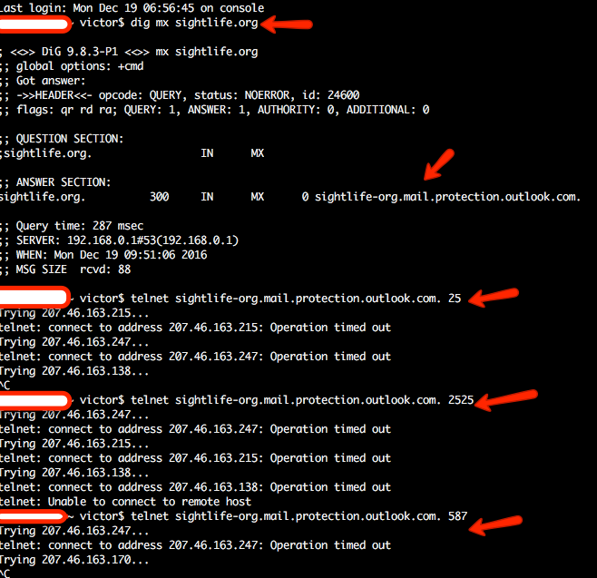


7. INTRODUCTION TO DIG
DIG (Domain Information Groper) is a powerful DNS query tool used to retrieve detailed DNS records from name servers. Unlike simple lookup tools, DIG provides granular control and detailed output, making it the preferred choice for DNS troubleshooting and penetration testing.
DIG is widely used to verify DNS configurations and identify misconfigurations.

8. OBJECTIVE OF USING DIG
DIG is used to:
- Query specific DNS record types
- Identify authoritative name servers
- Troubleshoot DNS resolution paths
- Detect DNS misconfigurations
DIG is used in both passive and active reconnaissance.

9. WORKING MECHANISM OF DIG
DIG sends DNS queries directly to specified name servers and displays raw DNS responses. It allows testers to analyze TTL values, flags, authority sections, and additional records.
This level of detail makes DIG extremely valuable for advanced DNS analysis.

10. COMMAND USAGE AND ANALYSIS (DIG)
10.1 Basic DNS Query
dig example.com

10.2 Query Specific Record Types
dig example.com MX
dig example.com NS
dig example.com TXT

10.3 Query a Specific Name Server
dig @8.8.8.8 example.com

10.4 Trace DNS Resolution Path
dig example.com +trace
Reveals the complete DNS resolution chain from root servers.

11. PRACTICAL CASE STUDY (DIG)
Findings
- Misconfigured MX records exposed mail servers
- TXT records revealed SPF and verification data
Impact
DIG helped identify weak DNS hygiene and potential attack vectors.

12. ADVANTAGES & LIMITATIONS (DIG)
Advantages
- Extremely detailed DNS output
- Supports advanced DNS troubleshooting
- Preferred by professionals
Limitations
- Complex output for beginners
- Requires DNS knowledge

PART C: NSLOOKUP TOOL

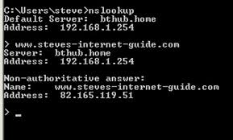

13. INTRODUCTION TO NSLOOKUP
NSLOOKUP is a traditional DNS query tool used to obtain domain-to-IP mappings and DNS records. It is widely available on Windows, Linux, and macOS, making it one of the most accessible DNS tools.
Although older than DIG, NSLOOKUP remains useful for quick DNS checks.

14. OBJECTIVE OF USING NSLOOKUP
NSLOOKUP is used to:
- Resolve domain names to IP addresses
- Query basic DNS records
- Verify DNS server responses
- Perform quick troubleshooting

15. WORKING MECHANISM OF NSLOOKUP
NSLOOKUP queries DNS servers and displays resolved records. It can operate in both command-line mode and interactive mode, allowing multiple queries in a single session.

16. COMMAND USAGE AND ANALYSIS (NSLOOKUP)
16.1 Basic Lookup
nslookup example.com

16.2 Query Specific Record Type
nslookup -type=MX example.com

16.3 Query a Specific DNS Server
nslookup example.com 8.8.8.8

16.4 Interactive Mode
nslookup
> set type=NS
> example.com

17. PRACTICAL CASE STUDY (NSLOOKUP)
Findings
- Confirmed DNS resolution issues
- Identified misaligned name server entries
Impact
NSLOOKUP provided quick validation before deeper analysis.

18. COMPARISON: WHOIS vs DIG vs NSLOOKUP
Tool | Primary Purpose | Best Use Case
WHOIS | Ownership & registration | Organizational recon
DIG | Advanced DNS analysis | Professional DNS testing
NSLOOKUP | Basic DNS queries | Quick checks & learning

19. SECURITY & DEFENSIVE CONSIDERATIONS
Organizations should:
- Limit public exposure of WHOIS data
- Regularly audit DNS records
- Monitor DNS misconfigurations
- Implement DNS security best practices

20. LEGAL & ETHICAL CONSIDERATIONS
These tools must be used only for authorized security testing and academic learning. Even passive reconnaissance can violate policies if misused.

21. CONCLUSION
WHOIS, DIG, and NSLOOKUP are foundational tools in cyber security reconnaissance. While simple in nature, they provide critical intelligence that shapes all subsequent penetration testing phases. Mastery of these tools is essential for any cybersecurity student or professional.

