Assignment – 1

Task 1

Question 1: Briefly explain about the following
a) Coarticulation:
Coarticulation refers to the overlapping of articulatory movements during speech production. When we speak, sounds are not produced in isolation—each phoneme is influenced by its neighboring sounds. This phenomenon ensures smooth and natural speech flow.
b) Phonation:
Phonation is the process by which the vocal folds in the larynx vibrate to produce sound. Air from the lungs passes through the glottis, causing the vocal cords to vibrate. The rate of vibration determines the fundamental frequency (pitch) of the voice.
c) Fundamental Frequency (F₀):
It is the lowest frequency component of a voiced speech sound, corresponding to the vibration rate of the vocal folds. Measured in Hertz (Hz), it defines the pitch of a person’s voice.
d) Epochs:
Epochs are the instants of significant excitation in the speech signal, marking moments of glottal closure during voiced sounds.

Question 2:
Statement: “Female pitch is more when compared to Male pitch.”
Answer: True.
Justification:
Pitch depends on the vibration frequency of the vocal folds. Females have shorter, thinner vocal folds, leading to higher vibration frequency (around 200–250 Hz), while males have longer, thicker folds (85–180 Hz). Hence, female voices are higher-pitched.

Question 3:
Speech is a complex acoustic signal generated by the vocal tract when humans communicate. It is a time-varying signal carrying linguistic and emotional information. Unlike simple or mechanical signals, speech is non-stationary, quasi-periodic, and rich in spectral content.

Task 2
Recording sentence: “I am from Kakinada.”
Steps performed using Wavesurfer/Audacity:
1. Record at 16 kHz, 16-bit.



2. Display waveform.
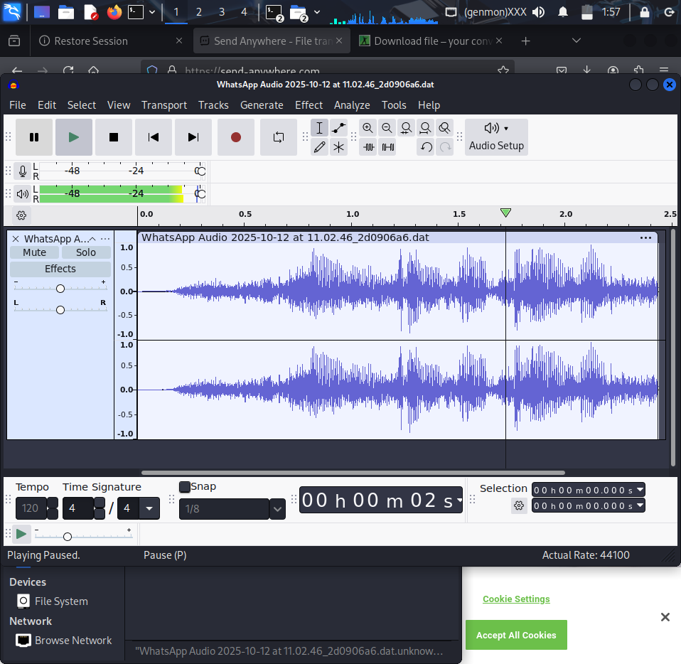
3. Annotate voiced, unvoiced, silence, and plosive regions.
Segment | Type | MOA | POA | Voicing | Observation
/aɪ/ | Vowel (diphthong) | Glide | Front | Voiced | Smooth periodic waveform; clear harmonic structure
/æm/ | Vowel + Nasal | Open vowel then nasal closure | Central vowel / Bilabial (/m/) | Voiced | Periodic energy for vowel; nasal murmur for /m/
/f/ | Fricative | Narrow constriction → turbulent flow | Labiodental | Unvoiced | High-frequency noisy energy, low amplitude
/r/ | Approximant | Narrow channel but not closure | Alveolar/post-alveolar | Voiced | Low-amplitude periodic energy; smooth formant transitions
/k/ | Stop (plosive) | Complete closure then release | Velar (soft palate) | Unvoiced (burst) | Short silence/closure followed by burst on release
/ɪnədə/ | Vowels + Nasal | Vowel nuclei with nasal consonant | Front/Central/Alveolar | Voiced | Voiced formant structure with transition between vowels and nasal
Time-Varying System Description:
Segment | Description
/aɪ/ | Tongue moves from low-front to high-front; vocal tract narrows during the glide (F1↓, F2↑).
/æm/ | Tongue low/central for /æ/ (VT widely open); bilabial closure for /m/ (lips closed) with nasal port open → nasal radiation.
/f/ | Lower lip approaches upper teeth forming a narrow constriction; turbulent airflow at labiodental place produces frication noise.
/r/ | Tongue approximates postalveolar area; no complete closure so voiced energy with lowered amplitude and gradual formant changes.
/k/ | Tongue dorsum contacts velum (complete closure); on release there is a burst and rapid change in VT area function.
/ɪnədə/ | Sequence of voiced vowels with formant trajectories: fronting for /ɪ/, alveolar obstruction for /n/ (nasal formant), and central schwa-like nucleus with voiced energy.

Observation: Voiced portions have periodic glottal pulses; unvoiced fricatives show random high-frequency components.
https://drive.google.com/file/d/1phNjzKvVBpX4ePbnayvaAaDnb4Ok7Row/view?usp=drive_link

Task 3
Recording sentence: “I am son of Lakshmi.”
Follow same steps as in Task 2.



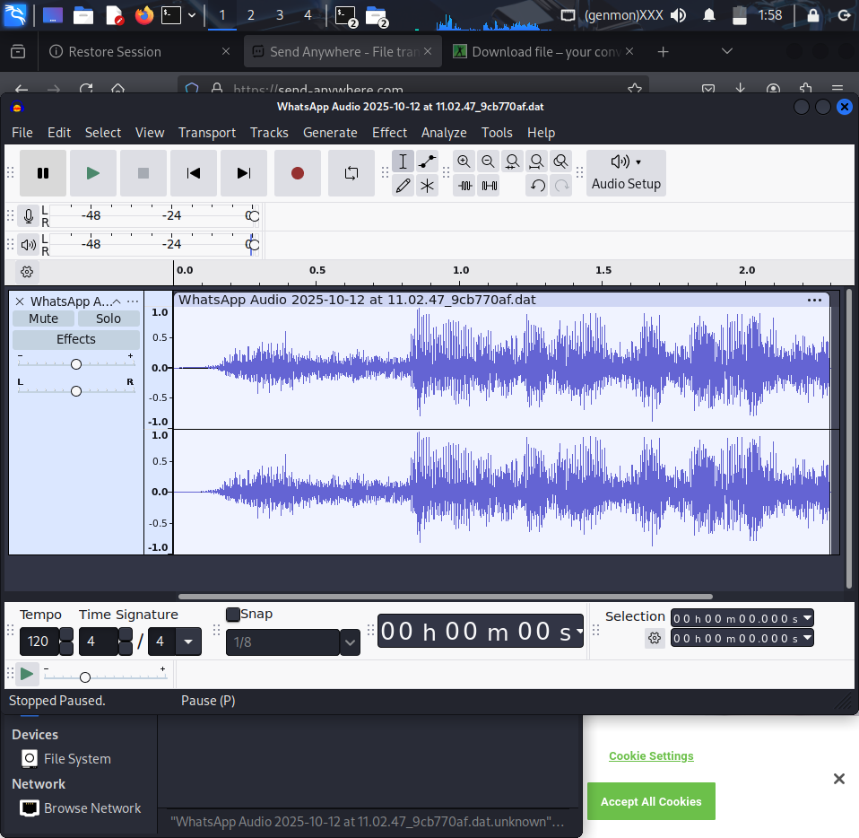
Segment | Type | MOA | POA | Voicing | Observation
/aɪ/ | Vowel (diphthong) | Glide | Front | Voiced | Smooth periodic waveform; pitch movement at diphthong start
/æm/ | Vowel + Nasal | Open vowel then bilabial closure | Central vowel / Bilabial | Voiced | Periodic vowel energy; nasal murmur for /m/
/s/ | Fricative | Narrow constriction → turbulent flow | Alveolar | Unvoiced | Strong high-frequency noise (aperiodic)
/ʌn/ | Vowel + Nasal | Vowel nucleus then alveolar nasal | Central vowel / Alveolar | Voiced | Voiced vowel then nasal resonance on /n/
/lækʃmɪ/ | Consonant cluster + vowels | Lateral onset + velar stop + postalveolar fricative + voiced transitions | Alveolar (/l/), Velar (/k/), Postalveolar (/ʃ/) | Voiced (mostly) | /l/ shows lateral formant pattern; /k/ has closure+burst; /ʃ/ shows high-frequency friction; following vowels are voiced
/i/ (final) | Vowel | High front steady state | Front | Voiced | Sustained high F2, low F1 indicating front vowel
Time-Varying System Description:
Segment | Description
/aɪ/ | Tongue moves from low-front to high-front (formant trajectories: F1 decreases, F2 increases).
/æm/ | Open vocal tract for /æ/ then bilabial closure for /m/ with nasal coupling (nasal formant present).
/s/ | Narrow alveolar constriction produces broadband turbulent energy concentrated at higher frequencies.
/ʌn/ | Tongue centralizes for /ʌ/ then alveolar closure for /n/; nasal coupling damps some formants and produces nasal resonance.
/lækʃmɪ/ | /l/: tongue tip at alveolar ridge, lateral airflow and characteristic formant lowering; /k/: dorsum-to-velum closure and burst on release; /ʃ/: postalveolar narrow channel causing high-frequency frication; vowels following these show voiced periodic energy and shifting formants.
/i/ | Tongue high-front; narrow front cavity produces high F2 and low F1 (sustained vowel resonance).

Observation: Voiced regions exhibit periodic waveforms with strong harmonics; unvoiced and plosive regions show irregular amplitude patterns.
https://drive.google.com/file/d/1EBQa_-Zm3S9xHTfE6Guo5G2gf8Cb0OcD/view?usp=drive_link

