Phishing Awareness Lab - Terminal Screenshot
This document contains a screenshot from a controlled educational cybersecurity lab used for studying phishing awareness, fake login page behavior, and defensive security concepts.

Lab Screenshot
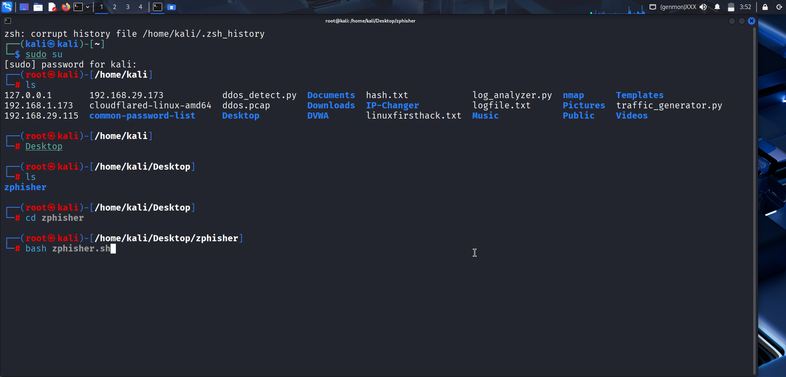
Figure 1: Kali Linux phishing awareness lab environment.

Disclaimer
This project is intended strictly for educational and cybersecurity awareness purposes only. Unauthorized or malicious use against real targets is prohibited.

