**ASSIGNMENT – 1**

**1.**The following is a list of 10 students ages: ages = [19, 22, 19, 24, 20, 25, 26, 24, 25, 24]

• Sort the list and find the min and max age • Add the min age and the max age again to the list

• Find the median age (one middle item or two middle items divided by two)

• Find the average age (sum of all items divided by their number)

• Find the range of the ages (max minus min)

* First sorted the list using sort()
* Then added minimum and maximum ages using append
* Then founded the median of list
* Average of the list
* Range of the list

**2**• Create an empty dictionary called dog

• Add name, color, breed, legs, age to the dog dictionary

•Create a student dictionary and add first_name, last_name, gender, age, marital status, skills, country, city and address as keys for the dictionary

• Get the length of the student dictionary

• Get the value of skills and check the data type, it should be a list

• Modify the skills values by adding one or two skills

• Get the dictionary keys as a list

• Get the dictionary values as a list

**3.** • Create a tuple containing names of your sisters and your brothers (imaginary siblings are fine)

• Join brothers and sisters tuples and assign it to siblings • How many siblings do you have?

• Modify the siblings tuple and add the name of your father and mother and assign it to family_members

**4.** it_companies = {'Facebook', 'Google', 'Microsoft', 'Apple', 'IBM', 'Oracle', 'Amazon'} A = {19, 22, 24, 20, 25, 26} B = {19, 22, 20, 25, 26, 24, 28, 27} age = [22, 19, 24, 25, 26, 24, 25, 24]

• Find the length of the set it_companies

• Add 'Twitter' to it_companies

• Insert multiple IT companies at once to the set it_companies

• Remove one of the companies from the set it_companies

• What is the difference between remove and discard

• Join A and B

• Find A intersection B

• Is A subset of B

• Are A and B disjoint sets

• Join A with B and B with A

• What is the symmetric difference between A and B

• Delete the sets completely

• Convert the ages to a set and compare the length of the list and the set.

5.The radius of a circle is 30 meters.

• Calculate the area of a circle and assign the value to a variable name of _area_of_circle

• Calculate the circumference of a circle and assign the value to a variable name of _circum_of_circle_ • Take radius as user input and calculate the area.

**6.** “I am a teacher and I love to inspire and teach people”

• How many unique words have been used in the sentence? Use the split methods and set to get the unique words.

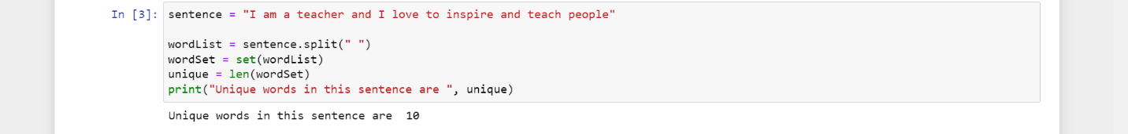

**7.** Use a tab escape sequence to get the following lines.

Name Age Country City

Asabeneh 250 Finland Helsinki



**8.** Use the string formatting method to display the following: radius = 10 area = 3.14 * radius ** 2 “The area of a circle with radius 10 is 314 meters square.”



**9.** Write a program, which reads weights (lbs.) of N students into a list and convert these weights to kilograms in a separate list using Loop.

N: No of students (Read input from user)

Ex: L1: [150, 155, 145, 148]

Output: [68.03, 70.3, 65.77, 67.13]

