SIMATSENGINEERING

ASSESSMENTTOOL1

COURSENAME: CSA16COURSECODE:DataWarehousingandDataMining

COURSEOUTCOMECOVERED
CO5:Applyassociationruleminingtechniquestodiscoverinterestingrelationshipsand patterns within large datasets
AssessmentToolWeightage:35%

QUESTIONS:05 TotalMarks:50
AnnexureA
Constraint-BasedProblemSolving

Criteria | Problem Understanding (2.5) | Constraint Analysis (2.5) | Solution Development (2.5) | Applicationof Concepts (1.5) | Justification  (1) | Total(10)
Weightage | 25% | 25% | 25% | 15% | 10% | 100%
Q1
Q2
Q3
Q4
Q5

Codeof Conduct:

I M. Jayaprakash Narayana Reddy/192425268(Name / Reg No) certify that this submission is my original work and that I have adhered to the guidelines specified for this assessment.
Iunderstandthatanyviolationofacademicintegrityruleswillresultindisciplinary action.
jayaprakash
Signatureofthestudent:

RUBRICSFORCALCULATION:

Constraint-Based Problem SolvingAssessmentRubric
Criteria | Weightage | Level 4 (Exemplary) | Level 3 (Proficient) | Level 2 (Developing) | Level 1 (Beginning)
Problem Understanding | 25% | Clearly defines the problemand identifies all relevant constraints  accurately | Identifies most constraintswith minor gaps | Partial understanding; misses key constraints | Failstoidentify constraints correctly
Constraint Analysis | 25% | Analyzes constraints effectively and prioritizes them  logically | Provides reasonable analysiswith some prioritization | Limited analysis;weak prioritization | Nomeaningful analysis or prioritization
Solution Development | 25% | Develops optimal and feasible solutions satisfyingall  constraints | Develops workable solutionswith minor limitations | Solutions partiallysatisfy constraints | Solutionsdo not meet constraints
Applicationof Concepts | 15% | Effectively applies appropriate concepts,  methods,or tools | Applies conceptswith minor errors | Limited application; requires guidance | Unable to applyrelevant concepts
Justification | 10% | Provides strong justification fordecisions with logical  reasoning | Provides justification with some clarity | Weak or unclear justification | Nojustification provided

AnnexureA

Constraint-BasedProblemSolving(6Marks)(BL4–BL5)–Reframed with New Scenarios
Q1.Dataset:HospitalPatientRecords

PIDSymptomsObserved
P1 Fever, CoughP2 Fever,Headache
P3 Cough, Headache
P4 Fever,Cough,Headache P5 Fever, Fatigue

Question:
Applyassociationruleminingwithminimumsupport=50%andconfidence=70%,under the constraint that all generated rules must include "Fever". Identify the valid association rules and justify why they satisfy the given constraints. (BL4 – 1.2 Marks)

Q2.Dataset:OnlineLearningPlatform

StudentID CoursesEnrolled
S1 Python, SQL
S2 Python,Data Science
S3 SQL,MachineLearning
S4 Python,SQL,Data Science
S5 Python,MachineLearning

Question:
Using the dataset, generate frequent itemsets with minimum support = 40%, applying the constraintthateachitemsetmustcontainatleasttwocourses.Explainhowtheconstraint helps in pruning candidate itemsets during mining. (BL4 – 1.2 Marks)

Q3.Dataset:LibraryBorrowingRecords

TransactionID BooksBorrowed
T1 DataMining,Python Programming
T2 DataMining,DatabaseSystems
T3 PythonProgramming,DatabaseSystems
T4 DataMining,PythonProgramming,DatabaseSystems T5 Data Mining, Artificial Intelligence

Question:
Apply the Apriori algorithm with the constraint that the maximum itemset size is 3. Identify thefrequentitemsetsandexplainhowtheconstraintreducescomputationalcomplexityduring candidate generation.

Q4.Dataset:UniversityCourseHierarchy

StudentID CoursesTaken
S1 Engineering,ComputerScience,MachineLearning S2 Engineering, Information Technology
S3 Engineering,ComputerScience
S4 Engineering,ComputerScience,MachineLearning S5 Engineering, Information Technology

Question:
Applymultilevelassociationruleminingwiththeconstraintthatrulesshouldbegenerated only at the "Computer Science" level. Explain how the course hierarchy affects the discovery of association rules. (BL5 – 1.2 Marks)

Q5.Dataset:InsuranceCustomerRecords

CIDAgeGroupIncomeLevelPolicyPurchased

C1 | Young | High | HealthInsurance
C2 | Middle | Medium | VehicleInsurance
C3 | Young | Low | TravelInsurance
C4 | Senior | High | HealthInsurance
C5 | Young | Medium | VehicleInsurance

Question:
ApplymultidimensionalassociationruleminingwiththeconstraintAgeGroup="Young". Identify meaningful patterns involving income level and policy type, and explain how these patterns can support targeted marketing strategies. (BL4 – 1.2 Marks)

Q1.HospitalPatientRecords —AssociationRuleMining

Transactions:5
Minimumsupport=50%→atleast3transactions Minimum confidence = 70%
Constraint:EveryrulemustincludeFever. Step 1: Frequent itemsets
Itemset | Count | Support
Fever | 4 | 80%
Cough | 3 | 60%
Headache | 3 | 60%
Fever,Cough | 2 | 40%
Fever,Headache | 2 | 40%

Thecombinationscontaining Feverdo notreachtherequired50%support.

Therefore,nonon-trivialassociationrulecontainingFeversatisfiesbothsupport≥50% and confidence ≥ 70%.

Forexample:

- Fever→Cough
Support= 2/5=40%→ failssupport.
- Cough→ Fever
Support= 2/5=40%→ failssupport.
- Fever→Headache
Support= 2/5=40%→ failssupport.
- Headache→Fever
Support= 2/5=40%→ failssupport.

Answer:

Novalidnon-trivialassociationrulescanbegeneratedunderthegivenconstraints.

TheconstraintrequiringFeverfurtherprunesallcandidaterulesthatdonotcontainFever, while the 50% support threshold eliminates the Fever-containing pairs.

Output:
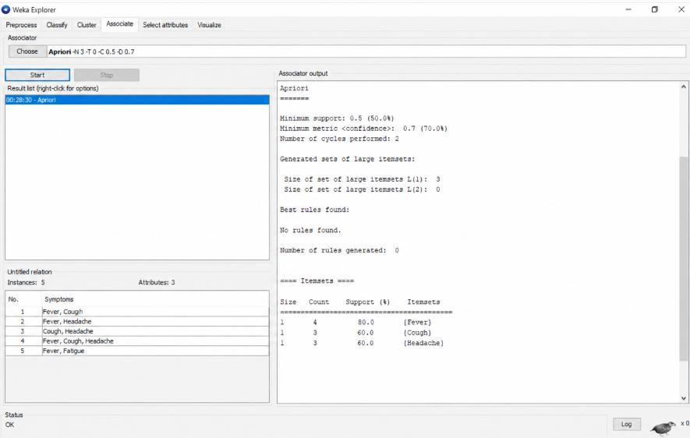

Q2.OnlineLearningPlatform—FrequentItemsets Transactions = 5
Minimum support = 40%

Therefore, anitemsetmustoccurinatleast:

5×40%=2

transactions.

Constraint:Itemsetmustcontainatleast2courses. 2-itemsets

Itemset CountSupportValid?

Python, SQL | 2 | 40% | ✓
Python,Data Science | 2 | 40% | ✓
Python,MachineLearning | 1 | 20% | ✗
SQL,MachineLearning | 1 | 20% | ✗

Itemset CountSupportValid?
SQL,DataScience 1 20% ✗
DataScience,MachineLearning0 0% ✗

3-itemset

Itemset CountSupport
Python, SQL, Data Science 1 20% So it is not frequent.

Answer:

Thefrequentitemsetssatisfying support ≥40% andsize≥2 are:

{Python,SQL}—40%
- {Python,DataScience}—40% How the constraint helps pruning
Theminimum-sizeconstrainteliminatesall1-itemsetsimmediately.Hence,thealgorithm starts candidate generation from 2-itemsets, reducing the number of candidates and the computational effort required for support counting.

OUTPUT:
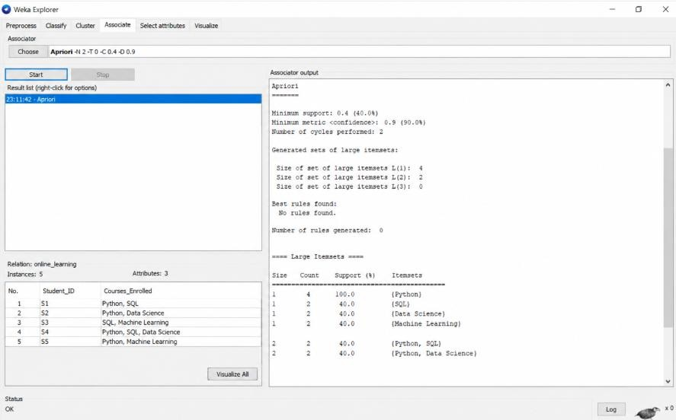

Q3.LibraryBorrowingRecords—Apriori Transactions = 5
Maximumitemset size=3.

Sincenominimumsupportisexplicitlystated,wecanusethesame50%thresholdimplied by the dataset-style question, i.e., an itemset must occur at least 3 times.

1-itemsets
Item Count | Support
DataMining 4 | 80%
PythonProgramming3 | 60%
DatabaseSystems 3 | 60%
ArtificialIntelligence1 | 20%
Frequent1-itemsets:

{DataMining},{PythonProgramming},{DatabaseSystems} 2-itemsets
Itemset CountSupport
DataMining,Python Programming 2 40%
DataMining,DatabaseSystems 2 40%
PythonProgramming,DatabaseSystems 2 40%

Nonereaches50%.

Therefore,nofrequent2-itemsetsareavailable.

Consequently,nofrequent3-itemsetcanbegeneratedusingApriori'spruningproperty.

Answer:

Frequentitemsetsare:

- {DataMining}—80%
- {PythonProgramming}—60%
- {DatabaseSystems}— 60%

Themaximum-sizeconstraintof3preventsgenerationofitemsetslargerthanthreeitems. This reduces candidate generation and support-counting operations.

Note:Thequestiondoesnotexplicitlyprovideminimumsupport.Ifyourinstructorintended a different threshold, the frequent 2- and 3-itemsets will change accordingly.

OUTPUT
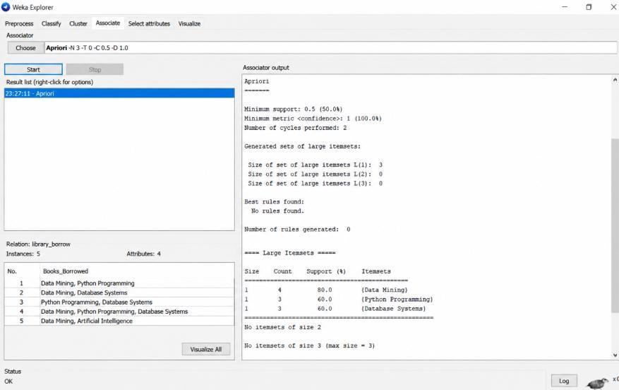

Q4.UniversityCourseHierarchy—MultilevelAssociationRuleMining Constraint:RulesshouldbegeneratedonlyattheComputerSciencelevel. Transactions containing Computer Science:
- S1→Engineering,ComputerScience,Machine Learning
- S3→Engineering,ComputerScience
- S4→Engineering,ComputerScience,MachineLearning Thus:
ComputerScience= 3/5= 60%

AmongthesethreeComputerSciencetransactions:

- MachineLearning occurs in S1and S4→2/3= 66.7%
- Engineering occurs in all three → 3/3 = 100% Therefore,themeaningfulassociationattherequestedlevelis: Computer Science → Engineering
Support:

3
× 100=60%
5

Confidence:
𝑆𝑢𝑝𝑝𝑜𝑟𝑡(𝐶,𝑆𝐸𝑛𝑔𝑖𝑛𝑒𝑒𝑟𝑖𝑛𝑔) 60%
𝑆𝑢𝑝𝑝𝑜𝑟𝑡(𝐶𝑆) =60%=100%

Anotherpossiblepattern is:

ComputerScience→MachineLearning

Support:
2
=40%
5

Confidence:

2/5

3/5
=66.7%

Answer:

AttheComputerSciencelevel,the strongestpattern is:

ComputerScience→Engineering

with60%supportand100%confidence.

Thehierarchyallowsminingataspecificabstractionlevelratherthanmixingrulesfromall course categories. Restricting the mining to the Computer Science level reduces irrelevant candidate rules and produces more focused relationships.

Output:

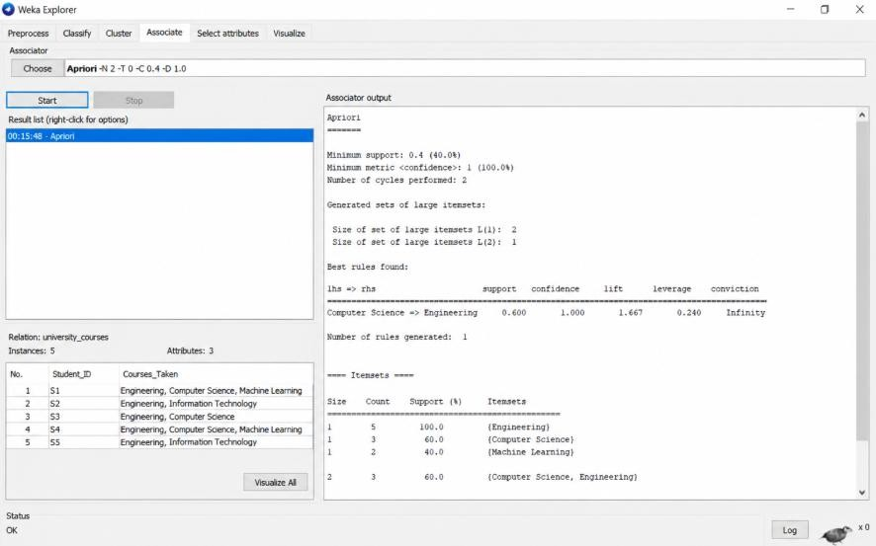

Q5.InsuranceCustomerRecords—MultidimensionalAssociationRuleMining Constraint: Age Group = Young
Young customers:

CustomerAgeIncomePolicy
C1 Young HighHealth InsuranceC3 Young LowTravel Insurance C5 Young Medium Vehicle Insurance
Thereare3Youngcustomers. Income patterns
Eachincomecategory occursonce:

- Young+High→ HealthInsurance=1/3 = 33.3%
- Young+Low→TravelInsurance=1/3= 33.3%
- Young+Medium→VehicleInsurance=1/3=33.3% Meaningful patterns
- Young+HighIncome→HealthInsurance
  - Support= 1/5 =20%

  - WithinYoung customers=1/3= 33.3%
- Young+LowIncome→TravelInsurance
  - Support= 1/5 =20%
  - WithinYoung customers=1/3= 33.3%
- Young+MediumIncome→VehicleInsurance
  - Support= 1/5 =20%
  - WithinYoungcustomers=1/3=33.3% Marketing application
Thesepatternscanhelpinsurerscreateage-andincome-specificcampaigns:

- Young+Highincome:promoteHealthInsurance.
- Young+Mediumincome:promoteVehicle Insurance.
- Young+Lowincome:promoteaffordableTravel Insurance.

Becausethedatasethasonly5customers,thesepatternsshouldbetreatedaspreliminary rather than strong general-market conclusions.

Output:

