ITMS
Anomaly Detection & Alert System
A novelty-focused build plan for M6 (incident detection) and M8 (vision)
Two fused detection streams — a graph-based traffic-pattern detector and a
phase-aware vision stream — gated by a statistically calibrated alert threshold,
with a human-in-the-loop confirmation step and an audit trail throughout.
Prepared for the ITMS capstone · Vijayawada corridor build
Planning document — September 2026

1. Executive Summary
This document plans an anomaly-detection and alert system for the ITMS platform that avoids the “regular” approaches most student projects take — a single threshold on sensor values, or an opaque video classifier deciding an incident on its own. Instead it combines four deliberately chosen, research-grounded design choices into one coherent, buildable system:
- Graph-aware pattern detection — A spatiotemporal graph neural network scores deviation from learned-normal traffic behaviour per road link, using the topology already imported into PostGIS, instead of a flat per-sensor threshold.
- Self-generated, perfectly labelled ground truth — The SUMO simulation this project already runs can inject a stalled vehicle or a blocked lane at an exact tick, giving perfect ground-truth timestamps that real-world traffic datasets almost never provide.
- Auditable, phase-aware vision features — Vehicle detection and tracking (YOLO11 + ByteTrack) feed a deterministic rule engine — stationary duration, deceleration, and critically the live signal-phase state — instead of a black-box “accident” classifier.
- Calibrated alerting with a feedback loop — The alert threshold is chosen by conformal calibration so the false-alarm rate is statistically bounded, and it recalibrates online using operator-rejected candidates as new evidence.
The plan is scoped so the pattern stream (Section 5) can be built and gated today, entirely on CPU, using data the project already produces — and the vision stream (Section 6) slots into the same architecture later, once M8's real or recorded camera feed exists, exactly as the project's own README already schedules it.

2. Where This Fits in the Existing Build
The ITMS repository already anticipates this module. The web demo names it “Anomaly-driven detection / Multi-modal fusion,” ADR-006 already commits to a human-in-the-loop gate (“vision may confirm a stopped vehicle on its own — and never a person”), and the event contracts already reserve incident_candidate.avsc, incident_detected.avsc and incident_updated.avsc for milestone M6. This plan gives those reserved names a real design.
Milestone | Scope | Status
M0–M5 | Skeleton → safety kernel → baselines → CA-MP adaptive control | Done
M6 | Incident detection → dispatch → routing | Not started — this plan
M7 | Green corridor + anticipation + debt | Not started
M8 | Vision on real footage (GPU-dependent) | Not started — needs a real/recorded feed

Constraint honoured: the project's own vision-service README already says M8 is “GPU-dependent work that needs the incident pipeline (M6) and a real or recorded camera feed to be worth building against.” Section 6 of this plan is therefore a design to build later, not a step to start now.

3. Gaps in the Regular Approach
A survey of the common way student and industry projects build this feature, and why each falls short here:
Regular approach | Why it falls short
Fixed threshold / z-score on speed or occupancy per sensor | No spatial context — a normal queue at one junction looks identical to a jam at another; can't tell a red-light queue from an obstruction
Train a CNN classifier directly on crash videos to call the incident | Opaque and unauditable — exactly what this project's own ADR-006 already rejects
Pick an alert threshold by eyeballing an ROC curve | No statistical guarantee on false-alarm rate; breaks silently when demand shifts from light to heavy traffic
Evaluate only on real-world datasets | Real incidents are rare and messily labelled — exact detection-latency ground truth is essentially unobtainable

4. The Novelty Thesis — Four Pillars

4.1 Graph-topology-aware anomaly detection
The road network already imported into PostGIS (road_edge / road_junction, since M1) becomes the graph a spatiotemporal model runs on. A link's queue is judged relative to its neighbours and its own history, not against one global constant — the central weakness of per-sensor thresholding.

4.2 Perfect, self-generated ground truth
M4 already built bottleneck_lane_speeds_mps and a live QueueStateSampler for the CA-MP ablation. Extending that into a proper incident injector gives exact tick-level “starts here, ends here” labels — something almost no published traffic-incident dataset can offer — enabling rigorous precision, recall, and detection-latency scoring in the same honest, gate-table style already used for M3–M5.

4.3 Deterministic, auditable vision features
Detect and track (YOLO11 + ByteTrack), then derive interpretable per-track signals — stationary duration, deceleration, wrong-lane heading — and fuse them with the signal-phase state this project already publishes (SignalChanged): a stopped cluster during a green phase is the real anomaly signal; the same cluster during red is an expected, lawful queue. No other project can do this fusion off the shelf, because it needs this project's own live phase state.

4.4 Conformal-calibrated alerting with feedback
Rather than a hand-picked cutoff, the alert threshold is chosen by conformal calibration on a held-out set of normal traffic so the false-alarm rate is provably bounded at a chosen budget, and it recalibrates online: every operator-rejected candidate (already part of the planned flow — rejects “become a training label”) is added back as a confirmed-normal calibration point. This mirrors 2025–2026 research on adaptive conformal anomaly detection rather than a static ROC-picked number.

5. System Architecture
Two independent streams feed one interpretable fusion layer, gated by a calibrated threshold, with a human confirmation step before anything becomes a real incident:
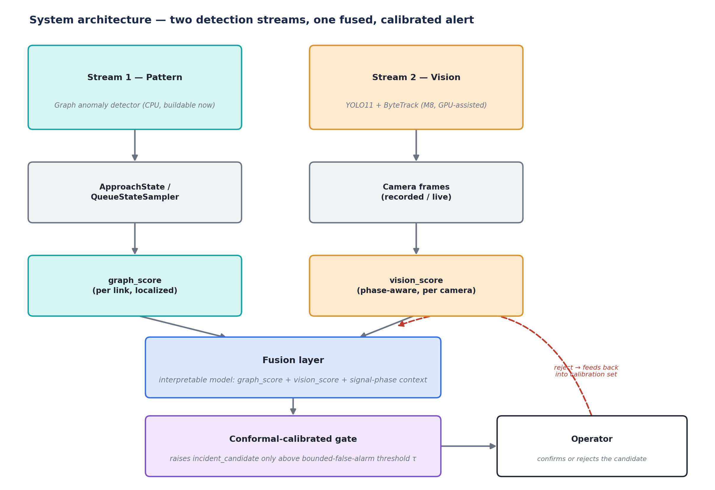
Figure 1 — two detection streams fused into one calibrated, human-gated alert.

This mirrors the detection-to-dispatch timeline already promised on the project's own demo page:
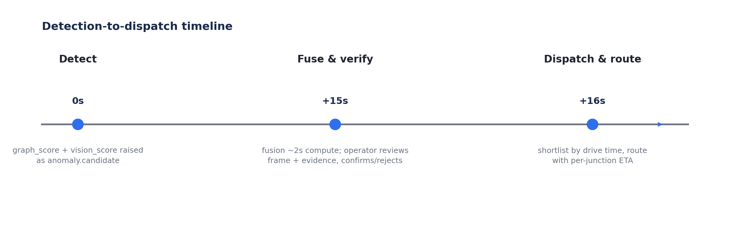
Figure 2 — detect, fuse & verify, dispatch & route, with the timing already committed to in the demo copy.

Design property: the fusion layer degrades gracefully when vision_score does not exist yet — it simply runs graph-only. Stream 1 can therefore be built, gated, and shipped as the real M6 deliverable today; Stream 2 slots into the same code path later at M8 with no rework.

6. Stream 1 — Pattern / Graph Anomaly Detector (buildable now)
No external dataset or new data collection is needed — it trains on the project's own simulated traffic.
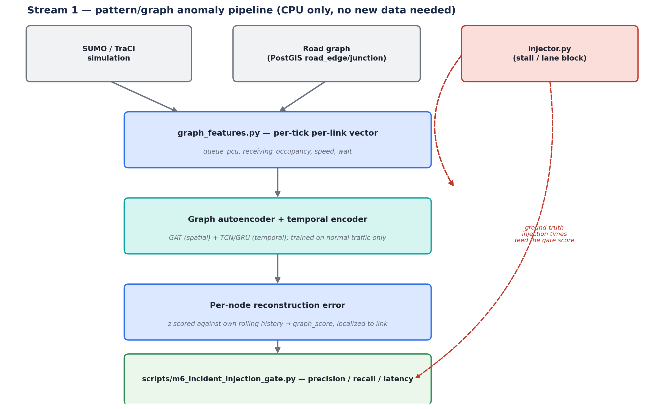
Figure 3 — pattern-stream pipeline: features, model, injector, and the gate script.

6.1 Model
- Architecture — Graph attention layers (spatial) combined with a temporal convolution or GRU (temporal), trained as a one-step-prediction / reconstruction autoencoder over per-link features (queue_pcu, receiving_occupancy, speed, wait time). Per-node reconstruction error, z-scored against that node's own rolling history, becomes graph_score — localized to the specific link, which is what later lets it align with a camera.
- Training — Purely on “normal” simulated traffic across the light / medium / heavy demand levels already generated for M4 — no incident labels required for training. Roughly 30–40 nodes, a handful of features each: tens of thousands of parameters, trains in minutes on CPU.
- Baseline to beat — A plain per-link EWMA / z-score threshold with no graph structure — the same “compare a new controller against a real baseline” discipline already used for Webster vs. CA-MP.

6.2 Ground-truth injection
Reuse and extend the existing bottleneck_lane_speeds_mps hook: (a) a stalled vehicle (traci.vehicle.setSpeed(id, 0) held for N seconds on a randomly chosen lane and time), and (b) a lane obstruction (near-zero max speed on a lane for a duration), at each of the three existing demand levels, paired-seed exactly like the M3/M4 benchmark design.

7. Stream 2 — Vision (planned now, built at M8)
Designed in full here so it slots into the fusion layer without rework, but deliberately not started until M8 has a real or recorded camera feed — consistent with this project's own discipline of not building against data that does not exist yet.
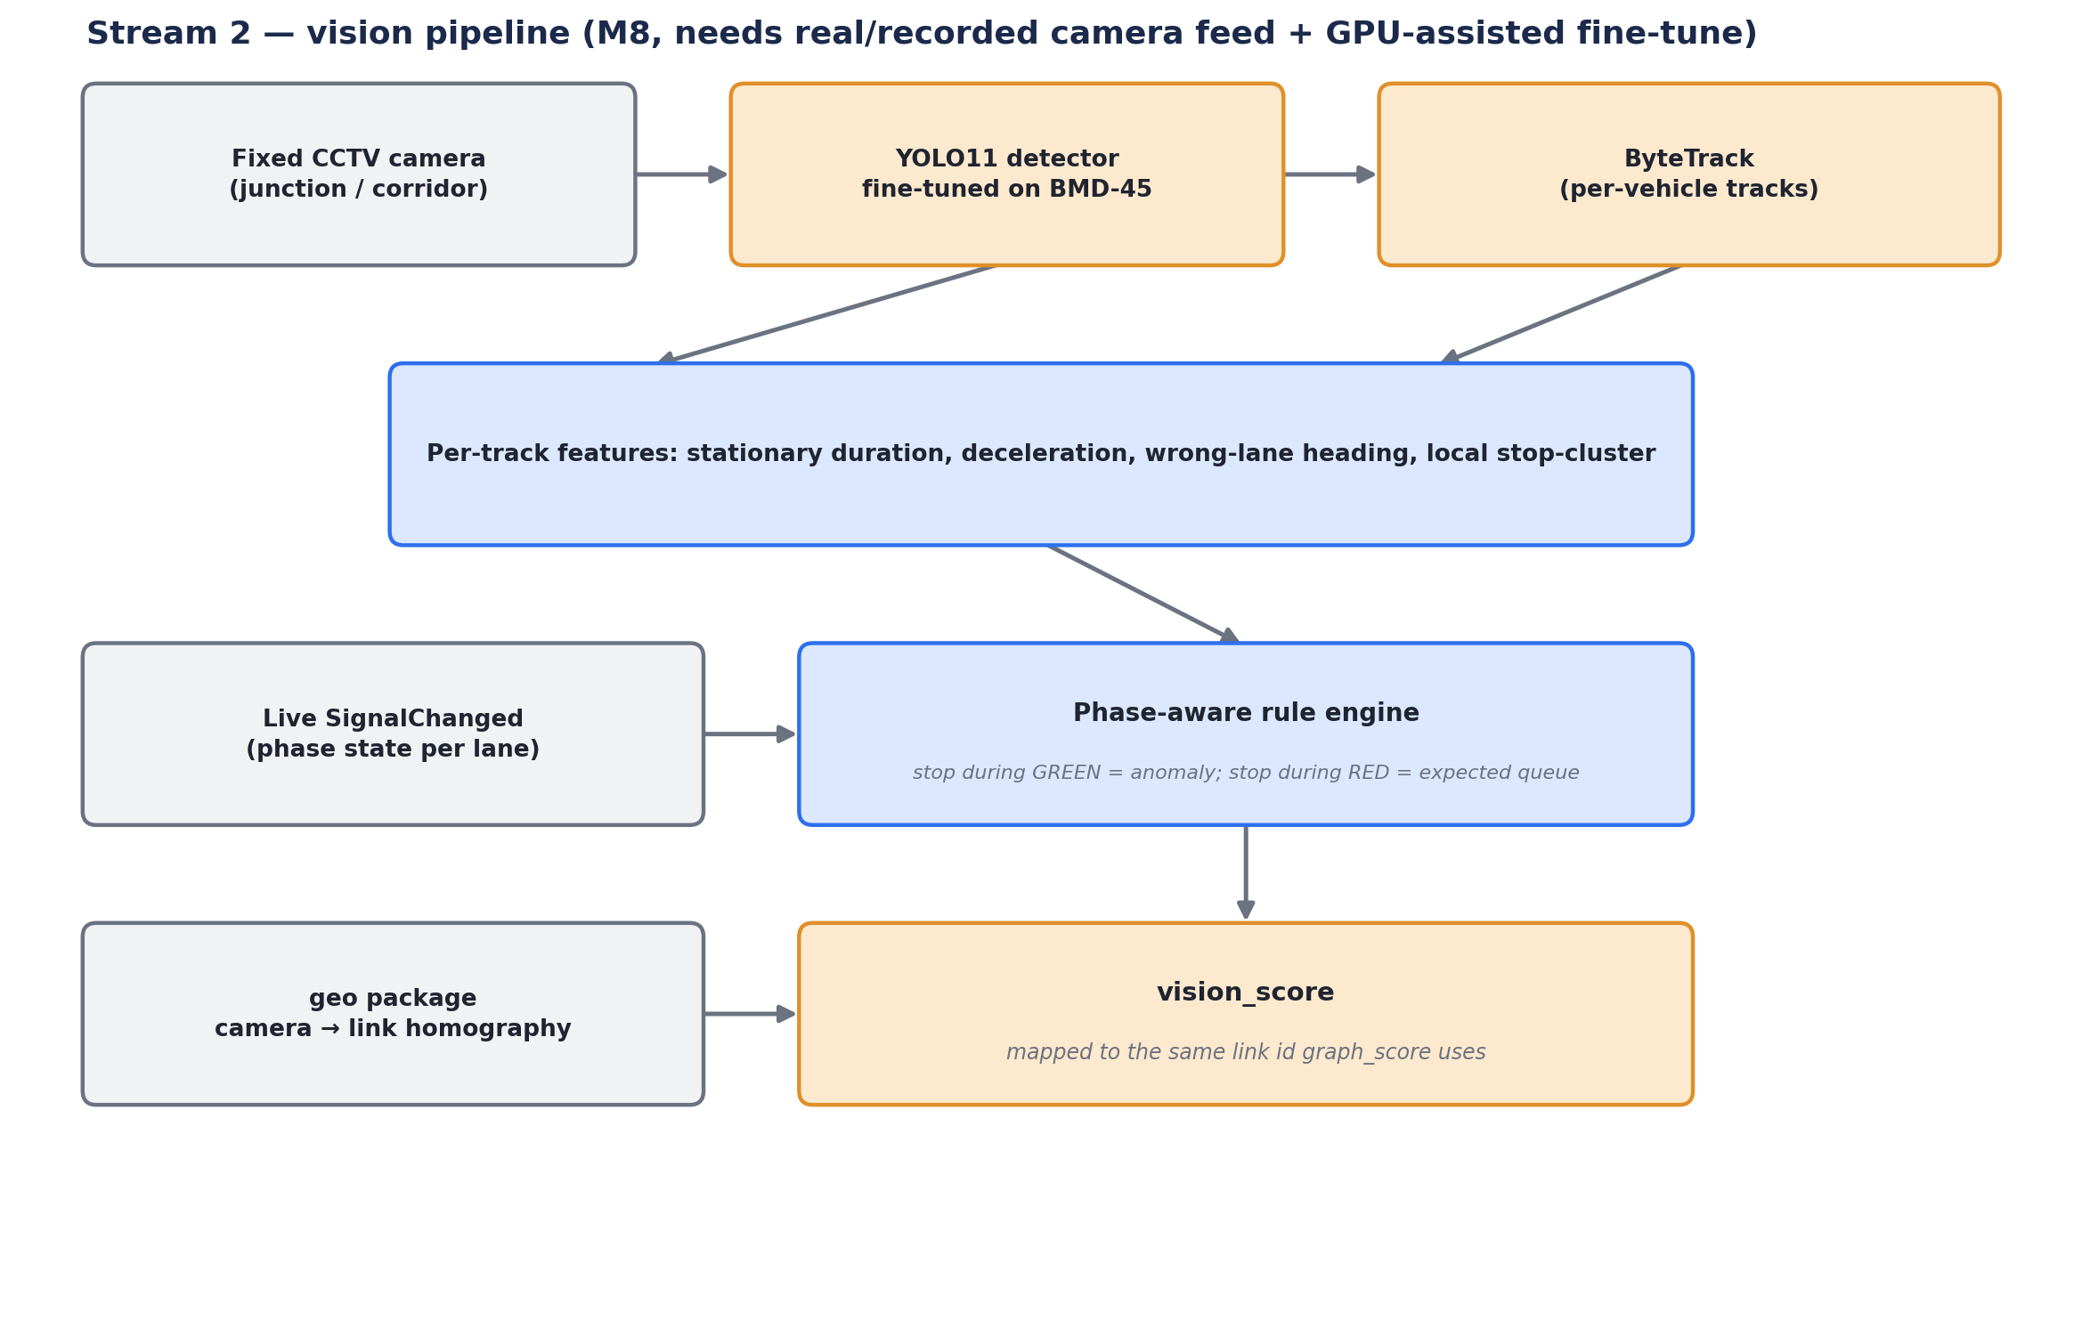
Figure 4 — vision-stream pipeline: detection, tracking, phase-aware rules, and camera→link mapping.

7.1 Why rules, not a trained accident classifier
ADR-006 already draws this line: vision may confirm a stopped vehicle on its own, but must never infer human behaviour. So Stream 2 detects and tracks vehicles, then computes deterministic features — stationary duration, deceleration, wrong-lane heading, local stop-clustering — and fuses them with the live SignalChanged phase state already published on the bus: a stop during a green phase is flagged; the same stop during red is an expected queue and is not.

7.2 Detector fine-tuning
YOLO11 (already named in the project's own technology chips) fine-tuned on BMD-45, a fixed-CCTV vehicle detection dataset with auto-rickshaw and other Indian-traffic classes matching this corridor's vehicle mix — see Section 8 for the full dataset rationale.

8. Datasets
A hybrid strategy: self-generated data for the pattern stream, external datasets only where a real camera model is needed.

8.1 Stream 1 — pattern / graph detector
Use | Source | Why
Training (required) | Self-generated — multi-seed, multi-demand-level SUMO runs, normal traffic only | Unsupervised; no incident labels needed; unlimited volume
Evaluation ground truth (required) | Self-injected incidents via the extended injector | Exact tick-level timestamps — real datasets cannot offer this precision
External validation (optional, strengthens the report) | PeMS-BAY / METR-LA, or FT-AED (2024, radar-based) | Standard spatiotemporal-GNN benchmarks with real incident timestamps; shows the method generalizes beyond this project's own simulator

8.2 Stream 2 — vision (for M8)
Dataset | Role | Why this one
BMD-45 (Hugging Face: iisc-aim/BMD-45) | Primary detector fine-tuning | Fixed Safe-City CCTV cameras — matches this project's camera geometry, not dashcam; 14 classes incl. auto-rickshaws, matching the corridor's own vType mix. Its own paper shows UA-DETRAC-trained models generalize badly here (33.6% mAP vs. 83.8% in-domain)
DriveIndia / IDD (IIIT-Hyderabad) | Supplementary Indian-road pretraining | Broader unstructured Indian traffic coverage
TU-DAT (2025, roadside CCTV accidents) | Vision-logic validation | Roadside CCTV footage, closer to this project's camera placement than dashcam-based DoTA

9. Model Choices at a Glance
Component | Model | Why this, not the obvious pick
Graph anomaly detector | Graph attention (spatial) + TCN/GRU (temporal), autoencoder-style | Follows recent (2024) graph-autoencoder traffic-anomaly work, not an isolation-forest / ARIMA baseline
Localization | Per-node score from the same model; optionally a dual-level graph transformer | Identifies which link is anomalous, needed to later align with a camera
Vision detector (M8) | YOLO11 fine-tuned on BMD-45 | Already this project's stated stack; fixes the CCTV generalization gap
Tracker (M8) | ByteTrack | Cheap, CPU-feasible at low frame rate
Fusion | Logistic regression / small gradient-boosted trees over ~4–6 engineered features | Interpretable — a deep fusion net would break the project's own audit principle
Alert threshold | Split / adaptive conformal calibration | Provable false-alarm bound instead of a picked number
Baseline | Plain per-link EWMA / z-score, no graph | Proves the GNN actually helps, rather than assuming it

10. Calibrated Alerting
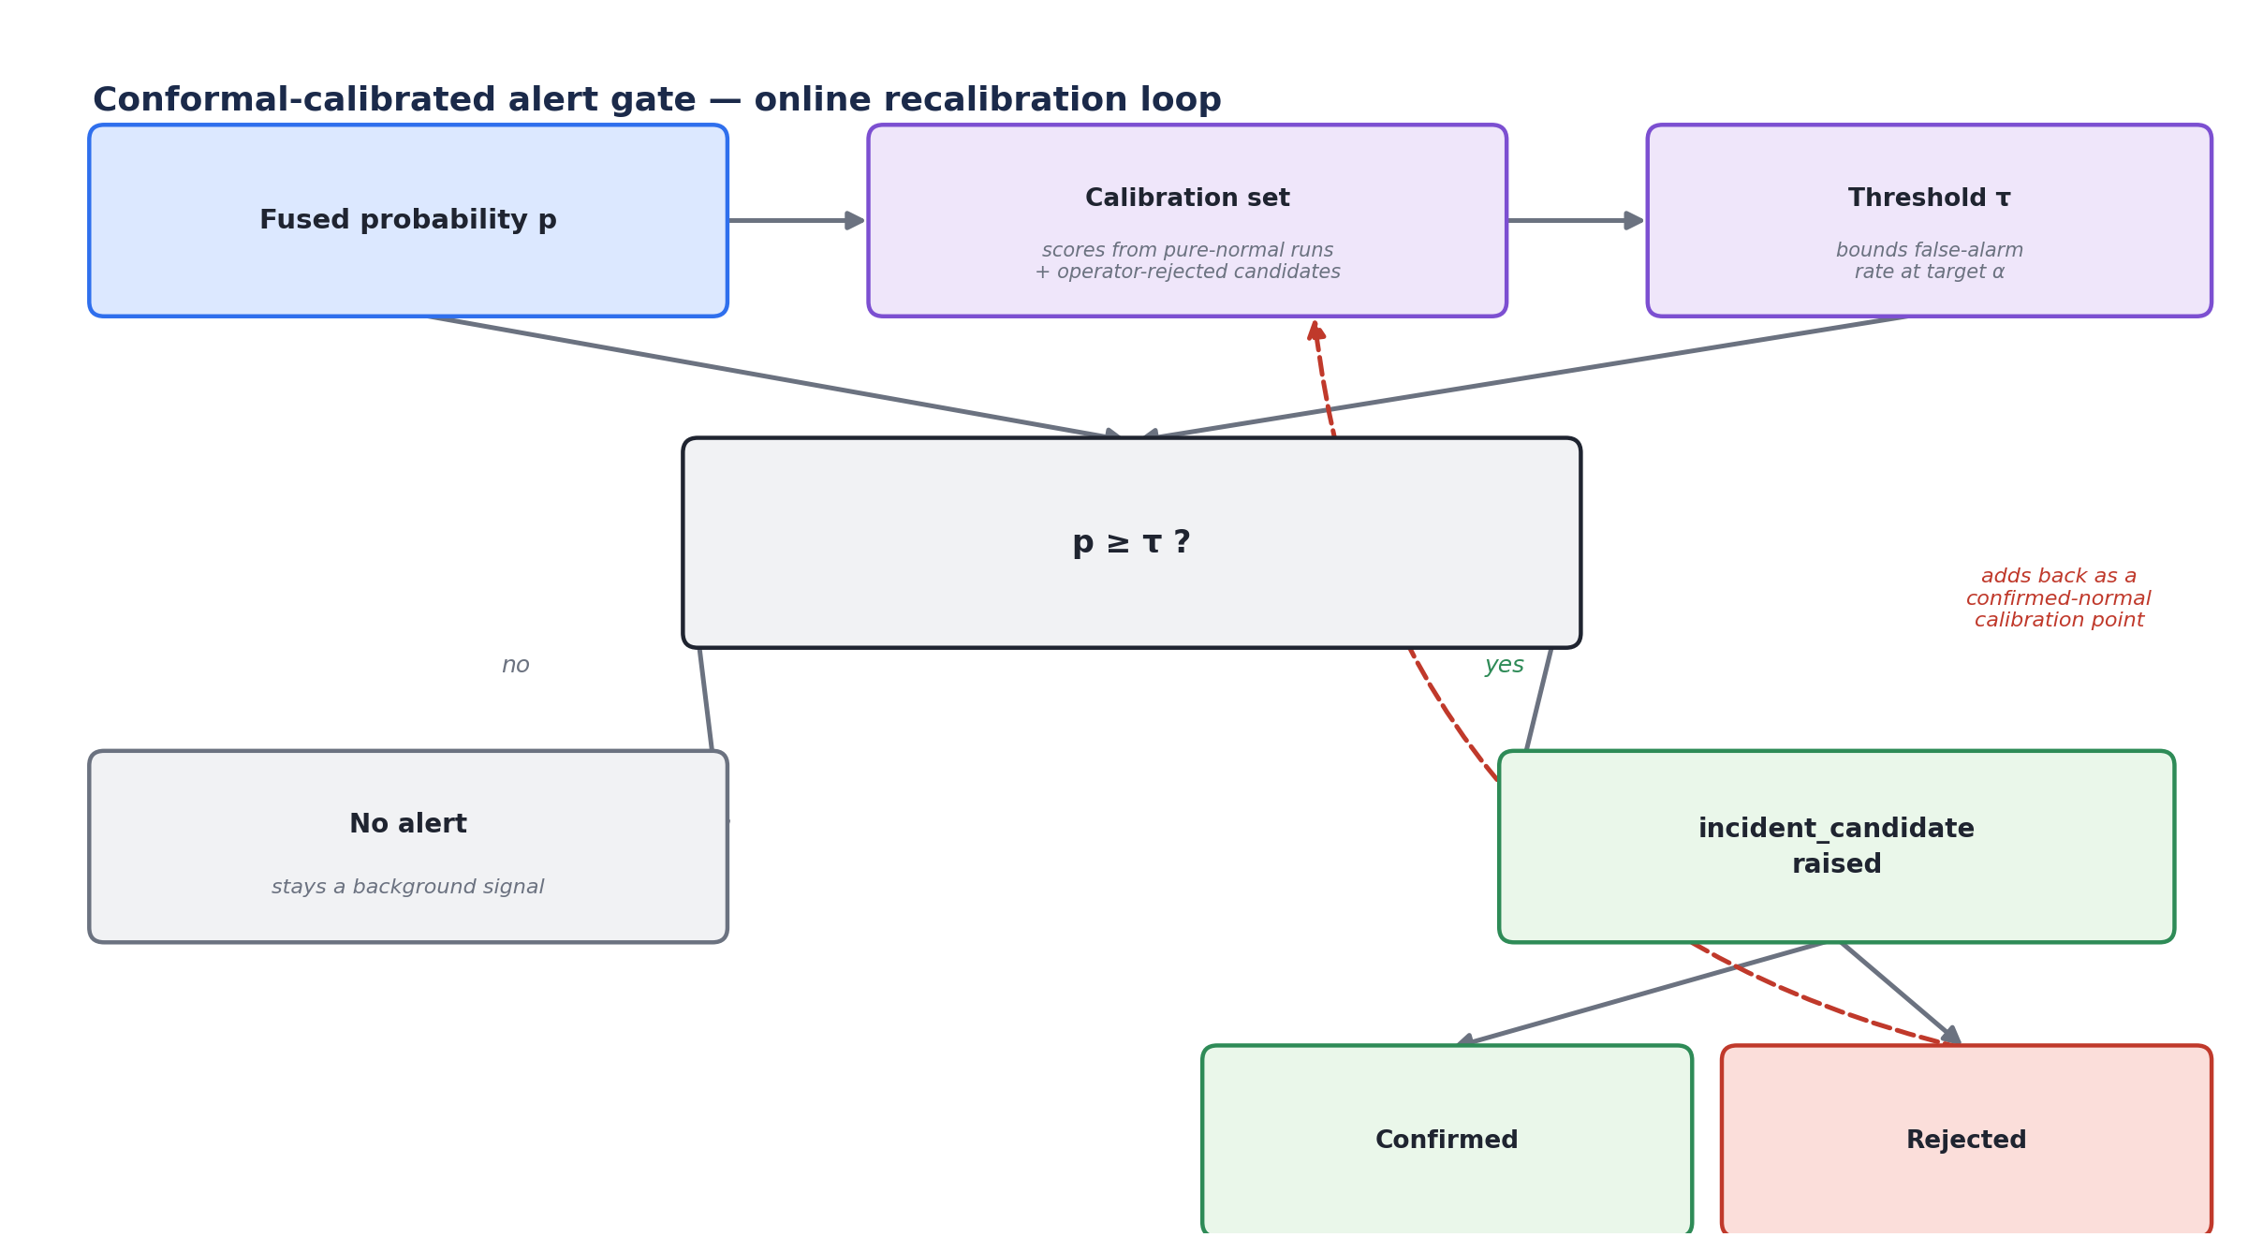
Figure 5 — conformal-calibrated gate with an online recalibration loop from operator rejections.

The calibration set is built from the fused-probability distribution on held-out pure-normal runs. The threshold τ is chosen so the empirical false-positive rate on that set does not exceed a target budget α (e.g. 1–5%, treated like a validated safety constant in the style of Tier0Config). Because traffic is not fully exchangeable across light/medium/heavy demand or time of day, an adaptive variant — a sliding calibration window with weighted quantiles — is recommended over a single static calibration set, following 2025–2026 adaptive conformal anomaly detection literature.

11. Evaluation and Gate Criteria
Following this project's own gate convention (a specific, measurable pass/fail statement per milestone):
“≥ 90% recall on injected incidents, mean detection latency < 30 seconds, empirical false-alarm rate within 2× the conformal target α, at light / medium / heavy demand, graph-only mode.”
Metric | How it's measured
Precision / Recall / F1 | Against self-injected incident windows, per demand level
Detection latency | Seconds from injection tick to raised incident_candidate
False-alarm rate | On pure-normal runs, checked against the conformal target α
Localization accuracy | Whether the flagged link matches the injected link

12. GPU or CPU?
Component | Hardware | Notes
Stream 1 — graph detector, fusion, conformal calibration | CPU only | Tiny model (tens of thousands of parameters); trains in minutes
Stream 2 — vision, prototyping | CPU is fine | 1–5 fps on one camera is enough for a “stopped ≥ N seconds” rule
Stream 2 — YOLO11 fine-tuning on BMD-45 | GPU recommended, not required | A free-tier Colab/Kaggle T4 is enough to cut fine-tuning time significantly
Stream 2 — real-time multi-camera deployment | GPU recommended | Needed only to scale to several simultaneous camera feeds at higher frame rate

13. Build Order
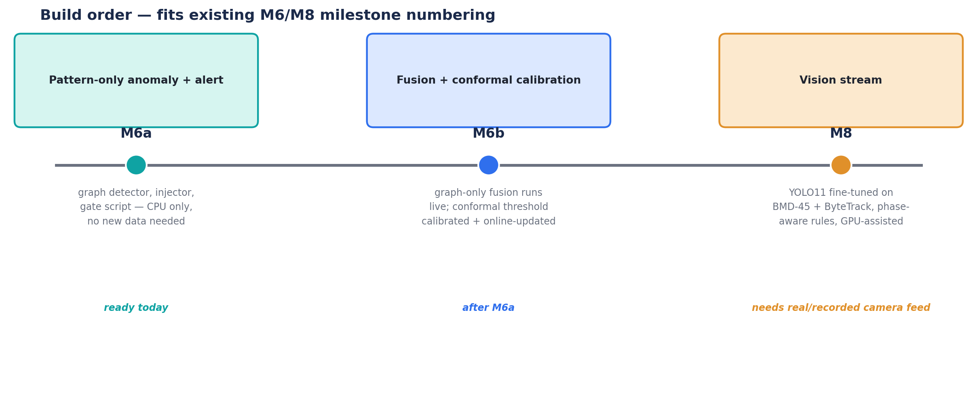
Figure 6 — build order, fitted to the existing M6/M8 milestone numbering.

13.1 M6a — pattern-only anomaly + alert
Buildable immediately, no new data collection required.
- sim_service/control/anomaly/graph_features.py — builds the static road graph and per-tick per-link feature vector
- sim_service/control/anomaly/detector.py — the graph autoencoder / temporal model, train + infer
- sim_service/control/anomaly/injector.py — extends bottleneck_lane_speeds_mps into a stall / lane-block injector
- sim_service/control/anomaly/calibration.py — conformal threshold fit + online update
- packages/domain/itms_domain/incident.py — the incident state machine (already flagged as M6's domain growth)
- contracts/events/incident_candidate.avsc, incident_detected.avsc, incident_updated.avsc — already named; this plan gives them a real payload shape
- scripts/m6_incident_injection_gate.py — produces the gate table in Section 11, matching the existing scripts/m*_*.py convention

13.2 M6b — fusion + conformal calibration
Runs in graph-only mode until Stream 2 exists; same code path both before and after M8.

13.3 M8 — vision stream
Exactly as already scoped in the project's own README: YOLO11 fine-tuned on BMD-45, ByteTrack, the phase-aware rule engine, and the camera→link mapping via the geo package's homography (also arriving M8) — plugging into the fusion layer built in M6b.

14. Risks and Open Questions
- Demand realism — the current uncalibrated demand (flagged since M3) may make “normal” traffic too uniform for the graph detector to learn a rich baseline — worth revisiting once calibrated OD demand exists (M8.5).
- Conformal exchangeability — traffic is not fully exchangeable over time; the adaptive/sliding-window conformal variant mitigates but does not eliminate this.
- Dataset licensing — BMD-45 is very recent (2026); confirm licensing terms before use in any published report.
- Camera-to-link mapping accuracy — only meaningful once M8's camera geometry and the geo package's homography exist; until then Stream 2 stays a design, not code.

15. Sources Consulted
- BMD-45 dataset — huggingface.co/datasets/iisc-aim/BMD-45
- BMD-45 paper — arxiv.org/html/2604.24419
- TU-DAT — pmc.ncbi.nlm.nih.gov/articles/PMC12158254
- DoTA — ieeexplore.ieee.org/document/9712446
- UA-DETRAC — arxiv.org/pdf/1511.04136
- FT-AED — arxiv.org/pdf/2406.15283
- Graph autoencoder + mirror TCN for traffic anomaly detection (2024) — nature.com/articles/s41598-024-51374-3
- DG-Trans — arxiv.org/pdf/2303.12238
- Adaptive Conformal Anomaly Detection (ICLR 2026) — arxiv.org/abs/2604.20122
- Conformal ML for industrial anomaly detection — sciencedirect.com/science/article/abs/pii/S0951832026002334
- India Driving Dataset (IDD) — blogs.iiit.ac.in/idd-dataset
- DriveIndia — arxiv.org/html/2507.19912v1

