**Component name**

### Document Properties

| Item | Details |
| --- | --- |
| Document | Technical Specification Document |
| Application | Dropdown |
| Author | Prakash Reddy |
| Creation Date | 09/20/2020 |
| Last Updated | 09/21/2020 |
| Status | Completed |

Contents

Document Properties 1

1. Component Overview 3

1.1 Objective 3

1.2 Use Cases 3

1.3 Risks 4

1.4 Out of Scope 4

2. Technical Specifications 4

2.1 NPM details 4

2.2 NPM repo 5

3.Unit Testing 5

4. Assumptions 6

5. Concerns and Issues 6

1. Component Overview

DropDown permits the user to make a Select Option , i.e. a choice between one of single possible options.

* 1. Objective

It consists mainly 4 parts of checkbox button.

* As a standalone component, to allow the users to select Default dropdown.
* The user to select active dropdown.
* To Select Error dropdown.
* Selected User disable dropdown.
  1. **Use Cases**

There are 4 uses cases are present in checkbox component.

* Default State – its should be default state.

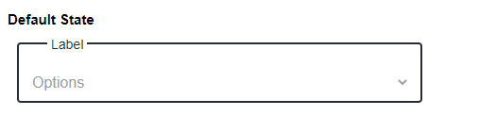

* Active State – the Active state will be show in user.

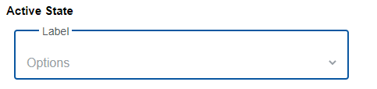

* Error State – if user not selected dropdown its shows error state.

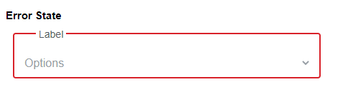

* Disable State - if application its show’s disable state.
* 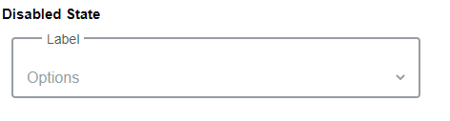
  1. Risks
* NA
* 1.4 Out of Scope

Defined certain styles for alignment and positioning for creating the base component.

* 2. Technical Specifications

Provide detailed technical specifications for required component such as properties used to generate dropdown or any other component.

* 2.1 NPM details

Following packages are installed for project:

“lit-element” – “^2.2.1”

“lit-html” – “^1.1.2”

“Orxe/cli version” - v2.0.20

Following command creating and running the component:

* Installing orxe/cli - npm install -g @orxe3/cli
* Create a new component workspace - orxe new component-workspace BaseComponent
* Create a component – orxe g c dropdown
* Serving the component – orxe serve
* 2.2 NPM repo

1. Npm repository link -

https://packages.common.cnxloyalty.com/service/rest/repository/browse/npm-stage-hosted/%40BaseComponent/

2. npm package – npm install @BaseComponent/dropdown@0.0.1

3. Used Render Selector - <orxe-dropdown></orxe-dropdown>

* 3.Unit Testing

The test cases written for orxe-dropdown component it consists two test suites. One is default dropdown axe file and other dropdown spec file. All function and line coverage are done with spec file.

All test cases of orxe-dropdown component are written in dropdown.axe.ts and dropdown.spec.ts file. Test cases are available below.

1. Should create.
2. Should support all WCAG Accessibility Rules. When Default is rendered.
3. Should function render is call.
4. Should metadata have value (label).
5. Should function dropdown is call and selected options.

The unit test cases 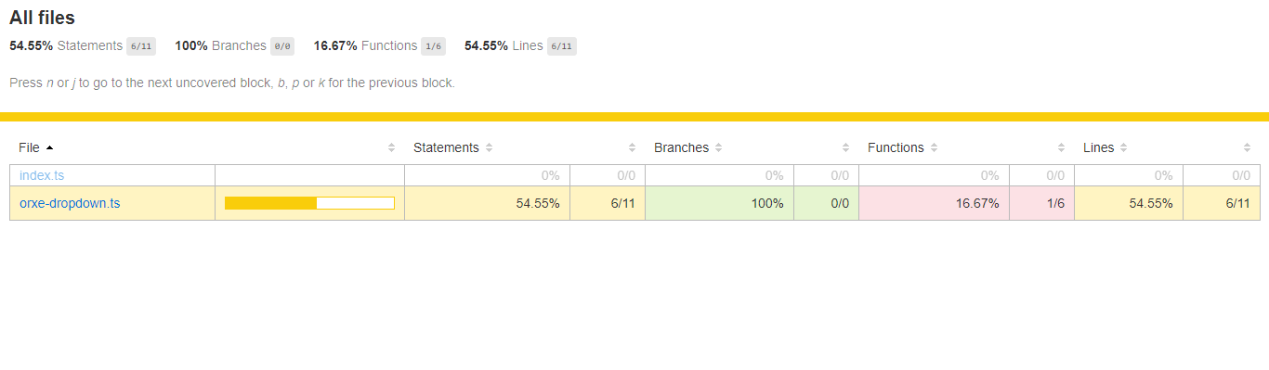

* 4. Assumptions

This component is developed based on the design guidelines provided by Tavisca on the confluence page.

* 5. Concerns and Issues

NA