Flood monitoring and early warning system

**Introduction**

* The existing flood monitoring system consists of two microcontrollers and one sensor. The microcontroller used here is node MCU and the sensor used is an ultrasonic sensor which senses the level. The ultrasonic sensor continuously monitors the level of water each time it reaches the certain defined level. The flood warning system utilizes computer technology, database technology, communication technology, and sensor technology. Powered by IoT technology, rainfall and water levels are monitored and floods are predicted. Early warning of impending flooding can save lives and reduce extensive property damage.

**Proposed system**

* The Proposed system consists of Rain Sensor, Ultrasonic Sensor, Power Source, Node MCU ESP8266, Buzzer and LEDs and finally Blank App. This Wireless Sensor Node is Kept in desired location Like dam, Bridge. etc. and Blynk App is downloaded by victims near the flooding area. The Schematic Diagram of the proposed flood forecasting and Monitoring System **fig 1.1.**
* The proposed system will help in predicting the flood with the factors of water level change and rain fall intensity. The wireless sensor node consists of rain sensor which is used to measure the rain intensity. When there is no rain fall the intensity is “0” and if rain fall starts the intensity starts increasing and the speed the rain fall the intensity increases. The intensity is sent to Node MCU which checks the value which is defined in code. the checked value with threshold. if more than threshold then there will be a alert to victims as flood is predicted.
* Even when the water level changes based on given threshold values it checks and send alerts. The warning is in three stages Safe level, Warning Level, Critical Level. The alert can of 2 types one way is send notification to victims and other one way is buzzer sound.
* For Sending Notifications The victims should have Blynk App in Mobile phone. The LEDs are also displayed according to the water level, green, yellow, red. The connections of devices are done using jumper wires. The code is Written is Arduino ide and dumped into NodeMCU. The sending of information from Node MCU to Blynk app is with the help of Esp 8266. The ESP8266 is Wi-Fi module which is in built in Node MCU.

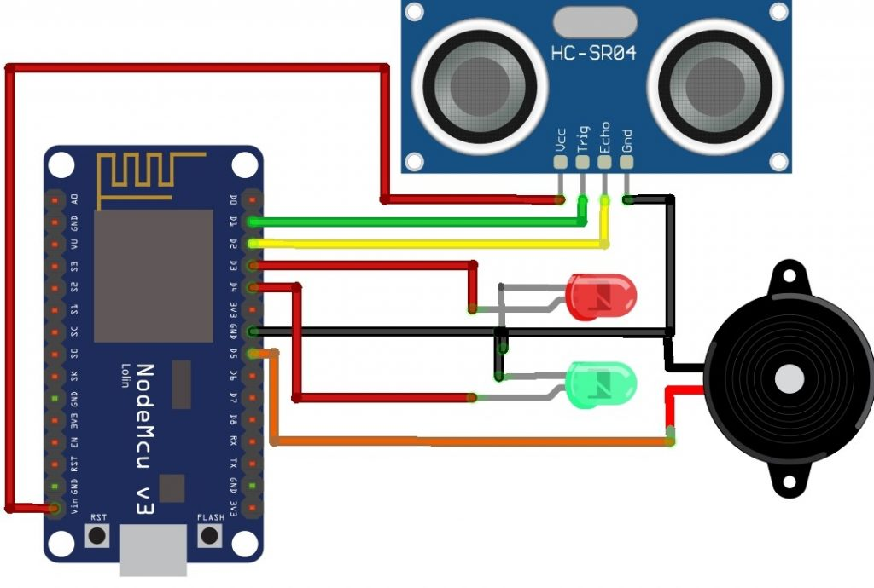

**Fig 1.1 Circuit Diagram of Proposed System**

**[ESP8266 Wi-Fi MCU](https://www.espressif.com/en/products/socs/esp8266):**

* The ESP8266 WiFi Module is a self contained SOC with integrated TCP/IP protocol stack that can give any microcontroller access to your WiFi network. The ESP8266 is capable of either hosting an application or offloading all Wi-Fi networking functions from another application processor.

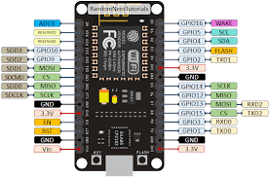

Fig1.2 **ESP8266 WiFi Module**

**Result:**

* The prototype works accordingly, an experiment was conducted to test the measurement of water detected by wireless sensor node. Buzzer and LED started to trigger when the water level reached 40 until it reaches critical level (62) in the gauge, a notification sent to victim through Blynk and email. Rain sensor detects the rain intensity and sends an alert when rain heavily started.
* There are two interface tabs mode displays on the screen of the smartphone. It displayed the water level and rain intensity to alert victims in a high prone area of flood. The distance of the water is also displayed on the widgets which used gauge as the indicator and also the show the value in labeled value widget. This history graph can be used to track the flood level in real time condition. There will be two stages which are level 1, level 2 to give alarm to the people. The data sensed by the sensor was displayed on the Blynk’s interface reflecting the level indicator as well as the distance. Once the data being received, LED started to trigger when level 1 of flood level detected. Then, at level 2 white LED turn on, as well as the buzzer. Once the water level reached 40, 62 in gauge , the system will send the alert warning and critical notification to the user via email and Blynk push notification.

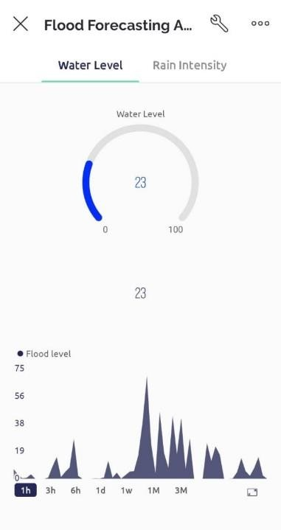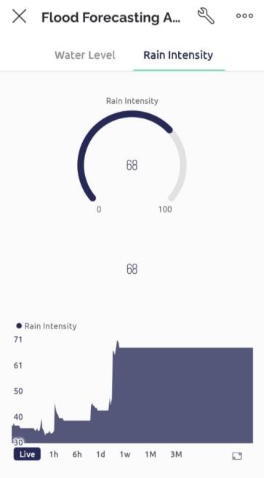 Fig 1.3: Interface of Water Level and Rain Intensity

* 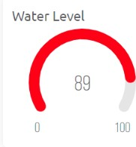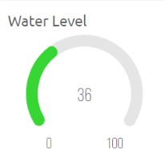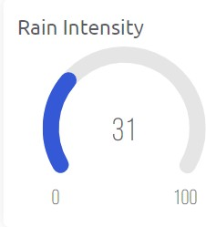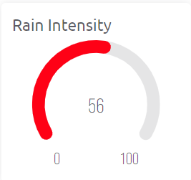The level of rain intensity which is in Blue colour shows that the rain just started to fall. This indicates that the people who live nearby should alert as they know their place will get a very disastrous disaster if the rain started heavily. The user receives a "Rain Warning!!" warning in order to alert them.

Fig 1.**4 Low & High Rain Intensity fig1.5Medium & Critical levels of water**

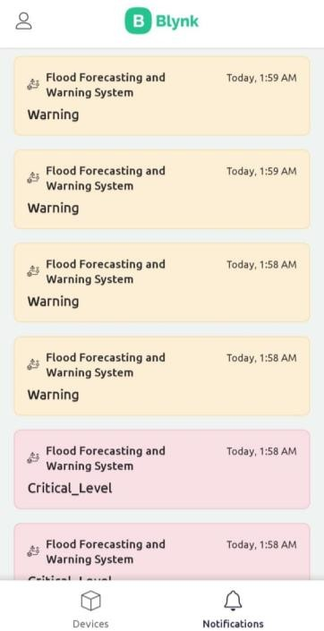

Fig1.6S**: Notifications in Blynk app**

Conclusion:

* This project is built on creating a smart flood monitoring system with NodeMCU and Blynk application utilizing ultrasonic sensors. Flexibility, efficiency, and cheap cost are provided by the outcomes. A suitable platform for monitoring flash floods and issuing early warnings is a wireless sensor node based on the Blynk platform. In order to detect and give precise sensing data for monitoring and alerting purposes, ultrasonic sensors and a rain sensor connected with NodeMCU are able to work. Hence, the system shows that it may be utilized for flooding area detection, monitoring, and community warning.
* This prototype is only uses a small scale of sensor detection within 20cm. If the system is placed at the riverside to detect flood, it must detect the flood for around 1 to 2 meters in the real world. Also, this prototype needs to have better water-resistant features so that when it starts to rain, the sensor node won't be harmed. The system must be installed correctly before it can be placed on any surface to prevent collapse when the water level rises. Hence, if further work could be done on the system, it may save the lives of a great number of victims.