**India's Agricultural Crop Production Analysis Using Tableau**

1. **INTRODUCTION:**

# Overview:

Agriculture has always been the cornerstone of India's socio-economic fabric, with a legacy that dates back millennia. Today, as the nation grapples with the challenges of modernization, changing climate patterns, and evolving market demands, a deeper dive into agricultural data becomes crucial. This analysis, facilitated by the powerful visualization platform, Tableau, endeavors to offer a panoramic view of India's crop production landscape.

Utilizing Tableau's capabilities, we've transformed extensive agricultural data into coherent, insightful visual narratives. This report traverses the intricate pathways of regional production, seasonal variations, and crop-specific trends. Our goal is to provide stakeholders with a lucid understanding of the current agricultural scenario, its challenges, and its opportunities, setting the stage for informed policy-making and strategic interventions.

# Purpose:

The primary aim of this report is to harness the visualization strengths of Tableau to analyze and present patterns in India's agricultural crop production. By evaluating regional outputs, crop-wise distributions, and seasonal variations, we strive to offer stakeholders a comprehensive understanding of the nation's agricultural landscape. This analysis serves as a foundation for shaping policies, making informed agricultural decisions, and identifying potential areas for growth and intervention.

## PROBLEMDEFINITION&DESIGNTHINKING:

## Empathy map

## C:\Users\Welcome\Desktop\Project In Boys\Empathy map.png

**Ideation&Brainstorming**

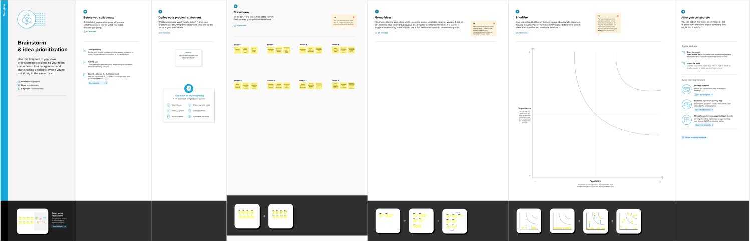

## RESULT:

## Dataset Download

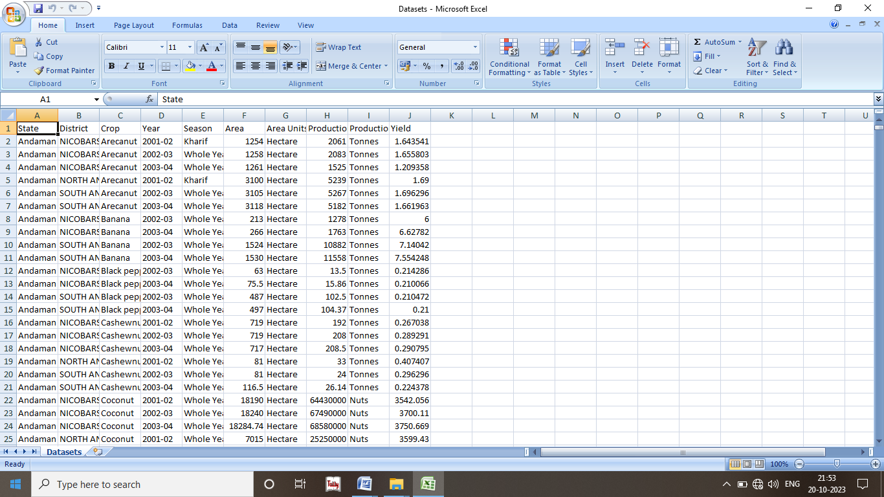

## Tableau:

**Dashboard**

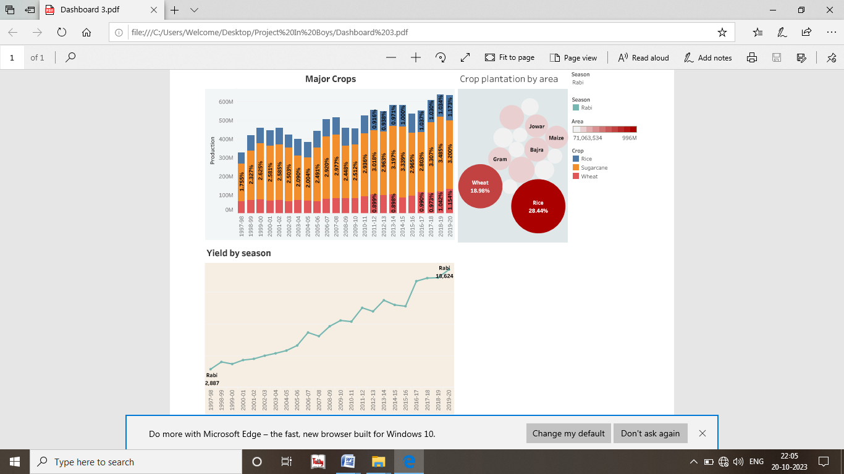

## Story

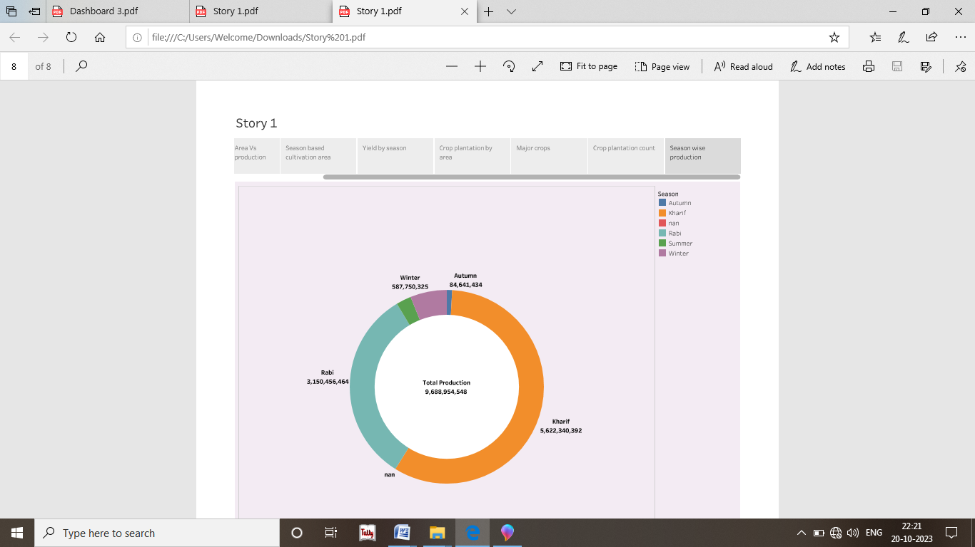

**Publish**

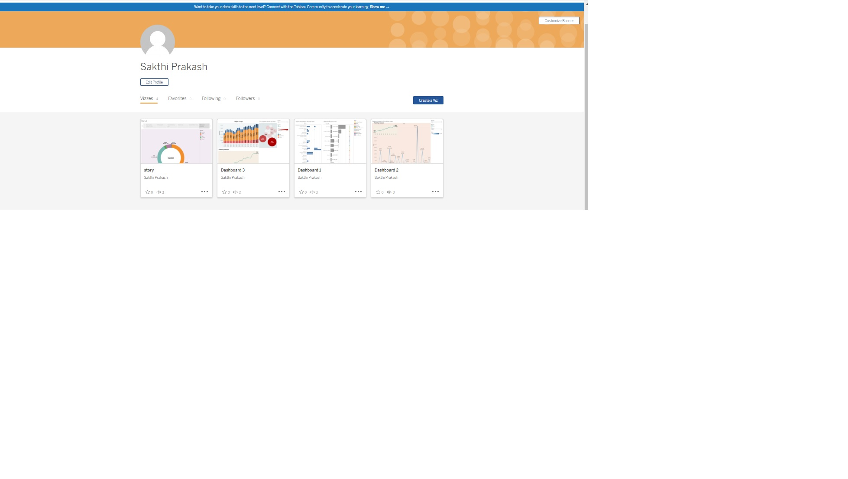

## VSCode

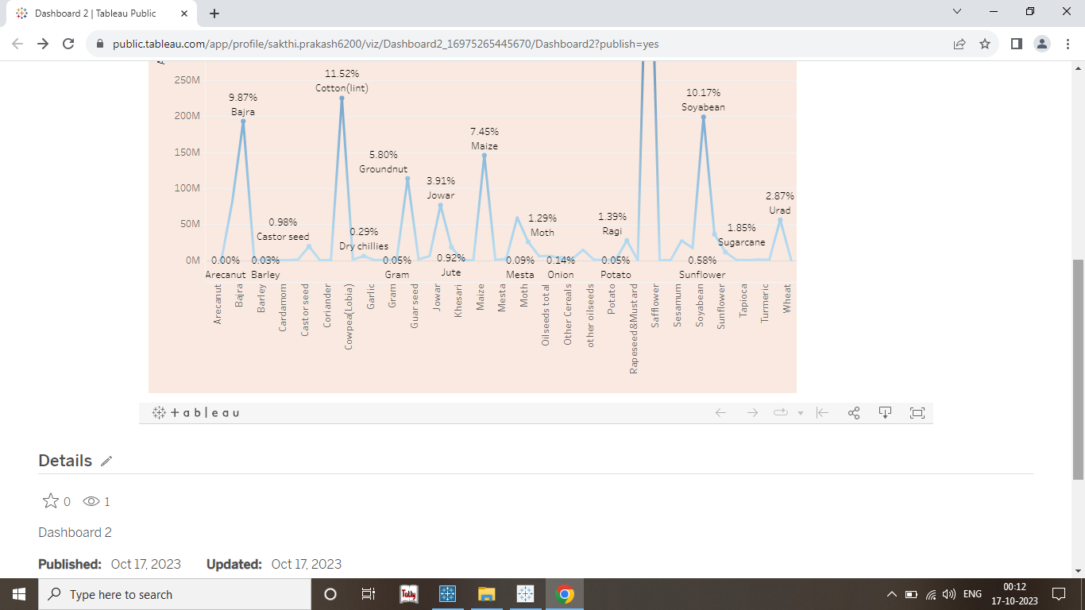

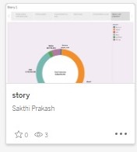

1. **ADVANTAGES:**

* *Data Visualization*: Transforms vast agricultural datasets into easily understandable visuals.
* *Timely Insights*: Facilitates real-time data analysis, aiding in swift decision-making.
* *Integration Capabilities*: Seamlessly merges data from diverse agricultural sources.
* *Trend Spotting*: Identifies patterns in crop yields, seasonal outputs, and regional variations.
* *Collaborative Tool*: Enables shared access, fostering collaborative research and policy planning.

Tableau's capabilities offer a holistic view of agricultural trends, providing a foundation for strategic agricultural planning and interventions.

## DISADVANTAGES:

* *Learning Curve*: For those unfamiliar, mastering Tableau's features can be time-consuming.
* *Cost Concerns*: Premium features of Tableau come at a significant cost.
* *Data Limitations*: Handling extremely vast datasets can lead to performance lags.
* *Internet Dependency*: For real-time updates and cloud features, a stable internet connection is essential.
* *Data Security*: Publishing data on public platforms can raise concerns about the security and privacy of sensitive agricultural data.

Certainly, while Tableau offers many benefits for analyzing data, it has its limitations. Here's a concise list of its disadvantages when used for India's agricultural crop production analysis:

## APPLICATIONS:

* + Airplanecrashmetinhillstation.
  + RainingArea
  + At thesametimetwoplanesarecrossingarea
  + Afoggyplace

## CONCLUSIONS:

Tableau stands out as a powerful tool for visualizing and understanding the intricate dynamics of India's agricultural crop production. Its ability to transform complex datasets into clear visuals is unparalleled. While it offers a plethora of advantages, it's crucial to navigate its limitations, especially when dealing with vast and sensitive agricultural data. As the agricultural sector evolves, tools like Tableau will be instrumental in shaping data-driven strategies, ensuring sustainable growth and informed policymaking for the nation's agrarian future..

## FUTURESCOPE:

As agriculture in India progresses, the integration of Tableau with emerging technologies like IoT, AI, and remote sensing promises enhanced predictive analytics and real-time monitoring. There's potential for deeper dives into micro-level data, enabling precise interventions in crop health, water usage, and soil management. With growing datasets, Tableau's evolution will likely prioritize scalability, tighter security measures, and improved integration capabilities, further streamlining India's journey towards sustainable and tech-driven agriculture.

## APPENDIX:

**SourceCode:**