Requirements

MVP:

User journey

User should be able to register with email id

User should be able to login and logoff

Should be able to search people based on id

Should be able to send and accept a friend request

Should be able to send messages to friends (text/photo/video)

Should be able to post his/her stories(text/photo/video)

(Later add phone call and video call features)

Application journey

Authenticate user

Maintain sessions

Give friend suggestions based on connections

Enable real time messaging

Technology Stack

Backend – C#/ Java/ Python/ Nodejs

Front end – (Single Page Applications) React or vue js

Version Control – Git

Database – SQL

Designing – Clone Instagram application

Reference -

<https://www.educative.io/courses/grokking-the-system-design-interview/m2yDVZnQ8lG>

<https://medium.com/double-pointer/system-design-interview-instagram-or-a-similar-app-snapchat-flickr-picasa-design-52ab03f5f2ea>

[Designing Instagram: System Design of News Feed](https://www.youtube.com/watch?v=QmX2NPkJTKg&list=RDCMUCRPMAqdtSgd0Ipeef7iFsKw&start_radio=1&rv=QmX2NPkJTKg&t=1312&ab_channel=GauravSen)

[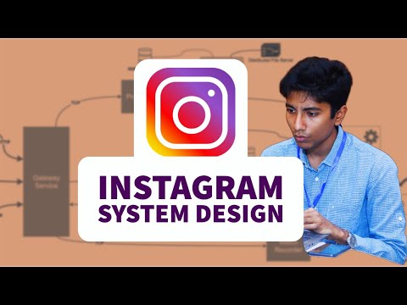](https://www.youtube.com/watch?v=QmX2NPkJTKg&list=RDCMUCRPMAqdtSgd0Ipeef7iFsKw&start_radio=1&rv=QmX2NPkJTKg&t=1312&ab_channel=GauravSen)

[System Design: Tinder as a microservice architecture](https://www.youtube.com/watch?v=tndzLznxq40&list=RDCMUCRPMAqdtSgd0Ipeef7iFsKw&index=2&ab_channel=GauravSen)

[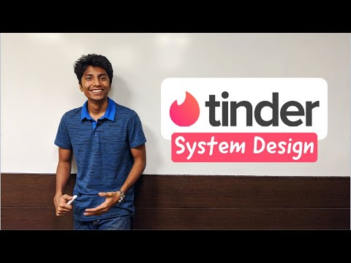](https://www.youtube.com/watch?v=tndzLznxq40&list=RDCMUCRPMAqdtSgd0Ipeef7iFsKw&index=2&ab_channel=GauravSen)