

|  |  |  |
| --- | --- | --- |
| [Document subtitle] |  |  |
| Prakash.Tamang | [Date] | [Course title] |

# Login

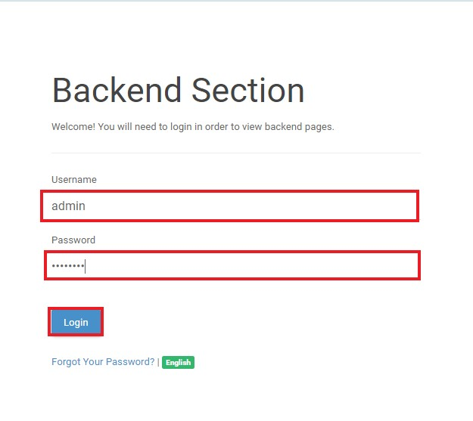

# Calander Page

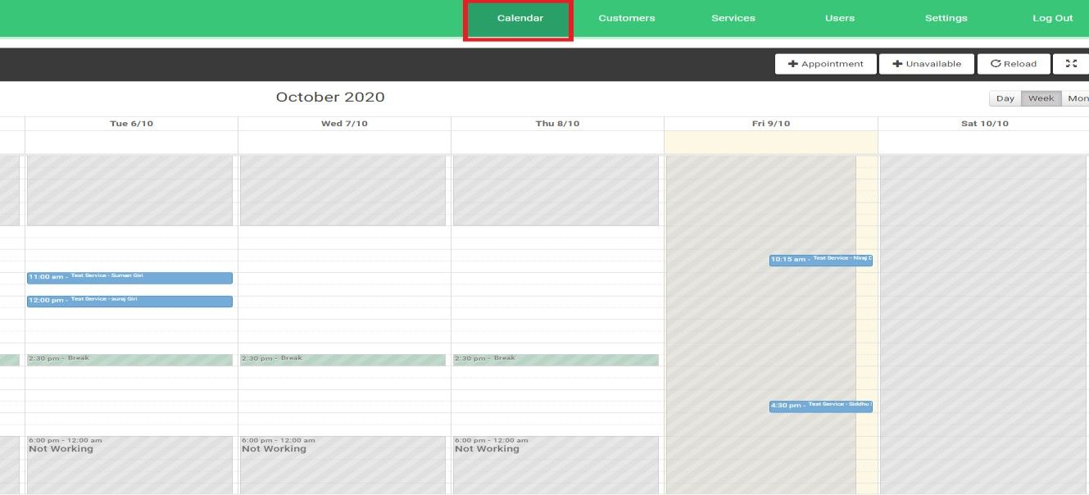

Display Calendar can be changed

