QUOTATION

Fitness 7 — App & Website
Date: 3 October 2026 · Quote no: F7-2026-01 · Valid for 30 days
Prepared for: Fitness 7 Gym Unisex, TS Square, 3rd Floor, Nethaji Bypass (opp. Govt Hospital), Dharmapuri 636701
Prepared by: Prakash Ashrith · 2001ashrith@gmail.com

What you get
One Android and iPhone app, the fitness7gym.in website and a staff admin panel, all running on one shared backend. Every screen below is a real screenshot from the current build.

Sign in and Home
Members sign in with their phone number or Google. Home shows streaks, offers, quick actions and photo-led sections, in dark or light theme.
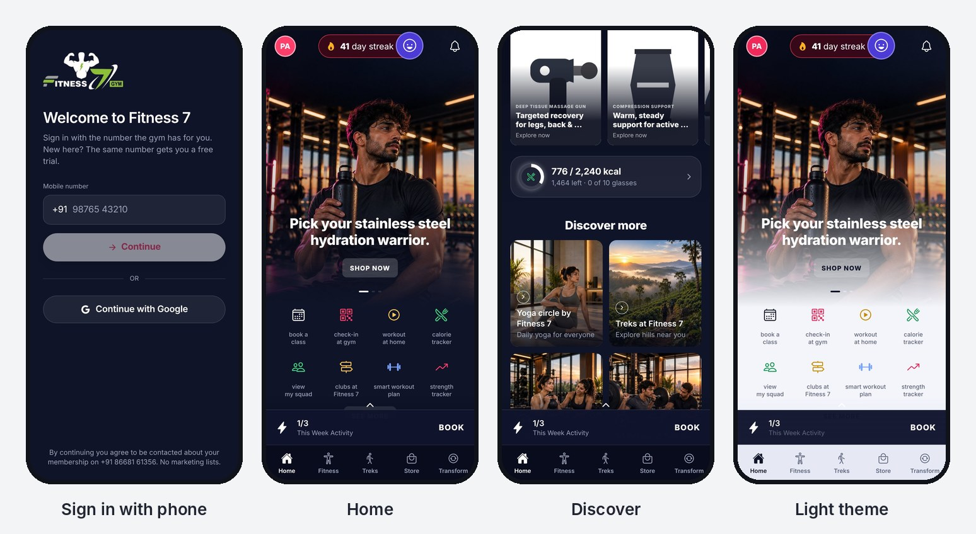

Train at the gym
Class schedule by day and slot, class details with exercises, a personal workout plan, and gym check-in with a member code.
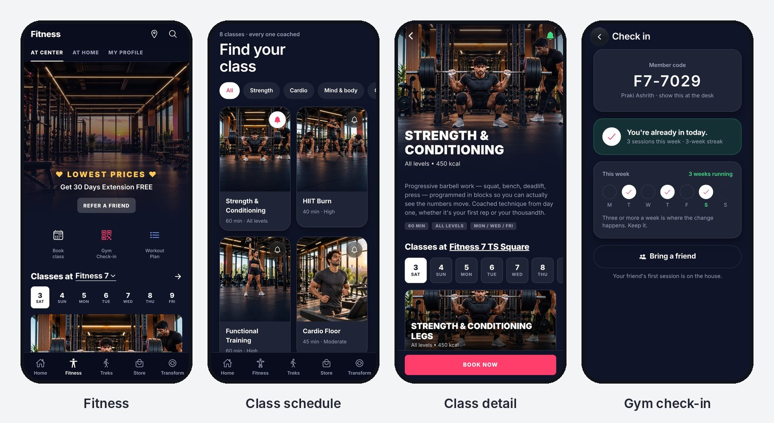

Monthly treks and the Fitness 7 store
Trek listings with member pricing and trek passes. A full store with categories, product pages, coupons, cart and checkout.
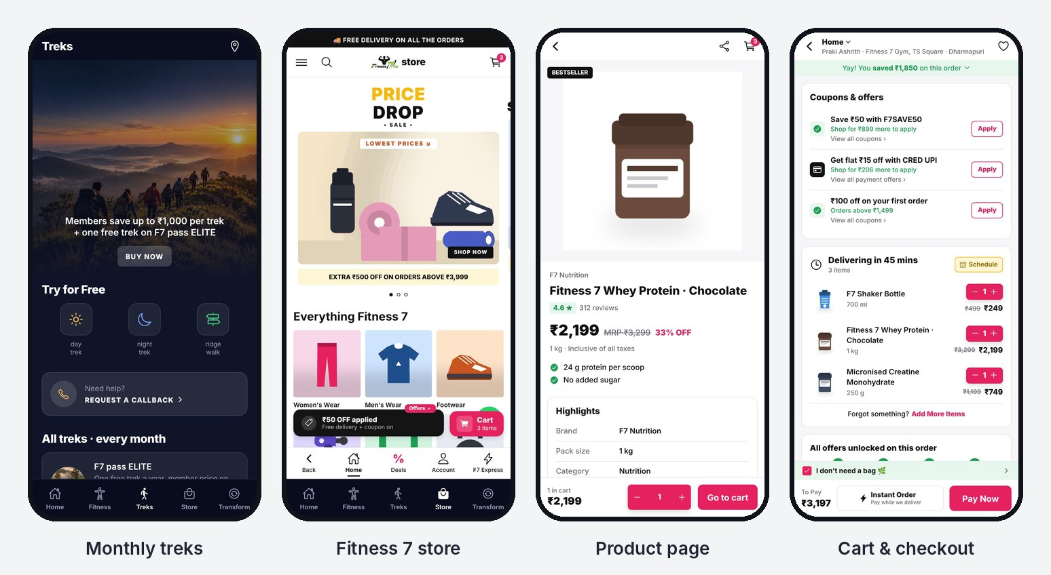

Calorie tracker
A complete calorie tracker built for Indian food: about 1,900 foods and 146 plates (idli-sambar, biryani, meals), typo-tolerant search, meal budgets and daily insights.
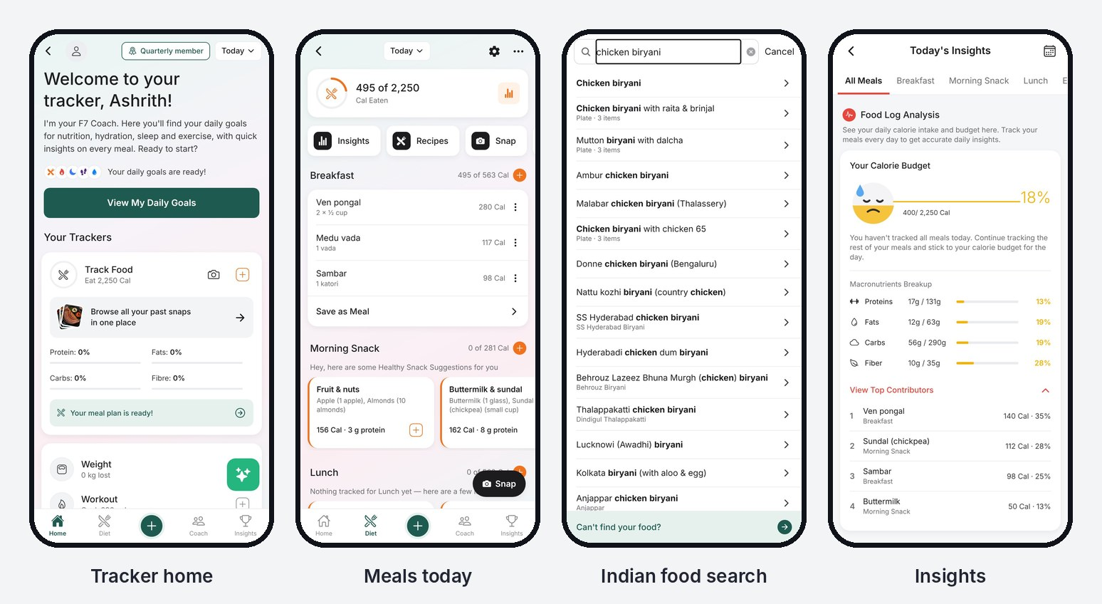
It also covers healthy recipes, weight, sleep and water, with AI logging from a photo or a typed sentence.
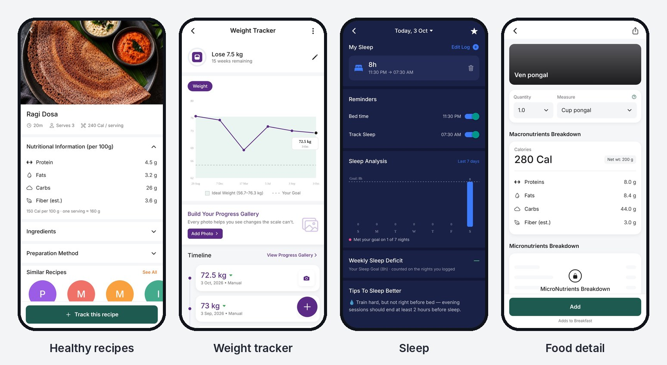

Membership and community
Plans and renewals, coach-led transformation programmes, a squad leaderboard to keep members coming back, and an Ask F7 assistant that answers questions about timings, prices and treks.
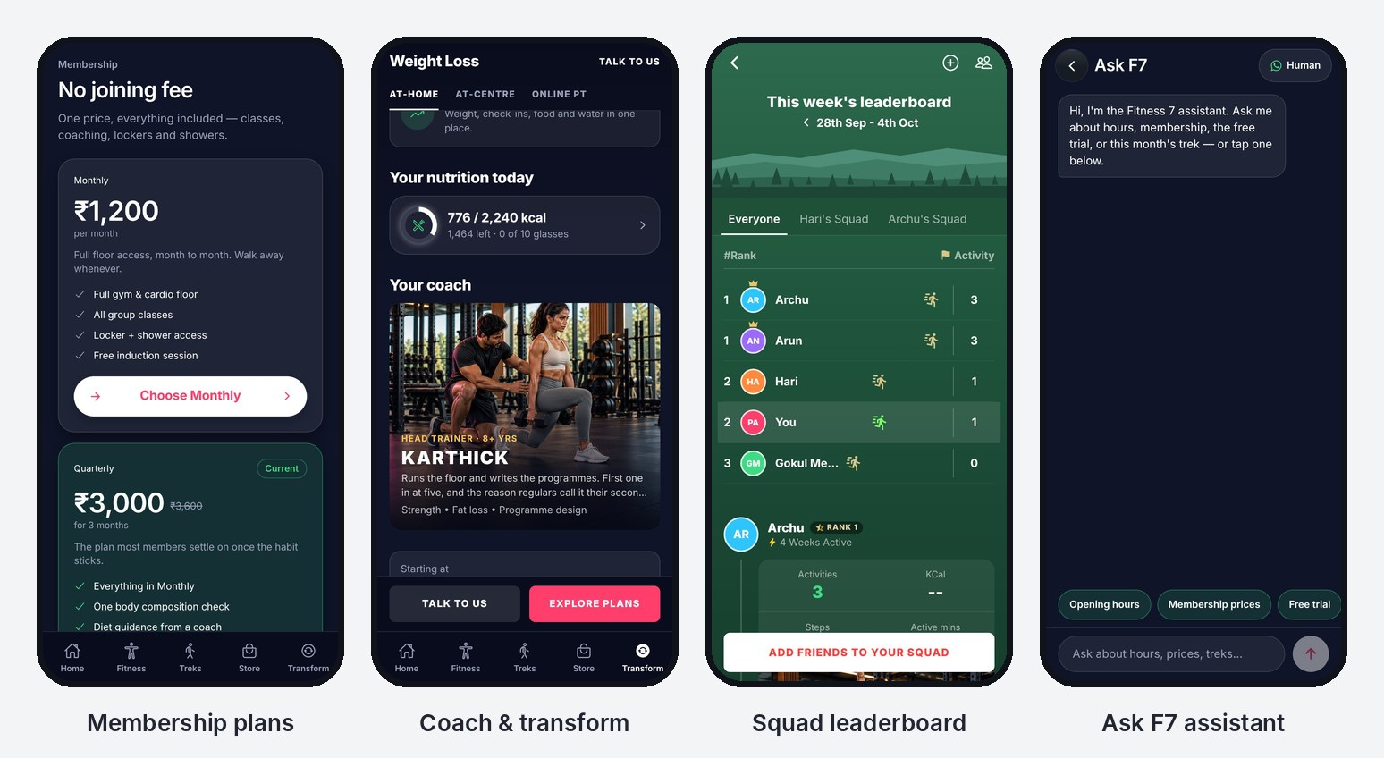

Behind the app
- Website at fitness7gym.in with class, trek and plan pages, enquiry capture and the same assistant.
- Admin panel for the owner, admins and coaches: members, plans, staff notes, leads, treks with photos, and announcements.
- Backend with phone OTP login, Google sign-in and offline-first sync, so the app keeps working on a weak signal.

Quotation
The full build comes to ₹2,60,000, a one-time fee covering design, development, testing and launch on both app stores.
# | Item | What's included | Amount (₹)
1 | Mobile app, Android + iPhone | Design and build of the 5-tab app: Home, Fitness, Treks, Store, Transform; light and dark themes | 90,000
2 | Calorie tracker | Indian food database (~1,900 foods, 146 plates), smart search, meal budgets, insights, recipes, weight, sleep, water, AI photo and text logging | 45,000
3 | Website | fitness7gym.in with class, trek and plan pages, enquiry capture and the Ask F7 assistant | 35,000
4 | Admin panel | Members, plans, staff roles, leads, treks, announcements | 30,000
5 | Store module | Catalogue, categories, product pages, coupons, cart and checkout | 25,000
6 | Backend and login | Phone OTP, Google sign-in, database, offline-first sync | 25,000
7 | App store launch | Play Store and App Store listings, screenshots, review submission | 10,000
 | Total |  | 2,60,000

Prices exclude GST, if applicable. Online payment gateway (Razorpay) and WhatsApp reminder automation are not included and can be quoted separately.

Running costs and support
Third-party accounts are opened in the gym's name and paid at actuals, so Fitness 7 owns them. Expect roughly ₹10,000–12,000 in the first year while member numbers are small.
Service | What it's for | Approx. cost
Apple Developer account | Publishing the iPhone app | US$99 a year (~₹8,500)
Google Play Console | Publishing the Android app | US$25 once (~₹2,200)
Domain renewal | fitness7gym.in | ~₹1,000 a year
Website and database hosting | Render and Supabase | Free tier to start; ~US$7–32 a month once traffic grows
AI food logging | Photo and text meal logging | Pay per use, a few hundred rupees a month at gym scale

Optional support plan: ₹5,000 a month. Covers bug fixes, app updates for new Android and iOS versions, and up to 6 hours of content or small feature changes each month. The first 30 days after launch are free.

Timeline and terms
The app and website are already built, so launch is about 2–3 weeks after approval, mostly waiting on app store review.
Milestone | When | Payment
Quotation accepted | Day 0 | 40% advance — ₹1,04,000
Gym details, prices and photos finalised; apps submitted to stores | Week 1–2 | 40% — ₹1,04,000
Apps live on Play Store and App Store | Week 2–3 | 20% — ₹52,000

- Ownership: on final payment, Fitness 7 owns the app, website, source code, data and store listings.
- Changes: two rounds of changes to text, prices and photos are included; new features are quoted separately.
- Validity: this quotation is valid for 30 days from the date above.
- Payment details: [UPI ID / bank account to be added]

For Fitness 7 Gym Unisex  ______________________  Name, signature & date | Prakash Ashrith  ______________________  Signature & date

