**Professional Summary**

**Prakash Manoharan**  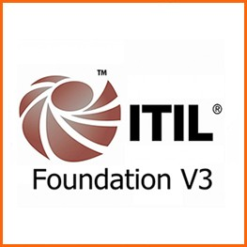 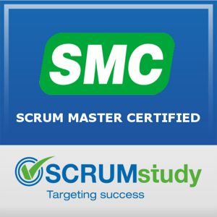  
**M:** 0470 084 197 **E:** [prax@outlook.com.au](mailto:prax@outlook.com.au)

A tech savvy web developer, having about 3+ years of website design expertise, a track record of creating dynamic, rich and interesting web portals and providing long term solutions for front end development.

As a self-directed and self-managed developer, I always thrive to deliver excellent work with great value and have an eye to opportunity for continuous improvement. Keenly looking for a suitable position, to join an enthusiastic team who enjoy challenges.

**Areas of Expertise include:**

* Web development
* Web content management
* Website optimization
* Programming and designing skills
* Excellent problem-solving skills
* Strong collaborative skills
* Layout aesthetics
* Stakeholder relationship management

**Core Skills**

* Excellent experience in coding and development for content-driven websites
* Expertise in source and version control - GitHub
* Expertise in the mobile first responsive framework - Bootstrap and Materialize CSS
* Strong expertise in HTML5, XHTML/HTML and SASS, CSS3
* Outstanding ability to uphold CSS driven development standards
* JavaScript ES6, ReactJS and associated libraries like react router, express, web pack, babel, bootstrap, jest.
* Configuring development environment and web deployment.
* Knowledge of Photoshop and Illustrator, and basics of InDesign
* Sound knowledge of W3C standards cross-browser compatibility cross-platform testing and coding best practices

**Key Projects**

IJCNC - <http://airccse.org/journal/ijcnc.html>

Wireilla – <https://wireilla.org>

AIRCCJ – <https://airccj.org>

**Professional Experience**

|  |  |  |
| --- | --- | --- |
| **DATE** | **ORGANISATION** | **ROLE** |
| Jun 2018 – Current | Wireilla, Sydney | Front-End Developer |
| Jun 2017 – May 2018 | Wireilla, Sydney | Web Developer |
| Jun 2016 – May 2017 | Wireilla, Sydney | Junior Web Developer |

**Wireilla Jul 2016 – Current**

**Technologies –** HTML5, CSS3, BootstrapV4, Materialize CSS, JavaScript ES6, React, Photoshop

**Roles & Responsibilities**

* Delivering websites that are user-friendly, effective, rich user experience
* Developing new pages for cross-browser support and mobile platforms (Android, iOS)
* Optimising web-pages for speed and performance
* Make suggestions for improvements in technology, content and user interaction
* Leading web projects with 5- 6 junior developers
* Develop concepts, and ensure deliverable are met on time
* Adaptable and able to pick new technologies in a short time
* Ability to manage priorities across multiple projects
* Fixed bugs from existing websites and implemented enhancements that significantly improved web functionality and speed

**Training & Certifications**

* Website training course certification (Udemy) 2017
* Agile Scrum Master Certification 2016
* ITIL Foundation V3 Certification 2015

**Personal Skills**

* Self-motivated
* Customer-centric
* Result-oriented
* Team-focused
* Self-competitive
* Self-leadership

**Qualification**

Bachelor’s Degree in Electronics and Communication Engineering, Madras Institute of Technology