# Chapter 2 Analysis

## Introduction

The project life cycle begins with the analysis phase where proper research is done on every parameter that can or may directly or indirectly could affect the project and product after release. It is the part where every direction of project is identified and the measurements are taken to make the project go smoothly while development and after release. Analysis helps us to determine user and system requirements along with how it can be achieved. Analysis helps us determine how feasible is the system to develop, weather cost is feasible or not, what features are to be integrated in the system and what users want from the system.

## 2.1 Information Gathering

The first step of analysis is information gathering which helps us communicate with the users, what they want from the system and how important it is in the current context.

Different techniques can be used to gather information. Some of the techniques used during analysis are described below: -

1. Observation

Observation is the basic technique that was used to perform analysis for the need of problem reporting platform in this case. Observation showed that the many common problems around the locality are not solved and people are getting affected because of government’s negligence.

Observation around the locality showed problems like broken roads and drainage problems. It also showed unmanaged traffic problems and electricity problems.

1. Interview

Interview is the most common technique used to gather information from the real-life scenario. From interview with the people in current context they suggested that the common problems around people’s day today life have not been solved due to the political stability and current state of government. So people desired a system that can be used to pressurize government to take actions of the problems and solve it. Interview also helped determine that people want system to directly complain about the problem on the click of button.

1. Questionnaire

Questionnaire is the tool used to gather information from people which consist of series of questions which people are supposed to answer. The collected sets of data can be used later to decide user requirements and system requirements of the project.

Some of the questions that were asked in the questionnaire are listed below

1. What do you think you can do to report problems around you to the government?
2. If you were to develop problem reporting platform what are the features that you want to integrate in the application?
3. How often do you use mobile?
4. What you think will mobile application or desktop application will be better to report a problem?
5. Will you do a survey on your mobile if that will help fix problems like road and drainage around your locality?
6. Will you stop if you are on the way to report a problem where the report will be strong enough to change the locality?
7. Will you do a survey if nothing of your personal data is collected to improve locality with your help?

## 2.2 Feasibility Study

Feasibility study is the beginning of the design stage where all the logical elements that could affect the system are analyzed and required measures are taken to make the project success. Feasibility study studies about expertise level required, qualitative and quantitative assessments of resources and estimation of time and cost along with the identification of critical problem.

Some of the factors studied in this project to identify the feasibility of system are described below:

1. Legal Feasibility Study

Legal Feasibility Study helps us determine if any legal implications can or may arise against the project. It helps project maintain all the legal and ethical requirements that a project must have. The problem reporting platform does not need any legal requirements but some ethical requirements are maintained in the project like no personal data is collected from users’ mobile devices and all the collected data are open to public which anyone can view at any required time.

1. Economic Feasibility Study

Economic feasibility study deals with the cost that will be required during the development and implementation of the project in the society. Since this project does not need hiring other member to work on project, the tools used are open source which are free of cost. The only cost required are to establish a database and domain for web UI which is not much. Neither money is required to collect data as normal people will be the one submitting data to the database. So, this project is economically feasible to develop and implement.

1. Social Feasibility Study

Social Feasibility Study helps us determine if the application will be acceptable in the society or not, can it grab user attention or not and can any user file a lawsuit against the project or not and similar factors. The information gathering result shows that problem reporting platform is what users want and in a current context there are many problems in the society. So, this shows that this project is socially feasible for implementation.

1. Technical Feasibility Study

Technical Feasibility Study studies the technical factors of the project like system require, user knowledge required, the cost to availability ratio etc. The system required is android which most people now a days have and user with any level of knowledge can do the survey within the application. The tools required for development are open source which are freely available on internet and the cost required to establish web UI is not much. So technically everything required are available which shows this project is technically feasible to develop.

1. Operational Feasibility Study

Operational feasibility study deals with the factors like process used, evaluation of end product, implementation adapt to the need etc. It helps us determine if the product can operate smoothly in the changing environment and what methods are to be taken to improve the system.

## 2.3 Analysis Methodology

Structured systems analysis and design method (SSADM) is the type of analysis methodology used for this project. SSADM is a rigorous document-led approach for the development of information systems.

SSADM is basically waterfall method for the design of information systems. The use of this kind of methodology helps generate a well-documented and accurate information systems.

## 2.4 Requirement Specifications

The requirement specification is whole description of the product that is going to be developed. The requirement specification is basically documentation of what users wanted and what the system is. Requirement specification must fulfill all the business need or what features users want.

Requirement specification is the agreement between customer and development team which describes their needs of the application and what the application will have to fulfill their needs. The ultimate goal of the requirement specification is to reduce the problem of redesigning of the system later after if customers wanted to change the requirements.

There are basically two types of requirement specifications. They are listed and described below

### Functional Requirements

Functional requirements are defined as the tasks that product must do to fulfill the business requirement of the user of functional requirement are the functions of the product with which clients’ daily activity requirements are met.

It includes interface requirements, business requirement, compliance requirement, and security requirement.

The functional requirements of the problem reporting platform are explained below in table.

|  |  |  |  |  |
| --- | --- | --- | --- | --- |
| ID | Title | Description | Rational | Dependencies |
| Fr 1 | Admin Registration | A user must be signed up as admin at initial which has control over the whole database and product. | For username and password for admin. | None |
| Fr 2 | Admin Login | Login for admin so that he can manage the whole application when needed. | For privacy and easiness for management and control. | Fr 1 |
| Fr 3 | User Registration | Registration for the user so that he can make complains by filling an survey. | For reporting problems. | None |
| Fr 4 | User Login | Login for user after which users can start taking surveys. | For username and password to login as user. | Fr 3 |
| Fr 5 | Manage Users | For user management by the admin who can modify add or delete the user. | For management and privacy reasons. | Fr1, Fr2, Fr3, Fr4 |
| Fr 6 | Making Complaints | For reporting the exact problem by taking photos and submitting problem with description, picture and GPS location. | For reporting a problem. | Fr3, Fr4 |
| Fr 7 | Manage Records | For managing the data sent by users which contains problems details. | For generation of web UI, graphs, data visualization, and manage the database. | Fr1, Fr3, Fr 6 |
| FR 8 | View My Records | To view the complaints made by any user. | For visualizing data for one user. | Fr 3,Fr 4 |
| FR 9 | Reward User | For rewarding the user who makes continuous complaints. | To promote more users. | Fr3,Fr6 |

### Non-Functional Requirements

Those type of requirements that are to be included in the project but does not have any functions within the application but would be better if application contained those features can be said as non-functional requirements. nonfunctional requirements are any requirements that cannot be categorized in the functional data or process requirements.

Non functional requirements are the factors that define the usability and performance parameters of the systems. Some of the non-functional requirements are described below: -

1. User Interface

Easy user interface is the non-functional requirement of any project. User interface does not have any functional requirement but a project would be better if it has easy user interface for the user which user can use to interact with the application.

1. Security

Data submitted by the user must be kept secure and the application should not gather any kind of user personal data. The application or system is better if it has good security measures applied within the system so that the data and information are not misused for any other use.

1. Availability

Availability of application is the non-functional requirement since it is not functional requirement but a application is better if it is available every time to the user if they want at any time of the day. A properly available system can gather and connect with more users if it is available every time for the users.

1. Reliability

Reliability of the application can be described as its non-functional requirement because it is not described as functional requirement but a system will gain more trust with user if it is reliable for storing and retrieving the information from inside and outside the system.

## 2.5 Prioritization

The business requirement of the organization must be prioritized before the development of the application which helps us meet the cost and time factor of the project. If requirements are prioritized then the user can have at least the basic working application that will fulfill the basic business requirement even if all the aims are not achieved by the end of the deadline because of problems during the development.

For prioritization of the aims and features that a application will have MOSCOW prioritization technique is used. MOSCOW helps us identify must have, should have, could have and wont have features of the application that will pave the road for the upcoming development and implementation stages of the project.

Using MOSCOW prioritization the features are differentiated as below:-

1. Must Have Features

The features that fulfills the basic business requirement of project are must have features. Some of the must have features are listed below:-

1. Registration for one system admin with full control of application.
2. Registration for users.
3. Get GPS location of the Phone.
4. Make Complaints about phone
5. Web UI to visualize the data.
6. Rewards for user to promote users for making complaints.
7. Store data locally if not online.
8. Unregistered Users can make a complaint but cannot view unless not registered.
9. In app user guide.
10. Should Have Features

Some of the should have features are

1. Easy User interface.
2. Encryption system to secure data over network.
3. Could Have Features

Some Could Have features are

1. Online help.
2. Rewards to user who makes maximum complaints.
3. Wont Have Features

Some of the wont have features are listed below:-

1. Include multimedia content with complaints.

## 2.6 System Requirements

System requirements are the environment parameters that help what system can run the application. A application must be made to run on the existing system of the organization so that organization should not use more cost just developing the platform to run the newly purchased application.

System requirements include hardware and software requirements required to run the application. Some of the hardware requirements are listed below:-

1. Android system with processor higher or equivalent to 1 GHz.
2. RAM equal or more than 512 MB.
3. Storage required 10MB on phone.
4. Screen resolution at least 1280*720 px.

Some of the software requirements are listed below:-

1. Operating System Android above or equal than lollipop or Android 5.0.
2. Browser to view the data visualization done with Web UI.
3. Back end database software-MySql.

## 2.7 System Architecture

In the current application scenario application should gather information from user, send to the database and retrieve from the database. So the system is a client server system so three tire architecture is used to develop this application.

This type of architecture consists of presentation tire, application tire and data tier. The components of system architecture are described below:-

1. Presentation Tier

Presentation tier is the top level that displays information related to services and functionality included inside the system. This system interacts with remaining component by sending data to the other system over the network..

1. Application Tier

Application tier is the middle tier or main logic tier of the information system. This tier controls application usability and functionality by performing detailed analyzation and processing of data and information.

1. Data tier

Data tier is the storage area for the data and information. It houses database servers where data are stored and shown in the presentation tier.

The diagram below shows the three tier architecture

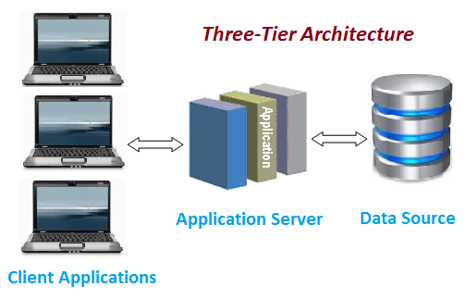

The main advantage of using three tier architecture is that each component can be developed individually. Because the programming for a tier can be changed or relocated without affecting the other tiers, the 3-tier model makes it easier for an enterprise or software packager to continually evolve an application as new needs and opportunities arise.

## 2.8 Natural Language Analysis

Natural Language Analysis is the technique used to find out how real life scenario gets embedded in the system by analyzing the scenario written in high level language. This process includes identification of nouns verbs and adjectives from the scenario which are possible class, method and attribute name for the application.

A non profit organization “Help for All” has been conducting awareness and helping people in need. The company is changing the focus for pressuring the government and help people solve the problems around the community. Due to political stability simple problems are neglected by the government.

Now this organization wants to user to collect the information lying around the locality like water, drainage, road etc. and has told to make a survey by user through their phone. Once the user is registered he/she can make complaints and view the records. After logging in the system does not need any internet connection for making complains or made are stored locally on the phone which gets uploaded the device is online. GPS location is noted and image is taken clearly showing the problem and some other information like road type and problem details. Also web to visualize data is necessary as per the requirement of organization.

After analyzing the scenario the possible classes are described below in table

|  |  |  |
| --- | --- | --- |
| Nouns | Verbs | Adjectives |
| Help for All, company, government, complaints, user, unregistered user,logn,dashboard,registration | Add, edit, delete, remove, search, view | Name, address, phone, email, problem name, problem description, quality |

## 2.9 Use Case

Use case diagram is the static diagram that show the human interaction with the system and what process they can perform as a certain type of user. It defines roles of system and user to achieve certain type of goal.

The main components of use case diagram are

1. Actor

Actor is the main user of the system who interact with the system to achieve certain type of goal. A system does not perform on its own without the actor.

1. System

System is the application which actor uses to fulfill their business requirements. System performs task along with user.

1. Use Cases

Use cases are the exact activity that a actor does to achieve the goal where system works with the actor to meet a certain type of need with the help of application.

The use case diagram for this current scenario is shown below

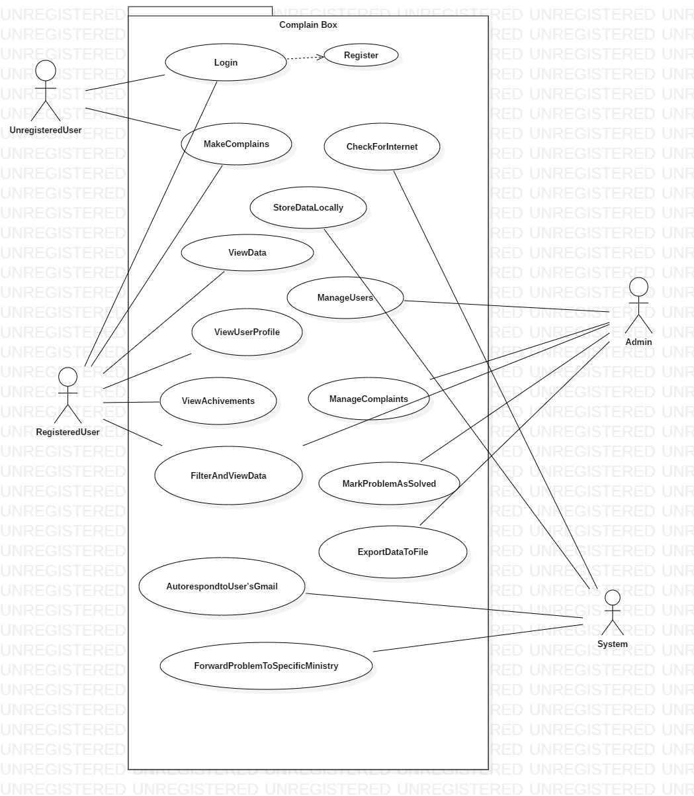

## 2.10 Class Diagram

Class diagram is the static diagram that shows the structure of the system by showing the system’s classes, methods and attributes and their relationship with each other.

The class diagram works as the basic building block of the system which shows the main elements, interactions in the system and the classes to be programmed.

