Table of Content

Introduction

* 1. Introduction to the system
  2. Background of the system
     1. Problem Definition
  3. Justification of the System
  4. Overview of proposed System

1. Scope
   1. Aims of the Project
   2. Objectives of project
   3. Features to be included
   4. Overview of the scope
2. Design Methodology
   1. Methodology to be used
   2. Design Pattern
   3. Work Breakdown Structure
   4. Milestones
   5. Gantt Chart
3. Risk Management
4. Configuration Management
5. Conclusion

Bibliography and Referencing

Chapter-1 :-Overview

* 1. Introduction to the system

This project entitled “Complain Box” is a app created with the main motto of taking local problems to the government and pressuring them to act for the betterment of society and country as a whole.

This app allows a user to take a picture of any problem lying around themselves so that small effort done by local people can make a difference around them.

Anybody can take a picture of any problems like broken roads, poles, drainage or even people breaking rules so that government is compelled to fix the problem faster.

For pinpointing the actual location of the spot where problem lies, application uses gps technology to read the exact location of problem which makes us informed to where exactly the problem is around us.

* 1. Background of the system

The main inspiration to this topic came from problems around me. I always had to face the different problems while moving around the city. I always wondered if I could do something that helps take problems to the government. And as a desire to pressuring the government this project gradually evolved with basic inspiration around me.

* + 1. Problem Statement

I had to face two problems as I am walking the same road. Similarly, there are so many problems that are lying around us and if everybody use it to complain to the government it would be just a matter of time before thousands of problem records are recorded.

People can use it to post complains about traffics, electricity, road lights, broken roads etc. around us.

* 1. Justification of the system

People will be able to complain the problems around them with just a app installed on their smartphones.

The application stored on the user phone will be capable of storing the images with problems even if its offline and post to database as it gets connected to the internet.

The application will have a web UI to visualize the database with the feature of sorting and filtering.

* 1. Overview of Proposed System

This application will use MYSQL database to store the information and the records are plotted in web UI.

This app will not be capable of showing the UI on the application.

Chapter-2:-Scope

2.1 Aims of the project

Some of the main aims of this application are:-

1. Provide android app with easy UI for all.
2. Collect information of problems around the city.
3. Encourage people to complain as many problems as possible that lie around them.

2.2 Objectives of the system

Some of the objectives of the project are as follows:-

1. To intricate the gps functionality into the application.
2. To provide the web UI for data visualization and sorting.
3. To provide proper documentation of the application so that any maintenance will be easier in future.
4. To provide feedback system within the application and UI so further improvements can be done on app.
5. To make the database accessible to everybody so that no data collected is kept private or in ownership of anybody.
6. To make application store many records offline and post it to database as it gets connected to the internet.

2.3 Features to be included

Some of the features of this application are:-

1. Registration
2. Support for problems related to different categories like roads, traffic, electricity, drainage etc.
3. Awards for users when they report the certain numbers of problems.
4. Data Visualization system.
5. Easy web and android UI.

2.4 Overview of the scope

I think this application can have a great scope in country like Nepal as it is moving from under develop to developing country.

The main idea will be to build android application as almost all the people own an android and they can use their smartphones to report the problem as they see since everyone carry their phone around.

Chapter-3:- Design methodology

3.1 Methodology to be used

Application can be developed using different development methodology like agile but rather I selected older development methodology Waterfall Methodology as a development methodology of this application. Agile would give more people-oriented product whereas waterfall rather the system guidelines oriented. The complete completion of one stage only leads to another stage in this type of development methodology and returning back to previous stage alters the whole process but as the guidelines are fixed, I think waterfall Methodology will be appropriate to develop this product.

The different stages for Waterfall Software Development Methodology are shown in figure.

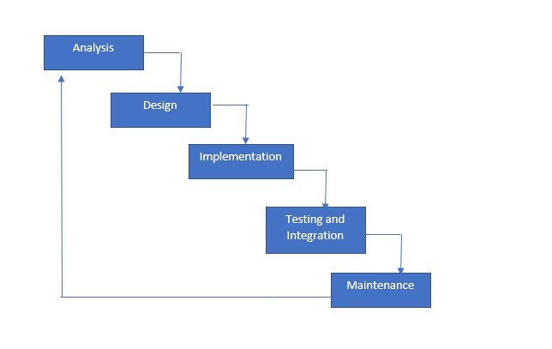

Figure 1 Waterfall Model

The stages of waterfall model are described below :-

1. Analysis

It is the starting phase of software development life cycle or waterfall model where analysis is done on the market and feasibility study is done to identify if the software will be feasible to develop or not.

1. Design

This is the second phase of waterfall model where if the analysis is feasible the design of software is created which later works as architecture for the development of application.

1. Implementation

This is the third and main phase of waterfall model where coding Is done and user required methods are built to fulfill the requirement of user.

1. Testing and Integration

This is the longest phase of waterfall model where the application build on implementation phase are put to different white box and black box testings’ which helps reduce the bugs and increase the efficiency of application. After everything is passed the application is then installed on user device.

1. Maintenance

This is the final phase of Waterfall model where an implemented system is monitored for performance issues and to check if it still contains any bugs. Thus, identified bugs are again analyzed and the process starts again.

3.2 Design Pattern

As for the design pattern this application follows Module View Controller(MVC) pattern where the core application data is stored on module. The view is the UI part of the application which a user sees on the screen and spends his most time on. The controller is the bridge linking module and view and allows module data to go to view and vice versa.

But because of system dependencies of C# view and controller are at same place where module is separated.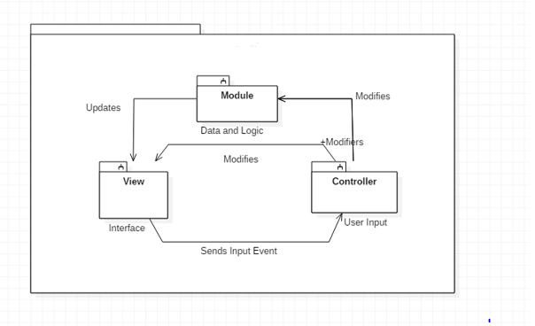

Figure 2 MVC Design Pattern

Chapter-4

4.1 Work Breakdown Structure

The work breakdown structure is a technique of managing projects which are designed to help break down complex big projects into smaller chunks which can be effectively estimated and supervised.

WBS is also created to help with assigning responsibility and to show control points and project milestones.

Work breakdown structure also allows for precise estimation of cost ,risk and time and also helps explain the projects to stakeholders.

The example of work breakdown structure of this project is shown below:-

Complain Box

Design

Testing and Integration

Coding

Analysis

Project Management

Database Design

Database

Overview

Requirement Gathering

Maintenance

UI design

UI

Development Methodology

Use Case Diagram

Unit Testing

Scheduling

Class Diagram

Integration Testing

Risk Management

Activity Diagram

Black Box Testing

Configuration Management

Architecture

Submission

4.2 Milestones

In order for a application to be successfully developed it has to pass through different milestones successfully. The successful completion of milestones indicates a project is successfully going as expected

|  |  |
| --- | --- |
| Milestones | Date |
| Project Management   1. Overview 2. Development Methodology 3. Scheduling 4. Risk Management 5. Configuration Management 6. Submission | June 16 to July 1St |
| Analysis   1. Requirement Gathering 2. Use Case Diagram 3. Class Diagram 4. Activity Diagram 5. Architecture | July 2nd to July 29th |
| Design   1. Structural Model 2. Database Design 3. UI Design | July 30th to Aug 29th |
| Implementation   1. Database Coding 2. Web UI Coding 3. Application Coding | Aug 30th to September 20th |
| Testing and Implementation   1. Unit Testing 2. Integration Testing 3. Black Box Testing 4. Deployment | September 21st to September 30th |
| Maintenance |  |

4.3 Gantt Chart

Chapter-5:-Risk Management

There are many risks to this system which may cause different amount of damage to the system. The likelihood of such risks vary and are represented in a table below.

|  |  |
| --- | --- |
| Likelihood | Value |
| Low | 1 |
| Medium | 2 |
| High | 3 |

Occurrence Table

The Impact to the system can be high or low which on numbers can be divided as in table below .

|  |  |
| --- | --- |
| Consequence | Value |
| Very Low | 1 |
| Low | 2 |
| Medium | 3 |
| High | 4 |
| Very High | 5 |
|  |  |

Risk Table

|  |  |  |  |  |  |
| --- | --- | --- | --- | --- | --- |
| SN | Risk Description | Likelihood | Consequences | Impact | Action |
|  | Slow Database | 3 | 2 | Low | Better Server for the application can be built. |
|  | GPS Pinpointing Location | 1 | 2 | Low | Try Again with a small radius. |
|  | Attacks on servers | 2 | 4 | High | IPS and IDS must be installed along with servers. |
|  | Fake Registrations | 3 | 1 | Low | Users are removed if they are not active for long period. |
|  | Power Fluctuations | 2 | 5 | High | Backup Powers must be used to power servers. |
|  | People Submitting fake information | 2 | 2 | Low |  |
|  | Database Failure | 1 | 5 | High | Backup of data must be done regularly and must be kept offline. |
|  | Lack of User Awareness | 2 | 3 | Medium | More publicity stunts must be done to get much traffic flow. |

Chapter -6:-Configuration Management

Configuration management is the process for establishing and maintaining products consistency of products performance physical and functional information. Configuration management determines that a system performs as intended and is identified and documented in sufficient detail to support its projected life cycle. Configuration management helps to minimize the problems in the project.

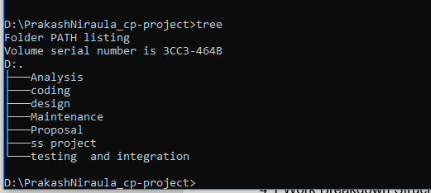

Figure Repository Local Directory

For software configuration a publishing directory is created in github whose local directory is shown in image as above.

Chapter-7 :-Conclusion

I propose the development of application as per the requirements stated above. The application will be as simple to use and as efficient as possible.

Thus, the system if developed can be used for the betterment of society and country as a whole.

Chapter -8: Referencing And Bibliography

En.wikipedia.org. (2019). *Configuration management*. [online] Available at: https://en.wikipedia.org/wiki/Configuration_management [Accessed 30 Jun. 2019].

Freetutes.com. (2019). *Waterfall Software Development Life Cycle Model*. [online] Available at: https://www.freetutes.com/systemanalysis/sa2-waterfall-software-life-cycle.html [Accessed 30 Jun. 2019].

Project Management Docs. (2019). *Work Breakdown Structure (WBS) - Project Management Docs*. [online] Available at: https://www.projectmanagementdocs.com/template/project-planning/work-breakdown-structure/#axzz5sLRFaZEC [Accessed 30 Jun. 2019].