**show databases;**

**use newdatabase;**

**CREATE TABLE PERSON3 (**

**driver_id VARCHAR(10) PRIMARY KEY,**

**name VARCHAR(50),**

**address VARCHAR(100)**

**);**

**CREATE TABLE CAR3 (**

**reg_num VARCHAR(10) PRIMARY KEY,**

**model VARCHAR(30),**

**year INT,**

**address VARCHAR(100)**

**);**

**CREATE TABLE ACCIDENT3 (**

**report_num INT PRIMARY KEY,**

**accident_date DATE,**

**location VARCHAR(100)**

**);**

**CREATE TABLE OWNS0 (**

**driver_id VARCHAR(10),**

**reg_num VARCHAR(10),**

**PRIMARY KEY(driver_id, reg_num),**

**FOREIGN KEY(driver_id) REFERENCES PERSON3(driver_id),**

**FOREIGN KEY(reg_num) REFERENCES CAR3(reg_num)**

**);**

**CREATE TABLE PARTICIPATED0 (**

**driver_id VARCHAR(10),**

**reg_num VARCHAR(10),**

**report_num INT,**

**damage_amount INT,**

**PRIMARY KEY(driver_id, reg_num, report_num),**

**FOREIGN KEY(driver_id) REFERENCES PERSON3(driver_id),**

**FOREIGN KEY(reg_num) REFERENCES CAR3(reg_num),**

**FOREIGN KEY(report_num) REFERENCES ACCIDENT3(report_num)**

**);**

**INSERT INTO PERSON3 VALUES**

**('D1','Ravi Kumar','Bengaluru'),**

**('D2','Anita Sharma','Mysuru'),**

**('D3','John Mathew','Hubli'),**

**('D4','Priya Singh','Belagavi'),**

**('D5','Arun Das','Mangaluru');**

**INSERT INTO CAR3 VALUES**

**('KA01AB1234','Hyundai i20',2020,'Bengaluru'),**

**('KA02CD5678','Maruti Swift',2019,'Mysuru'),**

**('KA03EF9012','Tata Nexon',2021,'Hubli'),**

**('KA04GH3456','Honda City',2018,'Belagavi'),**

**('KA05IJ7890','Ford EcoSport',2020,'Mangaluru');**

**INSERT INTO ACCIDENT3 VALUES**

**(101,'2023-01-10','MG Road'),**

**(102,'2023-02-14','Ring Road'),**

**(103,'2023-03-20','Airport Road'),**

**(104,'2023-04-05','NH 48'),**

**(105,'2023-05-12','Brigade Road');**

**INSERT INTO OWNS0 VALUES**

**('D1','KA01AB1234'),**

**('D2','KA02CD5678'),**

**('D3','KA03EF9012'),**

**('D4','KA04GH3456'),**

**('D5','KA05IJ7890');**

**INSERT INTO PARTICIPATED0 VALUES**

**('D1','KA01AB1234',101,15000),**

**('D2','KA02CD5678',102,30000),**

**('D3','KA03EF9012',103,25000),**

**('D4','KA04GH3456',104,5000),**

**('D5','KA05IJ7890',105,40000);**

**select * from PERSON3;**

**select * from CAR3;**

**select * from PARTICIPATED0;**

**select * from ACCIDENT3;**

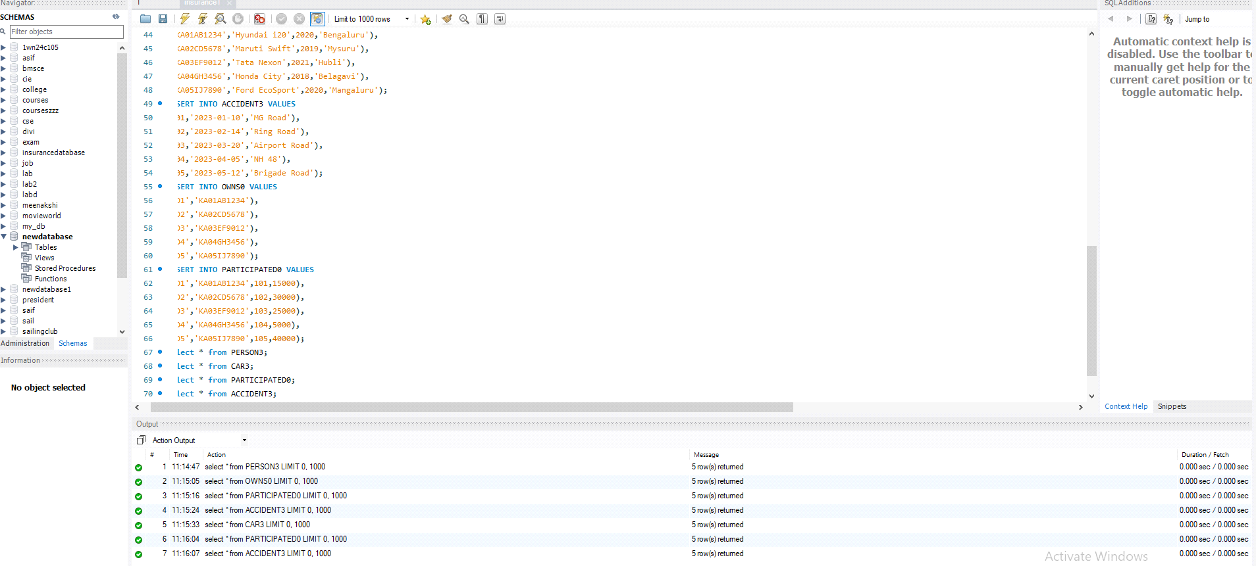

**QUERIES**

**1.select * from CAR3 order by year asc;**

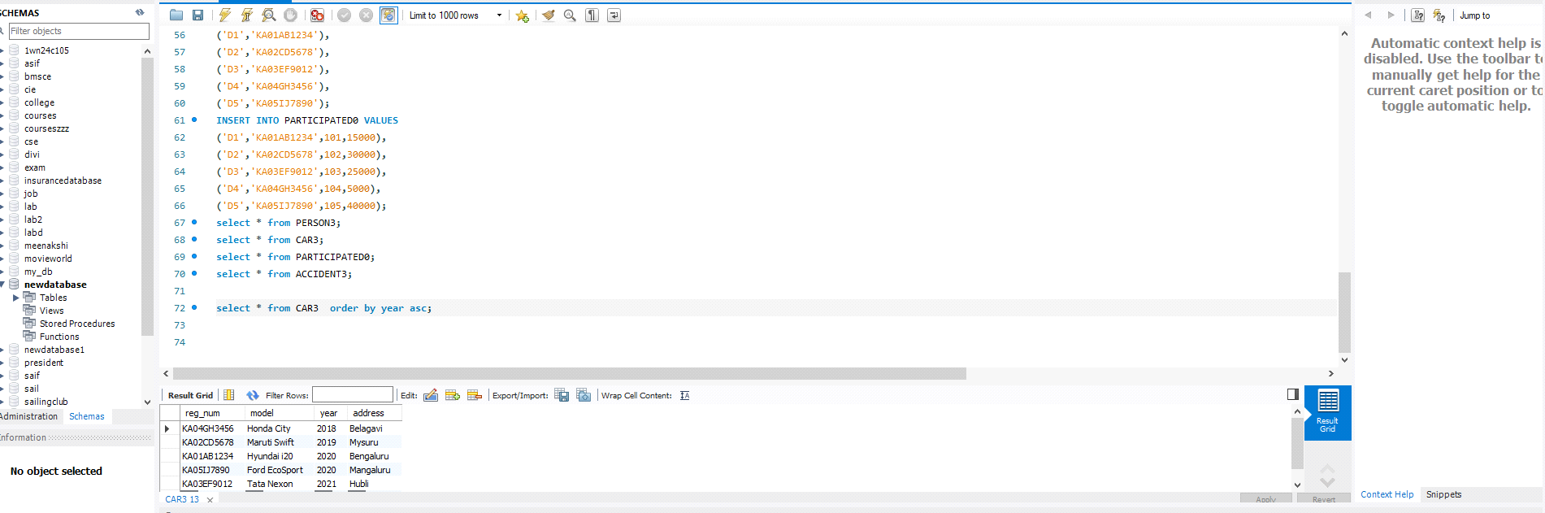

**2.select count(report_num)**

**from CAR3 c,PARTICIPATED0 P**

**where c.reg_num=p.reg_num and c.model='Hyundai i20';**

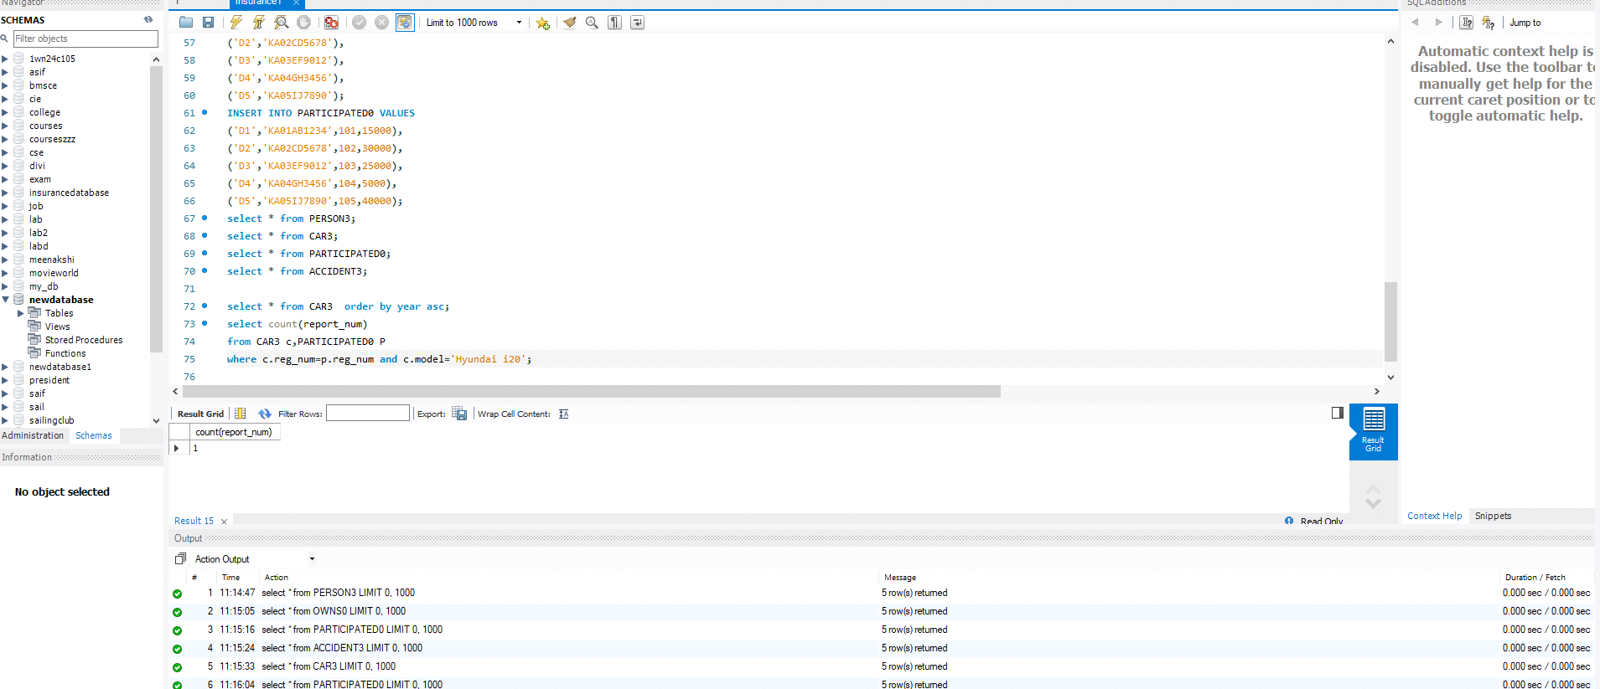

**3.SELECT accident_date, location**

**FROM ACCIDENT3;**

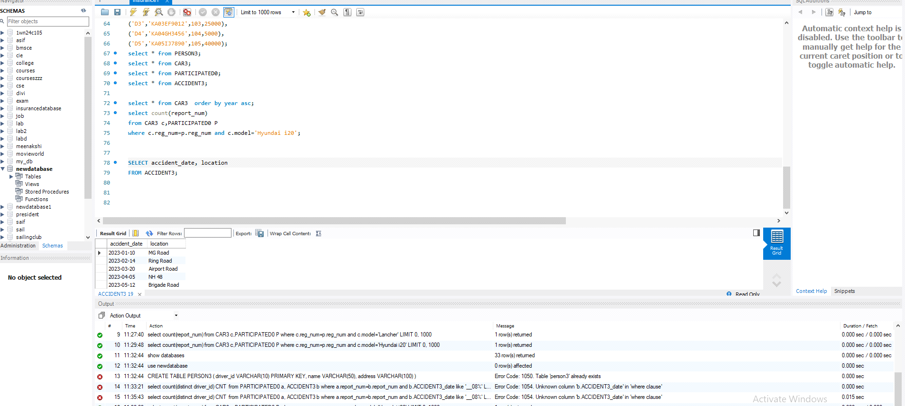

**4.SELECT DISTINCT driver_id**

**FROM PARTICIPATED0**

**WHERE damage_amount >= 25000;**

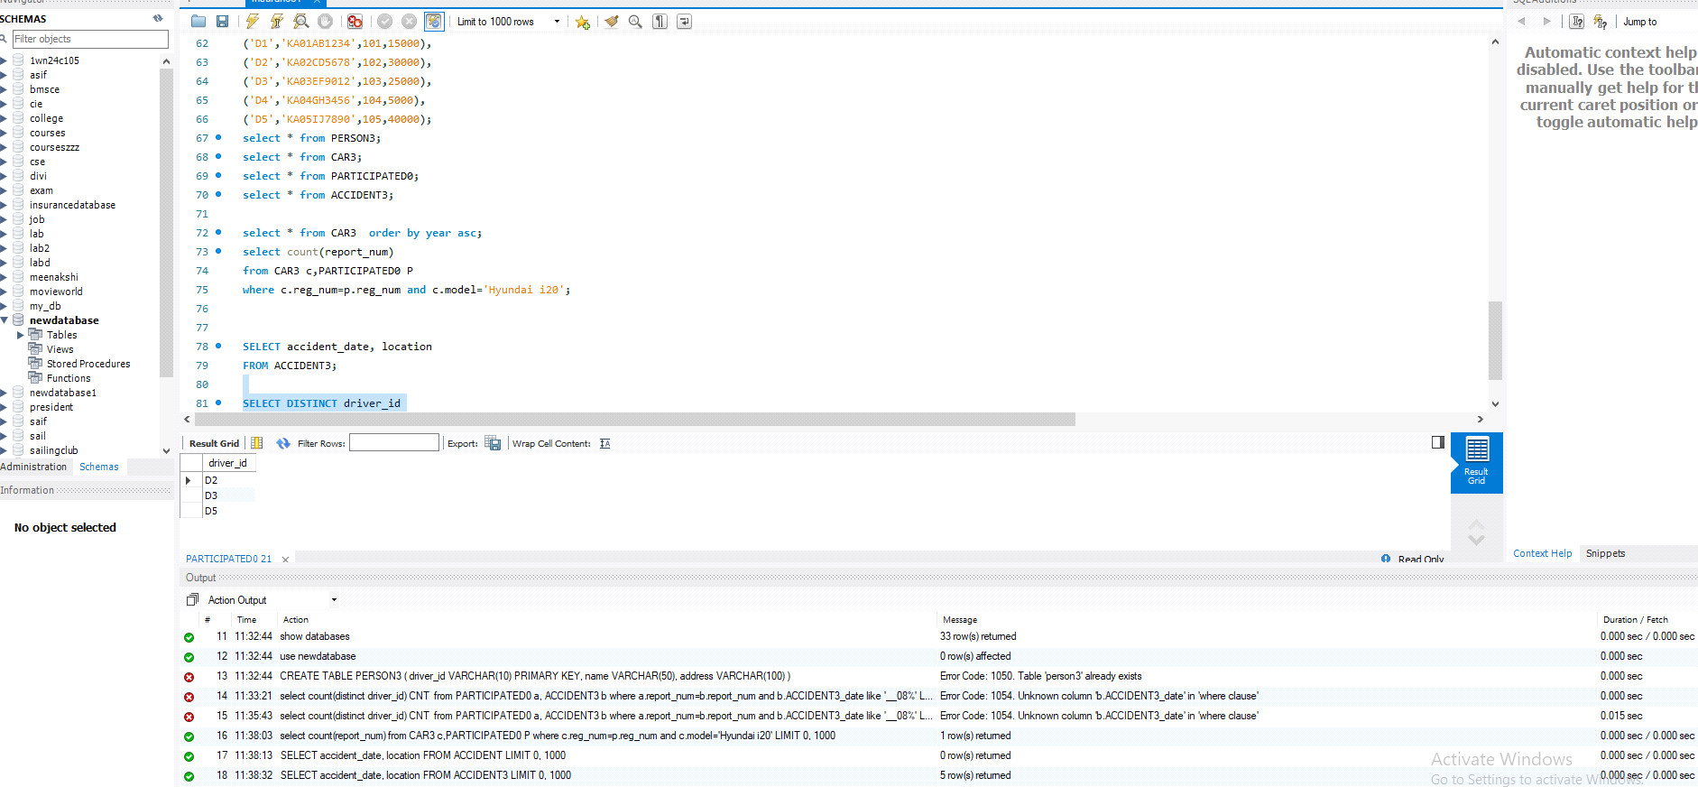

**5.**

**select * from PERSON3 P**

**JOIN PARTICIPATED0 Pa ON P.driver_id = Pa.driver_id**

**WHERE Pa.damage_amount >= 25000;**

