Phase 1 — SQL Analytics Layer (Business Intelligence Foundation)

Tasks
- Create a new database schema for the hospital system.
During Phase 1 ingestion, the approved_amount field in the raw billing data was loaded as text due to inconsistent formatting and missing values in the source CSV. Additionally, the Vacareum MySQL environment restricted UPDATE operations, preventing in-place data correction.
To maintain data integrity while preserving the raw source as an immutable layer, a cleaned transformation layer (billing_clean) was created. This table standardizes financial fields into numeric types and normalizes missing approvals to zero, enabling accurate computation of revenue realization ratios, rejection rates, and payment delay metrics. This layered approach mirrors real-world data lake and warehouse practices, where raw data is preserved and cleaned, analytics-ready tables are derived for reporting and modeling.
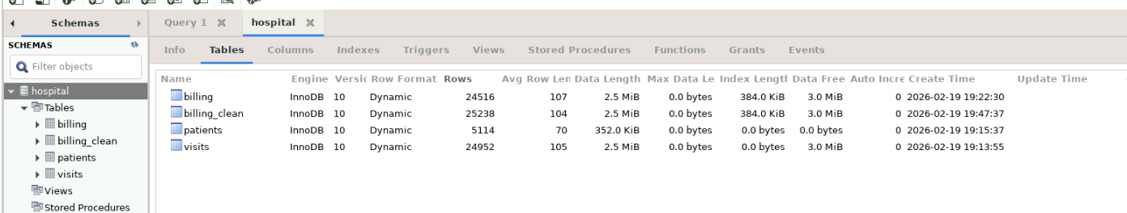
- Define SQL tables: patients, visits, and billing with appropriate data types.
- Define primary keys and foreign key relationships between tables.
- Document which queries benefit from which indexes.
- 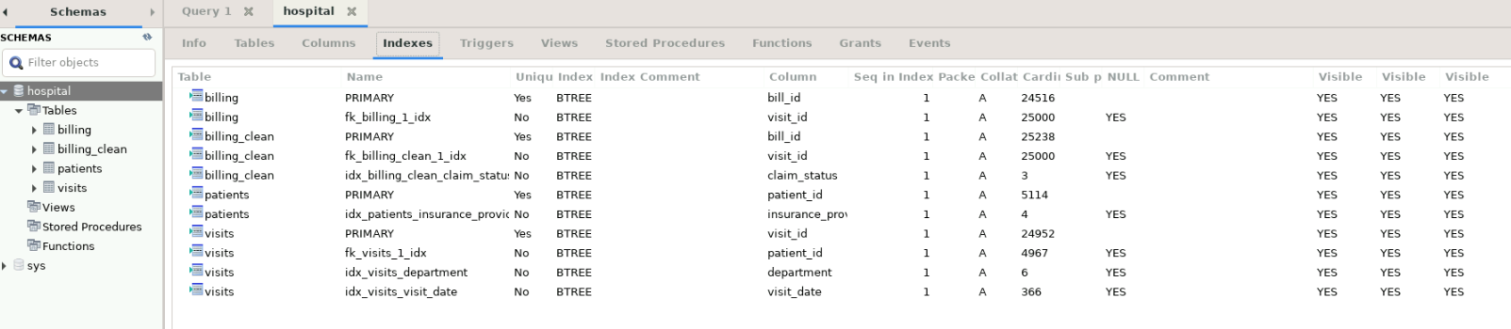
Analysis
- Operational Analysis

  - Retrieve the top 10 departments by total visit volume.
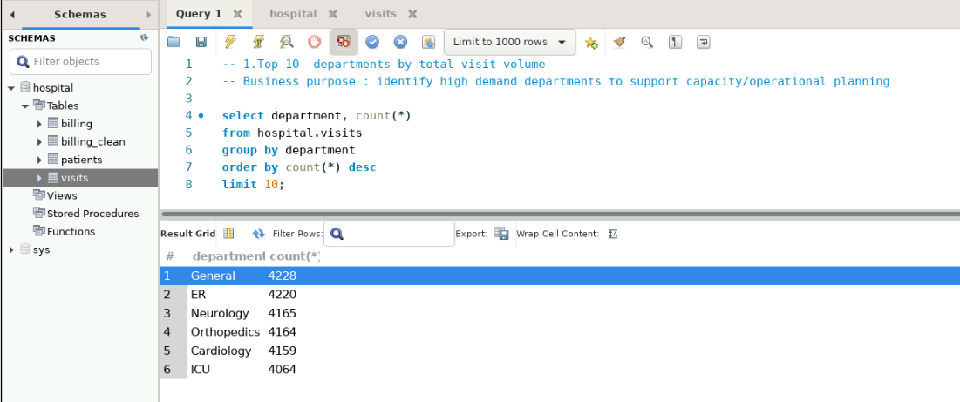
  - Identify the top 5 departments with the highest average length of stay.
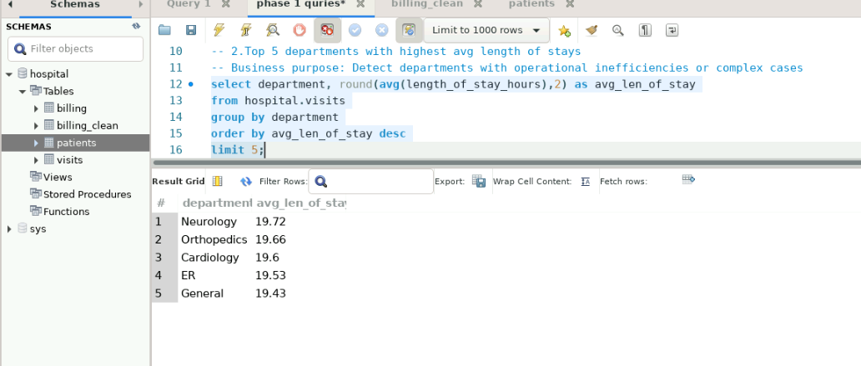
  - Find the percentage of High Risk visits per department.
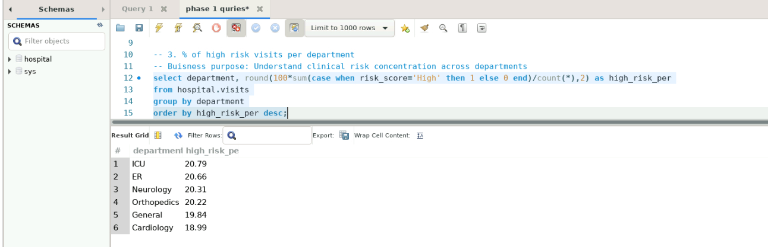

  - Determine the average number of visits per patient by city.
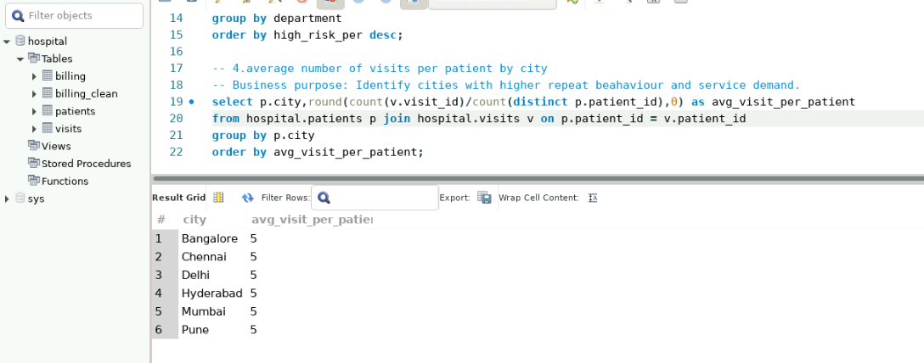

  - Identify doctors handling the highest number of High Risk visits.
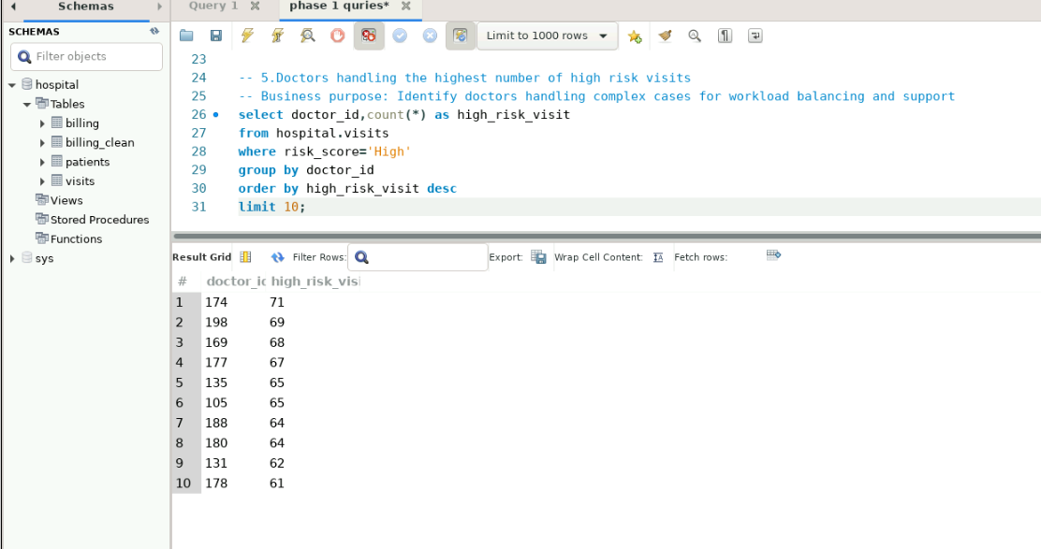
- Financial Analysis
  - Retrieve the top 10 insurance providers by total billed amount.
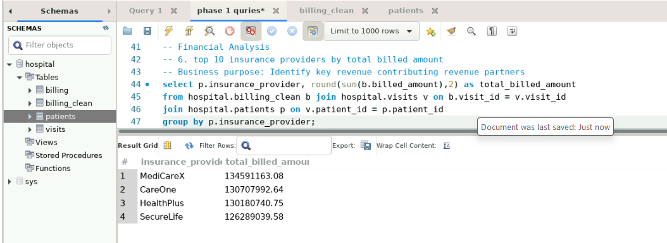
  - Identify the top 5 insurance providers with the highest claim rejection rate.
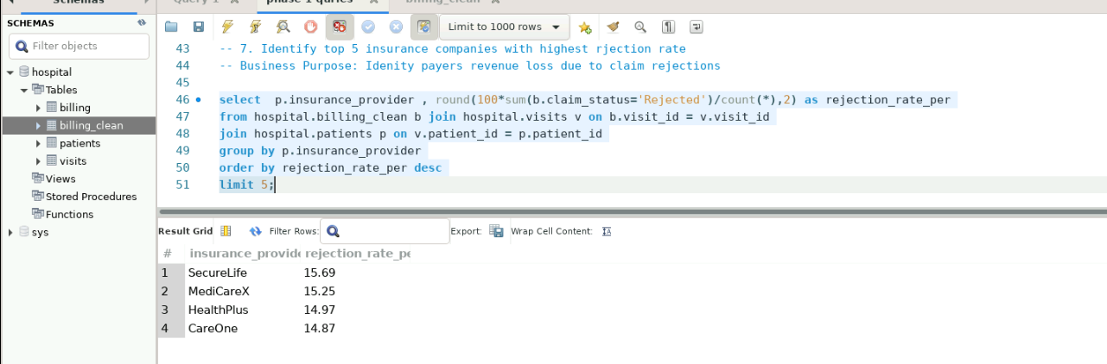

  - Find the average payment delay (payment_days) by insurance provider.
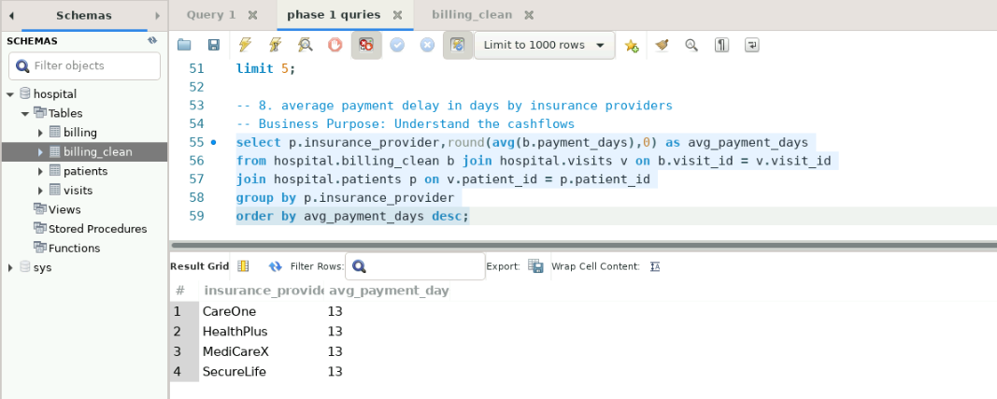

  - Calculate the revenue realization ratio (approved_amount / billed_amount) by department.
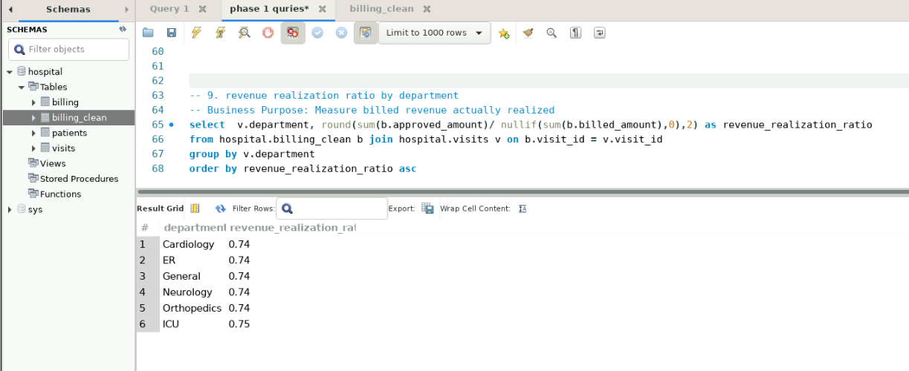

  - Identify visits where billed_amount is high but approved_amount is zero or missing.
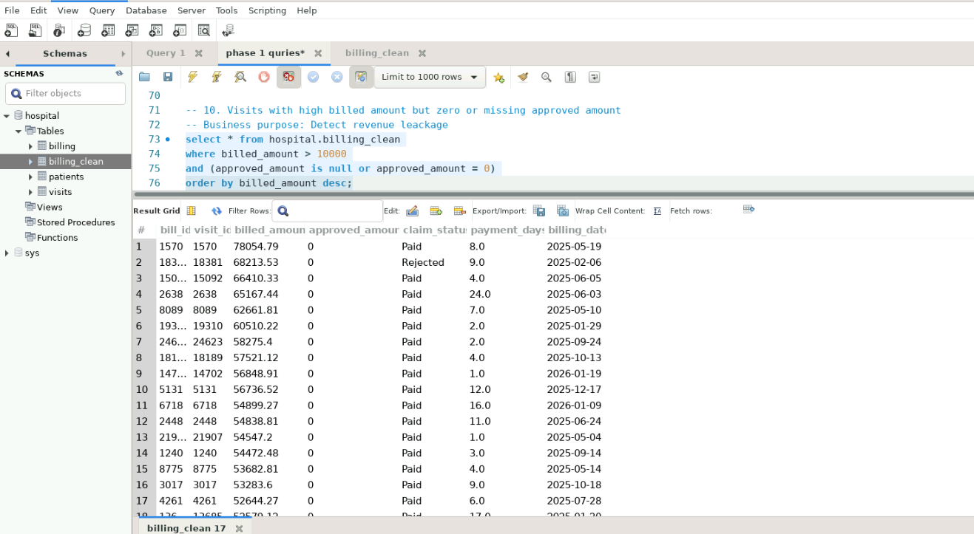

- Data Quality and Integrity Checks
  - Detect visits that do not have a corresponding billing record.
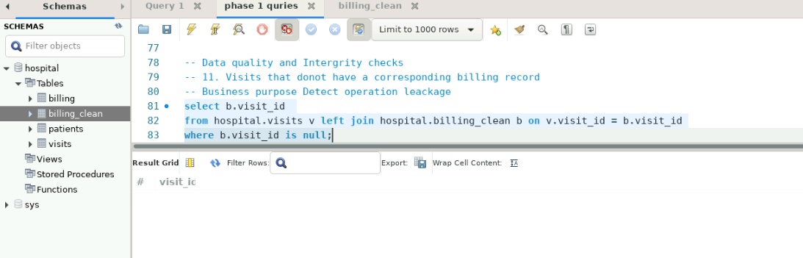

  - Detect billing records that do not have a corresponding visit.
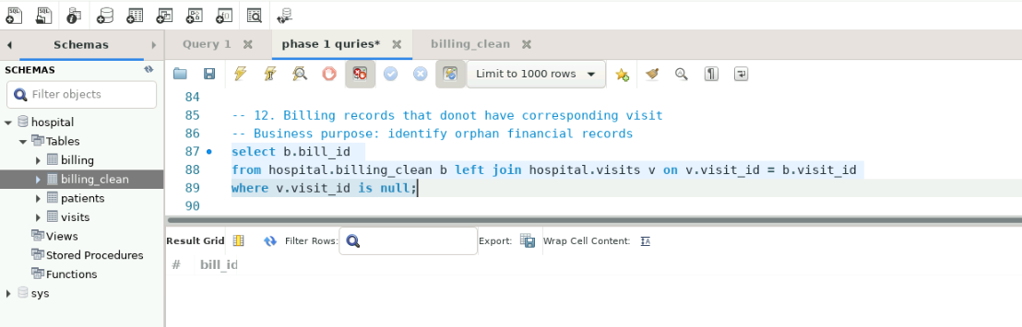

  - Identify patients with duplicate patient_id values.
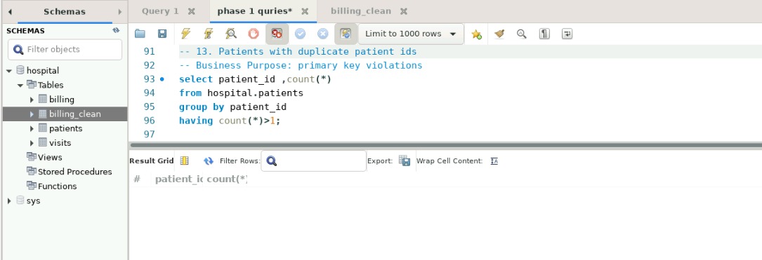

  - Find records with missing or invalid length_of_stay_hours or payment_days.
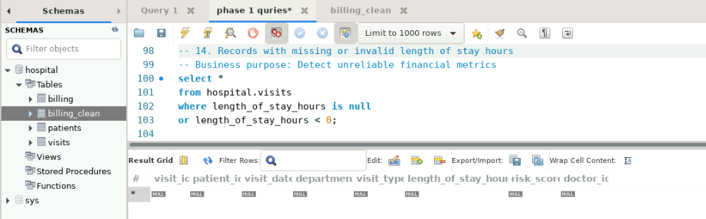

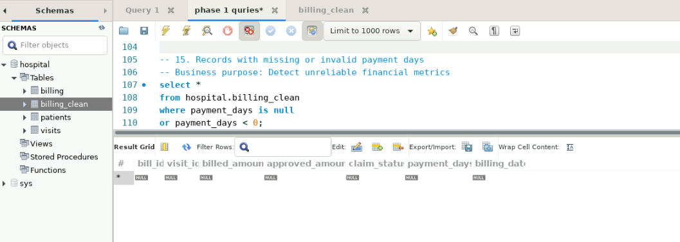

  - Identify visits linked to patients with missing insurance provider information.
