msant@vm-ttdb-103:~$ echo $DISPLAY

localhost:10.0

msant@vm-ttdb-103:~$ xauth list

vm-ttdb-103/unix:10 MIT-MAGIC-COOKIE-1 3d9ab027c2de9e5a452be3a1c7ba1a46

msant@vm-ttdb-103:~$ pbrun su - oracle

|-----------------------------------------------------------------|

| This system is for the use of authorized users only. |

| Individuals using this computer system within, or in |

| excess of their authority, are subject to having all of their |

| activities on this system monitored and recorded by system |

| personnel. |

| This elevated sesssion is recorded. |

|-----------------------------------------------------------------|

Interactive session, need password for msant:

Password:

Last login: Mon Aug 2 11:40:08 CEST 2021 on pts/6

oracle@vm-ttdb-103:~$

oracle@vm-ttdb-103:~$

oracle@vm-ttdb-103:~$ xauth

Using authority file /home/oracle/.Xauthority

xauth>

xauth> list

vm-ttdb-103/unix:10 MIT-MAGIC-COOKIE-1 bd74e430be312babbbe7dbf5ab892df7

vm-ttdb-103/unix:11 MIT-MAGIC-COOKIE-1 fb9a279a549e8fb7bbb579a97e40c435

xauth> remove vm-ttdb-103/unix:10

1 entries removed

xauth> list

vm-ttdb-103/unix:11 MIT-MAGIC-COOKIE-1 fb9a279a549e8fb7bbb579a97e40c435

xauth> add vm-ttdb-103/unix:10 MIT-MAGIC-COOKIE-1 3d9ab027c2de9e5a452be3a1c7ba1a46

xauth> list

vm-ttdb-103/unix:11 MIT-MAGIC-COOKIE-1 fb9a279a549e8fb7bbb579a97e40c435

vm-ttdb-103/unix:10 MIT-MAGIC-COOKIE-1 3d9ab027c2de9e5a452be3a1c7ba1a46

xauth>

xauth>

xauth>

xauth> exit

Writing authority file /home/oracle/.Xauthority

oracle@vm-ttdb-103:~$ echo $DISPLAY

oracle@vm-ttdb-103:~$ export DISPLAY=localhost:10.0

oracle@vm-ttdb-103:~$

oracle@vm-ttdb-103:~$

oracle@vm-ttdb-103:~$ xclock

oracle@vm-ttdb-103:~$ cd /u01/app/oracle/product/19.3.0/grid/

oracle@vm-ttdb-103:/u01/app/oracle/product/19.3.0/grid$ ./gridSetup.sh

Launching Oracle Grid Infrastructure Setup Wizard...

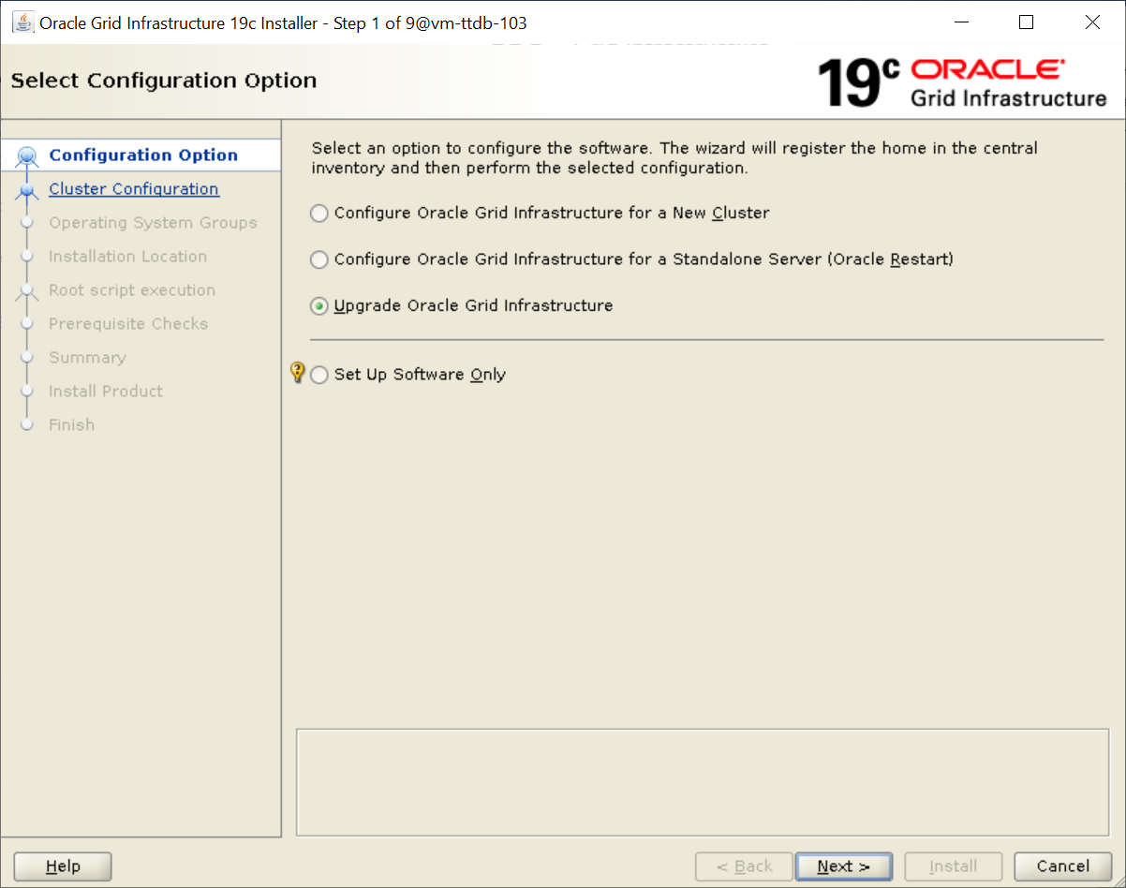

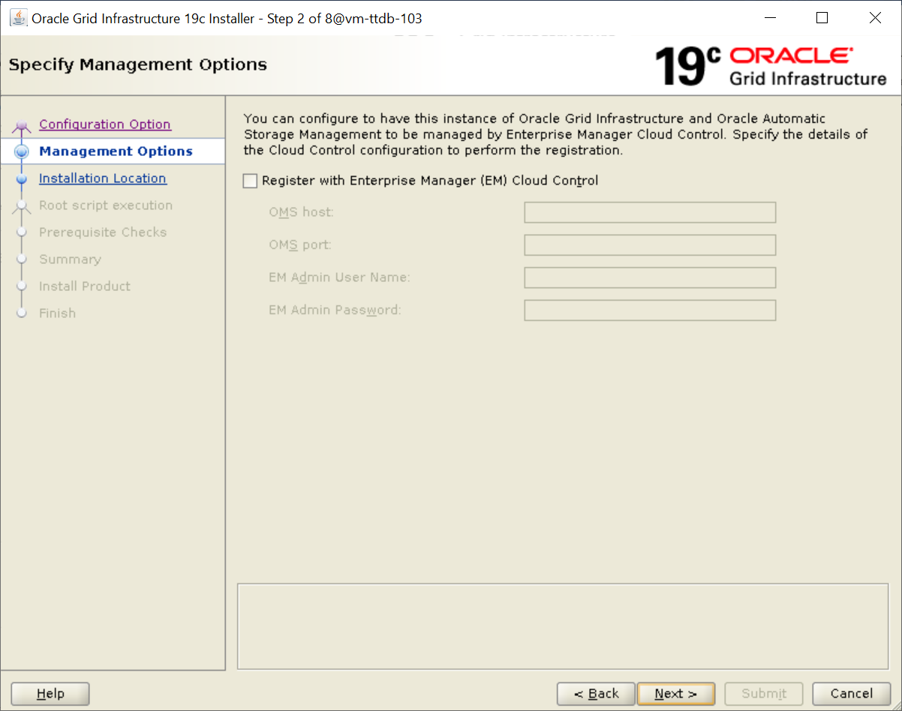

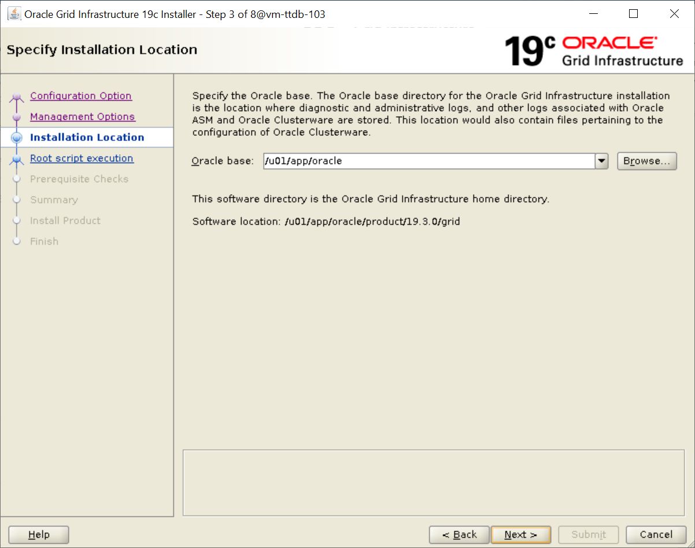

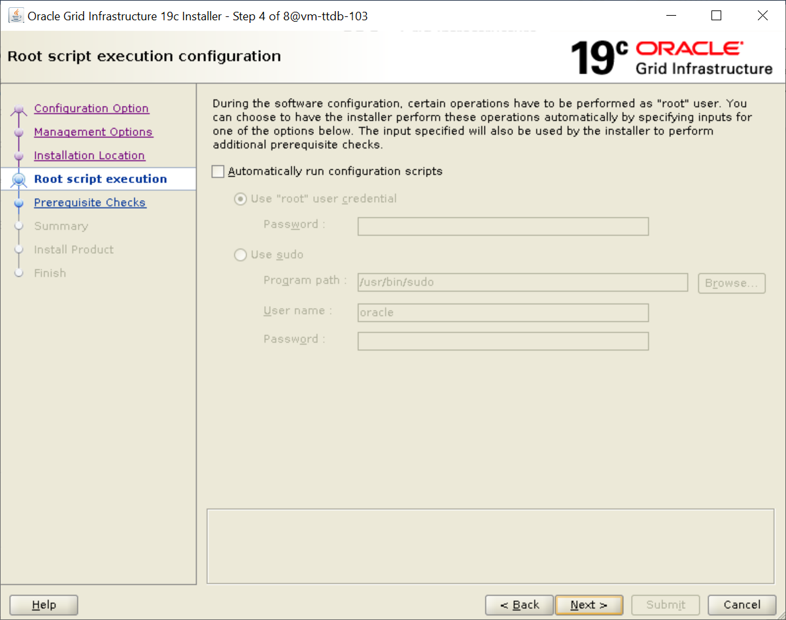

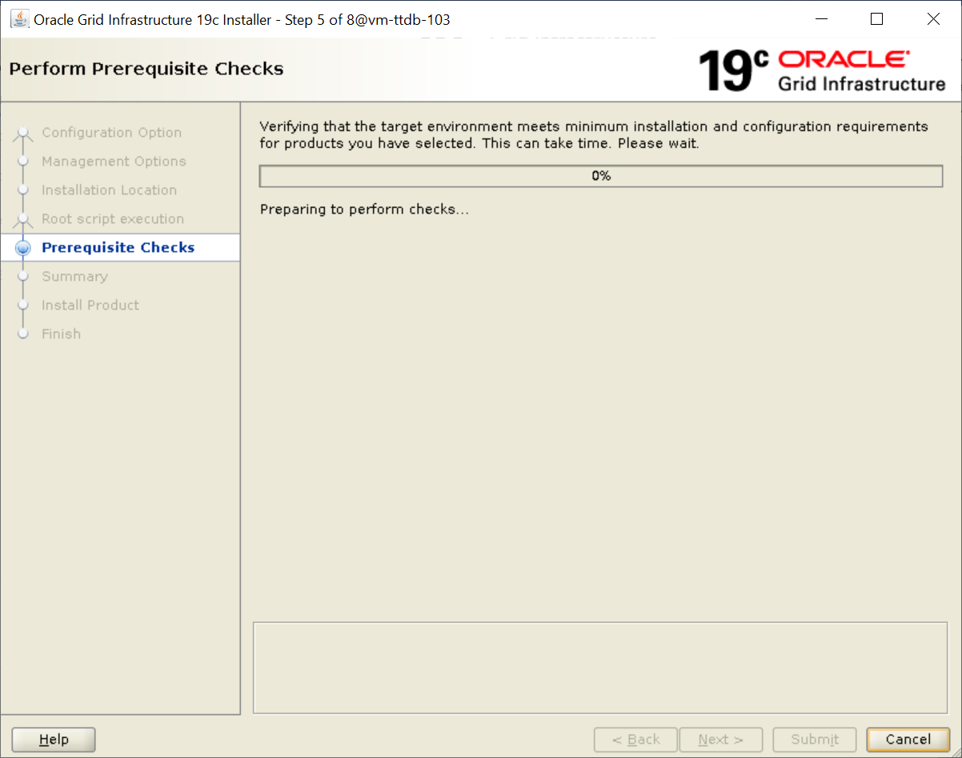

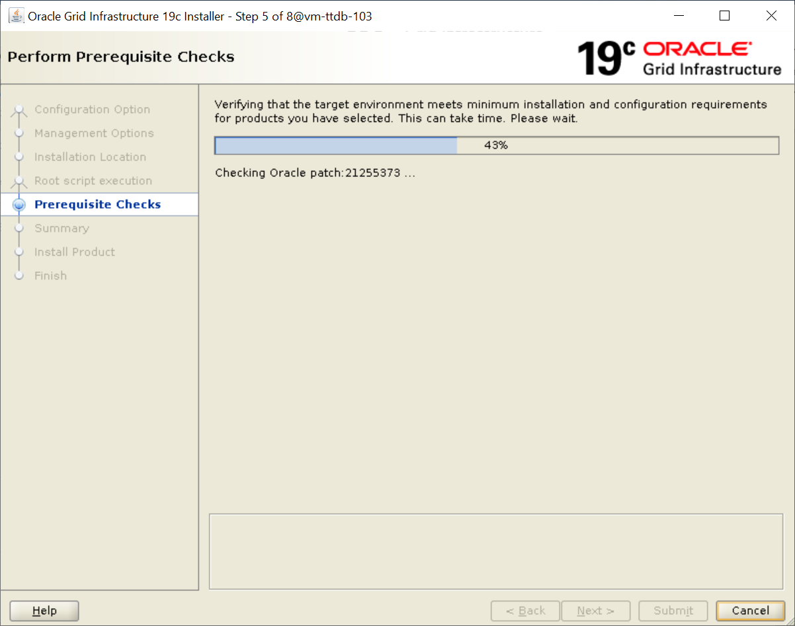

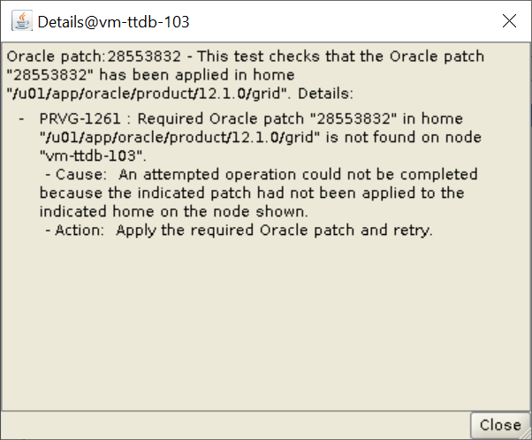

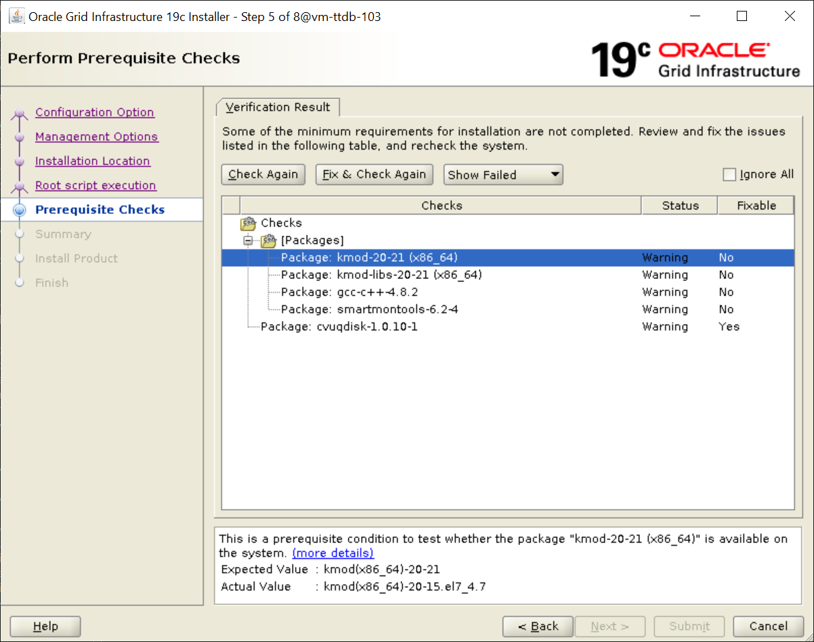

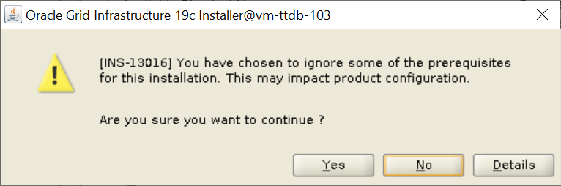

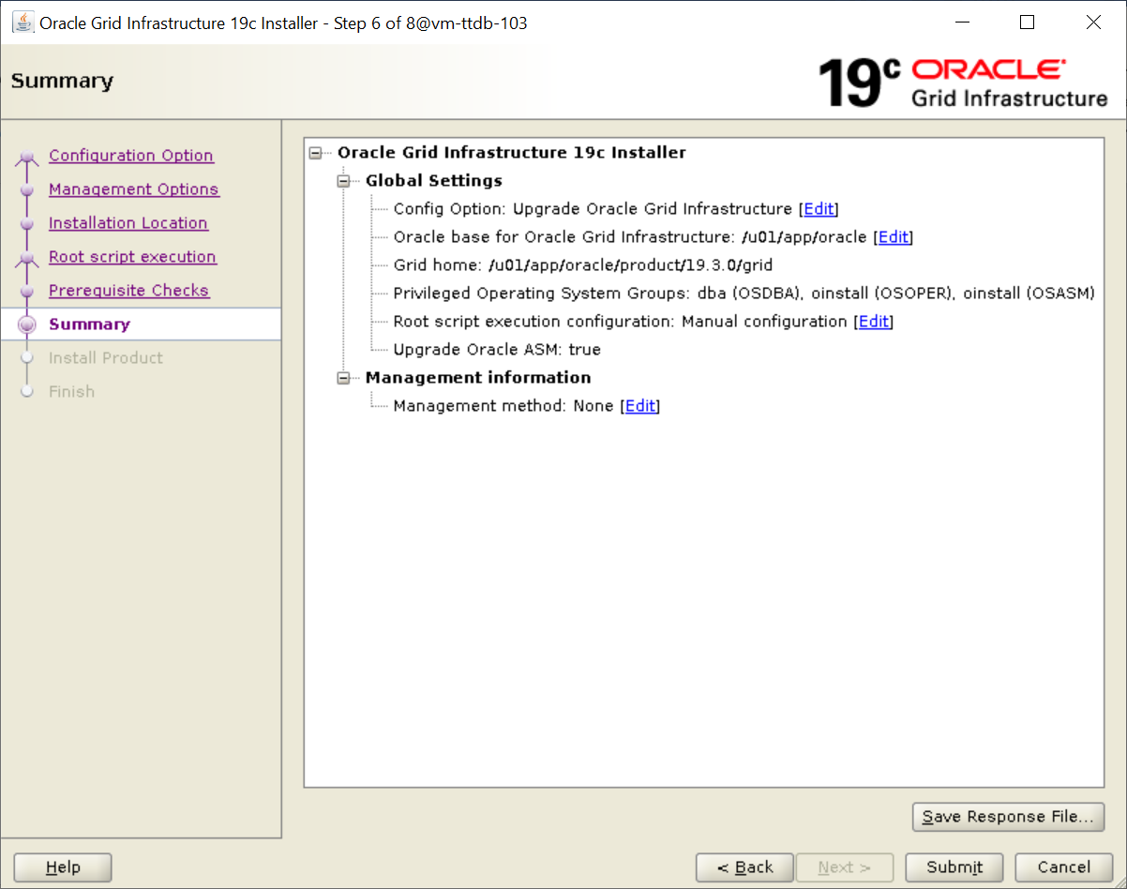

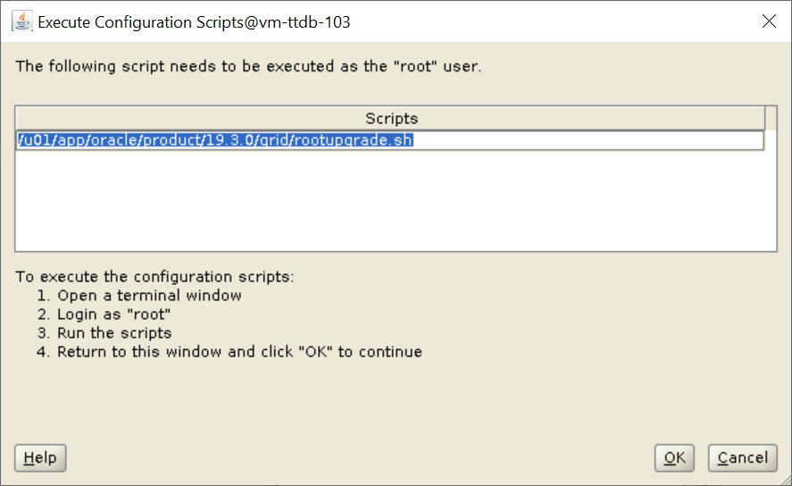

root@vm-ttdb-103:/u01/app/sw/32495126# /tmp/GridSetupActions2021-08-09_06-05-24PM/CVU_19.0.0.0.0_oracle/runfixup.sh

All Fix-up operations were completed successfully.

root@vm-ttdb-103:/u01/app/sw/32495126# /u01/app/oracle/product/19.3.0/grid/rootupgrade.sh

Performing root user operation.

The following environment variables are set as:

ORACLE_OWNER= oracle

ORACLE_HOME= /u01/app/oracle/product/19.3.0/grid

Enter the full pathname of the local bin directory: [/usr/local/bin]:

The contents of "dbhome" have not changed. No need to overwrite.

The file "oraenv" already exists in /usr/local/bin. Overwrite it? (y/n)

[n]: y

Copying oraenv to /usr/local/bin ...

The file "coraenv" already exists in /usr/local/bin. Overwrite it? (y/n)

[n]:

Entries will be added to the /etc/oratab file as needed by

Database Configuration Assistant when a database is created

Finished running generic part of root script.

Now product-specific root actions will be performed.

Using configuration parameter file: /u01/app/oracle/product/19.3.0/grid/crs/install/crsconfig_params

The log of current session can be found at:

/u01/app/oracle/crsdata/vm-ttdb-103/crsconfig/roothas_2021-08-09_07-50-24PM.log

2021/08/09 19:50:58 CLSRSC-595: Executing upgrade step 1 of 12: 'UpgPrechecks'.

2021/08/09 19:51:05 CLSRSC-363: User ignored prerequisites during installation

2021/08/09 19:51:14 CLSRSC-595: Executing upgrade step 2 of 12: 'GetOldConfig'.

2021/08/09 19:51:21 CLSRSC-595: Executing upgrade step 3 of 12: 'GenSiteGUIDs'.

2021/08/09 19:51:22 CLSRSC-595: Executing upgrade step 4 of 12: 'SetupOSD'.

2021/08/09 19:51:22 CLSRSC-595: Executing upgrade step 5 of 12: 'PreUpgrade'.

ASM has been upgraded and started successfully.

2021/08/09 19:53:56 CLSRSC-595: Executing upgrade step 6 of 12: 'UpgradeAFD'.

2021/08/09 19:53:59 CLSRSC-595: Executing upgrade step 7 of 12: 'UpgradeOLR'.

clscfg: EXISTING configuration version 0 detected.

Creating OCR keys for user 'oracle', privgrp 'oinstall'..

Operation successful.

2021/08/09 19:54:07 CLSRSC-595: Executing upgrade step 8 of 12: 'UpgradeOCR'.

LOCAL ONLY MODE

Successfully accumulated necessary OCR keys.

Creating OCR keys for user 'root', privgrp 'root'..

Operation successful.

CRS-4664: Node vm-ttdb-103 successfully pinned.

2021/08/09 19:54:13 CLSRSC-595: Executing upgrade step 9 of 12: 'CreateOHASD'.

2021/08/09 19:54:17 CLSRSC-595: Executing upgrade step 10 of 12: 'ConfigOHASD'.

2021/08/09 19:54:18 CLSRSC-329: Replacing Clusterware entries in file 'oracle-ohasd.service'

2021/08/09 19:55:12 CLSRSC-595: Executing upgrade step 11 of 12: 'UpgradeSIHA'.

vm-ttdb-103 2021/08/09 19:58:16 /u01/app/oracle/crsdata/vm-ttdb-103/olr/backup_20210809_195816.olr 724960844

vm-ttdb-103 2016/11/01 13:59:37 /u01/app/oracle/product/12.1.0/grid/cdata/vm-ttdb-103/backup_20161101_135937.olr 3696455212

2021/08/09 19:58:17 CLSRSC-595: Executing upgrade step 12 of 12: 'InstallACFS'.

2021/08/09 20:06:14 CLSRSC-327: Successfully configured Oracle Restart for a standalone server

root@vm-ttdb-103:/u01/app/sw/32495126#

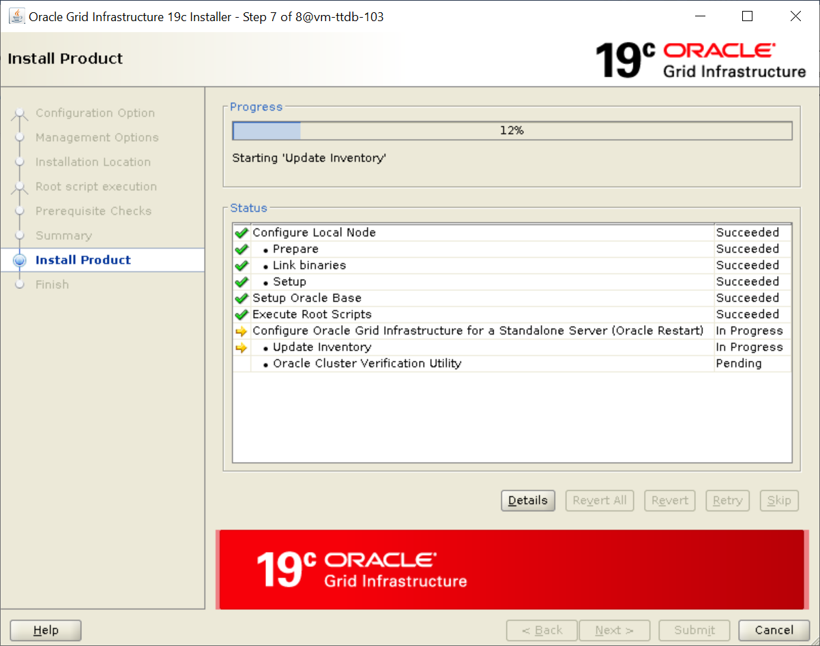

oracle@vm-ttdb-103:/u01/app/oracle/product/19.3.0/grid$ crsctl stat res -t

--------------------------------------------------------------------------------

Name Target State Server State details

--------------------------------------------------------------------------------

Local Resources

--------------------------------------------------------------------------------

ora.ARCH1.dg

ONLINE ONLINE vm-ttdb-103 STABLE

ora.DGRP1.dg

ONLINE ONLINE vm-ttdb-103 STABLE

ora.LISTENER.lsnr

ONLINE ONLINE vm-ttdb-103 STABLE

ora.asm

ONLINE ONLINE vm-ttdb-103 Started,STABLE

ora.ons

OFFLINE OFFLINE vm-ttdb-103 STABLE

--------------------------------------------------------------------------------

Cluster Resources

--------------------------------------------------------------------------------

ora.cssd

1 ONLINE ONLINE vm-ttdb-103 STABLE

ora.ctt103.db

1 OFFLINE OFFLINE Instance Shutdown,ST

ABLE

ora.diskmon

1 OFFLINE OFFLINE STABLE

ora.evmd

1 ONLINE ONLINE vm-ttdb-103 STABLE

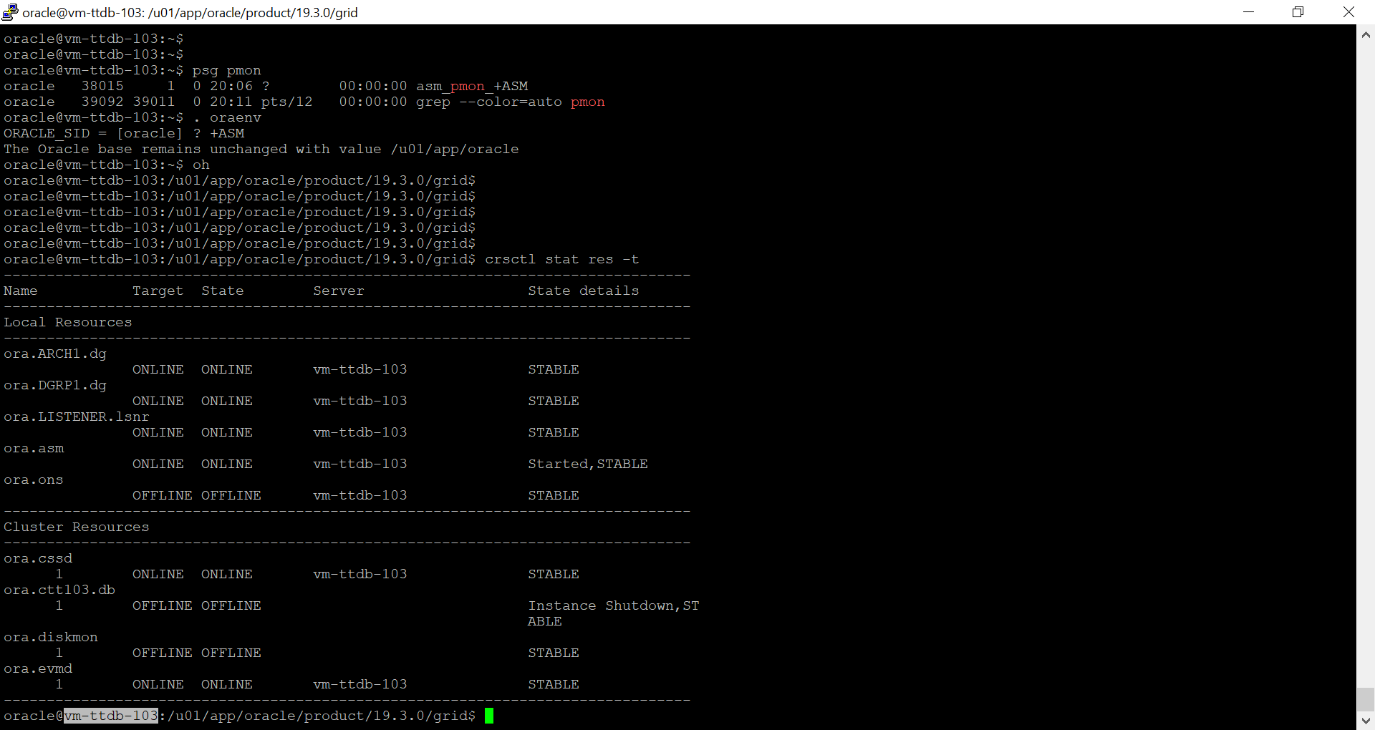’’’’

Database Binary Installation :

oracle@vm-ttdb-103:/u01/app/oracle/product/19.3.0/dbhome_1$

oracle@vm-ttdb-103:/u01/app/oracle/product/19.3.0/dbhome_1$ unzip /u01/app/sw/LINUX.X64_193000_db_home.zip^C

[oracle@vm-ttdb-103:/u01/app/oracle/product/19.3.0/dbhome_1$](mailto:oracle@vm-ttdb-103:/u01/app/oracle/product/19.3.0/dbhome_1$)

oracle@vm-ttdb-103:/u01/app/oracle/product/19.3.0/dbhome_1$ ./runInstaller

Launching Oracle Database Setup Wizard...

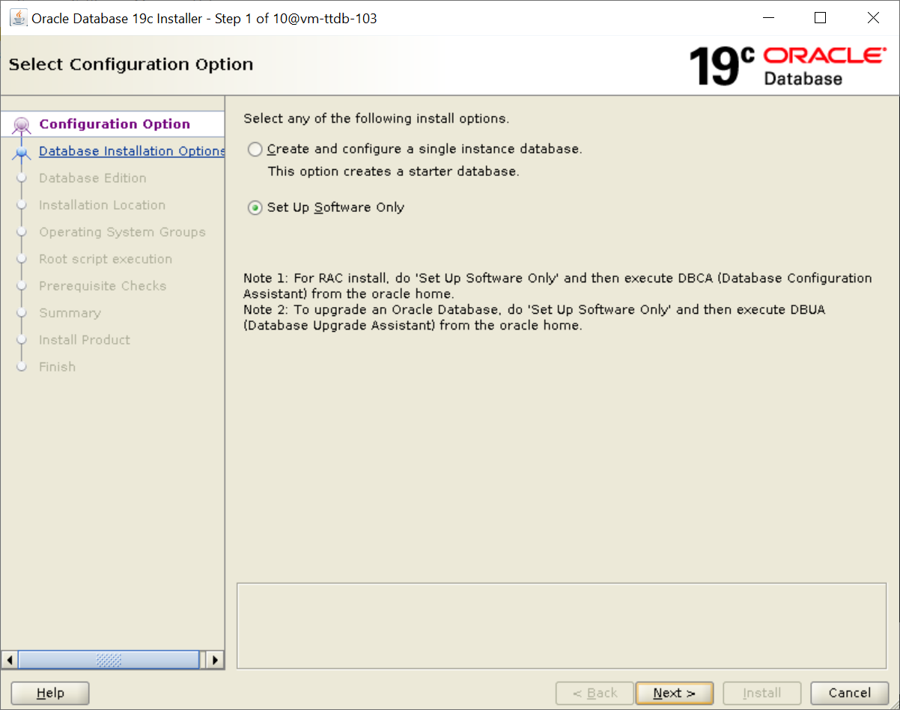

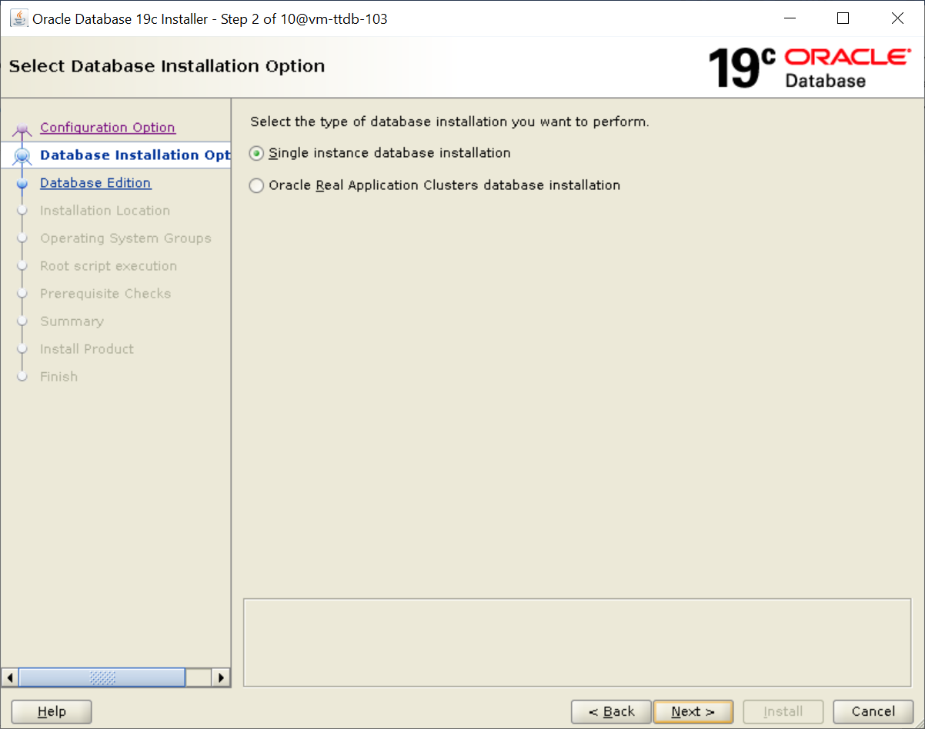

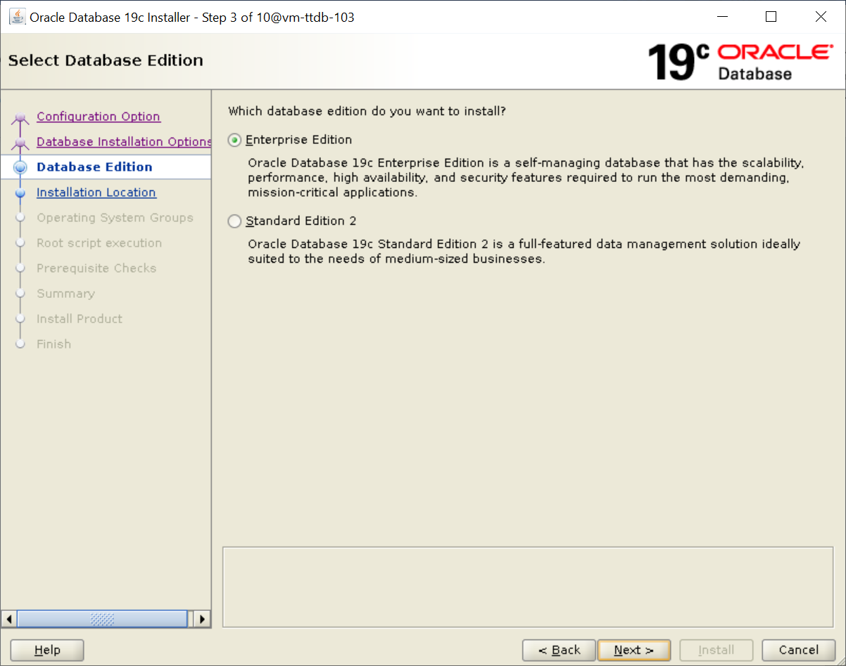

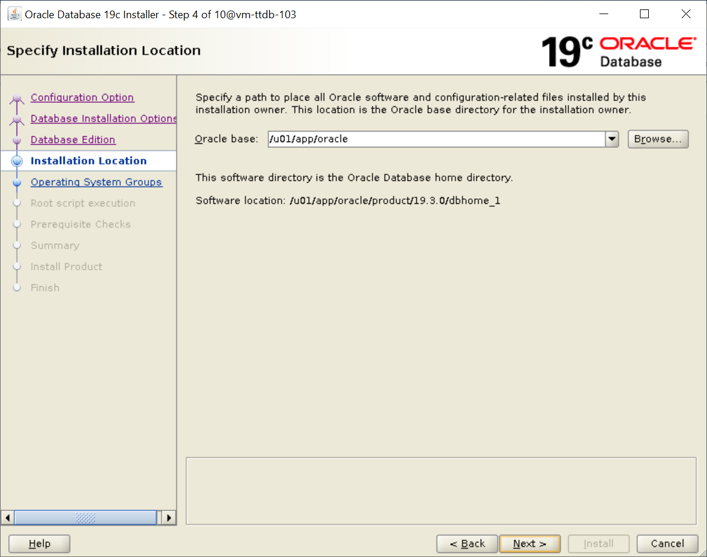

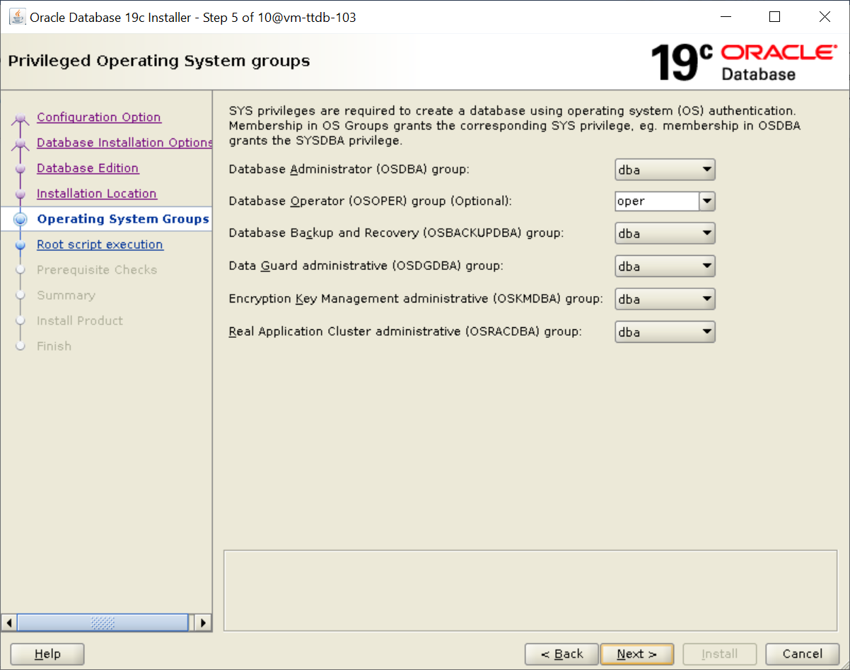

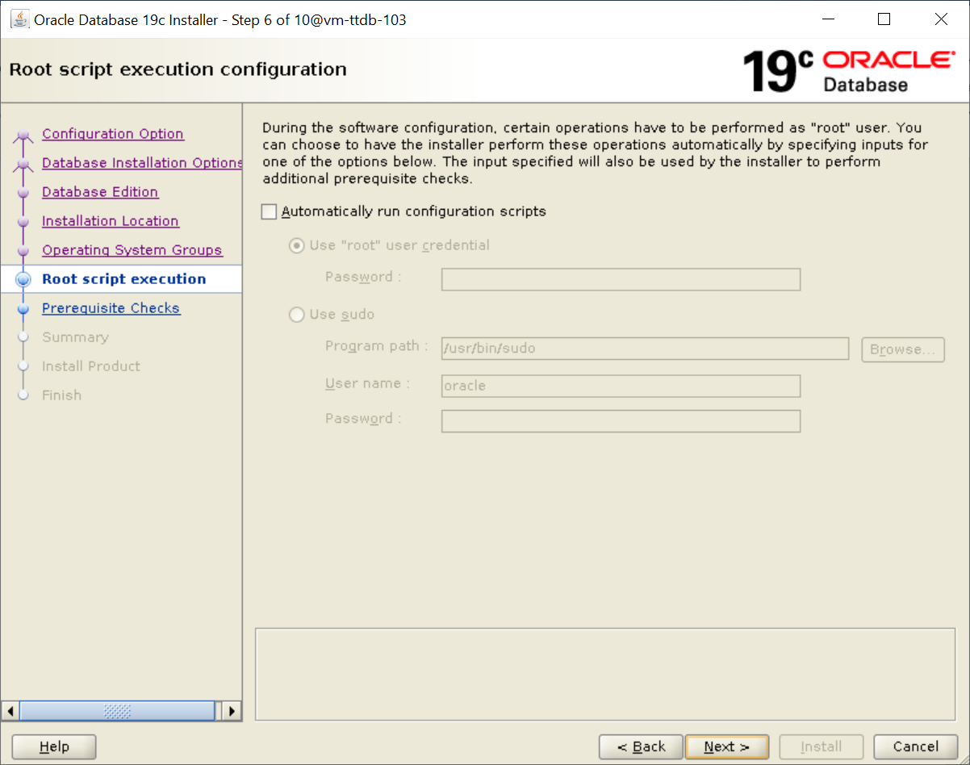

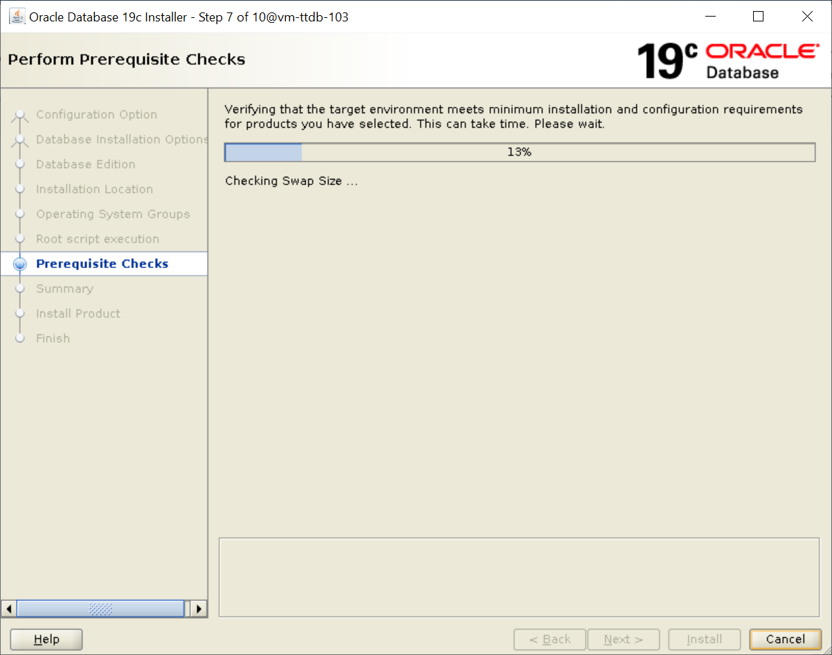

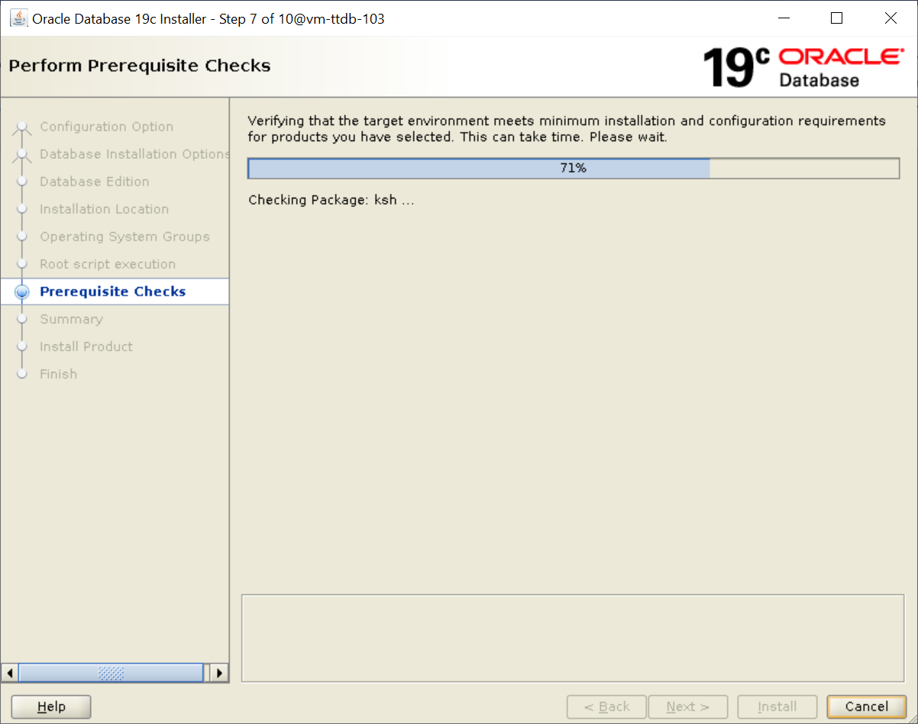

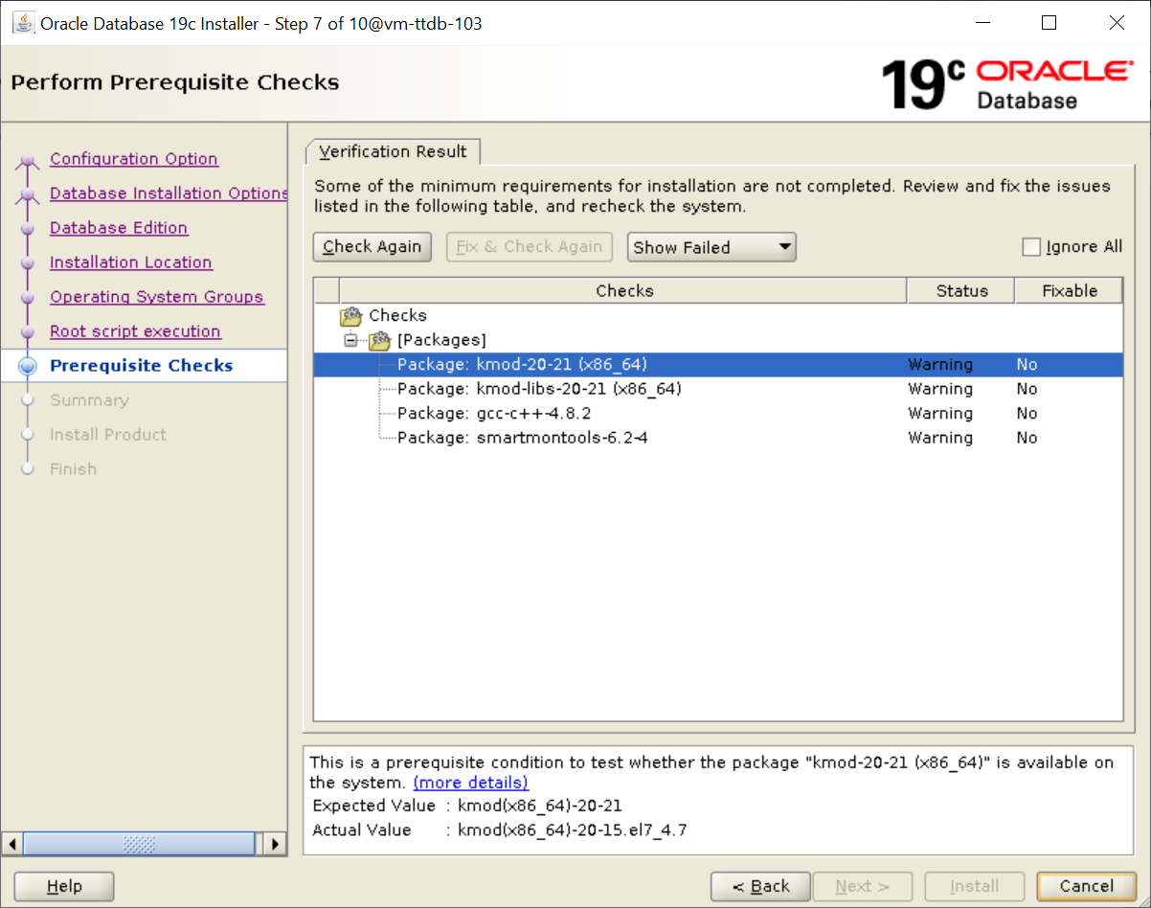

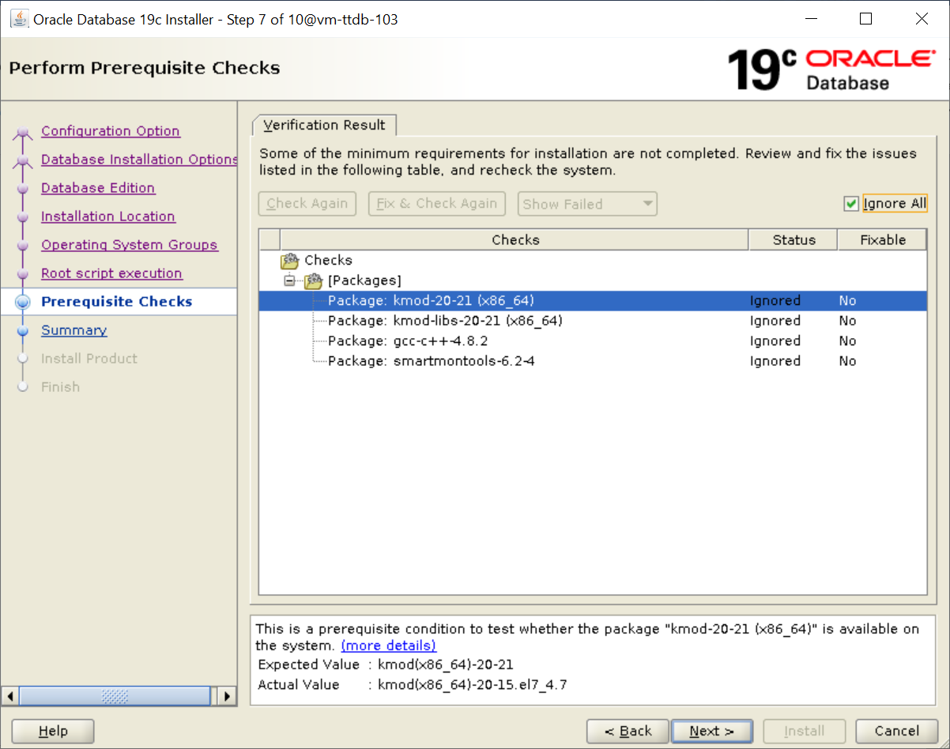

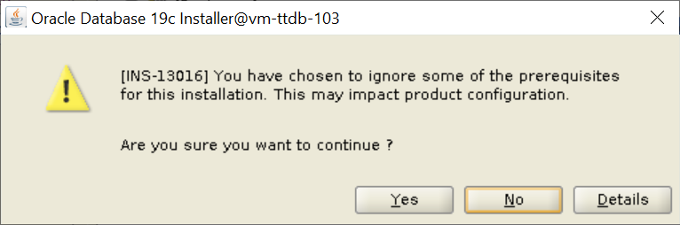

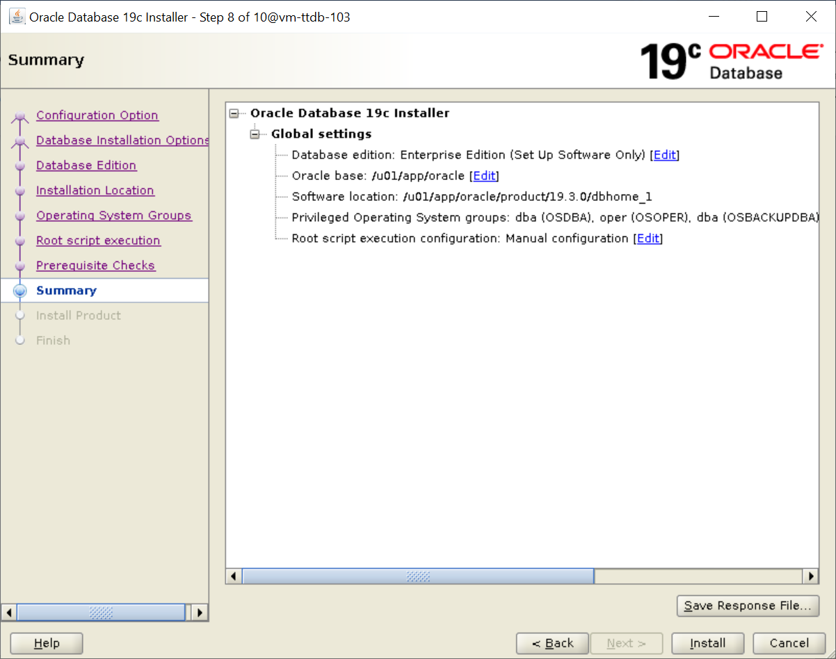

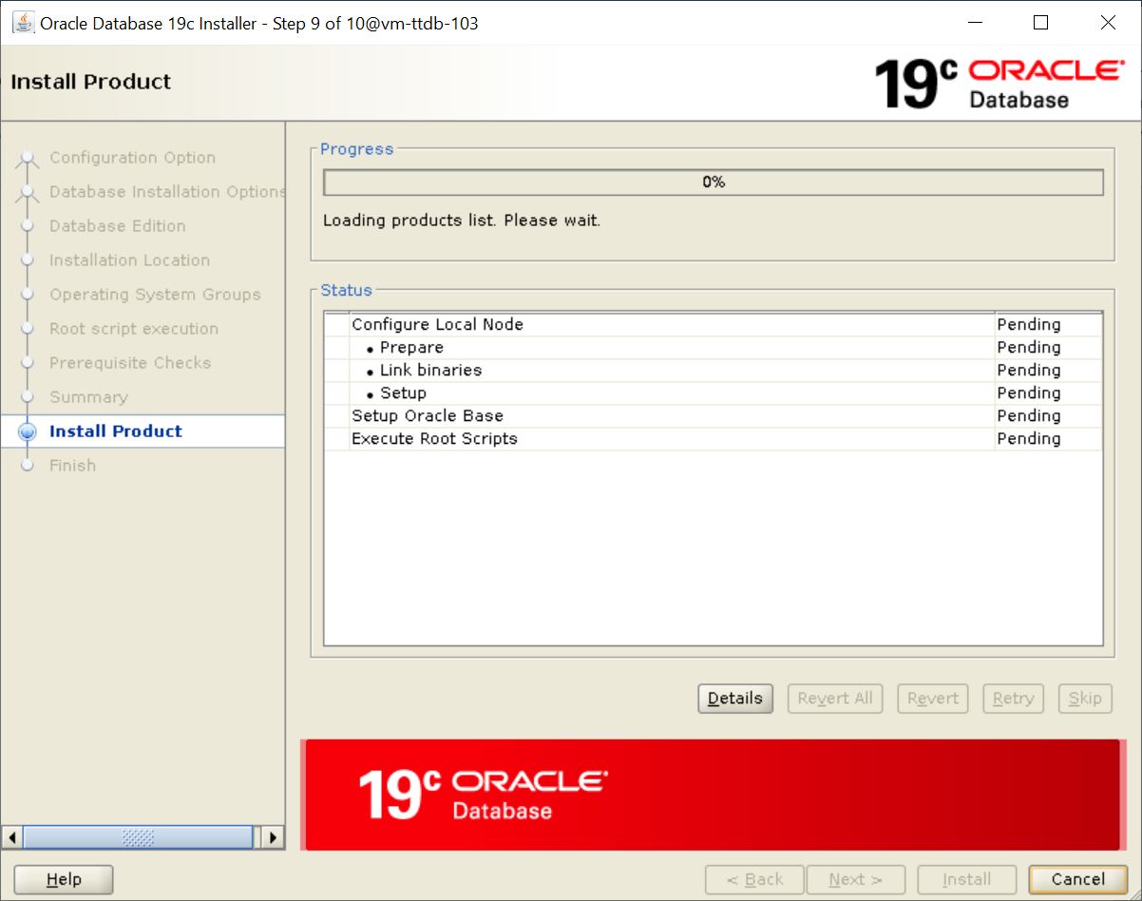

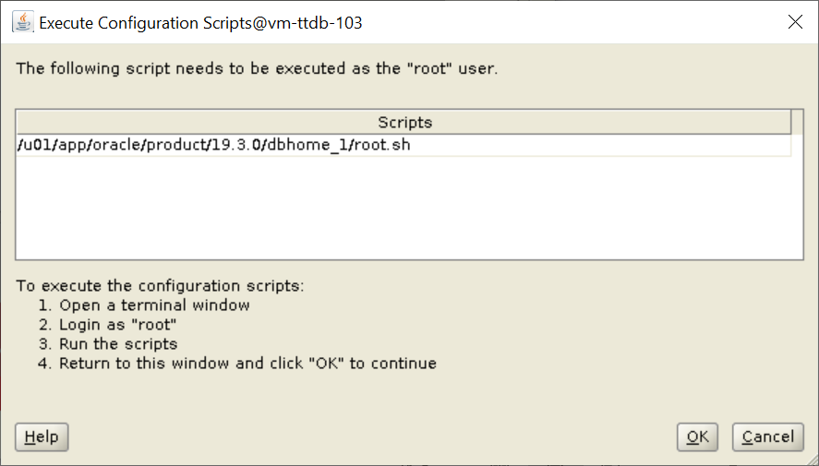

root@vm-ttdb-103:/u01/app/sw/32895426# /u01/app/oracle/product/19.3.0/dbhome_1/root.sh

Performing root user operation.

The following environment variables are set as:

ORACLE_OWNER= oracle

ORACLE_HOME= /u01/app/oracle/product/19.3.0/dbhome_1

Enter the full pathname of the local bin directory: [/usr/local/bin]:

The contents of "dbhome" have not changed. No need to overwrite.

The contents of "oraenv" have not changed. No need to overwrite.

The file "coraenv" already exists in /usr/local/bin. Overwrite it? (y/n)

[n]:

Entries will be added to the /etc/oratab file as needed by

Database Configuration Assistant when a database is created

Finished running generic part of root script.

Now product-specific root actions will be performed.

Oracle Trace File Analyzer (TFA - Standalone Mode) is available at :

/u01/app/oracle/product/19.3.0/dbhome_1/bin/tfactl

Note :

1. tfactl will use TFA Service if that service is running and user has been granted access

2. tfactl will configure TFA Standalone Mode only if user has no access to TFA Service or TFA is not installed

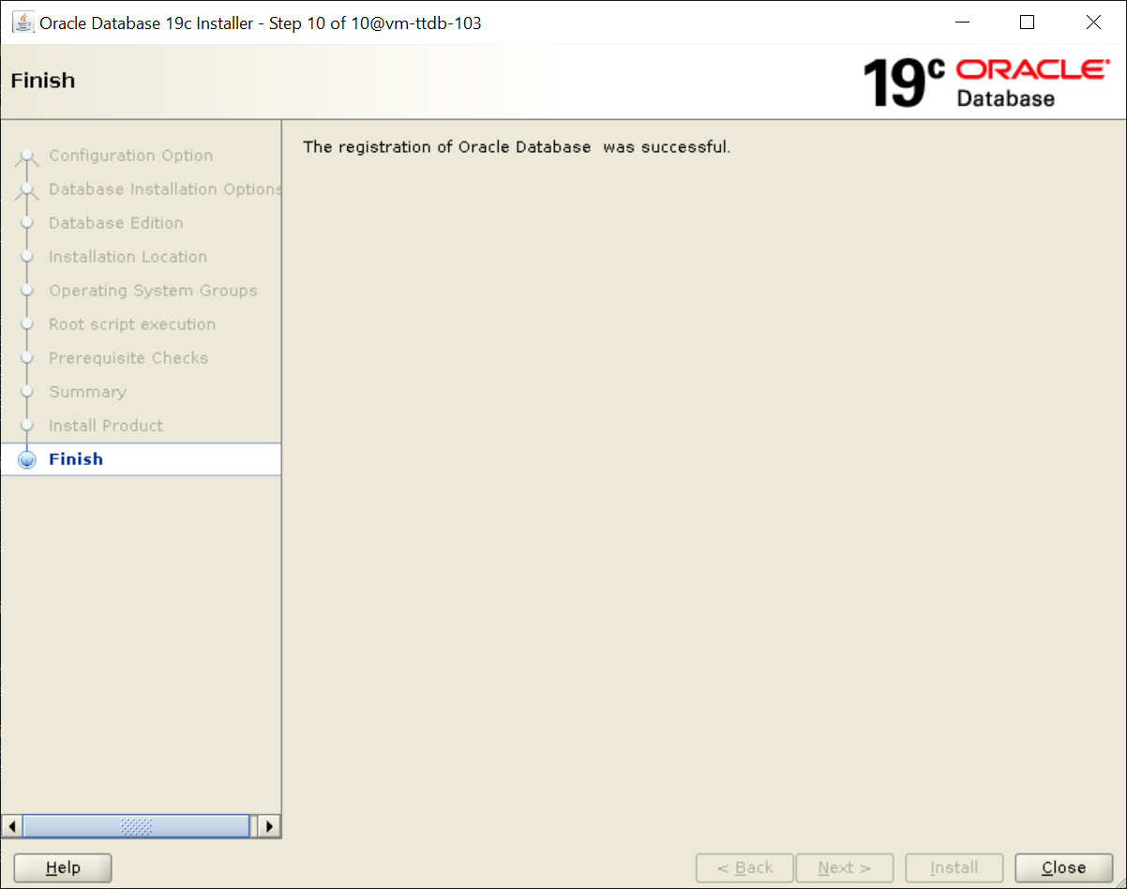

**Patching :**

oracle@vm-ttdb-103:/u01/app/sw/32895426$ /u01/app/oracle/product/19.3.0/grid/OPatch/opatch prereq CheckConflictAgainstOHWithDetail -phBaseDir /u01/app/sw/32895426/32904851

Oracle Interim Patch Installer version 12.2.0.1.25

Copyright (c) 2021, Oracle Corporation. All rights reserved.

PREREQ session

Oracle Home : /u01/app/oracle/product/19.3.0/grid

Central Inventory : /u01/app/oraInventory

from : /u01/app/oracle/product/19.3.0/grid/oraInst.loc

OPatch version : 12.2.0.1.25

OUI version : 12.2.0.7.0

Log file location : /u01/app/oracle/product/19.3.0/grid/cfgtoollogs/opatch/opatch2021-08-10_12-46-48PM_1.log

Invoking prereq "checkconflictagainstohwithdetail"

Prereq "checkConflictAgainstOHWithDetail" passed.

OPatch succeeded.

oracle@vm-ttdb-103:/u01/app/sw/32895426$ /u01/app/oracle/product/19.3.0/grid/OPatch/opatch prereq CheckConflictAgainstOHWithDetail -phBaseDir /u01/app/sw/32895426/32916816

Oracle Interim Patch Installer version 12.2.0.1.25

Copyright (c) 2021, Oracle Corporation. All rights reserved.

PREREQ session

Oracle Home : /u01/app/oracle/product/19.3.0/grid

Central Inventory : /u01/app/oraInventory

from : /u01/app/oracle/product/19.3.0/grid/oraInst.loc

OPatch version : 12.2.0.1.25

OUI version : 12.2.0.7.0

Log file location : /u01/app/oracle/product/19.3.0/grid/cfgtoollogs/opatch/opatch2021-08-10_12-47-10PM_1.log

Invoking prereq "checkconflictagainstohwithdetail"

Prereq "checkConflictAgainstOHWithDetail" passed.

OPatch succeeded.

oracle@vm-ttdb-103:/u01/app/sw/32895426$ /u01/app/oracle/product/19.3.0/grid/OPatch/opatch prereq CheckConflictAgainstOHWithDetail -phBaseDir /u01/app/sw/32895426/32915586

Oracle Interim Patch Installer version 12.2.0.1.25

Copyright (c) 2021, Oracle Corporation. All rights reserved.

PREREQ session

Oracle Home : /u01/app/oracle/product/19.3.0/grid

Central Inventory : /u01/app/oraInventory

from : /u01/app/oracle/product/19.3.0/grid/oraInst.loc

OPatch version : 12.2.0.1.25

OUI version : 12.2.0.7.0

Log file location : /u01/app/oracle/product/19.3.0/grid/cfgtoollogs/opatch/opatch2021-08-10_12-47-24PM_1.log

Invoking prereq "checkconflictagainstohwithdetail"

Prereq "checkConflictAgainstOHWithDetail" passed.

OPatch succeeded.

oracle@vm-ttdb-103:/u01/app/sw/32895426$ /u01/app/oracle/product/19.3.0/grid/OPatch/opatch prereq CheckConflictAgainstOHWithDetail -phBaseDir /u01/app/sw/32895426/32918050

Oracle Interim Patch Installer version 12.2.0.1.25

Copyright (c) 2021, Oracle Corporation. All rights reserved.

PREREQ session

Oracle Home : /u01/app/oracle/product/19.3.0/grid

Central Inventory : /u01/app/oraInventory

from : /u01/app/oracle/product/19.3.0/grid/oraInst.loc

OPatch version : 12.2.0.1.25

OUI version : 12.2.0.7.0

Log file location : /u01/app/oracle/product/19.3.0/grid/cfgtoollogs/opatch/opatch2021-08-10_12-47-36PM_1.log

Invoking prereq "checkconflictagainstohwithdetail"

Prereq "checkConflictAgainstOHWithDetail" passed.

OPatch succeeded.

oracle@vm-ttdb-103:/u01/app/sw/32895426$

root@vm-ttdb-103:/u01/app/sw/32895426# /u01/app/oracle/product/19.3.0/grid/OPatch/opatchauto apply

OPatchauto session is initiated at Tue Aug 10 13:53:29 2021

System initialization log file is /u01/app/oracle/product/19.3.0/grid/cfgtoollogs/opatchautodb/systemconfig2021-08-10_01-53-37PM.log.

Session log file is /u01/app/oracle/product/19.3.0/grid/cfgtoollogs/opatchauto/opatchauto2021-08-10_01-53-50PM.log

The id for this session is UP8H

Executing OPatch prereq operations to verify patch applicability on home /u01/app/oracle/product/19.3.0/grid

Patch applicability verified successfully on home /u01/app/oracle/product/19.3.0/grid

Executing patch validation checks on home /u01/app/oracle/product/19.3.0/grid

Patch validation checks successfully completed on home /u01/app/oracle/product/19.3.0/grid

Performing prepatch operations on CRS - bringing down CRS service on home /u01/app/oracle/product/19.3.0/grid

Prepatch operation log file location: /u01/app/oracle/crsdata/vm-ttdb-103/crsconfig/hapatch_2021-08-10_01-54-35PM.log

CRS service brought down successfully on home /u01/app/oracle/product/19.3.0/grid

Start applying binary patch on home /u01/app/oracle/product/19.3.0/grid

Binary patch applied successfully on home /u01/app/oracle/product/19.3.0/grid

Performing postpatch operations on CRS - starting CRS service on home /u01/app/oracle/product/19.3.0/grid

Postpatch operation log file location: /u01/app/oracle/crsdata/vm-ttdb-103/crsconfig/hapatch_2021-08-10_02-06-19PM.log

CRS service started successfully on home /u01/app/oracle/product/19.3.0/grid

OPatchAuto successful.

--------------------------------Summary--------------------------------

Patching is completed successfully. Please find the summary as follows:

Host:vm-ttdb-103

SIHA Home:/u01/app/oracle/product/19.3.0/grid

Version:19.0.0.0.0

Summary:

==Following patches were SUCCESSFULLY applied:

Patch: /u01/app/sw/32895426/32585572

Log: /u01/app/oracle/product/19.3.0/grid/cfgtoollogs/opatchauto/core/opatch/opatch2021-08-10_13-55-11PM_1.log

Patch: /u01/app/sw/32895426/32904851

Log: /u01/app/oracle/product/19.3.0/grid/cfgtoollogs/opatchauto/core/opatch/opatch2021-08-10_13-55-11PM_1.log

Patch: /u01/app/sw/32895426/32915586

Log: /u01/app/oracle/product/19.3.0/grid/cfgtoollogs/opatchauto/core/opatch/opatch2021-08-10_13-55-11PM_1.log

Patch: /u01/app/sw/32895426/32916816

Log: /u01/app/oracle/product/19.3.0/grid/cfgtoollogs/opatchauto/core/opatch/opatch2021-08-10_13-55-11PM_1.log

Patch: /u01/app/sw/32895426/32918050

Log: /u01/app/oracle/product/19.3.0/grid/cfgtoollogs/opatchauto/core/opatch/opatch2021-08-10_13-55-11PM_1.log

Following homes are skipped during patching as patches are not applicable:

/u01/app/oracle/product/12.1.0/dbhome_1

OPatchauto session completed at Tue Aug 10 14:08:16 2021

Time taken to complete the session 14 minutes, 49 seconds

root@vm-ttdb-103:/u01/app/sw/32895426#

root@vm-ttdb-103:/u01/app/sw/32895426# /u01/app/oracle/product/19.3.0/dbhome_1/OPatch/opatchauto apply -oh /u01/app/oracle/product/19.3.0/dbhome_1

OPatchauto session is initiated at Tue Aug 10 14:13:20 2021

System initialization log file is /u01/app/oracle/product/19.3.0/dbhome_1/cfgtoollogs/opatchautodb/systemconfig2021-08-10_02-13-26PM.log.

Session log file is /u01/app/oracle/product/19.3.0/dbhome_1/cfgtoollogs/opatchauto/opatchauto2021-08-10_02-13-33PM.log

The id for this session is 29UR

Executing OPatch prereq operations to verify patch applicability on home /u01/app/oracle/product/19.3.0/dbhome_1

Patch applicability verified successfully on home /u01/app/oracle/product/19.3.0/dbhome_1

Executing patch validation checks on home /u01/app/oracle/product/19.3.0/dbhome_1

Patch validation checks successfully completed on home /u01/app/oracle/product/19.3.0/dbhome_1

Verifying SQL patch applicability on home /u01/app/oracle/product/19.3.0/dbhome_1

No step execution required.........

Preparing to bring down database service on home /u01/app/oracle/product/19.3.0/dbhome_1

No step execution required.........

Bringing down database service on home /u01/app/oracle/product/19.3.0/dbhome_1

Database service successfully brought down on home /u01/app/oracle/product/19.3.0/dbhome_1

Start applying binary patch on home /u01/app/oracle/product/19.3.0/dbhome_1

Binary patch applied successfully on home /u01/app/oracle/product/19.3.0/dbhome_1

Starting database service on home /u01/app/oracle/product/19.3.0/dbhome_1

Database service successfully started on home /u01/app/oracle/product/19.3.0/dbhome_1

Preparing home /u01/app/oracle/product/19.3.0/dbhome_1 after database service restarted

No step execution required.........

Trying to apply SQL patch on home /u01/app/oracle/product/19.3.0/dbhome_1

No step execution required.........

OPatchAuto successful.

--------------------------------Summary--------------------------------

Patching is completed successfully. Please find the summary as follows:

Host:vm-ttdb-103

SIDB Home:/u01/app/oracle/product/19.3.0/dbhome_1

Summary:

==Following patches were SKIPPED:

Patch: /u01/app/sw/32895426/32915586

Reason: This patch is not applicable to this specified target type - "oracle_database"

Patch: /u01/app/sw/32895426/32585572

Reason: This patch is not applicable to this specified target type - "oracle_database"

Patch: /u01/app/sw/32895426/32918050

Reason: This patch is not applicable to this specified target type - "oracle_database"

==Following patches were SUCCESSFULLY applied:

Patch: /u01/app/sw/32895426/32904851

Log: /u01/app/oracle/product/19.3.0/dbhome_1/cfgtoollogs/opatchauto/core/opatch/opatch2021-08-10_14-14-36PM_1.log

Patch: /u01/app/sw/32895426/32916816

Log: /u01/app/oracle/product/19.3.0/dbhome_1/cfgtoollogs/opatchauto/core/opatch/opatch2021-08-10_14-14-36PM_1.log

OPatchauto session completed at Tue Aug 10 14:24:03 2021

Time taken to complete the session 10 minutes, 44 seconds

Pre checks Database upgrade :

oracle@vm-ttdb-103:/u01/app/oracle/product/19.3.0/dbhome_1$ /u01/app/oracle/product/12.1.0/dbhome_1/jdk/bin/java -jar /u01/app/oracle/product/19.3.0/dbhome_1/rdbms/admin/preupgrade.jar FILE TEXT DIR /u01/app/sw/log

==================

PREUPGRADE SUMMARY

==================

/u01/app/sw/log/preupgrade.log

/u01/app/sw/log/preupgrade_fixups.sql

/u01/app/sw/log/postupgrade_fixups.sql

Execute fixup scripts across the entire CDB:

Before upgrade:

1. Execute preupgrade fixups with the below command

$ORACLE_HOME/perl/bin/perl -I$ORACLE_HOME/perl/lib -I$ORACLE_HOME/rdbms/admin $ORACLE_HOME/rdbms/admin/catcon.pl -l /u01/app/sw/log/ -b preup_ctt103 /u01/app/sw/log/preupgrade_fixups.sql

2. Review logs under /u01/app/sw/log/

After the upgrade:

1. Execute postupgrade fixups with the below command

$ORACLE_HOME/perl/bin/perl -I$ORACLE_HOME/perl/lib -I$ORACLE_HOME/rdbms/admin $ORACLE_HOME/rdbms/admin/catcon.pl -l /u01/app/sw/log/ -b postup_ctt103 /u01/app/sw/log/postupgrade_fixups.sql

2. Review logs under /u01/app/sw/log/

Database Upgrade :

oracle@vm-ttdb-103:/u01/app/oracle/product/19.3.0/dbhome_1/bin$ ./dbua

Logs directory: /u01/app/oracle/cfgtoollogs/dbua/upgrade2021-08-10_03-14-41PM