Forecasting Architecture
AI-Powered Conversational Analytics Platform
Technical report series on the predictive-analytics subsystem
Table of Contents

Report 1 — Forecasting Architecture
AI-Powered Conversational Analytics Platform Technical report series on the predictive-analytics subsystem.

1. Purpose and scope
This report describes the structure of the forecasting subsystem: where it sits in the application, why it is isolated from the language model, and how a forecast travels from SQL result rows to rendered chart, narrative and export.
The mathematics of individual methods is deferred to Report 2 — Method Reference; detection rules to Report 3; parameter semantics to Report 4; evaluation to Report 5.

2. Design position

2.1 The separation of concerns
The platform combines a large language model with a statistical forecasting engine. The central architectural decision is that these two never overlap:
Concern | Owner | Rationale
Translating a question into SQL | Gemini | Natural-language understanding
Narrating descriptive results | Gemini | Fluent prose over observed rows
Computing every displayed figure | Python | Arithmetic must be verifiable
Producing forecasts | numpy / statsmodels | Predictions must be reproducible
Narrating forecasts | Python | See §2.2
The language model is never asked to predict a value, and never asked to restate one. This is not a performance optimisation; it is a correctness property. A generative model asked to report a number may round it, reformat it, or produce a plausible neighbour of it, and no output-side validation can reliably detect this. The defence is structural: the model is never given the opportunity.

2.2 Why the narrative is also computed
An intuitive design would compute the forecast numerically and then ask the model to describe it. This was rejected. Passing a forecast to a generative model for description reintroduces exactly the failure mode §2.1 eliminates — the model must restate figures it did not compute.
app/core/forecast_narrative.py therefore composes the predictive-analytics prose arithmetically from the ForecastResult and its TimeSeriesProfile. Consequences:
- Determinism. Identical inputs yield identical prose, so the text is assertable in unit tests (tests/test_forecast_narrative.py).
- Zero marginal cost. No API call, so forecasting is free at any volume.
- Offline capability. The predictive layer functions with no network.
- Export parity. report_export renders the same generated text, so an exported document cannot disagree with the screen.
The cost is expressive range: the prose follows a fixed rhetorical structure rather than adapting to context. For a quantitative report this is arguably a virtue, since the reader learns where to look.

3. Position in the request pipeline
A forecast is the fourth stage of a four-stage pipeline, and the only stage that consumes neither tokens nor a database round-trip.

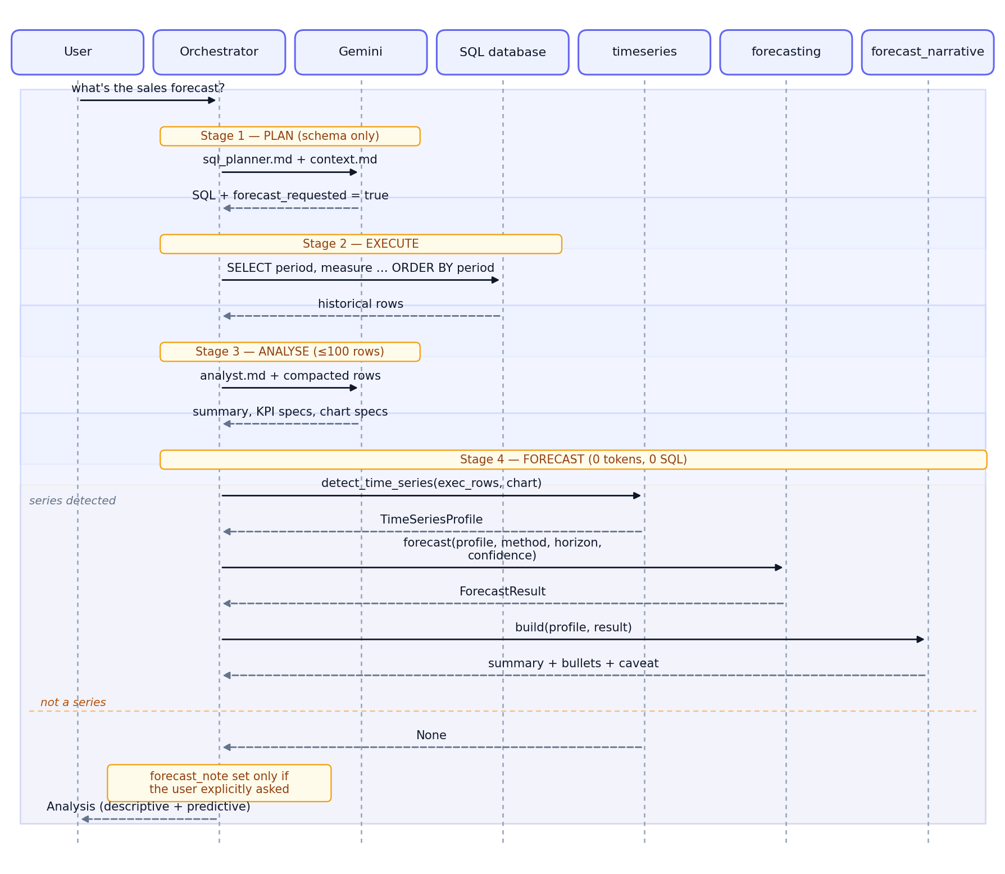
Figure 1. Forecasting in the request pipeline

The critical property is that stage 4 reuses the rows already fetched in stage 2. It issues no second query. A user who changes the forecasting method afterwards triggers neither a database round-trip nor an API call.

4. Module structure

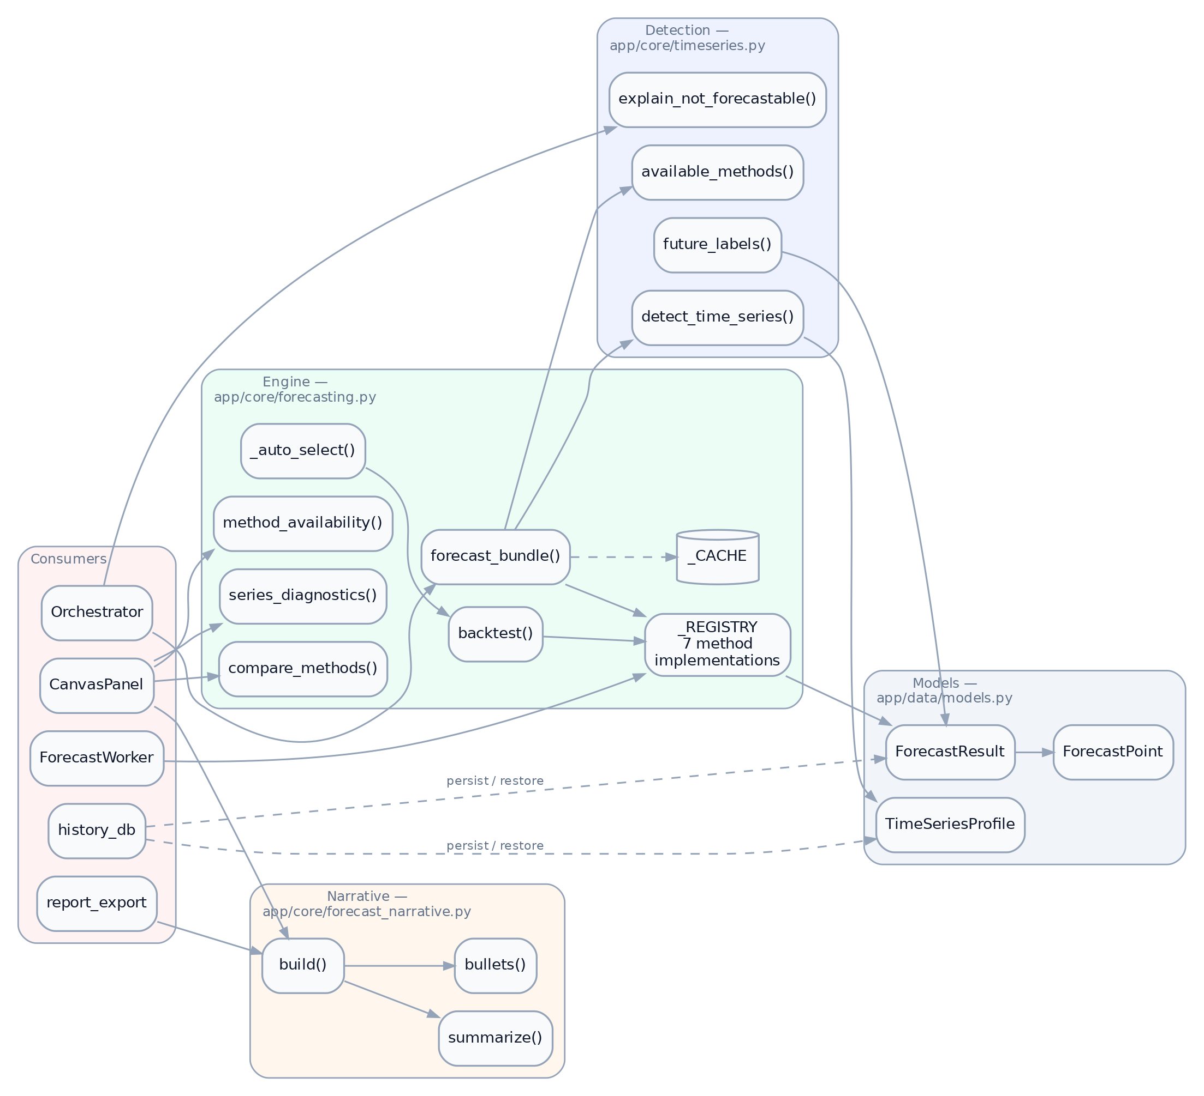
Figure 2. Module structure of the forecasting subsystem

4.1 Module responsibilities
Module | Depends on | Must never import
timeseries.py | pandas, numpy, data.models | Qt, statsmodels, any LLM client
forecasting.py | numpy, timeseries, optional statsmodels | Qt, any LLM client
forecast_narrative.py | numpy, forecasting, data.models | Qt, any LLM client
report_export.py | forecast_narrative | Qt
ui/workers/forecast_worker.py | Qt, forecasting | —
The prohibition on Qt is what makes the entire subsystem testable in a headless environment. The prohibition on LLM clients is what enforces §2.1 mechanically rather than by convention: a module that cannot import a client cannot call one.

4.2 Optional dependency handling
statsmodels is imported inside a try block at module load:
try:
from statsmodels.tsa.holtwinters import ExponentialSmoothing, Holt
from statsmodels.tsa.statespace.sarimax import SARIMAX
_HAS_STATSMODELS = True
except Exception:
_HAS_STATSMODELS = False
supported_methods() reflects the flag, so Holt, Holt-Winters and SARIMA simply disappear from the offered list when the package is absent. Any request for them degrades to linear_trend with a recorded warning. The application therefore runs — with reduced method coverage — on a minimal install.
numpy is a hard requirement of the engine. history_db imports forecasting lazily, inside the restore function, so conversation history remains readable even where numpy is unavailable.

5. Data flow and object lifecycle
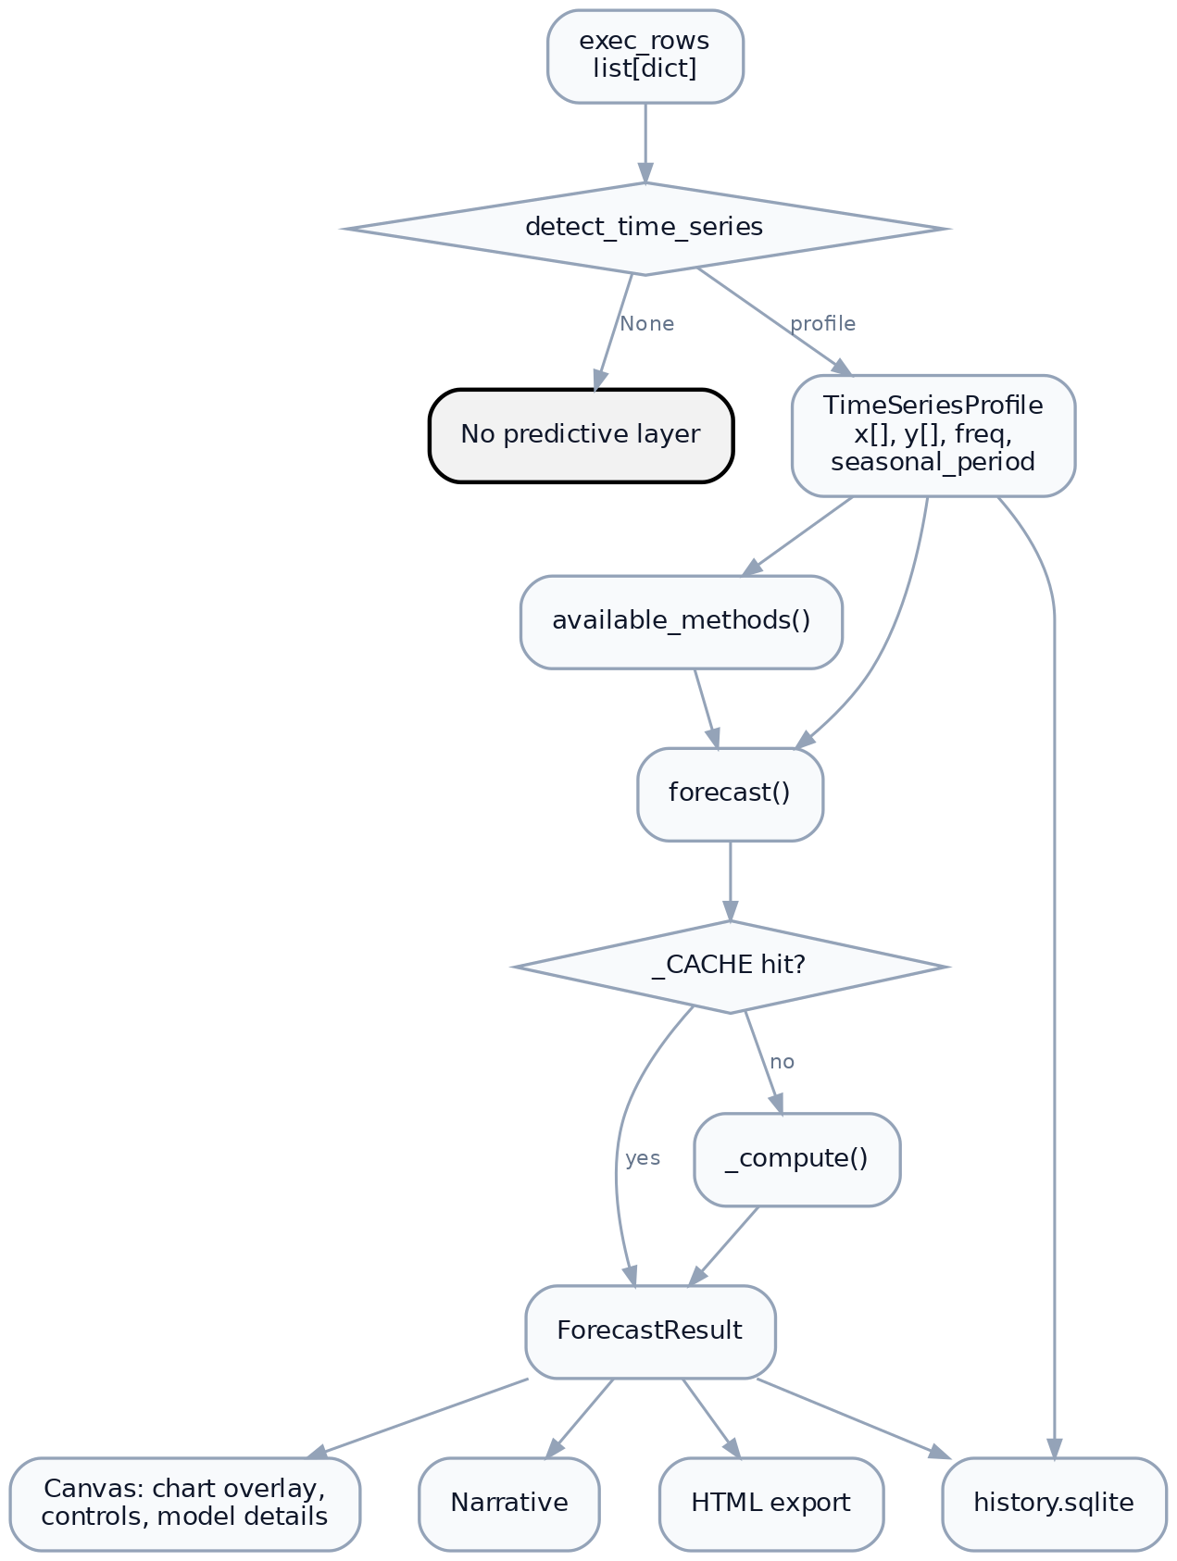
Figure 3. Data flow and object lifecycle

5.1 TimeSeriesProfile — the normalised series
Detection output, and the sole input to every method. It is a cleaned series, not the raw rows: same-period rows summed, ordered ascending, non-parsing rows dropped, period labels canonicalised.
Field | Meaning
time_column, value_column | Which result columns were selected
freq | One of D, W, M, Q, Y
n_points | Number of distinct periods
x, y | Aligned labels and values, ascending
seasonal_period | Cycle length for the frequency, or None
is_seasonal | Whether at least two full cycles are present

5.2 ForecastResult — the output record
Field | Meaning
method | The resolved method (auto already collapsed)
horizon, confidence | Parameters used
points | ForecastPoint(x, yhat, lower, upper) per period
fitted | In-sample fit aligned to history, for chart continuity
metrics | {mae, rmse, mape} from backtesting
warnings | Auto-selection notes, degradations, fallbacks
That method holds the resolved rather than requested value matters for persistence: replaying a saved analysis reproduces the exact model used, not a fresh selection that might differ if the data or code changed.

5.3 Memoisation
forecast() keys _CACHE on the tuple
(tuple(y), freq, last_label, seasonal_period, method, horizon, round(confidence, 4))
and clears wholesale past 128 entries. The values are the sole determinants of _compute, so the cache cannot serve a stale result. It exists so that toggling a control back and forth is instant, and so the model-comparison table — which backtests every eligible method — is cheap to redraw.

6. Concurrency
Forecast computation is CPU-bound and, for SARIMA, can take appreciable time. All computation happens off the GUI thread.
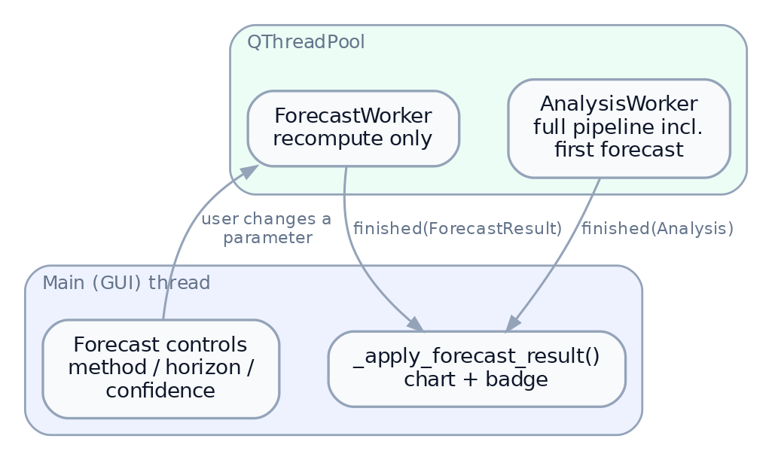
Figure 4. Concurrency: where forecasts are computed
ForecastWorker holds the in-memory TimeSeriesProfile and calls forecasting.forecast() directly. It touches neither Gemini nor the database — which is why a method change is instantaneous and free, and why it remains available when the connection has since been dropped.

7. Persistence
A forecast is stored twice over, deliberately (see §9 of docs/ARCHITECTURE.md):
- The result verbatim — every point, band, fitted value, metric and warning. This is the authoritative record of what the user was shown, and it cannot drift if the engine is later modified. Reconstruction requires no numpy.
- The inputs — the TimeSeriesProfile plus resolved method, horizon and confidence. These keep the controls live on a replayed analysis, so a user can change the horizon on a month-old result and have it recompute locally.
Approximately 2.6 KB for a 36-point series with a 12-period horizon.
Numerical care is required at the boundary: backtest() returns NaN metrics for series too short to score, and NaN is not valid JSON. _num() maps NaN and infinities to null on write.

8. Failure containment
The subsystem is bound by the application’s fourth design rule: degrade, never crash. A descriptive answer must survive any predictive failure.
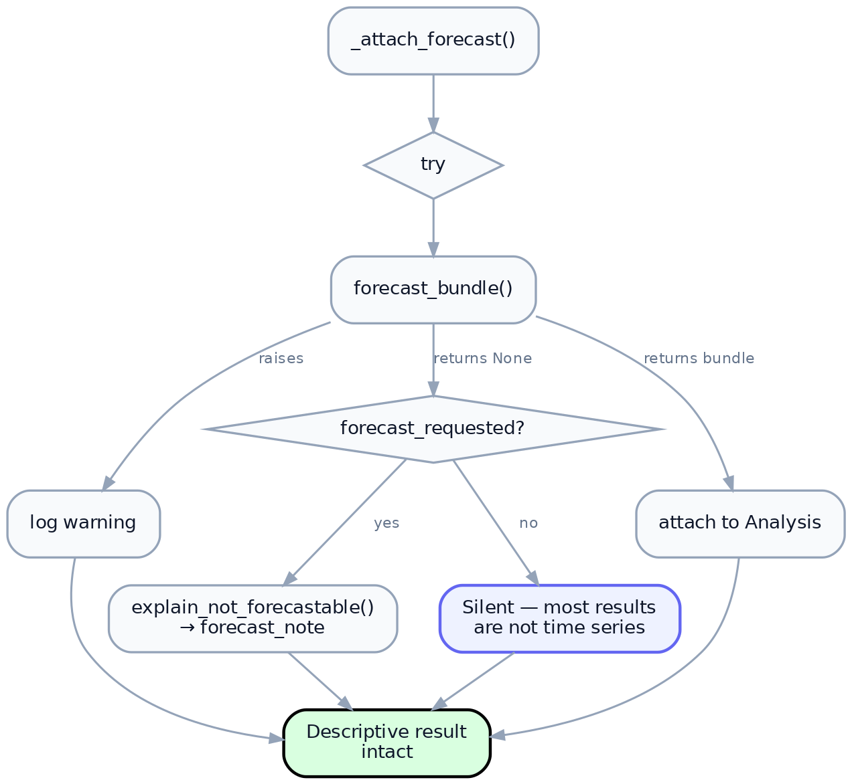
Figure 5. Failure containment in the predictive layer
Layered defences:
Layer | Behaviour on failure
Individual method | _compute catches, falls back to linear_trend, records a warning
Missing statsmodels | Method withheld from the list; explicit fallback if requested
Detection returns None | No predictive layer; explanation only if explicitly requested
_attach_forecast | Broad except, logged, descriptive result untouched
Narrative composition | Broad except, returns {}, section omitted
History restore | Malformed profile or points degrade to descriptive-only replay
The asymmetry in the third row is deliberate. Most query results are not time series; announcing that fact on every categorical breakdown would be noise. But when the planner has flagged forecast_requested, silence would read as the application ignoring the request, so an explanation is owed.

9. Verification
Concern | Test module
Detection thresholds and rejection | tests/test_timeseries.py
Method correctness and band behaviour | tests/test_forecasting.py
Narrative content and determinism | tests/test_forecast_narrative.py
Pipeline attachment | tests/test_orchestrator_forecast.py
Persistence round-trip | tests/test_history_db.py
Export rendering | tests/test_report_export.py
Notable invariants asserted:
- Auto-selection’s chosen method equals the top-scoring row of the comparison table — the transparency panel cannot contradict the selection.
- A stored forecast restores bit-identically, and the stored result takes precedence over recomputation.
- The narrative is byte-identical across repeated calls on the same inputs.

10. Known limitations
Recorded here rather than in the method reports, since they are structural.
- 500-row execution cap. Orchestrator.MAX_EXEC_ROWS truncates before detection, so a series longer than 500 periods is silently shortened. Daily data over two years exceeds this.
- Univariate only. One measure against one time axis. Multi-series forecasting (“by region”) is unsupported; the planner is instructed to aggregate instead.
- No exogenous regressors. Promotions, holidays and price changes cannot be supplied, even where the database contains them. Holiday effects are absorbed into the seasonal term or treated as noise.
- No missing-period imputation. Absent periods are simply absent; gaps reduce the regularity ratio and may cause rejection rather than interpolation.
- No outlier handling. A single anomalous period influences every method, most severely naive.
- Fixed cache size. _CACHE clears wholesale at 128 entries rather than evicting by recency.

