Method Reference
AI-Powered Conversational Analytics Platform
Technical report series on the predictive-analytics subsystem
Table of Contents

Report 2 — Method Reference
AI-Powered Conversational Analytics Platform Technical report series on the predictive-analytics subsystem.

1. Notation
Throughout, let
- $y_{1},…,y_{n}$ be the observed series (TimeSeriesProfile.y), ordered ascending;
- $n$ the number of periods (n_points);
- $h=1,…,H$ the forecast step, $H$ the horizon;
- $m$ the seasonal period (seasonal_period), where defined;
- ${\hat{y}}_{n+h}$ the point forecast $h$ steps ahead;
- $z$ the standard-normal quantile for the requested confidence (§2);
- $\hat{σ}$ an estimate of the one-step error standard deviation.
Implementations live in app/core/forecasting.py, dispatched through _REGISTRY. Each returns the five-tuple (yhat, lower, upper, fitted, warnings).

2. Confidence bands: the common machinery

2.1 Quantiles without SciPy
Interval half-widths use hard-coded normal quantiles rather than a SciPy dependency:
$$z∈\{1.2816, 1.6449, 1.9600, 2.5758\} \text{for} 1−α∈\{0.80, 0.90, 0.95, 0.99\}$$
_z(confidence) returns the exact entry when present and otherwise the nearest available level. A request for 85% therefore silently yields the 80% quantile. This is a deliberate trade — one fewer heavyweight dependency in a desktop application that ships as a PyInstaller bundle — and the UI only ever offers 80/90/95, so the approximation is unreachable through normal use.

2.2 Band growth with horizon
Three growth regimes appear, and the distinction is substantive:
Regime | Half-width at step $h$ | Used by
Random-walk | $z\hat{σ}\sqrt{h}$ | naive
Seasonal random-walk | $z\hat{σ}\sqrt{⌈h/m⌉}$ | seasonal_naive
Constant | $z\hat{σ}$ | moving_average
Regression | $z⋅s\sqrt{1+1/n+{(x_{f}−\overset{‾}{x})^{2}}/{S_{xx}}}$ | linear_trend
Residual $\sqrt{h}$ | $z\hat{σ}\sqrt{h}$ | holt, holt_winters
Model-derived | from the state-space covariance | sarima
The $\sqrt{h}$ growth is the exact variance accumulation for a random walk: if $y_{t}=y_{t−1}+ε_{t}$ with $Var(ε)=σ^{2}$, then $Var(y_{n+h}∣y_{n})=hσ^{2}$.
Applying the same $\sqrt{h}$ rule to Holt and Holt-Winters (_resid_band) is an approximation, not the exact prediction variance for those models. The true expression for Holt’s linear trend involves the smoothing parameters:
$$Var(y_{n+h})=σ^{2}\left[1+\sum_{j=1}^{h−1}{(}α+jαβ^{*})^{2}\right]$$
The implemented approximation is generally narrower than the exact interval for trended series. Intervals from these two methods should be read as indicative rather than exact. SARIMA, which obtains intervals from the fitted state-space model, does not share this caveat.

2.3 Non-negativity clamping
After band construction, _compute applies:
if lower is not None and float(np.min(y)) >= 0:
lower = [max(0.0, v) for v in lower]
If no observed value is negative, the lower bound is clamped at zero. This prevents the visually absurd “sales of −40,000” on short or volatile series. It is a presentation-layer correction, not a distributional one: the clamped interval no longer has exactly the nominal coverage, and is conservative on the lower side. The alternative — modelling on a log scale — would change the point forecasts too, and was rejected as too large a behavioural change for the benefit.

3. Naive
Registry key naive · Implementation _naive · numpy only

Point forecast
$${\hat{y}}_{n+h}=y_{n} h=1,…,H$$

Error estimate and band
Residuals are first differences, $\hat{σ}=sd(Δy)$ where $Δy_{t}=y_{t}−y_{t−1}$:
$${\hat{y}}_{n+h}±z\hat{σ}\sqrt{h}$$

Fitted values
${\hat{y}}_{t}=y_{t−1}$, with ${\hat{y}}_{1}=y_{1}$ to keep the array aligned to history.

Assumptions and use
Optimal when the series is a random walk — that is, when changes are unpredictable from the past. Despite its triviality it is the correct baseline: any method that cannot beat naive on backtest has learned nothing generalisable from the data. In §5 of Report 5 it beats three more elaborate methods on the Walmart weekly series.
Weakness: it discards all information but the final observation, so a single anomalous last period propagates across the entire horizon.

4. Seasonal naive
Registry key seasonal_naive · Implementation _seasonal_naive · numpy only

Point forecast
$${\hat{y}}_{n+h}=y_{n−m+((h−1)modm)+1}$$
Each future period repeats the corresponding period of the most recent complete cycle: next January takes last January’s value.

Error estimate and band
Residuals are seasonal differences, $\hat{σ}=sd(y_{t}−y_{t−m})$. The band widens once per cycle rather than per step:
$${\hat{y}}_{n+h}±z\hat{σ}\sqrt{⌈h/m⌉}$$
so all periods within the first cycle share a width. This is correct for a seasonal random walk, where uncertainty accumulates per cycle.
Where $n≤m$ — insufficient history for a seasonal difference — the code falls back to $sd(Δy)$.

Assumptions and use
Assumes a stable seasonal pattern and no trend. Strong on the Walmart series, where the Thanksgiving and Christmas peaks recur reliably; it placed second there on MAPE. Systematically biased under a trend, since it carries forward level from a full cycle ago.

5. Moving average
Registry key moving_average · Implementation _moving_average · numpy only

Point forecast
With window $w=\text{max}(1,\text{min}(m\text{ or }3, n))$:
$${\hat{y}}_{n+h}=\frac{1}{w}\sum_{t=n−w+1}^{n}{y_{t}} \text{for all }h$$
A flat projection at the trailing mean.

Error estimate and band
Fitted values are the trailing means ${\hat{y}}_{t}=\frac{1}{w}\sum_{i=t−w+1}^{t}{y_{i}}$ (expanding for $t<w$); $\hat{σ}=sd(y−\hat{y})$; the band is constant in $h$:
$${\hat{y}}_{n+h}±z\hat{σ}$$

Assumptions and use
Assumes a locally constant level with additive noise. The constant band is honest for that assumption and misleading when it is violated: a trended series gets an interval that does not widen even as the point forecast drifts further from plausibility.
Note the window defaults to the seasonal period when one exists. On a monthly seasonal series this averages a full year, which usefully cancels seasonality but responds slowly to genuine level change.

6. Linear trend
Registry key linear_trend · Implementation _linear_trend · numpy only

Point forecast
Ordinary least squares of $y$ on the time index $x_{t}=t−1$, via np.polyfit:
$$\hat{y}(x)={\hat{β}}_{1}x+{\hat{β}}_{0}, {\hat{y}}_{n+h}={\hat{β}}_{1}(n−1+h)+{\hat{β}}_{0}$$

Error estimate and band
This is the only method using a textbook-exact interval. With residual standard error
s=t​(yt−yt)2n−2, Sxx=t​(xt−x)2
the prediction standard error at $x_{f}=n−1+h$ is
$$se(x_{f})=s\sqrt{1+\frac{1}{n}+\frac{(x_{f}−\overset{‾}{x})^{2}}{S_{xx}}}$$
$${\hat{y}}_{n+h}±z⋅se(x_{f})$$
The three terms are, in order: irreducible noise, uncertainty in the intercept, and uncertainty in the slope amplified by distance from the centre of the data. The band is a hyperbola, narrowest at $\overset{‾}{x}$ and widening outward — the correct qualitative behaviour for extrapolation.
Strictly, $z$ should be a $t_{n−2}$ quantile rather than normal. For $n≥30$ the difference is under 4%; for $n=8$ it is around 20% and the interval is correspondingly too narrow.

Assumptions and use
Assumes a deterministic linear trend with homoscedastic independent errors. It is also the universal fallback: _run_method defaults to it for unknown keys, and every failure path degrades to it. It always runs and always produces a band.
Weakness: extrapolates without bound. Over a long horizon it will happily project negative or implausibly large values — hence the clamping in §2.3.

7. Holt’s linear trend
Registry key holt · Implementation _holt · requires statsmodels

Model
Exponential smoothing with level $ℓ_{t}$ and trend $b_{t}$:
$$\begin{matrix}ℓ_{t} & =αy_{t}+(1−α)(ℓ_{t−1}+b_{t−1}) \\ b_{t} & =β^{*}(ℓ_{t}−ℓ_{t−1})+(1−β^{*})b_{t−1} \\ {\hat{y}}_{n+h} & =ℓ_{n}+h b_{n}\end{matrix}$$
$α,β^{*}∈(0,1)$ are estimated by maximum likelihood (initialization_method="estimated").

Band
$\hat{σ}=sd(y−{\hat{y}}^{\text{fitted}})$, then _resid_band with $\sqrt{h}$ growth — the approximation discussed in §2.2.

Assumptions and use
Trend, no seasonality. Unlike linear_trend it weights recent observations more heavily, so it adapts to a changing slope. Requires $n≥6$.
The distinction from linear_trend is worth stating plainly: linear trend fits one straight line to all history; Holt tracks a locally linear trend that may change. On a series whose growth rate shifted, Holt adapts and linear trend averages the two regimes into something matching neither.

8. Holt-Winters
Registry key holt_winters · Implementation _holt_winters · requires statsmodels

Model
Additive trend and additive seasonality:
$$\begin{matrix}ℓ_{t} & =α(y_{t}−s_{t−m})+(1−α)(ℓ_{t−1}+b_{t−1}) \\ b_{t} & =β^{*}(ℓ_{t}−ℓ_{t−1})+(1−β^{*})b_{t−1} \\ s_{t} & =γ(y_{t}−ℓ_{t−1}−b_{t−1})+(1−γ)s_{t−m} \\ {\hat{y}}_{n+h} & =ℓ_{n}+h b_{n}+s_{n−m+((h−1)modm)+1}\end{matrix}$$
Configured trend="add", seasonal="add", with seasonal_periods = m (falling back to 2 if undefined).

Band
As Holt: residual standard deviation with $\sqrt{h}$ growth.

Assumptions and use
Trend and stable seasonality, with seasonal amplitude roughly constant in absolute terms. Requires two complete cycles. The best performer on the Walmart weekly series (MAPE 0.6%), which has both a mild trend and a pronounced 52-week cycle.
The additive-only configuration is a limitation: where seasonal swings scale with the level — common in revenue that has grown severalfold — a multiplicative formulation would fit better. The code does not offer one.

9. SARIMA
Registry key sarima · Implementation _sarima · requires statsmodels

Model
$\text{SARIMA}(1,1,1)×(1,1,0)_{m}$, fixed orders:
$$(1−ϕ_{1}B)(1−Φ_{1}B^{m})(1−B)(1−B^{m})y_{t}=(1+θ_{1}B)ε_{t}$$
where $B$ is the backshift operator. Non-seasonal part: one AR term, one degree of differencing, one MA term. Seasonal part: one seasonal AR term and one seasonal difference. Where $m$ is undefined or $n<2m$, the seasonal order collapses to $(0,0,0,0)$ and the model reduces to ARIMA(1,1,1).
enforce_stationarity=False and enforce_invertibility=False are set so that fitting does not fail outright on borderline series; the cost is that estimated parameters may lie outside the stationary region, and such fits should be treated with suspicion.

Band
Unlike every other method here, intervals come from the fitted model: get_forecast(H).conf_int(alpha=1-confidence). These are proper model-based prediction intervals accounting for parameter and innovation uncertainty — the most statistically defensible bands the application produces.

Assumptions and use
The most flexible method, and the most demanding. Requires $n≥\text{max}(2m,16)$ and $m≤24$; the latter excludes it from weekly data ($m=52$), where a $(1,1,0)_{52}$ seasonal term would need hundreds of observations to estimate.
The orders are fixed, not selected. There is no auto.arima-style search over $(p,d,q)×(P,D,Q)$. $(1,1,1)×(1,1,0)_{m}$ is a reasonable general-purpose default, but a genuinely ARIMA-appropriate series will usually be fitted better by a searched specification. This is the largest gap between the implementation and standard practice.

10. Auto
Registry key auto — a strategy, not a method. See _auto_select.
Not present in _REGISTRY: _compute resolves it before dispatch by backtesting every eligible candidate and keeping the lowest MAPE. Full treatment in Report 5 §4.
Two consequences worth noting here:
- ForecastResult.method never holds "auto" — it holds the resolved method. This is what is persisted, so replay reproduces the model actually used.
- The selection is recorded as a warning, e.g. "auto-selected holt_winters (backtest MAPE 0.6%)", and surfaced in the UI badge.

11. Comparison
Method | Trend | Season | Min $n$ | Band growth | Dependency
Naive | — | — | 2 | $\sqrt{h}$ | numpy
Seasonal naive | — | ✓ | $2m$ | $\sqrt{⌈h/m⌉}$ | numpy
Moving average | — | — | 1 | constant | numpy
Linear trend | ✓ (global) | — | 2 | hyperbolic (exact) | numpy
Holt | ✓ (local) | — | 6 | $\sqrt{h}$ (approx) | statsmodels
Holt-Winters | ✓ (local) | ✓ | $2m$ | $\sqrt{h}$ (approx) | statsmodels
SARIMA | ✓ | ✓ | $\text{max}(2m,16)$, $m≤24$ | model-derived | statsmodels

Selection guidance
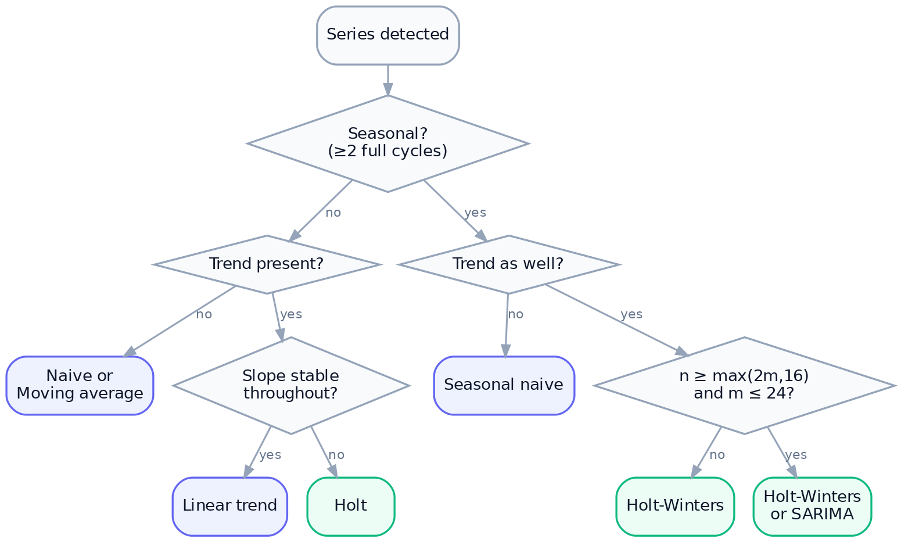
Figure 1. Method selection by series characteristics
In practice Auto implements this decision empirically rather than by rule, and is the default. The tree is offered for readers who wish to reason about why a given method won.

12. Implementation notes

12.1 Uniform signature
Every method is fn(y, horizon, period, z, confidence) -> MethodResult, so _REGISTRY dispatch requires no special-casing and a new method needs only an entry in the registry plus availability rules.

12.2 Fitted values
Each method returns an in-sample fit aligned to history, used by the chart to draw a continuous line from history into projection. The naive methods pad the first $m$ (or one) entries with observed values to preserve alignment; those padded entries are not genuine fits and should not be read as such.

12.3 Failure handling
try:
yhat, lower, upper, fitted, mwarn = _run_method(chosen, ...)
except Exception as exc:
warnings.append(f"{chosen} failed ({type(exc).__name__}); fell back to linear_trend.")
chosen = "linear_trend"
yhat, lower, upper, fitted, _ = _linear_trend(...)
Statsmodels raises on singular or degenerate fits (constant series, too few points after differencing). Rather than surfacing a stack trace, the engine falls back and records the substitution in warnings, which reaches the UI badge and the narrative.

References
Hyndman, R.J. & Athanasopoulos, G. (2021). Forecasting: Principles and Practice, 3rd ed. OTexts. — Chapters 3 (benchmarks), 8 (exponential smoothing), 9 (ARIMA).
Box, G.E.P., Jenkins, G.M., Reinsel, G.C. & Ljung, G.M. (2015). Time Series Analysis: Forecasting and Control, 5th ed. Wiley.
Hyndman, R.J. & Koehler, A.B. (2006). Another look at measures of forecast accuracy. International Journal of Forecasting, 22(4), 679–688.

