The Relevance Gate
AI-Powered Conversational Analytics Platform
Technical report series on the predictive-analytics subsystem
Table of Contents

Report 3 — The Relevance Gate
AI-Powered Conversational Analytics Platform Technical report series on the predictive-analytics subsystem.

1. The problem
A conversational analytics tool receives questions of every shape. “Sales by region”, “top 10 products”, “how many orders last month”, “monthly revenue” — only the last is a time series. Offering a forecast on the others would be worse than useless: it would attach a projection to a categorical axis, implying a temporal ordering that does not exist.
The gate is the mechanism that decides. It is implemented in app/core/timeseries.py as detect_time_series(), which returns a TimeSeriesProfile or None. None means the entire predictive layer is skipped — no chart overlay, no controls, no narrative.
The design commitment is that the gate should be conservative: a false negative costs a missing forecast on a valid series, which the user can work around by rephrasing. A false positive attaches a confident projection to meaningless data, which the user may believe.

2. The decision procedure
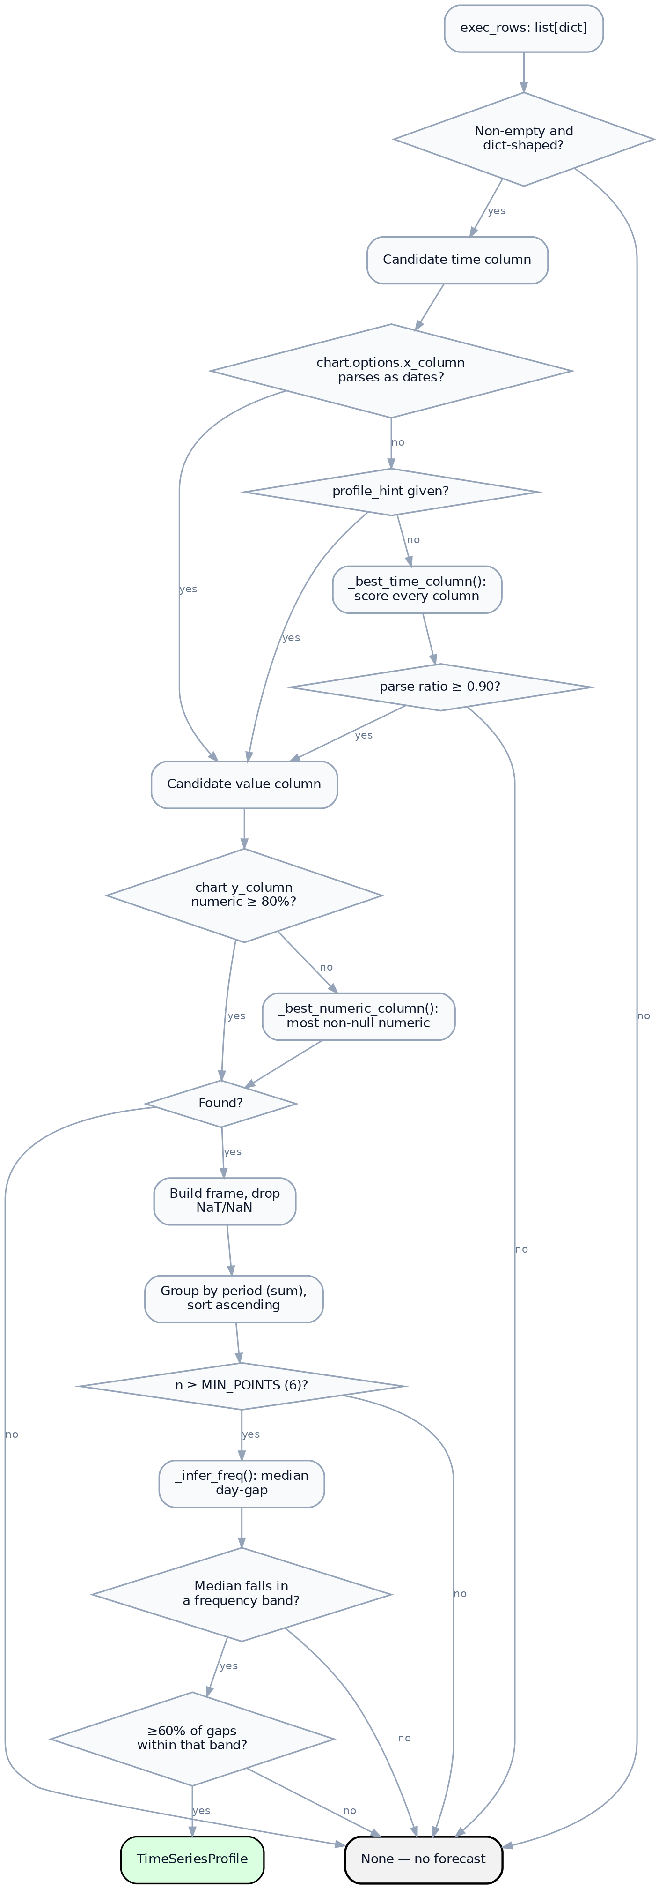
Figure 1. The detection procedure
Every branch to None is a rejection, and each has a distinct explanation in explain_not_forecastable() (§7).

3. Column selection

3.1 Time column
Three sources are tried in order:
- chart.options.x_column — the analyst LLM’s stated x-axis. Accepted only if the column exists and parses as dates above threshold. The model’s suggestion is a hint, never trusted on its own.
- profile_hint — an explicit caller override, used in testing.
- _best_time_column() — scoring across all columns.
The scoring function is:
$$\text{score}(c)=ρ(c)+0.05⋅1[\text{name hints at time}]$$
where $ρ(c)$ is the fraction of values in column $c$ that parse as dates, and the name hints are
date, day, month, year, period, time, week, quarter, dt
The 0.05 nudge only breaks ties between columns with near-equal parse ratios; it cannot promote a column that does not parse. A column named order_date holding free text will still be rejected.
The winner must then independently satisfy
$$ρ(c)≥\text{PARSE_THRESHOLD}=0.90$$

3.2 Why 90% rather than 100%
Real query results contain nulls and occasional malformed values. Demanding perfect parsing would reject otherwise sound series over a single bad row. Demanding much less would admit columns that merely resemble dates — a free text field where a tenth of entries happen to be parseable.
At 90%, a 143-week series tolerates 14 unparseable periods. Non-parsing rows are dropped rather than imputed, so tolerance and data loss trade off directly.

3.3 Value column
Accepted if at least 80% of entries are numeric (_is_numeric_col). Where the analyst’s y_column fails, _best_numeric_column() selects the column with the most non-null numeric values, excluding the time column.
The lower threshold reflects that numeric columns are more often sparse — a measure legitimately null for some periods is common, whereas a date column with 10% junk suggests it is not really a date column.

4. Temporal parsing
_parse_time() handles three cases before falling back to general parsing:

4.1 Bare years
If every value is an integer in $[1900,2100]$, values are read as annual periods (2019 → 2019-01-01) and the frequency hint Y is returned directly.
This exists because a year column is numerically indistinguishable from a measure. Without the special case, 2019, 2020, 2021 would be parsed as nanosecond epochs or rejected.

4.2 Quarter strings
The regular expression
^\s*(?:(\d{4})[-/\s]*q([1-4])|q([1-4])[-/\s]*(\d{4}))\s*$
matches both 2024-Q3 and Q3 2024, case-insensitively, mapping to the first day of the quarter. Hint Q is returned.

4.3 General parsing
Everything else goes to pd.to_datetime(errors="coerce"), with the mixed-format UserWarning suppressed — heterogeneous date strings are expected here, and falling back to dateutil per element is the intended behaviour.

5. Frequency inference

5.1 Procedure
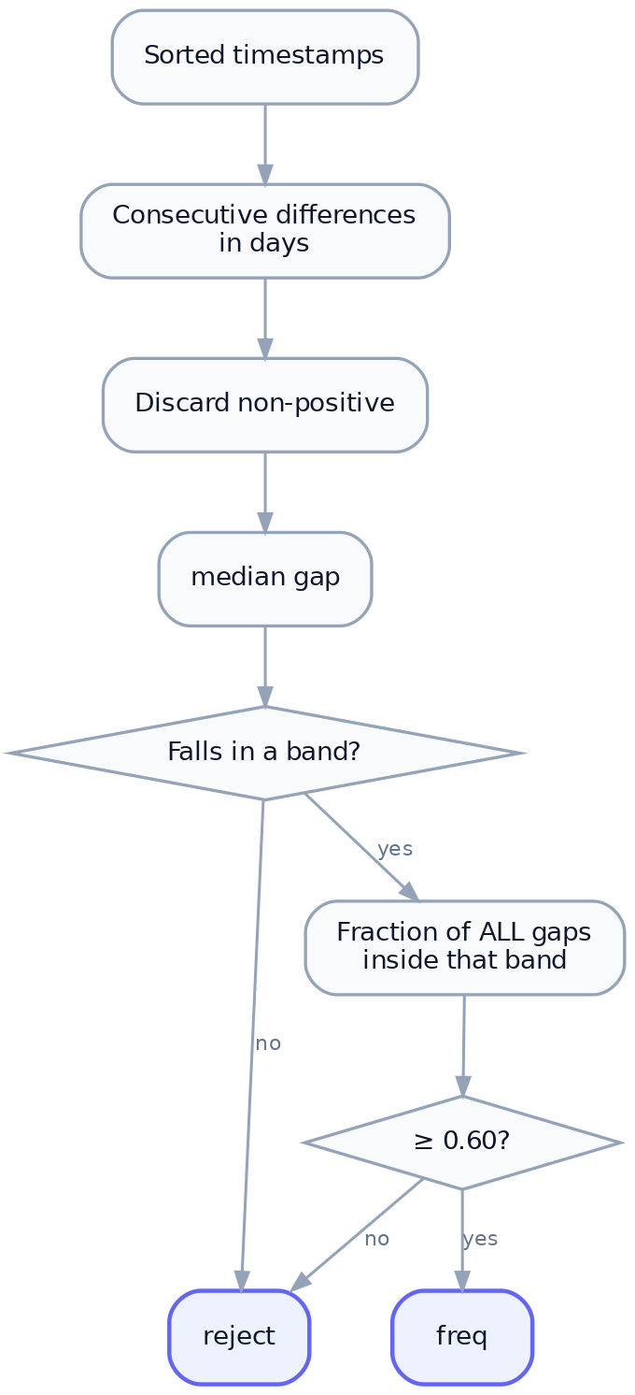
Figure 2. Frequency inference

5.2 The bands
Frequency | Lower (days) | Upper (days) | Nominal | Seasonal period $m$
D daily | 0.5 | 2.0 | 1 | 7
W weekly | 5.0 | 9.0 | 7 | 52
M monthly | 26.0 | 32.0 | 30.4 | 12
Q quarterly | 84.0 | 96.0 | 91.3 | 4
Y yearly | 350.0 | 380.0 | 365.25 | —
Bands are asymmetric and deliberately generous. Calendar months range from 28 to 31 days, so a strict interval around 30.4 would misclassify February. The monthly band spans 26–32 to absorb this. Gaps between 2 and 5 days, or 9 and 26, match nothing and cause rejection — there is no “every 3 days” frequency.
Y has no seasonal period: annual data cannot exhibit within-year seasonality by construction.

5.3 The regularity criterion
Median classification alone is insufficient. A series of mostly-monthly gaps with several multi-year jumps would have a monthly median while not being a regular monthly series. So after classification:
$$\frac{|\{d_{i}:\text{lo}≤d_{i}≤\text{hi}\}|}{|\{d_{i}\}|}≥\text{_REGULARITY}=0.60$$
At 60%, up to 40% of intervals may be irregular. This is lenient — deliberately so, because real business data has gaps: closed periods, missing weeks, partially loaded data. The tolerance admits series with genuine holes rather than rejecting them outright.
The residual risk is that a badly gapped series passes and is then forecast as though evenly spaced, since no imputation occurs. Missing periods are simply absent from y, so a monthly series missing three months is modelled as though those months never existed. This is limitation 4 in Report 1.

6. Aggregation and seasonality

6.1 One value per period
frame = frame.groupby("t", as_index=False)["y"].sum().sort_values("t")
Rows sharing a timestamp are summed, not averaged. This suits the dominant case — SQL returning transaction-level rows that should total per period. It is wrong for intensive measures such as average price or temperature, where summing duplicates is meaningless. The planner is instructed to aggregate in SQL, so duplicates should be rare, but the behaviour is worth knowing.

6.2 Minimum length
$$n≥\text{MIN_POINTS}=6$$
Six is the smallest count permitting a meaningful holdout: the default holdout is $\text{min}(6,\text{max}(1,⌊n/4⌋),m)$, capped at $n−2$, so at $n=6$ a holdout of 1–4 still leaves points to fit on. Below six, no method can be scored, so no method can be justified.

6.3 Seasonality determination
$$\text{is_seasonal}=(m≠\text{None})∧(n≥2m)$$
Two complete cycles is the minimum for estimating a seasonal pattern at all: one cycle cannot distinguish seasonality from trend or noise. Note the criterion is purely structural — no statistical test for seasonal significance is performed. A 24-month series is declared seasonal whether or not a real annual pattern exists. The consequence is that seasonal methods are offered; whether they are chosen is settled empirically by backtest.

7. Explaining rejection
When the planner set forecast_requested, silence would read as the application ignoring the user. explain_not_forecastable() re-walks the same checks and reports the first failure in the user’s terms.
Failure | Message
No rows | “The query returned no rows, so there is nothing to project.”
No date column | “This result has no date or period column… Columns returned: …”
Below parse threshold | “The column ‘x’ could not be read as dates — only n% of its values parsed…”
No numeric measure | “No numeric measure was returned alongside the dates…”
Too few periods | “Only n distinct periods came back, and at least 6 are needed…”
Irregular spacing | “The periods are spaced too irregularly… Grouping with DATE_TRUNC usually fixes this.”
Two properties are enforced by test: each message names the specific obstruction — the actual column list, the actual period count — and each suggests a remedy. test_explanation_is_always_a_usable_sentence asserts every path returns a capitalised, full-stopped sentence for arbitrary input.
The function duplicates the detection logic rather than instrumenting it. This is a conscious trade: detect_time_series stays a clean predicate returning Optional, at the cost of the two walking the same checks. They must be kept in step, and the shared constants (MIN_POINTS, PARSE_THRESHOLD) reduce the surface where they could diverge.

8. Worked example — Walmart weekly sales
From the shipped input_data/walmart_sales.csv, aggregated weekly:
Stage | Outcome
Time column | sale_week — 100% parse, name hint matched
Value column | total_sales — 100% numeric
Rows after cleaning | 143
Median gap | 7.0 days
Band matched | W (5.0–9.0)
Regularity | 100% of gaps in band
$n≥6$ | Yes (143)
$m$ | 52
$n≥2m$ | $143≥104$ → seasonal
Range | 2010-02-05 → 2012-10-26
Result: profile accepted, all seven methods eligible except SARIMA, which is withheld because $m=52>24$ (see Report 4 §3).

9. Summary of constants
Constant | Value | Location | Governs
MIN_POINTS | 6 | timeseries.py | Minimum periods
PARSE_THRESHOLD | 0.90 | timeseries.py | Date-parse fraction
_REGULARITY | 0.60 | timeseries.py | Gap-conformity fraction
numeric threshold | 0.80 | _is_numeric_col | Measure numeric fraction
name-hint bonus | 0.05 | _best_time_column | Tie-break weight
seasonal minimum | $2m$ | detect_time_series | Seasonality flag
All are module-level and unconfigurable at runtime. They were chosen against the bundled retail datasets and have not been tuned against a broader corpus — a fair criticism of the current implementation, and the obvious avenue for future work.

