Parameter Selection
AI-Powered Conversational Analytics Platform
Technical report series on the predictive-analytics subsystem
Table of Contents

Report 4 — Parameter Selection
AI-Powered Conversational Analytics Platform Technical report series on the predictive-analytics subsystem.

1. The three parameters
A forecast is determined by exactly three user-facing parameters plus the detected series:
Parameter | Type | Default | Range | Effect
Method | enumerated | auto | eligible methods only | Which model generates the projection
Horizon | integer | 12 | 1–36 (FORECAST_MAX_HORIZON) | How many periods ahead
Confidence | float | 0.80 | 0.80 / 0.90 / 0.95 | Width of the interval
Defaults are configurable in Settings → Forecasting and persisted in Settings.forecast_default_method, forecast_default_horizon, forecast_confidence, forecast_enabled_by_default.
The design principle governing all three: the user may only choose options that are valid for their data. Rather than accepting a request and failing, or silently substituting, the interface offers only what the series supports and explains what it withholds.

2. Method eligibility

2.1 The rules
available_methods(profile) derives the offered list from the profile alone:
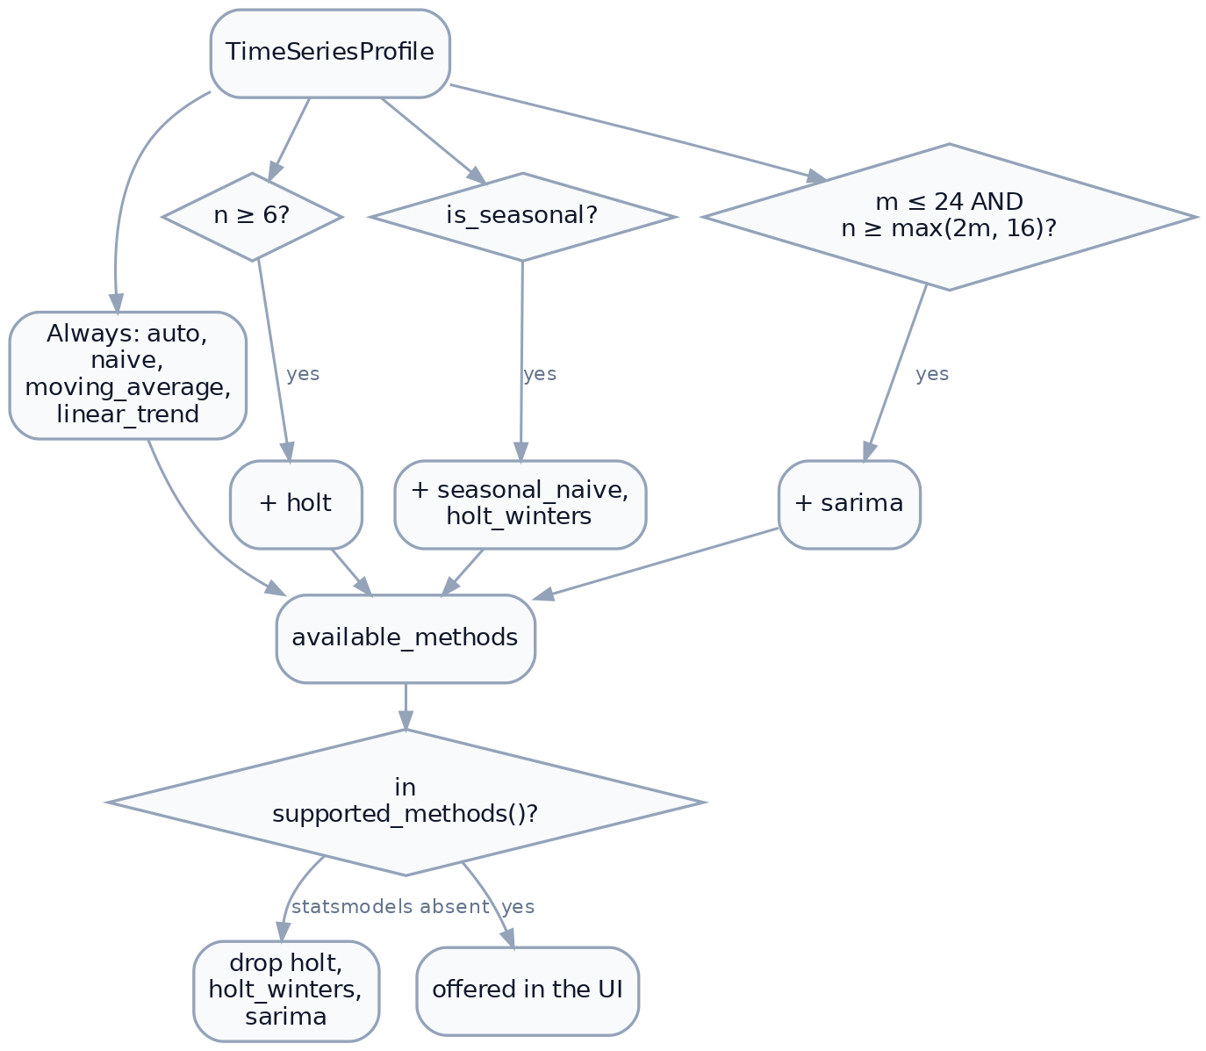
Figure 1. Method eligibility rules
Method | Condition | Justification
auto, naive, moving_average, linear_trend | always | Need no structure beyond two points
holt | $n≥6$ | Two smoothing parameters plus initial level and trend
seasonal_naive, holt_winters | is_seasonal ($n≥2m$) | A seasonal index needs two cycles to estimate
sarima | $m≤24$ and $n≥\text{max}(2m,16)$ | See §2.2

2.2 Why SARIMA is excluded from weekly data
The $m≤24$ ceiling is the most consequential eligibility rule, because it excludes SARIMA from every weekly series ($m=52$).
A $(1,1,0)_{52}$ seasonal component requires estimating a parameter that relates each observation to the one 52 periods earlier. Reliable estimation needs many complete cycles — several years of weekly data — and the state-space fit costs grow steeply with seasonal order. On the 143-week Walmart series, fitting would be both slow and poorly identified: barely three cycles for a parameter that needs far more.
The rule is a pragmatic ceiling, not a theoretical bound. A user with ten years of weekly data would benefit from SARIMA and cannot have it. This is a known conservatism, documented rather than hidden.

2.3 Availability is explained, not merely enforced
method_availability(profile) returns every known method with a reason, so the panel can show why a method is missing:
Situation | Message
Offered | “Available.”
statsmodels absent | “Needs statsmodels, which is not installed.”
holt, $n<6$ | “Needs at least 6 periods; this series has n.”
Seasonal methods, not seasonal | “Needs a full seasonal cycle. At F frequency that is m periods twice over; this series has n.”
sarima, $m>24$ | “Seasonal period of m is too long to fit reliably.”
sarima, too short | “Needs at least max(2m,16) periods; this series has n.”
This turns a shrinking dropdown from something arbitrary into something informative: the user learns what their data would need to support the method.

3. Horizon

3.1 Units
Horizon is measured in periods of the detected frequency, not fixed calendar units. A horizon of 12 means twelve weeks on weekly data and twelve months on monthly data. The control makes this explicit through a suffix drawn from PERIOD_NOUN, so the spin box reads 12 weeks rather than 12.
Future period labels come from future_labels(), which advances the last observed timestamp by the frequency and formats to match the historical labels — so a monthly series continues 2025-06, 2025-07, … and a quarterly one continues 2025-Q2, 2025-Q3, ….

3.2 The cap
$$H≤\text{FORECAST_MAX_HORIZON}=36$$
Enforced in _compute via max(1, min(horizon, 36)), so an out-of-range request is clamped rather than rejected.
The cap is a statement about credibility rather than computation. Thirty-six periods is three years monthly, nine months weekly, nine years quarterly. Beyond that, extrapolation from a purely historical model is not defensible for any method here, none of which incorporate external information.

3.3 Relationship to series length
There is no rule tying horizon to $n$. A user may request 36 periods from a 6-point series. The forecast will compute, and the interval will be wide, but nothing prevents it.
A common heuristic caps the horizon at $n/3$ or similar. It is not implemented. The partial defence is that the narrative reports interval width relative to the projected value, so an absurd extrapolation announces itself:
By 2028-06 the 90% interval spans 12,400 to 918,300 — about 730% of the projected value.
A reader who ignores that has been told.

4. Confidence

4.1 Semantics
The confidence level sets the nominal coverage of the shaded band: a 90% band is constructed so that the actual value falls inside it 9 times in 10, if the model’s assumptions hold.
The tooltip states this carefully — “wider means less precise, not more certain” — because the intuitive reading is backwards. Raising confidence from 80% to 95% does not make the forecast better; it makes the band wider to admit more of the uncertainty that was always present.

4.2 Available levels
Only 80%, 90% and 95% are offered, matching the exact entries in the _Z table (§2.1 of Report 2). The 99% quantile exists in the table but is not exposed; at that level bands on short series become so wide as to convey nothing.
_z() falls back to the nearest available quantile for any other value, so a programmatic caller requesting 0.85 receives the 0.80 band. Reachable only through the API, not the UI.

4.3 Interaction with method
Confidence affects only band width for six of seven methods — the point forecast is unchanged. SARIMA is the exception: conf_int(alpha=1-confidence) derives intervals from the fitted state-space model, so changing confidence there re-derives from the model rather than rescaling a residual estimate.
Confidence also enters backtest() and therefore auto-selection, but only as a pass-through to the method; MAPE compares point forecasts, so the selected method is in practice invariant to confidence.

5. Interaction and recomputation
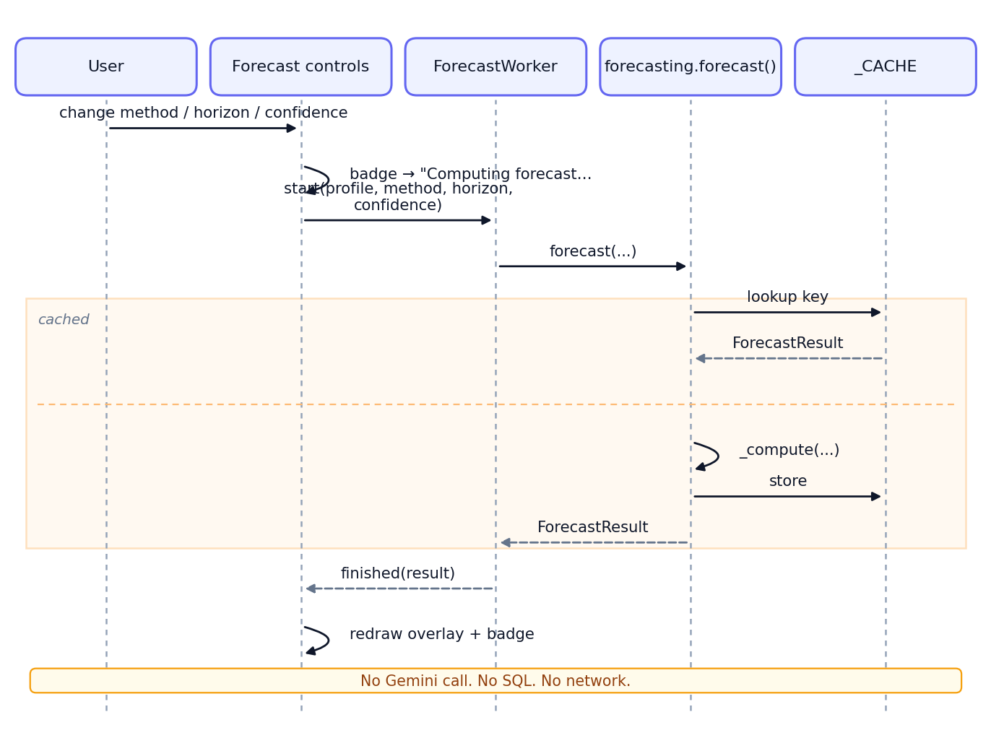
Figure 2. Recomputation after a parameter change
Three properties follow:
- Free. No tokens, no query. A user may explore every method at no cost.
- Fast. Repeated settings hit _CACHE; toggling back and forth is instant.
- Available offline. Recomputation works after the database connection has been dropped, and on a replayed historical analysis.
The third point is why the persistence layer stores the TimeSeriesProfile alongside the result: without it the controls would be dead on a replayed item.

6. Defaults
Setting | Default | Reasoning
forecast_enabled_by_default | True | Forecasts are relevance-gated, so enabling costs nothing on non-series results
forecast_default_method | auto | Empirical selection beats a fixed guess across unknown datasets
forecast_default_horizon | 12 | One year monthly, one quarter weekly — a natural planning window
forecast_confidence | 0.80 | Narrower band, more readable chart; the honest 90/95 alternatives crowd the plot on volatile series
The 80% default deserves scrutiny. It is the least conservative offered, chosen for legibility. A reader who wants the conventional 95% must select it. The counter-argument — that a default should be conservative because most users never change defaults — is reasonable, and this is a defensible point of disagreement rather than a settled question.

7. What cannot be configured
Documented so the boundary is explicit:
Fixed | Value | Where
Detection thresholds | MIN_POINTS, PARSE_THRESHOLD, _REGULARITY | timeseries.py module constants
Frequency bands | 5 bands, fixed day ranges | _FREQ_BANDS
Seasonal periods | D→7, W→52, M→12, Q→4 | _SEASONAL_PERIOD
SARIMA orders | $(1,1,1)×(1,1,0)_{m}$ | _sarima
Moving-average window | $m$ or 3 | _moving_average
Backtest holdout | $\text{min}(6,⌊n/4⌋,m)$ | backtest()
Auto-selection criterion | lowest MAPE | _auto_select
Cache size | 128 entries | forecast()
None are exposed in Settings. The reasoning is that they are modelling decisions rather than preferences: a user well-informed enough to tune the regularity threshold is better served editing the source. The counter-view is that fixed SARIMA orders in particular are a significant limitation for anyone with genuinely ARIMA-appropriate data.

8. Parameter effects at a glance
Change | Point forecast | Band | Method | Cost
Method | changes | changes | — | one fit
Horizon ↑ | extends | widens (most methods) | unchanged | one fit
Confidence ↑ | unchanged¹ | widens | unchanged | one fit
More history | changes | usually narrows | may change under auto | new query
¹ Except SARIMA, where intervals are model-derived (§4.3).

