Backtesting and Accuracy
AI-Powered Conversational Analytics Platform
Technical report series on the predictive-analytics subsystem
Table of Contents

Report 5 — Backtesting and Accuracy
AI-Powered Conversational Analytics Platform Technical report series on the predictive-analytics subsystem.

1. Purpose
Every forecast the application displays carries an accuracy figure, and the default method is chosen by comparing those figures. This report defines how they are computed, what they do and do not establish, and where the procedure departs from best practice.
The governing principle is that a forecast without an error estimate is an assertion. The application refuses to present one: _compute always calls backtest() before returning, and the narrative states the result in words — “strong”, “reasonable”, “weak”, “poor” — so that a number the reader may not know how to interpret is at least characterised.

2. Procedure

2.1 Holdout construction
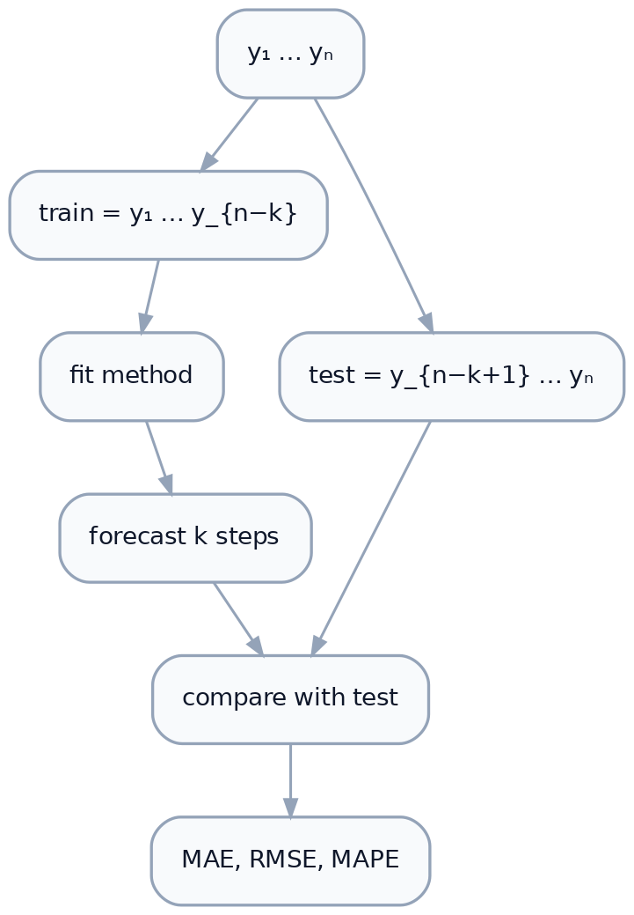
Figure 1. Holdout construction
The holdout size is
$$k=\text{min}​\left(6, \text{max}(1,⌊n/4⌋), m\text{ or }6\right), k←\text{min}(k, n−2)$$
Each term serves a purpose:
Term | Effect
$6$ | Absolute ceiling — a longer holdout starves the fit
$⌊n/4⌋$ | At most a quarter of history withheld
$m$ | Never more than one seasonal cycle
$n−2$ | Always leaves at least two points to fit on
For the 143-week Walmart series: $\text{min}(6,35,52)=6$, so six weeks are held out and 137 used for fitting. For a 12-month series: $\text{min}(6,3,12)=3$.
Where $k<1$ the metrics are NaN — the series is too short to score at all, which the narrative reports explicitly (“too short to score a backtest, so treat the projection as indicative only”).

2.2 Scoring
The method is fitted on train and asked for exactly $k$ steps, which are compared against test. With $e_{i}=y_{i}−{\hat{y}}_{i}$ over the holdout:
$$MAE=\frac{1}{k}\sum_{i=1}^{k}{|}e_{i}|$$
$$RMSE=\sqrt{\frac{1}{k}\sum_{i=1}^{k}{e_{i}^{2}}}$$
$$MAPE=\frac{100}{k}\sum_{i=1}^{k}{\left|\frac{e_{i}}{y_{i}}\right|}$$
MAPE uses np.nanmean over a denominator where $|y_{i}|<{10}^{−9}$ has been replaced by NaN, so zero-valued periods are excluded rather than producing infinities. If every holdout value is zero, MAPE is NaN and the method is unscorable.
Failures during fitting return NaN metrics rather than propagating — a method that cannot be fitted simply cannot be scored, and sorts last.

3. Interpreting the three metrics
Each answers a different question, which is why all three are shown.
Metric | Units | Answers | Sensitive to
MAE | measure’s own | “How far off on average?” | all errors equally
RMSE | measure’s own | “How far off, weighting big misses?” | outliers, quadratically
MAPE | percent | “How far off relative to size?” | small denominators

3.1 Why MAPE drives selection
MAPE is scale-free, so it is comparable across series with different magnitudes and gives a threshold vocabulary that transfers between datasets. The narrative uses fixed bands:
MAPE | Description
< 10% | strong
< 20% | reasonable
< 50% | weak
≥ 50% | poor
These are conventional rules of thumb, not derived from theory, and they are generous for a series as regular as weekly retail sales while harsh for volatile data.

3.2 MAPE’s known defects
Documented because the application relies on it:
- Asymmetry. MAPE penalises over-forecasting more than under-forecasting. Predicting 150 when the truth is 100 scores 50%; predicting 50 scores 50% too, but predicting 0 scores 100% while there is no over-forecast that can exceed 100% by the same margin. Selection is therefore mildly biased toward methods that under-predict.
- Undefined at zero. Handled by exclusion, which means a series with frequent zeros is scored on a subset of its holdout.
- Unstable for small values. Near-zero actuals inflate the ratio, so a sparse series can produce a large MAPE despite small absolute errors.
Hyndman & Koehler (2006) recommend MASE — mean absolute scaled error — which is scale-free, defined at zero, and symmetric. It would be the better criterion and is not implemented. This is the clearest single improvement available to the evaluation layer.

3.3 Reading MAE against RMSE
Because RMSE squares errors before averaging, $RMSE≥MAE$ always, and the ratio is diagnostic. A ratio near 1 means errors are uniform; a large ratio means a few periods are badly missed while most are close.
From the Walmart comparison (§5): Holt-Winters has RMSE/MAE = 1.20, seasonal naive 1.38. Seasonal naive’s average error is only 12% worse, but it takes noticeably larger individual misses — presumably in the holiday weeks, where carrying forward last year’s value cannot absorb a shift in timing.

4. Automatic selection

4.1 Procedure
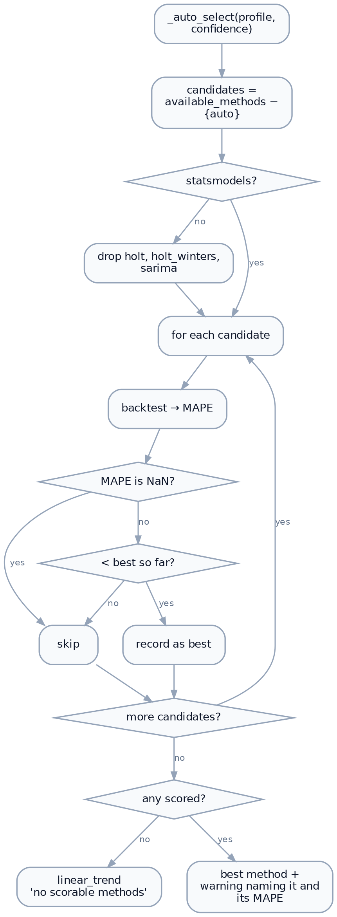
Figure 2. Automatic method selection
The winner is refitted on full history — including the holdout — before producing the displayed forecast. Backtesting selects the method; it does not produce the projection.

4.2 Transparency
compare_methods() runs the same backtest across every eligible method and returns the full table shown in the “Model details” panel. The invariant that makes the panel trustworthy is asserted in tests/test_forecast_narrative.py::test_comparison_picks_the_same_winner_as_auto:
the top scored row of the comparison table must equal auto’s resolved method
Without that test, the table could quietly disagree with the selection and no one would notice. Unscorable methods sort last with — rather than being hidden, so the user sees that a method exists and could not be evaluated.

4.3 Limitations of the selection procedure
- Single holdout, not cross-validated. One split of at most six periods. Rolling-origin evaluation would be far more robust; it is not implemented, principally because it multiplies fitting cost by the number of origins and the panel is redrawn interactively.
- Selection on the same data that is scored. The reported MAPE for the winning method is optimistically biased, because that method was chosen for having the lowest value on this holdout. With seven candidates the winner’s error is a minimum of seven draws, not an unbiased estimate. The displayed figure should be read as “best observed” rather than “expected”.
- Recency-weighted by construction. The holdout is always the tail, so selection favours methods that suit the most recent six periods. For a seasonal series this may be an unrepresentative window.
- No parsimony penalty. Ties go to whichever method was evaluated first; there is no preference for the simpler model.
Limitation 2 is the one worth stating to any reader of the output. The mitigation in place is that the comparison table shows all methods, so a reader can see whether the winner led by a wide margin or edged out a rival.

5. Worked example — Walmart weekly sales
Series as characterised in Report 3 §8: 143 weekly periods, 2010-02-05 to 2012-10-26, seasonal with $m=52$, observed range 31,027,057 to 51,828,493. Holdout $k=6$.
Rank | Method | MAPE | MAE | RMSE | RMSE/MAE
1 | Holt-Winters (seasonal) | 0.6% | 209,827 | 252,131 | 1.20
2 | Seasonal naive | 0.7% | 234,364 | 322,803 | 1.38
3 | Naive | 2.3% | 832,974 | 1,008,110 | 1.21
4 | Holt (trend) | 3.8% | 1,352,551 | 1,495,454 | 1.11
5 | Moving average | 5.1% | 1,833,515 | 1,923,153 | 1.05
6 | Linear trend | 5.5% | 1,975,166 | 2,060,305 | 1.04
— | SARIMA | — | — | — | withheld, $m=52>24$

Observations
The two seasonal methods dominate. Both score under 1% while every non-seasonal method is above 2%. On a series whose defining feature is an annual retail cycle, this is the expected and reassuring result: the evaluation procedure identifies the structure that is actually present.
Naive beats both trend methods. This is the more instructive finding. Holt (3.8%) and linear trend (5.5%) are more sophisticated than repeating last week’s value (2.3%), and both do worse. The reason is that week-to-week change in this series is dominated by seasonality rather than trend; a method that fits a trend through seasonal oscillation extracts a slope that is largely artefact. This is precisely why naive is retained as a baseline — a method that cannot beat it has not learned anything transferable.
The margin at the top is thin. Holt-Winters leads seasonal naive by 0.1 percentage points of MAPE. Given limitation 4.3.2 — the winner’s score is the minimum of six draws — that margin should not be read as establishing Holt-Winters as decisively superior. The RMSE/MAE ratio is the better discriminator here: Holt-Winters distributes its error more evenly.
Ordering is stable across metrics. MAPE, MAE and RMSE rank the six methods identically, which is not guaranteed and increases confidence in the ranking. Where they disagree, the disagreement is itself informative.

6. Presentation to the user
Accuracy reaches the reader through four channels, all from the same ForecastResult.metrics:
Channel | Content
Badge under the chart | Model: Holt-Winters · backtest MAPE 0.6% · MAE 209,827
Predictive Analytics bullet | “Backtesting against held-out history gives 0.6% mean error — strong accuracy for this series.”
Model details table | All methods, all three metrics, sorted
HTML export | Method, MAPE, MAE and the standing disclaimer
The narrative always pairs the number with a word, because “0.6%” means nothing to a reader who does not know the metric, and “strong” without the number is unfalsifiable. Both together are checkable.
The standing caveat accompanies every forecast:
Forecasts are model estimates extrapolated from history, not guaranteed outcomes. They assume past patterns continue and cannot anticipate changes in the business, market or data collection.

7. Summary of gaps
Consolidated for anyone extending this work.
# | Gap | Impact | Difficulty
1 | MAPE rather than MASE | Asymmetric, undefined at zero | Low
2 | Single holdout, no rolling origin | Fragile estimates | Medium
3 | Selection bias in the reported score | Optimistic accuracy | Low (report a caveat) or Medium (nested validation)
4 | Fixed SARIMA orders | Underfits ARIMA-appropriate data | Medium
5 | Approximate bands for Holt / Holt-Winters | Intervals narrower than nominal | Medium
6 | No prediction-interval coverage check | Band calibration unverified | Medium
7 | No parsimony tie-break | Arbitrary choice among equals | Low
Item 6 deserves emphasis: the application reports point accuracy but never checks whether its 80% bands actually contain the truth 80% of the time. Given the approximations in §2.2 of Report 2, empirical coverage is likely below nominal for the exponential-smoothing methods. A coverage backtest — the fraction of holdout points falling inside the predicted interval — would be a natural addition and would use machinery already present.

References
Hyndman, R.J. & Koehler, A.B. (2006). Another look at measures of forecast accuracy. International Journal of Forecasting, 22(4), 679–688.
Hyndman, R.J. & Athanasopoulos, G. (2021). Forecasting: Principles and Practice, 3rd ed. OTexts. — Chapter 5.8 (evaluation), 5.10 (time-series cross-validation).
Tashman, L.J. (2000). Out-of-sample tests of forecasting accuracy: an analysis and review. International Journal of Forecasting, 16(4), 437–450.

