Describing data as follows   
  
6  
count = 150  
Attribute type is numerical  
summation = 876.5000000000002  
mean = 5.843333333333335  
standard deviation = 0.8280661279778629  
min = 4.3  
max = 7.9  
index = 37.5  
0.25 th percentile is = 5.1  
0.5 th percentile is = 5.8  
0.75 th percentile is = 6.4  
  
  
  
count = 150  
Attribute type is numerical  
summation = 458.10000000000014  
mean = 3.0540000000000007  
standard deviation = 0.4335943113621737  
min = 2.0  
max = 4.4  
index = 37.5  
0.25 th percentile is = 2.8  
0.5 th percentile is = 3.0  
0.75 th percentile is = 3.3  
  
  
  
count = 150  
Attribute type is numerical  
summation = 563.8000000000004  
mean = 3.7586666666666693  
standard deviation = 1.7644204199522617  
min = 1.0  
max = 6.9  
index = 37.5  
0.25 th percentile is = 1.6  
0.5 th percentile is = 4.35  
0.75 th percentile is = 5.1  
  
  
  
count = 150  
Attribute type is numerical  
summation = 179.8000000000001  
mean = 1.1986666666666672  
standard deviation = 0.7631607417008414  
min = 0.1  
max = 2.5  
index = 37.5  
0.25 th percentile is = 0.3  
0.5 th percentile is = 1.3  
0.75 th percentile is = 1.8  
  
  
  
count = 150  
attribute type is nominal

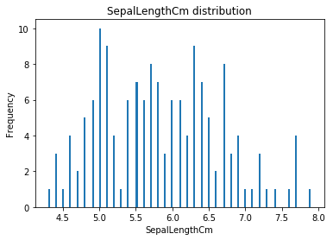

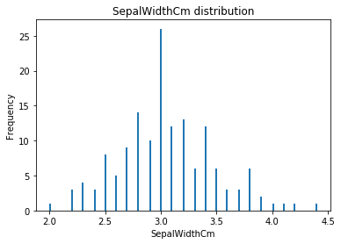

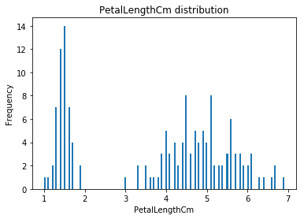

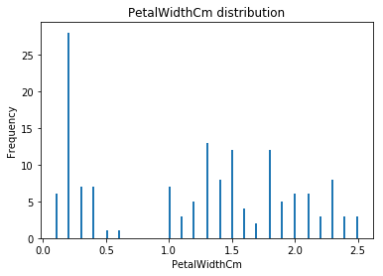

now printing boxplot

Out[2]:

<matplotlib.axes._subplots.AxesSubplot at 0x25a36fab0f0>

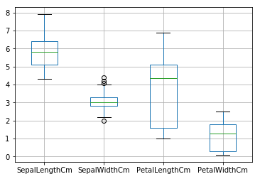

In [ ]:

​